Introduction to the Poultry Industry
Created: 07/2019 by the National FFA Organization

The National FFA Organization and U.S. Poultry and Egg Association lesson plan series provides educators with a comprehensive curriculum resource to teach students about the commercial poultry and egg industry. Additionally, lessons are infused with FFA and SAE activities to easily integrate into any agricultural education program.

Student Learning Objectives:
After completing these activities, students will …
- List and explain the vertically integrated structure of the modern poultry industry.
- Identify and describe common meat and layer breeds of chickens.
- Identify and describe the most common meat breed of turkey.
- Discover careers in the poultry industry.

Essential Questions
- What are the components or levels of the modern poultry industry?
- What does it mean to be vertically integrated?
- What are the common breeds of meat and laying chickens?
- What is the common meat breed used in the commercial turkey industry?

Time Required: 90 minutes
Resources:
- National Chicken Council, https://www.nationalchickencouncil.org/
- American Poultry Association, http://www.amerpoultryassn.com/
- “Introduction to the Poultry Industry” PowerPoint, https://ffa.box.com/s/m82lcvx51p1xwunt1mds7ucx2to51e0n
- “Ag Minute: Vertical Integration,” https://youtu.be/ozqEnkiKvTg?t=25s
- AgExplorer, https://agexplorer.ffa.org/

Equipment and Supplies Needed:
- A copy of the “Vertical Integration Video Sheet” worksheet for each student
- A pre-cut copy of the “Vertical integration Segment” cards for each group of students
- A copy of the “Vertical Integration Notes” sheet for each student
- A copy of the “Poultry Family Tree Info Sheet” worksheet for each student
- A copy of the “Career Profile” worksheet for each student
- A copy of the “Bell Ringer” and “Exit Ticket” capture sheets for each student
- Blank paper for each student
- Internet access to play the video in real time or embed it in a PowerPoint ahead of time
- Computer access, ideal for students to work in pairs or small groups

Terms:
The following terms are presented in the lesson and appear in bold italics:
- Breeds
- Breeder
- Feed Mill
- Growout Farms
- Hatchery
- Marketing
- Primary Breeder
- Processing Plant
- Transportation

These activities are aligned to the following standards:
AFNR Performance Element
- AS.01. Analyze historic and current trends impacting the animal systems industry.
- FPP.04. Explain the scope of the food industry and the historical and current developments of food products and processing.
FFA Precept
- FFA.PL-A.Action: Assume responsibility and take the necessary steps to achieve the desired results, no matter what the goal or task at hand.
- FFA.PG-J.Mental Growth: Embrace cognitive and intellectual development relative to reasoning, thinking and coping.
- FFA.CS-M.Communication: Effectively interact with others in personal and professional settings.
Common Career Technical Core
- AG1 Analyze how issues, trends, technologies and public policies impact systems in the Agriculture, Food & Natural Resources Career Cluster.
- AG2 Evaluate the nature and scope of the Agriculture, Food & Natural Resources Career Cluster and the role of agriculture, food, and natural resources (AFNR) in society and the economy.
- AG5 Describe career opportunities and means to achieve those opportunities in each of the Agriculture, Food & Natural Resources Career Pathways.
- AG6 Analyze the interaction among AFNR systems in the production, processing, and management of food, fiber, and fuel and the sustainable use of natural resources.
- AG-ANI1 Analyze historic and current trends impacting the animal systems industry.
- AG-FD4 Explain the scope of the food industry and the historical and current developments of food products and processing.
NASDCTEc
- AGC10.03 Compare and contrast issues affecting the AFNR industry including biotechnology, employment, safety, environmental and animal welfare to demonstrate an understanding of the trends and issues important to careers in this industry.
AFNR Cluster Skills
- CS.01. Analyze how issues, trends, technologies and public policies impact systems in the Agriculture, Food & Natural Resources Career Cluster.
- CS.02. Evaluate the nature and scope of the Agriculture, Food & Natural Resources Career Cluster and the role of agriculture, food and natural resources (AFNR) in society and the economy.
- CS.05. Describe career opportunities and means to achieve those opportunities in each of the Agriculture, Food & Natural Resources career pathways.
- CS.06. Analyze the interaction among AFNR systems in the production, processing and management of food, fiber and fuel and the sustainable use of natural resources.
Common Core–Writing
- CCSS.ELA-Literacy.W.9-10.2 Write informative/explanatory texts to examine and convey complex ideas, concepts, and information clearly and accurately through the effective selection, organization, and analysis of content.
Common Core–Speaking and Listening
- CCSS.ELA-Literacy.SL.9-10.1 Initiate and participate effectively in a range of collaborative discussions (one-on-one, in groups, and teacher-led) with diverse partners on grades 9-10 topics, texts, and issues, building on others' ideas and expressing their own clearly and persuasively.
- CCSS.ELA-Literacy.SL.9-10.2 Integrate multiple sources of information presented in diverse media or formats (e.g., visually, quantitatively, orally) evaluating the credibility and accuracy of each source.
- CCSS.ELA-Literacy.SL.9-10.4 Present information, findings, and supporting evidence clearly, concisely, and logically such that listeners can follow the line of reasoning and the organization, development, substance, and style are appropriate to purpose, audience, and task.
AFNR Career Ready Practices
- CRP.02. Apply appropriate academic and technical skills. Career-ready individuals readily access and use the knowledge and skills acquired through experience and education to be more productive.
- CRP.04. Communicate clearly, effectively, and with reason. Career-ready individuals communicate thoughts, ideas and action plans with clarity, whether using written, verbal and/or visual methods.
Partnership for 21st Century Skills
- Communication
- Critical Thinking and Problem Solving

Lesson Plan:
- Bell Ringer: Have students use the “Bell Ringer capture sheet” to list as many poultry-based products as they can think of in one minute.

- Interest Approach: Bring two to three highly processed, poultry-based products (Examples: chicken nuggets, sliced turkey meat from the deli, chicken-based dog food) to class to pass around or display at the front of the room. If bringing items is not an option, display images of these items (found on correlating PowerPoint) on a projector screen. Discuss the products briefly using the questions below:
  - What do these items have in common with each other?
  - What happened to these items to get them from their original state to their current state?
  - What do we know about the process for adding value to these products from their original state to their current state?

- Instruction:

Student Learning Objective One: Students will be able to list and explain the vertically integrated structure of the modern poultry industry.

- There are many segments of the poultry industry. These segments are all interlinked, and many times, they owned by the same company. This type of ownership is called Vertical Integration.  - Vertical Integration  - It is a style of business management that allows for maximum control of the products produced.  - It is much like a ladder concept as each segment relies on the segment below it to supply it with what it needs, while that segment must produce the product the next segment needs.  - It is like a hierarchy of needs that are met within one company.  - It allows the poultry industry to develop its product efficiently and to produce a high-quality product.  - The Structure  - The ladder consists of eight steps:  - Primary Breeders  - Feed Mill  - Breeders  - Hatchery  - Growout Farms  - Processing Plants  - Further Processing  - Transportation and Marketing  - Primary Breeders  - Their responsibility is to develop and reproduce strains of chicken that meet the requirements of chicken producers and processing companies.  - Through development and reproduction, they aim to achieve desirable characteristics such as abundant white meat and efficient feed conversion.  - Breeder chicks with the appropriate mix of desirable characteristics are then sold to integrated chicken firms.  - Feed Mill  - Chicken companies own feed mills that convert raw materials into finished feed according to very specific formulas developed by poultry nutritionists.  - They produce four to five different formulas to feed all the different nutrition stages of chickens.  - Breeders  - Operated by contract growers who raise the breeder chicks to adult birds.  - Breeding hens and roosters are kept under tight biosecurity on breeder farms to produce fertile hatching eggs.  - The offspring of breeder parents will then be raised to become broilers for the market.  - Hatchery  - A hatchery is a specialized facility designed to hatch fertile eggs received from breeder farms.  - Fertile eggs are placed in incubators and carefully monitored to ensure that correct temperature and humidity levels are maintained throughout the entire incubation period.  - Towards the end of incubation, the eggs are placed in hatching trays where the chicks hatch by pecking their way through the large end of the egg.  - Growout Farms  - The newly hatched chicks are transported to growout farms where independent farmers raise them to market weight under contract with the company.  - The company provides the chicks, the feed and any necessary pharmaceuticals.  - The farmer provides the growout barn, water, bedding (“litter”), electricity and his or her own management skills.  - The chickens reach market weight in six or seven weeks and are collected and transported to the processing plant.  - Processing Plants  - The processing plant harvests the birds by humane standards and are inspected by the USDA for any disease or defects.  - The carcasses are then chilled with air chillers or cold-water chillers to limit the growth of bacteria.  - Following chilling, they are packaged for distribution or cut into parts.  - Further Processing  - These are specialized operations or plants that receive whole chicken or cut-up parts and perform a variety of further processing steps.  - These steps include cooking, breading or marinating.  - Transportation and Marketing  - Chicken products are transported in refrigerated trucks from the processing and further processing plants to grocery stores, restaurants and other customers.  - Value to the Economy  - Vertical integration within the poultry industry gives producers greater control over the production of quality products that successfully meet consumer wants and needs.  - It has shown to be more cost effective for the company as well. | Activity 1:  Direct students to watch “Ag Minute: Vertical Integration” from 0:25 to 2:01 (https://youtu.be/ozqEnkiKvTg?t=25s).  As students watch the brief video, instruct them to complete the associated worksheet, “Vertical Integration Video Sheet.” Provide a few minutes after the video for students to complete the three questions and compare answers in pairs. As a class, discuss answers to these questions:  - What is vertical integration?  - Why is vertical integration positive for the producer?  - Why is vertical integration positive for the consumer?  Activity 2:  Part 1: Provide each student with the “Vertical Integration Segment” cards, pre-cut and scrambled. There are 16 cards: eight terms or segments and eight definitions that match each segment. Have students work individually to correctly match each segment with the corresponding definition. Once students finish have them compare their match with a partner.  - Partners can be determined before starting the activity or they can pair up as they finish this part of the activity.  Once pairs agree about their matches, they will check-in with the teacher to confirm the segments have been correctly matched to the definition. After matches are confirmed, direct students to tape them together (segment and definition side-by-side).  Part 2: Have students work in their pairs to arrange the segments of vertical integration working from the bottom (segment 1) to the top (segment 8). When complete, compare to a neighboring group.  Once both groups are in agreement with their order of the vertical integration segments, they will check-in with the teacher to confirm the segments are in the proper order. After matches are confirmed, direct students to tape them in the proper order on their notes sheet under term and definition.  Part 3: After all students have completed Part 2, have a class discussion about each of the eight segments of vertical integration. Afterward, have students complete the “Segments” portion of the “Vertical Integration Notes” sheet. For this portion, students will identify the segment title and draw a picture to represent that segment.

Student Learning Objectives Two and Three: Students will be able to identify and describe common meat and layer breeds of chickens. Students will be able to identify and describe the most common meat breed of turkey.

Chickens  - The chicken industry has well over fifty breeds that are recognized by the American Poultry Association. These breeds are broken down by classifications and use. The uses of these animals are layers, meat and dual use.  - Meat Breeds  - They are not really breeds.  - Instead, they are hybrid varieties or combinations of many different breeds.  - These varieties are developed for specific characteristics:  - grow faster and larger.  - larger breast-meat yield.  - more efficient feed conversion.  - more disease resistance.  - These varieties are used by broiler-producing companies that commercially produce broilers sold in supermarkets.  - Weakness of these varieties:  - They do not lay as many eggs as the layer breeds.  - Specific Variety Used in Industry  - Cornish Cross  - White Cornish x White Plymouth Rock  - Their fast growth allows them to reach for to five pounds in six weeks and six to 10 pounds in eight to 12 weeks.  - White Cornish  - They are part of the English Class.  - They have a very broad and meaty body.  - White Plymouth Rock  - They are part of the American Class.  - They tend to be docile and a fairly good dual-purpose breed.  - Layers Breeds  - They have been genetically selected for high egg productivity.  - They tend to be small bodied so they are undesirable for meat production.  - Their small bodies allow the bird to put more nutrients toward egg production instead of body size.  - They are divided into two types:  - White egg layers and brown egg layers.  - Chicken breeds with white ear lobes lay white eggs, whereas chickens with red ear lobes lay brown eggs.  - Specific Breeds Used in Industry  - White Leghorns  - They are part of the Mediterranean Class.  - Very good layer of white eggs  - Basis of commercial egg industry  - Rhode Island Red  - They are part of the American Class.  - They lay brown eggs.  - Production-bred strains lay very well.  Turkeys  - There are currently eight breeds of turkeys that are recognized by the American Poultry Association. There are several breeds that are not officially recognized as a breed, but these are the varieties that are commercially used by the industry. These breeds are predominately used for meat.  - Meat Breed  - Broad-Breasted White  - Commercially, the most widely used breed of domesticated turkey.  - They have shorter breast bones and legs than “standard” turkeys.  - They are unable to breed naturally and require assistance from humans.  - They produce more breast meat, and their pin feathers are less visible when the carcass is dressed due to their white color. | Activity 1:  Set context that the poultry industry utilizes many breeds for various purposes, chicken (over 50 breeds) and turkey (eight breeds). To understand the classification and use of the most popular breeds and types, students will create a “Poultry Family Tree.”  To complete the Poultry Family Tree, each student will need one “Poultry Family Tree Info Sheet” and one blank sheet of paper. Students will complete their own Poultry Family Tree but may work together as a group when doing so.  To complete the activity, discuss the Poultry Family Tree by drawing an outline on a whiteboard and drawing student attention to specific qualities or characteristics that should be added to each branch.  An example of a Poultry Family Tree is below:  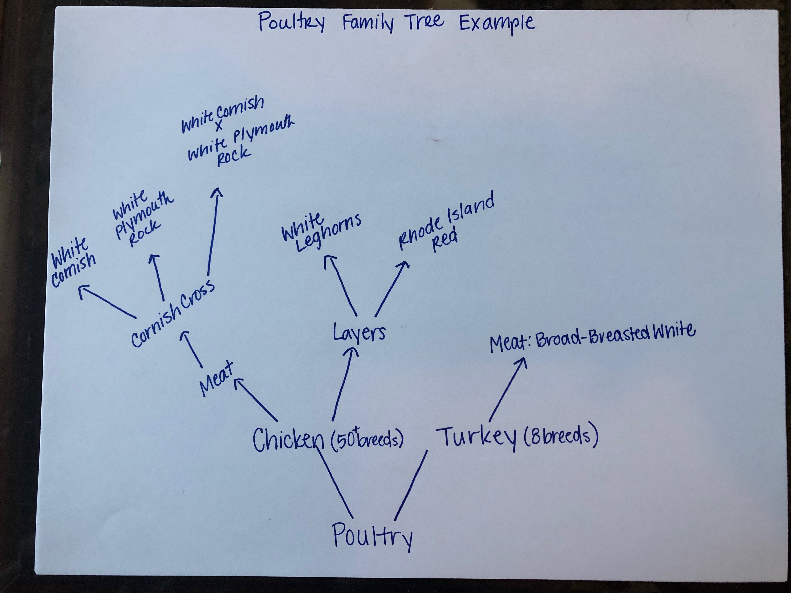

- Follow-up: If time allows, place students in groups of six (other group sizes will work, but in this case, each student will have one breed to research). Each student will be responsible for finding an image of one poultry breed or type using phones or laptops.
- Turkey: Broad-Breasted White
- Chicken: Rhode Island Red
- Chicken: White Leghorns
- Chicken: White Plymouth Rock
- Chicken: White Cornish
- Chicken: White Cornish x White Plymouth Rock (Cornish Cross)

Once each student has found an image of their assigned breed/type, they will display the image to their group members like a flashcard. The remaining group members will use their info sheets and family trees to point out characteristics of the animal on the image and recall qualities of the breed/type. The activity is complete when each breed/type has been reviewed.

- FFA/SAE Connection: Each student will need a copy of the “Career Profile” worksheet. Students will discover careers in the poultry industry by utilizing the career profiles on AgExplorer, available at https://agexplorer.ffa.org/. Have students search the career focus areas to identify poultry industry careers. Each student will choose one career to complete the “Career Profile” worksheet.
*The careers might not directly say poultry as they could also be in a different species. Ensure students are thinking about all vertical integration segments.

- Exit Ticket: On the “Exit Ticket capture sheet”, direct students to respond to the following: “Justify why vertical integration benefits the poultry industry and its consumers. Why are various breeds and types of poultry produced?”

Name: _________________________________________ Period: ____________
Week of: _________________________________________ Class: _________________

Bell Ringer Activity
Monday, ___________  Question:  Answer: | Tuesday, ____________  Question:  Answer:
Wednesday, ____________  Question:  Answer: | Thursday, _____________  Question:  Answer:
Friday, _____________  Question:  Answer: | 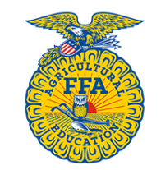

EXIT TICKETS
Monday, ___________  Question:  Answer: | Tuesday, ____________  Question:  Answer:
Wednesday, ____________  Question:  Answer: | Thursday, _____________  Question:  Answer:
Friday, _____________  Question:  Answer: | Summarize the learning objectives for the week.

*Worksheet modified from a resource created by Chasten Bear – Riverside High School, Indianapolis, Ind.
Vertical Integration Video Sheet
Aligned to the following standards:
AS.01; FPP.04; FFA.PL-A; FFA.PG-J; FFA.CS-M; AG1; AG2; AG5; AG6; AG-ANI1; AG-FD4; AGC10.03; CS.01; CS.02; CS.05; CS.06; CCSS.ELA.W.9-10.2; CCSS.ELA.SL.9-10.1; CCSS.ELA.SL.9-10.2; CCSS.ELA.SL.9-10.4; CRP.02; CRP.04
Directions:
While watching the “Ag Minute: Vertical Integration” video (https://youtu.be/ozqEnkiKvTg?t=25s), answer the questions below.



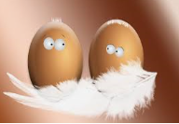

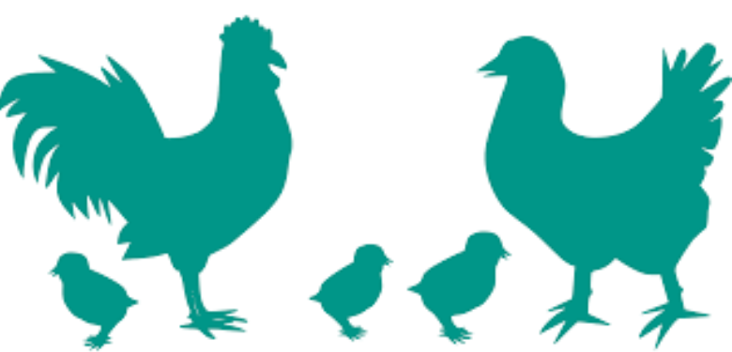
Vertical Integration Cards
Aligned to the following standards:
AS.01; FPP.04; FFA.PL-A; FFA.PG-J; FFA.CS-M; AG1; AG2; AG5; AG6; AG-ANI1; AG-FD4; AGC10.03; CS.01; CS.02; CS.05; CS.06; CCSS.ELA.W.9-10.2; CCSS.ELA.SL.9-10.1; CCSS.ELA.SL.9-10.2; CCSS.ELA.SL.9-10.4; CRP.02; CRP.04

Primary Breeders | Their responsibility is to develop and reproduce strains of chicken that meet the requirements of chicken producers and processing companies.  Through development and reproduction, they aim to achieve desirable characteristics such as abundant white meat and efficient feed conversion.  Breeder chicks with the appropriate mix of desirable characteristics are then sold to integrated chicken firms.
Feed Mill | Chicken companies own these to convert raw materials into finished feed according to very specific formulas developed by poultry nutritionists.  They produce 4 to 5 different formulas to feed all the different nutrition stages of chickens.
Breeders | Operated by contract growers who raise the breeder chicks to adult birds.  Breeding hens and roosters are kept under tight biosecurity on breeder farms to produce fertile hatching eggs.  The offspring of breeder parents will become broilers for the market.
Hatchery | A specialized facility designed to hatch fertile eggs received from breeder farms.  Fertile eggs are placed in incubators and carefully monitored to ensure that correct temperature and humidity levels are maintained throughout the entire incubation period.  Toward the end of incubation, the eggs are placed in hatching trays where the chicks hatch by pecking their way through the large end of the egg.
Growout Farms | The newly hatched chicks are transported to these where independent farmers raise them to market weight under contract with the company.  The company provides the chicks, the feed and any necessary pharmaceuticals.  The farmer provides the growout barn, water, bedding (“litter”), electricity and his or her own management skills.  The chickens reach market weight in six or seven weeks and are collected and transported to the processing plant.
Processing Plants | This is where birds are harvested by humane standards and are inspected by the USDA for any disease or defects.  The carcasses are then chilled with air chillers or cold-water chillers to limit the growth of bacteria.  Following chilling, they are packaged for distribution or cut into parts.
Further Processing | These are specialized operations or plants that receive whole chicken or cut-up parts and perform a variety of additional processing steps.  These steps include cooking, breading or marinating.
Transportation and Marketing | Chicken products are transported in refrigerated trucks from the processing and further processing plants to grocery stores, restaurants and other customers.

Aligned to the following standards:
AS.01; FPP.04; FFA.PL-A; FFA.PG-J; FFA.CS-M; AG1; AG2; AG5; AG6; AG-ANI1; AG-FD4; AGC10.03; CS.01; CS.02; CS.05; CS.06; CCSS.ELA.W.9-10.2; CCSS.ELA.SL.9-10.1; CCSS.ELA.SL.9-10.2; CCSS.ELA.SL.9-10.4; CRP.02; CRP.04

Vertical Integration Notes Sheet
Segment | Term | Definition

Poultry Family Tree Info Sheet
Aligned to the following standards:
AS.01; FPP.04; FFA.PL-A; FFA.PG-J; FFA.CS-M; AG1; AG2; AG5; AG6; AG-ANI1; AG-FD4; AGC10.03; CS.01; CS.02; CS.05; CS.06; CCSS.ELA.W.9-10.2; CCSS.ELA.SL.9-10.1; CCSS.ELA.SL.9-10.2; CCSS.ELA.SL.9-10.4; CRP.02; CRP.04

Directions:
Use the information below to craft a “family tree” of poultry types and breeds common to the chicken and turkey production industries.

Chicken
The chicken industry has well over fifty breeds that are recognized by the American Poultry Association. These breeds are broken down by classifications and use. The uses of these animals are layers, meat and dual use.

Meat Breeds
- Hybrid varieties or combinations of many different breeds.
- These varieties are developed for specific characteristics:
  - Grow faster and larger.
  - Larger breast-meat yield.
  - More efficient feed conversion.
  - More disease resistance.
- Used by broiler-producing companies that commercially produce broilers sold in supermarkets.

Specific Varieties Used in Industry:
- Cornish Cross
  - White Cornish x White Plymouth Rock
    - Their fast growth allows them to reach 4 to 5 pounds in 6 weeks and 6 to 10 pounds in 8 to 12 weeks.
  - White Cornish
    - They are part of the English Class.
    - They have a very broad and meaty body.
  - White Plymouth Rock
    - They are part of the American Class.
    - They tend to be docile and a fairly good dual-purpose breed.

Layer Breeds
- They have been genetically selected for high egg productivity.
- They tend to be small bodied so they are undesirable for meat production.
  - Their small bodies allow the bird to put more nutrients toward egg production instead of body size.
- They are divided into two types:
  - White egg layers and brown egg layers.
  - Chicken breeds with white ear lobes lay white eggs, whereas chickens with red ear lobes lay brown eggs.

Specific Breeds Used in Industry:
- White Leghorns
  - Part of the Mediterranean Class
  - Very good layer of white eggs
  - Basis of commercial egg industry
- Rhode Island Red
  - They are part of the American Class.
  - They lay brown eggs.
  - Production-bred strains lay very well.

Turkey
There are currently eight breeds of turkeys that are recognized by the American Poultry Association. There are several breeds that are not officially recognized as a breed, but these are the varieties that are commercially used by the industry. These breeds are predominately used for meat.

Meat Breed
- Broad-Breasted White
  - Commercially, the most widely used breed of domesticated turkey.
  - They have shorter breast bones and legs than “standard” turkeys.
    - They are unable to breed naturally and require assistance from humans.
- They produce more breast meat, and their pin feathers are less visible when the carcass is dressed due to their white color.

Career Profile
Aligned to the following standards:
AS.01; FPP.04; FFA.PL-A; FFA.PG-J; FFA.CS-M; AG1; AG2; AG5; AG6; AG-ANI1; AG-FD4; AGC10.03; CS.01; CS.02; CS.05; CS.06; CCSS.ELA.W.9-10.2; CCSS.ELA.SL.9-10.1; CCSS.ELA.SL.9-10.2; CCSS.ELA.SL.9-10.4; CRP.02; CRP.04

Directions:
Utilize AgExplorer (https://agexplorer.ffa.org/) to discover careers in the poultry industry. You will choose one of the careers and complete a career profile about it.
Cover Photo: (Setting)

Profile Picture

Career Focus Area:
Interest/Skills: (What skills are needed for this career?)
Name of Career:
Friends: (Who would I work with?)
Basic Information: (Where do I work? What other careers fit in this career focus area? What SAE project can be tied to this career? What companies could I work for/with?)

About: (What do I do?)

Status Update: (Why is your career the coolest?)
Schooling: (What education is needed for this career?)

EXAMPLE: Career Profile
Aligned to the following standards:
AS.01; FPP.04; FFA.PL-A; FFA.PG-J; FFA.CS-M; AG1; AG2; AG5; AG6; AG-ANI1; AG-FD4; AGC10.03; CS.01; CS.02; CS.05; CS.06; CCSS.ELA.W.9-10.2; CCSS.ELA.SL.9-10.1; CCSS.ELA.SL.9-10.2; CCSS.ELA.SL.9-10.4; CRP.02; CRP.04

Cover Photo: (Setting)
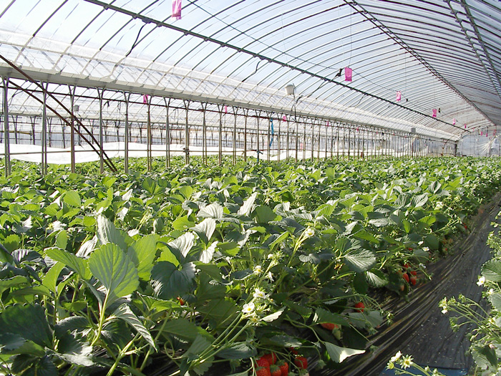

Profile Picture
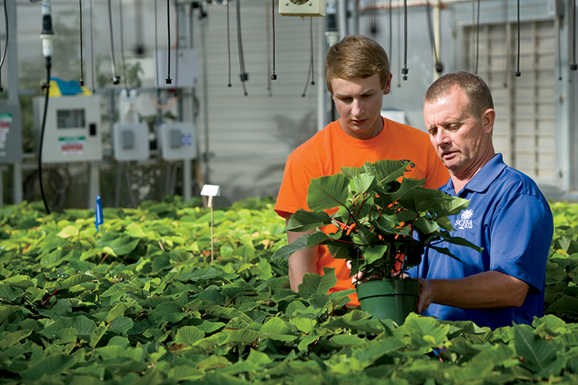

Career Focus Area: Ag Ed
Interest/Skills: (What skills are needed for this career?)
Communication
Organization

Name of Career: Agriculture Education Teacher
Friends: (Who would I work with?)

Middle and high school students
School administration
Extension agents

Basic Information: (Where do I work? What other careers fit in this career focus area? What SAE project can be tied to this career? What companies could I work with?)

Schools: rural or urban setting

Agriculture communications: journalist, advocacy

Agricultural education: younger students

Farm Bureau, extension, National FFA Organization

About: (What do I do?)

I teach students about all aspects of agriculture (animals, plants, mechanics, etc.). I am an advisor for the FFA, which is the largest youth organization in the world. I get to inspire and develop future leaders every day.

Status Update: (Why is your career the coolest?)

I get to work with future agriculturists every day!

Schooling: (What education is needed for this career?)

Bachelor’s degree (4 years of college)
-teaching certification

KEY: Vertical Integration Video Sheet
Aligned to the following standards:
AS.01; FPP.04; FFA.PL-A; FFA.PG-J; FFA.CS-M; AG1; AG2; AG5; AG6; AG-ANI1; AG-FD4; AGC10.03; CS.01; CS.02; CS.05; CS.06; CCSS.ELA.W.9-10.2; CCSS.ELA.SL.9-10.1; CCSS.ELA.SL.9-10.2; CCSS.ELA.SL.9-10.4; CRP.02; CRP.04

Directions:
While watching the “Ag Minute: Vertical Integration” video (https://youtu.be/ozqEnkiKvTg?t=25s), answer the questions below.

