Poultry Anatomy and Physiology
Created: 07/2019 by the National FFA Organization

The National FFA Organization and U.S. Poultry and Egg Association lesson plan series provides educators with a comprehensive curriculum resource to teach students about the commercial poultry and egg industry. Additionally, lessons are infused with FFA and SAE activities to easily integrate into any agricultural education program.
Student Learning Objectives:
After completing these activities, students will …
- Recognize terms and definitions of poultry anatomy and physiology.
- Discuss the functions of major body systems of poultry.

Essential Questions:
- What is the difference between the location of an organ and its actual purpose?
- How does avian anatomy and physiology differ from mammals?
Time Required: 90 minutes
Resources:
- “Poultry Anatomy and Physiology” PowerPoint, https://ffa.box.com/s/j5touaybqf7p8y0ht3rj3s4s6ijktmm8
- AgExplorer, https://agexplorer.ffa.org/
Equipment and Supplies Needed:
- A copy of the “Poultry Anatomy and Physiology” worksheet for each student
- A copy of the “Mural: Poultry Systems” outline for each student
- A copy of each “Systems Information Sheet” for each group of students
- Internet access
- Computer access, ideal for students to work in pairs or small groups
- Random classroom supplies and poster board or markers and posterboard

Terms:
The following terms are presented in the lesson and appear in bold italics:
- Bronchi
- Wattle
- Comb
- Larynx
- Pneumatic Bones
- Plumage
- Filoplumes
- Inhalation
- Exhalation
- Air Sacs
- Nares
- Uric Acid
- Medullary
- Shank
- Ductus Deferens
- Rudimentary Phallus
- Vent
- Deglutition
- Crop
- Proventriculus
- Ceca
- Cloaca
- Bile
- Erythrocyte
- Gizzard
- Leukocyte

These activities are aligned to the following standards:
AFNR Performance Element
- AS.06. Classify, evaluate, and select animals based on anatomical and physiological characteristics.
- AS.07. Apply principles of effective animal health care.
FFA Precept
- FFA.PG-J.Mental Growth: Embrace cognitive and intellectual development relative to reasoning, thinking and coping.
- FFA.CS-N.Decision Making: Analyze a situation and execute an appropriate course of action.
Common Career Technical Core
- AG-ANI6 Classify, evaluate, and select animal based on anatomical and physiological characteristics.
- AG-ANI7 Apply principles of effective animal health care.
NASDCTEc
- AGPC01.01 Produce and/or manage animals in domesticated and/or natural environments using an application of knowledge regarding anatomy and physiology to enhance animal production.
Common Core–Reading: Informational Text
- CCSS.ELA-Literacy.RI.9-10.1 Cite strong and thorough textual evidence to support analysis of what the text says explicitly as well as inferences drawn from the text.
Common Core–Speaking and Listening
- CCSS.ELA-Literacy.SL.9-10.4 Present information, findings, and supporting evidence clearly, concisely, and logically such that listeners can follow the line of reasoning and the organization, development, substance, and style are appropriate to purpose, audience, and task.
Common Core–Science & Technical Subjects
- CCSS.ELA-Literacy.RST.9-10.9 Compare and contrast findings presented in a text to those from other sources (including their own experiments), noting when the findings support or contradict previous explanations or accounts.
Common Core–Math Practices
- CCSS.MP6 Attend to precision.
- CCSS.MP7 Look for and make use of structure.
AFNR Career Ready Practices
- CRP.07. Employ valid and reliable research strategies. Career-ready individuals are discerning in accepting and using new information to make decisions, change practices or inform strategies.
Partnership for 21st Century Skills
- Critical Thinking and Problem Solving
- Information Literacy

Lesson Plan:
- Bell Ringer: What are the main anatomical differences between poultry and other animals?

- Interest Approach: Use sticky notes to label a student using the four anatomical terms: dorsal, ventral, cranial, caudal. Discuss each term as you label the student. Transition by noting that today’s topic will focus on anatomical terms.

- Instruction: Option 1: Utilize the accompanying PowerPoint and “Poultry Anatomy and Physiology” outline to discuss the important systems of poultry.
Option 2: Another option is to cover the various systems by assigning the “Mural: Poultry Systems” project.

Student Learning Objective One: Students will be able to recognize terms and definitions of poultry anatomy and physiology.

I. Anatomy  A. Anatomy is the science of the structure of animals. The word is derived from the Greek word meaning “to cut up.”  II. Physiology  A. Physiology is the science that deals with the functions of the living organism and its parts.  III. Anatomical Terms  - The following terms are used to describe locations on the animal body.  - Dorsal pertains to the upper surface of the animal.  - Ventral relates to the lower and abdominal surface.  - Cranial (or anterior) applies to the front or head.  - Caudal (or posterior) pertains to the tail or rear. | Go through this information while utilizing the “Poultry Anatomy and Physiology” worksheet.

Student Learning Objective Two: Students will be able to discuss the functions of major body systems of poultry.

I. Integumentary System  - The skin, or integumentary system, of poultry is similar to mammals, except for feather production. They have a wattle, defined as the red skin underneath the beak, and a comb, defined as the red skin located on top of their head. Blood circulates between the wattle and comb and helps to regulate body temperature.  - Poultry have plumage and beaks.  - Plumage is defined as the outer covering of a bird’s body. This includes feathers, scales and filoplumes, which are hair-like structures located at the base of feathers. Scales are located on the legs and feet. The plumage allows for altered shape to facilitate necessary body cooling and heating for maintenance of body temperature. Plumage shape is particularly important for cooling since birds lack sweat glands. Although it is not common for production birds to fly, plumage type and form is an important determinant in flight for aerial species. Plumage protects against abrasions and bruises when birds are in groups or lying on the ground.  - Birds have beaks as opposed to lips and teeth. The beak is used for eating and drinking, as well as self-defense and protection from other animals.  II. Respiratory System  - The respiratory system of poultry is vastly different from the mammalian respiratory system. Unlike mammals, birds lack a diaphragm to inflate and deflate the lungs. Instead, birds have nine air sacs located in the neck region and body cavity that function to inflate the lungs.  - Gas exchange occurs in the avian lung, and the air sacs function to move air in and out of the respiratory system.  - The breathing process has two phases: inhalation and exhalation.  - Inhalation: when the bird breathes in, air bypasses the lungs and enters the posterior air sacs. At the same time, air in the lungs from the last exhalation phase exits the lungs and enters the anterior air sacs.  - Exhalation: the bird releases air from the posterior air sacs, which enters the lungs. The air that filled the anterior air sacs from the inhalation phase is then released from the body through the trachea.  - Nares are the nostrils located on the beak. They serve as the passageway for air to be breathed in and out of the trachea.  III. Skeletal System of Poultry  - Pneumatic Bones  - Poultry have pneumatic, or hollow, bones. These bones connect with the respiratory system, and their light weight is an adaptation for flight.  - Medullary Bone  - Medullary bone contains high amounts of calcium, and this storage source is used by the female hen when developing the egg shell during reproductive periods.  - Fused Bones  - Bones in the foot, or shank, are fused and cause birds to walk upright.  - Many vertebra along the backbone are fused for the purpose of flight.  IV. Digestive System  - The purpose of the poultry digestive system is to use nutrients found in feed through the processes of digestion and absorption.  - The digestive system begins at the oral cavity and ends at the vent.  - Oral cavity  - Tongue: the tongue functions to move food within the oral cavity and initiates deglutition, or swallowing, of feed.  - Esophagus  - The esophagus is a flexible tube that carries food from the oral cavity to the crop and proventriculus.  - Crop  - The crop is an outcropping, or pouch, of the esophagus.  - The crop functions to store feed. No digestion of food takes place in the crop.  - Proventriculus  - The proventriculus is the true stomach of the bird, similar to the mammalian stomach.  - The proventriculus uses acid and other digestive enzymes to begin the chemical breakdown of food.  - Gizzard  - The gizzard is also called the ventriculus.  - The gizzard contains well-developed musculature and functions by grinding and contracting to aid in the mechanical reduction of food particles.  - The gizzard may contain small pebbles or gravel from foraging to aid in the reduction of food particle size.  - Small Intestine  - After passing the gizzard and being reduced to the proper particle size, food enters the small intestine for further digestion and absorption.  - There are three regions of the small intestine:  - Duodenum.  - Jejunum.  - Ileum.  - The small intestine has a very large absorptive area due to many folds and finger-like projections located along its length.  - Ceca  - Poultry have two ceca.  - The ceca are two dead-end pouches that contain microbes.  - The microbes ferment any leftover food particles and produce molecules that the bird can use as an energy source.  - Colon  - Also referred to as the large intestine.  - This a short section of the digestive tract that starts after the ceca and ends at the cloaca.  - The function of the colon is to absorb water.  - Cloaca  - This is also known as the vestibule and is the chamber responsible for the expulsion of feces and urine.  - Liver  - The liver is an accessory organ of the digestive system.  - The liver produces a substance called bile, which helps to digest fats. Bile is stored in the gall bladder.  - Pancreas  - The pancreas is an accessory organ of the digestive system.  - This is a yellow organ located in the loop of the duodenum.  - The pancreas produces digestive enzymes that are released into the small intestine to help digest protein and carbohydrates.  - The pancreas produces the hormones insulin and glucagon, which work together to control blood-sugar levels.  V. Circulatory System  - The purpose of the circulatory system is to control the flow of blood throughout the body.  - There are many organs of the circulatory system:  - Heart  - A large organ located in the chest cavity.  - The poultry heart has four chambers: two atria and two ventricles.  - The heart pumps blood throughout the body to deliver oxygen and nutrients to tissues and to remove carbon dioxide and metabolic waste from tissues.  - Blood Vessels  - Arteries deliver blood from the heart to tissues.  - Arterioles: smaller branches of arteries that direct blood to certain tissues.  - Capillaries: site of gas, nutrient and waste exchange between the blood and the body’s tissues.  - Veins deliver blood from the tissues to the heart and lungs for oxygenation.  - Blood  - Composed of plasma and blood cells  - Avian red blood cells, also known as erythrocytes, are nucleated, unlike non-nucleated mammalian red blood cells. They are produced in the bone marrow and transport oxygen.  - White blood cells, or leukocytes, are important in fighting disease in the body. They are cells of the immune system.  - Plasma makes up the majority of the blood. It contains many different molecules, such as water, glucose, plasma proteins and plasma enzymes.  VI. Urinary System  - Kidneys: two multi-lobular structures located in the rib cage.  - The kidneys produce urine by removing waste products from the blood.  - Ureters  - Transport kidney filtrate from the kidneys to the cloaca for excretion.  - Birds do not have a bladder, so urine is not stored, but rather excreted into the cloaca when produced.  - Cloaca  - Feces and urine exit out of the bird’s body through this region in the abdominal cavity.  - Uric Acid Excretion  - Poultry excreta contain uric acid. Uric acid is very high in nitrogen and is semi-solid due to low water content.  VII. Reproductive System  - Male Reproductive Tract  - Two testes located internally in the body.  - Ductus Deferens  - Deliver semen from the testes to the phallus.  - Rudimentary phallus  a. Poultry have no external penis, but rather a protuberance termed a rudimentary phallus.  - Female Reproductive Tract  - Ovary  a. Poultry have only one functioning ovary, usually the left ovary.  - Oviduct  - Function  - To produce albumen (egg white), shell membrane and the shell around the yolk.  - Five regions  - Infundibulum: receives the follicle and is the location of conception where the male and female gametes come together  - Magnum: produces the albumen  - Isthmus: produces the inner and outer shell membranes  - Uterus: plumps the egg, forms the shell and cuticle (seals pores of the egg shell) and determines the shell pigment.  - Vagina: produces some cuticle, expels the egg and regulates timing of egg production  - Cloaca: also known as the vestibule. The cloaca is the common chamber through which the egg passes and is also responsible for the expulsion of feces and urine.  - Vent: the exterior opening through which passage occurs from the digestive system, the urinary tract and the reproductive tract.  - Ovulation: the releasing of the egg yolk from the ovary to begin its journey through the oviduct.  - Oviposition: the process of laying the fully formed egg, which is regulated by hormones. | Divide the class into seven groups.  1. Integumentary  2. Respiratory  3. Skeletal  4. Digestive  5. Circulartory  6. Urinary  7. Reproductive  Each group will receive one system information sheet. (In case there is a smaller class size, you may combine two of the smaller, less complex systems.)  Once each group has an information sheet, direct each group to use the information on the sheet in combination with any external resources (smartphones, laptops, iPads) to visualize the system and the elements or processes noted on the information sheet.  Groups will work together to create a “Systems Mural” for their system.  Example of a system mural: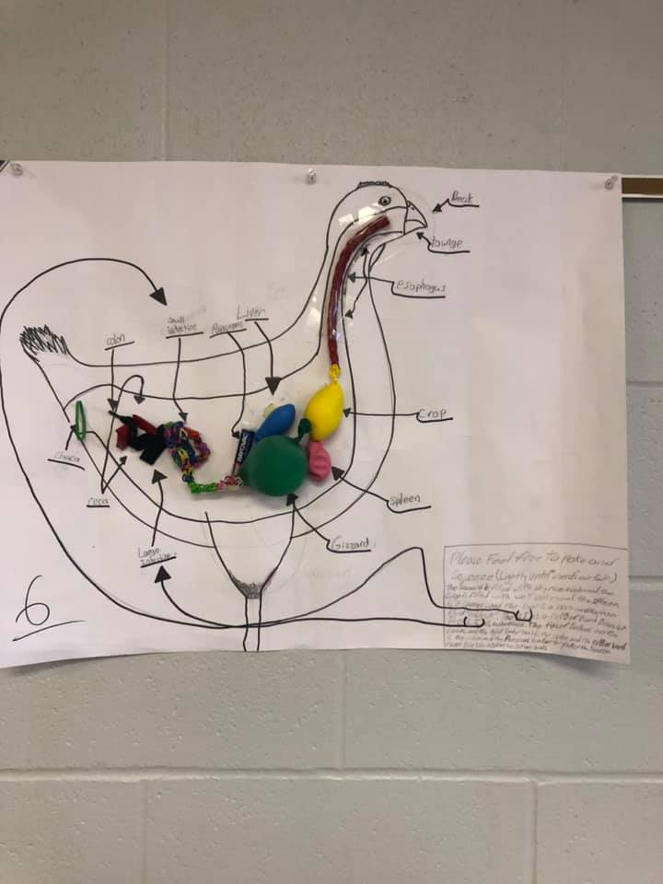  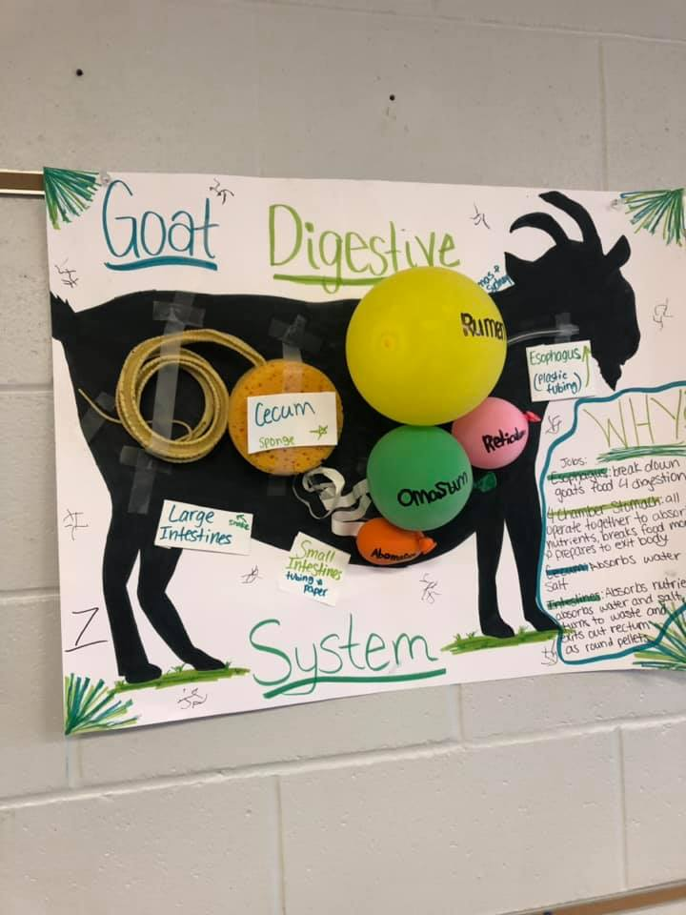  Variations of this assignment could include markers and paper or posters instead of items found in the classroom. Additionally, arrows or moving parts could be used to depict movement in processes.  Once all systems murals have been finished, students should conduct a gallery walk, visiting each mural and spending at least one minute at each stop.

- Follow-up: Conduct an explosion discussion (the conversation will start small, then “explode” to include the entire class discussing the same topic). Begin in pairs of two, then combine to groups of four, then groups of eight, doubling each time until reaching the full class size. Utilize the following prompts:
  - Which systems are the most similar between poultry and other mammals?
  - Which systems are the most different between poultry and other livestock?

- FFA/SAE Connection:
Have students visit AgExplorer (AgExplorer.ffa.org) and type “poultry” into the search bar. Direct students to think about which careers would need benefit from people who understand the various poultry systems in their daily work. Then, have students plan the components of an agricultural literacy SAE utilizing the information and activities found in the U.S. Poultry Companion Guide.

- Exit Ticket: Explain why it is important to understand the various parts of poultry and other mammals.

Poultry Anatomy and Physiology
Aligned to the following standards:
AS.06; AS.07; FFA.PG-J; FFA.CS-N; AG-ANI6; AG-ANI7; AGPC01.01; RI.9-10.1; SL.9-10.4; RST.9-10.9; CCSS.MP6, CCSS.MP7; CRP.07

Term | Ways to remember this term | Draw a picture of the term
Anatomy
Physiology
Dorsal
Ventral
Cranial (Anterior)
Caudal (Posterior)

Label the chicken below using the correct anatomical terms:

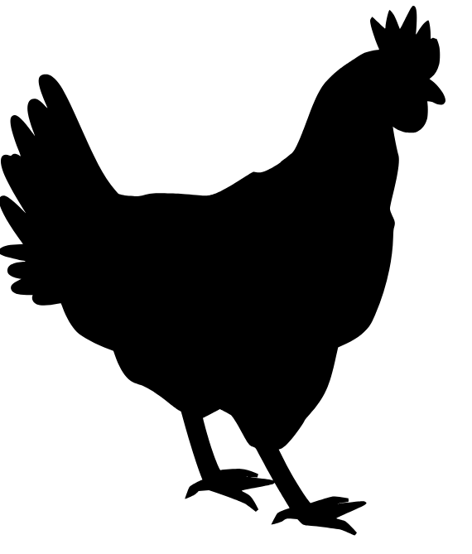
Five examples of mammals are:

Poultry Systems and Mammalian Comparison
Aligned to the following standards:
AS.06; AS.07; FFA.PG-J; FFA.CS-N; AG-ANI6; AG-ANI7; AGPC01.01; RI.9-10.1; SL.9-10.4; RST.9-10.9; CCSS.MP6, CCSS.MP7; CRP.07

Name of System | Description | 2 ways the system is similar to mammals | 2 ways the system is different from mammals
Integumentary

Respiratory

Skeletal
Digestive
Circulatory

Urinary

Reproductive

Summary:

Which systems are the most similar between poultry and other mammals?

Which systems are the most different between poultry and other mammals?

Why is it important to understand systems of poultry and other animals?

Mural: Poultry Systems
Aligned to the following standards:
AS.06; AS.07; FFA.PG-J; FFA.CS-N; AG-ANI6; AG-ANI7; AGPC01.01; RI.9-10.1; SL.9-10.4; RST.9-10.9; CCSS.MP6, CCSS.MP7; CRP.07

Directions:
Work in groups to create a mural of your assigned poultry system.

My assigned system is ____________________________________________________________.

Use the systems information sheet and other online sources (if available) to better understand the assigned system. Create a drawing or 3-D model of the system, labeling the important structures or areas.
CATEGORY | Master  4 points | Apprentice  3 points | Novice  2 points | Untrained 1 point | Score
Drawings | Drawings and 3-D components are recognizable, detailed and colored accurately. Overall, the drawings are original and skillful. | Drawings and 3-D components are recognizable and colored accurately. Overall, the drawings are original and done with some skill. | Drawings and 3-D components are recognizable and reasonably accurate. | Drawn objects and 3-D components are difficult to recognize AND/OR are not accurate. | Score x 3
Planning/Organization | Student can describe the intent and plan of complete mural and how his/her part will contribute to the whole. Works with team to come up with general plan of what will be done before beginning. | Student has carefully planned his/her part of the mural and can describe how he/she will get the work done and has a vision for his/her part. Gets team input on plan for his/her contribution before beginning. | Student has planned his/her part of the mural and can describe how he/she will get the work done and has a vision for his/her part. Does not solicit much group input when making plan. | Student leaps into action without any evidence of planning or focus. | Score x 2
Collaboration and Teamwork | The group worked well together with all members contributing significant amounts of quality work. All group members participated in discussion and actively listened to others. | The group generally worked well together with all members contributing some quality work. All group members participated in discussion and actively listened to others. | The group worked fairly well together with all members contributing some work. Most group members participated in discussion and actively listened to others. | The mural appeared to be the work of only one to two students in the group AND/OR there was little discussion, working together or active listening. | Score x 2
Knowledge about Murals | Student can accurately answer questions using three details about the assigned system. | Student can accurately answer questions using one to two details about the assigned system. | Student can somewhat answer questions about his or her assigned system but uses no detail. | Student cannot accurately answer two questions about his or her assigned system. | Score x 3
Total

Reproductive System Information Sheet

Male Reproductive Tract
- Two testes located internally in the body.

- Ductus Deferens
  - Deliver semen from the testes to the phallus.

- Rudimentary phallus
  - Poultry have no external penis, but rather a protuberance termed a rudimentary phallus.

Female Reproductive Tract
- Ovary
- Poultry have only one functioning ovary, usually the left ovary.

- Oviduct: function is to produce albumen (egg white), shell membrane and the shell around the yolk.

- Five regions
  - Infundibulum receives the follicle and is the location of conception where the male and female gametes come together.
  - Magnum: produces the albumen
  - Isthmus: produces the inner and outer shell membranes
  - Uterus: plumps the egg, forms the shell and cuticle (seals pores of the egg shell) and determines the shell pigment
  - Vagina: produces some cuticle, expels the egg and regulates timing of egg production

- Cloaca: also known as the vestibule. The cloaca is the common chamber through which the egg passes and is also responsible for the expulsion of feces and urine.

- Vent: the exterior opening through which passage occurs from the digestive system, the urinary tract and the reproductive tract.

- Ovulation: the releasing of the egg yolk from the ovary to begin its journey through the oviduct.
- Oviposition: the process of laying the fully formed egg, which is regulated by hormones

Urinary System Information Sheet

- Kidneys: two multi-lobular structures located in the rib cage.
  - The kidneys produce urine by removing waste products from the blood.

- Ureters: transport kidney filtrate from the kidneys to the cloaca for excretion.
  - Birds do not have a bladder, so urine is not stored, but rather excreted into the cloaca when produced.

- Cloaca: feces and urine exit out of the bird’s body through this region in the abdominal cavity.

- Uric Acid Excretion: poultry excreta contain uric acid. Uric acid is very high in nitrogen and is semi-solid due to low water content.

Circulatory System Information Sheet
The purpose of the circulatory system is to control the flow of blood throughout the body.

There are many organs of the circulatory system.
- Heart
  - A large organ located in the chest cavity.
  - The poultry heart has four chambers: two atria and two ventricles.
  - The heart pumps blood throughout the body to deliver oxygen and nutrients to tissues and to remove carbon dioxide and metabolic waste from tissues.

- Blood Vessels
  - Arteries deliver blood from the heart to tissues.
  - Arterioles: smaller branches of arteries that direct blood to certain tissues.
  - Capillaries: site of gas, nutrient and waste exchange between the blood and the body’s tissues.
  - Veins deliver blood from the tissues to the heart and lungs for oxygenation.

- Blood is composed of plasma and blood cells.
  - Avian red blood cells, also known as erythrocytes, are nucleated, unlike non-nucleated mammalian red blood cells. They are produced in the bone marrow and transport oxygen.
  - White blood cells, or leukocytes, are important in fighting disease in the body. They are cells of the immune system.
  - Plasma makes up the majority of the blood. It contains many different molecules, such as water, glucose, plasma proteins and plasma enzymes.

Digestive System Information Sheet
- The purpose of the poultry digestive system is to use nutrients found in feed through the processes of digestion and absorption.

- The digestive system begins at the oral cavity and ends at the vent.

- Oral cavity
  - Tongue: The tongue functions to move food within the oral cavity and initiates deglutition, or swallowing, of feed.
  - Esophagus: The esophagus is a flexible tube that carries food from the oral cavity to the crop and proventriculus.

- Crop: The crop is an outcropping, or pouch, of the esophagus.
  - The crop functions to store feed. No digestion of food takes place in the crop.

- Proventriculus: The proventriculus is the true stomach of the bird, similar to the mammalian stomach.
  - The proventriculus uses acid and other digestive enzymes to begin the chemical breakdown of food.

- Gizzard: The gizzard is also called the ventriculus.
  - The gizzard contains well-developed musculature and functions by grinding and contracting to aid in the mechanical reduction of food particles.
  - The gizzard may contain small pebbles or gravel from foraging to aid in the reduction of food particle size.

- Small Intestine
  - After passing the gizzard and being reduced to the proper particle size, food enters the small intestine for further digestion and absorption.
  - There are three regions of the small intestine:
    - Duodenum.
    - Jejunum.
    - Ileum.
  - The small intestine has a very large absorptive area due to many folds and finger-like projections located along its length.

- Ceca
  - Poultry have two ceca, while mammals have one (appendix).
  - The ceca are two dead-end pouches that contain microbes.
  - The microbes ferment any leftover food particles and produce molecules that the bird can use as an energy source.

- Colon: also referred to as the large intestine.
  - This a short section of the digestive tract that starts after the ceca and ends at the cloaca.
  - The function of the colon is to absorb water.

- Cloaca: This is also known as the vestibule and is the chamber responsible for the expulsion of feces and urine.

- Liver: The liver is an accessory organ of the digestive system.
  - The liver produces a substance called bile, which helps to digest fats. Bile is stored in the gall bladder.

- Pancreas: The pancreas is an accessory organ of the digestive system.
  - This is a yellow organ located in the loop of the duodenum.
  - The pancreas produces digestive enzymes that are released into the small intestine to help digest protein and carbohydrates.
  - The pancreas produces the hormones insulin and glucagon, which work together to control blood-sugar levels.

Skeletal System Information Sheet

- Pneumatic Bones
  - Poultry have pneumatic, or hollow, bones. These bones connect with the respiratory system, and their light weight is an adaptation for flight.

- Medullary Bone
  - Medullary bone contains high amounts of calcium, and this storage source is used by the female hen when developing the egg shell during reproductive periods.

- Fused Bones
  - Bones in the foot, or shank, are fused and cause birds to walk upright.
  - Many vertebra along the backbone are fused for the purpose of flight.

Respiratory System Information Sheet

- The respiratory system of poultry is vastly different than the mammalian respiratory system. Unlike mammals, birds lack a diaphragm to inflate and deflate the lungs. Instead, birds have nine air sacs located in the neck region and body cavity that function to inflate the lungs.

- Gas exchange occurs in the avian lung, and the air sacs function to move air in and out of the respiratory system.

- The breathing process has two phases: inhalation and exhalation.
  - Inhalation: when the bird breathes in, air bypasses the lungs and enters the posterior air sacs. At the same time, air in the lungs from the last exhalation phase exits the lungs and enters the anterior air sacs.
  - Exhalation: the bird releases air from the posterior air sacs, which enters the lungs. The air that filled the anterior air sacs from the inhalation phase is then released from the body through the trachea.
  - Nares are the nostrils located on the beak. They serve as the passageway for air to be breathed in and out of the trachea.

Integumentary System Information Sheet

Integumentary System

- The skin, or integumentary system, of poultry is similar to mammals, except for feather production. They have a wattle, defined as the red skin underneath the beak, and a comb, defined as the red skin located on top of their head. Blood circulates between the wattle and comb and helps to regulate body temperature.

- Poultry have plumage and beaks.
  - Plumage is defined as the outer covering of a bird’s body. This includes feathers, scales and filoplumes, which are hair-like structures located at the base of feathers. Scales are located on the legs and feet. The plumage allows for altered shape to facilitate necessary body cooling and heating for maintenance of body temperature. Plumage shape is particularly important for cooling since birds lack sweat glands. Although it is not common for production birds to fly, plumage type and form is an important determinant in flight for aerial species. Plumage protects against abrasions and bruises when birds are in groups or lying on the ground.

  - Birds have beaks as opposed to lips and teeth. The beak is used for eating and drinking, as well as self-defense and protection from other animals.

