Chicken Genetics and Reproduction
Created: 07/2019 by the National FFA Organization

The National FFA Organization and U.S. Poultry and Egg Association lesson plan series provides educators with a comprehensive curriculum resource to teach students about the commercial poultry and egg industry. Additionally, lessons are infused with FFA and SAE activities to easily integrate into any agricultural education program.
Student Learning Objectives:
After completing these activities, students will …
- Understand the shift from dual purpose to single purpose breeds of poultry through genetic selection.
- Understand the measurement of performance data in genetic research.
- Identify the effects of genetic selection on DNA.
- Evaluate a group of laying hens and broilers to select desirable physical traits.

Essential Questions:
- What reasons are behind genetic selection? What are the possible advantages and disadvantages?
- What traits are used to determine which individuals should be selected?
- What is breeding stock?

Time Required: 90 minutes
Resources:
- Aviagen Group, http://www.aviagen.com/
- Cobb-Vantress, http://www.cobb-vantress.com/
- Hy-Line, http://www.hyline.com/
- Chicken Genetics and Reproduction PowerPoint, https://ffa.box.com/s/vc3pmynyywy3h4mdg42dy0njyf3z4lq9

Equipment and Supplies Needed:
- A copy of the “One of These Things Is Not Like the Other” worksheet for each student
- A copy of the “Egg Producer Map” worksheet for each student
- A copy of the “Broiler Map” worksheet for each student
- A copy of the “Genetics Memory Card” worksheet for each group of students (one per group cut up)
- A copy of the “Dual Purpose vs. Single Purpose T-Chart” worksheet for each student
- A copy of the “Breeding Stock” worksheet for each student
- A copy of the “Where Does It All Come From?” worksheet for each student
- A copy of the “Wanted” worksheet for each student
- Blank white paper
- Glue
- Scissors

Terms:
The following terms are presented in the lesson and appear in bold italics:
- Poultry
- Domestication
- Single Purpose
- Dual Purpose
- Genetic Selection
- Clutch Length
- Growth Rate
- Resilience
- Quantify
- Heritability
- Breeding Stock
- Broiler Breeder
- Layer Breeder

These activities are aligned to the following standards:
AFNR Performance Element
- AS.04. Apply principles of animal reproduction to achieve desired outcome for performance, development, and/or economic production.
FFA Precept
- FFA.PL-A.Action: Assume responsibility and take the necessary steps to achieve the desired results, no matter what the goal or task at hand.
- FFA.PG-J.Mental Growth: Embrace cognitive and intellectual development relative to reasoning, thinking and coping.
- FFA.CS-M.Communication: Effectively interact with others in personal and professional settings.
- FFA.CS-N.Decision Making: Analyze a situation and execute an appropriate course of action.
Common Career Technical Core
- AG-ANI4 Apply principles of animal reproduction to achieve desired outcome for performance, development, and/or economic production.
- AG2 Evaluate the nature and scope of the Agriculture, Food & Natural Resources Career Cluster and the role of agriculture, food, and natural resources (AFNR) in society and the economy.
NASDCTEc
- AGPC01.04 Analyze and summarize factors that influence an animal's reproduction cycle to demonstrate an understanding of the species response.
AFNR Cluster Skills
- CS.02. Evaluate the nature and scope of the Agriculture, Food, and Natural Resources Career Cluster and the role of agriculture, food, and natural resources (AFNR) in society and the economy.
Common Core–Reading: Informational Text
- CCSS.ELA-Literacy.RI.9-10.4 Determine the meaning of words and phrases as they are used in a text, including figurative, connotative, and technical meanings; analyze the cumulative impact of specific word choices on meaning and tone (e.g., how the language of a court opinion differs from that of a newspaper).
Common Core–Writing
- CCSS.ELA-Literacy.W.9-10.1 Write arguments to support claims in an analysis of substantive topics or texts, using valid reasoning and relevant and sufficient evidence.
- CCSS.ELA-Literacy.W.9-10.2 Write informative/explanatory texts to examine and convey complex ideas, concepts, and information clearly and accurately through the effective selection, organization, and analysis of content.
Common Core–Speaking and Listening
- CCSS.ELA-Literacy.SL.9-10.1 Initiate and participate effectively in a range of collaborative discussions (one-on-one, in groups, and teacher-led) with diverse partners on grades 9-10 topics, texts, and issues, building on others' ideas and expressing their own clearly and persuasively.
- CCSS.ELA-Literacy.SL.9-10.1.D Respond thoughtfully to diverse perspectives, summarize points of agreement and disagreement, and, when warranted, qualify or justify their own views and understanding and make new connections in light of the evidence and reasoning presented.
- CCSS.ELA-Literacy.SL.9-10.2 Integrate multiple sources of information presented in diverse media or formats (e.g., visually, quantitatively, orally) evaluating the credibility and accuracy of each source.
- CCSS.ELA-Literacy.SL.9-10.4 Present information, findings, and supporting evidence clearly, concisely, and logically such that listeners can follow the line of reasoning and the organization, development, substance, and style are appropriate to purpose, audience, and task.
Next Generation Science
- HS-LS3-1 Ask questions to clarify relationships about the role of DNA and chromosomes in coding the instructions for characteristic traits passed from parents to offspring.
- HS-LS3-3 Apply concepts of statistics and probability to explain the variation and distribution of expressed traits in a population.
AFNR Career Ready Practices
- CRP.02. Apply appropriate academic and technical skills. Career-ready individuals readily access and use the knowledge and skills acquired through experience and education to be more productive.
- CRP.04. Communicate clearly, effectively, and with reason. Career-ready individuals communicate thoughts, ideas and action plans with clarity, whether using written, verbal and/or visual methods.
- CRP.07. Employ valid and reliable research strategies. Career-ready individuals are discerning in accepting and using new information to make decisions, change practices or inform strategies.
- CRP.08. Utilize critical thinking to make sense of problems and persevere in solving them. Career-ready individuals readily recognize problems in the workplace, understand the nature of the problem, and devise effective plans to solve the problem.

Partnership for 21st Century Skills
- Communication
- Critical Thinking and Problem Solving
- Productivity and Accountability

Lesson Plan:
- Bell Ringer: Students will write their best definition of the word “genetics.” After students have finished writing, take a few responses to discuss and note that today’s topic will focus on genetics in poultry.

- Interest Approach: Ensure each student has a “One of These Things Is Not Like the Other” worksheet. Provide students with approximately five minutes to complete the worksheet individually. As a class, discuss answers to each of the three questions.

- Instruction:

Student Learning Objective One: Understand the shift from dual purpose to single purpose breeds of poultry through genetic selection.

I. Poultry: Domesticated fowl that are valued for meat or eggs.  a. Domestication: the process of taking a group of animals from the wild and, through a process of selection, causing them to become accustomed to human interaction.  1. Domestication usually involves selecting for certain desirable characteristics by breeding two animals with the desirable characteristic.  b. Broiler: Before modern production, a number of domesticated varieties of birds existed, each with their own unique qualities.  1. The two most common traits that were selected for were egg production and meat production. In some cases, birds were better to eat, while others were better for producing eggs, but most birds were good for both egg and meat production.  a. Birds that were used for both egg and meat production were known as dual purpose breeds. Examples:  (1) Rhode Island  (2) Plymouth Rock  (3) New Hampshire  2. Other birds were selected for different qualities. Examples include the following:  a. different colored eggs.  b. feathers on their feet.  c. unique color.  d. unique comb shape.  D. Transition to single purpose  1. Birds selected for either meat production or egg production, but not both  2. Traditional animal breeding programs were used to produce specialized birds for either meat or egg production.  3. Selection of males and females to participate in breeding programs was largely based upon phenotypic traits.  a. Phenotypic traits are measurable and/or observable, and this allows for mating of males and females that both have high rates of gain or females that have high rates of egg lay.  b. Poultry breeding programs have resulted in tremendous improvements in animal performance and production efficiencies.  (1) This has permitted chicken and eggs to be a very inexpensive source of protein. | Activity 1:  Each student needs a copy of the “Dual vs. Single Purpose T-Chart” worksheet. Have students follow along and complete the chart as you teach using the PowerPoint. Have students think back to previous lessons to answer the last prompt on the worksheet.

Student Learning Objective Two: Understand the measurement of performance data in genetic research.

1. Phenotypic traits of importance for genetic selection  A. Phenotypes are observable or measurable traits while genotype is the genetic make-up of the individual.  B. Phenotypes are a result of two contributing factors: environment and genotype.  1. Environment can influence phenotype, so it is important to maintain environmental consistency in breeding programs and facilities.  2. The genotype describes the genes that the animal possesses.  3. Therefore, when selecting for a particular phenotype, one is also selecting for a specific set of genes that are associated with the phenotype.  4. Consequently, using phenotypes to select for animals also results in genetic selection.  C. Phenotypic traits used to select for meat-type (broiler) and egg-type (layer) birds are very different.  D. Consequently, the genotype of broilers and layers is quite different from each other since certain traits selected for in one have not always been selected for in another.  1. Egg layers  a. Clutch  (1) The amount of eggs laid consecutively without a break.  (2) A chicken can lay about one egg per day.  b. Clutch length  (1) The number of consecutive days a hen lays an egg before missing a day.  (2) Ability to lay a large number of eggs is a highly desirable trait.  c. Shell quality  (1) A strong shell is necessary for the egg to be transported from the farm to the store.  (2) Shells are made from calcium, so a bird’s ability to absorb calcium and convert it into eggshell is a highly desirable trait.  d. Sexual maturity  (1) Chickens are only able to reproduce or produce eggs once they have reached sexual maturity.  (2) With very early maturity, birds will produce eggs sooner in life, increasing a producer’s profitability.  e. Size  (1) Size of egg  (a) Consumers want mostly large eggs. If hens are producing medium or jumbo eggs, producers may not get paid as much.  (2) Size of the hen  (a) A large hen eats too much, and a hen that is too small cannot produce enough eggs to be profitable.  f. Temperament: Birds that are not aggressive  2. Broilers  a. Growth rate  (1) The rate at which a meat bird gains body weight  (2) Feed conversion (the rate at which consumed feed is converted to body weight gain) is an important trait since this relates to production efficiency.  b. Skeletal development  (1) A strong skeleton is very important to support body weight and muscle development.  (2) Bones are synthesized from calcium, so a bird’s ability to absorb calcium and convert it into bone is very important.  c. Resilience  (1) The ability of the bird to withstand disease and other environmental factors.  E. Quantifying: the ability to measure the quantity of something  Traits that are easily quantified are easier to pass on,  F. Heritability  - The ability of a trait to be passed on is known as heritability.  - Traits with high heritability are passed on easily and improve quickly in the population.  - Low rates of heritability take a much longer time to improve within the population. | Activity 1:  Ensure that each student has a copy of the “Egg Producer Map” and the “Broiler Map.” Have students fill in the bubbles as they go so they have accurate notes for the upcoming activities.

Student Learning Objective Three: Identify the effects of genetic selection on DNA.

1. Genetic Selection and DNA  A. Breeding Stock  1. Sexually mature poultry of both sexes raised specifically to produce offspring  2. The genetic make-up of an individual is contained within the animal’s DNA.  3. In the same way that animals can be selected for phenotypic traits, animals can also be selected for genotypic traits.  a. Genotype is determined by sequencing DNA.  b. DNA is composed of nucleotides that are arranged in unique sequences.  c. DNA is packaged within chromosomes, and chromosomes are located within the nucleus of every cell.  d. DNA provides the blueprint for the manufacturing of every protein within the cell.  e. By measuring genetic markers, or sequences of DNA, within an individual, identification of genes associated with desired production characteristics can be determined.  4. The breeding stock responsible for production of meat-type birds are known as broiler breeders.  a. Broiler breeders are selected for desired phenotypic and genotypic traits.  b. A relatively small number of broiler breeders are responsible for the production of millions of meat-type birds.  c. Broiler breeders are organized into a pyramid scheme that originates with an elite stock of birds.  (1) The elite stock is the most highly valued group of breeders since they contain the ideal genetics and are responsible for maintaining the genetic line.  (2) The parent stock consists of the breeders that produce either the meat or egg-type bird that is used in commercial production.  (3) Any desired phenotypic or genetic changes are made with the elite stock.  (4) It typically takes five generations or more for a trait to be passed down from the elite stock to the commercial bird.  (5) Consequently, poultry breeders have to anticipate the needs and desires of commercial birds well in advance. | Activity 1:  Each student needs a copy of the “Where Does It All Come From?” worksheet. Students will complete this worksheet as you discuss DNA.  Activity 2:  Hand out a copy of the “Breeding Stock” worksheet to each student. Students will record the levels of breeding stock. Students will also draw a picture next to each level to help them remember.  Activity 3:  Ensure that students are in small groups (three to four students per group). Each group should have one set of “Genetics Memory Cards” (cut before class). Set context for the activity by asking if anyone has played the game “memory” before. Ask a student who has played to quickly share the instructions. Once the instructions of the “memory” game have been recapped, direct students to play the game until they believe all pairs have been matched correctly. Move amongst the groups to check if pairs have been matched correctly or not.  After all groups have completed matching, use the attached key to discuss the terms and ensure that all matches are correct. Have students glue the cards onto a blank sheet of paper to keep as notes. For students in the group that are not keeping the cut and pasted chart, hand out a separate copy (not cut up) of the chart to the other group members.  Activity 4:  Have students create a “Wanted” poster by drawing the most ideal layer and broiler bird. Students should be sure to include labels.

- Follow-up: Once students have developed their “Wanted” posters, have students pair up with another student and compare and contrast their “Wanted” birds. When finished, have students share with the class what they feel would be the ideal bird. If class discussion is not an option, have students write a three- to five-sentence paragraph.

- FFA/SAE Connection: Have students get in groups of four and lay out their wanted posters. Students need to place the birds one through four (best to least) and write an explanation or set of reasons explaining why they placed the birds as they did. This activity is similar to placing and giving reasons in the poultry evaluation career development event. If live birds are an option, have student place a set of live birds and give reasons either verbally or in written format.

- Exit Ticket: Students should use the “green-yellow-red” method to recap the lesson. On the exit ticket capture sheet, ask students to recap one thing they completely understand (green), one thing they understand partially but need more explanation on (yellow) and one thing they do not understand at all (red).
One of These Things Is Not Like the Other
Aligned to the following standards:
AS.04; FFA.PL-A; FFA.PG-J; FFA.CS-M; FFA.CS-N; AG-ANI4; AG2; AGPC01.04; CS.02; CCSS.ELA.RI.9-10.4; CCSS.ELA.W.9-10.1; CCSS.ELA.W.9-10.2; CCSS.ELA.SL.9-10.1; CCSS.ELA.SL.9-10.1D; CCSS.ELA.SL.9-10.2; CCSS.ELA. SL.9-10.4; HS-LS3-1; HS-LS3-3; CRP.02; CRP.04; CRP.07; CRP.08
Directions:
Study the three images below, and then answer the questions about similarities and differences among the birds in the images.
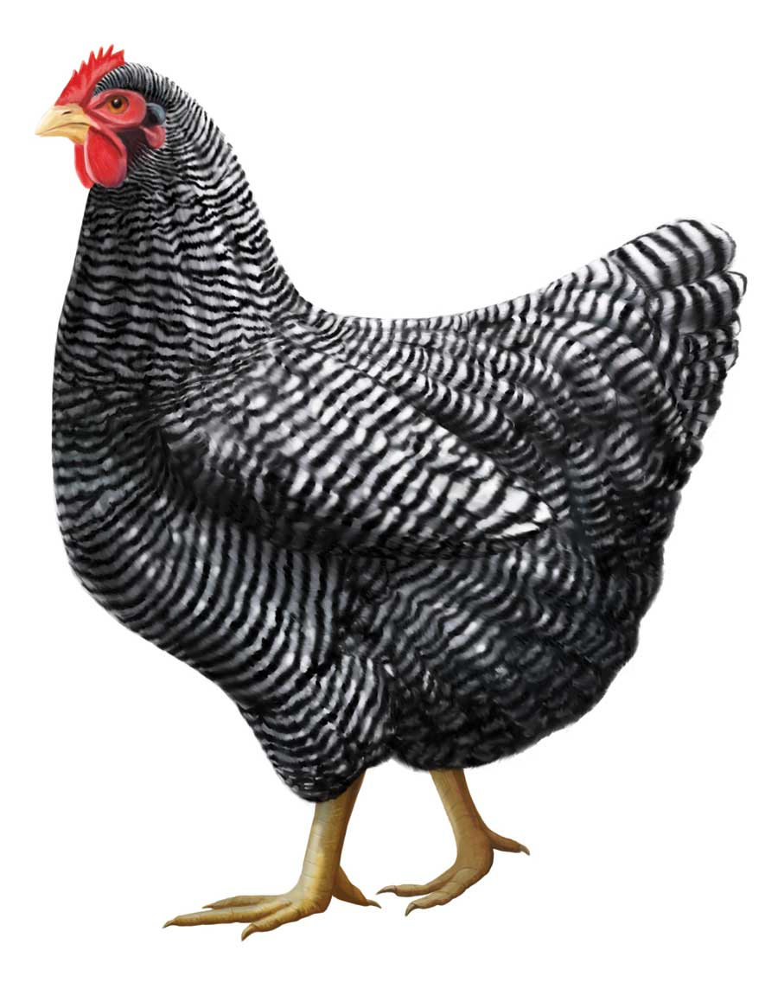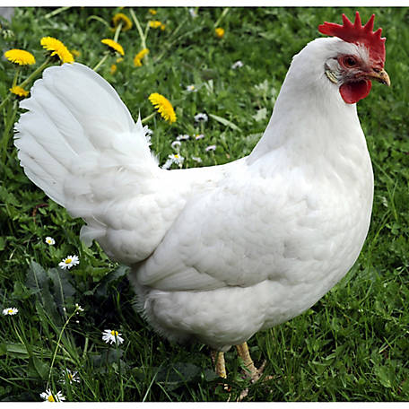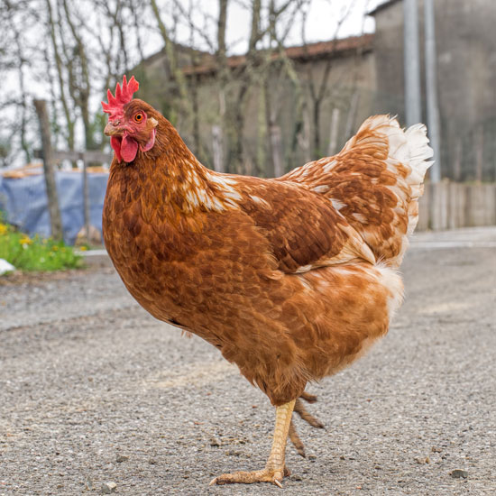
What do you see that is similar among the chickens in the images?


Do you believe there are differences among the chickens pictured above that you cannot see? List what some of those could be.

What do you see that is different among the chickens pictured above?

Dual Purpose vs. Single Purpose T-Chart
Aligned to the following standards:
AS.04; FFA.PL-A; FFA.PG-J; FFA.CS-M; FFA.CS-N; AG-ANI4; AG2; AGPC01.04; CS.02; CCSS.ELA.RI.9-10.4; CCSS.ELA.W.9-10.1; CCSS.ELA.W.9-10.2; CCSS.ELA.SL.9-10.1; CCSS.ELA.SL.9-10.1D; CCSS.ELA.SL.9-10.2; CCSS.ELA. SL.9-10.4; HS-LS3-1; HS-LS3-3; CRP.02; CRP.04; CRP.07; CRP.08
Directions:
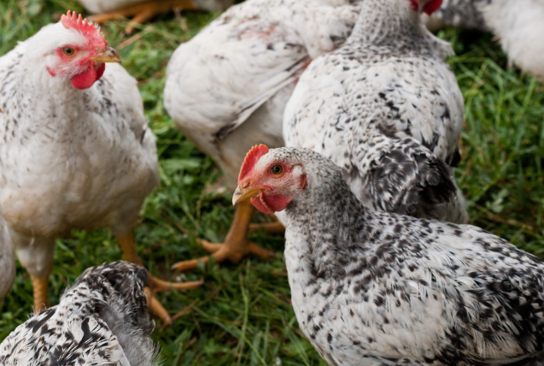
Complete this T-Chart to compare dual purpose and single purpose breeds.
Dual Purpose | Single Purpose
What does this term mean? | What does this term mean?
Pros: | Pros:
Cons: | Cons:
What specific breeds of chickens fit into this category? | What specific breeds of chickens fit into this category?

Egg Producer Map
Aligned to the following standards:
AS.04; FFA.PL-A; FFA.PG-J; FFA.CS-M; FFA.CS-N; AG-ANI4; AG2; AGPC01.04; CS.02; CCSS.ELA.RI.9-10.4; CCSS.ELA.W.9-10.1; CCSS.ELA.W.9-10.2; CCSS.ELA.SL.9-10.1; CCSS.ELA.SL.9-10.1D; CCSS.ELA.SL.9-10.2; CCSS.ELA. SL.9-10.4; HS-LS3-1; HS-LS3-3; CRP.02; CRP.04; CRP.07; CRP.08
Directions:
Record information about each of the following traits as your teacher discusses it.

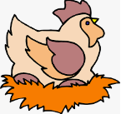
Broiler Map
Aligned to the following standards:
AS.04; FFA.PL-A; FFA.PG-J; FFA.CS-M; FFA.CS-N; AG-ANI4; AG2; AGPC01.04; CS.02; CCSS.ELA.RI.9-10.4; CCSS.ELA.W.9-10.1; CCSS.ELA.W.9-10.2; CCSS.ELA.SL.9-10.1; CCSS.ELA.SL.9-10.1D; CCSS.ELA.SL.9-10.2; CCSS.ELA. SL.9-10.4; HS-LS3-1; HS-LS3-3; CRP.02; CRP.04; CRP.07; CRP.08
Directions:
Record information about each of the following traits as your teacher discusses it.

Where Does It All Come From?
Aligned to the following standards:
AS.04; FFA.PL-A; FFA.PG-J; FFA.CS-M; FFA.CS-N; AG-ANI4; AG2; AGPC01.04; CS.02; CCSS.ELA.RI.9-10.4; CCSS.ELA.W.9-10.1; CCSS.ELA.W.9-10.2; CCSS.ELA.SL.9-10.1; CCSS.ELA.SL.9-10.1D; CCSS.ELA.SL.9-10.2; CCSS.ELA. SL.9-10.4; HS-LS3-1; HS-LS3-3; CRP.02; CRP.04; CRP.07; CRP.08
Directions:
Complete the following chart to learn more about genetics.
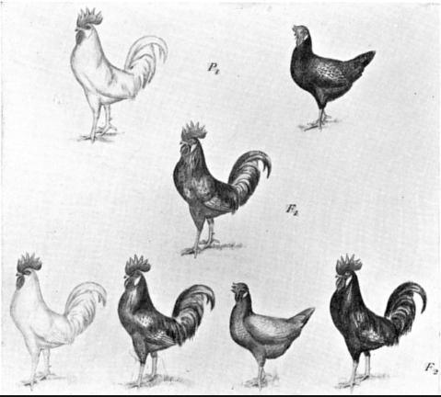

What is DNA?
What is phenotype?
What is genotype?
Two examples in layers:
Two examples in broilers:
What role does genetics play in poultry production?

Breeding Stock
Aligned to the following standards:
AS.04; FFA.PL-A; FFA.PG-J; FFA.CS-M; FFA.CS-N; AG-ANI4; AG2; AGPC01.04; CS.02; CCSS.ELA.RI.9-10.4; CCSS.ELA.W.9-10.1; CCSS.ELA.W.9-10.2; CCSS.ELA.SL.9-10.1; CCSS.ELA.SL.9-10.1D; CCSS.ELA.SL.9-10.2; CCSS.ELA. SL.9-10.4; HS-LS3-1; HS-LS3-3; CRP.02; CRP.04; CRP.07; CRP.08
Directions:
Identify and label the breeding pyramid scheme for broilers and egg producing birds. Next to each level, draw a picture to represent that level of bird.

How many generations does it take to pass down traits to the products that we eat?
Genetics Memory Cards
Aligned to the following standards:
AS.04; FFA.PL-A; FFA.PG-J; FFA.CS-M; FFA.CS-N; AG-ANI4; AG2; AGPC01.04; CS.02; CCSS.ELA.RI.9-10.4; CCSS.ELA.W.9-10.1; CCSS.ELA.W.9-10.2; CCSS.ELA.SL.9-10.1; CCSS.ELA.SL.9-10.1D; CCSS.ELA.SL.9-10.2; CCSS.ELA. SL.9-10.4; HS-LS3-1; HS-LS3-3; CRP.02; CRP.04; CRP.07; CRP.08
Directions:
Using the rules from the game “memory,” match each of the following terms and definitions.

Domestication | The process of taking a group of animals from the wild and, through a process of selection, causing them to become accustomed to human interaction. Usually involves selecting for certain desirable characteristics by breeding two animals with the desirable characteristic.
Phenotypes | Observable or measurable traits;  a result of two contributing factors:  environment and genotype
Heritability | The ability of a trait to be passed on
Breeding Stock | Sexually mature poultry of both sexes raised specifically to produce offspring

Broiler Breeders | The breeding stock responsible for production of meat-type birds.
Elite Stock | The most highly valued group of breeders  since they contain the ideal genetics and  are responsible for maintaining the  genetic line.
Genotype | Describes the genes that the animal possesses within its DNA
Parent Stock | The breeders that produce either the meat- or egg-type bird that is used in  commercial production.

Wanted!
Aligned to the following standards:
AS.04; FFA.PL-A; FFA.PG-J; FFA.CS-M; FFA.CS-N; AG-ANI4; AG2; AGPC01.04; CS.02; CCSS.ELA.RI.9-10.4; CCSS.ELA.W.9-10.1; CCSS.ELA.W.9-10.2; CCSS.ELA.SL.9-10.1; CCSS.ELA.SL.9-10.1D; CCSS.ELA.SL.9-10.2; CCSS.ELA. SL.9-10.4; HS-LS3-1; HS-LS3-3; CRP.02; CRP.04; CRP.07; CRP.08
Directions:

Now that you have an understanding of the qualities needed for the ideal broiler and egg-producing chicken, create a “wanted” poster for each type of chicken. Be sure to draw your chicken so that it depicts the ideal characteristics. Also, be sure to label your chicken so that someone looking at the poster will have an idea of what to look for when looking for your suspect! Include both genotypic and phenotypic characteristics as discussed in the lesson.
Aligned to the following standards:
AS.04; FFA.PL-A; FFA.PG-J; FFA.CS-M; FFA.CS-N; AG-ANI4; AG2; AGPC01.04; CS.02; CCSS.ELA.RI.9-10.4; CCSS.ELA.W.9-10.1; CCSS.ELA.W.9-10.2; CCSS.ELA.SL.9-10.1; CCSS.ELA.SL.9-10.1D; CCSS.ELA.SL.9-10.2; CCSS.ELA. SL.9-10.4; HS-LS3-1; HS-LS3-3; CRP.02; CRP.04; CRP.07; CRP.08
KEY: Dual Purpose vs. Single Purpose
Aligned to the following standards:
AS.04; FFA.PL-A; FFA.PG-J; FFA.CS-M; FFA.CS-N; AG-ANI4; AG2; AGPC01.04; CS.02; CCSS.ELA.RI.9-10.4; CCSS.ELA.W.9-10.1; CCSS.ELA.W.9-10.2; CCSS.ELA.SL.9-10.1; CCSS.ELA.SL.9-10.1D; CCSS.ELA.SL.9-10.2; CCSS.ELA. SL.9-10.4; HS-LS3-1; HS-LS3-3; CRP.02; CRP.04; CRP.07; CRP.08
Directions:
Complete this T-Chart to compare dual purpose and single purpose breeds.
Dual Purpose | Single Purpose
What does this term mean?  Birds used for BOTH egg and meat production. | What does this term mean?  Birds used for EITHER egg or meat production, not both.
Pros:  Most domesticated breeds were good at both.  Fit the needs of the era for “backyard chicken” production | Pros:  Increased efficiency of production of eggs or meat  Created a low-cost protein source
Cons:  Generally, birds were not overly efficient at egg or meat production but were moderate at both.  Chicken = expensive source of protein | Cons:  Less genetic diversity in high production breeds
What specific breeds of chickens fit into this category?  Examples: Rhode Island Red, Plymouth Rock, New Hampshire | What specific breeds of chickens fit into this category?  Example: White Leghorn

KEY: Egg Producer Map
Aligned to the following standards:
AS.04; FFA.PL-A; FFA.PG-J; FFA.CS-M; FFA.CS-N; AG-ANI4; AG2; AGPC01.04; CS.02; CCSS.ELA.RI.9-10.4; CCSS.ELA.W.9-10.1; CCSS.ELA.W.9-10.2; CCSS.ELA.SL.9-10.1; CCSS.ELA.SL.9-10.1D; CCSS.ELA.SL.9-10.2; CCSS.ELA. SL.9-10.4; HS-LS3-1; HS-LS3-3; CRP.02; CRP.04; CRP.07; CRP.08
Directions:
Record information about each of the following traits as your teacher discusses it.
The amount of eggs laid consecutively without a break.
The number of consecutive days a hen lays an egg before taking a break.

A strong shell is necessary for the egg to be transported.
The ability of a female chicken to reproduce or produce eggs. Earlier is better.
Large eggs desired to ensure return for producers.
A large hen eats too much, and a hen that is too small cannot produce large enough eggs.

KEY: Broiler Map
Aligned to the following standards:
AS.04; FFA.PL-A; FFA.PG-J; FFA.CS-M; FFA.CS-N; AG-ANI4; AG2; AGPC01.04; CS.02; CCSS.ELA.RI.9-10.4; CCSS.ELA.W.9-10.1; CCSS.ELA.W.9-10.2; CCSS.ELA.SL.9-10.1; CCSS.ELA.SL.9-10.1D; CCSS.ELA.SL.9-10.2; CCSS.ELA. SL.9-10.4; HS-LS3-1; HS-LS3-3; CRP.02; CRP.04; CRP.07; CRP.08
Directions:
Record information about each of the following traits as your teacher discusses it.
Bad temperament could equal harm to other birds.
The rate at which a meat bird grows.

The process of taking feed and converting it into body weight.
A strong skeleton is very important to support body weight.

The ability of the bird to withstand disease and other environmental factors.

KEY: Where Does It All Come From?
Aligned to the following standards:
AS.04; FFA.PL-A; FFA.PG-J; FFA.CS-M; FFA.CS-N; AG-ANI4; AG2; AGPC01.04; CS.02; CCSS.ELA.RI.9-10.4; CCSS.ELA.W.9-10.1; CCSS.ELA.W.9-10.2; CCSS.ELA.SL.9-10.1; CCSS.ELA.SL.9-10.1D; CCSS.ELA.SL.9-10.2; CCSS.ELA. SL.9-10.4; HS-LS3-1; HS-LS3-3; CRP.02; CRP.04; CRP.07; CRP.08
Directions:
Complete the following chart to learn more about genetics.
What is DNA?
DNA is composed of nucleotides that are arranged in unique sequences.
DNA is packaged within chromosomes, and chromosomes are located within the nucleus of every cell.
DNA provides the blueprint for the manufacturing of every protein within the cell.

What is phenotype?
Observable or measurable traits; a result of two contributing factors: environment and genotype
What is genotype?

Describes the genes that the animal possesses within its DNA
Two examples in layers:
Examples: large clutch, good shell quality

Two examples in broilers:
Example: large breast meat, high growth rate
What role does genetics play in poultry production?
Genetics is important to allow breeders to select the traits to create a stock of birds that will be the most efficient in production practices.

KEY: Breeding Stock
Aligned to the following standards:
AS.04; FFA.PL-A; FFA.PG-J; FFA.CS-M; FFA.CS-N; AG-ANI4; AG2; AGPC01.04; CS.02; CCSS.ELA.RI.9-10.4; CCSS.ELA.W.9-10.1; CCSS.ELA.W.9-10.2; CCSS.ELA.SL.9-10.1; CCSS.ELA.SL.9-10.1D; CCSS.ELA.SL.9-10.2; CCSS.ELA. SL.9-10.4; HS-LS3-1; HS-LS3-3; CRP.02; CRP.04; CRP.07; CRP.08
Directions:
Identify and label the breeding pyramid scheme for broilers and egg producing birds. Next to each level, draw a picture to represent that level of bird.

How many generations does it take to pass down traits to the products that we eat?

Five
Elite Stock
Pictures should be included by each level. They will vary by student.
Great Grandparent Stock
Grandparent Stock
Parent Stock
Broilers or Layers
Chicken Meat
Eggs for Consumption

