Turkey Reproduction
Created: 07/2019 by the National FFA Organization

The National FFA Organization and U.S. Poultry and Egg Association lesson plan series provides educators with a comprehensive curriculum resource to teach students about the commercial poultry and egg industry. Additionally, lessons are infused with FFA and SAE activities to easily integrate into any agricultural education program.
Student Learning Objectives:
After completing these activities, students will …
- Identify and describe the parts and functions of the reproductive system of a hen and a tom.
- Compare and contrast two methods of breeding used in turkey production.
- Describe the stages of embryonic development in turkeys.

Essential Questions:
- What are the parts of the female reproductive system in turkeys? What are the functions of those organs?
- What are the methods of breeding used in poultry production?
- What are the stages of embryonic development in turkeys?

Time Required: 90 minutes.
Resources:
- Bearden, H. Joe. Applied Animal Reproduction. Sixth ed. Upper Saddle River, N.J: Prentice Hall, 2004.
- American Poultry Association, http://www.amerpoultryassn.com/
- “Peacock Courtship: World’s Weirdest,” https://youtu.be/TTwT1-TpFhE.
- “Wild Turkey Waltz,” https://youtu.be/3Hpl0oGcx3o
- “Embryonic Development of the Turkey,” https://www.hybridturkeys.com/documents/520/Embryonic_Development_19x13.5_ENG.pdf
- “Turkey Reproduction” PowerPoint, https://ffa.box.com/s/q915iphxxhmr4nnrf1ezw4z5zyf8soiy
- “FFA Fundamentals Choice Board,” https://FFA.box.com/v/ffafundamentalschoiceboard

Equipment and Supplies Needed:
- Play-Doh, modeling clay, craft supplies and candy
- Markers
- Blank 8 ½” x 11” paper
- A copy of the “Female Reproductive System” handout for student
- A copy of the “Male Reproductive System” handout for each student
- A copy of the “Reproductive Systems Project Guide” worksheet for each student
- A copy of the “Reproductive Systems Project Rubric” worksheet for each student
- A copy of the “Different but Alike” worksheet for each student
- A copy of the “Embryonic Development” worksheet for each student
- A copy of “Embryonic Development” notes for each student
- Internet access to play the videos or embed in a PowerPoint ahead of time

Terms:
The following terms are presented in the lesson and appear in bold italics:
- Artificial Insemination
- Cloaca
- Hen
- Infundibulum
- Isthmus
- Magnum
- Natural Mating
- Ovary
- Oviduct
- Reproductive System
- Testes
- Tom
- Uterus
- Vagina
- Candling
- Incubation

These activities are aligned to the following standards:
AFNR Performance Element
- AS.04. Apply principles of animal reproduction to achieve desired outcome for performance, development, and/or economic production.
FFA Precept
- FFA.PL-A.Action: Assume responsibility and take the necessary steps to achieve the desired results, no matter what the goal or task at hand.
- FFA.PG-J.Mental Growth: Embrace cognitive and intellectual development relative to reasoning, thinking and coping.
- FFA-CS-M.Communication: Effectively interact with others in personal and professional settings.
- FFA.CS-N.Decision Making: Analyze a situation and execute an appropriate course of action.
Common Career Technical Core
- AG-ANI4 Apply principles of animal reproduction to achieve desired outcome for performance, development, and/or economic production.
- AG2 Evaluate the nature and scope of the Agriculture, Food & Natural Resources Career Cluster and the role of agriculture, food, and natural resources (AFNR) in society and the economy.
NASDCTEc
- AGPC01.04 Analyze and summarize factors that influence an animal's reproduction cycle to demonstrate an understanding of the species response.
AFNR Cluster Skills
- CS.02. Evaluate the nature and scope of the Agriculture, Food, and Natural Resources Career Cluster and the role of agriculture, food, and natural resources (AFNR) in society and the economy.
Common Core–Reading: Informational Text
- CCSS.ELA-Literacy.RI.9-10.4 Determine the meaning of words and phrases as they are used in a text, including figurative, connotative, and technical meanings; analyze the cumulative impact of specific word choices on meaning and tone (e.g., how the language of a court opinion differs from that of a newspaper).
Common Core–Writing
- CCSS.ELA-Literacy.W.9-10.1 Write arguments to support claims in an analysis of substantive topics or texts, using valid reasoning and relevant and sufficient evidence.
- CCSS.ELA-Literacy.W.9-10.2 Write informative/explanatory texts to examine and convey complex ideas, concepts, and information clearly and accurately through the effective selection, organization, and analysis of content.
Common Core–Speaking and Listening
- CCSS.ELA-Literacy.SL.9-10.1 Initiate and participate effectively in a range of collaborative discussions (one-on-one, in groups, and teacher-led) with diverse partners on grades 9-10 topics, texts, and issues, building on others' ideas and expressing their own clearly and persuasively.
- CCSS.ELA-Literacy.SL.9-10.1.D Respond thoughtfully to diverse perspectives, summarize points of agreement and disagreement, and, when warranted, qualify or justify their own views and understanding and make new connections in light of the evidence and reasoning presented.
- CCSS.ELA-Literacy.SL.9-10.2 Integrate multiple sources of information presented in diverse media or formats (e.g., visually, quantitatively, orally) evaluating the credibility and accuracy of each source.
- CCSS.ELA-Literacy.SL.9-10.4 Present information, findings, and supporting evidence clearly, concisely, and logically such that listeners can follow the line of reasoning and the organization, development, substance, and style are appropriate to purpose, audience, and task.
AFNR Career Ready Practices
- CRP.02. Apply appropriate academic and technical skills. Career-ready individuals readily access and use the knowledge and skills acquired through experience and education to be more productive.
- CRP.04. Communicate clearly, effectively, and with reason. Career-ready individuals communicate thoughts, ideas and action plans with clarity, whether using written, verbal and/or visual methods.
- CRP.07. Employ valid and reliable research strategies. Career-ready individuals are discerning in accepting and using new information to make decisions, change practices or inform strategies.
- CRP.08. Utilize critical thinking to make sense of problems and persevere in solving them. Career-ready individuals readily recognize problems in the workplace, understand the nature of the problem, and devise effective plans to solve the problem.
Partnership for 21st Century Skills
- Communication
- Critical Thinking and Problem Solving
- Productivity and Accountability

Lesson Plan:
- Bell Ringer: Have students guess the number of days it should take for an egg to hatch after being laid by a female turkey. (28 days)

- Interest Approach: Hand out a sticky note to each student. Direct the class to watch the video “Peacock Courtship: World’s Weirdest” found at https://youtu.be/TTwT1-TpFhE. As students watch the video, direct them to write down the mannerisms the male peacock demonstrates in the process of trying to attract a mate. Afterward, discuss what mannerisms students noticed. Note that turkeys follow a very similar pattern in beginning reproduction.

- Instruction:

Student Learning Objective One: Students will be able to identify and describe the parts and functions of the reproductive system of a hen and a tom.

- Female turkeys, called hens, have a complex system of organs that make up the reproductive system. It is important that those interested in turkey production be familiar with these various organs and their functions.  - The reproductive tract of the hen is made up of two main parts:  - Ovary  - Only the left ovary and oviduct mature in these birds.  - The ovary begins to convert ova to egg yolks.  - Yolks are released from the ovary into the body cavity when they reach the correct size.  - An ovulated yolk is retrieved by the infundibulum, which is the first part of the oviduct.  - Oviduct  - Has two major functions  - Maintenance of fertility  - Formation of the egg  - Made up of six main parts and is in charge of egg formation  - Main parts of the oviduct and their functions are:  - Infundibulum: funnel shaped, catches the released yolk, or ovum, after ovary releases it; fertilization occurs here  - Magnum: the longest portion of the oviduct; produces bulk of albumen also known as the egg white  - Isthmus: inner and outer shell membranes are secreted here.  - Uterus (Shell Gland): plumps the egg, forms the shell and cuticle (seals pores of the egg shell) and determines the shell pigment  - Vagina: muscular tube through which egg is expelled; semen is stored here in deep tubule glands.  - Duration of fertility varies depending on age of hen, semen quality, number of sperm cells inseminated.  - Sperm is released from the sperm storage tubule.  - As egg is laid, the sperm is aided by contraction of tract by squeezing and natural migration up to fertilize another egg. Sperm will also steadily be released without tract contractions.  - Cloaca: Also known as the vestibule. The cloaca is the common chamber through which the egg passes and is also responsible for the expulsion of feces and urine.  - Vent: the exterior opening through which passage occurs from the digestive system, the urinary tract and the reproductive tract.  - The reproductive system in a male turkey, also called a tom, contains several interconnected parts that must all work together in order to have successful mating.  - Some of the major organs found in the reproductive system of a tom are:  - Testes: Inside the body and attached in the middle of the back; shaped like beans with a cream color in immature birds and white in mature birds; produces semen, which is a combination of spermatozoa and seminal plasma  - Sperm production increases when light increases (spring).  - Sperm production decreases when light decreases (autumn).  - Sperm is long and torpedo shaped  - Vas Deferens  - Transports semen  - Semen matures here  - Storage of semen before ejaculation  - Unejaculated semen is broken down and reabsorbed here.  - Cloaca  - End of the reproductive tract where the sperm exits the body of the tom.  - Papilla of the ductus deferens  - Organ in the wall of the cloaca that distributes semen onto the phallus.  - The phallus then puts the sperm onto the hen’s reproductive tract. | Activity 1:  After direct instruction, have students work in pairs to create models of the male and female reproductive systems using the “Reproductive Systems Project Guide” worksheet and “Reproductive Systems Project Rubric.”  - For this activity, you can determine what media you would like your students to use. Some options include Play-Doh, modeling clay, craft supplies, candy. If those items aren’t available, they can use paper and markers.  Students will utilize the media you select to design their models. They will label each part and complete the worksheet to identify their functions.

Student Learning Objective Two: Students will be able to compare and contrast two methods of breeding used in turkey production.

- There are two methods of breeding turkeys. They are natural mating and artificial insemination.  - Natural mating  - Peacocks aren’t the only birds who use their fancy tails to attract a mate. Each spring, male turkeys try to befriend as many females as possible. Male turkeys puff up their bodies and spread their tail feathers (just like a peacock). They grunt (make a “gobble, gobble” sound) and strut about shaking their feathers. This fancy turkey trot helps the male attract females for mating.  - Male mates directly with female.  - Artificial insemination  - The process of collecting semen from the male and introducing it into the reproductive tract of the female by a method other than natural mating.  - This is the current standard and is used almost exclusively in commercial turkey production. | Activity 1:  Each student needs a copy of the “Different but Alike” worksheet. Students will complete the worksheet as they discuss the methods of breeding.  Revisit the video used in the interest approach and discuss that there are two ways breeding may take place in turkeys, natural mating and artificial insemination.  Show the video “Wild Turkey Waltz” found at https://youtu.be/3Hpl0oGcx3o.  After watching the video, discuss what students noticed about the natural mating process. Discussion should be facilitated so that students arrived at these answers: puffed up bodies, spread tail feathers, gobbles or calls, and direct contact with the female.  Ask students how they believe artificial insemination may be different from natural mating. Discuss that artificial insemination is unique from natural mating as semen is collected from the male and introduced to the female by a human.  Ask students which method they believe happens more frequently in commercial turkey production (artificial insemination). Discuss why this may be (efficiency, maintenance of superior genetics, safety) and if they have heard of artificial insemination frequently being used in other species (beef, swine).

Student Learning Objective Three: Students will be able to describe the stages of embryonic development in turkeys.

- Before egg laying  - Fertilization occurs  - Division and growth of living cells  - Segregation of cells into groups of special functions (tissues)  - Between laying and incubation  - No growth; stage of inactive embryonic life  - During incubation  - Day one: blastoderm resumes activity, which means cells will continue to grow and divide  - Day two: start of backbone; nervous system; head; blood islands: there is no heart yet, but a system of blood vessels is forming that lies on the yolk  - Day three: heart beats, blood vessels very visible  - Day four: start of tongue; continued development of spine and beak; eyes pigmented  - Day five: development of legs, wings  - Day six: formation of reproductive organs and differentiation of sex; beak is barely visible; has all organs needed to sustain life  - Day seven: comb growth begins, egg tooth begins to appear  - Days eight and nine: wing bent at elbow; ear passages visible  - Days 10 and 11: egg tooth prominent; toe nails visible  - Days 12–15: lengthening of beak; feather germs more visible; eyelids start to grow over eyeball; ends of wings and legs getting longer  - Day 16–19: mostly feathered; scales on legs; external ear almost surrounded by feather germ; beak hardening  - Days 20 and 21: beak, claws and scales becoming firm and horny  - Days 22 and 23: beak turns toward air cell  - Days 24 and 25: eyes open and close; beak claps; starts to tuck; can sleep; vocal apparatus functional; yolk begins to be pulled into the body cavity  - Days 26 and 27: break into air cell; begins to breathe; makes noise; pips egg; nostrils open; yolk sac should be completely drawn into body cavity; embryo occupies almost the entire egg except the air cell; still not ready to hatch  - Day 28: hatching should occur | Activity 1:  After direct instruction, assign students a specific day in the embryonic development process. They should create a visual representation of that day on a blank 8 ½” x 11” piece of paper.  Each student needs a copy of the “Embryonic Development” worksheet. Students will display their creations in chronological order along the walls of the classroom. The class will conduct a gallery walk to learn about the process. Students will record the information on their worksheet.

- Follow-up: Have students create a flow-chart of the turkey reproduction process. The process should have at least four steps but could vary based on level of detail (ex. MatingFertilizationIncubationHatching). After students have completed the task individually, direct students to pair up, share their flow-chart verbally, and make any corrections needed. To complete, discuss as a class by creating a flow-chart on a whiteboard. Through solicitation of answers, add levels of detail for a thorough review.

- FFA/SAE Connection: Just as turkeys develop and hatch, students grow in their FFA membership through leadership. Have students complete the “FFA Fundamentals Choice Board” (https://ffa.box.com/v/ffafundamentalschoiceboard) to learn more about the opportunities available through FFA.

- Exit Ticket: What is embryology? Why is it important to have a clear understanding of the reproductive process of poultry?

Male Reproductive System
Aligned to the following standards:
AS.04; FFA.PL-A; FFA.PG-J; FFA.CS-M; FFA.CS-N; AG-ANI4; AG2; AGPC01.04; CS.02; CCSS.ELA.RI.9-10.4; CCSS.ELA.W.9-10.1; CCSS.ELA.W.9-10.2; CCSS.ELA.SL.9-10.1; CCSS.ELA.SL.9-10.1.D; CCSS.ELA.SL.9-10.2; CCSS.ELA.SL.9-10.4; CRP.02; CRP.04; CRP.07; CRP.08
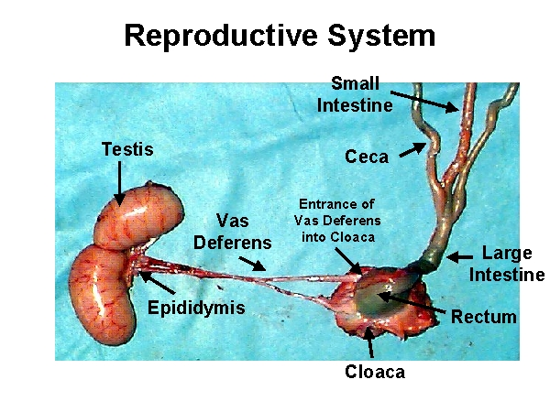

Female Reproductive System
Aligned to the following standards:
AS.04; FFA.PL-A; FFA.PG-J; FFA.CS-M; FFA.CS-N; AG-ANI4; AG2; AGPC01.04; CS.02; CCSS.ELA.RI.9-10.4; CCSS.ELA.W.9-10.1; CCSS.ELA.W.9-10.2; CCSS.ELA.SL.9-10.1; CCSS.ELA.SL.9-10.1.D; CCSS.ELA.SL.9-10.2; CCSS.ELA.SL.9-10.4; CRP.02; CRP.04; CRP.07; CRP.08

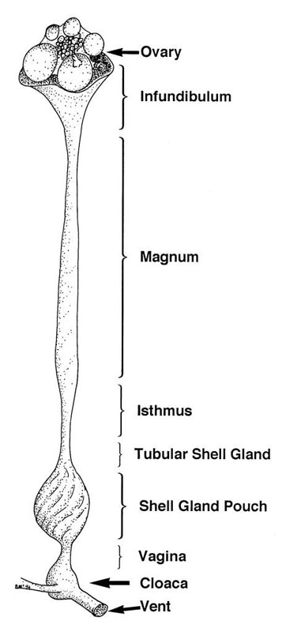

Reproductive Systems Project Guide
Aligned to the following standards:
AS.04; FFA.PL-A; FFA.PG-J; FFA.CS-M; FFA.CS-N; AG-ANI4; AG2; AGPC01.04; CS.02; CCSS.ELA.RI.9-10.4; CCSS.ELA.W.9-10.1; CCSS.ELA.W.9-10.2; CCSS.ELA.SL.9-10.1; CCSS.ELA.SL.9-10.1.D; CCSS.ELA.SL.9-10.2; CCSS.ELA.SL.9-10.4; CRP.02; CRP.04; CRP.07; CRP.08
Directions:
You will work with your partner to create a model of the male and female reproductive systems out of the material provided. Label each part and describe its function on the chart below.

Male Reproductive System
Part | Function

Female Reproductive System
Part | Function

Reproductive Systems Project Rubric
Aligned to the following standards:
AS.04; FFA.PL-A; FFA.PG-J; FFA.CS-M; FFA.CS-N; AG-ANI4; AG2; AGPC01.04; CS.02; CCSS.ELA.RI.9-10.4; CCSS.ELA.W.9-10.1; CCSS.ELA.W.9-10.2; CCSS.ELA.SL.9-10.1; CCSS.ELA.SL.9-10.1.D; CCSS.ELA.SL.9-10.2; CCSS.ELA.SL.9-10.4; CRP.02; CRP.04; CRP.07; CRP.08

Category | 10 | 8 | 6 | 4
Content Knowledge | Explanation by student indicates a clear and accurate understanding of content knowledge. | Explanation by student indicates an accurate understanding of content knowledge. | Explanation by student indicates relatively accurate understanding of content knowledge. | Explanation by the student illustrates little or no understanding of content knowledge.
Fluidity | Model is very creative and accurate. All parts are clearly labeled. | Model is creative and mostly accurate. Most parts are clearly labeled. | Model is a little creative and somewhat accurate. Some parts are clearly labeled. | Model is not very creative and inaccurate. A few parts are clearly labeled.
Construction: Materials | Appropriate materials were selected and creatively modified in ways that made them even better. | Appropriate materials were selected, and there was an attempt at creative modification to make them even better. | Appropriate materials were selected. | Construction appears careless or haphazard. Many details need refinement for a strong or attractive product.
Overall Appearance | Great care was taken in the construction process so that the structure is neat, attractive and accurate. | Construction was careful and accurate for the most part, but 1 to 2 details could have been refined for a more attractive product. | Construction is accurate, but 3 to 4 details could have been refined for a more attractive product. | Construction appears careless or haphazard. Many details need refinement for a strong or attractive product.
Following Directions | Student followed all directions. The project was turned in on time and was CLEARLY labeled. | Student followed the directions. The project was turned in on time and was labeled. | Student somewhat followed the directions. The project was on time but was NOT labeled. | Student did NOT follow directions. The project was LATE. The project was NOT labeled.

Different but Alike
Aligned to the following standards:
AS.04; FFA.PL-A; FFA.PG-J; FFA.CS-M; FFA.CS-N; AG-ANI4; AG2; AGPC01.04; CS.02; CCSS.ELA.RI.9-10.4; CCSS.ELA.W.9-10.1; CCSS.ELA.W.9-10.2; CCSS.ELA.SL.9-10.1; CCSS.ELA.SL.9-10.1.D; CCSS.ELA.SL.9-10.2; CCSS.ELA.SL.9-10.4; CRP.02; CRP.04; CRP.07; CRP.08
Directions:
Utilize the chart below to compare and contrast natural breeding and artificial insemination.
Artificial Insemination
Natural Breeding

Different | Alike | Different
Embryonic Development
Aligned to the following standards:
AS.04; FFA.PL-A; FFA.PG-J; FFA.CS-M; FFA.CS-N; AG-ANI4; AG2; AGPC01.04; CS.02; CCSS.ELA.RI.9-10.4; CCSS.ELA.W.9-10.1; CCSS.ELA.W.9-10.2; CCSS.ELA.SL.9-10.1; CCSS.ELA.SL.9-10.1.D; CCSS.ELA.SL.9-10.2; CCSS.ELA.SL.9-10.4; CRP.02; CRP.04; CRP.07; CRP.08
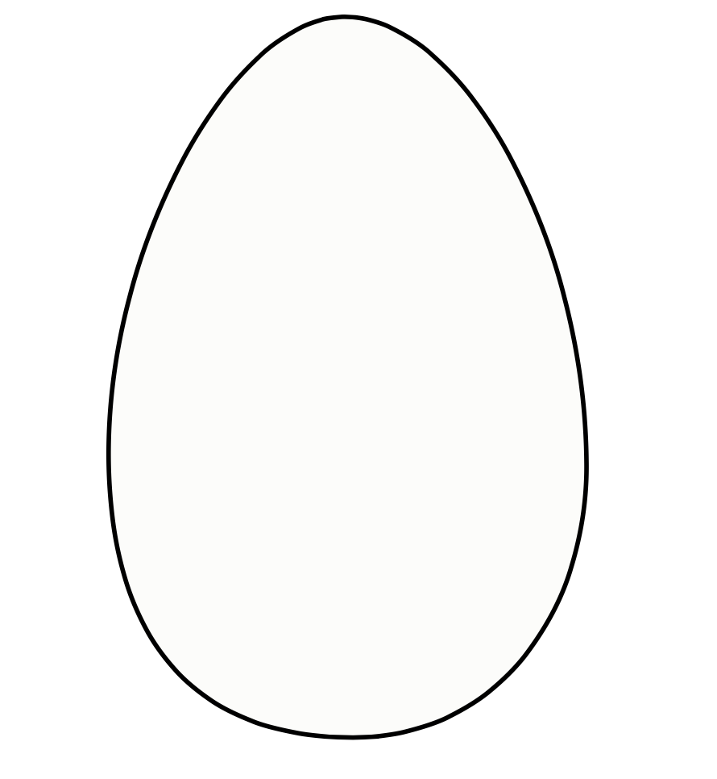

KEY: Reproductive Systems Project Guide
Aligned to the following standards:
CS.02; CS.05; FFA.PL-A; FFA.PL-C; FFA.PL-E; FFA.PL-F; FFA.PG-I; FFA.PG-J; FFA.CS-M; FFA.CS-N; AG2; AG5; AGC09.02; CCSS.ELA.SL.9-10.1; CCSS.ELA.SL.9-10.2; MP5; MP6; CRP.02; CRP.04;
Directions:
You will work with your partner to create a model of the male and female reproductive systems out of the material provided. Label each part and describe its function on the chart below.

Male Reproductive System
Part | Function
Testes | Inside the body and attached in the middle of the back; shaped like beans with a cream color in immature birds and white in mature birds; produces semen, which is a combination of spermatozoa and seminal plasma
Vas Deferens | Transports semen; semen matures here; storage of semen before ejaculation; unejaculated semen is broken down and reabsorbed here
Cloaca | End of the reproductive tract where the sperm exits the body of the tom
Papilla of the ductus deferens | Organ in the wall of the cloaca that distributes semen onto the phallus; the phallus then puts the sperm onto the hen’s reproductive tract

Female Reproductive System
Part | Function
Ovary | Only the left ovary and oviduct matures in these birds; the ovary begins to convert ova to egg yolks; yolks are released from the ovary into the body cavity when they reach the correct size; ovulated yolk is retrieved by the infundibulum, which is the first part of the oviduct
Oviduct | Maintenance of fertility and formation of the egg
Infundibulum | funnel shaped; catches the released yolk or ovum after ovary releases it; fertilization occurs here
Magnum | longest portion of the oviduct; produces bulk of albumen also known as the egg white
Isthmus | inner and outer shell membranes are secreted here
Uterus | plumps the egg; forms the shell and cuticle (seals pores of the egg shell) and determines the shell pigment
Vagina | muscular tube through which egg is expelled; semen is stored here in deep tubule glands
Cloaca | Also known as the vestibule; the cloaca is the common chamber through which the egg passes and is also responsible for the expulsion of feces and urine
Vent | the exterior opening through which passage occurs from the digestive system, the urinary tract and the reproductive tract
KEY: Different but Alike
Aligned to the following standards:
AS.04; FFA.PL-A; FFA.PG-J; FFA.CS-M; FFA.CS-N; AG-ANI4; AG2; AGPC01.04; CS.02; CCSS.ELA.RI.9-10.4; CCSS.ELA.W.9-10.1; CCSS.ELA.W.9-10.2; CCSS.ELA.SL.9-10.1; CCSS.ELA.SL.9-10.1.D; CCSS.ELA.SL.9-10.2; CCSS.ELA.SL.9-10.4; CRP.02; CRP.04; CRP.07; CRP.08
Directions:
Utilize the chart below to compare and contrast natural breeding and artificial insemination.
Artificial Insemination
Natural Breeding

Different | Alike | Different
Male turkeys puff up their bodies  and spread their tail feathers (just like  a peacock). They grunt (make a  “gobble, gobble” sound) and strut  about shaking their feathers. This  fancy turkey trot helps the male  attract females for mating.  Direct mating between male and  female | Method of breeding turkeys | Semen is collected from the male and introduced into the female reproductive tract by a human.  Ensures efficiency
KEY: Embryonic Development
Aligned to the following standards:
AS.04; FFA.PL-A; FFA.PG-J; FFA.CS-M; FFA.CS-N; AG-ANI4; AG2; AGPC01.04; CS.02; CCSS.ELA.RI.9-10.4; CCSS.ELA.W.9-10.1; CCSS.ELA.W.9-10.2; CCSS.ELA.SL.9-10.1; CCSS.ELA.SL.9-10.1.D; CCSS.ELA.SL.9-10.2; CCSS.ELA.SL.9-10.4; CRP.02; CRP.04; CRP.07; CRP.08
For a visual representation of each stage of development use the “Embryonic Development of the Turkey” PDF, available at https://www.hybridturkeys.com/documents/520/Embryonic_Development_19x13.5_ENG.pdf.

