Broiler Production
Created: 07/2019 by the National FFA Organization

The National FFA Organization and U.S. Poultry and Egg Association lesson plan series provides educators with a comprehensive curriculum resource to teach students about the commercial poultry and egg industry. Additionally, lessons are infused with FFA and SAE activities to easily integrate into any agricultural education program.
Student Learning Objectives:
After completing these activities, students will …
- Identify the organization of the commercial broiler industry.
- Describe broiler breeder management and its role in the commercial broiler industry.
- Diagram the process of broiler production.
- Explain how commercial broilers are raised and managed.

Essential Questions:
- Where do broiler chickens come from?
- How are meat type broilers raised for food production?

Time Required: 90 minutes
Resources:
- United State Department of Agriculture (USDA), http://www.usda.gov
- “Marvel Studios’ Captain Marvel,” https://youtu.be/Z1BCujX3pw8
- “Rogelio Ceja – SAE – Poultry,” https://vimeo.com/195969921
- “Broiler Production” PowerPoint, https://ffa.box.com/s/3fh3fdjfbeljgvvxludg2dr2aqs8cu1j
Equipment and Supplies Needed:
- A copy of the “Broiler Production — Farm to Fork” worksheet for each student
- A copy of the “Broiler Comic Strip: Overview” worksheet for each student
- A copy of the Broiler Comic Strip: Character Sheet” worksheet for each student
- A copy of the “Broiler Comic Strip: Template” worksheet for each student
- A copy of the “Broiler Comic Strip: Setting Description” worksheet for each student
- Internet access to play the video in real time or embed it in a PowerPoint ahead of time
- Computer access, ideal for students to work in pairs or small groups

Terms:
The following terms are presented in the lesson and appear in bold italics:
- Broiler
- Ration
- Starter
- Grower
- Developer
- Uniform Flock
- Deformity
- Shank
- Body Conformation
- Hatchery
- Setter
- Hatcher
- Sanitation
- Cross Contamination
- In Ovo
- Lighting Program
- Ventilation
- Brooders
- Litter Condition
- Culling
- Vertical Integration

These activities are aligned to the following standards:
AFNR Performance Element
- AS.01. Analyze historic and current trends impacting the animal systems industry.
- AS.02. Utilize best-practice protocols based upon animal behaviors for animal husbandry and welfare.
- AS.03. Design and provide proper animal nutrition to achieve desired outcomes for performance, development, reproduction and/or economic production.
- AS.05. Evaluate environmental factors affecting animal performance and implement procedures for enhancing performance and animal health.
- AS.06. Classify, evaluate, and select animals based on anatomical and physiological characteristics.
FFA Precept
- FFA.PL-A.Action: Assume responsibility and take the necessary steps to achieve the desired results, no matter what the goal or task at hand.
- FFA.PG-J.Mental Growth: Embrace cognitive and intellectual development relative to reasoning, thinking and coping.
- FFA.CS-M.Communication: Effectively interact with others in personal and professional settings.
- FFA.CS-N.Decision Making: Analyze a situation and execute an appropriate course of action.
Common Career Technical Core
- AG1 Analyze how issues, trends, technologies and public policies impact systems in the Agriculture, Food & Natural Resources Career Cluster.
- AG2 Evaluate the nature and scope of the Agriculture, Food & Natural Resources Career Cluster and the role of agriculture, food, and natural resources (AFNR) in society and the economy.
- AG6 Analyze the interaction among AFNR systems in the production, processing, and management of food, fiber, and fuel and the sustainable use of natural resources.
- AG-ANI1 Analyze historic and current trends impacting the animal systems industry.
- AG-ANI2 Utilize best-practice protocols based upon animal behaviors for animal husbandry and welfare.
- AG-ANI3 Design and provide proper animal nutrition to achieve desired outcomes for performance, development, reproduction and/or economic production.
- AG-ANI5 Evaluate environmental factors affecting animal performance and implement procedures for enhancing performance and animal health.
- AG-ANI6 Classify, evaluate, and select animals based on anatomical and physiological characteristics.
NASDCTEc
- AGPC01.01 Produce and/or manage animals in domesticated and/or natural environments using an application of knowledge regarding anatomy and physiology to enhance animal production.
- AGPC01.02 Recognize and interpret animal behaviors and execute protocols for safe handling to facilitate safety for both animals and humans.
- AGPC01.03 Provide proper nutrition using accepted protocols and processes to maintain animal performance.
- AGPC01.05 Evaluate environmental factors affecting animal performance and implement procedures for enhancing performance to demonstrate an effective application of principles to optimize performance.
- AGPC10.03 Compare and contrast issues affecting the AFNR industry including biotechnology, employment, safety, environmental and animal welfare to demonstrate an understanding of the trends and issues important to careers in this industry.
AFNR Cluster Skills
- CS.01. Analyze how issues, trends, technologies and public policies impact systems in the Agriculture, Food & Natural Resources Career Cluster.
- CS.02. Evaluate the nature and scope of the Agriculture, Food & Natural Resources Career Cluster and the role of agriculture, food and natural resources (AFNR) in society and the economy.
- CS.06. Analyze the interaction among AFNR systems in the production, processing and management of food, fiber and fuel and the sustainable use of natural resources.
Common Core–Writing
- CCSS.ELA-Literacy.W.9-10.2 Write informative/explanatory texts to examine and convey complex ideas, concepts, and information clearly and accurately through the effective selection, organization, and analysis of content.
Common Core–Speaking and Listening
- CCSS.ELA-Literacy.SL.9-10.1 Initiate and participate effectively in a range of collaborative discussions (one-on-one, in groups, and teacher-led) with diverse partners on grades 9-10 topics, texts, and issues, building on others' ideas and expressing their own clearly and persuasively.
- CCSS.ELA-Literacy.SL.9-10.2 Integrate multiple sources of information presented in diverse media or formats (e.g., visually, quantitatively, orally) evaluating the credibility and accuracy of each source.
- CCSS.ELA-Literacy.SL.9-10.4 Present information, findings, and supporting evidence clearly, concisely, and logically such that listeners can follow the line of reasoning and the organization, development, substance, and style are appropriate to purpose, audience, and task.
AFNR Career Ready Practices
- CRP.02. Apply appropriate academic and technical skills. Career-ready individuals readily access and use the knowledge and skills acquired through experience and education to be more productive.
- CRP.04. Communicate clearly, effectively, and with reason. Career-ready individuals communicate thoughts, ideas and action plans with clarity, whether using written, verbal and/or visual methods.
Partnership for 21st Century Skills
- Communication
- Critical Thinking and Problem Solving

Lesson Plan:
- Bell Ringer: What is a broiler? (A meat-type chicken.)

- Interest Approach: Watch the trailer for “Marvel Studios’ Captain Marvel” (found at https://youtu.be/Z1BCujX3pw8) or another superhero movie trailer. Set context that during today’s class, students will create their own comic strip, complete with a main character and setting description, all about broilers.

- Instruction:

Student Learning Objective One: Students will be able to identify the organization of the commercial broiler industry.

- A typical commercial company has different production segments that are involved in the production and processing of meat-type chickens, or broilers.  - Broiler breeders  - Broiler breeders consist of male and female chickens that are of reproductive age (approximately 20 weeks of age).  - Broiler breeders produce fertile eggs that are used to produce offspring that are raised for meat production.  - Offspring are raised for approximately 45 days in an open barn and are not confined to cages.  - Hatchery  - The hatchery is responsible for the incubation and hatching of chicks from fertile eggs obtained from broiler breeders.  - The hatchery consists of incubation equipment responsible for maintaining ideal environmental conditions for embryo development.  - Setter/Incubator  - Fertile eggs are incubated in the setter for 18 days.  - The setter provides ideal temperature and humidity conditions for embryo development.  - The eggs are stored on trays that are secured to incubator racks.  - The setter also rotates eggs to ensure proper orientation of the developing embryo in the egg.  - Hatcher  - After 18 days in the setter, eggs are transferred from trays to hatching baskets and are moved to the hatcher.  - The hatcher provides ideal temperature and humidity for late-stage embryo development and hatching.  - Unlike the setter, the hatcher does not rotate eggs.  - The chicks hatch after three days in the hatcher, resulting in a total incubation period of 21 days.  - While in the egg, chicks use their beak to break out of the shell, a process referred to as pipping.  - Chicks are damp when they exit the shell, or hatch, and the warm temperature in the hatcher plays an important role in drying the chick and maintaining their body temperature.  - Once hatched, chicks are removed from the hatching baskets and egg shell debris is discarded.  - Chicks are inspected and are serviced (vaccinated, loaded into boxes, etc.) prior to delivery to a grow-out farm.  - Chicks are counted into trays that are used for delivery to grow-out farms.  - The chick trays are loaded into an environmentally controlled delivery vehicle and are transported to the farm where they will be raised to market weight.  - Grow-out farms  - Grow-out farms are where broiler chickens are raised.  - Grow-out farms typically have a number of houses on site.  - Grow-out houses are specialized buildings that allow age-appropriate control of temperature, humidity, food delivery, water delivery, and lighting for the broilers.  - The grow-out house is completely enclosed to prevent predator entry and to promote biosecurity.  - The grow-out house provides birds the freedom to move throughout the house as they want.  - Grow-out houses are either curtain-sided or tunnel-ventilated.  - Curtain-sided  - These houses contain a curtain that runs along both sides of the house that can be raised or lowered depending upon external temperatures to maintain desired environmental conditions in the house.  - Tunnel-ventilated  - One end of the house contains large exhaust fans while the other end of the house contains large cool cells.  - The exhaust fans function to exchange air within the house.  - The cool cells function to cool air that enters the house.  - Cooling: ventilation fans draw air through the poultry house, creating enough airspeed to cool the temperature in the barn.  - To keep the broilers warm, minimum ventilation is used. This allows for fresh air but does not drastically drop temperatures.  - These houses contain solid walls on all sides of the house.  - Along the length of the house at the top of the side walls there are small openings, called vent boards.  - The vent boards control the direction of air entry into the house.  - Vent boards direct fresh air to the top of the house so it can be warmed.  - This prevents the broilers from encountering cold air or drafts.  - Grow-out houses contain automated feed lines that provide birds with access to feed at all times.  - The automated feed line contains feed pans for feed presentation.  - The number of feed pans along the feed line is sufficient to provide chicks access to feed at any time.  - Grow-out houses also contain water lines that provide birds with access to water at all times.  - The water lines contain nipples that the chicks activate so water is released.  - Proper use of water lines maintains the quality of the bedding substrate used in the facility.  - The number of nipples along the water lines is sufficient to provide chicks with immediate access to water at any time.  - Processing plant  - The processing plant is the location where market-weight broilers are delivered for processing.  - The processing plant is a highly automated facility.  - Most companies have slaughter plants as well as further processing.  - Further processing can refer to cut-up and cooked products.  - Feed mill  - The feed mill is responsible for preparing finished feed.  - Commercial broilers are fed four to five different diets during their lives.  - Feeding the birds a diet that closely matches their nutritional needs is essential for good health and maximum growth.  - The raw ingredients used to formulate the diets (corn, soy, etc.) are typically delivered by railcar or trucked in from local grain suppliers.  - The feed mill contains large storage bins for holding ingredients used in broiler diets.  - The feed mill has delivery trucks that transport the feed to the grow-out farms.  - Animal health  - Many commercial broiler-producing companies employ veterinarians to develop, maintain and implement an animal health plan.  - Most of the commercial poultry industry is vertically integrated.  - Vertical integration means that companies operate all the facilities involved in poultry production (e.g., hatchery, processing plant, feed mill and sometimes broiler breeder and grow-out farms).  - This provides the company with enhanced quality control and provides economic benefits as well.  - The industry continues to depend upon suppliers outside their company to provide service.  - These may include contract growers that are paid by the company to raise broilers at their farm.  - This may also include a contract feed mill that is paid by the company to produce custom feeds.  - The commercial broiler industry is predominantly located in the southeast.  - The top broiler-producing companies are in the southeastern United States.  - Georgia is the top broiler-producing state.  - Per capita consumption of chicken meat is the highest of all protein sources in the United States.  - Per capita chicken consumption has increased consistently over the past 100 years.  - In 1900, per capita chicken consumption was one pound per year.  - In 1965, per capita chicken consumption was 26 pounds per year.  - Today, the per capita chicken consumption is nearly 85 pounds per year.  - Consumption of chicken meat has increased due to many factors:  - Fast food chains have offered more chicken products.  - Chicken is an affordable source of protein. Chicken costs less than other meats, such as beef or lamb.  - Chicken is a healthy meat protein source. | Activity 1:  Each student will need a copy of the “Broiler Production — Farm to Fork” worksheet. Students will complete as you present the information. After instruction students will need a copy of the “Broiler Comic Strip: Overview” and the “Broiler Comic Strip: Outline.” Students will create a 6-pane comic strip! The development of this project will occur in three parts.  Step 1: First students will need to develop the main character of your comic strip. This character is going to be the focal point that will guide the reader throughout your comic strip. Using the worksheet “Broiler Comic Strip: Character Sheet,” students will draw a picture of what their main character will look like. Then, they will develop their character’s personality by describing the origin of the character and two superpowers they possess. The character they create will teach their readers about the poultry industry, and they should be well equipped for such a trip!  *Teacher information sheets are provided if using without direct instruction.

Student Learning Objective Two: Students will be able to describe broiler breeder management and its role in the commercial broiler industry.

- Broiler breeders are defined as male (rooster) and female (hen) meat-type birds that are of reproductive age.  - Broiler breeders are not used for meat production, but rather for the production of fertile eggs.  - The offspring of broiler breeders are the meat-type chicken, or broiler, that is raised for meat production.  - Broiler breeders are an extremely important component of the industry since they are the source of all meat-type birds used in production.  - Broiler breeder facilities are separate operations that are isolated from grow-out farms.  - Given the importance of broiler breeders to the industry, broiler breeders are maintained at a separate site for biosecurity and management purposes.  - Unlike broilers that are raised for meat production, broiler breeders are raised under unique management conditions that collectively promote optimal reproductive development.  - Housing  - Broiler breeders are maintained in pullet houses during the period of reproductive development.  - Broiler breeders are maintained in pullet houses for approximately 20 weeks since this is the amount of time required for reproductive maturity for the male and female.  - Broiler breeders are maintained in breeder houses during the period of reproduction and egg lay.  - A typical reproductive period for a broiler breeder flock is 10 months.  - Breeder houses are stocked with 10 females per male.  - Breeder houses are designed to promote reproductive behavior.  - Breeder houses are open-space houses with a central scratch area where breeding takes place and a raised slat area that contain nest boxes for hens to lay their eggs.  - Eggs are gathered daily, either by hand or by automated egg gathering equipment.  - Environment  - The environment is managed to optimize reproductive development and production.  - Light duration is a major regulator of reproductive development and performance.  - Once birds are moved to the breeder house, light duration is increased to stimulate hens to initiate egg lay.  - Feeding regimens are also utilized to control body weight since this has a major influence on development of the reproductive system and on fertility.  - Grower houses contain separate male and female feeders to ensure they are obtaining the optimal nutrients for reproductive performance.  - Broiler breeders are intensively selected for specific performance and livability traits.  - Improvements in genetic selection over the past 50 years have resulted in tremendous improvements in broiler production efficiencies.  - During their development, broiler breeders are constantly evaluated and selected for criteria that will result in improved performance of their offspring.  - Typical selection criteria include the following:  - Body weight.  - Feed conversion.  - Resistance to disease.  - Breast yield.  - Skeletal integrity.  - Body conformation.  - Due to the short generation intervals of chickens, genetic improvements in broiler performance can be made quickly.  - Breeding companies develop and/or maintain the genetic lines and perform the selection(s).  - Commercial broiler producers purchase broiler breeders that have the desired performance and livability traits that are best suited for their operations and market. | Activity 1:  Step 2: Using the worksheet “Broiler Comic Strip: Outline,” students will develop their 6-pane comic strip depicting each step in the broiler production process, from hatching through processing. They will need to include pictures, captions and the character you developed in Step 1. Students should be creative and use color throughout their comic strip while incorporating all that they have learned about broiler production.  *Teacher information sheets are provided if using without direct instruction.

Student Learning Objective Three: Students will be able to explain how commercial broilers are raised and managed.

- Meat-type broilers are raised in environmentally controlled grow-out houses contained on grow-out farms.  - It is typical in the commercial broiler industry for grow-out farms to contain many grow-out houses.  - It is typical for a farm to contain tens of thousands of birds at any one time.  - Broilers are placed in a grow-out house after hatching.  - Once hatched at the hatchery, broiler chicks are transferred by vehicle to a grow-out farm.  - Chick trays are carried into a grow-out house and chicks are placed on the floor.  - Grow-out houses do not contain cages and broilers are allowed to walk throughout the entire house.  - Broilers of the same age are placed into a grow-out house.  - This is referred to as all-in all-out housing.  - The broilers placed into a house are collectively referred to as a flock.  - Grow-out houses are thoroughly cleaned on a regular basis.  - In addition to cleaning, the house is left vacant for sufficient downtime.  - Grow-out houses contain specific equipment to control environmental conditions and to provide feed and water.  - Flooring substrate  - Rice hulls or wood shavings are often used as flooring substrate material for broilers.  - Heaters  - May be forced air heaters or radiant heaters.  - Feed lines  - Provide feed into feeding pans located along the length of the house.  - Feed pans are automatically filled when feed levels drop below a minimum level and trigger an activator switch.  - Feed Bins  - Provide an enclosed and safe storage site for feed.  - Feed silos are located outside the house and contain an automated delivery system that moves feed into the house for delivery into the feed lines.  - Water lines  - Provide water via nipple drinkers located along the length of the house.  - Provide a fresh source of water for birds at any time of the day.  - Exhaust fans  - Located at the end of the house opposite the cool cells.  - Exhaust fans facilitate air exchange in the house by pulling in fresh air via the vent boards or cool cells.  - Cool cells  - Located at the end of the house opposite the exhaust fans.  - Cools cells are used as an evaporative cooler.  - Water runs through the cool cells and air is cooled as it moves through the cool cell and into the house.  - Vent boards  - Located at the top of the walls along both sides of the house.  - Provide directed air inlet to promote proper air mixing, heating and ventilation.  - Curtains  - Run along the length of the house and are raised and lowered to alter the flow of air in and out of the house.  - Computer  - A computer monitors and controls all automated equipment in the house to ensure proper environmental control at all times.  - Broilers require specific management conditions for optimal growth.  - Depending on the age of the broiler, proper ventilation, lighting and nutritional programs are implemented to ensure optimal growth and welfare.  - Temperature  - Heating  - Broilers are not capable of regulating their body temperature during the first 10 to 14 days of life.  - The grow-out house must provide supplemental heating to ensure the birds maintain their body temperature and remain comfortable.  - Heating is achieved through radiant pancake brooders and/or forced air heaters.  - Cooling  - During the last few weeks of life, broilers produce significant amounts of heat and the house requires cooling.  - Cooling during hot weather is achieved primarily through increased ventilation and/or use of cool cell pads or fogging systems.  - Ventilation  - The rate of air exchange has a major impact on temperature control within the grow-out house.  - Ventilation rates when broilers are young are geared to maintain a comfortable brooding temperature and designed to cool broilers approaching market weight.  - Lighting  - Lighting programs are used to help improve broiler health and growth.  - Nutrition  - Broiler diets are designed to closely meet their nutrient requirements for growth. | Activity 1:  Step 3: Now that they have developed their main character and have created their comic strip, students will describe the setting of their comic strip, where their main character resides and the adventure they took through the comic strip. Be sure students write at least two full paragraphs and use as many vocabulary words as possible. Use the worksheet “Broiler Comic Strip: Setting Description” to write their story.  *Teacher information sheets are provided if using without direct instruction.

- Follow-up: Once students have completed their comic strips, character sheets and setting descriptions, provide time for students to “read” each other’s work. Provide three to four minutes per rotation to allow students to partner and swap their comic strips, characters and settings. Once three rotations have taken place, as a class, discuss some of the similarities and differences between the comic strips they read.

- FFA/SAE Connections: Watch the video “Rogelio Ceja – SAE – Poultry.” Learn how Rogelio works with broilers and what having an SAE and being in FFA means to him. The URL is https://vimeo.com/195969921.

- Exit Ticket: Have each student create a flow chart to map out the broiler production process. Next, on a scrap sheet of paper, students should complete a “Take One, Get One.” Have each student write one fact they learned during today’s class period. Then, direct students to find a partner and capture the fact they wrote down as well. Have each student describe what they learned to the other student.

Broiler Production — From Farm to Fork
Aligned to the following standards:
AS.01; AS.02; AS.03; AS.05; AS.06; FFA.PL-A; FFA.PG-J; FFA.CS-M; FFA.CS-N; AG1; AG2; AG6; AG-ANI1; AG-ANI2; AG-ANI3; AG-ANI5; AG-ANI6; AGPC01.01; AGPC01.02; AGCP01.03; AGPC01.05; AGPC10.03; CS.01; CS.02; CS.06; CCSS.ELA.W.9-10.2; CCSS.ELA.SL.9-10.1; CCSS.ELA.SL.9-10.2; CCSS.ELA.SL.9-10.4; CRP.02; CRP.04
Directions:
Complete the guided notes below as your teacher presents the information. You will need this information later for an activity.

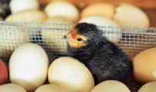
- ______________________
- ______________________
- ______________________
- ______________________
- ______________________
- ______________________
What are the 6 segments of broiler production?
Segment 1: _________________
Male = _______________
+
Female = _____________

Lay ________ eggs to

become _________________.
Segment 2: __________________________________
Responsible for _____________________________________________________________________________________________________________________________________________
Contains equipment to maintain an ________ environment for __________ development. The equipment is: ____________________ and ____________________.
Incubator/Setter
Hatcher

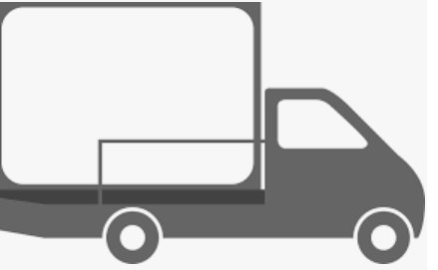
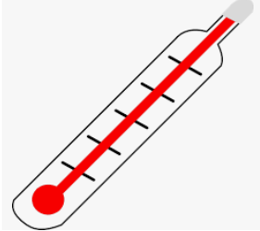
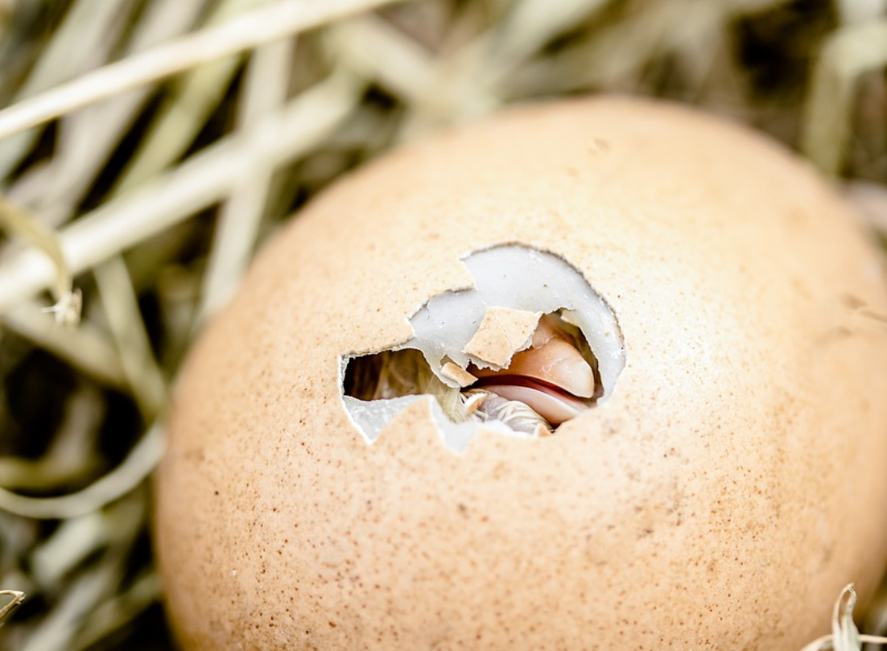
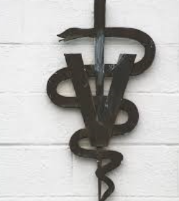
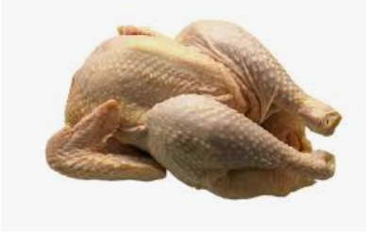

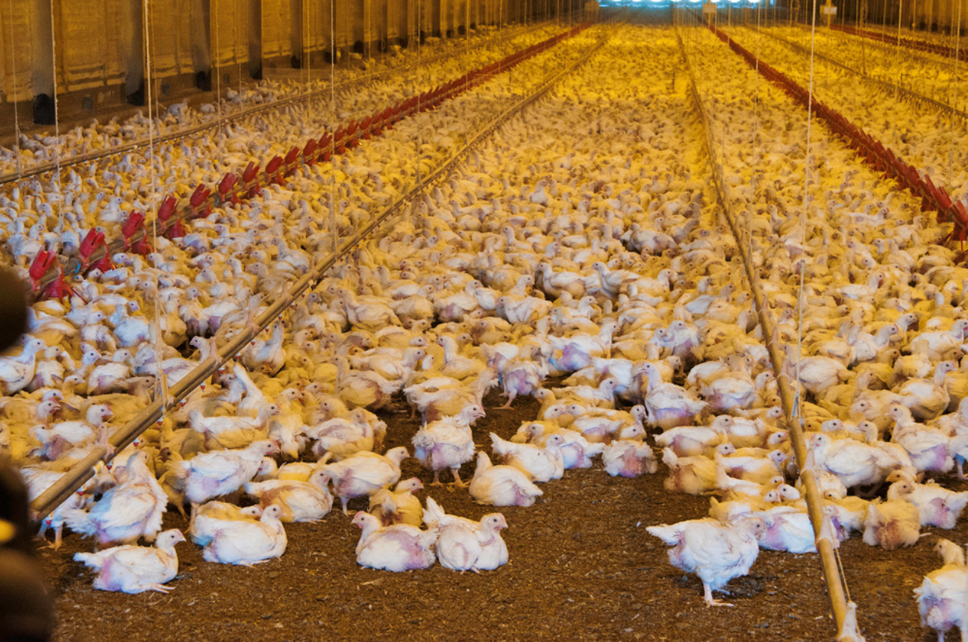
What is the process at the hatchery?

- ______________________________________________________________________________________________________________________________________________________________________________________
- ______________________________________________________________________________________________________________________________________________________________________________________
- ______________________________________________________________________________________________________________________________________________________________________________________
- ______________________________________________________________________________________________________________________________________________________________________________________
- ______________________________________________________________________________________________________________________________________________________________________________________
- ______________________________________________________________________________________________________________________________________________________________________________________

What happens here?
Segment 3: _______________________________

How are the chickens kept cool?

- ____________________

- ____________________
Segment 5: _______________________________________

What happens in this segment?
Segment 6: _______________________________________

What is done to ensure this segment takes place?
Segment 4: _______________________________________

What happens in this step?
How do we ensure the broilers have food and water at all times?
Broiler Comic Strip: Overview
Aligned to the following standards:
AS.01; AS.02; AS.03; AS.05; AS.06; FFA.PL-A; FFA.PG-J; FFA.CS-M; FFA.CS-N; AG1; AG2; AG6; AG-ANI1; AG-ANI2; AG-ANI3; AG-ANI5; AG-ANI6; AGPC01.01; AGPC01.02; AGCP01.03; AGPC01.05; AGPC10.03; CS.01; CS.02; CS.06; CCSS.ELA.W.9-10.2; CCSS.ELA.SL.9-10.1; CCSS.ELA.SL.9-10.2; CCSS.ELA.SL.9-10.4; CRP.02; CRP.04
Directions:
Today you are going to get creative and develop your own 6-pane comic strip! The development of this project will occur in three parts. Follow these instructions to ensure that you have developed the perfect comic strip.

Step 1: First you will need to develop the main character of your comic strip. This character is going to be the focal point that will guide the reader throughout your comic strip. Using the worksheet “Broiler Comic Strip: Character Sheet,” draw a picture of what your main character will look like. Next, develop your character’s personality by describing the origin of your character and two superpowers they possess. Remember, the character you create will teach your reader about the poultry industry, and they should be well equipped for such a trip!

Step 2: Using the worksheet “Broiler Comic Strip: Outline,” develop your 6-pane comic strip depicting each step in the broiler production process, from hatching through processing. You will need to include pictures, captions and the character you developed in Step 1. Be creative and use color throughout your comic strip while incorporating all that you have learned about broiler production. Use your Farm to Fork notes to help you.

Step 3: Now that you have developed your main character and have created your comic strip, describe the setting of your comic strip, where your main character resides and the adventure they took through the comic strip. Be sure to write at least two full paragraphs and use as many vocabulary words as possible. Use the worksheet “Broiler Comic Strip: Setting Description” to write your story.

Category | Excellent  (10–8 points) | Good  (7–5 points) | Needs Improvement  (4–3 points) | Poor  (2–0) points | Comments
Content | Each stage of poultry production is included: breeders, hatchery, grow-out, processing plant and feed mill. | Missing one stage of poultry production: breeders, hatchery, grow-out, processing plant and feed mill. | Missing two stages of poultry production: breeders, hatchery, grow-out, processing plant and feed mill. | Missing three or more stages of poultry production: breeders, hatchery, grow-out, processing plant and feed mill.
Vocabulary Usage | 10 or more vocab words used | Eight to nine vocab words used | Seven to eight vocab words used | Less than seven vocab words used
Character Development | The character was well developed, did not detract from the story and had a clear connection to the story. The character was included in every pane. | The character was developed and was used in every pane. More thought could have been placed into character use and the character’s role in the story. | The character could use more thought and or was missing from one pane of the comic strip. | The character was not included in every pane of the comic strip and detracted from the story.
Story | The story was well developed and had a clear progression and purpose. | Complete but had some disconnect between panes and the story line that was included | Choppy story line; Comic strip and story did not line up well. | Little to no story with little to no connections between panes
Color, Creativity, Neatness, Execution | Demonstrated lots of creativity and color and was very neat and easy to read | Color and neatness were used in every pane but lacked some creativity | Two or more panes missing color and lacked creativity and neatness | No color was used and little to no creativity was present; Sloppy work
Formatting | Six panes used | Five panes used | Four panes used | Less than four panes used
Grammar and Spelling | No more than one error | Two errors | No more than three errors | More than three errors
Total: ________

Broiler Comic Strip: Character Sheet
Aligned to the following standards:
AS.01; AS.02; AS.03; AS.05; AS.06; FFA.PL-A; FFA.PG-J; FFA.CS-M; FFA.CS-N; AG1; AG2; AG6; AG-ANI1; AG-ANI2; AG-ANI3; AG-ANI5; AG-ANI6; AGPC01.01; AGPC01.02; AGCP01.03; AGPC01.05; AGPC10.03; CS.01; CS.02; CS.06; CCSS.ELA.W.9-10.2; CCSS.ELA.SL.9-10.1; CCSS.ELA.SL.9-10.2; CCSS.ELA.SL.9-10.4; CRP.02; CRP.04
Directions:
Use the content from the “Broiler Production — Farm to Fork” worksheet to help you draw your main character, create two superpowers and craft a brief origin story.
Character Image

Superpower 1: Superpower 2:

Origin Story:

Broiler Comic Strip: Outline
Aligned to the following standards:
AS.01; AS.02; AS.03; AS.05; AS.06; FFA.PL-A; FFA.PG-J; FFA.CS-M; FFA.CS-N; AG1; AG2; AG6; AG-ANI1; AG-ANI2; AG-ANI3; AG-ANI5; AG-ANI6; AGPC01.01; AGPC01.02; AGCP01.03; AGPC01.05; AGPC10.03; CS.01; CS.02; CS.06; CCSS.ELA.W.9-10.2; CCSS.ELA.SL.9-10.1; CCSS.ELA.SL.9-10.2; CCSS.ELA.SL.9-10.4; CRP.02; CRP.04
Directions:
Draw a comic strip depicting the broiler production process. Be creative! But, make sure to highlight each step of the process visually and through the caption. Take your main character on an adventure!

Broiler Comic Strip: Setting Description
Aligned to the following standards:
AS.01; AS.02; AS.03; AS.05; AS.06; FFA.PL-A; FFA.PG-J; FFA.CS-M; FFA.CS-N; AG1; AG2; AG6; AG-ANI1; AG-ANI2; AG-ANI3; AG-ANI5; AG-ANI6; AGPC01.01; AGPC01.02; AGCP01.03; AGPC01.05; AGPC10.03; CS.01; CS.02; CS.06; CCSS.ELA.W.9-10.2; CCSS.ELA.SL.9-10.1; CCSS.ELA.SL.9-10.2; CCSS.ELA.SL.9-10.4; CRP.02; CRP.04
Directions:
Using the lines below, describe the setting of your comic strip—where your main character resides. Be sure to write at least two full paragraph and use as many vocabulary words as possible.

Broiler Comic Strip: Teacher Information Sheet 1
Aligned to the following standards:
AS.01; AS.02; AS.03; AS.05; AS.06; FFA.PL-A; FFA.PG-J; FFA.CS-M; FFA.CS-N; AG1; AG2; AG6; AG-ANI1; AG-ANI2; AG-ANI3; AG-ANI5; AG-ANI6; AGPC01.01; AGPC01.02; AGCP01.03; AGPC01.05; AGPC10.03; CS.01; CS.02; CS.06; CCSS.ELA.W.9-10.2; CCSS.ELA.SL.9-10.1; CCSS.ELA.SL.9-10.2; CCSS.ELA.SL.9-10.4; CRP.02; CRP.04

Broiler Production Process Information:

Broiler breeders
Broiler breeders consist of male and female chickens that are of reproductive age (approximately 20 weeks of age).
Broiler breeders produce fertile eggs that are used to produce offspring that are raised for meat production.
      - Offspring are raised for approximately 45 days in an open barn and are not confined to cages.

Hatchery
The hatchery is responsible for the incubation and hatching of chicks from fertile eggs obtained from broiler breeders.
The hatchery consists of incubation equipment responsible for maintaining ideal environmental conditions for embryo development.
Setter/Incubator
- Fertile eggs are incubated in the setter for 18 days.
- The setter provides ideal temperature and humidity conditions for embryo development.
- The eggs are stored on trays that are secured to incubator racks.
- The setter also rotates eggs to ensure proper orientation of the developing embryo in the egg.

Hatcher
    - After 18 days in the setter, eggs are transferred from trays to hatching baskets and are moved to the hatcher.
    - The hatcher provides ideal temperature and humidity for late-stage embryo development and hatching.
    - Unlike the setter, the hatcher does not rotate eggs.
    - The chicks hatch after three days in the hatcher, resulting in a total incubation period of 21 days.
    - While in the egg, chicks use their beak to break out of the shell, a process referred to as pipping.
    - Chicks are damp when they exit the shell, or hatch, and the warm temperature in the hatcher plays an important role in drying the chick and maintaining their body temperature.
    - Once hatched, chicks are removed from the hatching baskets and egg shell debris is discarded.
    - Chicks are inspected and are serviced (vaccinated, loaded into boxes, etc.) prior to delivery to a grow-out farm.
    - Chicks are counted into trays that are used for delivery to grow-out farms.
    - The chick trays are loaded into an environmentally controlled delivery vehicle and are transported to the farm where they will be raised to market weight.

Grow-out farms
Grow-out farms are where broiler chickens are raised.
Grow-out farms typically have a number of houses on site.
- Grow-out houses are specialized buildings that allow age-appropriate control of temperature, humidity, food delivery, water delivery and lighting for the broilers.
- The grow-out house is completely enclosed to prevent predator entry and to promote biosecurity.
- The grow-out house provides birds the freedom to move throughout the house as they want.
- Grow-out houses are either curtain-sided or tunnel-ventilated.
  - Curtain-sided
    - These houses contain a curtain that runs along both sides of the house that can be raised or lowered depending upon external temperatures to maintain desired environmental conditions in the house.
  - Tunnel-ventilated
    - One end of the house contains large exhaust fans while the other end of the house contains large cool cells.
      - The exhaust fans function to exchange air within the house.
      - The cool cells function to cool air that enters the house.
    - Cooling: ventilation fans draw air through the poultry house, creating enough airspeed to cool the temperature in the barn.
    - To keep the broilers warm, minimum ventilation is used. This allows for fresh air but does not drastically drop temperatures.
    - These houses contain solid walls on all sides of the house.
    - Along the length of the house at the top of the side walls there are small openings, called vent boards.
    - The vent boards control the direction of air entry into the house. Vent boards direct fresh air to the top of the house so it can be warmed. This prevents the broilers from encountering cold air or drafts.

    - Grow-out houses contain automated feed lines that provide birds with access to feed at all times. The automated feed line contains feed pans for feed presentation. The number of feed pans along the feed line is sufficient to provide chicks access to feed at any time.

    - Grow-out houses also contain water lines that provide birds with access to water at all times. The water lines contain nipples that the chicks activate to release the water. Proper use of water lines maintains the quality of the bedding substrate used in the facility. The number of nipples along the water lines is sufficient to provide chicks with immediate access to water at any time.
Processing plant
- The processing plant is the location where market-weight broilers are delivered for processing.
- The processing plant is a highly automated facility.
- Most companies have slaughter plants as well as further processing.
  - Further processing can refer to cut-up and cooked products.
Feed mill
- The feed mill is responsible for preparing finished feed.
- Commercial broilers are fed four to five different diets during their lives.
  - Feeding the birds a diet that closely matches their nutritional needs is essential for good health and maximum growth.
- The raw ingredients used to formulate the diets (corn, soy, etc.) are typically delivered by railcar or trucked in from local grain suppliers.
- The feed mill contains large storage bins for holding ingredients used in broiler diets.
- The feed mill contains delivery trucks that transport the feed to the grow-out farms.

Broiler Comic Strip: Teacher Information Sheet 2
Aligned to the following standards:
AS.01; AS.02; AS.03; AS.05; AS.06; FFA.PL-A; FFA.PG-J; FFA.CS-M; FFA.CS-N; AG1; AG2; AG6; AG-ANI1; AG-ANI2; AG-ANI3; AG-ANI5; AG-ANI6; AGPC01.01; AGPC01.02; AGCP01.03; AGPC01.05; AGPC10.03; CS.01; CS.02; CS.06; CCSS.ELA.W.9-10.2; CCSS.ELA.SL.9-10.1; CCSS.ELA.SL.9-10.2; CCSS.ELA.SL.9-10.4; CRP.02; CRP.04
Broiler breeders are defined as male (rooster) and female (hen) meat-type birds that are of reproductive age.
  - Broiler breeders are not used for meat production, but rather for the production of fertile eggs.
  - The offspring of broiler breeders are the meat-type chicken, or broiler, that is raised for meat production.
  - Broiler breeders are an extremely important component of the industry since they are the source of all meat-type birds used in production.

Broiler breeder facilities are separate operations that are isolated from grow-out farms.
  - Given the importance of broiler breeders to the industry, broiler breeders are maintained at a separate site for biosecurity and management purposes.
  - Unlike broilers that are raised for meat production, broiler breeders are raised under unique management conditions that collectively promote optimal reproductive development.
    - Housing
      - Broiler breeders are maintained in pullet houses during the period of reproductive development.
        - Broiler breeders are maintained in pullet houses for approximately 20 weeks since this is the amount of time required for reproductive maturity for the male and female.
      - Broiler breeders are maintained in breeder houses during the period of reproduction and egg lay.
        - A typical reproductive period for a broiler breeder flock is 10 months.
        - Breeder houses are stocked with 10 females per male.
      - Breeder houses are designed to promote reproductive behavior.
        - Breeder houses are open-space houses with a central scratch area where breeding takes place and a raised slat area that contain nest boxes for hens to lay their eggs.
        - Eggs are gathered daily, either by hand or by automated egg-gathering equipment.
    - Environment
      - The environment is managed to optimize reproductive development and production.
      - Light duration is a major regulator of reproductive development and performance.
        - Once birds are moved to the breeder house, light duration is increased to stimulate hens to initiate egg lay.
      - Feeding regimens are also utilized to control body weight since this has a major influence on development of the reproductive system and on fertility.
        - Grower houses contain separate male and female feeders to ensure they are obtaining the optimal nutrients for reproductive performance.

Broiler breeders are intensively selected for specific performance and livability traits.
  - Improvements in genetic selection over the past 50 years have resulted in tremendous improvements in broiler production efficiencies.
  - During their development, broiler breeders are constantly evaluated and selected for criteria that will result in improved performance of their offspring.
    - Typical selection criteria include the following:
      - Body weight.
      - Feed conversion.
      - Resistance to disease.
      - Breast yield.
      - Skeletal integrity.
      - Body conformation.
  - Due to the short generation intervals of chickens, genetic improvements in broiler performance can be made quickly.
  - Breeding companies develop and/or maintain the genetic lines and perform the selection(s).
  - Commercial broiler producers purchase broiler breeders that have the desired performance and livability traits that are best suited for their operations and market.

Broiler Comic Strip: Teacher Information Sheet 3
Aligned to the following standards:
AS.01; AS.02; AS.03; AS.05; AS.06; FFA.PL-A; FFA.PG-J; FFA.CS-M; FFA.CS-N; AG1; AG2; AG6; AG-ANI1; AG-ANI2; AG-ANI3; AG-ANI5; AG-ANI6; AGPC01.01; AGPC01.02; AGCP01.03; AGPC01.05; AGPC10.03; CS.01; CS.02; CS.06; CCSS.ELA.W.9-10.2; CCSS.ELA.SL.9-10.1; CCSS.ELA.SL.9-10.2; CCSS.ELA.SL.9-10.4; CRP.02; CRP.04
Meat-type broilers are raised in environmentally controlled grow-out houses contained on grow-out farms.

It is typical in the commercial broiler industry for grow-out farms to contain many grow-out houses.
    - It is typical for a farm to contain tens of thousands of birds at any one time.

Broilers are placed in a grow-out house after hatching.
    - Once hatched at the hatchery, broiler chicks are transferred by vehicle to a grow-out farm.
    - Chick trays are carried into a grow-out house and chicks are placed on the floor.
    - Grow-out houses do not contain cages and broilers are allowed to walk throughout the entire house.

Broilers of the same age are placed into a grow-out house.
    - This is referred to as all-in all-out housing.
    - The broilers placed into a house are collectively referred to as a flock.

Grow-out houses are thoroughly cleaned on a regular basis.
    - In addition to cleaning, the house is left vacant for sufficient downtime.

Grow-out houses contain specific equipment to control environmental conditions and to provide feed and water.
    - Flooring substrate
      - Rice hulls or wood shavings are often used as flooring substrate material for broilers.

    - Heaters
      - May be forced air heaters or radiant heaters.

    - Feed lines
      - Provide feed into feeding pans located along the length of the house.
      - Feed pans are automatically filled when feed levels drop below a minimum level and trigger an activator switch.

    - Feed Bins
      - Provide an enclosed and safe storage site for feed.
      - Feed silos are located outside the house and contain an automated delivery system that moves feed into the house for delivery into the feed lines.

    - Water lines
      - Provide water via nipple drinkers located along the length of the house.
      - Provide a fresh source of water for birds at any time of the day.

    - Exhaust fans
      - Located at the end of the house opposite the cool cells.
      - Exhaust fans facilitate air exchange in the house by pulling in fresh air via the vent boards or cool cells.

    - Cool cells
      - Located at the end of the house opposite the exhaust fans.
      - Cools cells are used as an evaporative cooler.
      - Water runs through the cool cells, and air is cooled as it moves through the cool cell and into the house.

    - Vent boards
      - Located at the top of the walls along both sides of the house.
      - Provide directed air inlet to promote proper air mixing, heating and ventilation.

    - Curtains
      - Run along the length of the house and are raised and lowered in order to alter the flow of air in and out of the house.

    - Computer
      - A computer monitors and controls all automated equipment in the house to ensure proper environmental control at all times.

Broilers require specific management conditions for optimal growth.
  - Depending on the age of the broiler, proper ventilation, lighting and nutritional programs are implemented to ensure optimal growth and welfare.

    - Temperature
      - Heating
        - Broilers are not capable of regulating their body temperature during the first 10 to 14 days of life.
        - The grow-out house must provide supplemental heating to ensure the birds maintain their body temperature and remain comfortable.
        - Heating is achieved through radiant pancake brooders and/or forced air heaters.
      - Cooling
        - During the last few weeks of life, broilers produce significant amounts of heat and the house requires cooling.
        - Cooling during hot weather is achieved primarily through increased ventilation and/or use of cool cell pads or fogging systems.

    - Ventilation
      - The rate of air exchange has a major impact on temperature control within the grow-out house.
      - Ventilation rates when broilers are young are geared to maintain a comfortable brooding temperature and designed to cool broilers approaching market weight.

    - Lighting
      - Lighting programs are used to help improve broiler health and growth.

    - Nutrition
      - Broiler diets are designed to closely meet their nutrient requirements for growth.

Key: Broiler Production — From Farm to Fork
Aligned to the following standards:
AS.01; AS.02; AS.03; AS.05; AS.06; FFA.PL-A; FFA.PG-J; FFA.CS-M; FFA.CS-N; AG1; AG2; AG6; AG-ANI1; AG-ANI2; AG-ANI3; AG-ANI5; AG-ANI6; AGPC01.01; AGPC01.02; AGCP01.03; AGPC01.05; AGPC10.03; CS.01; CS.02; CS.06; CCSS.ELA.W.9-10.2; CCSS.ELA.SL.9-10.1; CCSS.ELA.SL.9-10.2; CCSS.ELA.SL.9-10.4; CRP.02; CRP.04
Directions:
Complete the guided notes below as your teacher presents the information. You will need this information later for an activity.
- Animal health
- Feed mill
- Processing plant
- Grow-out
- Hatchery
- Broiler breeders
What are the 6 segments of broiler production?
Segment 1: Broiler breeders
Male = Rooster
+
Female = Hen

Lay fertile eggs to

become broilers.
Segment 2: Hatchery
Responsible for the incubation and hatching of chicks
from fertile eggs obtained from broiler breeders.

Contains equipment to maintain an ideal environment for embryo development. The equipment is: setter/incubator and hatcher.
Incubator/Setter
Fertile eggs are incubated in the setter for 18 days.

The setter provides ideal temperature and humidity
conditions for embryo development.

The eggs are stored on trays that are secured to incubator racks.

The setter also rotates eggs to ensure proper orientation of the developing embryo in the egg.

Hatcher
After 18 days in the setter, eggs are transferred
from the trays to hatching baskets and are
moved to the hatcher.

The hatcher provides ideal temperature and
humidity for late-stage embryo development and
hatching.

Unlike the setter, the hatcher does not rotate
eggs.

The chicks hatch after three days in the hatcher,
resulting in a total incubation period of 21 days.

While in the egg, chicks use their beak to break out
of the shell, a process referred to as pipping.

Chicks are damp when they exit the shell, or
hatch, and the warm temperature in the hatcher
plays an important role in drying the chick and
maintaining their body temperature.

What is the process at the hatchery?

- The hatchery is responsible for the incubation and hatching of chicks from fertile eggs obtained from broiler breeders.
- The hatchery consists of incubation equipment responsible for maintaining ideal environmental conditions for embryo development.
- Certain vaccinations may be administered “in ovo,” injected through the shell.
- Once hatched, chicks are removed from the hatching baskets and egg shell debris is discarded.
- Chicks are inspected and are serviced (vaccinated, loaded into boxes, etc.) prior to delivery to a grow-out farm.
- Chicks are counted into trays that are used for delivery to grow-out farms.

What happens here?
Segment 3: Grow-out farms

- Grow-out farms are where broiler chickens are raised.
- Grow-out houses are specialized buildings that allow age-appropriate control of temperature, humidity, food delivery, water delivery and lighting of the broilers.
- The grow-out house provides birds the freedom to move throughout the house as they want.

How are the chickens kept cool?

- Curtain-sided

- Tunnel-ventilated
The chicks are loaded into an environmentally friendly vehicle and are transported to the farm where they will be raised to market weight.
Automated feed and water lines
Segment 5: Feed mill

What happens in this segment?

The feed mill is responsible for preparing finished feed. Different feed rations are used for newly hatched chicks (starter), birds in the development phase (developer) and mature birds (grower).

Segment 6: Animal health

What is done to ensure this segment takes place?

Many commercial broiler-producing companies employ veterinarians to develop, maintain and implement an animal health plan.

Segment 4: Processing plant

What happens in this step?

The processing plant is the location where market-weight broilers are transported for harvesting.

How do we ensure the broilers have food and water at all times?

