Turkey Production
Created: 07/2019 by the National FFA Organization

The National FFA Organization and U.S. Poultry and Egg Association lesson plan series provides educators with a comprehensive curriculum resource to teach students about the commercial poultry and egg industry. Additionally, lessons are infused with FFA and SAE activities to easily integrate into any agricultural education program.
Student Learning Objectives:
After completing these activities, students will …
- Describe the production and consumption of turkey in the United States.
- Describe the breeding process in turkey production as well as describe why natural breeding cannot be used.
- List the six key factors in incubation and describe the importance of each.
- Compare and contrast the breeding and market pathways of turkey production.

Essential Questions:
- What U.S. states produce the most turkeys?
- How much turkey does the average American consume each year?
- What are the desired traits when selecting turkeys?
- Why are turkeys artificially inseminated?
- What are the six key factors to consider when incubating turkey eggs?
- What are the two different paths turkey take through the production cycle?
Time Required: 90 minutes
Resources:
- Field, Thomas G., and Robert E. Taylor. Scientific Farm Animal Production: An Introduction to Animal Science. 8th ed. New Jersey: Pearson, 2004.
- United State Department of Agriculture (USDA), http://www.usda.gov
- “Turkey Production” PowerPoint, https://ffa.box.com/s/33dpc3vb7rkmjg4ohwr267xj6jadedty
- National Chicken Council, https://www.nationalchickencouncil.org/about-the-industry/statistics/per-capita-consumption-of-poultry-and-livestock-1965-to-estimated-2012-in-pounds/
- National Turkey Federation, https://www.eatturkey.org/
- “Turkey Farm and Processing Plant Tour: Temple Grandin” video, https://youtu.be/852zxDEAR-Q
- “Turkey Hatching in Time-Lapse” video, https://youtu.be/sITr4_Qhn5Q
- SAE Idea Cards, https://FFA.app.box.com/folder/50742484511
- SAE Idea Cards – Blank Template, https://FFA.box.com/s/p1ldu8gc1vj83n0b0zfxu0b48n6drz32

Equipment and Supplies Needed:
- A copy of the “Give It Your Best Guess!” worksheet for each student
- A copy of the “Turkey Traits” worksheet for each student
- A copy of the “Incubation Hatching” worksheet for each student
- A copy of the “Breeders vs. Market Birds” worksheet for each student
- A copy of the “Hatching Eggs” handout for each student
- Internet access to play the videos or embed in a PowerPoint ahead of time

Terms:
The following terms are presented in the lesson and appear in bold italics:
- Artificial Insemination
- By-product
- Consumption
- Hatchability
- Humidity
- Incubation
- Shell Tooth
- Molt

These activities are aligned to the following standards:
AFNR Performance Element
- AS.01. Analyze historic and current trends impacting the animal systems industry.
- AS.02. Utilize best-practice protocols based upon animal behaviors for animal husbandry and welfare.
- AS.03. Design and provide proper animal nutrition to achieve desired outcomes for performance, development, reproduction and/or economic production.
- AS.05. Evaluate environmental factors affecting animal performance and implement procedures for enhancing performance and animal health.
- AS.06. Classify, evaluate, and select animals based on anatomical and physiological characteristics.
FFA Precept
- FFA.PL-A.Action: Assume responsibility and take the necessary steps to achieve the desired results, no matter what the goal or task at hand.
- FFA.PG-J.Mental Growth: Embrace cognitive and intellectual development relative to reasoning, thinking and coping.
- FFA.CS-M.Communication: Effectively interact with others in personal and professional settings.
- FFA.CS-N.Decision Making: Analyze a situation and execute an appropriate course of action.
Common Career Technical Core
- AG1 Analyze how issues, trends, technologies and public policies impact systems in the Agriculture, Food & Natural Resources Career Cluster.
- AG2 Evaluate the nature and scope of the Agriculture, Food & Natural Resources Career Cluster and the role of agriculture, food, and natural resources (AFNR) in society and the economy.
- AG6 Analyze the interaction among AFNR systems in the production, processing, and management of food, fiber, and fuel and the sustainable use of natural resources.
- AG-ANI1 Analyze historic and current trends impacting the animal systems industry.
- AG-ANI2 Utilize best-practice protocols based upon animal behaviors for animal husbandry and welfare.
- AG-ANI3 Design and provide proper animal nutrition to achieve desired outcomes for performance, development, reproduction and/or economic production.
- AG-ANI5 Evaluate environmental factors affecting animal performance and implement procedures for enhancing performance and animal health.
- AG-ANI6 Classify, evaluate, and select animals based on anatomical and physiological characteristics.
NASDCTEc
- AGPC01.01 Produce and/or manage animals in domesticated and/or natural environments using an application of knowledge regarding anatomy and physiology to enhance animal production.
- AGPC01.02 Recognize and interpret animal behaviors and execute protocols for safe handling to facilitate safety for both animals and humans.
- AGPC01.03 Provide proper nutrition using accepted protocols and processes to maintain animal performance.
- AGPC01.05 Evaluate environmental factors affecting animal performance and implement procedures for enhancing performance to demonstrate an effective application of principles to optimize performance.
- AGC10.03 Compare and contrast issues affecting the AFNR industry including biotechnology, employment, safety, environmental and animal welfare to demonstrate an understanding of the trends and issues important to careers in this industry.
AFNR Cluster Skills
- CS.01. Analyze how issues, trends, technologies and public policies impact systems in the Agriculture, Food & Natural Resources Career Cluster.
- CS.02. Evaluate the nature and scope of the Agriculture, Food & Natural Resources Career Cluster and the role of agriculture, food and natural resources (AFNR) in society and the economy.
- CS.06. Analyze the interaction among AFNR systems in the production, processing and management of food, fiber and fuel and the sustainable use of natural resources.
Common Core–Writing
- CCSS.ELA-Literacy.W.9-10.2 Write informative/explanatory texts to examine and convey complex ideas, concepts, and information clearly and accurately through the effective selection, organization, and analysis of content.
Common Core–Speaking and Listening
- CCSS.ELA-Literacy.SL.9-10.1 Initiate and participate effectively in a range of collaborative discussions (one-on-one, in groups, and teacher-led) with diverse partners on grades 9-10 topics, texts, and issues, building on others' ideas and expressing their own clearly and persuasively.
- CCSS.ELA-Literacy.SL.9-10.2 Integrate multiple sources of information presented in diverse media or formats (e.g., visually, quantitatively, orally) evaluating the credibility and accuracy of each source.
- CCSS.ELA-Literacy.SL.9-10.4 Present information, findings, and supporting evidence clearly, concisely, and logically such that listeners can follow the line of reasoning and the organization, development, substance, and style are appropriate to purpose, audience, and task.
AFNR Career Ready Practices
- CRP.02. Apply appropriate academic and technical skills. Career-ready individuals readily access and use the knowledge and skills acquired through experience and education to be more productive.
- CRP.04. Communicate clearly, effectively, and with reason. Career-ready individuals communicate thoughts, ideas and action plans with clarity, whether using written, verbal and/or visual methods.
Partnership for 21st Century Skills
- Communication
- Critical Thinking and Problem Solving

Lesson Plan:
- Bell Ringer: Have students utilize the bell ringer capture sheet to list as many uses for turkeys as possible. Give students one minute to complete.

- Interest Approach: Each student needs a copy of the “Give It Your Best Guess!” worksheet. Have students work individually to give their best guess to the questions on the worksheet. Give them three minutes to complete this activity. Once they are finished, have students pair up with a partner and compare their guesses. Record the highest and lowest guesses from each question on the board or flip chart paper. You will reference these during the instruction.

- Instruction:

Student Learning Objective One: Students will be able to describe the production and consumption of turkey in the United States.

- U.S. Turkey Production  - Turkeys produced in 2017  - 243 million turkeys  - 7.5 billion pounds  - 2017 top states by number produced  - Minnesota 42 million  - North Carolina 32.5 million  - Arkansas 26.5 million  - Indiana 20 million  - Missouri 18.8 million  - Virginia 16.8 million  - Turkey consumed in U.S.  - U.S. 16.4 pounds per person  - 28.5 percent of turkeys produced are consumed during holidays.  - Uses for turkey  - Meat  - Bacon, lunch meat, ground meat, hot dogs, fillets, drumsticks  - Whole birds  - By-products  - Feathers ground into animal feed  - Quill fibers used in nylon and yarn  - Grow-out house litter used as fuel source in electric power plants, fertilizer and mulches | Activity 1:  Using the information (high and low numbers) recorded during the interest approach activity, talk students through the actual number for each of the turkey facts. Students will record the “actual” numbers in a different color than they did their best guess.

Student Learning Objective Two: Students will be able to describe the breeding process in turkey production as well as describe why natural breeding cannot be used.

- Selecting  - Male turkeys selected for meat traits:  - Thicker thighs (no selection for thighs, this comes along with the selection for larger animals).  - Plumper breast (higher percent per carcass)  - Meatier drumsticks (higher percent per carcass)  - Faster rate of growth  - Improved feed efficiency  - Female turkeys selected for:  - Fertility  - Hatchability  - Egg size  - Meat conformation. This is part of the primary breeders’ selection criteria for Pedigree Stock.  - Method of Breeding  - Artificial Insemination  - Due to the large breasts and mature size of males or toms, they cannot breed naturally.  - Semen of one male or tom is collected for every 10 hens inseminated. | Activity 1:  Each student needs a copy of the “Turkey Traits” worksheet. First, direct students to brainstorm verbally in pairs what traits they believe male and female turkeys would be selected for. Solicit and record answers from students on the board. Provide students with direct instruction, and as you do, compare the traits the students identified with the actual traits used by the industry. After instruction, have students complete the worksheet.

Student Learning Objective Three: Students will be able to list the six key factors in incubation and describe the importance of each.

- Incubation  - An incubator is a box that holds and rotates eggs while maintaining appropriate temperature, humidity and oxygen levels.  - Turkey eggs are incubated for 28 days.  - Incubators are monitored continually to ensure optimum environment is maintained.  - Six Keys to Incubation  - Temperature (most critical)  - 99.5°F to 100°F  - Inadequate temperature will lead to deformed poults (immature turkeys) and embryonic death.  - Humidity  - 60 to 65 percent  - Improper humidity affects the development of the shell and the poult’s ability to break it.  - Position of eggs  - Extremely important; if placed incorrectly, poult will not be able to break the shell and hatch out  - Large end of egg should be facing up or horizontal.  - Never with small end up as poult will die  - Turning of eggs  - Eggs must be turned periodically or poult embryos will become stuck to shell membrane.  - Should be turned at least five times per day.  - Oxygen and Carbon Dioxide Content  - 21 percent oxygen  - The closer to hatching, the more oxygen is needed.  - .5 percent carbon dioxide; once CO₂ reaches 2 percent, embryos begin to die.  - Sanitation  - Must be kept disease free or new poults will contract disease  - Hatching  - Few days before (day 25), hatching eggs are moved from incubator to hatcher unit  - The eggs are removed from the egg trays and placed into hatcher baskets. The hatcher basket provides a solid flat surface for the poults as they come out of the shell.  - Hatcher has increased humidity to assist in hatching process.  - The tip of the poult’s beak, known as the shell tooth, will peck away at the inside of the eggshell until the shell is broken enough to push the shell apart.  - Hatching usually takes 10 to 20 hours. | Activity 1:  Each student needs a copy of the “Incubation Hatching” worksheet. Students will complete the flow chart identifying the six keys to incubation and the accompanying questions.  If you have the resources to incubate eggs, utilize the “Hatching Eggs” handout. During the process, have your students monitor and track the key factors in incubation and hatching. If you don’t have the resources show students the “Turkey Hatching in Time-Lapse” video, available at https://youtu.be/sITr4_Qhn5Q.

Student Learning Objective Four: Students will be able to compare and contrast the breeding and market pathways of turkey production.

- Turkeys follow one of two commercial paths: breeders or market birds.  - Breeders  - Reach sexual maturity at 30 weeks old.  - Capable of 25-week laying cycle.  - Lay 95 to 100 eggs, then they are “spent”  - Usually after laying cycle, hens are harvested for meat.  - Hens can be molted and go through a second laying cycle  - Molting takes three months.  - Hens can then have another 25-week laying cycle.  - Produce fewer eggs in second cycle (75 to 80 eggs).  - Turkey eggs are not used for human consumption as they are more expensive.  - Breeder turkeys are generally reared in floor houses.  - These are open buildings with wood shavings covering the floor.  - Clean nesting boxes are provided for hens to lay their eggs.  - Feeding  - Must be limited as turkeys will eat until the food is gone (this applies only to turkey breeder males).  - Limited amounts: turkeys given a specific amount each day (this applies only to turkey breeder males)  - Market (Commercial) Birds  - Toms marketed at 17 and 20 weeks of age.  - Weigh 26.4 to 32.3 pounds  - Hens marketed at 14 to 16 weeks of age.  - Weigh 14.7 to 17.5 pounds  - Free fed to allow faster weight gain  - Fed high protein feed for breast muscle development.  - Two types of housing  - Conventional (enclosed) housing  - Windowless houses with environmental control.  - Pole barn  - Long houses with open sides; can be closed off with curtains  - Birds are provided at least one to two square feet per bird.  - Feeding and water systems are computer controlled in most modern facilities. | Activity 1:  Have students watch the National Turkey Federation video “Turkey Farm and Processing Plant Tour: Temple Grandin” until time marker 4:30. The video URL is https://youtu.be/852zxDEAR-Q.  As students watch, have them think about how market birds are different than breeders in the following areas:  –Housing  –Feed/Water  –Technology  Each student will need a copy of the “Breeders vs. Market Birds” worksheet. After watching the video, provide direct instruction on market birds and breeders. After instruction, students will complete the worksheet.

- Follow-up: Have all students stand up. Similar to musical chairs, have all students move around the room until you say “Freeze!” When students freeze, they must turn to the person nearest them and share a piece of information you request. Repeat as much as time allows, possibly using a prompt more than one time.

Possible prompts include:
    - A number/figure you learned in relation to turkey production
    - A top-five state in turkey production
    - An ideal trait for a male turkey
    - An ideal trait for a female turkey
    - One of the six keys to incubation

- FFA/SAE Connection: Have students search through the SAE Idea Cards to identify project ideas related to turkey production. The SAE Idea Cards URL is https://ffa.app.box.com/folder/50742484511. Students will identify three ideas and create a new card using the template provided based on the content they learned about in this lesson. The blank idea card template can be found at https://ffa.box.com/s/p1ldu8gc1vj83n0b0zfxu0b48n6drz32.

- Exit Ticket: On the exit slip collection sheet, have students answer the following prompts in relation to turkey production:
- “I used to think …”
- “Now, I think …”

Give It Your Best Guess!
Aligned to the following standards:
AS.01; AS.02; AS.03; AS.05; AS.06; FFA.PL-A; FFA.PG-J; FFA.CS-M; FFA.CS-N; AG1; AG2; AG6; AG-ANI1; AG-ANI2; AG-ANI3; AG-ANI5; AG-ANI6; AGC10.03; AGPC01.01; AGPC01.02; AGPC01.03; AGPC01.05; CS.01; CS.02; CS.06; CCSS.ELA.W.9-10.2; CCSS.ELA.SL.9-10.1; CCSS.ELA.SL.9-10.2; CCSS.ELA.SL.9-10.4; CRP.02; CRP.04
Directions:
Provide your best guess for the turkey facts within each feather. On the map below, label the top 5 turkey-producing states with the numbers 1 to 5.
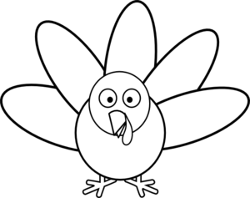
Pounds of turkeys produced
Pounds per person consumed
# of turkeys produced
% consumed during holidays
Top 5 producing states

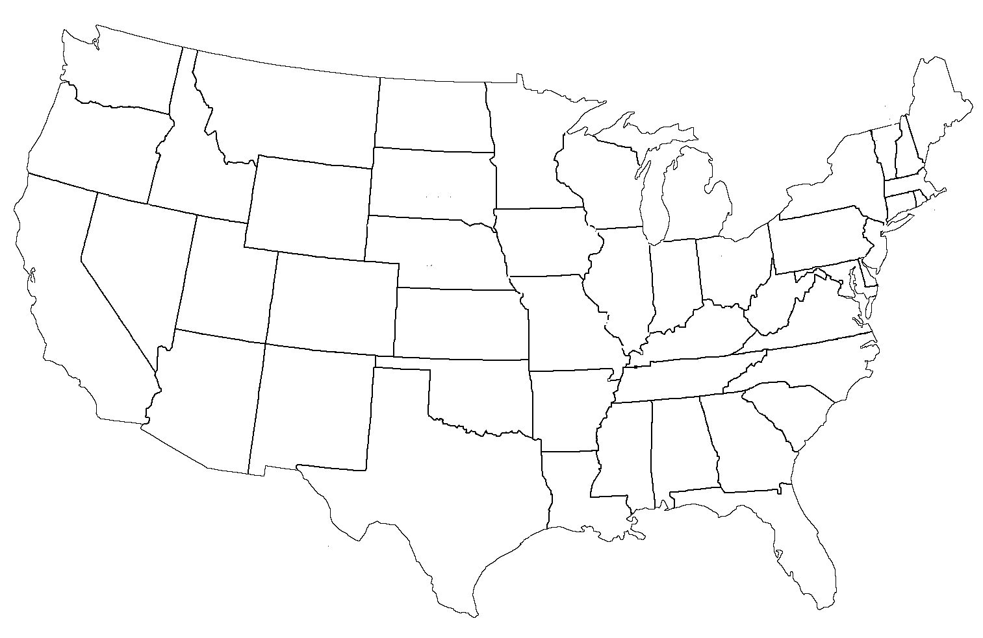

Turkey Traits
Aligned to the following standards:
AS.01; AS.02; AS.03; AS.05; AS.06; FFA.PL-A; FFA.PG-J; FFA.CS-M; FFA.CS-N; AG1; AG2; AG6; AG-ANI1; AG-ANI2; AG-ANI3; AG-ANI5; AG-ANI6; AGC10.03; AGPC01.01; AGPC01.02; AGPC01.03; AGPC01.05; CS.01; CS.02; CS.06; CCSS.ELA.W.9-10.2; CCSS.ELA.SL.9-10.1; CCSS.ELA.SL.9-10.2; CCSS.ELA.SL.9-10.4; CRP.02; CRP.04

Directions:
Draw a picture of a male and a female turkey and then label the traits each are selected for. Identify what we call each in the small boxes below male and female.
Male Turkey

Female Turkey

Traits:

1.

2.

3.

4.

5.

Traits:

1.

2.

3.

4.

Why is artificial insemination used in turkey production?

Incubation Hatching
Aligned to the following standards:
AS.01; AS.02; AS.03; AS.05; AS.06; FFA.PL-A; FFA.PG-J; FFA.CS-M; FFA.CS-N; AG1; AG2; AG6; AG-ANI1; AG-ANI2; AG-ANI3; AG-ANI5; AG-ANI6; AGC10.03; AGPC01.01; AGPC01.02; AGPC01.03; AGPC01.05; CS.01; CS.02; CS.06; CCSS.ELA.W.9-10.2; CCSS.ELA.SL.9-10.1; CCSS.ELA.SL.9-10.2; CCSS.ELA.SL.9-10.4; CRP.02; CRP.04

Directions:
Use your notes and knowledge to complete the worksheet.

Incubation

      - Which key to incubation is the most critical? Why?

      - What will happen if the position of the eggs is incorrect?

      - What does the hatcher have that the incubator does not? Why?

Breeders vs. Market Birds
Aligned to the following standards:
AS.01; AS.02; AS.03; AS.05; AS.06; FFA.PL-A; FFA.PG-J; FFA.CS-M; FFA.CS-N; AG1; AG2; AG6; AG-ANI1; AG-ANI2; AG-ANI3; AG-ANI5; AG-ANI6; AGC10.03; AGPC01.01; AGPC01.02; AGPC01.03; AGPC01.05; CS.01; CS.02; CS.06; CCSS.ELA.W.9-10.2; CCSS.ELA.SL.9-10.1; CCSS.ELA.SL.9-10.2; CCSS.ELA.SL.9-10.4; CRP.02; CRP.04

Directions:
Compare and contrast breeders and market (commercial) birds using the chart below.
Breeders
Market Birds
How are they the same?
How are they different?

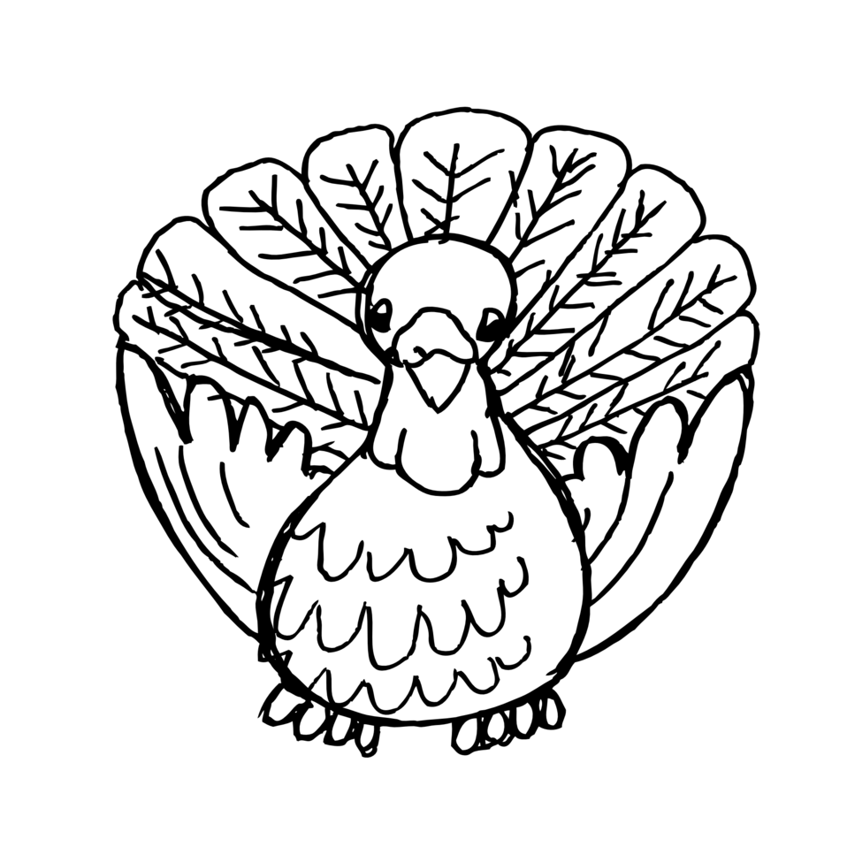

Hatching Eggs
Aligned to the following standards:
AS.01; AS.02; AS.03; AS.05; AS.06; FFA.PL-A; FFA.PG-J; FFA.CS-M; FFA.CS-N; AG1; AG2; AG6; AG-ANI1; AG-ANI2; AG-ANI3; AG-ANI5; AG-ANI6; AGC10.03; AGPC01.01; AGPC01.02; AGPC01.03; AGPC01.05; CS.01; CS.02; CS.06; CCSS.ELA.W.9-10.2; CCSS.ELA.SL.9-10.1; CCSS.ELA.SL.9-10.2; CCSS.ELA.SL.9-10.4; CRP.02; CRP.04

Preparing to Hatch Eggs

Step 1: Order fertilized eggs from a hatchery or from poultry farmers. The eggs should be medium sized and free from holes or cracks. If you are breeding chickens, the best way for the eggs to hatch is to allow the hens to sit on them. This is called setting.

Step 2: Choose an incubator. A forced-air incubator is large, great for large numbers of eggs and has a fan. A still-air incubator is smaller, hatches a fewer number of eggs and does not have a fan. Most experts prefer a forced-air incubator. Speak to a veterinarian or a poultry farmer to find out which incubator is best for your needs.

Step 3: Test the incubator before putting eggs into it for about twenty-four hours to make sure the temperature and humidity stays consistent within the incubator. The incubator should be placed indoors, and the room should have proper ventilation.

The Eggs and the Incubator

Step 1: Place the eggs into an incubator. The temperature will naturally go down in the incubator for the first few hours. Do not adjust the temperature for the first 48 hours after setting the eggs. The incubation period is about 21 days for chickens and 28 days for turkeys.

Step 2: Keep the temperature steady at about 100 degrees Fahrenheit in a forced-air incubator. In a still-air incubator, the temperature should be kept at about 102 degrees Fahrenheit.

Step 3: Set the humidity at 58 to 60 percent and then increase it to 65 percent when the eggs start hatching.

Step 4: Turn the eggs about half a turn four to six times a day. However, do not turn the eggs within three days of hatching. Never set eggs with the small ends pointing upward. All the eggs should hatch within about twenty-four hours.

Step 5: Do not help any of the chicks out of the shells once the eggs start hatching. Chicks need to work their own way out of the egg for proper maturity.

Step 6: Clean the incubator after the eggs have hatched and before reusing the incubator.

KEY: Give It Your Best Guess!
Aligned to the following standards:
AS.01; AS.02; AS.03; AS.05; AS.06; FFA.PL-A; FFA.PG-J; FFA.CS-M; FFA.CS-N; AG1; AG2; AG6; AG-ANI1; AG-ANI2; AG-ANI3; AG-ANI5; AG-ANI6; AGC10.03; AGPC01.01; AGPC01.02; AGPC01.03; AGPC01.05; CS.01; CS.02; CS.06; CCSS.ELA.W.9-10.2; CCSS.ELA.SL.9-10.1; CCSS.ELA.SL.9-10.2; CCSS.ELA.SL.9-10.4; CRP.02; CRP.04
Directions:
Provide your best guess for the turkey facts within each feather. On the map below, label the top 5 turkey-producing states with the numbers 1 to 5.
Pounds of turkeys produced
Pounds per person consumed
# of turkeys produced
% consumed during holidays
Top 5 producing states
243 million
16.4
28.5
7.5 billion
Minnesota
North Carolina
Arkansas
Indiana
Missouri

1

5
4
2
3

KEY: Turkey Traits
Aligned to the following standards:
AS.01; AS.02; AS.03; AS.05; AS.06; FFA.PL-A; FFA.PG-J; FFA.CS-M; FFA.CS-N; AG1; AG2; AG6; AG-ANI1; AG-ANI2; AG-ANI3; AG-ANI5; AG-ANI6; AGC10.03; AGPC01.01; AGPC01.02; AGPC01.03; AGPC01.05; CS.01; CS.02; CS.06; CCSS.ELA.W.9-10.2; CCSS.ELA.SL.9-10.1; CCSS.ELA.SL.9-10.2; CCSS.ELA.SL.9-10.4; CRP.02; CRP.04

Directions:
Draw a picture of a male and a female turkey and then label the traits each are selected for. Identify what we call each in the small boxes below.
Male Turkey

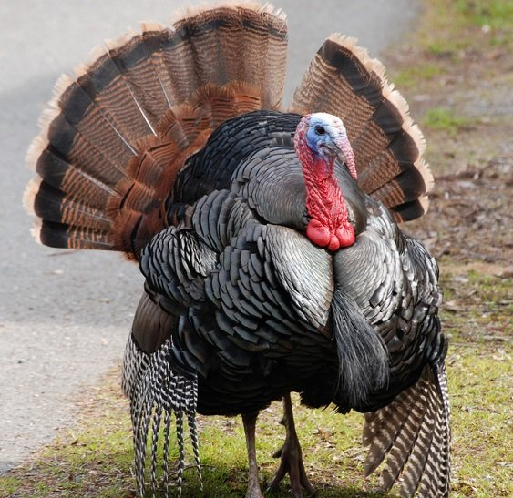

Traits:
- Thicker thighs
- Plumber breast
- Meatier drumstick
- Faster rate of growth
- Improved feed efficiency
Female Turkey

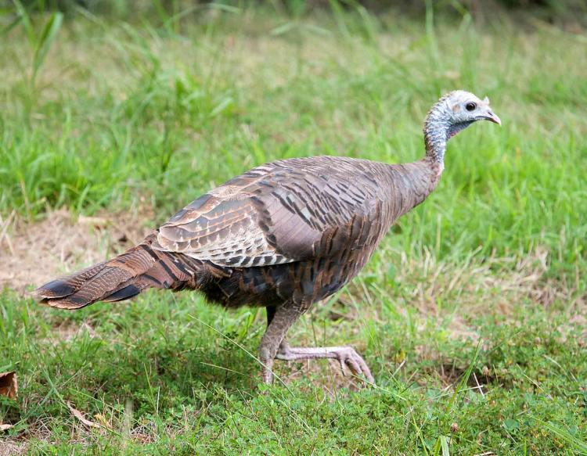

Traits:
- Fertility
- Hatchability
- Egg size
- Meat conformation

HEN
TOM

Why is artificial insemination used in turkey production?

Due to the large breasts and mature size of males or toms, they cannot breed naturally.

KEY: Incubation Hatching
Aligned to the following standards:
AS.01; AS.02; AS.03; AS.05; AS.06; FFA.PL-A; FFA.PG-J; FFA.CS-M; FFA.CS-N; AG1; AG2; AG6; AG-ANI1; AG-ANI2; AG-ANI3; AG-ANI5; AG-ANI6; AGC10.03; AGPC01.01; AGPC01.02; AGPC01.03; AGPC01.05; CS.01; CS.02; CS.06; CCSS.ELA.W.9-10.2; CCSS.ELA.SL.9-10.1; CCSS.ELA.SL.9-10.2; CCSS.ELA.SL.9-10.4; CRP.02; CRP.04

Directions:
Use your notes and knowledge to complete the worksheet.

Incubation

Hatching

- Which key to incubation is the most critical? Why?
Temperature. Inadequate temperature will lead to deformed poults (immature turkeys)
and embryonic death.

- What will happen if the position of the eggs is incorrect?
Poult will not be able to break the shell and hatch out.

- What does the hatcher have that the incubator does not? Why?
Increased humidity because it helps in the hatching process.

KEY: Breeders vs. Market Birds
Aligned to the following standards:
AS.01; AS.02; AS.03; AS.05; AS.06; FFA.PL-A; FFA.PG-J; FFA.CS-M; FFA.CS-N; AG1; AG2; AG6; AG-ANI1; AG-ANI2; AG-ANI3; AG-ANI5; AG-ANI6; AGC10.03; AGPC01.01; AGPC01.02; AGPC01.03; AGPC01.05; CS.01; CS.02; CS.06; CCSS.ELA.W.9-10.2; CCSS.ELA.SL.9-10.1; CCSS.ELA.SL.9-10.2; CCSS.ELA.SL.9-10.4; CRP.02; CRP.04

Directions:
Compare and contrast breeders and market (commercial) birds using the chart below.
Breeders
Market Birds
How are they the same?
How are they different?
Free feed for faster weight gain
Kept in enclosed buildings
Feed is limited to specific amounts each day
Kept in open buildings
Raised and maintained for a specific purpose

