Eggs and Egg Processing
Created: 07/2019 by the National FFA Organization

The National FFA Organization and U.S. Poultry and Egg Association lesson plan series provides educators with a comprehensive curriculum resource to teach students about the commercial poultry and egg industry. Additionally, lessons are infused with FFA and SAE activities to easily integrate into any agricultural education program.
Student Learning Objectives:
After completing these activities, students will …
- Explain egg processing.
- Describe the different structures of an egg and how the color of the egg is determined.
- Evaluate egg grades and sizes.
- Explain the packaging and storage of eggs.
- Distinguish between the types of eggs sold at the grocery store.

Essential Questions:
- Why are there different processing systems?
- Why do eggs need to be processed?
- How do eggs need to be handled?
- Why do eggs need to be labeled?
Time Required: 90 minutes
Resources:
- The United Egg Producers (UEP), http://www.unitedegg.org/
- The United States Department of Agriculture (USDA) Egg Grading Manual, https://www.ams.usda.gov/grades-standards/egg-grading-manual
- The Pacific Egg and Poultry Association (P.E.P.A.), http://www.pacificegg.org
- “Eggs 101: Eggs Part 2,” https://youtu.be/0thHpVl1hn8?si=gJLKfKE2iWm8L1Qo
- National FFA Poultry Evaluation Career Development Handbook, https://ffa.box.com/s/n9tdh9j0huaipr7w69o2drb8khmgaz9e
- “Egg Processing” PowerPoint (Reference or can be used for direct instruction), https://ffa.box.com/s/f8zkx7dvj9j5v51swyb0rd78kqcgo9pr

Equipment and Supplies Needed:
- A copy of the “Egg Processing Station Guide” worksheet for each student
- Approximately two dozen eggs of different weights and grades
- Two egg cartons, if possible
- A candler, if possible. If not, a cell-phone light or small flashlight will be sufficient
- A dark space to candle eggs
- A paper plate to crack eggs on; a dark color works best
- A laptop or computer to watch Station 1 video

Terms:
The following terms are presented in this lesson and appear in bold italics:
- Satellite Farms
- Conveyor System
- Blood Spots
- Loose Packaging
- Flat
- Carton
- Specialty Eggs
- Internal Temperature
- Processing Plant
These activities are aligned to the following standards:
AFNR Performance Element
- FPP.01. Develop and implement procedures to ensure safety, sanitation, and quality in food product and processing facilities.
- FPP.03. Select and process food products for storage, distribution and consumption.
- FPP.04. Explain the scope of the food industry and the historical and current developments of food products and processing.
FFA Precept
- FFA.PL-A.Action: Assume responsibility and take the necessary steps to achieve the desired results, no matter what the goal or task at hand.
- FFA.PG-J.Mental Growth: Embrace cognitive and intellectual development relative to reasoning, thinking and coping.
- FFA-CS-M.Communication: Effectively interact with others in personal and professional settings.
- FFA.CS-N.Decision Making: Analyze a situation and execute an appropriate course of action.
Common Career Technical Core
- AG-FD1 Develop and implement procedures to ensure safety, sanitation, and quality in food product and processing facilities.
- AG-FD3 Select and process food products for storage, distribution, and consumption.
- AG-FD4 Explain the scope of the food industry and the historical and current developments of food products and processing.
NASDCTEc
- AGPA01.01 Design and implement procedures and plans that demonstrate application of food processing principles to manage quality control in the food product and processing industry.
- AGAP01.03 Plan, implement, manage, and/or provide services associated with the preservation and packaging of food and food products to prepare products for distribution.
- AGPA01.04 Identify and apply food processing, handling, and storage factors to demonstrate their impact on product quality and safety.
AFNR Cluster Skills
- CS.01. Analyze how issues, trends, technologies and public policies impact systems in the Agriculture, Food & Natural Resources Career Cluster.
- CS.02. Evaluate the nature and scope of the Agriculture, Food, and Natural Resources Career Cluster and the role of agriculture, food, and natural resources (AFNR) in society and the economy.
- CS.03. Examine and summarize the importance of health, safety and environmental management systems in AFNR workplaces.
Common Core–Writing
- CCSS.ELA-Literacy.W.9-10.2 Write informative/explanatory texts to examine and convey complex ideas, concepts, and information clearly and accurately through the effective selection, organization, and analysis of content.
Common Core–Speaking and Listening
- CCSS.ELA-Literacy.SL.9-10.1 Initiate and participate effectively in a range of collaborative discussions (one-on-one, in groups, and teacher-led) with diverse partners on grades 9-10 topics, texts, and issues, building on others' ideas and expressing their own clearly and persuasively.
- CCSS.ELA-Literacy.SL.9-10.2 Integrate multiple sources of information presented in diverse media or formats (e.g., visually, quantitatively, orally) evaluating the credibility and accuracy of each source.
- CCSS.ELA-Literacy.SL.9-10.4 Present information, findings, and supporting evidence clearly, concisely, and logically such that listeners can follow the line of reasoning and the organization, development, substance, and style are appropriate to purpose, audience, and task.
AFNR Career Ready Practices
- CRP.02. Apply appropriate academic and technical skills. Career-ready individuals readily access and use the knowledge and skills acquired through experience and education to be more productive.
- CRP.04. Communicate clearly, effectively, and with reason. Career-ready individuals communicate thoughts, ideas and action plans with clarity, whether using written, verbal and/or visual methods.
Partnership for 21st Century Skills
- Communication
- Critical Thinking and Problem Solving

Lesson Plan:
- Bell Ringer: Describe and draw what a “perfect” egg looks like inside and out.

- Interest Approach: Ask students to raise their hand if they have ever smelled a rotten egg. For those that have, ask them to describe what the smell was like. Next, ask students to compare the smell of a rotten egg to that of a freshly cooked egg. What does it smell like? Is it appetizing? Transition by noting that today students will discover the characteristics of an ideal egg and learn about egg processing.

- Instruction:

In small groups, students will rotate around the room to eight stations to learn about egg processing.
These stations are as follows:
      - Processing and Refrigeration
      - Egg Structure and Color
      - Internal Grading
      - Using Candling as a Grading Technique
      - External Grading
      - Size Determination
      - Packaging and Labeling
      - Eggs at the Grocery Store

As students visit each station, they will have an instruction sheet to guide them through that station’s activity. As students complete the station’s activity, they will capture information on their “Egg Processing Station Guide.” Each rotation, including movement to the next station, should take approximately 10 minutes.
(Note: If the supplies are not available, there are alternate activities for Stations 3, 4, 5 and 6. See the “Alternative Activity” worksheets for those stations.) Helpful Hint- Laminate all the Station Guides in case of accidents

Student Learning Objective One: Students will be able to explain egg processing.

I. In-Line Processing (Figure 1)  - Egg processing occurs at the same location as the egg production facility.  - This processing method is the most efficient method available of collecting and processing eggs. Eggs are automatically delivered from the egg production facility to the egg processing facility.  - Egg handling and processing is performed with automated equipment.  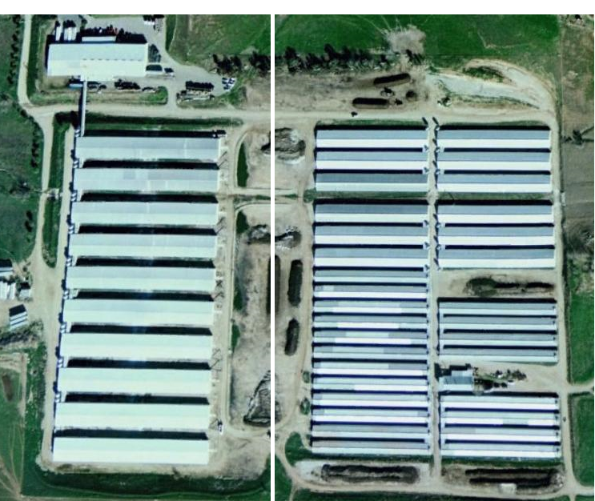  Egg Processing  Egg Production  Conveyor  Figure 1. In-line egg processing. Figure 2. Off-line egg processing.  II. Off-Line Processing (Figure 2)  - Egg processing occurs separately from the egg production facility.  - This processing method utilizes satellite farms. Satellite farms are egg production facilities that are located at a different location from the egg processing facility.  - Eggs produced at satellite farms must be gathered daily (Figure 3) and delivered to the egg processing facility.  - Egg handling and gathering is performed with automated equipment.  Figure 3. Egg gathering.  III. Care of eggs on the farm  - Regardless of on-line or off-line processing, steps are taken to maintain egg quality on the farm.  - These include, but are not limited to, egg collection occurring several times daily, careful egg handling procedures, egg cooling, egg cleaning and use of clean packaging materials. | Station 1 Instructions:  Watch the video “Eggs 101: Eggs Part 2” found at  https://youtu.be/0thHpVl1hn8?si=gJLKfKE2iWm8L1Qo .  While watching, create a flow chart (see Station 1 section of the “Egg Processing Station Guide” worksheet for an example) for the egg processing process beginning with washing the egg and ending with refrigerated storage at the point of sale. You should use arrows to point from one step to the next.  Pay special attention to names of any equipment used or temperatures at which the eggs are stored.  Feel free to stop and start the video if you need to spend extra time capturing key information.  Once you have completed your flow chart, compare with your group members to make sure each flow chart is as complete as possible.

Student Learning Objective 2: Students will be able to describe the different structures of an egg and how the color of the egg is determined.

- Chickens have ear lobes.  - The color of the ear lobe determines what color egg the hen will lay.  - White ear lobe — white egg  - Red ear lobe — brown egg  - Yellow/brownish-color ear lobe — blue/green egg  II. Eggs have a variety of different structures.  - Yolk  - This is the yellow part in the center of the egg.  - The actual color of the egg yolk varies based on what the hen was fed.  - Hens fed a diet high in corn or alfalfa tend to have a dark yellow to orange-colored yolk because those feeds are high in a fat-soluble pigment called xanthophyll.  - Hens who are fed a diet of mostly wheat, which is low in xanthophyll, would have a very light yellow or even slightly grayish yolk.  - Separated from the white by the vitelline membrane  - The yolk provides “food” that is essential for the developing chick embryo.  - Germ  - The small white circle found on the yolk.  - In a fertile egg, this is where the embryo starts to develop.  - In non-fertile eggs, this spot stays small and white.  - Albumen  - Also known as the “egg white.” Page 7  - There are two types of albumen:  - Thick white  - Located closest to the yolk  - The less liquid, denser portion of the white  - The thick albumen is denser in fresher eggs than in older eggs.  - Thin white  - The more liquid, “runny” portion of the egg white.  - Shell  - The hard, normally white (may also be brown or greenish blue) coating that provides the egg’s solid structure and shape and protects the developing embryo.  - The shell of an egg contains thousands of tiny pores.  - Shell Membranes  - Membranes located just inside the shell  - Act as a barrier between the shell and the albumen  - Air Cell  - The small open space at the large end of an egg  - Formed by the separation of the two shell membranes  - Provides the chick with an air supply during the final stage of development just before hatching  - Older non-fertile eggs will have a larger air cell due to moisture loss.  - Chalaza  - The small, white rope-like structures at both ends of the yolk.  - These structures help keep the yolk centered within the egg.  If the yolk were to come into contact with the shell during embryo development, the process would be aborted and the embryo would cease development. | Station 2 Instructions:  Review the information on the “Station 2: Egg Structures and Color” sheet, and then, on the Station 2 section of the “Egg Processing Station Guide,” correctly identify the structures of the egg.

Student Learning Objective Three: Students will be able to evaluate egg grades and sizes.

- Cleaning the Eggs  A. All eggs in the United States are washed in temperature-controlled water with a mild detergent and pH adjustments in order to remove any contaminants (manure, grease, blood, yolk, etc.) before they are sold for human consumption.  B. Eggs are dried to remove excess moisture prior to packaging.  C. Removal of contaminants prevents egg spoilage by bacteria.  D. Eggs that are not clean or that contain defects are removed from the processing line and are not packaged for shell-egg sale. These eggs are sent to further processing, including pasteurization.  II. Grading  - Grading refers to the process of grouping eggs according to similar characteristics, such as quality and weight.  - Quality assurance is performed by company employees.  - The USDA has a stringent set of requirements for the grading of fresh shell eggs.  - Egg grading is dependent upon examination of internal quality factors (e.g., condition of the egg white and yolk, air cell size). Examples are shown in Figure 4.  Figure 4  - Internal quality factors are determined by candling (Figure 5).  - Candling involves holding the egg to a concentrated light source for visual inspection of internal defects, such as blood spots, double yolks and air cell size.  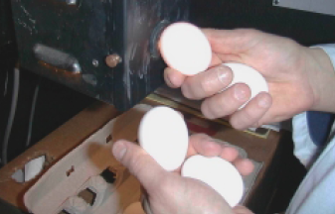  Figure 5  - Egg grading is also dependent upon external quality factors (e.g., shape, texture, cleanliness and soundness of the shell). A USDA egg grading diagram showing differences in external quality factors is shown in Figure 6.  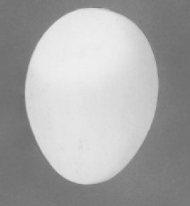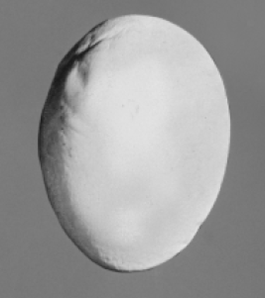  Figure 6A. Ideal egg shape. Figure 6B. Abnormal egg shape.  - External quality can be determined by candling for illumination and detection of egg shell cracks.  - An AA grade egg contains the most desirable characteristics while an egg with a B grade contains the least desirable characteristics. USDA specifications for egg shell, air cell, egg white and egg yolk characteristics are shown in Figure 7.  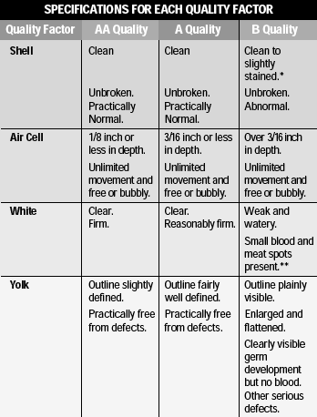  Figure 7  III. Size Determination  - Sizes are determined by weight. There are six different weight categories: peewee, small, medium, large, extra large, and jumbo. Each size category receives a different price on the farm as well as at the retail level.  Minimum Average Weight for one dozen eggs  Peewee: 15 ounces  Small: 18 ounces  Medium: 21 ounces  Large: 24 ounces  Extra Large: 27 ounces  Jumbo: 30 ounces  IV. Packaging  - Eggs are packaged into all sorts of containers designed for safe shipment of and product appearance for the consumer.  - Loose packaging is a simple way of moving large quantities of eggs in an efficient but also plain fashion. Loose packaging usually refers to either a thirty egg large or extra large flat, or a twenty egg jumbo flat. Loose sales mostly consist of sales to restaurants or other food service consumers.  - In retail settings, eggs are often packaged in cartons containing either one dozen or eighteen eggs. This packaging method is designed to be handled by the final consumer and is therefore usually designed to be quite appealing. There are several different varieties of eggs available to the consumer, which are called specialty or designer eggs by the industry. | Station 3 Instructions:  (Reference the “Station 3: Internal Grading” sheet.) Egg grading is partially based on the quality of the internal characteristics of the egg, like the yolk.  As a group, select an egg to internally grade. Gently crack the egg on the paper plate or clean surface provided.  Use the guide to grade the internal quality of the egg. Pay close attention to the grading scale as some differences are subtle. Once you have graded the egg, provide reasons as to why that egg received the grade given.  (For an alternative activity, if you do not have eggs, see the Station 3 alternative activity worksheet.)  Station 4 instructions:  (Reference the “Station 4: Using Candling as a Grading Technique” sheet.) Internal grading may also take place through candling, or shining a concentrated light through the egg in a dark room, to observe the size of the air cell and note any blood spots, double yolks or abnormalities in air cell size.  Take the provided eggs and hold them in front of the candler as shown in the image below. If no candler is available, the light of a cell phone will be sufficient. Remember, the room must be dark to see the internal qualities of the egg.  Once you are able to observe the egg, look closely for the air cell. Using the diagrams below, grade the egg and write your grade on your “Egg Processing Station Guide.” Additionally, give your reason for selecting that grade. Note any additional abnormalities like blood spots, if necessary.  (For an alternative activity, if you do not have eggs, see the “Station 4: Using Candling as a Grading Technique Alternative Activity.”)  Station 5 Instructions:  (Reference the “Station 5: External Grading” sheet.)  Egg grading is also dependent on external factors like cleanliness of the shell, stains and cracks. Using the images below as a guide, determine the grade of the eggs provided. The egg on the left would be graded AA, as the shell is clean, smooth and stain free. The egg on the left would be graded B, as the shell is uneven, blemished, and has raised calcium bumps.  Once each grade is determined, give reasons for why the grade was given.  (For an alternative activity, if you do not have eggs, reference the Station 5 alternative activity worksheet.)  Station 6 Instructions:  (Reference the “Station 6: Size Determination” sheet.) Egg sizes are determined by weight. There are six different weight categories: peewee, small, medium, large, extra large and jumbo. Each size category receives a different price on the farm and at the retail level.  To calculate the size of each egg, first select the egg to weigh. Place the egg on the scale and measure the weight in ounces. Record the weight on your guide.  Once you have recorded the individual weight, multiple the weight by 12. Match the product with the correct minimum average weight listed below. Hint: One dozen eggs weighing 23.5 ounces would be sized medium, not large.  Minimum average weight for one dozen eggs:  Peewee: 15 ounces  Small: 18 ounces  Medium: 21 ounces  Large: 24 ounces  Extra Large:27 ounces  Jumbo: 30 ounces  Complete this process for each egg provided.  (For an alternative activity, if you do not have eggs, reference the Station 6 alternative activity worksheet.)

Student Learning Objective Four: Students will be able to explain the packaging and storage of eggs.

I. Refrigeration  A. Eggs must be cooled to an internal temperature of 45˚F.  B. All graded eggs being transported must be hauled in a refrigerated trailer so that the core temperature is held above freezing but below 45˚F.  II. Mechanical Handling  - Eggs are moved using conveyor systems between the production facility and the processing plant. Egg flow is normally managed with computerized flow control systems.  B. The processing machinery is fully mechanized and most of the equipment on commercial farms wash, dry, sort by weight and quality and package the eggs into specified packaging.  C. Once eggs are consolidated to pallets, fork lifts are used to handle the product.  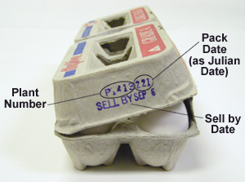  Figure 8  I. Sell-by Date  - Every individual package of eggs processed must contain a sell-by date that is set from the date of processing.  II. Julian Date  - This is the three-digit day number relative to the day in the year the eggs were processed. This date is calculated with January 1 as 001 and December 31 as 365.  III. Grade  - Both the size of the eggs and the level of quality are printed on the carton.  - The quality is signified by an A or AA grade on almost all fresh shell eggs.  IV. Plant Code  - A code is printed on every carton produced in a processing plant. Each plant has its own individual code so that if there is a need to find the origin of the finished product, it can be traced all the way back to the processing plant.  V. Nutritional Facts  - Nutritional information is printed on every package for retail sale. This information varies slightly depending on the egg size and also the type of egg (designer eggs).  VI. “Keep Refrigerated”  - All egg packages are labeled with a cautionary “keep refrigerated” label. The reason for this warning pertains to the effort to reduce growth of salmonella, if present.  VII. U.E.P. “Animal Care Certified”  - Nationwide, more than 80 percent of egg farmers have voluntarily joined the United Egg Producers (UEP), which sets a score of regulations to ensure the overall welfare of chickens being used for egg production. When a farm becomes “Animal Care Certified,” this label can be used to inform the consumer that the product they are purchasing was produced in accordance with accepted animal welfare standards. | Station 7 instructions:  (Reference the “Station 7: Packaging and Labeling” sheet.) Each carton of eggs is packaged with a purpose and contains important labeling information. Read the definitions and identify each element on the labeled image.

Student Learning Objective Five: Students will be able to distinguish between the types of eggs sold at the grocery store.

I. Regular white egg  a. Most commonly found and generally cheapest eggs on market  II. Specialty Eggs  a. Brown Eggs  1. Can sometimes be slightly more expensive  2. No difference between white and brown eggs other than shell color  b. Omega-3 eggs  1. Eggs contain additional Omega-3 fatty acids.  2. Provides perception of increased health benefits  c. Reduced cholesterol eggs  1. Viewed as a heart healthier alternative to regular eggs  d. Free-range eggs  1. Hens are required to be given some access to the outdoors.  e. Cage-free eggs  1. Hens are not allowed to be housed in wire cages.  2. Typically hens are housed in a large floor house with nest boxes.  f. Organic Eggs  1. Hens must be fed a completely organic diet from hatching.  2. Other restrictions on use of pesticides, antibiotics, etc. may also exist.  g. Fertile eggs  1. A specialty type of egg that was laid by a hen who was given the opportunity to mate.  2. Supermarkets and consumers must be extremely careful to properly handle and store these eggs or the embryo may begin to develop, resulting in what looks like a black comma on the yolk surface.  h. Nutritionally enhanced such as Eggland’s Best | Station 8 Instructions:  (Reference the “Station 8: Types of Eggs Sold at the Grocery Store” sheet.) On the Station 8 section of the “Egg Processing Station Guide” sheet, students will correctly match the type of egg with the definition.

- Follow-up: Return to the bell ringer. Using the knowledge students now have, they need to answer this question: “What does an ideal egg look like, inside and out?” Once each student has a response, discuss as a class to create a summative answer to the question on the white board.

- FFA/SAE Connection: Incorporate/reference some of the activities from the poultry evaluation career development event in your lesson, such as the interior and exterior grading of eggs, found on pages 14 and 15 in the National FFA Poultry Evaluation Career Development Event handbook, available at https://FFA.box.com/s/n9tdh9j0huaipr7w69o2drb8khmgaz9e.

- Exit Ticket: On the exit ticket capture sheet, students should identify three differences between their first answer and final answer to the question “What does an ideal egg look like, inside and out?”

Station 1: Processing and Refrigeration
Aligned to the following standards:
FPP.01.; FPP.03.; FPP.04.; FFA.PL-A.; FFA.PG-J.; FFA.CS-M.;FFA.CS-N.; AG-FD1; AG-FD3; AG-FD4; AGPA01.01; AGPA01.03; AGPA01.04; CS.01; CS.02; CS.03; CCSS.ELA.W.9-10.2; CCSS.ELA.SL.9-10.1; CSS.ELA.SL.9-10.2; CCSS.ELA.SL.9-10.4; CRP.02; CRP.04
Directions:

Watch the video “Eggs 101: Eggs Part 2” found at https://youtu.be/0thHpVl1hn8?si=gJLKfKE2iWm8L1Qo .

While watching, create a flow chart for the egg processing process beginning with washing the egg and ending with refrigerated storage at the point of sale. You should use arrows to point from one step to the next.

**Pay special attention to names of any equipment used or temperatures at which the eggs are stored.

Feel free to stop and start the video if you need extra time to capture key information!

Once you have completed your flow chart, compare with your group members to make sure each flow chart is as complete as possible.

Flow Chart Example:



Station 2: Egg Structures and Color
Aligned to the following standards:
FPP.01.; FPP.03.; FPP.04.; FFA.PL-A.; FFA.PG-J.; FFA.CS-M.;FFA.CS-N.; AG-FD1; AG-FD3; AG-FD4; AGPA01.01; AGPA01.03; AGPA01.04; CS.01; CS.02; CS.03; CCSS.ELA.W.9-10.2; CCSS.ELA.SL.9-10.1; CSS.ELA.SL.9-10.2; CCSS.ELA.SL.9-10.4; CRP.02; CRP.04
directions:
Use the information below to complete the chart on your “Egg Processing Station Guide” notes sheet.

Yolk
- This is the yellow part in the center of the egg.
- The actual color of the egg yolk varies based on what the hen was fed.
- Hens fed a diet high in corn or alfalfa tend to have a dark yellow to orange-colored yolk because those feeds are high in a fat-soluble pigment called xanthophyll.
- Hens who are fed a diet of mostly wheat, which is low in xanthophyll, would have a very light yellow or even slightly grayish yolk.
- Separated from the white by the vitelline membrane
- The yolk provides “food” that is essential for the developing chick embryo.

Germ
- The small white circle found on the yolk.
- In a fertile egg, this is where the embryo starts to develop.
- In non-fertile eggs, this spot stays small and white.

Shell
- The hard, normally white (may also be brown or greenish blue) coating that provides the egg’s solid structure and shape and protects the developing embryo.
- The shell of an egg contains thousands of tiny pores.



Albumen
- Also known as the “egg white.” Page
- There are two types of albumen:
- Thick white
  - Located closest to the yolk
  - The less liquid, denser portion of the white
  - The thick albumen is denser in fresher eggs than in older eggs.
- Thin white
  - The more liquid “runny” portion of the egg white

Shell Membranes
- Membranes located just inside the shell
- Act as a barrier between the shell and the albumen

Chickens have ear lobes.

The color of the ear lobe determines what color egg the hen will lay.

- White ear lobe — white egg
- Red ear lobe — brown egg
- Yellowish/brownish ear lobe — blue/green egg

Air Cell
- The small open space at the large end of an egg
- Formed by the separation of the two shell membranes
- Provides the chick with an air supply during the final stage of development just before hatching
- Older non-fertile eggs will have a larger air cell due to moisture loss.

Chalaza
- The small, white rope-like structures at both ends of the yolk.
  - These structures help keep the yolk centered within the egg.

Station 3: Internal Grading
Aligned to the following standards:
FPP.01.; FPP.03.; FPP.04.; AS.01.; AS.02.; AS.03.; AS.05.; AS.06.;FFA.PL-A.; FFA.PG-J.; FFA.CS-M.;FFA.CS-N.;AG1; AG2; AG6; AG-ANI1; AG-ANI2; AG-ANI3; AG-ANI5; AG-ANI6; AGC10.03.;AGPC01.01; AGPA01.01; AGPA01.03; AGPA01.04;AGPC01.01;AGPC01.02, AGPC01.03, AGPC01.05, CS.01, CS.02, CS.03,CCSS.ELA.W.9-10.2, C CCSS.ELA.SL.9-10.2;CSS.ELA.SL.9-10.2; CCSS.ELA.SL.9-10.4; CRP.02; CRP.04;
Directions:

Egg grading is partially based on the quality of the internal characteristics of the egg, like the yolk.

As a group, select an egg to internally grade. Gently crack the egg on the paper plate or clean surface provided.

Use the guide below to grade the internal quality of the egg. Pay close attention to the grading scale as some differences are subtle. Once you have graded the egg, provide reasons why that egg received the grade given.

Station 4: Using Candling as a Grading Technique
Directions:

Internal grading may also take place through candling, or shining a concentrated light through the egg in a dark room, to observe the size of the air cell and note any blood spots or abnormalities.

Take the provided eggs and hold them in front of the candler as shown in the image below. If no candler is available, the light of a cell phone will be sufficient. Remember, the room must be dark to see the internal qualities of the egg.

Once you are able to observe the egg, look closely for the air cell. Using the diagrams below, grade the egg and write your grade on your “Egg Processing Station Guide.” Additionally, give your reason for selecting that grade. Note any additional abnormalities like blood spots, if necessary.

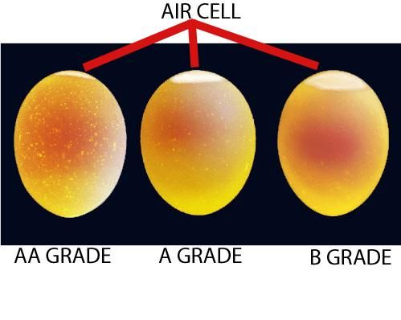
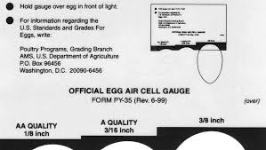

Aligned to the following standards:
FPP.01.; FPP.03.; FPP.04.; FFA.PL-A.; FFA.PG-J.; FFA.CS-M.;FFA.CS-N.; AG-FD1; AG-FD3; AG-FD4; AGPA01.01; AGPA01.03; AGPA01.04; CS.01; CS.02; CS.03; CCSS.ELA.W.9-10.2; CCSS.ELA.SL.9-10.1; CSS.ELA.SL.9-10.2; CCSS.ELA.SL.9-10.4; CRP.02; CRP.04

Station 5: External Grading
Aligned to the following standards:
FPP.01.; FPP.03.; FPP.04.; FFA.PL-A.; FFA.PG-J.; FFA.CS-M.;FFA.CS-N.; AG-FD1; AG-FD3; AG-FD4; AGPA01.01; AGPA01.03; AGPA01.04; CS.01; CS.02; CS.03; CCSS.ELA.W.9-10.2; CCSS.ELA.SL.9-10.1; CSS.ELA.SL.9-10.2; CCSS.ELA.SL.9-10.4; CRP.02; CRP.04
Directions:

Egg grading is also dependent on external factors like cleanliness of the shell, stains cage scratches, deformations and cracks. Using the images below as a guide, determine the grade of the eggs provided. The egg on the left would be graded AA, as the shell is clean, smooth and stain free. The egg on the left would be graded B, as the shell is uneven, blemished and has raised calcium bumps.

Once each grade is determined, write your grade on your “Egg Processing Station Guide” and give reasons for why the grade was given.

Station 6: Size Determination
Aligned to the following standards:
FPP.01.; FPP.03.; FPP.04.; FFA.PL-A.; FFA.PG-J.; FFA.CS-M.;FFA.CS-N.; AG-FD1; AG-FD3; AG-FD4; AGPA01.01; AGPA01.03; AGPA01.04; CS.01; CS.02; CS.03; CCSS.ELA.W.9-10.2; CCSS.ELA.SL.9-10.1; CSS.ELA.SL.9-10.2; CCSS.ELA.SL.9-10.4; CRP.02; CRP.04
Directions:

Egg sizes are determined by weight. There are six different weight categories: peewee, small, medium, large, extra large and jumbo. Each size category receives a different price on the farm and at the retail level.

To calculate the size of each egg, first select an egg to weigh. Place the egg on the scale and measure the weight in ounces. Record the weight on your “Egg Processing Station Guide.”

Once you have recorded the individual weight, multiple the weight by 12. Match the product with the correct minimum average weight listed below. Hint: One dozen eggs weighing 23.5 ounces would be sized medium, not large.

Minimum average weight for one dozen eggs:
Peewee: 15 ounces
Small: 18 ounces
Medium: 21 ounces
Large: 24 ounces
Extra Large:27 ounces
Jumbo: 30 ounces

Complete this process for each egg provided.

Station 7: Packaging and Labeling
Directions:

Each carton of eggs is packaged with a purpose and contains important labeling information. Read the definitions below and identify each element on the labeled image.
Plant Number:

A code is printed on every carton produced in a processing plant. Each plant has its own individual code so that if there is a need to find the origin of the finished product, it can be traced all the way back to the processing plant. This is done for food safety.

Julian Date:

This is the three-digit day number relative to the day in the year the eggs were processed. This date is calculated with January 1 as 001 and December 31 as 365.

Grade: Both the size of the eggs and the level of quality are printed on the top of the carton. The quality is signified by an A or AA grade on almost all fresh shell eggs.

Sell-by Date:

Every individual package of eggs processed must contain a sell-by date that is set from the date of processing.

Locate the plant number, Julian date and sell-by date for the following cartons. Capture the correct information on your “Egg Processing Station Guide.” (Note: Your teacher may opt to use real cartons instead of the images here. Be sure to check that you are identifying the labeling on the correct cartons.)

Aligned to the following standards:
FPP.01.; FPP.03.; FPP.04.; FFA.PL-A.; FFA.PG-J.; FFA.CS-M.;FFA.CS-N.; AG-FD1; AG-FD3; AG-FD4; AGPA01.01; AGPA01.03; AGPA01.04; CS.01; CS.02; CS.03; CCSS.ELA.W.9-10.2; CCSS.ELA.SL.9-10.1; CSS.ELA.SL.9-10.2; CCSS.ELA.SL.9-10.4; CRP.02; CRP.04
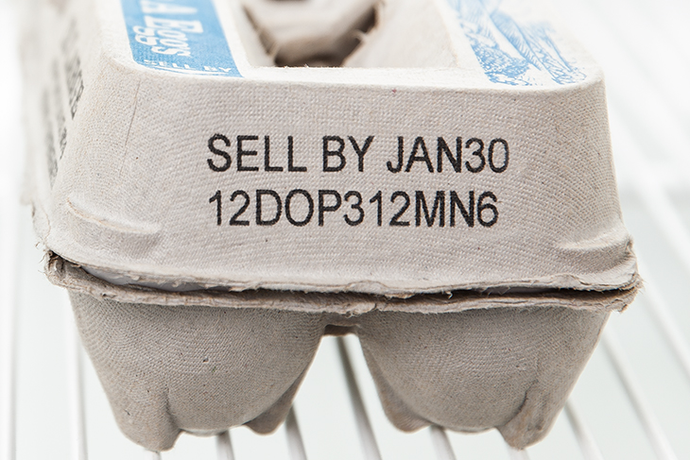

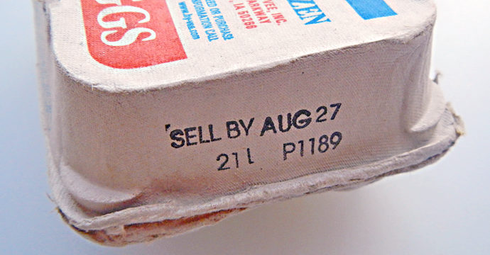

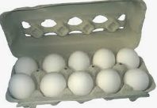
Station 8: Eggs at the Grocery Store
directions:
Use the information below to complete your “Egg Processing Station Guide” notes sheet.

Regular white egg
- Most commonly found and generally cheapest eggs on market

Specialty Eggs

Brown Eggs
- Can sometimes be slightly more expensive
- No difference between white and brown eggs other than shell color

Cage-free eggs
- Hens are not allowed to be housed in wire cages.
- Typically, hens are housed in a large floor house with nest boxes.

Organic Eggs
- Hens must be fed a completely organic diet from hatching.
- Other restrictions on use of pesticides, antibiotics, etc. may also exist

Omega-3 eggs
- Eggs contain additional Omega-3 fatty acids.
- Provides perception of increased health benefits

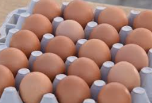
Aligned to the following standards:
FPP.01.; FPP.03.; FPP.04.; FFA.PL-A.; FFA.PG-J.; FFA.CS-M.;FFA.CS-N.; AG-FD1; AG-FD3; AG-FD4; AGPA01.01; AGPA01.03; AGPA01.04; CS.01; CS.02; CS.03; CCSS.ELA.W.9-10.2; CCSS.ELA.SL.9-10.1; CSS.ELA.SL.9-10.2; CCSS.ELA.SL.9-10.4; CRP.02; CRP.04
Nutritionally enhanced such as Eggland’s Best.

Fertile eggs
- A specialty type of egg that was laid by a hen who was given the opportunity to mate.
- Supermarkets and consumers must be extremely careful to properly handle and store these eggs or the embryo may begin to develop, resulting in what looks like a black comma on the yolk surface.

Free-range eggs
- Hens are required to be given some access to the outdoors.

Reduced cholesterol eggs
- Viewed as a heart healthier alternative to regular eggs

Egg Processing Station Guide
Aligned to the following standards:
FPP.01.; FPP.03.; FPP.04.; FFA.PL-A.; FFA.PG-J.; FFA.CS-M.;FFA.CS-N.; AG-FD1; AG-FD3; AG-FD4; AGPA01.01; AGPA01.03; AGPA01.04; CS.01; CS.02; CS.03; CCSS.ELA.W.9-10.2; CCSS.ELA.SL.9-10.1; CSS.ELA.SL.9-10.2; CCSS.ELA.SL.9-10.4; CRP.02; CRP.04
Directions:
Use the following guide to capture all responses to questions from each station.

Station 1: Processing and Refrigeration
Example Style-Flow Chart


Capture your flow chart in the space below.

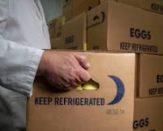

Station 2: Egg Structures and Color


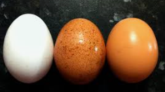
A) ___________________________

B) ___________________________

C) ___________________________

D) ___________________________

E) ___________________________

What is the germ?
How is the color of an egg determined?
Aligned to the following standards:
FPP.01.; FPP.03.; FPP.04.; FFA.PL-A.; FFA.PG-J.; FFA.CS-M.;FFA.CS-N.; AG-FD1; AG-FD3; AG-FD4; AGPA01.01; AGPA01.03; AGPA01.04; CS.01; CS.02; CS.03; CCSS.ELA.W.9-10.2; CCSS.ELA.SL.9-10.1; CSS.ELA.SL.9-10.2; CCSS.ELA.SL.9-10.4; CRP.02; CRP.04
Station 3: Internal Grading

Egg Grade:

Reasons for grade selected:
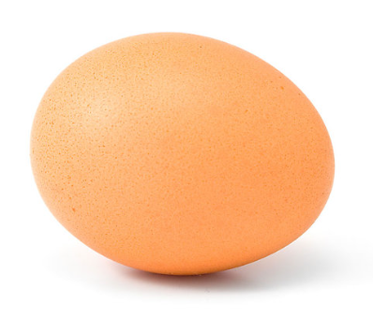

5
1

6
2

7
3

8
4

9

Station 4: Using Candling as a Grading Technique  Egg 1:  Grade:  2 Reasons for grade selected:  1 Abnormality: | Egg 2:  Grade:  2 Reasons for grade selected:  1 Abnormality:
Station 5: External Grading  Egg 1:  Grade:  Reason for grade selected: | Egg 2:  Grade:  Reason for grade selected:  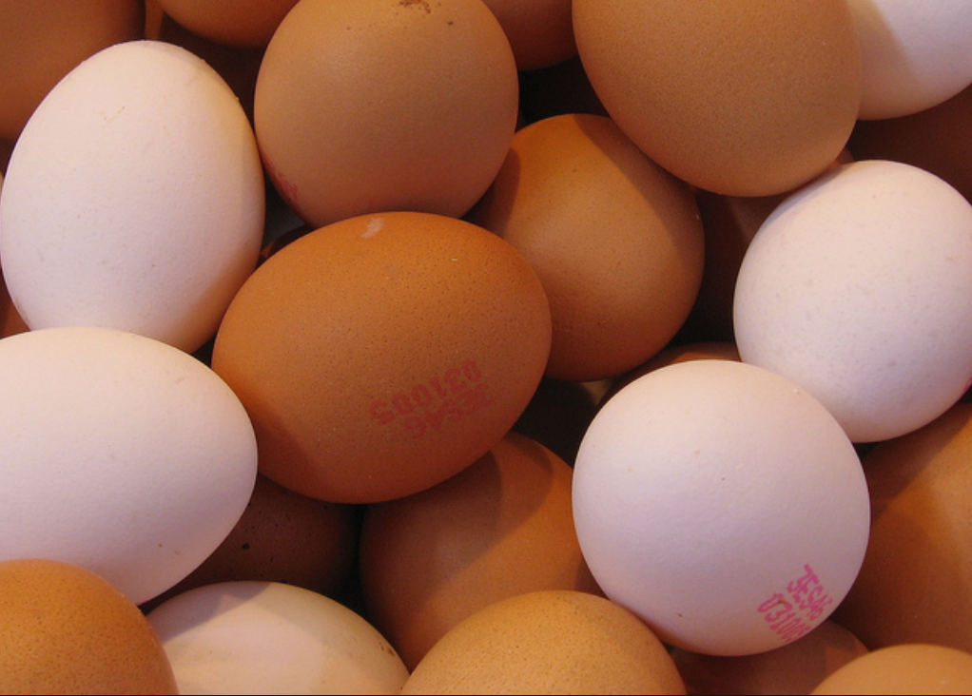
Station 6: Size Determination  Egg 1:  Weight of egg:  Product of weight x 12:  Size of egg: | Egg 2:  Weight of egg:  Product of weight x 12:  Size of egg:
Station 7: Packaging and Labeling  Carton 1:  Plant Number:  Julian Date:  Sell-by Date: | Carton 2:  Plant Number:  Julian Date:  Sell-by Date:
Aligned to the following standards:
FPP.01.; FPP.03.; FPP.04.; FFA.PL-A.; FFA.PG-J.; FFA.CS-M.;FFA.CS-N.; AG-FD1; AG-FD3; AG-FD4; AGPA01.01; AGPA01.03; AGPA01.04; CS.01; CS.02; CS.03; CCSS.ELA.W.9-10.2; CCSS.ELA.SL.9-10.1; CSS.ELA.SL.9-10.2; CCSS.ELA.SL.9-10.4; CRP.02; CRP.04
Station 8: Types of Eggs Sold at the Grocery Store
Aligned to the following standards:
FPP.01.; FPP.03.; FPP.04.; FFA.PL-A.; FFA.PG-J.; FFA.CS-M.;FFA.CS-N.; AG-FD1; AG-FD3; AG-FD4; AGPA01.01; AGPA01.03; AGPA01.04; CS.01; CS.02; CS.03; CCSS.ELA.W.9-10.2; CCSS.ELA.SL.9-10.1; CSS.ELA.SL.9-10.2; CCSS.ELA.SL.9-10.4; CRP.02; CRP.04

Match the type of egg by drawing an arrow to the correct description.

Omega-3 Eggs
Brown Eggs
Reduced Cholesterol Eggs
Free-Range Eggs
Cage-Free Eggs
Organic Eggs
Fertile Eggs
Hens must be fed a completely organic diet from hatching. Some restrictions on use of pesticides, antibiotics, etc. may also exist.
A specialty type of egg that was laid by a hen who was given the opportunity to mate.
Hens are not allowed to be housed in wire cages. Typically, hens are housed in a large floor house with nest boxes.
Hens are required to be given some access to the outdoors.
Viewed as a heart healthier alternative to regular eggs.
Eggs contain additional Omega-3 fatty acids. Provides perception of increased health benefits
Can sometimes be slightly more expensive; no difference from a white egg, other than color
Aligned to the following standards:
FPP.01.; FPP.03.; FPP.04.; FFA.PL-A.; FFA.PG-J.; FFA.CS-M.;FFA.CS-N.; AG-FD1; AG-FD3; AG-FD4; AGPA01.01; AGPA01.03; AGPA01.04; CS.01; CS.02; CS.03; CCSS.ELA.W.9-10.2; CCSS.ELA.SL.9-10.1; CSS.ELA.SL.9-10.2; CCSS.ELA.SL.9-10.4; CRP.02; CRP.04
Station 3: Internal Grading Alternative Activity
Directions:
Grade the egg in the pictures below. Write the grade in the corresponding box and explain the reason for the grade.
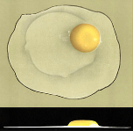
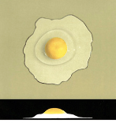

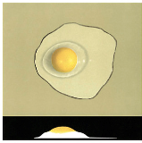
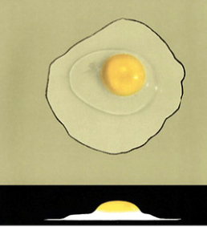

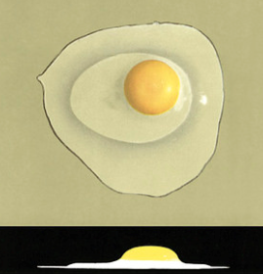

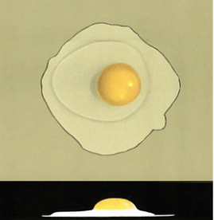

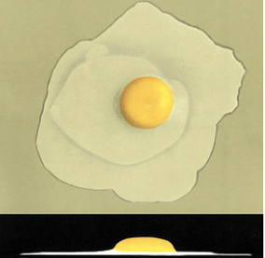

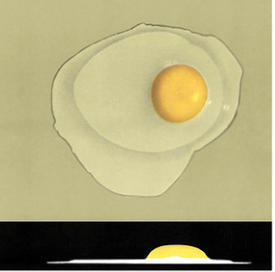

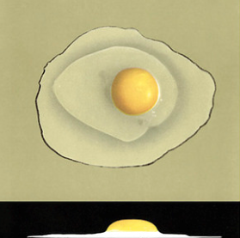

Station 4: Using Candling as a Grading Technique Alternative Activity
Aligned to the following standards:
FPP.01.; FPP.03.; FPP.04.; FFA.PL-A.; FFA.PG-J.; FFA.CS-M.;FFA.CS-N.; AG-FD1; AG-FD3; AG-FD4; AGPA01.01; AGPA01.03; AGPA01.04; CS.01; CS.02; CS.03; CCSS.ELA.W.9-10.2; CCSS.ELA.SL.9-10.1; CSS.ELA.SL.9-10.2; CCSS.ELA.SL.9-10.4; CRP.02; CRP.04
DIRECTIONS:
Reference the pictures below and draw an egg with that grade in the corresponding box. Then, explain why the egg received that grade.

AA Grade:
A Grade
B Grade

Why is it important to candle eggs?

Station 5: External Grading Alternative Activity
directions:
Based on the information learned about external grading, grade the external shell of the eggs below and list reasons for your grade.

1) 2)

What is your grade for 2)? ______

What is your grade for 1)? ______

Aligned to the following standards:
FPP.01.; FPP.03.; FPP.04.; FFA.PL-A.; FFA.PG-J.; FFA.CS-M.;FFA.CS-N.; AG-FD1; AG-FD3; AG-FD4; AGPA01.01; AGPA01.03; AGPA01.04; CS.01; CS.02; CS.03; CCSS.ELA.W.9-10.2; CCSS.ELA.SL.9-10.1; CSS.ELA.SL.9-10.2; CCSS.ELA.SL.9-10.4; CRP.02; CRP.04
Station 6: Size Determination Alternative Activity
directions:
Determine the category the eggs would fit in based on the weights provided. The weight given below is for one egg. To determine the weight (and category) of a dozen of those same eggs, multiply by 12 and record that weight and what category it would be. Note: One dozen eggs weighing 23.5 ounces would be sized medium, not large.

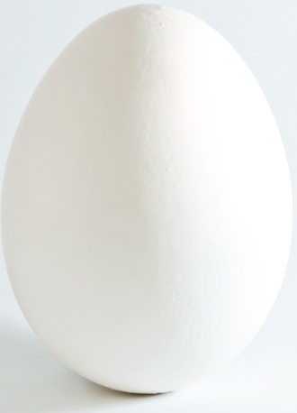
3 ounces
Total weight:
Category:
1 ounce
Total weight:
Category:
1.5 ounces
Total weight:
Category:
1.75 ounces
Total weight:
Category:
1.85 ounces
Total weight:
Category:
2.25 ounces
Total weight:
Category:

Why is it important for the consumer to understand the weights of eggs?

Aligned to the following standards:
FPP.01.; FPP.03.; FPP.04.; FFA.PL-A.; FFA.PG-J.; FFA.CS-M.;FFA.CS-N.; AG-FD1; AG-FD3; AG-FD4; AGPA01.01; AGPA01.03; AGPA01.04; CS.01; CS.02; CS.03; CCSS.ELA.W.9-10.2; CCSS.ELA.SL.9-10.1; CSS.ELA.SL.9-10.2; CCSS.ELA.SL.9-10.4; CRP.02; CRP.04
Aligned to the following standards:
FPP.01.; FPP.03.; FPP.04.; FFA.PL-A.; FFA.PG-J.; FFA.CS-M.;FFA.CS-N.; AG-FD1; AG-FD3; AG-FD4; AGPA01.01; AGPA01.03; AGPA01.04; CS.01; CS.02; CS.03; CCSS.ELA.W.9-10.2; CCSS.ELA.SL.9-10.1; CSS.ELA.SL.9-10.2; CCSS.ELA.SL.9-10.4; CRP.02; CRP.04
KEY — Station 3: Internal Grading Alternative Activity
Directions:
Grade the egg in the pictures below. Write the grade in the corresponding box and explain the reason for the grade.
High “AA”

Low “B”

Average “AA”

Low “AA”

High “A”

Average “A”

Average “B”

High “B”

Low “A”

KEY — Station 4: Using Candling as a Grading Technique Alternative Activity
Aligned to the following standards:
FPP.01.; FPP.03.; FPP.04.; FFA.PL-A.; FFA.PG-J.; FFA.CS-M.;FFA.CS-N.; AG-FD1; AG-FD3; AG-FD4; AGPA01.01; AGPA01.03; AGPA01.04; CS.01; CS.02; CS.03; CCSS.ELA.W.9-10.2; CCSS.ELA.SL.9-10.1; CSS.ELA.SL.9-10.2; CCSS.ELA.SL.9-10.4; CRP.02; CRP.04
DIRECTIONS:
Reference the pictures below and draw an egg with that grade in the corresponding box. Then, explain why the egg received that grade.

AA Grade:
Drawing can vary.
The air cell is less than an 1/8 inch.
A Grade
Drawing can vary.
The air cell is 3/16 inch.

B Grade
Drawing can vary.
The air cell is 3/8 inch.

Why is it important to candle eggs? Answers can vary, but could include: allows for visual inspection of internal defects, such as blood spots, double yolks and/or air cell size.

KEY — Station 5: External Grading Alternative Activity
Aligned to the following standards:
FPP.01.; FPP.03.; FPP.04.; FFA.PL-A.; FFA.PG-J.; FFA.CS-M.;FFA.CS-N.; AG-FD1; AG-FD3; AG-FD4; AGPA01.01; AGPA01.03; AGPA01.04; CS.01; CS.02; CS.03; CCSS.ELA.W.9-10.2; CCSS.ELA.SL.9-10.1; CSS.ELA.SL.9-10.2; CCSS.ELA.SL.9-10.4; CRP.02; CRP.04
directions:
Based on the information learned about external grading, grade the external shell of the eggs below and list reasons for your grade.

1) 2)

What is your grade for 2)?
B

Shell is abnormal in shape and appears to not be clean.

What is your grade for 1)?
AA

Clean, unbroken, practically normal

KEY — Station 6: Size Determination Alternative Activity
Aligned to the following standards:
FPP.01.; FPP.03.; FPP.04.; FFA.PL-A.; FFA.PG-J.; FFA.CS-M.;FFA.CS-N.; AG-FD1; AG-FD3; AG-FD4; AGPA01.01; AGPA01.03; AGPA01.04; CS.01; CS.02; CS.03; CCSS.ELA.W.9-10.2; CCSS.ELA.SL.9-10.1; CSS.ELA.SL.9-10.2; CCSS.ELA.SL.9-10.4; CRP.02; CRP.04
directions:
Determine the category the eggs would fit in based on the weights provided. The weight given below is for one egg. To determine the weight (and category) of a dozen of those same eggs, multiply by 12 and record that weight and what category it would be. Note: One dozen eggs weighing 23.5 ounces would be sized medium, not large.

3 ounces
Total weight: 36 ounces
Category: Jumbo
1 ounce
Total weight: 12 ounces
Category: Peewee
1.5 ounces
Total weight: 18 ounces
Category: Small
1.75 ounces
Total weight: 21 ounces
Category: Medium
1.85 ounces
Total weight: 22.2 ounces
Category: Medium
2.25 ounces
Total weight: 27 ounces
Category: Extra Large

Why is it important for the consumer to understand the weights of eggs?
Aligned to the following standards:
FPP.01.; FPP.03.; FPP.04.; FFA.PL-A.; FFA.PG-J.; FFA.CS-M.;FFA.CS-N.; AG-FD1; AG-FD3; AG-FD4; AGPA01.01; AGPA01.03; AGPA01.04; CS.01; CS.02; CS.03; CCSS.ELA.W.9-10.2; CCSS.ELA.SL.9-10.1; CSS.ELA.SL.9-10.2; CCSS.ELA.SL.9-10.4; CRP.02; CRP.04
KEY — Station 2: Egg Structures and Color
A) Shell membrane

B) Chalaza

C) Yolk

D) Albumen

E) Air cell

What is the germ?
The small white circle found on the yolk. In a fertile egg, this is where the embryo starts to develop. In non-fertile eggs, this spot stays small and white.
How is the color of an egg determined?
The color of the ear lobe determines what color egg the hen will lay.
White ear lobe – white egg
Red ear lobe – brown egg
Yellowish/brownish-color ear lobe – blue/green egg
Aligned to the following standards:
FPP.01.; FPP.03.; FPP.04.; FFA.PL-A.; FFA.PG-J.; FFA.CS-M.;FFA.CS-N.; AG-FD1; AG-FD3; AG-FD4; AGPA01.01; AGPA01.03; AGPA01.04; CS.01; CS.02; CS.03; CCSS.ELA.W.9-10.2; CCSS.ELA.SL.9-10.1; CSS.ELA.SL.9-10.2; CCSS.ELA.SL.9-10.4; CRP.02; CRP.04
KEY — Station 8: Types of Eggs Sold at the Grocery Store
Omega-3 Eggs
Brown Eggs
Reduced Cholesterol Eggs
Free-Range Eggs
Cage-Free Eggs
Organic Eggs
Fertile Eggs
Hens must be fed a completely organic diet from hatching. Some restrictions on use of pesticides, antibiotics, etc. may also exist.
A specialty type of egg that was laid by a hen who was given the opportunity to mate.
Hens are not allowed to be housed in wire cages. Typically, hens are housed in a large floor house with nest boxes.
Hens are required to be given some access to the outdoors.
Viewed as a heart healthier alternative to regular eggs.
Eggs contain additional Omega-3 fatty acids. Provides perception of increased health benefits

Can sometimes be slightly more expensive. No difference from a white egg, other than color

