Niche Poultry Markets
Created: 07/2019 by the National FFA Organization

The National FFA Organization and U.S. Poultry and Egg Association lesson plan series provides educators with a comprehensive curriculum resource to teach students about the commercial poultry and egg industry. Additionally, lessons are infused with FFA and SAE activities to easily integrate into any agricultural education program.
Student Learning Objectives:
After completing these activities, students will …
- List and explain the differences in market structure between the commercial poultry industry and niche markets.
- Understand the different production practices associated with different niche poultry markets.

Essential Questions:
- Why would niche markets not use the full vertical integration market structure like the commercial poultry industry?
Time Required: 90 minutes
Resources:
- Squab Producers of California, http://www.squab.com
- American Poultry Association, http://www.amerpoultryassn.com
- California Poultry Federation, http://www.cpif.org
- “Niche Poultry Markets” PowerPoint, https://ffa.box.com/s/jt1a4llj4l8izvb6kpwbjce78jzzhf3w
- “Hunter Low – SAE – Poultry and Game Birds” SAE video, https://vimeo.com/235946707

Equipment and Supplies Needed:
- A copy of the “Niche Market Research” worksheet for each student
- A copy of the “Niche Poultry Markets” worksheet for each student
- Internet access for student research

Terms:
The following terms are presented in this lesson and appear in bold italics:
- Cooperative
- Vertical Integration
- Further Processed
- Squab
- Monogamous
- Clutch
- Brown Leghorn Pullet
- Muscovy
- Pekin
- Drake
These activities are aligned to the following standards:
AFNR Performance Element
- ABS.01. Apply management planning principles in AFNR businesses.
- AS.01. Analyze historic and current trends impacting the animal systems industry.
- AS.02. Utilize best-practice protocols based upon animal behaviors for animal husbandry and welfare.
- AS.03. Design and provide proper animal nutrition to achieve desired outcomes for performance, development, reproduction and/or economic production.
- AS.05. Evaluate environmental factors affecting animal performance and implement procedures for enhancing performance and animal health.
- AS.06. Classify, evaluate, and select animals based on anatomical and physiological characteristics.
FFA Precept
- FFA.PL-A.Action: Assume responsibility and take the necessary steps to achieve the desired results, no matter what the goal or task at hand.
- FFA.PG-J.Mental Growth: Embrace cognitive and intellectual development relative to reasoning, thinking and coping.
- FFA.CS-M.Communication: Effectively interact with others in personal and professional settings.
- FFA.CS-N.Decision Making: Analyze a situation and execute an appropriate course of action.
Common Career Technical Core
- AG-BIZ1 Apply management planning principles in AFNR businesses.
- AG1 Analyze how issues, trends, technologies and public policies impact systems in the Agriculture, Food & Natural Resources Career Cluster.
- AG2 Evaluate the nature and scope of the Agriculture, Food & Natural Resources Career Cluster and the role of agriculture, food, and natural resources (AFNR) in society and the economy.
- AG6 Analyze the interaction among AFNR systems in the production, processing, and management of food, fiber, and fuel and the sustainable use of natural resources.
- AG-ANI1 Analyze historic and current trends impacting the animal systems industry.
- AG-ANI2 Utilize best-practice protocols based upon animal behaviors for animal husbandry and welfare.
- AG-ANI3 Design and provide proper animal nutrition to achieve desired outcomes for performance, development, reproduction and/or economic production.
- AG-ANI5 Evaluate environmental factors affecting animal performance and implement procedures for enhancing performance and animal health.
- AG-ANI6 Classify, evaluate, and select animals based on anatomical and physiological characteristics.
NASDCTEc
- AGPG01.01 Employ leadership skills to accomplish goals and objectives in an AFNR business environment.
- AGC10.03 Compare and contrast issues affecting the AFNR industry including biotechnology, employment, safety, environmental and animal welfare to demonstrate an understanding of the trends and issues important to careers in this industry.
- AGPC01.01 Produce and/or manage animals in domesticated and/or natural environments using an application of knowledge regarding anatomy and physiology to enhance animal production.
- AGPC01.02 Recognize and interpret animal behaviors and execute protocols for safe handling to facilitate safety for both animals and humans.
- AGPC01.03 Provide proper nutrition using accepted protocols and processes to maintain animal performance.
- AGPC01.05 Evaluate environmental factors affecting animal performance and implement procedures for enhancing performance to demonstrate an effective application of principles to optimize performance.
AFNR Cluster Skills
- CS.01. Analyze how issues, trends, technologies and public policies impact systems in the Agriculture, Food & Natural Resources Career Cluster.
- CS.02. Evaluate the nature and scope of the Agriculture, Food & Natural Resources Career Cluster and the role of agriculture, food and natural resources (AFNR) in society and the economy.
- CS.06. Analyze the interaction among AFNR systems in the production, processing and management of food, fiber and fuel and the sustainable use of natural resources.
Common Core–Writing
- CCSS.ELA-Literacy.W.9-10.2 Write informative/explanatory texts to examine and convey complex ideas, concepts, and information clearly and accurately through the effective selection, organization, and analysis of content.
Common Core–Speaking and Listening
- CCSS.ELA-Literacy.SL.9-10.1 Initiate and participate effectively in a range of collaborative discussions (one-on-one, in groups, and teacher-led) with diverse partners on grades 9-10 topics, texts, and issues, building on others' ideas and expressing their own clearly and persuasively.
- CCSS.ELA-Literacy.SL.9-10.2 Integrate multiple sources of information presented in diverse media or formats (e.g., visually, quantitatively, orally) evaluating the credibility and accuracy of each source.
- CCSS.ELA-Literacy.SL.9-10.4 Present information, findings, and supporting evidence clearly, concisely, and logically such that listeners can follow the line of reasoning and the organization, development, substance, and style are appropriate to purpose, audience, and task.
AFNR Career Ready Practices
- CRP.02. Apply appropriate academic and technical skills. Career-ready individuals readily access and use the knowledge and skills acquired through experience and education to be more productive.
- CRP.04. Communicate clearly, effectively, and with reason. Career-ready individuals communicate thoughts, ideas and action plans with clarity, whether using written, verbal and/or visual methods.
- CRP.07. Employ valid and reliable research strategies. Career-ready individuals are discerning in accepting and using new information to make decisions, change practices or inform strategies.
- CRP.08. Utilize critical thinking to make sense of problems and persevere in solving them. Career-ready individuals readily recognize problems in the workplace, understand the nature of the problem, and devise effective plans to solve the problem.
Partnership for 21st Century Skills
- Communication
- Critical Thinking and Problem Solving

Lesson Plan:
- Bell Ringer: “In your opinion, what is the definition of the word ‘Niche’?”
Answer: Denoting or relating to products, services or interests that appeal to a small, specialized section of the population.

- Interest Approach: Show students the pictures included in the PowerPoint of the following poultry species: quail, dove, duck, squab and goose. See if students can identify them and determine why they are important to the poultry industry. After receiving responses to what they are and why they are important, based on your classroom, you can ask the following questions: “What poultry/poultry products have we eaten other than chicken or turkey?” “If we haven’t eaten any other poultry species, what species have we heard of that we know are safe to eat?” “Who here has eaten a goose? Squab? Dove? Duck? Quail?”

- Instruction:

Student Learning Objective One: Students will be able to list and explain the differences in market structure between the commercial poultry industry and niche markets.

Student Learning Objective Two: Students will be able to understand the different production practices associated with different niche poultry markets.

Objective 1:  - Common Niche Markets  - Live Bird Markets  - Chickens, ducks, geese and other fowl are often sold at live bird markets.  - Some suppliers are partially integrated.  - It is normal for a supplier to own breeder farms, grow-out facilities, trucking and transportation. However, most of the suppliers will not own their own feed mill or hatchery. This is mainly because of the smaller size of the company.  - Relatively few suppliers and many markets  - Many consumers at live bird markets are of various Asian ethnicities.  - These consumers choose to inspect the bird live to make sure that it does not have any noticeable illnesses or defects.  - Traditional Asian consumers prefer to process their own birds at home for cultural reasons and to guarantee freshness.  - Younger generations may prefer their bird processed professionally.  - Duck Producers  - The market structure of the duck industry is similar to the commercial broiler and turkey industries, but the market for duck in the U.S. is much smaller.  - Some duck companies are fully integrated — owning all major aspects of production.  - Processors typically own their own farms or contract with duck growers and market under their own brand.  - Marketed to high-end restaurants and grocery stores  - Some duck processors offer further processed products.  - Cut-up products  - Cooked products  - Squab Producers  - A squab is a young pigeon.  - There is a high demand in the Asian (principally Chinese) community for squab, and it is also marketed to high-end restaurants and retail markets.  - Squab Producers of California is an agricultural cooperative.  - Members pool their resources and work together to process and market their squab.  - Squab Producers of California operates the largest squab processing plant outside of Asia.  - Growers own their farms and their birds. Collectively, the members own and control the cooperative.  - By joining together, the squab growers can have more control over the supply, demand and, consequently, the price of squab.  - Members also benefit from a more efficient processing plant. Instead of having many small processors, a single state-of-the-art processing plant is utilized by all members.  - Upland Game Bird Growers  - Upland game birds include pheasants, chukars and quail.  - These birds are raised for the specific purpose of hunting at hunt clubs.  - Some growers breed, hatch and growout their birds.  - Some larger growers might even have their own hunt clubs.  - Importance of Niche Markets  - Although the niche poultry markets are much smaller than the commercial poultry industry, they still are very valuable to the economy.  - Because of niche markets, consumers have a choice between different products.  - Many Asian American and Asian immigrants in the United States take advantage of the niche markets for traditional cultural reasons.  Objective 2:  - Production Differences  - Live Bird Market Suppliers  Live Bird markets often offer chickens, ducks, geese and other fowl. However, this section focuses mainly on chickens.  - Breed differences from commercial broilers  - Brown Leghorn Pullet  - The first brown chickens raised for meat in the U.S. in the early 1980s.  - Companies make regular deliveries but some also offer  on-farm pick up for birds to be brought to the market.  - Chicken flock lifespan  - Age of bird varies with time of year and breed  - Most common age bird sold is 16 to 20 weeks old  - The bird maturity plays a part in the time of the sale  - Diet differences  - Due to the manner in which the bird is prepared, the meat is often tougher than traditional broiler birds.  - Most birds are either boiled or barbequed.  - Feed formulas are exclusive to the individual supplier.  - They can consist of chick starter, grower and a developer.  - Processing  - Processing can be done by the consumer at home.  - Processing is also done at commercial processing plants that offer custom processing.  - Birds that are processed must be sold and consumed within seven days in order to maintain freshness.  - Birds are never frozen and then sold in the markets as fresh.  - Whether the birds are professionally or personally processed, the bird is left whole with the head and feet attached.  - This is called a Buddhist-style process.  - The consumer can also tell the age of the bird by the size of the comb.  - A “Hot Plant” is offered for consumers to pick out the live bird they want and have it processed in a state-inspected processing facility.  - All other processing is done at USDA-inspected facilities.  - The birds are packaged with custom labels or packed directly on ice for transport.  - Marketing  - Birds are sold in grocery stores, restaurants and live bird markets.  - Most live markets offer both live and processed product.  - The store is divided in two by a panel to separate the live birds from the processed cold storage.  - Duck Producers  - Descriptive terms  - Drake – male duck  - Hen – female duck  - Ducklings – adolescent ducks  - Major meat breeds  - Aylesbury: popular in England where the breed originated  - Appearance: white feathered, white skin, flesh-colored bills, light orange legs and feet.  - Adult drakes: up to nine pounds  - Adult hens: up to eight pounds  - Muscovy: unrelated to other meat breeds; Wild Muscovy originated in South America; however, the French domesticated the Muscovy duck for commercial production and brought it to the United States.  - Appearance: many varieties, white is most desirable for markets  - Drakes weigh up to 11 pounds and hens weigh up to six pounds  - Non-migratory bird  - Still considered a waterfowl; however, it is more comfortable on the ground than water. Enjoys scavenging in the mud and dirt.  - White Pekin: Major commercial breed in the United States. Originated in China and introduced in the U.S. in 1870s  - Appearance: white feathered, orange-yellow bills, reddish orange legs and feet.  - Can reach market weight of approximately 6.25 pounds in eight weeks  - Migratory bird  - The majority of duck producers are located in Indiana.  - Flock lifespan of meat birds  - Muscovy vs. Pekin  - Muscovy ducks take no longer than 10 (hens) to 12 (drakes) weeks to reach market weight.  - Pekin ducks can reach market weight in 5.5 to 6 weeks.  - Breeding and reproduction  - Male and female “lines”  - Male lines are bred for structural correctness, breeding productivity, efficient feed conversion ratios and desirable carcass characteristics.  - Female lines are bred to lay an optimal amount of eggs.  - Crossing these two lines produces a superior terminal product (hybrid vigor).  - Incubation period  - Muscovy: 35 days  - All other breeds: 28 days  - Grow-out  - Brood/Grow-out (very similar to chicken and turkey production)  - Heat source  - For the first week, ducklings need an extra heat source. The first week the temperature should be about 90 degrees Fahrenheit. Duck growers use brood stoves similar to the commercial poultry industry.  - Litter  - Mold resistant materials must be used for the floor cover, i.e., rice hulls, peat moss, straw or shavings  - Feeding  - All feed mixes are designed by an animal nutritionist with the health and welfare of the birds in mind.  - Starter – high percentage of protein (about 22 percent).  - Grower – about 18 percent protein.  - Finisher – about 16 percent protein.  - Squab Growers  - Uniqueness of Squab  - Pigeon breeders are monogamous and mate for life.  - Squabs are processed at about one month of age, before the bird can fly.  - Squab meat is dark, moist and flavorful.  - Reproduction and production  - Pigeon Pair: mated male and female pigeon. Since pigeons mate for life, they are referred to as a pair.  - Nest: each pair has their own nest. This is where the eggs are laid and the squabs are raised.  - Controlled mating: a pair of birds are manually placed in a nest together. Common practice for widowed pigeons.  - Natural mating is when the grower places the young birds in a pen and lets the pigeons choose their own mate. This is the most common industry practice.  - Clutch: a set of eggs (Usually two for pigeons) laid during the mating period.  - Pigeon breeders are often given an identification band on their leg to help the producer keep production records.  - Once the squab reaches about three weeks of age, the hen will lay another clutch of eggs. The female will be responsible for incubating the new eggs and the male will take charge of feeding the squab.  - Pigeon’s egg production peaks at about three years of age.  - A pair can produce about 22 squab per year at their production peak. However, they average about 14 squab per year over their average 5 year economically viable breeding lifespan.  - The grower collects the squab for processing at about 26 to 28 days of age.  - Processing and marketing  - In California, the vast majority of squab is processed by Squab Producers of California.  - Squab Producers of California was founded in 1943 in San Francisco. Today the headquarters and processing plant are in Modesto, Cali.  - The plant has recently upgraded the chilling system to a state-of-the-art air chilling system.  - The most common process to chill carcasses is through an ice-water bath; however, some consumers are willing to pay more for an air-chilled product because they prefer the way it tastes, its color and skin crispness.  - Most squab is sold to metropolitan areas such as San Francisco, Los Angeles and New York City. It is marketed to high-end restaurants, grocery stores and other Asian (principally Chinese) markets. | Activity 1:  Students will be divided into four groups to research information about their given type of niche market (live bird markets, ducks, squab and upland game birds). Students will utilize the internet to complete their research. Each group will complete the “Niche Market Research” worksheet and use the information to teach their classmates.  After groups have completed their research, they will rotate through the other groups and have conversations to teach and learn about the other markets. Students will record information on the “Niche Poultry Markets” worksheet. Once all groups have met, have a class discussion about the various types of niche markets.  Activity 2:  Students will take notes on the remainder of the Niche Markets PowerPoint using the “Notes Sheet.”

- Follow-up: Students will use their prior knowledge to compare and contrast niche poultry markets and mainstream commercial poultry markets. When the teacher says “COMPARE,” students must state a comparison or similarity between niche and commercial poultry. When the teacher says “CONTRAST,” students must state a contrast or difference between niche and commercial poultry markets. This should be in a rapid-fire fashion. When students are no longer able to compare and contrast, move forward. (Take at least three answers for compare and contrast.)

- FFA/SAE Connection: Show students the video”Hunter Low – SAE – Poultry and Game Birds,” available at https://vimeo.com/235946707. While students are watching the video, have them use the “Notes Sheet” to record their thoughts on the left side. Have them finish the rest of the sheet at the completion of the video.

- Exit Ticket: On the exit ticket capture sheet, have students answer the question “In your opinion, which niche market discussed today is the most interesting and why?”

Niche Market Research
Aligned to the following standards:
ABS.01; AS.01; AS.02; AS.03; AS.05; AS.06; FFA.PL-A; FFA.PG-J; FFA.CS-M; FFA.CS-N; AG-BIZ1; AG1; AG2; AG6; AG-ANI1; AG-ANI2; AG-ANI3; AG-ANI5; AG-ANI6; AGPG01.01; AGC10.03; AGPC01.01; AGPC01.02; AGPC01.03; AGPC01.05; CS.01; CS.02; CS.06; CCSS.ELA.W.9-10.2; CCSS.ELA.SL.9-10.1; CCSS.ELA.SL.9-10.2; CCSS.ELA.SL.9-10.4; CRP.02; CRP.04; CRP.07; CRP.08
Directions:
Utilize the space below to collect your research and identify the important information about your given market to share with the class.

Niche Market: ___________________________________________

Information Dump (any information you find) | Information to Share (what you will share with the other groups)
Niche Poultry Markets
Aligned to the following standards:
ABS.01; AS.01; AS.02; AS.03; AS.05; AS.06; FFA.PL-A; FFA.PG-J; FFA.CS-M; FFA.CS-N; AG-BIZ1; AG1; AG2; AG6; AG-ANI1; AG-ANI2; AG-ANI3; AG-ANI5; AG-ANI6; AGPG01.01; AGC10.03; AGPC01.01; AGPC01.02; AGPC01.03; AGPC01.05; CS.01; CS.02; CS.06; CCSS.ELA.W.9-10.2; CCSS.ELA.SL.9-10.1; CCSS.ELA.SL.9-10.2; CCSS.ELA.SL.9-10.4; CRP.02; CRP.04; CRP.07; CRP.08
Directions:
Utilize the space below to record information as you hear from the other groups.
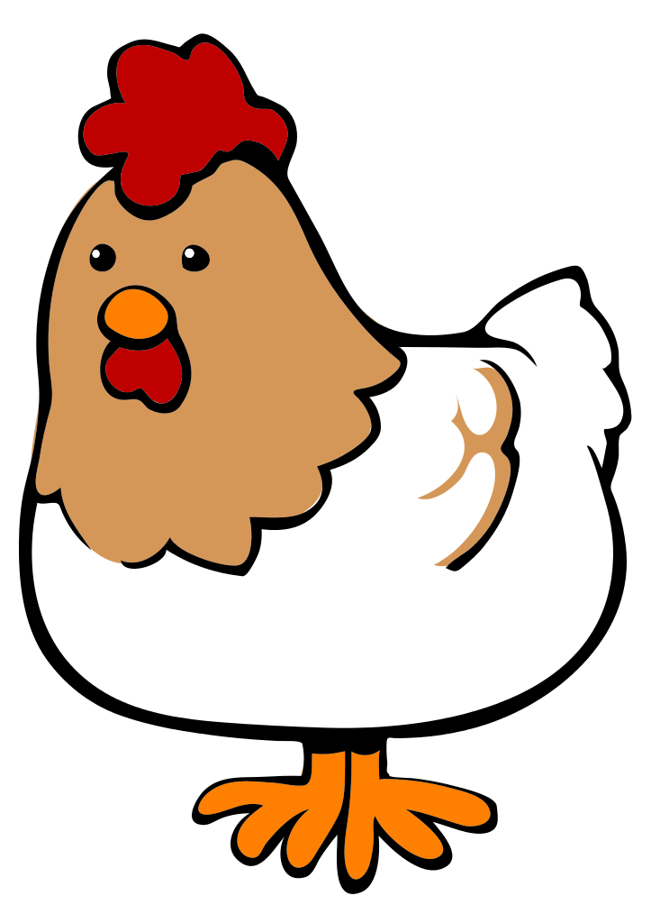
Niche Markets

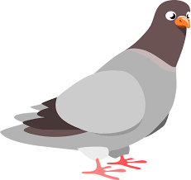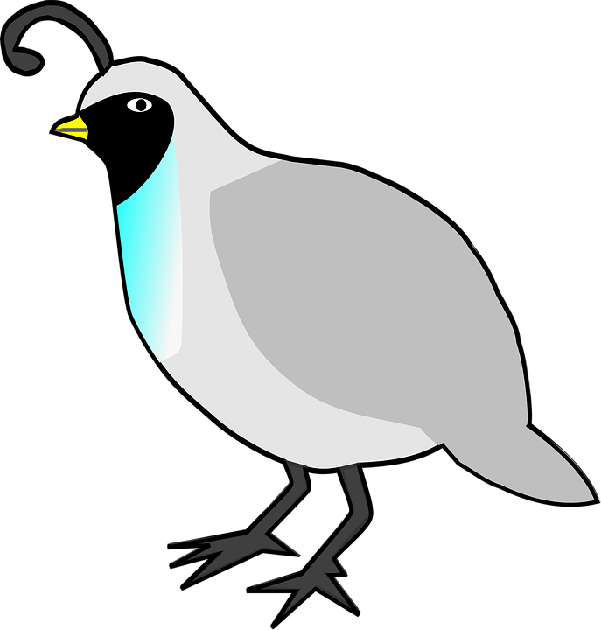

Notes Sheet
Aligned to the following standards:
ABS.01; AS.01; AS.02; AS.03; AS.05; AS.06; FFA.PL-A; FFA.PG-J; FFA.CS-M; FFA.CS-N; AG-BIZ1; AG1; AG2; AG6; AG-ANI1; AG-ANI2; AG-ANI3; AG-ANI5; AG-ANI6; AGPG01.01; AGC10.03; AGPC01.01; AGPC01.02; AGPC01.03; AGPC01.05; CS.01; CS.02; CS.06; CCSS.ELA.W.9-10.2; CCSS.ELA.SL.9-10.1; CCSS.ELA.SL.9-10.2; CCSS.ELA.SL.9-10.4; CRP.02; CRP.04; CRP.07; CRP.08
Lesson Title:

NOTES: | Draw a picture to summarize your learning.
Summarize the lesson in one statement or quote.

Give this lesson a new title.

