Careers with Animals: Production
Created: 08/2018 by the National FFA Organization

Student Learning Objectives:
After completing these activities, students will …
- Research the various species within animal production (beef, dairy, poultry, sheep, goats, swine, and equine).
- Determine the knowledge and skills needed in production-based careers with animals.

Time Required: 45 minutes
Resources:
- Video: “Turkey Farm and Processing Plant Tour: Temple Grandin“ video (stop at timestamp 4:29), https://www.youtube.com/watch?v=852zxDEAR-Q
- “Careers with Animals: Production” PowerPoint

Equipment and Supplies Needed:
- A copy of the “Animal Production: Knowledge and Skills” worksheet for each student
- A copy of the “What’s in a Word” worksheet for each student
- A copy of the “Animal Production by Species” worksheet for each student
- A copy of the “Careers with Animals: Production” worksheet for each student
- A copy of the “Careers with Animals: My Thoughts” worksheet for each student
- Internet access to play the video in real time or embed it in a PowerPoint ahead of time
- Computer access, ideal for students to work in pairs or small groups.

This quick lesson plan would work well as:
- An introduction to animal production.
- A complement to any agriculture careers unit.

These activities are aligned to the following standards:

AFNR Performance Element
- CS.01: Analyze how issues, trends, technologies and public policies impact systems in the Agriculture, Food & Natural Resources Career Cluster
- CS.05: Describe career opportunities and means to achieve those opportunities in each of the Agriculture, Food & Natural Resources career pathways.
FFA Precept
- FFA.PL-A.Action: Assume responsibility and take the necessary steps to achieve the desired results, no matter what the goal or task at hand.
- FFA.PL-C.Vision: Visualize the future and how to get there.
- FFA.PL-E.Awareness: Understand personal vision, mission and goals.
- FFA.PG-J.Mental Growth: Embrace cognitive and intellectual development relative to reasoning, thinking and coping.
- FFA.CS-M.Communication: Effectively interact with others in personal and professional settings.
- FFA.CS-N.Decision Making: Analyze a situation and execute an appropriate course of action.
Common Career Technical Core
- AG1: Analyze how issues, trends, technologies and public policies impact systems in the Agriculture, Food & Natural Resources Career Cluster.
- AG5: Describe career opportunities and means to achieve those opportunities in each of the Agriculture, Food & Natural Resources Career Pathways.
Common Core–Speaking and Listening
- CCSS.ELA-Literacy.SL.9-10.1: Initiate and participate effectively in a range of collaborative discussions (one-on-one, in groups, and teacher-led) with diverse partners on grades 9-10 topics, texts, and issues, building on others' ideas and expressing their own clearly and persuasively.
- CCSS.ELA-Literacy.SL.9-10.2: Integrate multiple sources of information presented in diverse media or formats (e.g., visually, quantitatively, orally) evaluating the credibility and accuracy of each source.
Common Core–Math Practices
- CCSS.MP3: Construct viable arguments and critique the reasoning of others.
- CCSS.MP6: Attend to precision.
AFNR Career Ready Practices
- CRP.02: Apply appropriate academic and technical skills. Career-ready individuals readily access and use the knowledge and skills acquired through experience and education to be more productive.
- CRP.04: Communicate clearly, effectively, and with reason. Career-ready individuals communicate thoughts, ideas and action plans with clarity, whether using written, verbal and/or visual methods.
- CRP.06: Demonstrate creativity and innovation. Career-ready individuals regularly think of ideas that solve problems in new and different ways, and they contribute those ideas in a useful and productive manner to improve their organization.
- CRP.07: Employ valid and reliable research strategies. Career-ready individuals are discerning in accepting and using new information to make decisions, change practices or inform strategies.
Partnership for 21st Century Skills
- Communication
- Initiative and Self-direction
- Leadership and Responsibility

Lesson Plan:
- Bell Ringer: Post this question on the board or screen: “What knowledge and skills are needed to raise and produce strawberries?” Allow students time to discuss in pairs or small groups and then share with the class. Likely answers will include the following: how plants/strawberries grow; how to take care of strawberries; strawberry pests and diseases; demand/market for strawberries; observation skills; strong work ethic; discipline; teamwork; etc.

- Introduction: Use the discussion about strawberry production to transition into discussion of the skills and knowledge needed to raise and produce animals. Students will identify and capture these necessary areas of information, knowledge and skills needed to raise and produce livestock by using the “Animal Production: Knowledge and Skill” worksheet. Ask or draw attention to the question on that worksheet: “What is one big difference between raising strawberries and animals?” Discuss.

- Activity 1: Hand out the “What’s in a Word” worksheet to students. Have students determine the word associated with each definition as a vocabulary review. After students determine the vocabulary word, they should write it in the blank and find the word in the word search.

- Activity 2: Hand out the “Animal Production by Species” worksheet to students. Students will pair up and select one species found on the chart. There should be only one group per species. Students will gain an understanding of their species by creating an informational brochure about the species they have selected. Students should be creative and use color, slogans and pictures/graphics to convey their message. Students should be trying to convince others to want to raise the species they are sharing. Make this a competition. Once all groups have finished their brochure, students should complete a gallery walk and complete their chart for all of the species. To have a gallery walk, hang all the posters around the room to display them, similar to an art gallery. Students will then walk by each poster and record the necessary information. Make it a competition!

- Activity 3: As a class, view the beginning of the “Turkey Farm and Processing Plant Tour: Temple Grandin“ video (stop at timestamp 4:29). The direct url is https://www.youtube.com/watch?v=852zxDEAR-Q. Have students add knowledge and skills to the worksheet “Animal Production: Knowledge and Skill” if they identify additional items that are necessary for animal production.

- Activity 4: As a class or in small groups, click through the “Careers with Animals: Production” PowerPoint, and have students capture the information in the corresponding worksheet, “Careers with Animals: Production.”

- Follow-up: After completing Activity 4, have students write three quiz questions based on the information they gathered from the PowerPoint. Have students pair up and quiz their partner using the questions they developed.

- Leveling Up:
  - Have students explore commodity group and producer support websites to identify resources and support material available to producers. Potential websites include but are not limited to www.pork.org, www.beef.org, www.uspoultry.org, www.sheepusa.org, www.americangoatfederation.org and www.dfamilk.com.
  - Invite a panel of three to five speakers with a diverse variety of producer jobs in the animal industry to speak to the class.

- Exit Ticket: Have students answer the questions on the “Careers with Animals: My Thoughts” worksheet.

What’s in a Word?
Aligned to the following standards:
CS.01; CS.05; FFA.PL-A; FFA.PL-C; FFA.PL-E; FFA.PG-J; FFA.CS-M; FFA.CS-N; AG1; AG5; CCSS.ELA.SL.9-10.1; CCSS.ELA.SL.9-10.2; MP3; MP6; CRP.02; CRP.04; CRP.06; CRP.07
Directions:
Determine the correct word for each definition. Write the answer next to the definition and find the word in the word search.

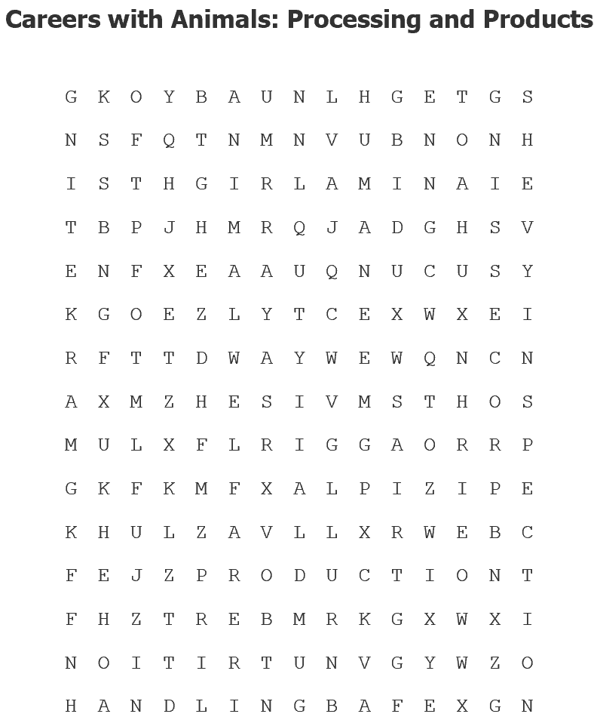
Careers with Animals: Production

- Security from the transmission and spread of microorganisms and disease. __________________________
- Ensuring an animal’s mental, physical and social well-being is being met. _________________________
- Treating animals in a compassionate manner in which no harm is caused. ___________________________
- The understanding and classification of materials in feedstuffs for animals as well as the impact on animal systems (Ex. digestive system, excretory system). _____________________________________
- The way in which animals are treated and managed. ___________________________________
- When the animal or product from an animal is prepared for human consumption (Ex. pasteurizing milk), this is called __________________________________.
- Viewing animal products to ensure quality and safety for human consumption is called ______________________________________.
- Rules and guidelines established by the government, which must be followed, are known as _________________ regulations.
- The process of gaining interest from buyers and sellers for a product is known as __________________.

Animal Production by Species
Aligned to the following standards:
CS.01; CS.05; FFA.PL-A; FFA.PL-C; FFA.PL-E; FFA.PG-J; FFA.CS-M; FFA.CS-N; AG1; AG5; CCSS.ELA.SL.9-10.1; CCSS.ELA.SL.9-10.2; MP3; MP6; CRP.02; CRP.04; CRP.06; CRP.07
Directions:
You and a partner will be assigned one of the species below. Your task is to research the production of the species assigned, complete your row of the chart below, and then create an educational brochure about the species you researched. Be sure to use color, slogans and pictures to convey your message. Once you have finished your brochure, you will complete a gallery walk to view the brochure for each of the other species listed below and record the information in the chart.

Species | Animal Selection Guidelines | Necessary Facilities for Production | Welfare | Sanitation | Meat Selection | Reproduction Strategies Utilized (Ex. artificial insemination, embryo transfer, etc.) | Challenges of the Industry | Daily Nutrition Required | Additional Information
Beef Cattle
Swine
Sheep
Goats
Horses
Poultry
Dairy Cattle
Small Animals

Animal Production: Knowledge and Skills
Aligned to the following standards:
CS.01; CS.05; FFA.PL-A; FFA.PL-C; FFA.PL-E; FFA.PG-J; FFA.CS-M; FFA.CS-N; AG1; AG5; CCSS.ELA.SL.9-10.1; CCSS.ELA.SL.9-10.2; MP3; MP6; CRP.02; CRP.04; CRP.07
Directions:
Record answers from the discussion about the knowledge and skills necessary to raise and produce livestock.

What is one big difference between raising strawberries and animals?

Directions:
While watching the “Turkey Farm and Processing Plant Tour: Temple Grandin” video, write any additional thoughts that come to mind about the necessary knowledge and skills needed for production animal careers.

Careers with Animals: Production
Aligned to the following standards:
CS.01; CS.05; FFA.PL-A; FFA.PL-C; FFA.PL-E; FFA.PG-J; FFA.CS-M; FFA.CS-N; AG1; AG5; CCSS.ELA.SL.9-10.1; CCSS.ELA.SL.9-10.2; MP3; MP6; CRP.02; CRP.04; CRP.07
Directions:
Click through the “Careers with Animals: Production” PowerPoint. Capture information in this worksheet about each species.

 | Production Notes: | Demand/Market Notes: | Hot Topics:
Beef
Dairy
Poultry
Sheep
Goats
Swine
Equine

List and explain the skills necessary for careers in animal production.

Careers with Animals: My Thoughts
Aligned to the following standards:
CS.01; CS.05; FFA.PL-A; FFA.PL-C; FFA.PL-E; FFA.PG-J; FFA.CS-M; FFA.CS-N; AG1; AG5; CCSS.ELA.SL.9-10.1; CCSS.ELA.SL.9-10.2; MP3; MP6; CRP.02; CRP.04; CRP.07
Directions:
Consider the questions and statements below and provide your responses.

Today, I was most surprised to learn ...

If you were to pursue a career as a producer, what kind of animal species would you raise and why?

What skill is the most important as a livestock producer and why?

I want to know more about ...

KEY — What’s in a Word?
Aligned to the following standards:
CS.01; CS.05; FFA.PL-A; FFA.PL-C; FFA.PL-E; FFA.PG-J; FFA.CS-M; FFA.CS-N; AG1; AG5; CCSS.ELA.SL.9-10.1; CCSS.ELA.SL.9-10.2; MP3; MP6; CRP.02; CRP.04; CRP.06; CRP.07
Directions:
Determine the correct word for each definition. Write the answer next to the definition and find the word in the word search.
Careers with Animals: Production

- Security from the transmission and spread of microorganisms and disease. Biosecurity
- Ensuring an animal’s mental, physical and social well-being is being met. Animal Welfare
- Treating animals in a compassionate manner in which no harm is caused. Humane
- The understanding and classification of materials in feedstuffs for animals as well as the impact on animal systems (Ex. digestive system, excretory system). Nutrition
- The way in which animals are treated and managed. Handling
- When the animal or product from an animal is prepared for human consumption (Ex. pasteurizing milk), this is called processing.
- Viewing animal products to ensure quality and safety for human consumption is called inspection.
- Rules and guidelines established by the government, which must be followed, are known as federal regulations.
- The process of gaining interest from buyers and sellers for a product is known as marketing.

Rubric — Animal Production by Species Brochure

Component | Brief Description | Points Received/  Points Possible
Brochure Content | This will be given to the class in order to convince them to raise your species. Remember you are competing with the other teams! Be CONVINCING!  Five points for each required piece of information found on the chart. | ______/40
Color | Color was utilized to grab the attention of the reader. | _______/10
Pictures/Graphics | Pictures and graphics were utilized throughout to grab and keep the attention of the reader. | _______/10
TOTAL |  | _______/60

KEY — Animal Production: Knowledge and Skills
Aligned to the following standards:
CS.01; CS.05; FFA.PL-A; FFA.PL-C; FFA.PL-E; FFA.PG-J; FFA.CS-M; FFA.CS-N; AG1; AG5; CCSS.ELA.SL.9-10.1; CCSS.ELA.SL.9-10.2; MP3; MP6; CRP.02; CRP.04; CRP.07
Directions:
Record answers from the discussion about the knowledge and skills necessary to raise and produce livestock.

Answers will vary.

What is one big difference between raising strawberries and animals?
Answers will vary but should include something about animals being alive and can be dangerous.

Directions:
While watching the “Turkey Farm and Processing Plant Tour: Temple Grandin” video, write any additional thoughts that come to mind about the necessary knowledge and skills needed for production animal careers.

Answers will vary.

KEY — Careers with Animals: Production
Aligned to the following standards:
CS.01; CS.05; FFA.PL-A; FFA.PL-C; FFA.PL-E; FFA.PG-J; FFA.CS-M; FFA.CS-N; AG1; AG5; CCSS.ELA.SL.9-10.1; CCSS.ELA.SL.9-10.2; MP3; MP6; CRP.02; CRP.04; CRP.07
Directions:
Click through the “Careers with Animals: Production” PowerPoint. Capture information in this worksheet about each species.

 | Production Notes: | Demand/Market Notes: | Hot Topics:
Beef | Cow/Calf or Feedlot operations  Raised in every state | Export to many countries including Japan, Mexico, South Korea, Canada, Hong Kong  Input costs (grain & feed), weather, tariffs and laws all impact markets & trade | Responsible antibiotic use  Traceability
Dairy | Raised in all 50 states  Some of the top producing states are CA, WI, ID, NY & PA  # of dairies down over past years but trending to dairies with more head and more milk produced per cow | U.S. dairy exports on the rise  Producer-Owned Cooperatives | Hormone usage  Government programs
Poultry | Poultry production includes broilers (meat), eggs, turkey, ducks | Health, disease and cost of inputs all impact market and trade | Poultry welfare  Antibiotics and hormones  Education & Labeling  Avian Influenza  Global Trade
Sheep | Produced for meat (lamb & mutton) and wool  Raised in all 50 states | U.S. imports lamb & mutton to meet consumer demands | Consumer preferences Competition from other meats and fiber sources  Predators
Goats | Produced for meat, milk and mohair | U.S. shifted from a net-exporter to a net-importer of goat meat  Demand for goat milk increasing to make products like goat cheese | Animal health and internal parasite control management  Predators  Goat meat marketing and education  Animal identification
Swine | 8 major breeds  16 to 17 weeks from farm to fork | U.S. pork production has nearly doubled in the last 50 years to meet demand | Animal welfare  Immigration  Product labeling  Federal funding  Responsible antibiotic use  Animal identification
Equine | Production for recreation and sports  Some of the top producing states are commonly TX, FL & CA | Genetics, disease and health impact markets and demand | Animal welfare  Wild horses  Horse health  Biosecurity

List and explain the skills necessary for careers in animal production.

Observation – watch, record and note animal health and well-being; environment, behavior and management
Problem-solving – ability to evaluate challenges and find solutions
Safety/handling – keeping yourself and animals safe throughout the production process; proper techniques and knowledge
Team player – establish, maintain and function with co-workers and/or family for production goals and outcomes

