Lesson 2: Matching Your Resume to the Job
Created: 05/2018 by the National FFA Organization
Student Learning Objectives:
After completing these activities, students will …
- Identify the parts of a job description.
- Determine how to tailor their resumes to the job description.
- Review their own resumes to determine where enhancements can occur.

Time Required: 50 minutes
Resources:
- FFA.org
- Article: “How to Decode a Job Advertisement,” https://www.thebalance.com/how-to-decode-a-job-advertisement-2061002
- A copy of the job description from ADM or AgCareers.com
- A copy of the job description from Valent or AgCareers.com
- A copy of the job description from AGCO or AgCareers.com
- Each student will need a completed resume from the FFA Resume Generator, https://resumegenerator.ffa.org/.

Equipment and Supplies Needed:
- A copy of each student’s completed resume.
- A copy of the “Job Description Breakdown” worksheet for each student.
- Various highlighters, pens, markers
- Sticky notes

These activities are aligned to the following standards:
FFA Precept
- PG-I. Professional Growth: Ability to assume responsibility for attaining and improving upon the skills needed for career success.
AFNR Cluster Skills
- CS.05. Describe career opportunities and means to achieve those opportunities in each of the Agriculture, Food & Natural Resources career pathways.
Common Core - Writing
- CCSS.ELA-LITERACY.W.9-10.4 Produce clear and coherent writing in which the development, organization, and style are appropriate to task, purpose, and audience.
- CCSS.ELA-LITERACY.W.9-10.5 Develop and strengthen writing as needed by planning, revising, editing, rewriting, or trying a new approach, focusing on addressing what is most significant for a specific purpose and audience.
Common Core - Speaking and Listening
- CCSS.ELA-LITERACY.SL.9-10.1 Initiate and participate effectively in a range of collaborative discussions (one-on-one, in groups, and teacher-led) with diverse partners on grades 9-10 topics, texts, and issues, building on others' ideas and expressing their own clearly and persuasively.
- CCSS.ELA-LITERACY.SL.9-10.6 Adapt speech to a variety of contexts and tasks, demonstrating command of formal English when indicated or appropriate.
Common Core - Language
- CCSS.ELA-LITERACY.L.9-10.6 Acquire and use accurately general academic and domain-specific words and phrases, sufficient for reading, writing, speaking, and listening at the college and career readiness level; demonstrate independence in gathering vocabulary knowledge when considering a word or phrase important to comprehension or expression.
Common Core - Math Practices
- CCSS.MP6: Attend to precision.
AFNR Career Ready Practices
- CRP.04. Communicate clearly, effectively, and with reason. Career-ready individuals communicate thoughts, ideas and action plans with clarity, whether using written, verbal and/or visual methods.
- CRP.10. Plan education and career path aligned to personal goals. Career-ready individuals take personal ownership of their own educational and career goals, and they regularly act on a plan to attain these goals.
Partnership for 21st Century Skills
- Communication
- Critical Thinking and Problem Solving
- Initiative and Self-direction
- Productivity and Accountability

Lesson Plan:
- Bell Ringer: Have students complete the “Slogan/Logo Match” worksheet.

- Introduction: Use something like this to introduce the topic: Job applicants tailor their resumes to fit the job for which they are applying. They utilize the job description to help them accomplish this task. Some descriptions are very clear and others are not. Today, we will break down job descriptions to help enhance our resumes.

- Activity: Each student needs a copy of the worksheet “Job Description Breakdown.”
    - Give students a copy of the article “How to Decode a Job Advertisement” or direct them to the article. The direct URL is https://www.thebalance.com/how-to-decode-a-job-advertisement-2061002. Have students use the article to complete Part 1 of the worksheet.

    - Give students copies of the job descriptions from ADM, AGCO and Valent or have students find their own job postings through AgCareers.com.

    - Students will utilize what they learned from the article to identify the parts of a job description.

    - Have students highlight, underline or circle the keywords/skills addressed in each job description.

    - Have students use what they learned about job descriptions to enhance their keywords/skills within their own resumes. When they have finished, have students answer the following questions:
      - How did you utilize the information learned in this lesson to strengthen your personal resume?
      - Why is it important to adjust your resume based on a job description?

- Follow-up: On a sticky note, have students share three new things they learned today that will “help them tailor their resumes to the job description.” Discuss their thoughts and then have them post their notes on the doorway as they leave.

- Leveling Up: Pair older students with younger FFA members as they work on resumes. The older students should help the younger students personalize their resumes for each job for which they apply.

- Exit Ticket: What are the essential things to consider when matching your resume to a job?

Job Description Breakdown
Aligned to the following standards:
FFA.PG-I; CS.05; CCSS.W.9-10.4; CCSS.W.9-10.5; CCSS.SL.9-10.1; CCSS.SL.9-10.6; CCSS.L.9-10.6; CCSS.MP6; CRP.04; CRP.10

Directions:
Read the article “How to Decode a Job Advertisement.” This article is available at https://www.thebalance.com/how-to-decode-a-job-advertisement-2061002. Identify the parts of a job description and what is included in each part. Record your answers below.

Part of Job Description What Is Included

ADM Job Description
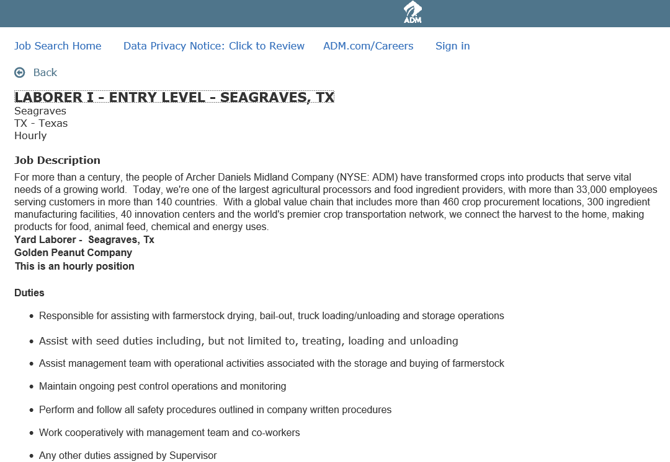
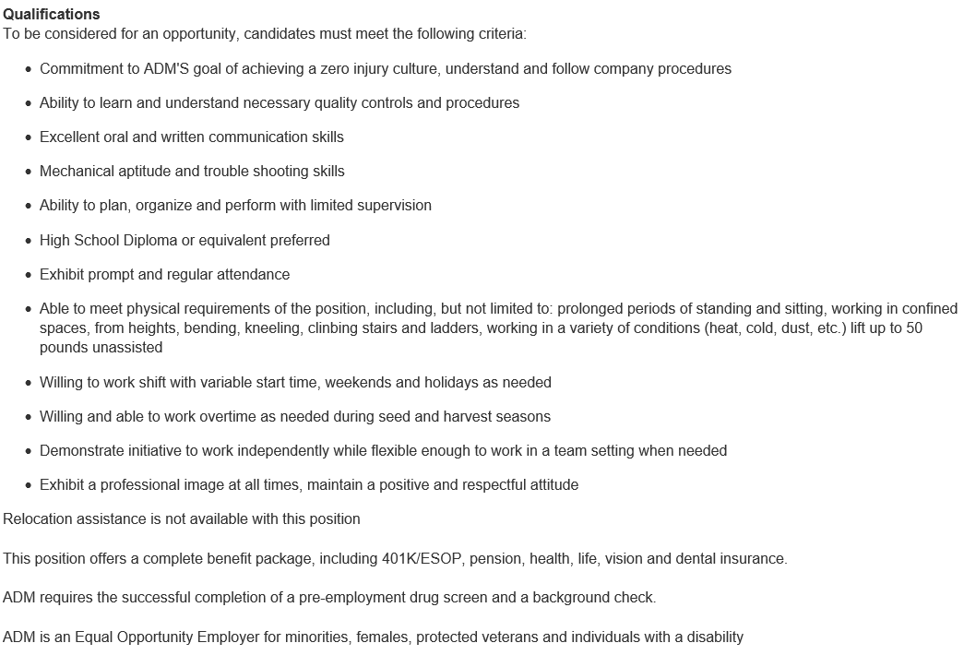

Valent Job Description
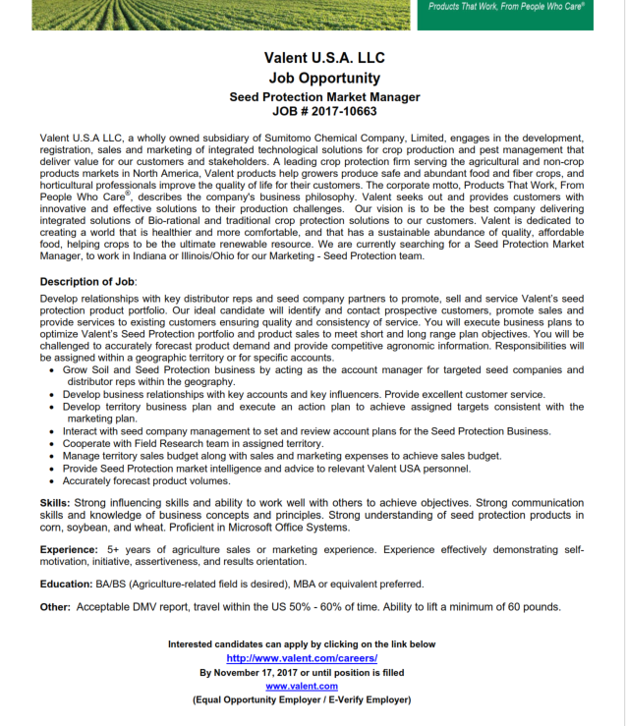

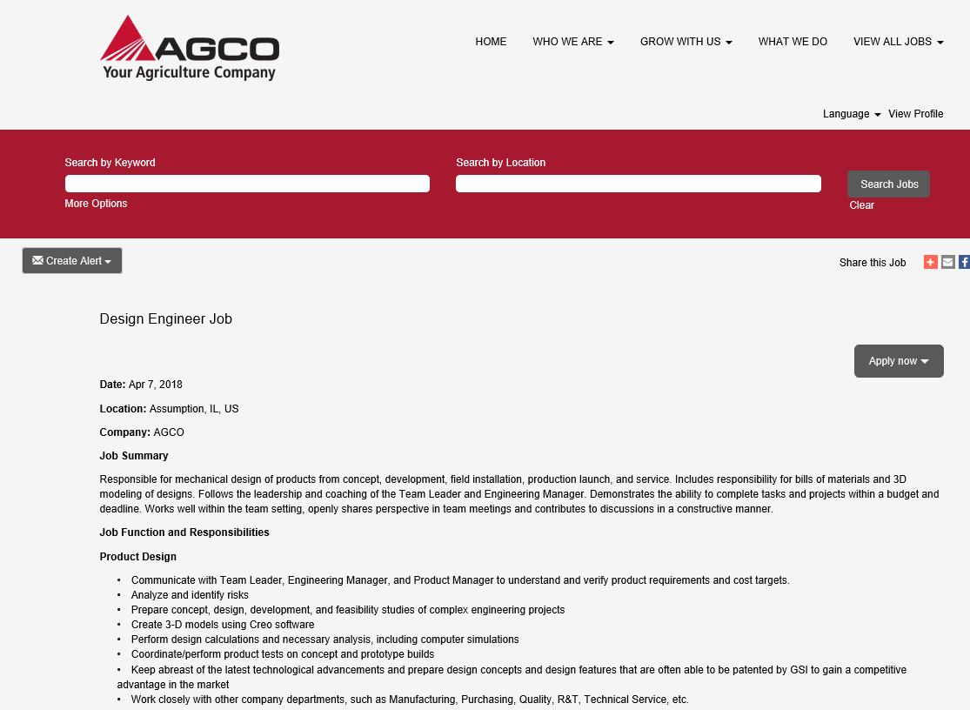
AGCO Job Description

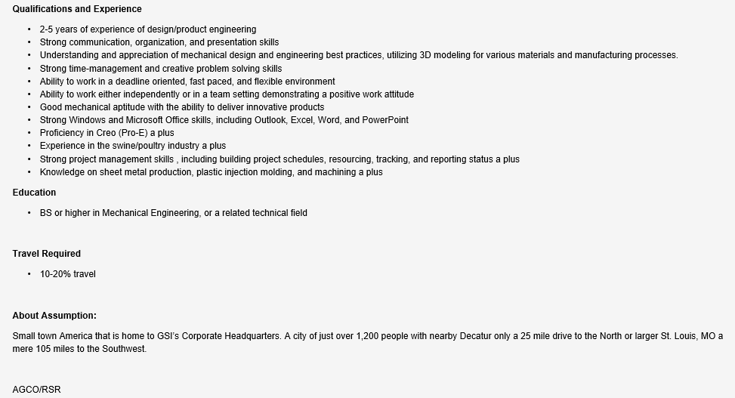

KEY: Job Description Breakdown
Aligned to the following standards:
FFA.PG-I; CS.05; CCSS.W.9-10.4; CCSS.W.9-10.5; CCSS.SL.9-10.1; CCSS.SL.9-10.6; CCSS.L.9-10.6; CCSS.MP6; CRP.04; CRP.10

Directions:
Read the article “How to Decode a Job Advertisement.” This article is available at https://www.thebalance.com/how-to-decode-a-job-advertisement-2061002. Identify the parts of a job description and what is included in each part. Record your answers below.

Part of Job Description What Is Included

These vary across industries and companies, but it is your first look at what the position is.
Job title

Requirements for the job (Ex. education level, years of experience, etc.)
Qualifications

What you will be doing at the job
Responsibilities

Background on the company This should be the starting point for your research on the company.
Experience Level
Benefits and Pay
About Us

Most will say “competitive salary” or “salary commensurate with experience”

Years of experience or career level

Slogan/Logo Match
Match the logo with the correlating slogan.


1. a. “Just Do it.”
b. “Finger Lickin’ Good!”
c. “Go Further.”

2. d. “Let’s Go places.”
E. “Happiest Place on earth.”
F. “I’m Lovin’ It.”

3. G. “Bet You Can’t Have just one.”
H. “Think different.”
I. “Have it your way.”

4. J. “Impossible is nothing.”


5.


6.


7.


8.


9.


10.

KEY: Slogan/Logo Match
Match the logo with the correlating slogan.

1. a. “Just Do it.”
b. “Finger Lickin’ Good!”
c. “Go Further.”
2. d. “Let’s Go places.”
E. “Happiest Place on earth.”
F. “I’m Lovin’ It.”
3. G. “Bet You Can’t Have just one.”
H. “Think different.”
I. “Have it your way.”
4. J. “Impossible is nothing.”

5.

Key:
- J
- I
- C
- H
- A
- D
- E
- B
- F
- G
6.

7.

8.

9.

10.

