Lesson Two: Plant Diseases
Created: 05/2017 by the National FFA Organization

Student Learning Objectives:
After completing these activities students will…
- Identify common diseases found in floriculture plants.
- Evaluate the causes and effects of diseases in floriculture plants.
- Discuss treatment and prevention strategies for diseases in floriculture plants.
Time Required:
Varies based on teaching method:
- Direct instruction learning — 55 minutes
- Cooperative learning — 60-90 minutes
- Individualized learning — 120+ minutes
Resources:
- Clemson University
http://www.clemson.edu/extension/hgic/pests/plant_pests/flowers/hgic2049.html
- Farmer’s Almanac
http://www.almanac.com/content/rust
- Pennsylvania State University
http://extension.psu.edu/pests/plant-diseases/all-fact-sheets/fungal-root-rots-and-chemical-fungicide-use
- Royal Horticulture Society
https://www.rhs.org.uk/advice/profile?pid=756
- Texas A&M University
http://plantdiseasehandbook.tamu.edu/problems-treatments/problems-affecting-multiple-crops/stem-and-root-rot/
- University of California
http://ipm.ucanr.edu/PMG/GARDEN/PLANTS/DISEASES/blackspot.html
http://ipm.ucanr.edu/PMG/PESTNOTES/pn74132.html
- University of Maine
https://extension.umaine.edu/ipm/ipddl/publications/5097e/
Equipment and Supplies Needed:
Direct Instruction Learning:
- “Plant Diseases” PowerPoint
- A copy of the “Information Chart” worksheet for each student
- A copy of the “What is That?!” worksheet for each student

Cooperative Learning:
- Internet access to research topics (per group)
- Materials to create posters/brochures
- A copy of the “Profile Worksheet” for each student
- A copy of the “Product Rubric (Group)” worksheet for each group
- A copy of the “Information Chart” worksheet for each student
- A copy of the “What is That?!” worksheet for each student

Individualized Learning:
- Internet access to research topics (per student)
- Materials to create PowerPoint/podcast/posters
- A copy of the “Profile Worksheet” for each student
- A copy of the “Product Rubric (Individual)” worksheet for each student
- A copy of the “Information Chart” worksheet for each student
- A copy of the “What is That?!” worksheet for each student
previous knowledge recommended for this lesson:
- Plant anatomy and physiology

These activities are aligned to the following standards:
FFA Precept
- FFA.PG-J.Mental Growth: Embrace cognitive and intellectual development relative to reasoning, thinking and coping.
- FFA-CS-M.Communication: Effectively interact with others in personal and professional settings.
- FFA.CS-N.Decision Making: Analyze a situation and execute an appropriate course of action.
NASDCTEc
- AGPB01.01 Produce and manage plants in both domesticated and natural environments using application of principles of anatomy and physiology to enhance plant production.
- AGPB01.03 Examine and apply fundamentals of production and harvesting when producing plants to demonstrate plant management and production techniques.
Common Core- Reading: Informational Text
- CCSS.ELA-Literacy.RI.9-10.1 Cite strong and thorough textual evidence to support analysis of what the text says explicitly as well as inferences drawn from the text.
Common Core- Speaking and Listening
- CCSS.ELA-Literacy.SL.9-10.4 Present information, findings, and supporting evidence clearly, concisely, and logically such that listeners can follow the line of reasoning and the organization, development, substance, and style are appropriate to purpose, audience, and task.
Common Core- Literacy in Science & Technical Subjects: Writing
- CCSS.ELA-Literacy.WHST.9-10.2 Write informative/explanatory texts, including the narration of historical events, scientific procedures/ experiments, or technical processes.
- CCSS.ELA-Literacy.WHST.9-10.2.a Introduce a topic and organize ideas, concepts, and information to make important connections and distinctions; include formatting (e.g., headings), graphics (e.g., figures, tables), and multimedia when useful to aiding comprehension.
- CCSS.ELA-Literacy.WHST.9-10.4 Produce clear and coherent writing in which the development, organization, and style are appropriate to task, purpose, and audience.
- CCSS.ELA-Literacy.WHST.9-10.7 Conduct short as well as more sustained research projects to answer a question (including a self-generated question) or solve a problem; narrow or broaden the inquiry when appropriate; synthesize multiple sources on the subject, demonstrating understanding of the subject under investigation.
- CCSS.ELA-Literacy.WHST.9-10.8 Gather relevant information from multiple authoritative print and digital sources, using advanced searches effectively; assess the usefulness of each source in answering the research question; integrate information into the text selectively to maintain the flow of ideas, avoiding plagiarism and following a standard format for citation.
- CCSS.ELA-Literacy.WHST.9-10.9 Draw evidence from informational texts to support analysis, reflection, and research
Common Core- Math Practices
- CCSS.MP3: Construct viable arguments and critique the reasoning of others.
AFNR Career Ready Practices
- CRP.02. Apply appropriate academic and technical skills. Career-ready individuals readily access and use the knowledge and skills acquired through experience and education to be more productive.
- CRP.04. Communicate clearly, effectively, and with reason. Career-ready individuals communicate thoughts, ideas and action plans with clarity, whether using written, verbal and/or visual methods.
- CRP.05. Consider the environmental, social and economic impact of decisions. Career-ready individuals understand the interrelated nature of their actions and regularly make decisions that positively impact and/or mitigate negative impact on other people, organizations and the environment.
- CRP.06. Demonstrate creativity and innovation. Career-ready individuals regularly think of ideas that solve problems in new and different ways, and they contribute those ideas in a useful and productive manner to improve their organization.
- CRP.07. Employ valid and reliable research strategies. Career-ready individuals are discerning in accepting and using new information to make decisions, change practices or inform strategies.
- CRP.08. Utilize critical thinking to make sense of problems and persevere in solving them. Career-ready individuals readily recognize problems in the workplace, understand the nature of the problem, and devise effective plans to solve the problem.
- CRP.11 Use technology to enhance productivity. Career-ready individuals find and maximize the productive value of existing and new technology to accomplish workplace tasks and solve workplace problems.
Partnership for 21st Century Skills
- Collaboration
- Communication
- Environmental Literacy
- Information Literacy
- Initiative and Self-direction
- Productivity and Accountability
- Think Creatively
Lesson Plan:
- Introduction (suggested time 10-15 minutes) If using the direct instruction method, refer to slides 1 and 2 of the “Plant Diseases” PowerPoint to present lesson objectives and do the introduction activity.

Bacteria and viruses cause diseases in humans and make us sick. We all have experienced being sick at least once, whether it was a common cold or a stomach bug. How can you tell if another person is sick?

For the introduction activity, first have students think about the type of symptoms they look for to identify sickness. Encourage students to refer to personal experiences when they or someone they know has been sick. Have them pair up with a partner and share their thoughts.

Because plants are living things, we share some very basic characteristics with them, but what about when it comes to diseases? How do you think you can tell if a plant is sick?

Have them think about how a disease affects a plant. You can’t ask a plant what is wrong or take its temperature, so how do you tell? Encourage students to visualize a healthy plant, what would the opposite of that look like? Have them pair up with a partner and share their thoughts.

Disease can affect all living things, and if not treated, it can severely harm the health of the human, animal or plant. In this lesson, we will identify several common plant diseases, learn how it affects the plant, learn associated symptoms, and how to prevent and treat the disease.

- Instruction (suggested time depends on teaching method) Select a teaching method based on your number of students, time frame and available resources. For an overview of the teaching methods in this lesson, review the “Teaching Methods” worksheet. All methods will cover the same information.

Direct Instruction
Refer to slides 3-30 of the “Plant Disease” PowerPoint to address the diseases identified in the floriculture CDE.

The teacher will identify the nine items classified as diseases by the floriculture CDE. Each disease is presented with an overview, symptoms, prevention, treatment, an image and resources. Students should record and categorize the information using the “Information Chart” worksheet throughout the lesson. The “Information Chart” can be turned in as a daily grade and/or formative assessment, but it should be returned to students because it will be used throughout unit two.

Cooperative learning
The teacher will divide the class into nine groups and assign each group a disease. Once assigned, each group will need at least one internet capable device and a “Profile Worksheet” to help them navigate and organize their research. Once they believe they have found enough information on their topic, the teacher should review their “Profile Worksheet” for accuracy and credibility. If finding information and credible sources is an issue, refer to the resources listed on this lesson plan.

After the research has been approved, the groups will begin to design their product. Depending on materials available, students can create a poster, infographic, brochure, etc., to display what they have learned. Once the product is finished, station the products around the room and give each student an “Information Chart.” Allow students to rotate around the stations and view their peers’ products while using them to fill in their chart.

Using the “Product Rubric,” the teacher can grade each group themselves or make multiple copies and have the students grade each product during the rotation. Rubrics can be collected and used as a project grade. The “Information Chart” can be turned in as a daily grade and/or formative assessment, but it should be returned to students because it will be used throughout unit two.

InDividual learning
Each student will be assigned one of the nine diseases. Once assigned, each student will need an internet capable device and a “Profile Worksheet” to help them navigate and organize their research. Once they believe they have found enough information on their topic, the teacher should review their “Profile Worksheet” for accuracy and credibility. If finding information and credible sources is an issue, refer to the resources listed on this lesson plan or in the “Plant Diseases” PowerPoint.

After the research has been approved, the students will begin to design their product. Depending on materials available, students can create an informative essay, PowerPoint, podcast, etc., to display what they have learned. Once the product is finished, have each student present his or her product to the class. During the presentation, give students the “Information Chart” worksheet, and have them fill in their chart using the information being presented. The “Information Chart” can be turned in as a daily grade and/or formative assessment, but it should be returned to students because it will be used throughout unit two.

- Reflection (suggested time 10-15 minutes) If using the direct instruction method, refer to slide 31 of the “Plant Diseases” PowerPoint to present the reflection activity.
In this lesson, we have identified several diseases. Knowing how to correctly identify a disease’s symptoms will help us know how to treat it. To practice our identification skills, let’s illustrate the symptoms we are looking for with each disease, making sure we address the following:
- Where is it located? (Ex. roots, stem, top or bottom of leaf)
- What does it look like? (Ex. powdery growth, round postules, black circles)
- What color is it? (Ex. black, yellow, rust)

Have students complete the “What is That?!” worksheet for all nine diseases. Students can turn this in for a daily grade and/or formative review. Be sure to review those responses before moving on to the next lesson.

- Leveling Up: For students who finish early or want to practice the identification activity in the floriculture CDE.
  - If you have access to live specimens, bring in examples for students to see and quiz their ability to identify disorders. You can quiz them using the “Practicum Disorder Score Card” found in the Floriculture CDE Handbook.
  - If you have internet access, have students use the identification cards on the National FFA Quizlet page to practice identifying disorders.
  - If you do not have internet access, create a set of flash cards using the slides of this PowerPoint, so students can practice identifying disorders.

Aligned to the following standards:
PS.03; FFA.PG-J, FFA.CS-M, FFA.CS-N; AG-PL3; AGPB01.01, AGPB01.03; CCSS.RI.9-10.1; CCSS.SL.9-10.4; WHST.9.10.2, WHST.9.10.2A, WHST.9.10.4, WHST.9.10.7, WHST.9.10.8, WHST.9.10.9; MP3; CPR.02, CPR.04, CPR.05, CPR.06, CPR.07, CPR.08, CPR.11

What is That?!
directions:
Identify the symptoms of the diseases discussed in this lesson by illustrating them on the drawings. Be sure to specify where and what the symptoms are, along with the color. Refer to the “Information Chart” or “Plant Disease” PowerPoint for help.

Disease:

Where:

What:

Color:

Disease:
Example Pox
Where:
Roots
Leaves (bottom)
What:
Spots
Color:
Red

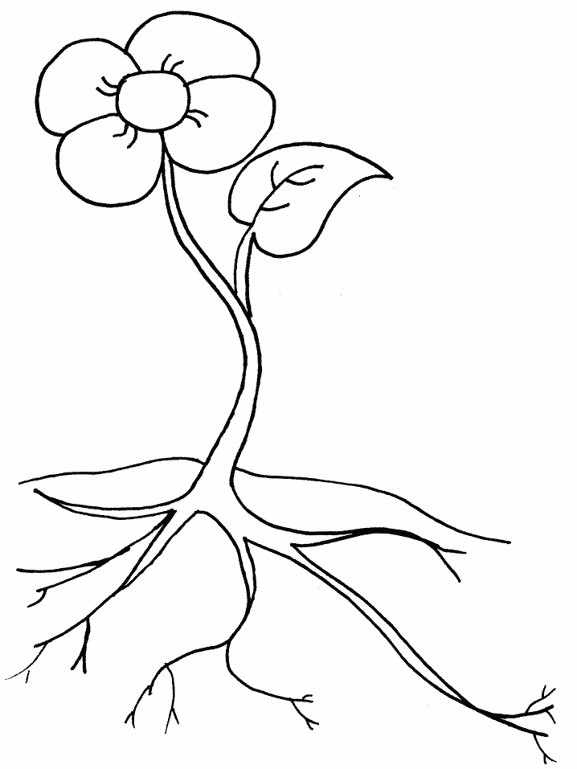

Disease:

Where:

What:

Color:

Disease:

Where:

What:

Color:

Disease:

Where:

What:

Color:

Disease:

Where:

What:

Color:

Disease:

Where:

What:

Color:

Disease:

Where:

What:

Color:

Disease:

Where:

What:

Color:

Disease:

Where:

What:

Color:

