Lesson Two: Potting and Propagation
Created: 01/2018 by the National FFA Organization

Student Learning Objectives:
After completing these activities, students will…
- Understand different methods of plant propagation.
- Understand the process of potting a plant.
- Apply skills learned about potting and propagation.

Time Required: 90 minutes
Resources:
- Nursery/Landscape CDE Handbook, https://ffa.box.com/s/yajzverkriebuvw9d9n16neh6v0a93fe
Equipment and Supplies Needed:
- “Potting and Propagation” PowerPoint
- “Planting Propagation Methods” worksheet, one copy per student
- Twizzlers
- Plastic knives
- Crushed graham crackers or Oreos
- Small cups — at least two per student
- Powdered sugar
- Sticky notes

These activities are aligned to the following standards:

AFNR Performance Element
- PS.02. Apply principles of classification, plant anatomy and plant physiology to plant production and management.
- PS.03. Propagate, culture, and harvest plants and plant products based on current industry standards.
FFA Precept
- FFA.PL-A.Action: Assume responsibility and take the necessary steps to achieve the desired results, no matter what the goal or task at hand.
- FFA.CS-N.Decision Making: Analyze a situation and execute an appropriate course of action.
Common Career Technical Core
- AG-PL2 Apply the principles of classification, plant anatomy and plant physiology to plant production and management.
- AG-PL3 Propagate, culture, and harvest plants and plant products based on current industry standards.
NASDCTEc
- AGPB01.03 Examine and apply fundamentals of production and harvesting when producing plants to demonstrate plant management and production techniques.
Common Core - Science & Technical Subjects
- CCSS.ELA-Literacy.RST.9-10.3 Follow precisely a complex multistep procedure when carrying out experiments, taking measurements, or performing technical tasks, attending to special cases or exceptions defined in the text.
- CCSS.ELA-Literacy.RST.9-10.4 Determine the meaning of symbols, key terms, and other domain-specific words and phrases as they are used in a specific scientific or technical context relevant to grades 9-10 texts and topics.
- CCSS.ELA-Literacy.RST.9-10.9 Compare and contrast findings presented in a text to those from other sources (including their own experiments), noting when the findings support or contradict previous explanations or accounts.
Green/Sustainability Knowledge and Skill Statements
- STEM Career Cluster, Statement 1 Understand and explain the concept of sustainability as it applies to STEM career fields.
AFNR Career Ready Practices
- CRP.02. Apply appropriate academic and technical skills. Career-ready individuals readily access and use the knowledge and skills acquired through experience and education to be more productive.
- CRP.04. Communicate clearly, effectively, and with reason. Career-ready individuals communicate thoughts, ideas and action plans with clarity, whether using written, verbal and/or visual methods.
Partnership for 21st Century Skills
- Communication
- Information Literacy
- Initiative and Self-direction
- Productivity and Accountability

Lesson Plan:
- Introduction

Hello class! You will see a few items in front of you. You should each have one sticky note, one Twizzlers twist, access to a plastic knife, powdered sugar, and crushed graham crackers or Oreos. Please leave these items at the top of your table or desk until later. Now, however, I want you to write on the sticky note. When I say “Go,” I will give you 30 seconds to write what you think each item represents in relation to plant propagation. What questions are there? Answer any questions.

Go. Allow students time to write what each item represents. The Twizzlers represents the plant stem, the crushed graham cracker or crushed Oreo represent the growing medium, and the powdered sugar represents the growth hormone. After 30 seconds, let the students read their guesses aloud, but do not tell them what the items represent yet.

Students, what did you think that some of these items represented? Good! I am not going to tell you what these items represent just yet, but I think the PowerPoint will help you know for sure. Make sure you point out where you see correlations as we cover the material.

Transition: Keep the items at the top of your desk or table and get out your notebook to take notes as we go over the PowerPoint on propagation and potting.

- Activity

Utilize the “Potting and Propagation” PowerPoint to teach about propagation methods and potting. After the PowerPoint presentation is finished, have students complete the “Propagation Methods” worksheet.

In addition to the worksheet, have the students practice a stem cutting using the Twizzlers, powdered sugar, and crushed graham crackers or Oreos. It would be helpful if you had an example for students to look at.

- Reflection

After all students have completed the worksheet, go over the worksheets to ensure that every student understands the different propagation methods. Check the students’ Twizzlers stem cuttings, go over any areas for improvement and then let the students eat them, if they desire.

- Leveling Up

For students interested in propagation, have those students practice methods of germination, propagation and potting as part of a CDE team or for a Supervised Agricultural Experience (SAE) program.
Plant Propagation Methods
Aligned to the following standards:
PS.02; PS.03; FFA.PL-A; FFA.CS-N; AG-PL2; AG-PL3; AGPB01.03; CCSS.RST.9-10.9; CRP.02; CRP.04
directions:
Use the pictures below to demonstrate where you would make the cut on the plant for the specific propagation method indicated. Draw a dotted line where the cut would occur.

- Stem Tip Cutting 2. Stem Medial Cutting 3. Leaf Cutting with Petiole

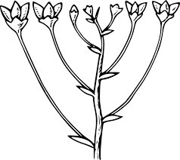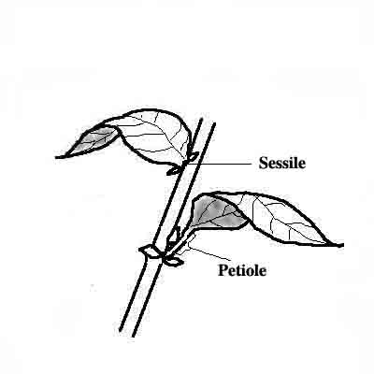

- Leaf Cutting without Petiole 5. Split Vein Leaf Cutting 6. Leaf Sections Cutting



Draw the steps of the following propagation methods:

7. Root Cutting 8. Tip Layering 9. Compound Layering

- Air Layering

