2021 Examination for the

National Agricultural Technology and

Mechanical Systems

Career and Leadership Development Event

You have 1.5 hours to complete this exam.
Answer Key
Do Not Distribute

2021 Written Examination for the

National Agricultural Technology & Mechanical Systems

Career and Leadership Development Event

1. Machinery: Approximately how many acres are in a rectangular area of land with adjacent sides that measure 6.5 kilometers and 0.75 miles? 1 acre = 43,560 square feet 1 mile = 5,280 feet 1 foot = 0.3048 meter Area of Rectangle = length x width 1000 meters = 1 kilometer

A. 1938.7 acres
[6.5 km x (1000 m / 1 km) x (1 ft/ 0.3048 m)] x [0.75 mi x (5280 ft / 1 mi)] x (1 ac / 43,560 ft²) =
1938.67812 ac
B. 2447.6 acres
C. 2954.5 acres
D. 3384.4 acres

2. Electrical: A rectangular farm building is poorly insulated and is located in a zone of the U.S. that typically requires 50 BTUs per square-foot of floor area to adequately heat the interior. If the interior floor dimensions of the rectangular building are 25.5 feet by 12 yards and the model of furnace being purchased is 77% efficient, what is the approximate size of the furnace required? Use the following formula to calculate the approximate furnace size (room height is not utilized in calculation). Furnace output is rated in British Thermal Units (BTUs) 1yd = 3 ft
Furnace Size in BTUs = Square footage of floor x number of BTUs recommended per square foot
Furnace Efficiency
A. 40,000 BTUs
Furnace Size = 25.5’ x 12 yds x 3’ /1 yd x 50 BTUs /sq ft = 59,610.39 BTUs
0.77
B. 50,000 BTUs
C. 60,000 BTUs
D. 70,000 BTUs

3. Compact Equipment: During the repair of an engine, a pilot-hole must be drilled to accommodate a 3/8” tap that will cut threads (for a 3/8” bolt) in the wall of the pilot-hole. The tap table indicates that the pilot-hole must have a 0.3125” diameter. All of the available twist drills have fractional rather than decimal measurements. What size twist drill should be used to drill the pilot-hole?

A. 5/16 inch
B. 11/32 inch
5/16” = 0.3125”
C. 21/64 inch
D. 12/32 inch

4. Structural: A small section of a tape measure with numerical values in inches is shown in the space below. The entire length of the tape measure is not shown. What length is indicated when measured from the end of the tape measure (not shown at the left of picture) to where the arrow touches the tape measure? Answer should be in feet, inches, and fractions of an inch.

A. 1’ 3~3/4”
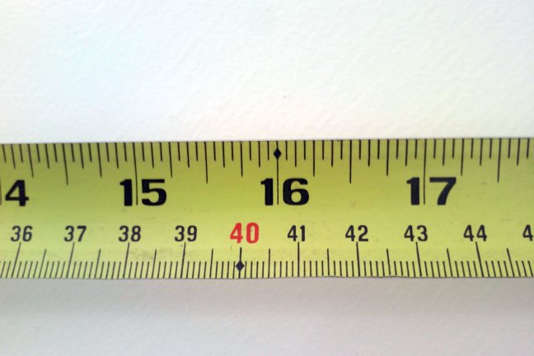
B. 1’ 4~5/16”
C. 1’ 4~11/16”
D. 1’ 6~7/8”

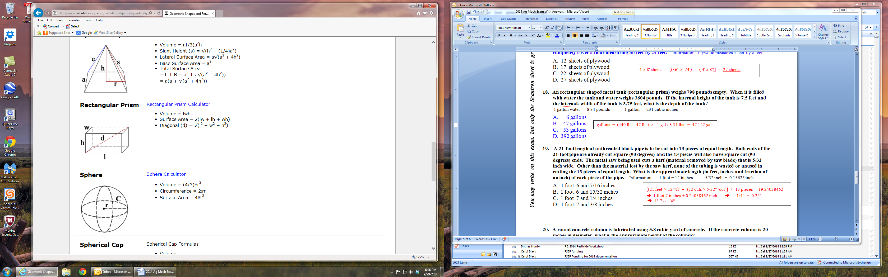
5. Environmental: A rectangular shaped metal container with a lid is used to transport bulk livestock feed. This container is transported on a trailer with tandem axles and each axle has a 3500-pound load carrying capacity. The total weight of the trailer and the empty container is 970 pounds. The internal dimensions of the hopper are 5.25 feet wide, 8.5 feet long, and 3 feet deep. When the feed container is completely filled, what is the maximum weight in pounds per cubic foot (approximate value) of the bulk feed if the load is to be transported on the trailer within the load carrying limits of the axles?

1 cubic-foot = 1728 cubic-inches
Picture of rectangular prism
Volume of rectangular prism = Length Width Height

A. 25 lbs / ft³
B. 35 lbs / ft³
(2 axles x 3500 lbs/axle) – 970 lbs = 6030 lbs

6030 lbs = 5.25’ x 8.5’ x 3’ x ??? lbs/ ft³ 45.04201681 lbs
C. 40 lbs / ft³
D. 45 lbs / ft³

6. Environmental: If a center pivot irrigation system is 1320 feet long (has a 2640-foot diameter), approximately how many acres can be irrigated under 300 degrees of the pivot's travel?
Area of a circle = (π) (radius)² π = 3.14 diameter = 2 radius 1 acre = 43,560 square feet 1 mile = 5,280 feet Complete circle = 360 degrees

A. 82.6 acres
Acres = 300⁰$/360⁰$ x 3.14 x (1320)² x 1 ac / 43,560 ft² = 104.66666667 ac
B. 104.7 acres
C. 125.8 acres
D. 156.9 acres

7. Machinery: Each cylinder in an eight cylinder tractor engine has a bore (diameter) of 5.65 inches and a piston stroke of 7.63 inches. What is the approximate total displacement of this engine in liters?
Area of a cylinder bore = (π) (radius)² π = 3.14 radius = (diameter ÷ 2)
Volumetric displacement of a single cylinder = (length of piston stroke) x (the area of the cylinder bore)
1 liter = 61 cubic inches 1 cubic inch = 0.0164 liter

A. 15 liters
8 cyl × 3.14 × (5.65 in / 2 )² × 7.63 in × (1 L / 61 in³ ) = 25.07559474 L
B. 20 liters
C. 25 liters
D. 30 liters

8. Electrical: The interior electrical lighting of a farm structure is being replaced with high efficiency LED lighting. There are 48 incandescent, 100-Watt lights that will be replaced with 30 LED, 45-Watt lights. The lights are operated 6 hours each day and 22 days each month. If electricity cost 13.15 cents per kilowatt-hour (kWh), what is the approximate reduction in electrical power costs during one year of operation? 1000 Watts = 1 kilowatt 12 months = 1 year

A. $ 684.82
[(48 lights x 100 W) – (30 lights x 45 W)] x $0.1315 / kwh x 6 hrs/day x 22 days/mth x 12 months/yr x 1 kwh / 1000 W = $ 718.6212 = $ saving / yr
B. $ 718.62
C. $ 831.42
D. $ 964.22

9. Compact Equipment: Which of the following has the greatest weight in pounds: 1.59 gallons of gasoline, 1.45 gallons of diesel, 1.36 gallons of 15W-40 engine oil, or 1.37 gallons of automatic transmission fluid?
1 gallon of gasoline = 6.3 pounds 1 gallon of diesel = 6.943 pounds
1 gallon 15W-40 engine oil = 7.3 pounds 1 gallon automatic transmission fluid = 7.298 pounds
1.59 gals gas x 6.3 lbs / 1 gal = 10.017 lbs
1.45 gals diesel x 6.943 lbs / 1 gal = 10.06735 lbs
1.36 gals oil x 7.3 lbs / 1 gal = 9.928 lbs
1.37 gals fluid x 7.298 lbs / 1 gal = 9.99826 lbs

A. gasoline
B. diesel
C. 15W-40 engine oil
D. automatic transmission fluid

10. Structural: Which of the following quantities of lumber has the smallest number of board-feet?
1 board-foot = 144 cubic inches 1 square foot = 144 square inches

A. 6 boards measuring 2 inches by 6 inches by 16 feet
Nominal Measurement Comparison (same answer for actual)
6 × 2" × 6" × 16' × 12"/1 ft × 1bd-ft/144in³ = 96 bd-ft
5 × 2" × 8" × 14' × 12"/1 ft × 1bd-ft/144in³ = 93.333 bd-ft
9 × 1" × 10" × 12' × 12"/1 ft × 1bd-ft/144in³ = 90 bd-ft
11 × 1" × 10"× 10' × 12"/1 ft × 1bd-ft/144in³ = 91.67 bd-ft
B. 5 boards measuring 2 inch by 8 inches by 14 feet
C. 9 boards measuring 1 inch by 10 inches by 12 feet
D. 11 boards measuring 1 inch by 10 inches by 10 feet

11. Structural: The round support column (cylinder) in a building is a vertical steel pipe with an outside diameter of 18 inches. The pipe has a wall thickness of 3/8” and will be filled with concrete. If the 20-foot tall pipe is to be completely filled, approximately how many cubic-yards of concrete are needed?
Volume of cylinder = (π) x (radius)² x height π = 3.14 radius = (diameter ÷ 2) 27 cubic feet = 1 cubic yard
Radius = (18” - 3/8” - 3/8”) ÷ 2 (18” - 0.375” - 0.375”) ÷ 2 = 8.625”
Radius = 8.625” x 1’/ 12” = 0.71875’
Vol. of Cylinder = π x r² x h = 3.14 x (0.71875’’)² x 20’ = 32.44257813 ft³
Cubic-Yards of Concrete = 32.44257813 ft³ x (1 yd³ / 27 ft³) = 1.201576968 yd³

A. 0.8 cubic yards
B. 1.2 cubic yards
C. 1.5 cubic yards
D. 1.9 cubic yards

12. Environmental: A dairy’s comprehensive nutrient management plan indicates that 20 tons of the dry manure should be applied to a crop field. If the wet manure being applied to the crop field has a 65% moisture content by weight, what is the approximate amount of wet manure that should be applied to be equivalent to the dry manure application weight?
A. 22.67 tons
20 tons / (1.00- 0.65) = 57.142857 tons
B. 30.77 tons
C. 38.25 tons
D. 57.14 tons

13. Machinery: What is the approximate speed, in miles per hour, for a pesticide boom sprayer that travels 200 yards in 1 minute and 12 seconds?
5,280 ft = 1 mile 60 seconds = 1 minute 60 minutes = 1 hour 1 yard = 3 feet

A. 4.2 miles per hour
(200 yds / 72 sec) x (3 ft / 1 yd) x (60 sec. / min. x 60 min. / 1 hr) x (1 mi / 5,280 ft)
Speed = 5.681818 mph

B. 4.7 miles per hour
C. 5.2 miles per hour
D. 5.7 miles per hour

14. Electrical: A water pump for a stock tank has an electrical motor that operates at 120 volts and uses 9.8 amps of current. If it is a 1.25 horsepower motor and it operates with a power factor of 0.95, what is the approximate efficiency of the motor? 1 horsepower = 746 Watts
Horsepower = voltage x amperage x power factor x efficiency
746

A. 73.5 %
1.25 hp = 120 V x 9.8 A x 0.95 x Efficiency >>>>> Eff. = 0.8345759757
746 Eff. = 83.5%
B. 78.5 %
C. 83.5 %
D. 88.5 %

15. Compact Equipment: A partial picture of a 6-inch dial caliper is shown in the space below. The jaws of the dial caliper are closed on a solid object and the measurement is displayed on the face of the dial caliper. What is the measurement displayed on the dial caliper?
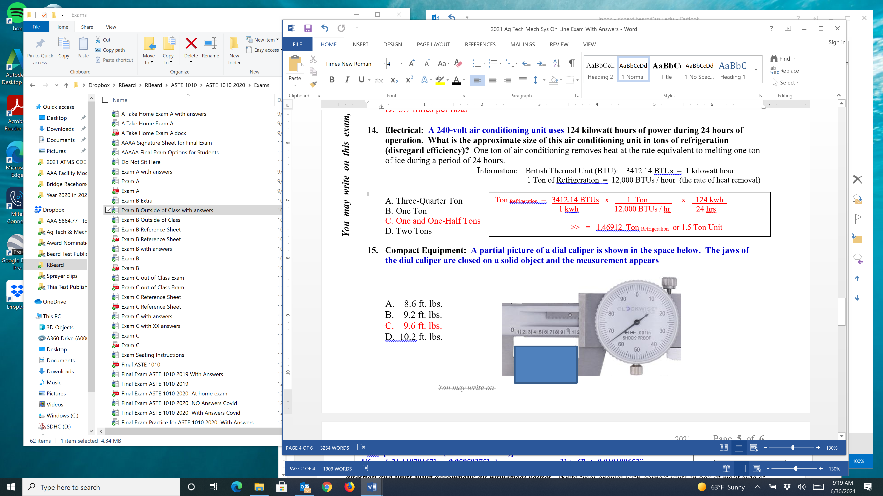

A. 1.065 inches
B. 1.165 inches
C. 1.650 inches
D. 1.265 inches

16. Compact Equipment: The operation of a walk-behind gasoline mower must generate sufficient income from cutting grass to generate a profit over purchase price, operating costs, and labor expenses. An $890 mower is operated 760 hours annually for three years and then sold at an estimated salvage value of $75. If total labor and operating costs are $28 per hour and an average of 1850 square-feet of grass can be cut in an hour, what approximate amount should be charged for each hour of the mower’s operation to produce a 50% profit margin?
[ ($890 - $75) / (3 yrs x 760 hrs/yr) ] + $28/hr = $28.357456

$28.357456 / 0.50 = $56.71491
A. $ 57
B. $ 63
C. $ 69
D. $ 75

17. Structural: A storage tank is shaped like a capsule with the following internal dimensions. The radius of the one-half spheres on each end are 23~5/8” and the height of the cylinder section is 9’ 11~7/8”. What is the approximate internal volume in gallons for this tank? diameter = (2 × radius)
Volume of cylinder = π × (cylinder radius)² × cylinder height π = 3.14 1 gallon = 231 cubic inches
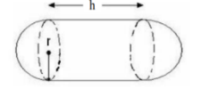
A. 1148.46 gallons Volume of sphere = 4/3 x π × (cylinder radius)³
B. 1199.35 gallons
r = 23~5/8” = 23.625” and h = 9’ 11~7/8” = 119.875”

Vol. of Tank = {[3.14 x (23.625”)² x 119.875”] + [4/3 x 3.14 x (23.625”)³ ]} x 1 gal/231 in³
Vol. of Tank = ( 210,088.3173 in³ + 55,205.68922 in³ ) x 1 gal/231 in³
Vol. of Tank = 265,294.0065 in³ x 1 gal/231 in³
Vol. of Tank = 1148.458903 gal

C. 1246.24 gallons
D. 1289.13 gallons

18. Environmental: A pesticide label specifies that 0.25 pint of pesticide concentration, mixed with 20 gallons of water, are to be applied per acre. Approximately how many gallons of pesticide concentration are required to treat a 400-acre field?
128 ounces = 1 gal 16 ounces = 1 pint

A. 6.3 gallons
Gallons = [(0.25 pts / ac) x (16 oz / pt) x (1 gal / 128 oz) x (400 acres)]
= 12.5 gallons
B. 9.4 gallons
C. 12.5 gallons
D. 15.6 gallons

19. Machinery: A tractor’s PTO produces 290 horsepower at a rated power take-off speed of 1000 revolutions per minute. How much torque in foot-pounds does the tractor produce at the power take-off shaft?
PTO Power = Torque x Rotational Speed ÷ 5252

A. 1,124 lb-ft
Torque = 5252 x 290 / 1000
= 1,523 lb-ft

B. 1,325 lb-ft
C. 1,426 lb-ft
D. 1,523 lb-ft

20. Electrical: A digital kilowatt-hour electric meter has the reading shown in the picture below. If last month’s reading was 19778, and electric power cost 11.58 cents per kilowatt-hour, what is the approximate charge for the past month’s electrical power?
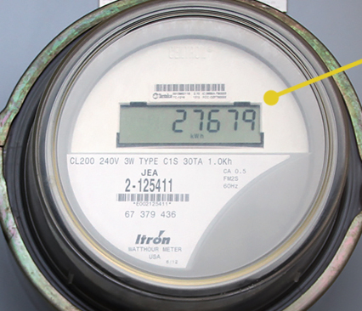

A. $ 885
Kilowatts-hours = 27679 - 19778 = 7901 kwh

7901 kwh x $0.1158 = $914.9358
B. $ 915
C. $ 945
D. $ 975

21. Electrical: The rooftop solar installation for a dairy has proven to reduce the monthly electric bill an average of $30 for the four coldest mouths (winter) of the year, $135 for one month in the fall, $135 for one month in the spring, and $270 per month during the six warmer months of the year. If the installation cost of the solar system was $24,000, approximately how many years must the system be utilized to achieve the economic “breakeven” point?
Breakeven in Years = Installation Cost / ($ savings/Year)

A. 10 years
Annual Energy Savings = [ (4 mth x $30/mth) + (2 mth x $135/mth) + (6 mth x $270/mth)] = $2010 / yr

Breakeven = $24,000 / $2010/yr = 11.94 yrs
B. 12 years
C. 14 years
D. 16 years

22. Compact Equipment: A self-propelled fertilizer spreader for specialty crop production has a 12-foot swath width and an averages travel speed of 4.5 miles per hour. Fertilizer is applied to an area measuring 185 yards long and 145 yards wide, by an inexperience operator that is only 70% efficient. Approximately how long will it take the inexperienced operator to complete the fertilizer application?
Information: 5280 ft = 1 mile 1 yard = 3 feet 60 minutes = 1 hour 60 seconds = 1 minute

A. 1 hours and 13 minutes
Hrs = 185 yds x 145 yds x (9 ft²/yd²) 1 = 1.209641063 hrs .
4.5 mi/hr x 5280 ft/mi x 12 ft 0.70
1 hour + (0.209641063 hrs x 60 min/hr) = 1 hours and 12.5784632 min
B. 1 hours and 33 minutes
C. 1 hours and 57 minutes
D. 2 hours and 15 minutes

23. Structural: Over the past year the cost of framing lumber has increased significantly. The following table list the March 2020 prices and the April 2021 prices for common size lumber. Which one of the lumber sizes listed in the table exhibits the highest percentage increase in cost?
Lumber Size | Price in 2019 | Price in 2021
2” x 4” x 8’ | $ 2.37 | $ 7.21
2” x 6” x 10’ | $ 5.37 | $ 15.29
2” x 8” x 10’ | $ 8.23 | $ 23.79
2” x 10” x 10’ | $ 10.81 | $ 29.37

$ 7.21 / $2.37 = 304.22%
$ 15.29 / $ 5.37 = 284.73%
$ 23.79 / $ 8.23 = 289.06%
$ 29.37 / $ 10.81 = 271.69%

A. 2” x 4” x 8’ lumber
B. 2” x 6” x 10’ lumber
C. 2” x 8” x 10’ lumber
D. 2” x 10” x 10’ lumber

24. Environmental: A portion of a topographic map is shown below. Two mountain peaks, A and B are identified with arrows on the map. Which of the following statements about the map is correct?
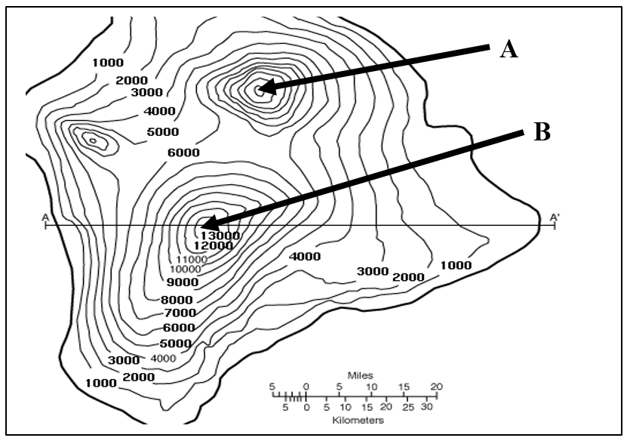

A. Elevation of point A cannot be determined.
B. Elevation of point A is higher than point B.
C. Elevation of point B is higher than point A.
D. Elevation of point A equals elevation of point B.
Based on the information on the topo map, the amount of elevation change between the contour lines is 1000 feet. Both points are identified as peaks and there are 7 contour lines above the 6000-foot contour line for Peak A. This indicates 6000 feet plus 7000 feet or 13,000 feet for Peak A which makes it the same height as Peak B.

25. Machinery: To determine the wheel slippage in a loaded tractor’s operation the following measurements were made. The rear wheels of a tractor each have a diameter of 5.15 feet, the test distance is 100 feet long, and the loaded tractor’s rear wheels make 6.8 rotations while traveling the 100 feet. What is the approximate wheel slippage for this tractor during each rotation of the rear wheel?
Circumference of a circle = (2) x (π) x (radius) π = 3.14 diameter of circle = (2) x (radius)

A. 0.28 feet/rotation, 1.73%
Wheel circumference = [ 2 x 3.14 x 5.15’/2 ] = 16.171 feet

6.8 rotations x 16.171 feet = 109.9628 feet in 6.8 rotations

This represents 9.9629 feet slippage over 100 feet or

9.9628 feet / 6.8 revolutions = 1.4651176 feet / rotation

B. 0.67 feet/rotation, 4.14%
C. 1.08 feet/rotation, 6.68%
D. 1.47 feet/rotation, 9.09%

