2021 Floriculture CDE
Instructions for completion of exam: Choose the best answer for each of the Problem Solving Questions

Problem Solving TEst

Problem Solving Question #1

A grower with a 1:150 ratio fertilizer injector and a 40-gallon stock tank desires to apply 300 ppm of nitrogen to a crop of mums. The available fertilizer has a 25-15-20 analysis.
How many pounds of this fertilizer should the grower dissolve in the stock tank?
The two formulas for calculating fertilizer amounts are:

A. Ounces in 100 gallons of water = ppm desired
% element x correction factor (0.75)
B. Pounds to add to stock tank =
Ounces per 100 gallons x second number of injector ratio x volume of stock tank in gallons
100 x 16

A. 62 lbs. B. 75 lbs. C. 60 lbs. D. 162 lbs.

Problem Solving #2
A gardener applies a dry 20-10-20 fertilizer to her flower beds. According to a soil test she wants to apply 2 pounds of actual potassium (K₂0) per 100 square feet, 2 times a year. She has five flower beds with the following dimensions: 2 beds 4’ X 8’, 1 bed 62 ‘ X 3’, 1 bed 35’ X 6’, and 1 bed on the border of her property that measures 150’ X 2’. If a 50 lb. bag of this fertilizer costs $9.50, how much is this gardener paying a year for this application? (Round your answer to the nearest ½ bag).
- $28.50
- $14.25
- $57.00
- $15.20

Problem Solving #3

You work at Forever Blooms Florist. Your manager asked you to price out a cascade bridal bouquet they are finishing. The store operates on a markup of 2 to 1 for hard goods and supplies and 3 to 1 for flowers and foliage. There is also a 20% labor fee added after the mark up. Below is a list of items included in the bouquet and their wholesale cost.
Quantity | Item | Wholesale Price
6 | Roses | $1.29
5 | Mini-Carnations Stems | $0.79
8 | Fern Stems | $1.20
6 | Salal Stems | $1.52
4 | Solid Aster Stems | $0.84
3 | Lily Stems | $2.67
1 | #9 Satin Ribbon | $0.93
1 | Floral Tape | $0.30
1 | Foam bouquet holder | $1.30

Determine the final price of the bouquet.
Round up to the nearest whole number

A. $40.00 B. $77.00 C. $120.00 D. $157.00

Problem Solving #4

Of the following plant list which is correct in terms of the origin of the plant?

- Tulip-Corm B. Tulip-Bulb
Gladiolus-Bulb Gladiolus-Bulb
Dutch Iris-Bulb Dutch Iris-Corm
Amaryllis-Corm Amaryllis-Corm
Crocus-Bulb Crocus-Corm
Alstroemeria-Bulb Alstroemeria-Corm
Daffodil-Bulb Daffodil-Corm
Peony-Tuber Peony-Tuber
Calla Lily-Root Division Calla Lily-Tuber
German Iris-Rhizome German Iris-Rhizome

- Tulip-Bulb D. Tulip-Bulb
Gladiolus-Corm Gladiolus-Corm
Dutch Iris-Corm Dutch Iris-Bulb
Amaryllis-Corm Amaryllis-Bulb
Crocus-Bulb Crocus-Corm
Alstroemeria-Tuber Alstroemeria-Rhizome
Daffodil-Corm Daffodil-Bulb
Peony-Root Division Peony-Root Division
Calla Lily-Bulb Calla Lily-Tuber
German Iris-Rhizome German Iris-Rhizome

Problem Solving #5

You work as a grower for Sunbelt greenhouses in South Georgia. You need to order potting soil for spring crops. Your plans are to purchase potting soil by the bag. You need enough potting soil to fill the following number of containers.
Quantity | Pot size
120 | 10” baskets without saucers
400 | 10” baskets with saucers
700 | 4” square pots
75 | 6” standard round pots
820 | 6” azalea pots
415 | 8” azalea pots
550 | 1204 true inserts for flats/trays

Use the chart on the following page from SunGro Horticulture to determine the number of bags of potting soil that must be ordered.
Round up to the nearest whole number
A. 250 B.105 C.87 D. 60

http://www.sungro.com/wp-content/uploads/2020/09/Grower-Calendar-2020.pdf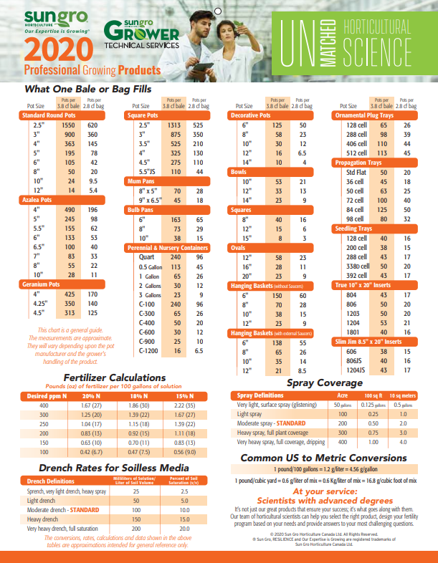

Problem Solving #6

You are the owner and operator of Fox Family Greenhouses. You have five (5) greenhouses in your operation. They are all the same size which is 28 feet wide and 78 feet in length. All the greenhouses have 18 benches that are 12.5 feet long and 5 feet wide.
You have committed three (3) of your greenhouses to finishing your Poinsettias crop. You are growing 6in pots of Poinsettias with one plant per pot. How many 6 inch Poinsettias can you grow if the final pot spacing will be on 1.5-foot centers?

A. 27 B. 63 C. 486 D. 1458

Problem Solving Question #7

An herbicide label instructs you to use a 5% solution for spot spraying the dandelions that have emerged in your annual flower bed. How many ounces of product would you add to make a total of 1 gallon of spray solution?

- 3.2 oz
- 64 oz
- 6.4 oz
- .8 oz

Problem Solving Question #8

How many pounds of ProGro, a 5-3-4 organic fertilizer, do you need to get the same amount of phosphorus as if you were using 15 pounds of a 15-10-10 chemical fertilizer?
- 45 lbs
- 50 lbs
- 37.5 lbs
- 75 lbs

Problem Solving #9

Your floral design class has decided to sell prom corsages for a fundraiser.

Each corsage will require:
1 stem of spray roses
1 stem of filler
1 stem of foliage
1 wristlet

Spray roses are sold in bunches of 5 stems for $12
Filler flowers are sold in bunches of 10 stems for $8
Foliage is sold in a bundle of 25 stems for $5
Wristlets are sold in a pack of 12 for $15

Determine the actual wholesale construction cost for each finished corsage.

- $4.65
- $4.85
- $6.65
- $3.40

Problem Solving #10

From Problem #9 if the class sells 50 corsages for $10, determine the profit:

- 330.00
- 167.50
- 267.50
- 252.50

