2021 National FFA Veterinary Science CDE
Math Exam
- Lucy, a 3-year-old Jack Russell Terrier, has been brought to your clinic for a Pro-Heart 6 injection. Lucy weighs 12 pounds. Dosage for Pro-Heart 6 is kg x 0.05ml=dose. How much Pro-Heart 6 will you administer to Lucy?
  - 0.27 ml
  - 0.6 ml
  - 1.32 ml
  - 1.6 ml
- Jack’s owner calls your clinic to make an appointment for a yearly exam and vaccinations. He has just moved to the area and they have never been to your practice. The owner tells you that Jack expressed anxiety and aggression at his visit last year. Since you have a fear free practice you recommend that Jack take Trazadone 2 hours before his appointment. If Jack weighs 47 pounds and the dosage your clinic uses is 5mg/kg. How many mgs of Trazadone will Jack get?
  - 10.7 mg
  - 107 mg
  - 235 mg
  - 517 mg
- Apple, a 25-year-old appaloosa, presents with colic. Apple weighs 430 kg and is obviously uncomfortable. You are directed to give her Flunixamine IV at a dose of 1ml/100 pounds. How many mls of Flunixamine will you give her?
  - 1.95 ml
  - 4.3 ml
  - 9.5 ml
  - 20.8 ml
- While out on a local farm call one of your patients presents with foot rot. You decide to administer Excede at 1.5ml/100 pounds. She weighs 1,000 pounds. How many mls will you administer?
  - 15 ml
  - 30 ml
  - 45 ml
  - 60 ml
- Rosie, a pet rat, comes in for a routine checkup. Rosie weighs 375 g. You must convert her weight to pounds to enter into your clinics electronic record keeping system. How much does Rosie weigh in pounds?
  - 0.83 lbs
  - 8.3 lbs
  - 3.75 lbs
  - 0.375 lbs
- The retail area of your clinic sells dog food. The markup per bag is 25%. If a bag of dog food cost the clinic $25.00, how much will the customer pay for it?
  - $25.25
  - $27.25
  - $29.25
  - $31.25
- Agnes, an 8-pound adult cat, comes in dehydrated. After examination it is determined she is 4% dehydrated. How many mls of IV fluids will Agnes need to correct her dehydration? (wt in kgs x % dehydration x 1000)
  - 14 mls
  - 145 mls
  - 1,450 mls
  - 14,500 mls
- Once you get Agnes rehydrated, how many mls of IV fluids will she need for her daily maintenance? (wt in kgs x 50)
  - 18 mls
  - 40 mls
  - 180 mls
  - 400 mls
- Solve 2.53 x 10².
  - 0.253
  - 253
  - 2,530
  - 25,300
- You write a prescription for a liquid medication. When dispensing the medication to the client you tell them to give 15ml PO once a day for 7 days. What household measurement can the owner use?
  - 1 tsp
  - 1 tbsp
  - 1 ounce
  - 1 cup
- A prescription reads give 2T q8h for 3 days. How many tablets will you dispense?
  - 6
  - 18
  - 24
  - 32
- If each of the tablets in the previous question cost $1.25, how much will the treatment cost?
  - $7.50
  - $22.50
  - $30.00
  - $40.00

Use the following label for questions 13-15.
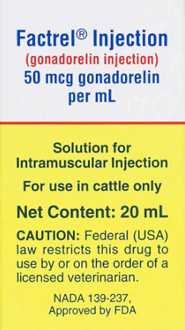
- How many mgs per mL?
  - 0.05
  - 0.5
  - 5
  - 50
- If the dose is 2 ml/cow, how many cows will one bottle treat?
  - 2
  - 5
  - 10
  - 20
- Based on a 2ml/cow dose, how many bottles are needed to treat a herd of 100 cows?
  - 5
  - 10
  - 15
  - 20

