STUDENTS DO NOT OPEN THIS TEST OR

BEGIN UNTIL INSTRUCTED TO START

2024 Examination for the

National Agricultural Technology and

Mechanical Systems

Career Development Event
Do Not Distribute
Name ________________________________________
Print Name Legibly

READ THE FOLLOWING INSTRUCTIONS:

Mark all answers on the scan-sheet using a pencil.

• You have one hour to complete this exam.
• You may write on this exam, but information on this exam is not graded. Blank sheets of paper are provided if additional calculation space or scratch paper is needed.
• If a diagram, picture, or table is needed to answer a question, the question will refer to the appropriate figure/page.
• Read each question carefully and determine the single correct answer.
• If a mark on the scan sheet needs to be changed, completely erase the incorrect answer and clearly mark the appropriate answer on the answer sheet.
• Each student needs a calculator to complete this examination, but calculators may not be shared between students.
• Formulas and conversion values are provided. Do not round off intermediate answers when using the calculator to solve these problems.

Students are NOT allowed to use any type of electronic communication device, including but not limited to cellular telephones, pagers, two way radios, or PDAs, during the CDE on Wednesday or Thursday. If a student uses, handles, or accesses any type of electronic communication device, she or he may be disqualified. If a personal emergency should arise during the CDE, students should contact a CDE official immediately for assistance.
.

This exam begins on the back of this sheet.

2024 Written Examination for the

National FFA Agricultural Technology & Mechanical Systems

Career Development Event

Mark all answers on the scan sheet using a pencil. Read each question carefully and mark the single correct answer on the scan sheet. Each student needs a calculator to complete this examination, but calculators may not be shared between students. Information written on this exam will not be graded.

1. Machinery: The John Deere 6M series 105HP utility tractor is equipped with an AutoPower/IVT transmission-hydraulic system that requires a fluid change at 1500 hours. The fluid capacity for the system is 60 liters. As a dealership manager, you have four tractors to service. Which purchase option is the least expensive with the least amount of fluid left over? 1 liter = 0.264172 gallon
One gallon = $26.00 Five Gallon Container = $123.00 Fifty-five Gallon Drum = $1,247
You may write on this exam, but only the scan sheet is graded.

A. (1) fifty-five-gallon barrel and (9) one-gallon containers
B. (2) fifty-five-gallon barrel
C. (1) fifty-five-gallon barrel, (1) five-gallon container, and (4) one-gallon containers
D. (12) five-gallon containers and (1) one-gallon container

2. Electrical: A technician needs to install an electronic device to determine the volumetric output of a water pump operating a center pivot irrigation system. What device does the technician install?

A. temperature sensor
B. flow sensor
C. pressure sensor
D. photoelectric sensor

3. Compact Equipment: When using a bench grinder safely, what is the maximum tool rest spacing?

A. 1/8”
B. 1/4”
C. 1/2”
D. 3/4”

4. Structural: A large pasture needs to be sectioned into four smaller equal-sized rectangular fields to allow for rotational grazing. The dimensions of the pasture include a length of 4350 feet and a width of 3582 feet. Three strands of four-point barb wire will be installed. Wire costs $120 per roll. Each roll has 1,320 feet of wire. Tax is 6.5% of the purchase price. Assume that you will need an additional 10% wire for any errors. A single 16-foot gate will be installed for the main pasture perimeter and a 16-foot gate for each of the four sections to allow livestock to rotate. No wire is needed where gates are installed. What is the cost of the barbed wire, including tax, for the project?
Perimeter of Rectangle = 2(Length + Width)

A. $ 4,474.96
B. $ 5,493.00
C. $ 6,524.00
D. $ 7,668.00

5. Environmental: During the silking stage, a corn variety has an evapotranspiration rate of 0.32 inches per day. The sandy loam soil has an available water storage capacity of 2.1 inches. The farmer would like to know when to schedule the next irrigation. How long (in days) will it take before the crop exhibits stress due to insufficient moisture?
Day until crop stress = Water Storage Capacity ÷ Evapotranspiration rate

A. 4.0 days
B. 6.5 days
C. 7.5 days
D. 8.0 days


6. Environmental: Using the NFPA symbol to the right, what is the level of health hazard for the fertilizer?

A. 0
B. 1
C. 3
D. 4

7. Machinery: For a hydraulic system, what is the result when a constant fluid flow rate encounters a reduction in the diameter of a hose?
You may write on this exam, but only the scan sheet is graded.

A. Increase in fluid pressure
B. Decrease in fluid pressure
C. Decrease in fluid velocity
D. Decrease in flow rate

8. Electrical: If the electric company charges $0.86 per kilowatt-hour, what is the cost to operate an electric water heater to raise the water temperature of 500 gallons from 60°F to 180°F over a three-hour period?
$$Power in kilowatts=\frac{Gallons of water x Temperature Rise in degrees fahrenheit}{325 x Time to heat in hours}$$

A. $52.92
B. $62.92
C. $92.87
D. $158.77

9. Compact Equipment: You have been asked to fabricate an engine mounting bracket. What is the approximate tap-drill bit size to make a 1/4-28 threaded hole?
Tap-drill bit size = major diameter – (1 ÷ number of threads per inch)

A. 0.123”
B. 0.214”
C. 0.234”
D. 0.250”

10. Structural: What is the common name for the layout tool provided in the picture below?
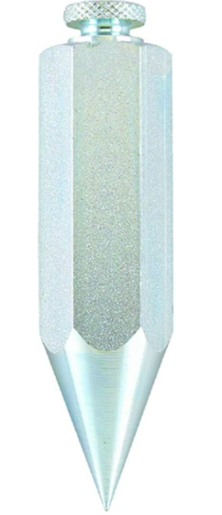
A. Plumb Bob
B. Plate Level
C. Line Level
D. Carpenter’s Level

11. Structural: What is the in-line device designed and constructed to provide a liquid seal that prevents the back passage of sewer gas into the adjoining spaces where it is installed?

A. plumbing fixture trap
B. sanitary drainage system
C. sewer cleanout
D. sewer vent pipe

You may write on this exam, but only the scan sheet is graded.
12. Environmental: If a center pivot irrigation system is 1220 feet long (has a 2440-foot diameter), approximately how many acres can be irrigated under 260 degrees of the pivot's travel?
Area of a circle = (π) (radius)² π = 3.14 diameter = 2 radius 1 acre = 43,560 square feet 1 mile = 5,280 feet Complete circle = 360 degrees

A. 72.6 acres
B. 75.4 acres
C. 77.5 acres
D. 87.5 acres

13. Machinery: Your current tractor produces 35 PTO-horsepower at a rated power take-off speed of 540 revolutions per minute. What horsepower is needed to operate a John Deere round baler that requires a PTO speed input of 540 rpm and a torque of 535 lb-ft? Does the 35 HP tractor have the capacity to operate the baler?
Torque = PTO Horsepower x 5252 ÷ PTO RPM

A. 25 HP, no
B. 35 HP, yes
C. 55 HP, yes
D. 55 HP, no

14. Electrical: Use the motor wiring diagram provided. Which wires must be connected but isolated from the power supply line for 230 V operation with counterclockwise shaft rotation?

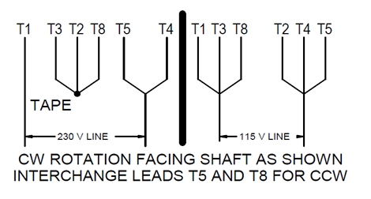
.

A. T3, T2, T5
B. T5, T4
C. T3, T2, T8
D. T1, T3, T5

15. Compact Equipment: What OSHA safety color designates machines or energized equipment that may cut, crush, or shock and emphasizes such hazards when a guard is removed?

A. Red
B. Orange
C. Yellow
D. Green

16. Compact Equipment: A ride-behind gasoline mower must generate sufficient income from cutting grass to generate a profit over the purchase price, operating costs, and labor expenses. A $1,200 mower operates 760 hours annually for three years and then sells at an estimated salvage value of $675. If total labor and operating costs are $32 per hour and an average of 1850 square-feet of grass can be cut in an hour, what approximate amount should be charged for each hour of the mower’s operation to produce a 50% profit margin?
Straight Line Depreciation = (Purchase Price – Salvage Value) ÷ (useful life of the equipment)

A. $ 55
B. $ 60
C. $ 65
D. $ 75

17. Structural: A concrete retaining wall shown below is 30” thick. Because of the sloping ground, the bottom of the concrete wall is angled, and the top is horizontal. An additional 5% concrete is ordered to allow for measurement errors. The Minimum concrete order is three yards, and concrete can only be ordered in half yard amounts above three yards. How much concrete will be needed to complete this pour?
1 cubic yard = 27 cubic feet 1 cubic foot = 1728 cubic inches 1 foot = 12 inches
Volume of rectangular prism = (length) x (width) x (height) π = 3.14
Volume of triangular prism = 0.5 * b * h * length
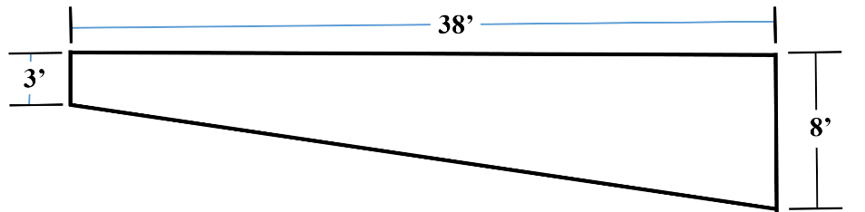

A. 19.5 cubic yards
B. 20.5 cubic yards
C. 25.5 cubic yards
D. 30.5 cubic yards
You may write on this exam, but only the scan sheet is graded.

18. Environmental: Using 2017 preliminary data, what percentage of the U.S. Energy consumption relies on renewable sources?
A. 10 percent
B. 25 percent
C. 30 percent
D. 40 percent

19. Machinery: For a 1.5” nominal pipe that is schedule 80, what is the inside diameter of the pipe?

A. 1.900”
B. 1.689”
C. 1.610”
D. 1.500”

20. Electrical: A water pump for a stock tank has an electrical motor that operates at 120 volts and uses 5.8 amps of current. If it is a 0.50 horsepower motor and operates with a power factor of 0.90, what is the approximate efficiency of the motor? 1 horsepower = 746 Watts
Horsepower = voltage x amperage x power factor x efficiency
746

A. 59.5%
B. 73.5%
C. 83.5%
D. 88.5%

21. Electrical: The rooftop solar installation for a hog finishing barn has proven to reduce the monthly electric bill by an average of $80 for the four coldest months (winter) of the year, $145 for one month in the fall, $145 for one month in the spring, and $280 per month during the six warmer months of the year. If the installation cost of the solar system was $45,000, excluding sales tax, approximately how many years must the system be utilized to achieve the economic “breakeven” point?
Breakeven in Years = Installation Cost / ($ savings/Year)
A. 14 years
B. 15 years
C. 19 years
D. 20 years

You may write on this exam, but only the scan sheet is graded.

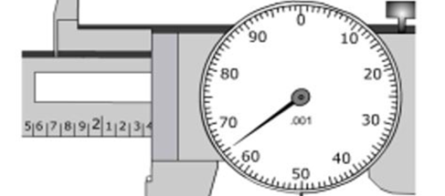
22. Compact Equipment: A partial picture of a 6-inch dial caliper is shown in the space below. The jaws of the dial caliper are closed on a solid object and the measurement is displayed on the face of the dial caliper. The measurement displayed on the dial caliper is between 3 inches and 4 inches. What measurement is displayed on the dial caliper?

A. 3.365 inches
B. 3.465 inches
C. 4.365 inches
D. 4.465 inches

23. Structural: Building material costs often fluctuate. The following table lists the prices for common size framing lumber in March 2020 and April 2024. Which one of the lumber sizes listed in the table exhibits the highest percentage increase in cost?
Lumber Size | Price in 2020 | Price in 2024
2” x 4” x 8’ | $ 2.37 | $ 2.42
2” x 6” x 10’ | $ 5.37 | $ 18.98
2” x 8” x 10’ | $ 8.23 | $ 13.75
2” x 10” x 10’ | $ 10.81 | $ 18.98

A. 2” x 4” x 8’ lumber
B. 2” x 6” x 10’ lumber
C. 2” x 8” x 10’ lumber
D. 2” x 10” x 10’ lumber

24. Environmental: A vertical distance of 400 ft is measured between the intake and discharge of a hydroelectric energy system. The water flow rate is approximately 900 gallons per hour. How many kilowatt-hours can be potentially generated in a 12-hour period?
60 gallons per hour = 1 gallon per minute Head in Feet x flow rate (gpm) ÷ 12 = Kilowatts

A. 24,000 Kilowatt-hours
B. 18,000 Kilowatt-hours
C. 6,000 Kilowatt-hours
D. 2,400 Kilowatt-hours

25. Machinery: The following measurements were taken to determine the wheel slippage in a loaded tractor’s operation. Each rear wheels have a diameter of 4.15 feet, the test distance is 100 feet long, and the loaded tractor’s rear wheels make 8.75 rotations while traveling 100 feet. What is the approximate wheel slippage for this tractor during each rear wheel rotation?
Circumference of a circle = (2) x (π) x (radius) π = 3.14 diameter of circle = (2) x (radius)

A. 1.28 feet/rotation, 1.73%
B. 1.37 feet/rotation, 4.14%
C. 1.48 feet/rotation, 6.68%
D. 1.60 feet/rotation, 12.30%

