
National FFA Week Implementation Guide
Created: 10/2025 by the National FFA Organization

This guide is a resource for agriculture educators, advisors, chapter FFA officers, state FFA officers, state FFA staff, alumni and supporters to assist in planning and executing an engaging National FFA Week experience for the FFA chapter, school and community.

Table of Contents
- Educational Standards Alignment
  - National FFA Week activities are aligned with national education standards.
- History of National FFA Week
  - National FFA Week has a rich history and tradition that is embedded in every FFA chapter. Learn about the history and tradition and why it exists.
- School and Community Roles
  - Learn how each person who has a connection with the FFA chapter can play a role in celebrating National FFA Week.
- Planning
  - A lot happens during FFA Week. Use these resources to begin planning the most impactful National FFA Week for your chapter.
    - Engagement Ideas
    - Each day of FFA Week with suggested activities for each group/role
    - Example of a National FFA Week Plan
    - National FFA Week Plan Template
    - Example of a National FFA Week — Daily Activity Plan
    - National FFA Week — Daily Activity Plan Template
    - Timeline template to plan and execute events/activities before and during National FFA Week
    - Sponsorship Toolkit
    - FFA T-shirt Design Brainstorm
    - School Board Meeting Presentation Planning Template
    - Scavenger Hunt
    - Agriculture Trivia
    - Agricultural Literacy Coloring Pages
- Alumni and Supporters
  - Local alumni and supporters are a resource of knowledge, skills and interest for helping prepare the future generation of leaders. Taking time to engage with these individuals during FFA Week is a great way to say thank you, gain support and involve those that have a vested interest.
    - Tips and Tricks for Involvement
- Media, Promotion and Advocacy
  - Telling your chapter’s story and inviting individuals to share in the National FFA Week celebration is an important component of making an impact in your community and school. The included resources will help you share FFA Week and your story throughout the community.
    - Strengthen Agriculture by Telling the FFA Story
    - Social Media Tips and Tricks Guide
    - Social Media Post Examples
    - National FFA Week on Social Media 2025
    - News Release Template
    - Public Service Announcement Scripts
    - Morning Announcement Script
    - Sample Congressional Letter
    - National FFA Week Proclamation
    - Fun facts about FFA to share
    - Planning for Advocacy
    - FFA.org/national-FFA-week
- Awards and Recognition
  - Recognizing people in the community, business world and school is an important component of celebrating National FFA Week as it allows a chapter to thank those individuals for their continued support, and by showing recognition, a chapter can continue to increase support.
    - Recognize Community Members and Local Businesses
    - Recognize Supporters in the School (Ex. superintendent, teachers, all school staff)
    - Family and Personal Support Recognition
    - Student Recognition
    - Certificate of Recognition
    - ShopFFA award and recognition products can be found here. Banquet supplies can be found here.
- Classroom Educational Materials
  - FFA is embedded in every agriculture class from agricultural mechanics to veterinary science. Include these turn-key lessons in your class to share FFA with all your students.
  - FFA Choice Board
  - Living the Legacy: The Impact of FFA on Agriculture and Leadership (middle school lesson)
  - Student Handbook Workbook
  - Ag Ed Academy
  - ShopFFA instructional materials can be found here.
- Living to Serve: FFA Week National Days of Service Resources and Opportunities
- Service is more important now than ever. During National FFA Week, we call attention to FFA and what we do as an organization. What better way to celebrate FFA Week than through a service project? We are encouraging FFA chapters across the country to register a service event to be hosted in February to be a part of the FFA Week National Days of Service.
  - National Days of Service Interactive Toolkit
  - Service and Volunteerism Ideas During COVID
  - FFA Day of Service Mini-Grant
  - National Days of Service Examples
  - Support Grants for Growing

*Link to Student Activity Sheets: (Word/PDF, Google)

Educational Standards Alignment 
FFA Precept
- FFA.PL-A.Action: Assume responsibility and take the necessary steps to achieve the desired results, no matter what the goal or task at hand.
- FFA.PL-B.Relationship: Build relationships, work as a team player and appreciate the talents of others.
- FFA.PL-C.Vision: Visualize the future and how to get there.
- FFA.PL-D.Character: Conduct oneself appropriately in relation to others regardless of the situation.
- FFA.PL-E.Awareness: Understand personal vision, mission and goals.
- FFA.PL-F.Continuous Improvement: Accept responsibility for learning and personal growth.
- FFA.PG-H.Social Growth: Successfully interact with others and adapt to various social situations.
- FFA.PG-I.Professional Growth: Assume responsibility for attaining and improving upon the skills needed for career success.
- FFA.PG-J.Mental Growth: Embrace cognitive and intellectual development relative to reasoning, thinking and coping.
- FFA.CS-M.Communication: Effectively interact with others in personal and professional settings.
- FFA.CS-N.Decision Making: Analyze a situation and execute an appropriate course of action.
- FFA.CS-O.Flexibility/Adaptability: Be flexible in various situations and adapt to change.
Common Core — Reading: Informational Text
- CCSS.ELA-Literacy.RI.9-10.4 Determine the meaning of words and phrases as they are used in a text, including figurative, connotative and technical meanings; analyze the cumulative impact of specific word choices on meaning and tone (e.g., how the language of a court opinion differs from that of a newspaper).
Common Core — Writing
- CCSS.ELA-Literacy.W.9-10.2 Write informative/explanatory texts to examine and convey complex ideas, concepts and information clearly and accurately through the effective selection, organization and analysis of content.
- CCSS.ELA-Literacy.W.9-10.6 Use technology, including the Internet, to produce, publish and update individual or shared writing products, taking advantage of technology’s capacity to link to other information and to display information flexibly and dynamically.
Common Core — Speaking and Listening
- CCSS.ELA-Literacy.SL.9-10.1 Initiate and participate effectively in a range of collaborative discussions (one-on-one, in groups and teacher-led) with diverse partners on grades 9-10 topics, texts and issues, building on others’ ideas and expressing their own clearly and persuasively.
- CCSS.ELA-Literacy.SL.9-10.2 Integrate multiple sources of information presented in diverse media or formats (e.g., visually, quantitatively, orally) evaluating the credibility and accuracy of each source.
- CCSS.ELA-Literacy.SL.9-10.5 Make strategic use of digital media (e.g., textual, graphical, audio, visual and interactive elements) in presentations to enhance understanding of findings, reasoning and evidence and to add interest.
Common Core — Literacy in Science & Technical Subjects: Writing
- CCSS.ELA-Literacy.WHST.9.10.4 Produce clear and coherent writing in which the development, organization and style are appropriate to task, purpose and audience.
- CCSS.ELA-Literacy.WHST.9.10.6: Use technology, including the Internet, to produce, publish and update individual or shared writing products, taking advantage of technology’s capacity to link to other information and to display information flexibly and dynamically.
AFNR Career Ready Practices
- CRP.02. Apply appropriate academic and technical skills. Career-ready individuals readily access and use the knowledge and skills acquired through experience and education to be more productive.
- CRP.04. Communicate clearly, effectively and with reason. Career-ready individuals communicate thoughts, ideas and action plans with clarity, whether using written, verbal and/or visual methods.
- CRP.06. Demonstrate creativity and innovation. Career-ready individuals regularly think of ideas that solve problems in new and different ways, and they contribute those ideas in a useful and productive manner to improve their organization.
- CRP.07. Employ valid and reliable research strategies. Career-ready individuals are discerning in accepting and using new information to make decisions, change practices or inform strategies.
- CRP.08. Utilize critical thinking to make sense of problems and persevere in solving them. Career-ready individuals readily recognize problems in the workplace, understand the nature of the problem and devise effective plans to solve the problem.
- CRP.11. Use technology to enhance productivity. Career-ready individuals find and maximize the productive value of existing and new technology to accomplish workplace tasks and solve workplace problems.
Partnership for 21st Century Skills
- Critical Thinking
- Creativity
- Collaboration
- Communication
- Flexibility and Adaptability
- Initiative and Self-Direction
- Leadership and Responsibility
- Technology Literacy
- Think Creatively

History of National FFA Week
Take a look at the National FFA Week 2024 Impact Report to learn how National FFA Week was celebrated in FFA chapters across the country last year.

Why should we celebrate National FFA Week?
Each year, FFA chapters around the country celebrate National FFA Week. It’s a time to share the story of what FFA is and how FFA is preparing future leaders through agricultural education. Currently, FFA has more than 1,042,245 student members as part of 9,407 local FFA chapters in all 50 states, Puerto Rico and the U.S. Virgin Islands. Additionally, the organization is supported by 760,152 alumni members in 2,033 chapters. What better way to show your support of FFA than to get involved in FFA Week? Whether it’s in person, on the phone or via social media, be sure to share your FFA stories. #FFAWeek




What are the roots of National FFA Week?
Designated as a national week in 1947, National FFA Week runs from Saturday to Saturday. The week of George Washington’s birthday was selected to celebrate the impact he had on agriculture. FFA Week gives FFA members an opportunity to educate the public about agriculture and show their local impact and story. During the week, chapters conduct a variety of activities to help others in their school and community learn about FFA and agricultural education.

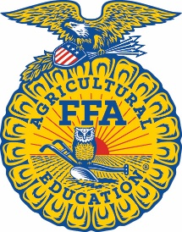
How can celebrating National FFA Week support my chapter, school and community?
By celebrating National FFA Week, the local chapter can engage all FFA members, students in the local school corporation, administration, faculty and staff, businesses in the community, alumni and supporters to bring awareness of the positive impact FFA and agricultural education have on members and students. Sharing each chapter’s story only helps to communicate the positive impact members will have as world-changing future leaders.
School and Community Roles
Explore the role of each group of people in your school and community during National FFA Week.

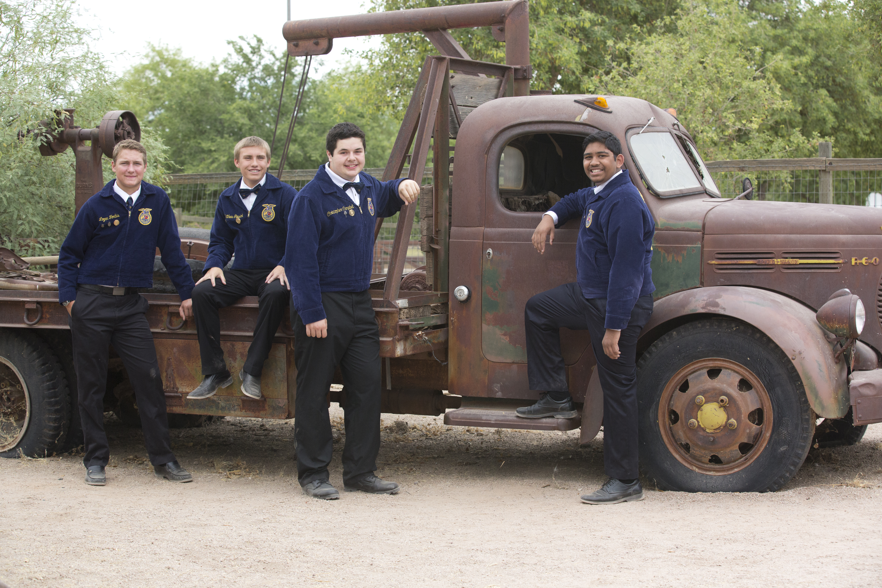
Community Members
National FFA Week provides a great time to welcome community members to events and involve them with the chapter by asking them to help with and provide materials for events. FFA Week is also the perfect opportunity to thank them and recognize them for their support.

FFA Advisor
The FFA advisor is the first point of contact for National FFA Week and should provide approval for all events. The FFA advisor can also assist in coordinating and planning events.

Chapter FFA Officers
FFA chapter officers should work alongside the advisor and FFA Alumni and Supporters to plan and execute the events for the week. This is a great time for chapter officers to help strengthen their team, improve member engagement and increase recruitment of new and younger members.

Feeder Schools
If there is a feeder school nearby (elementary or middle school whose students will feed into your school one day), National FFA Week is a great way to partner with them and introduce agricultural education and FFA to those students. Use fun activities so older students can engage with the younger ones.
School Leadership
School administration should approve all planned activities (per school rules). This is a great time to present to the school board about FFA as well as thank school leadership personnel for their support.
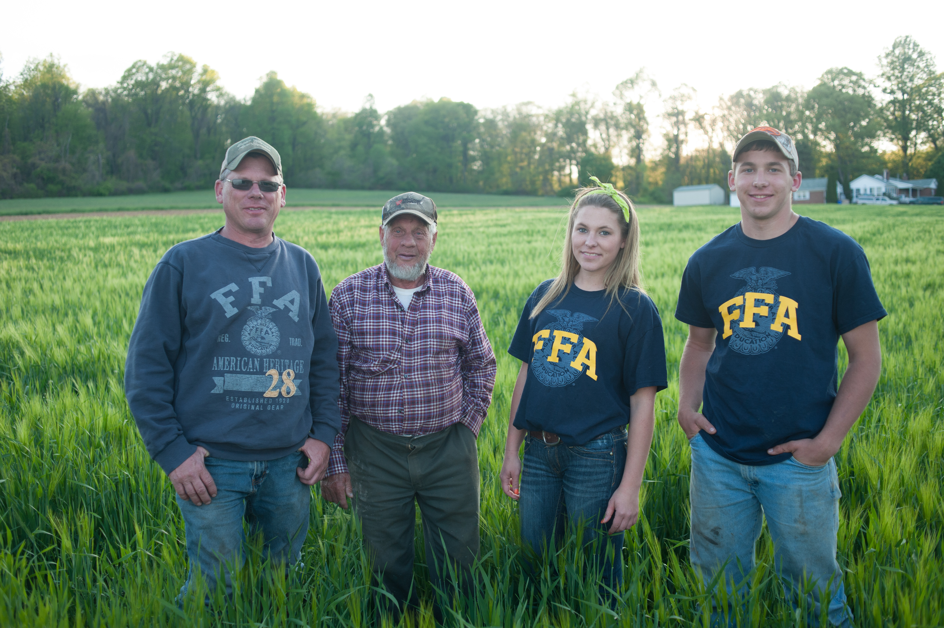
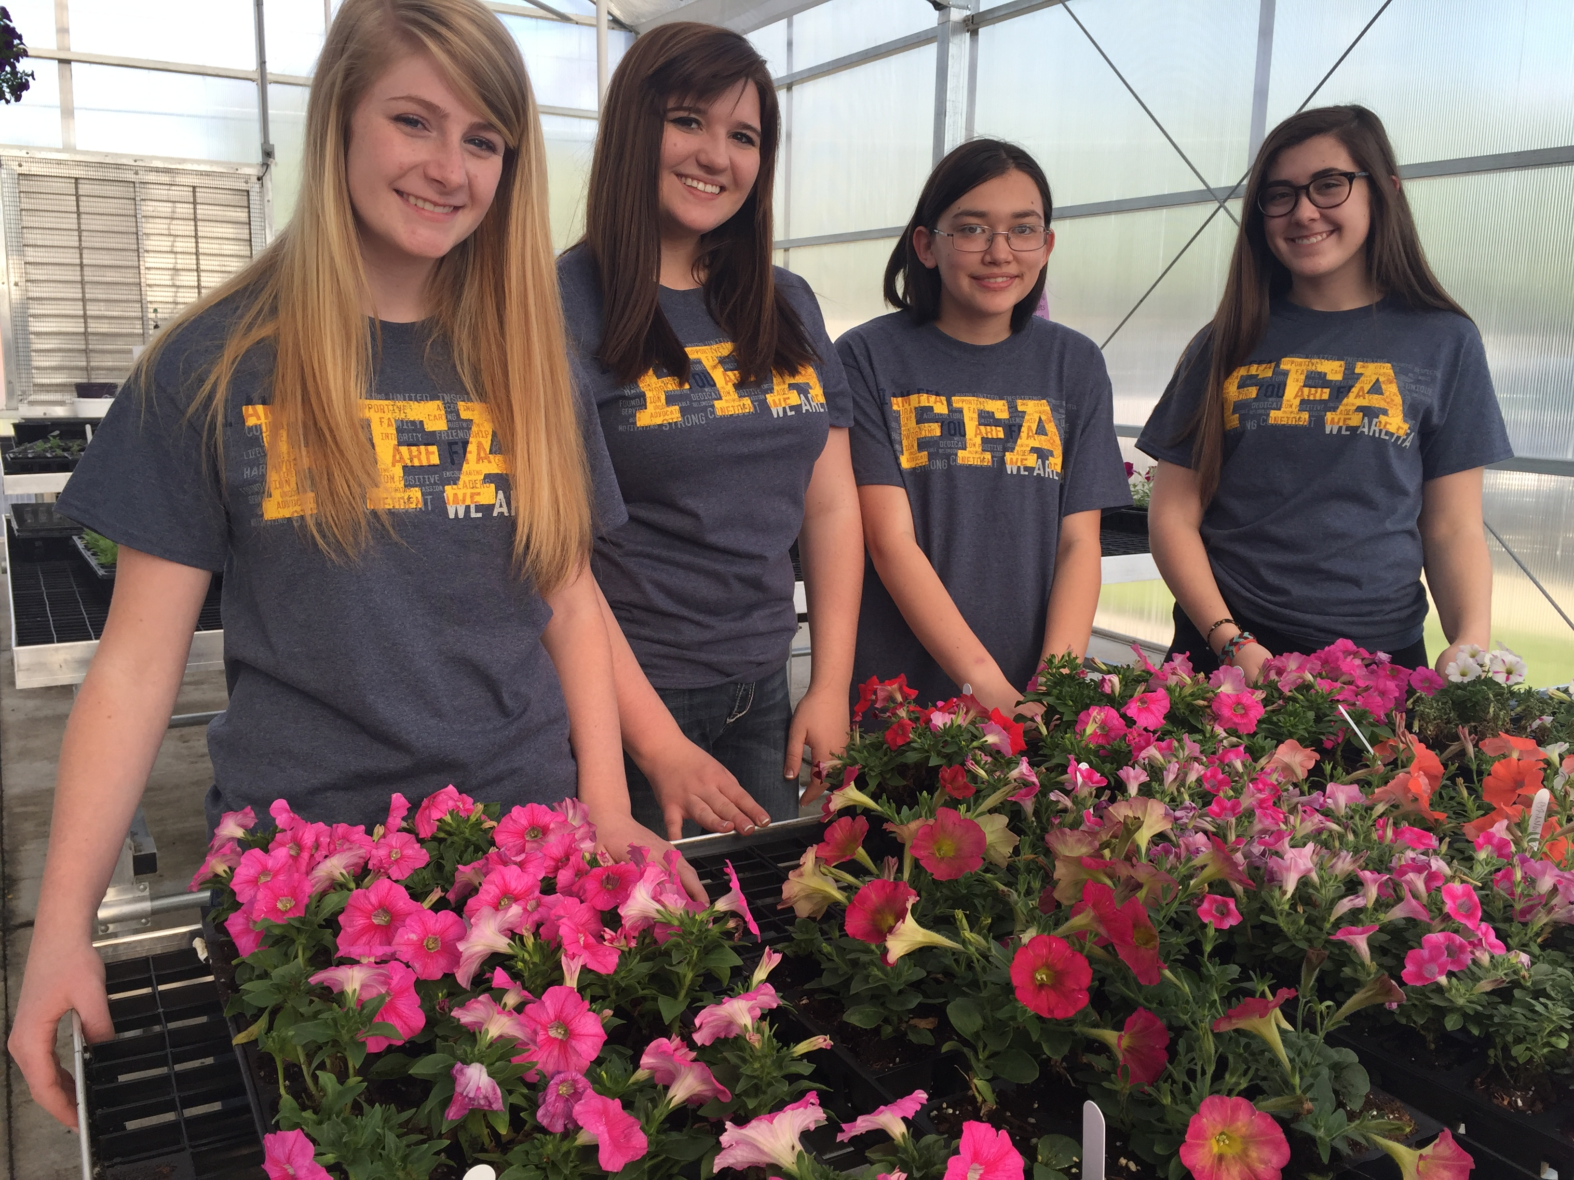
Chapter FFA Members
National FFA Week is a time to
celebrate FFA and the chapter at
your school. Take the time to engage members and have fun through a variety of activities. Prior to the week, form committees to plan ideas and involve different members to help every member gain even more leadership skills.
FFA Alumni and Supporters
FFA Alumni and Supporters can assist in helping to plan, coordinate and execute events throughout the week. These individuals can also provide support in the form of funds, grant access and supplies for functions. National FFA Week is also a great time to thank FFA Alumni and Supporters through recognition events.
General Student Body
This is a great week to share FFA with the general student body to allow them to learn about agriculture and the opportunities available. This also provides an opportunity to possibly recruit new members or students into the agriculture classroom. Take the time to engage students outside of FFA to create a tighter-knit student body.

Advisory Committee
The advisory committee is a great way to gain support and feedback on the events being planned. This is also a great time to thank your advisory committee members for their support and help.

Planning
A lot happens during National FFA Week. Use these resources to begin planning the most impactful FFA Week for your chapter. In the list below, you will find ideas and templates for implementation within your chapter.
- Engagement Ideas
  - Discover ideas for engaging all students, FFA members, alumni and supporters, administrators and teachers. Additionally, gain ideas for service opportunities, fundraisers and school dress-up days.
- Example of a National FFA Week Plan
  - Use this example to see how a National FFA Week full of activities may look.
- National FFA Week Plan Template
  - Use this template to plan activities for each day of National FFA Week.
- Example of a National FFA Week — Daily Activity Plan
  - Use this as an example of how one day during National FFA Week can be planned out so that nothing is forgotten.
- National FFA Week — Daily Activity Plan Template
  - Use this template to plan one day during National FFA Week in detail so that nothing is forgotten.
- Example Timeline to Prepare for FFA Week
  - Utilize this timeline as an example of how to plan for a successful National FFA Week. The examples listed can be used as idea starters for you and others involved in FFA Week planning.
- Your Chapter Timeline to Prepare for FFA Week
  - Use this template to plan your own National FFA Week.
- Sponsorship Toolkit
  - Use this toolkit to help you approach local businesses and partners to ask for help and/or donations.
- Give FFA Day
  - Information about Give FFA Day and how it can be supported by your chapter.
- FFA T-shirt Design Brainstorm
  - Utilize this template to brainstorm National FFA Week T-shirt designs.
- School Board Meeting Presentation Planning Template
  - Utilize this template to plan a presentation to the school board.
- Scavenger Hunt
  - A scavenger hunt can be a great way to get students excited and involved both in and out of the classroom. Three different types of scavenger hunts with which to engage students have been included.
- National FFA Week Box Exchange
  - Connect with another chapter by coordinating a box exchange.
- Agriculture Trivia
  - Agriculture trivia can be a great way to engage all students, faculty, staff and administration by introducing a competitive and fun game that can be played each day during lunch, during morning or afternoon announcements or in your classroom.
- Agricultural Literacy Coloring Pages
  - Use these coloring pages to engage elementary students in agricultural content during an agricultural literacy day or event.
- The National Chapter Resource and Recognition Guide
  - Use this resource to help make planning intentional to ensure it links to the overall purpose of National FFA Week.
Engagement Ideas 
Below is a collection of ideas to assist you in engaging each group of individuals in celebrating National FFA Week.

All Students
- Agriculture Trivia: Use the attached trivia questions for morning announcements or in your class.
- Scavenger Hunts: Attached are three types of scavenger hunts, one for around the classroom, one for around the school and one for around the community.
- Encourage FFA members to invite a nonmember to the next FFA chapter meeting.
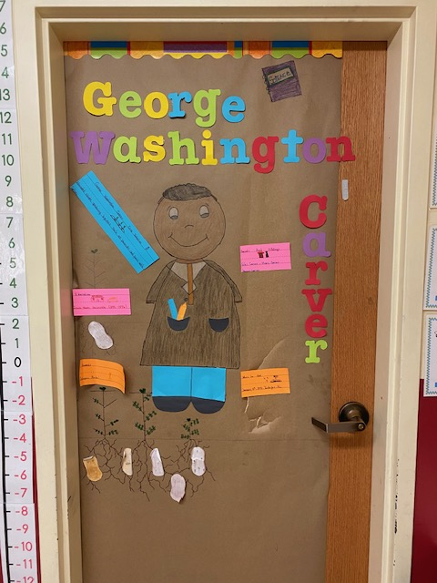
- Agriculture/FFA Facts Bulletin Board: Decorate a bulletin board in the hallway of the school to showcase FFA or agriculture facts.
- Penny Wars: Create a competition between classes to see who can raise the most pennies during FFA Week (the winning class could get a prize); donate the money that was raised to a local cause.
- Classroom Door Decorating: Create a competition between classes that requires classes to decorate their classroom doors in an agricultural theme; the winning class could get a prize.
- Drive a Tractor or Truck to School: Invite students to safely drive their tractors or trucks to school; work with your administration to organize a parade.
- Hat Day: Sell tickets for a dollar that will allow students to wear a hat on a specific day; donate the money that was raised to a local cause.
- Movie Night: Host a movie night with a family-friendly agriculture-themed movie to bring students and families together (movie options include Temple Grandin, Charlotte’s Webb and Ferdinand).
- FFA Pie in the Face: Ask several teachers or use your officers as candidates to be pied in the face. Allow them to decorate a shoebox to collect money in. The person with the most money will be pied, and you can donate the money you raised to a local cause.
- Host an “Ag Olympics” by organizing agriculture-themed games like wheelbarrow races, hay-bale tossing, stick-horse racing, milking a fake cow using calf bottles, roping a fake steer, etc.
- Host a breakfast or lunch featuring local produce, dairy or meats, showcasing the importance of supporting local agriculture.

FFA Members
- Members Only Lunch: Host a pizza lunch or cookout in the agriculture room during the lunch period(s) for FFA members only.
- Chapter Box Exchange: Work with another agriculture teacher in a different region or state to do a box exchange to learn more about each other’s programs.
- Chapter Kickball Game: Create kickball teams within your chapter or invite nearby chapters to play a kickball game during FFA Week.
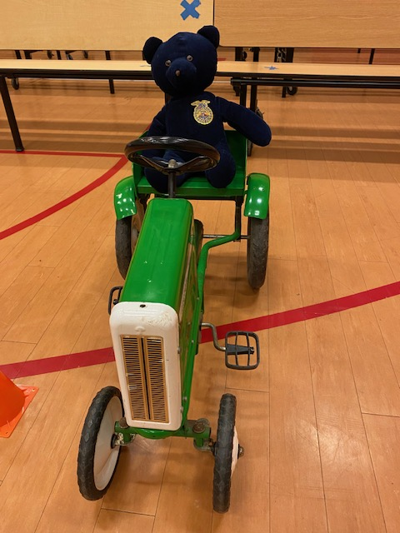
- FFA Member Yard/Locker Signs: Create FFA member signs or magnets that students can post in their front yards or on their lockers to show pride in being a member.
- Signing Day: Host a signing day during a school assembly where students can “sign” their commitment to their career field, college, trade school or FFA membership.
- FFA Wristbands: Give wristbands to your FFA members at the beginning of the week. Each day they visit the agriculture classroom and show their wristbands, give them a treat for members only.
- Chapter Meeting: Host your regular chapter meeting during FFA Week so your members can celebrate FFA together.
- Invite a State Officer: If your state officer team can be requested for chapter visits, request a visit during FFA Week.
- FFA Member Bingo: Use this bingo card to encourage your FFA members to get to know one another better by collecting signatures.
- FFA Talent Show: Organize a talent show where students can showcase their agricultural skills, such as roping, storytelling or showing off their projects.
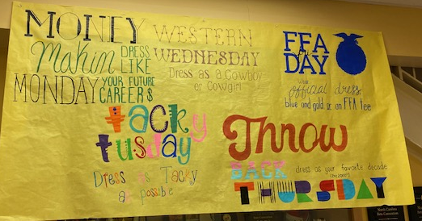
Dress-Up Days
- American Day/Patriotic Day
- Official Dress Day/FFA T-Shirt Day/Wear Blue Friday
- Camouflage/Blaze-Orange Day
- Character Day (superhero, movie star, cartoon, etc.)
- Farmer Day/Western Wednesday
- Ag Career Day
- Animal Day
- Throwback Thursday (vintage/retro)
- Twin Day

School Staff
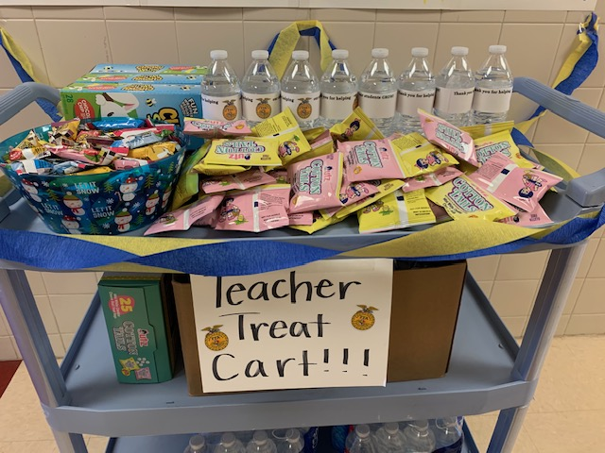
- Thank You Notes: Have your agriculture students and/or FFA members make and write thank you notes for teachers, administrators, janitors, cafeteria workers, bus drivers and other staff members.
- Staff Snack Cart: Use a cart to deliver fun snacks and drinks to staff members around the school. Get your FFA members in official dress to deliver the snacks and drinks.
- Meals for Staff: Host a potluck or catered meal for your staff members (pancake breakfast, catered lunch, after-school dessert).
- Plants for Staff: Gift extra plants from the greenhouse to your staff members. (Succulents make easy gifts!)
- FFA Alumni Staff Display: Ask staff members at your school if they were in FFA and if they still have their jackets; put the staff FFA jackets on display in the hallway.
- School Board Presentation: Request a presentation spot for the school board meeting that happens in the month of February to educate board members about FFA week.
- Staff CDE Stations: Work with your administration to allow your officers/members to host CDE stations at a staff meeting. This will allow staff members to understand the contests your FFA members compete in.

Alumni and Supporters
- Chapter Meeting Invitation: Invite your alumni and supporters to attend your FFA chapter meeting or another FFA Week event; organize an alumni versus FFA member game like kickball, softball or basketball.
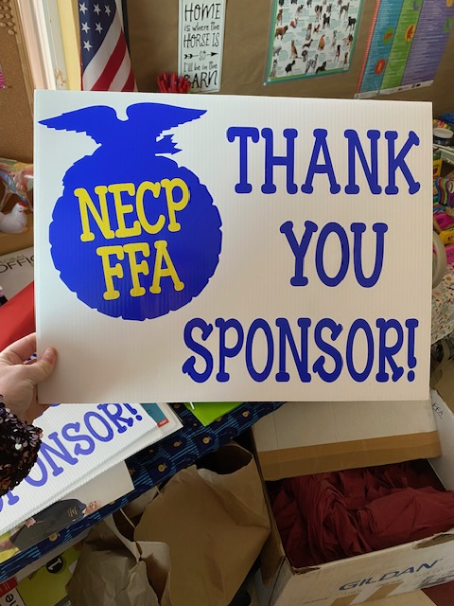
- Forever Blue Network (FBN): Reach out to your alumni and supporters and encourage them to join the FBN.
- FFA Call-a-Thon: Organize a call-a-thon where your FFA members can call your alumni and supporters and tell them thank you for being involved in alumni or for donating to and supporting the chapter.
- Sponsor Visits: With FFA members in official dress, visit local businesses that have sponsored your chapter; present them with a certificate or a gift as a thank you for supporting the chapter (yard signs are a hit!).
- Sponsorship Drive: If you still need to collect sponsorships for an FFA event (such as a banquet), use the time during FFA Week to visit local businesses and ask for sponsors (use this resource).
- FFA Open Mic: Partner with a local restaurant or coffee shop to host an open mic night where FFA members can showcase their talents.
- FFA Proclamation: Work with your town mayor or town manager to create a proclamation that will be presented at the February town hall meeting to recognize FFA Week. (Use this guide to help or this template.)

Service
- Build a Little Free Pantry for your community (see plans here).
- Start a Little Free Library for your community. Consider stocking it with books about agriculture.
- Complete a roadside or waterway clean-up project.
- Read children’s books about agriculture to local daycares or host a reading time at your local library.
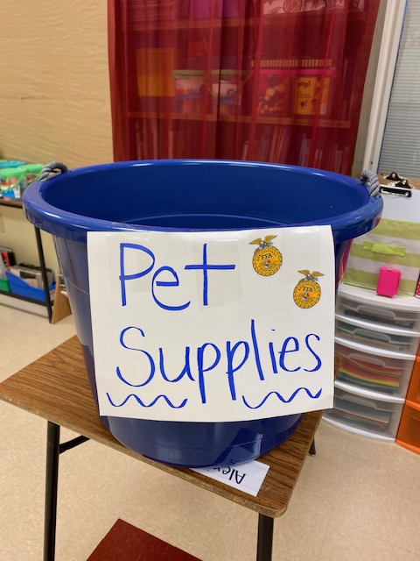
- Clean up your local fairgrounds or park or a nearby waterway.
- Start a school beautification project such as planting flowers, painting murals or creating outdoor learning spaces.
- Volunteer at your local soup kitchen, mission or food pantry.
- Walk dogs or play with cats at a local animal shelter.
- Host a canned food drive, toiletries drive or toy drive at your school.
- Create goody bags for the local nursing home.
- Check out some of the ideas in the “All Students” section above that highlight raising money to donate!
- Partner with your feeder schools (elementary or middle) and send FFA members to the schools to read agricultural children’s books or teach an agriculture lesson.
- Start a mentorship program with younger students. Teach them about agriculture, leadership and community service.
- Host an agriculture field day and invite the community or the feeder schools to attend.

Fundraisers
- Sell dinner plate tickets (spaghetti dinners, chicken plates, barbeque plates, etc.).
- Host a family bingo night — sell bingo cards, get donated prizes, incorporate a dinner or desserts.
- Organize a chili cook-off or pig-cooking contest.
- Set up a table at Tractor Supply (or another local hardware/farm store) to sell FFA T-shirts, baked goods, etc.
- Work with your local fairgrounds to put on a livestock show.
- Plant sale. Consider selling flowers, vegetables, herbs or succulents.
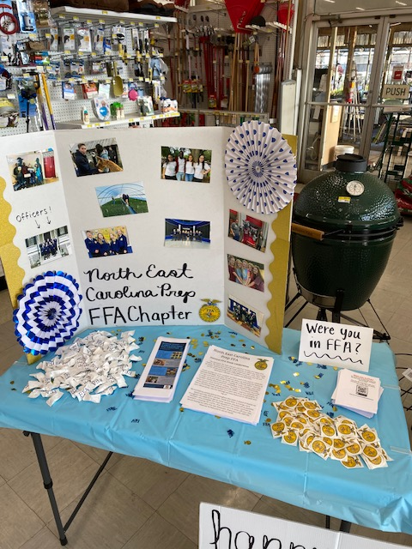
- Check out some of the ideas in the “All Students” section above that highlight ideas for raising money.
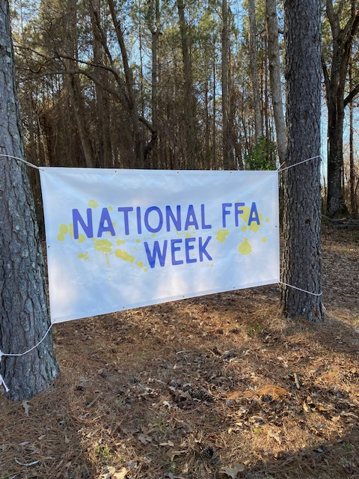
Use the FFA Activity Resource Guide to generate ideas for activities during FFA Week or all year.

Example of a National FFA Week Plan
Below is an example of a National FFA Week that a chapter may have planned. A template follows to help you plan your own week.
Day of the Week | Events
Saturday | - Host a chili cook-off and bags/cornhole tournament.  - Deliver yard signs to FFA member homes or place magnets on lockers.  - Make the chapter profile picture blue. #FFAWeek @NationalFFA
Sunday | - Have an FFA officer/FFA Week committee meeting to finalize details for the week.  - FFA pizza party at a local restaurant or meeting place  - Write thank you notes to alumni and supporters to be delivered during the week.
Monday | - Dress-up Day: All-American Day  - Morning announcement over the intercom, through social media or via a podcast episode  - Lunchtime trivia/trivia question of the day (first to respond wins)  - Volunteer in your community by cleaning up the side of the road by your school.  - Present at the school board meeting.
Tuesday | - Dress-up Day: Career Day — dress up for a future career  - Morning announcement over the intercom, through social media or via a podcast episode  - Alumni and Supporters Breakfast  - Have alumni or supporters serve as guest speakers and talk about their careers.  - Dodgeball tournament after school  - Write thank you notes and send them to alumni and supporters.  - Have a scavenger hunt based on career pathways (students will take pictures of themselves with a business or item from each career pathway).
Wednesday | - Dress-up Day: Dress Like Your Favorite Teacher Day  - Morning announcement over the intercom, through social media or via a podcast episode  - Deliver slices of pie to all school staff to support staff and administration.  - Have a pie-eating contest during each lunch period.  - After school, travel to the local humane society to walk dogs, play with cats and clean the facilities.
Thursday | - Dress-up Day: College Day — wear your favorite collegiate apparel  - Morning announcement over the intercom, through social media or via a podcast episode  - Have a collegiate FFA alumni member serve as a guest speaker.  - Movie watch party  - Encourage friends and family to give to FFA today! #GIVEFFADAY #FFAWeek  - Use the toolkit at FFA.org/GiveFFADay.
Friday | - Dress-up Day: Wear Blue!  - Morning announcement over the intercom, through social media or via a podcast episode  - Determine how many corn kernels are in the jar.  - Travel to the elementary school during class to read to elementary school students or read virtually.  - Basketball game canned-goods drive
Saturday | - Volunteer at a soup kitchen, mission or food pantry.  - Travel to a local nursing home and wave or sing to local residents.
Need ideas, tips and tricks for incorporating social media into your weeklong plan? Check out these resources in the Media, Promotion and Advocacy section!

National FFA Week Plan Template
Check out the editable version here.
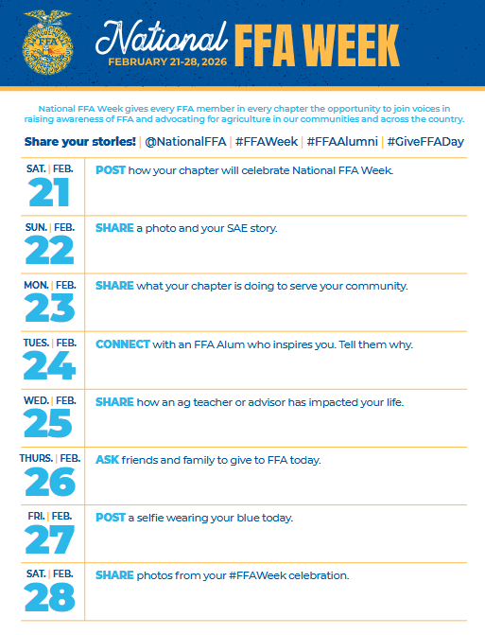
Example National FFA Week — Daily Activity Plan
Use this as an example of how one day during National FFA Week can be planned out so nothing is forgotten.
Day: Friday
Events | Description | Supplies Needed | Support | Steps/Tasks to Complete | Who Is Involved?
Morning School Announcement | Have an FFA officer make an announcement over the intercom. | - Script of what the officer is going to say | - Advisor  - Administration | - Gain permission from administration.  - Develop a script.  - Have the advisor look over and approve the script.  - Announcement | - FFA members  - Students outside of FFA  - Staff, support staff  - Administration
Dress-up Day: National Wear Blue Day | Invite everyone in the school to wear blue. Have the yearbook club/class take a picture of everyone wearing blue! | - Those participating will need something blue to wear. | - Advisor  - Administration | - Get approval from the advisor and administration.  - Make announcements over the intercom.  - Make and post dress-up day fliers.  - Dress up! | - FFA members  - Students outside of FFA  - Staff, support staff  - Administration
Count the number of corn kernels in the jar. | Have students at lunch try to guess the number of corn kernels in the jar. Have a treat (Ex. Candy bar, gift card, school T-shirt) for the person that gets closest to the actual number. | - Mason jar  - Corn kernels (any grain can be used)  - Reward (Ex. Candy bar, etc.) | - Advisor  - Administration | - Gain administrator and advisor approval.  - Gather the supplies for the event. (Ask around school or throughout your community for the necessary supplies.) Don’t forget a reward for the winner!  - Have the officers sign up for their lunch period to be in charge of the event.  - Complete the event during lunch. | - FFA members  - Students outside of FFA
Basketball game canned foods drive | Have students and community members attend the basketball game and gain admission by donating canned goods. Hand out FFA shirts during half-time for rewards for games. | - Collection boxes  - T-shirts  - Vehicle for transport of the canned goods that are collected | - Advisor  - Administration  - Alumni and supporters  - Parents  - Athletic director | - Gain advisor and administration approval.  - Meet with the athletic director to gain approval.  - Contact parents, supporters, alumni and FFA members to work the game (some collect cans while others work the half-time event).  - Contact the local food pantry/bank to discuss items that can be donated and to notify them of the delivery.  - Have an alumni, supporter or parent supply a truck to transport goods that are collected.  - Buy or get donated shirts to hand out at half-time.  - Have FFA members load the delivery vehicle.  - Prepare and deliver thank you cards to the administration and athletic director. | - FFA members  - Students outside of FFA  - Parents  - Alumni and supporters  - Community members

National FFA Week — Daily Activity Plan Template
Use this template to plan one day during National FFA Week. Creating a careful plan ensures nothing is forgotten.

Day: ___________________
Events | Description | Supplies Needed | Support | Steps/Tasks to Complete | Who Is Involved?
Example Timeline to Prepare for FFA Week
Utilize this timeline as an example of how to plan for a successful National FFA Week. The examples listed below can be used as idea starters for you and others involved in FFA Week planning. The following page has a blank template for you to use.
September
- Have the National FFA Week committee meet to begin mapping out activities and events for each day (this may take multiple meetings).
August
- Host an FFA meeting to put together a committee to plan and execute National FFA Week. Examples of committee members: FFA members, FFA officers, alumni and supporters, administration, etc.
Your Chapter Timeline to Prepare for FFA Week
November
- Gain administrator approval of events, dress-up days, service activities, etc.
- Begin reserving any spaces needed (Ex. gym) for events.
- Start getting donations if funds, items, etc. are needed. Need help asking businesses for support? Use the Proposal Letter Template.
- Design and vote on a chapter T-shirt for the week. Use the FFA T-shirt Design Brainstorm worksheet to sketch out ideas.
Don’t forget to link to your Program of Activities when planning your own timeline (also available in Google Docs)! The National Chapter Resource and Recognition Guide is also a great resource.
January
- Send letters and invitations to community members for any events they are invited to.
- Make posters for school advertisement (make sure to get administrator approval).
- Place any last-minute orders (Ex. cookies, pies, breakfast materials).
- Plan any social media posts and get approval. Use the National FFA Week on Social Media 2025 template to help plan and get approval.
- Write any thank you notes that are to be given out.
December
- Begin contacting any alumni and supporters who will help with your FFA Week activities.
- Place orders for any giveaways you may be planning to hand out (Ex. shirts, FFA pins, etc.).
- Determine any individuals that will be recognized during the week and print certificates (Ex. administrators, etc.).
October
- Gain chapter officer and advisor approval of National FFA Week activities.
Utilize the following template to help you plan what you need to do each month leading up to National FFA Week.
January
November
September
August

October

December

Don’t forget to link to your Program of Activities when planning your own timeline (also available in Google Docs)! The National Chapter Resource and Recognition Guide is also a great resource.

Sponsorship Toolkit
Planning for a Potential Partner Meeting or Call

Pre-Planning
- What are your goals for the visit or call?
  - It is important that you have a clear idea of what the expected outcomes of the call or visit are so the agenda can be developed appropriately.
  - If the agenda is too vague, the meeting will not focus on the issues that need to be addressed.

- How much do you know about the company? How much do you know about the person you will be calling or meeting?
  - Take the time to conduct some simple research about the company:
    - What kinds of projects does the company produce or support?
    - What connections can you make with the company’s mission and goals?
    - Make as many connections between your organization and the company as possible.
- Is the person with whom you will be meeting a decision maker, or will this person need to take your information and requests to a superior?

During the Meeting or Call
- Come prepared with opportunities for engagement.
- Have ideas of possible opportunities for involvement by the potential partner.
  - Sponsorship
  - Judges
  - Mentors
  - Events
  - Fundraisers
- Even if the meeting or call only lets you know what the company is NOT interested in, the meeting will at least give you information that can be used in a follow-up call.
- Your preparation for the meeting demonstrates how interested you really are in the company.

What to Leave Behind and Next Steps
- Make sure to leave behind a piece of information that the potential partner can use to evaluate possibilities with your organization (i.e., FFA one-page facts sheet, impact report, visibility plan) and easily share with others.
- A pin or some sort of giveaway with the school’s or FFA chapter’s name on it is also a nice touch.
- Make sure that the next steps and roles are defined before the meeting or call ends.
- Prompt and proper follow-up should be conducted after a promising meeting so that your effort is not lost.

Ask Questions and LISTEN
- Don’t be the only one doing the talking. Allow the potential partner to share information about the business and offer ideas on how a partnership/relationship might be mutually beneficial.
- Keep your presentation brief and elaborate as questions are asked.

Potential Partner Questions
- What has your exposure to our organization been?
- What interests you most about our organization?
- What other types of organizations does your company partner with?
- What does a successful partnership look like to your company? Does it include employee engagement, brand awareness and equity, student recruiting, connecting other companies to our mission, special perks or something else?
- What are the most critical results you would expect to see from this partnership?
Tips for Asking Local Businesses for Donations
- Include personal stories and the impact that donations can make.
- Keep a spreadsheet of donors with contact information, donation description, and any benefits or visibility they received.
- Businesses may be more likely to give if they are offered visibility.
  - Signs or banners in the agricultural education classroom or meeting/event locations
    - Could be specific (Snack Cart provided by)
  - Verbal recognition at events
  - Set amount of time to speak at an event
  - Sponsorship mentioned in the local newspaper
  - Social media shout outs
  - Business logo on any printed materials for events (Special thanks to our sponsors with their logo)
    - Programs
    - Table tents
    - Signage
  - Allow them to provide giveaway items (pens, hats, reusable bags) or coupons.
- Individuals and businesses may be more likely to continue sponsorship if they get special perks.
  - VIP seating and/or early admission
  - Meet and greets
  - T-shirt or gift
- Visibility plans could encourage higher levels of donations (see the Sample Sponsorship Levels below).
  - Get creative: use themed names for the sponsorship levels.
  - If you have any analytics about your program or event, share those. For example, 200 students and their families will see the business logo, or the chapter Facebook page has 200 followers.
- Thank sponsors after events or at the end of the school year.
  - Handwritten notes from students
  - Email
  - Social media
  - Include statistics
  - Include a picture
  - Plaque for their business
  - Banquet recognition
- Be consistent. Individuals and businesses may notice if others get extra benefits.
- In-kind donations are a great option for businesses that can’t donate money.
  - Food and beverages
  - Flowers and plants
  - Decorations
  - Printing and signage
  - T-shirts
- Businesses that can’t give cash or checks may be able to donate gift cards.
  - Gift cards can be used for giveaways, silent or live auctions and raffles.

Sponsorship Planning Worksheet

Planning for a Potential Meeting or Phone Call
Pre-Planning
Who are you calling and/or visiting?

_______________________________________________________________

- What are your goals for the visit or call? Two to three goals are usually a good start!

- What do you know about the company and the person you will be calling?

What kinds of projects does the company produce or support?

What connections can you make with the company’s mission and goals?



- Develop the agenda for the meeting or call here.



During the Meeting or Call
Use this space to brainstorm how you will introduce yourself and your purpose for the call or meeting. Don’t forget to include yourself and the purpose!

How can this company or person become involved and engaged? (Ex. sponsorship, judging, etc.)

Brainstorm a list of questions or points you want to remember for the meeting or call.



Tip: Set up questions so you are not doing all the talking.

What to Leave Behind and Next Steps
What can or will you leave behind? (Ex. FFA one-page fact sheet, impact report, visibility report, pins, etc.)

Don’t forget to thank individuals and businesses for their time!
What date will you follow-up?

_________________________

How will you follow-up? (Ex. phone call, letter, in person)

Sample Sponsorship Levels

(Name of Chapter) FFA Chapter
(Optional: insert specific event)
Sponsorship Levels
Forever Blue Sponsor $2,000+
- Opportunity to speak at event for up to five minutes
- Business logo on chapter website
- Business logo on event signage
- Business name on award plaque
- Opportunity to provide coupons or promotional materials
- Business logo in promotional email
- Business logo included on promotional and event materials
  - PowerPoints, printed flyers, programs, table tents, etc.
- VIP seating at chapter banquet
- Verbal recognition at event
- Social media recognition

Gold Sponsor $1,000 — $1,999
- Opportunity to provide coupons or promotional materials
- Business logo in promotional email
- Business logo included on promotional and event materials
  - PowerPoints, printed flyers, programs, table tents, etc.
- VIP seating at chapter banquet
- Verbal recognition at event
- Social media recognition

Silver Sponsor $500 — $999
- Business logo included on promotional and event materials
  - PowerPoints, printed flyers, programs, table tents, etc.
- VIP seating at chapter banquet
- Verbal recognition at event
- Social media recognition

Find an editable version here.

Sample Proposal Letter Template 1
Date

Name, Title
Company
Street Address
City, State and Zip

Dear (Name):

(Name of School) has (#) National FFA Organization members who are training to become the next generation of leaders to change our world. The FFA mission is to make a positive difference in the lives of students by developing their potential for premier leadership, personal growth and career success through agricultural education. FFA develops members’ potential and helps them discover their talents through hands-on experiences, which give members the tools to achieve real-world success.

As part of their FFA chapter experiences this school year, our students would like to (hold a classroom competition, attend a state or national conference, etc.). The (Chapter Name) FFA Chapter and I are writing to ask for your assistance. We are requesting that your organization/business provide/donate (make your special request such as materials or personnel to help judge an event) in support of this program.

(If there is an event, list the date, time and details here. Mention any recognition of sponsorship the company will receive in exchange for their sponsorship, goods or service.)

I hope we can count on your support of our students in this opportunity. I will call you in a few days to gather your feedback on this request and to find out any steps necessary to proceed. If you prefer, you may call me at (phone number) or send me an email at (email address) to let me know if your support of (Chapter Name) FFA might be possible.

As you and your colleagues are considering ways to impact our local community, consider (Chapter Name) FFA as a way to make a lasting impact. Thanks in advance for your support of agricultural education and young people who are learning to do, doing to learn, earning to live and living to serve.

Sincerely,

Name of instructor, alumni member or chapter officer
Title

Find an editable version here.

Sample Proposal Letter Template 2
(Chapter Name) FFA (Event)
Providing the Next Generation of Leaders Who Will Change the World
Date


(Student Name) walked into (his/her/their) first agricultural education class not knowing what to think. (He was/She was/They were) shy and didn’t grow up on a farm. Four years later, (student first name) says agriculture classes and (Chapter Name) FFA helped (him/her/them) grow into a leader in the school and community.

As part of (his/her/their) FFA experience, (student's first name) learned (hands-on skill). (He/She/They) also learned about the food insecurity needs in our community. (Student first name) and (his/her/their) classmates developed a program to supply food to the local food pantry to help those in need. In (month), (student first name) and (# of students) presented their project to the city council and encouraged local leaders to find more ways to address food insecurity in our community.

This fall, (student first name) plans to enroll at (college) as a freshman studying (major). (He credits/She credits/They credit) (his/her/their) involvement with FFA for helping (him/her/them) realize that everyone can be a part of agriculture and feeding the world. (Student first name) now has the confidence and passion to help others and make a difference.
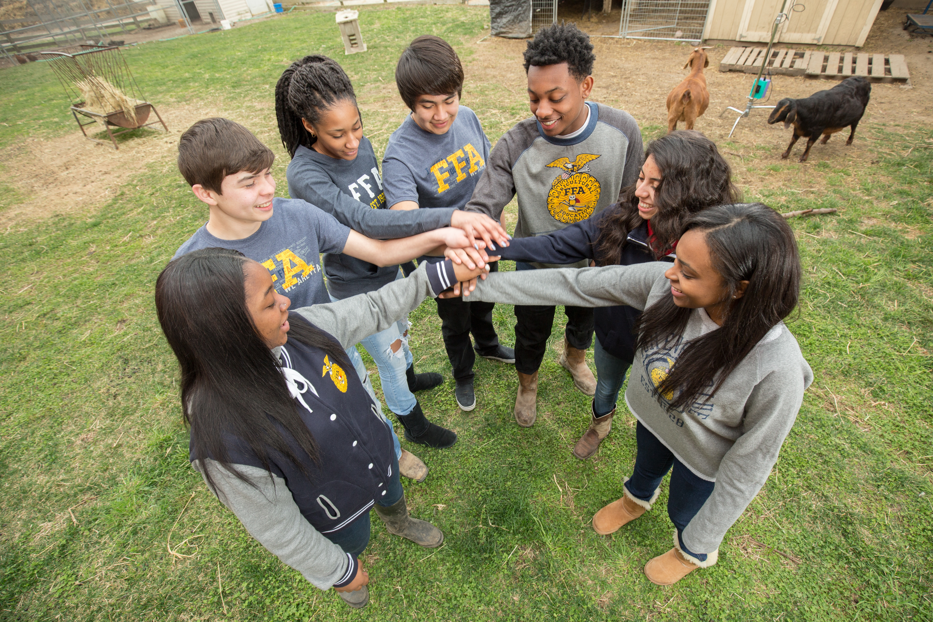
The (FFA Alumni and Supporters) is proud of (student first name) and all the local agricultural education students. We’re thrilled to play a small role in helping them become student leaders on a path to personal and career success.

Join us in supporting the next generation of leaders who will change the world! Become a sponsor of FFA.
Your sponsorship dollars will:
- Help fund FFA activities to give teachers more time to focus on the classroom.
- Promote agricultural literacy.
- Develop student leadership skills.
- Prepare students for a wide variety of career opportunities.
A range of sponsorship options means you can choose the level of support that meets your budget and impact goals. Please commit today to the sponsorship level that is right for you and see the attached form for more sponsorship details.

Forever Blue,

Name of Alumni Member
Alumni and Supporters Chapter Name

Find an editable version here.

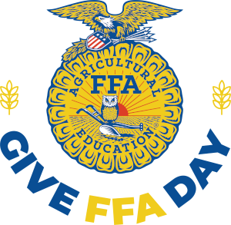
Give FFA Day

What Is Give FFA Day?
Give FFA Day is the day each year during National FFA Week that we encourage members, alumni and friends of FFA to show their support through a philanthropic gift. These donations help fund the programs that make a difference in the lives of students. Donations of all sizes are magnified when they become part of this larger giving effort.

When Is Give FFA Day?
Give FFA Day will be the 24 hours of the Thursday of National FFA Week. All donations made during those hours — no matter the time zone you live in — will be counted toward the Give FFA Day totals.

Why Should I Support Give FFA Day?
Give FFA Day is your chance to make the most out of your gift to FFA and show off your FFA pride. Every donation will count toward matching gifts throughout the day and each campaign description provides more information of what your gift would go toward.

How Can I Support Give FFA Day?
There are several ways you can help make Give FFA Day a success:
- Use the social media toolkit at GiveFFAday.FFA.org to help spread the word. Use the Save the Date graphics to invite your family and friends to join you in supporting FFA.
- Check your state FFA foundation’s website for details about your state’s Give FFA Day plans.
- Host an online or in-person watch party to join with others who support FFA and celebrate the donations coming in.
- Challenge FFA supporters in your area to meet a donation goal or offer a matching donation to incentivize others to support FFA.
- Donate and, on your social media accounts, share the news that you have donated with an invitation to your network to join you in supporting FFA.

Who Can I Contact With Additional Questions?
You can contact Kimberly Coveney at kcoveney@FFA.org or 317-802-4344.



FFA T-Shirt Design Brainstorm
Use this template to sketch design ideas for a custom National FFA Week shirt for your chapter! Be sure the shirt has been approved by the chapter advisor and school administration before sending to production.

Front
Back

School Board Meeting Presentation Planning Template
Use the following template to help prepare FFA members to present at a school board meeting. Be sure to go in Official Dress!
_____________________________________________
Welcome and Membership Update
National FFA Week Highlights and Invite
_____________________________________________
_____________________________________________
_____________________________________________
_____________________________________________
_____________________________________________
_____________________________________________
_____________________________________________
_____________________________________________
_____________________________________________
Accomplishments So Far This School Year
_____________________________________________
_____________________________________________
_____________________________________________
_____________________________________________
_____________________________________________
_____________________________________________
_____________________________________________
_____________________________________________
_____________________________________________
_____________________________________________
_____________________________________________
_____________________________________________
_____________________________________________
_____________________________________________
_____________________________________________
_____________________________________________
_____________________________________________
Additional Information to Share
_____________________________________________
_____________________________________________
_____________________________________________
_____________________________________________
_____________________________________________
_____________________________________________
_____________________________________________
_____________________________________________

Scavenger Hunt
A scavenger hunt can be a great way to get students excited and involved both in and out of the classroom. Below you will find three different types of scavenger hunts with which to engage students.
Scavenger Hunt in the Classroom
Prep:
- Select the trivia questions you would like to use. (Tip: Use the FFA Facts or Agriculture Trivia to save time!)
- Print and cut out each question separately.
- Number each trivia question.
- Create an answer key.
- Hide each question around the classroom or agriculture facility.

Student Instructions:
- Students will need their own notebook paper numbered to match the questions. (The numbers will depend on how many questions you hid around the room.)
- Students will move about the room to find each question. Once a question is found, they will write down the answer on their paper next to the correct number. (If the question says No. 6, they write the answer next to No. 6 on their paper.)
- Once students find and answer all the hidden questions, they turn the paper into the teacher or other designated person.
- Number each paper in the order they come in. (Tip: It is best to stay in one spot while students are moving around the room.)
- Wait until each student has turned in a paper.

Who Wins?
- Grade students with the answer key as papers come in.
- The students who turn in the papers with the most correct answers first wins.
  - Example: If Susie turns in her paper first and misses three, but Juan turns in his paper second and misses zero, Juan wins.
- Recognize the winner! (Award Ideas: extra credit, candy, etc.)

Scavenger Hunt Around the School
- Develop clues that can be linked throughout the school. For example, the corduroy resides here, which would lead students to the FFA jacket closet. Each stop needs to then have a clue to go to the next place.
- Hide the clues in their respective places.
- Have a surprise at the final destination.
OR
- Create a list of items they have to complete and explain how they have to show completion. Examples:
  - Find one friend that is on the livestock judging team. Take a picture with them.
  - Find an administrator and take a picture of you thanking them for their support of the chapter.
  - This is where we “grow” learning, take a picture. (Answer: greenhouse).
  - Score big when you take your shot at success. (Answer: basketball court)
- Hide clues in their respective places.
- Have a surprise at the final destination.
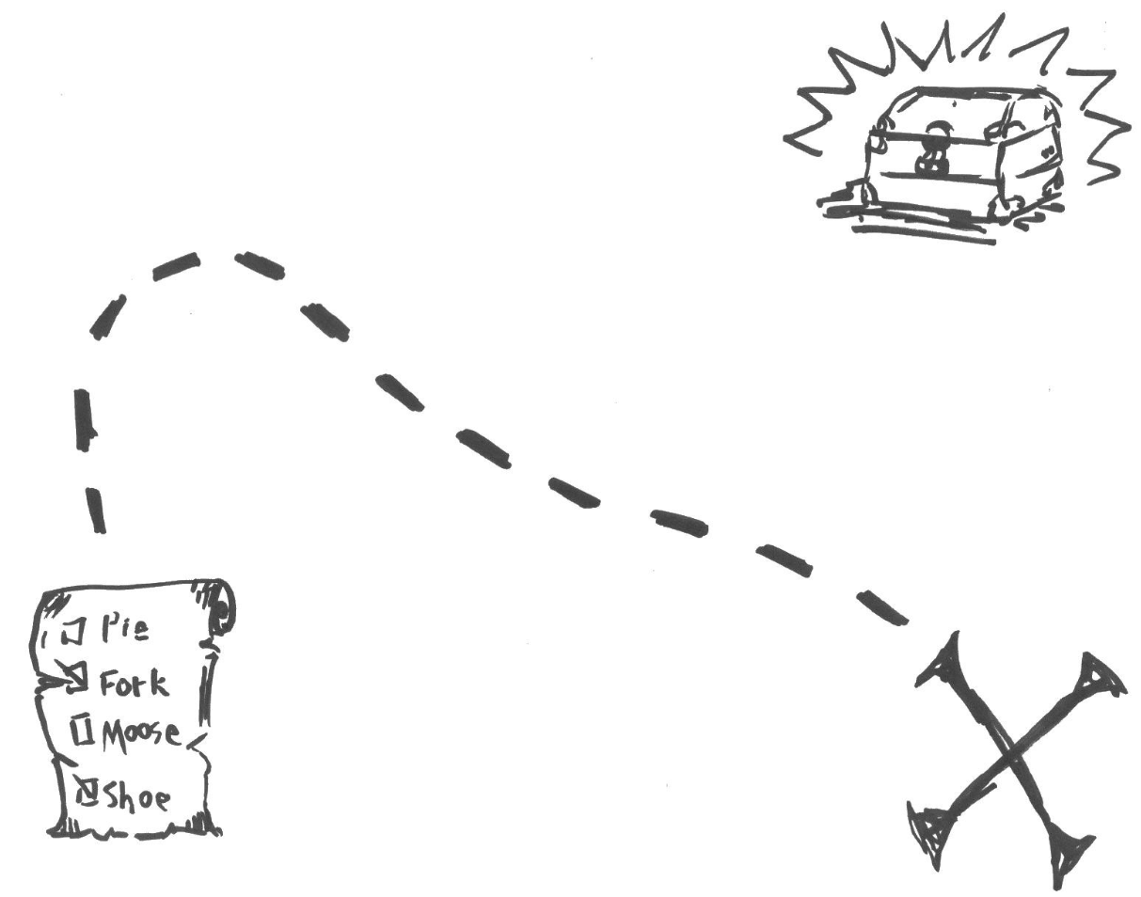
“Ag in the Community” Photo Scavenger Hunt
- Provide students with each of the different focus areas (Agribusiness Systems, Animal Systems, Biotechnology Systems, Environmental Service Systems, Food Products and Processing Systems, Natural Resources Systems, Plant Systems, and Power, Structural and Technical Systems) or the steps of the AFNR Value Chain.
- Have students travel throughout the community and take pictures of themselves at a location that represents/fits into each category.
- Have students send their pictures to a discussion post or share them online through sources such as GooseChase.
- Recognition of the winner:
- Consider having categories to award multiple students. Examples:
  - Most creative picture
  - Most unique site visit
  - Best collage
- Consider using the following to recognize winners:
  - Send out an email.
  - Post a winner video.
  - Host a live winner stream.
  - Place an announcement about the winner on the chapter’s social media.


National FFA Week Box Exchange
Would you love for your FFA members to get a chance to see what other FFA chapters do and to meet other FFA members? This activity provides an opportunity for teachers and chapters to connect.

National FFA Week Box Exchange can be used with officer teams (virtually or in person) or a particular class.
- Using the FFA chapter locator on FFA.org, locate a chapter in an opposite part of the country that would be interested in doing a box exchange. Discuss how many items/what types of items you would like to exchange.
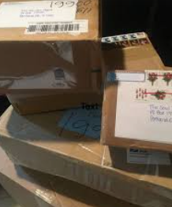

Consider adding some special items that might tell your chapter’s FFA or agriculture story. Have fun!
- Fill your box.
    - Determine items to be included in your box. Use the following list to help:

- Snack Attack Sunday
  - Send favorite bus snacks, CDE cravings, etc.

- Memory Monday
  - Have chapter officers create a five-minute video highlighting their agriculture facility/FFA chapter or what FFA means to them.

- T-shirt Tuesday
  - Do you have a box of old FFA shirts? Send some of your old FFA gear in random sizes and quantities.

- Working Wednesday
  - Send three to five examples of agriculture from your part of the world.
    - Maybe consider sending products from SAEs

- Thankful Thursday
  - Send notes of encouragement to each of the officers.

- Friendship Friday
  - Ask advisors to create a time to have the officer team or chapter members meet up on Zoom or another video conferencing service.
    - Potential Questions
      - What is your favorite community service activity?
      - How do you recruit FFA members?
      - What is your best FFA trip?
      - How do you fundraise?


Agriculture Trivia
Agriculture trivia can be a great way to engage all students, faculty, staff and administration by introducing a competitive and fun game that can be played each day during lunch, during morning or afternoon announcements or in your classroom.
Q: What percentage of U.S. farms are family-owned?

A: 99%
Q: How many acres of land in the United States are dedicated to farming?

A: 914 million acres
Q: What is the most popular meat food in the U.S.?

A: Chicken
Q: Which state has the most farms in the U.S.?

A: Texas
Q: Which state produces the most ducks?

A: Indiana
Q: What agricultural commodity is used to create crayons?

A: Soybeans
Q: On any given day, 1 in 8 Americans will eat this food:

A: Pizza
Q: Who was responsible for establishing the United States Department of Agriculture (USDA) in 1862?

A: Abraham Lincoln
Q: Which honeybees operate the hive and do all the work?

A: Worker bees
Q: About how much water does a dairy cow consume in a day?

A: 25 to 50 gallons
Q: On average, how many people can one American farmer feed?

A: 166 people annually
Q: Ethanol is a biofuel made from what agricultural commodity?

A: Corn
Q: Which branch of horticulture includes growing and marketing plants used in floriculture and landscaping?

A: Ornamental horticulture

Agricultural Literacy Coloring Pages

Use these coloring pages to engage elementary students in agricultural content during an agricultural literacy day or event.
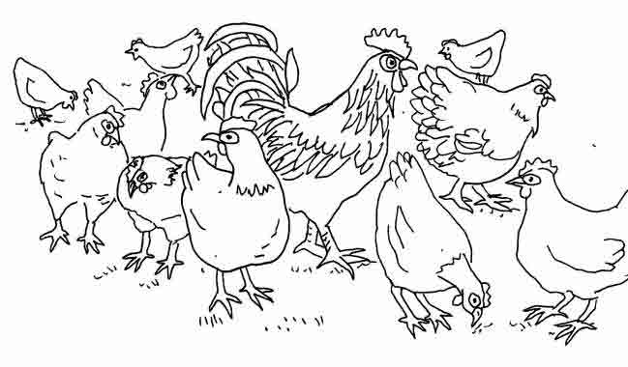
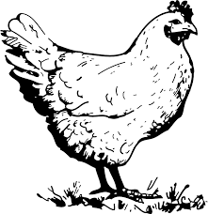
A male chicken is a rooster.
A female chicken is a hen.
Chickens give us eggs and meat.



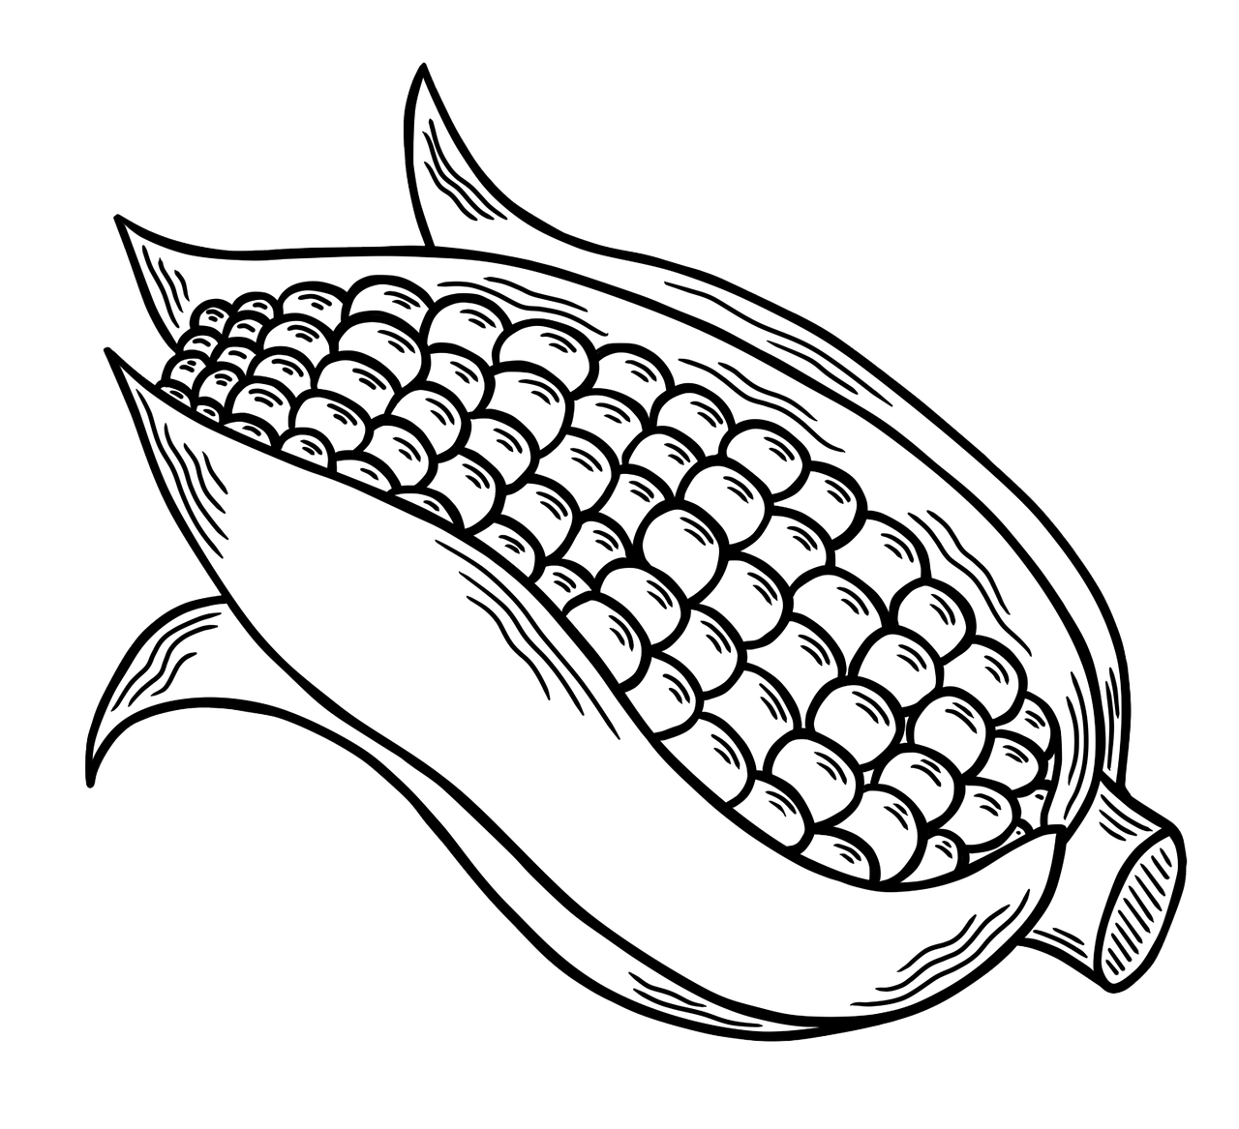


Farmers all over America grow our fruits and vegetables.
Tomato

Strawberry

Carrot

Apple

Grapes

Corn
Draw a line from the fruit or vegetable pictures to the correct name.



There are many careers in agriculture. Color the different examples below.




A veterinarian helps keep pets of all kinds healthy.

A florist will grow and arrange beautiful flowers for you.

A farmer grows plants and animals that we use for food, fiber and fuel.



A scientist is needed in agriculture to study how plants and animals grow and how we can use them. This is called biotechnology.
An agriculture mechanic will build and fix mechanical equipment used in farming, such as tractors.

Alumni and Supporters

Local FFA Alumni and Supporters are a resource of knowledge, skills and interest for helping prepare the future generation of leaders. Taking time to engage with these individuals during National FFA Week is a great way to say thank you, gain support and involve those who have a vested interest.
- Tips and Tricks for Involvement
  - Adult membership is open to anyone who is interested in supporting and promoting agriculture, agricultural education and FFA at the local, state and national levels. If you have individuals that are proud of FFA and want to help local FFA members acquire knowledge and experience from agricultural education and FFA activities, have them become an adult member! Anyone can join at FFA.org/alumni_and_supporters/join-alumni/. If you have not started a local FFA Alumni and Supporters chapter, learn more at https://FFA.box.com/v/start-an-alumni-chapter.
  - Many colleges and businesses have FFA Alumni and Supporter chapters with members that are eager to get involved at the local level! Consider inviting them to be a guest speaker or take a field trip to their location. They may want to help with a fundraiser or share how their FFA experiences led to success.
- Explore the Forever Blue Network
- Junior and senior FFA members along with alumni and supporters can create an account at https://ForeverBlueNetwork.org, and then join groups and events and find mentorships, internships and job opportunities. Use this webquest as a classroom activity.
- ShopFFA Alumni and Supporters
  - ShopFFA provides merchandise ready for the alumni and supporters in your chapter.
Tips for Involvement
Adult membership is open to anyone who is interested in supporting and promoting agriculture, agricultural education and FFA at the local, state and national levels. If you have individuals who are proud of FFA and want to help local FFA members acquire knowledge and experience from agricultural education and FFA activities, have them become an adult member!
- Share stories online with #FFAAlumni

- Register for the Forever Blue Network to connect with other alumni and share with your internal membership (FFA.org/alumnibenefits).

- Publish an article, editorial or blog about FFA experiences.

- Host a recruitment drive to attract new alumni and supporters (email alumni@FFA.org for free brochures).

- Host an FFA member ice cream social, cookout or other meet and greet.

- Provide certificates or banners for existing members.

- Participate in a fundraising campaign as an alumni and supporters chapter or in partnership with a local chapter.

- Promote Give FFA Day on Thursday, Alumni Day on Tuesday and Wear Blue Day on Friday.

- Bring an FFA jacket to work and tell a story to your coworkers.

- Wear an FFA shirt or other gear to work.

- Nontraditional chapters can invite local student chapters to tour their location/campus.

- Offer a job shadow day to your local agriculture teacher.

- Be a part of an organized career day at a local high school or community event with college/technical schools.

- Encourage members to mentor a student.

- Organize a community service activity.

- Apply for and/or implement a partnership activity with a local chapter through an FFA Alumni and Supporters Grant (FFA.org/alumni-and-supporters/chapter-opportunities/).

- Share a picture of your FFA jacket on social media with #FFAAlumni and #FFAWeek
Fans
Alumni and supporters who may not yet have the resources for large donations or the experience to volunteer as mentors, but who can support FFA by posting on social media, talking to peers about FFA and inspiring others to support FFA
- Post in and about https://ForeverBlueNetwork.org.
- Tell an FFA story using #FFAWeek @NationalFFA

Donors
Donors provide financial gifts, no matter the size, to help sustain and grow the mission and programs that FFA provides.
- Create a social media challenge and/or fundraising match and post using #GiveFFADay
- Join as a life member at FFA.org/JoinAlumni.
Supporters
These individuals may or may not have donned the blue jacket but have a vested interest in supporting FFA and agricultural education.
- Organize a movie night.
- Help prepare a pancake breakfast.

Volunteers
Volunteers contribute time, talent and resources to provide a service to FFA at the local, state or national levels.
- Chaperone an FFA chapter event.
- Apply for an FFA Alumni and Supporters grant at FFA.org/alumni-and-supporters/chapter-opportunities/.
Advocates
Alumni and supporters who openly promote FFA and agricultural education at the local, state or national levels
- Publish a blog or editorial about the positive impact of agriculture and agricultural education.
- Deliver flowers to legislators.
Mentors
Alumni and supporters who have been in the workforce and/or a volunteer for a few years and have a passion for sharing this experience with others to provide support, advice and guidance to student and/or adult members
- Host a student for a job shadow day.
- Offer to host a field trip or serve as a guest speaker.

Media, Promotion and Advocacy
Telling your chapter’s story and inviting individuals to share in the National FFA Week celebration are important components to making an impact in your community and school. The following resources will help you share your story and FFA Week events throughout the community.

- Strengthen Agriculture by Telling the FFA Story
  - How can you tell the story of FFA and your chapter? Here are some ideas to help with promotion throughout the community.
- Social Media Tips and Tricks Guide
  - Our shared goal during National FFA Week is to tell the world about FFA! Thousands of voices spreading the FFA message across social media elevates awareness of FFA, and that’s where you come in. Your chapter’s story is important in helping others learn who we are, what we do and the diversity of FFA across the country. Use these top 10 tips on using your voice on social media to promote your chapter and FFA during FFA Week.
- Social Media Post Examples
  - Utilize these examples to help plan your social media posts for National FFA Week.
- National FFA Week on Social Media 2026
  - Use the template to create your social media plan for the week and get approval from the chapter advisor and school administration.
- News Release Template
  - Use this template to create your news release announcing National FFA Week to the community.
- Public Service Announcement Scripts
  - Utilize these public service announcement scripts to help you share your National FFA Week story with the radio community.
- Morning Announcement Script
  - Use this morning announcement script to help you share your National FFA Week story with the school.
- Sample Congressional Letter
  - Use this template to draft a letter to your United States Representative/United States Senator about National FFA Week.
- National FFA Week Proclamation
  - Use this proclamation to share with your school and community the importance of National FFA Week.
- Fun Facts About FFA
  - Sharing FFA trivia can be a great way to help educate others about the organization while creating a fun and engaging activity that can be used in the classroom or any time during National FFA Week.
- Planning for Advocacy
  - Advocating is an important and essential role needed in agriculture. Use this activity to guide planning of an advocacy activity in your chapter.
- #SpeakAg Showcase
  - Have students create a short digital promotion showcasing agriculture in your state and/or chapter.
- FFA.org/national-FFA-week

Strengthen Agriculture by Telling the FFA Story!
How can I tell the story of FFA and my chapter? Here are some ideas to help with promotion throughout the community.


Social Media Tips and Tricks Guide
Interview an FFA Alumni or Supporter member. Put together a video of several interviews to show what FFA has meant to alumni or why they support FFA.

Create and place “FFA Supporter” signs in the windows of partnering businesses. (Yard signs are a great option also!)
Work with local billboard agencies and secure space for an FFA Week billboard. Ask them if they will donate the space for a month or so. (Some towns have old movie theatre sign space to rent too!)
Have a local mayor and/or town official sign the National FFA Week Proclamation. Take it a step further and reach out to the governor to sign the proclamation.
Write an editorial for your local newspapers. Highlight the many opportunities FFA has to offer.
Work with local newspapers and radio and TV stations to highlight the activities of the chapter and FFA members. Don’t forget about your school newspaper and announcements.

Utilize social media and the hashtags #FFAWeek and #SpeakAg to share fun facts about agriculture or FFA and to tell about the activities your chapter will do during FFA Week.

Develop an FFA Week supplement for the local paper or for the school newsletter. Make it electronic and post it on the websites.

Provide FFA facts for your local media and school newspaper.
Send a congressional letter to announce National FFA Week.
Send in ad slicks to area businesses for possible placement in newsletters, magazines, etc. Work with your local newspaper for donated ad space.

Take food or treats to the morning radio/TV stations. (Ex. cookies, candy, cupcakes, etc.)
Hold an open house for the community. Show off your classrooms, facilities and other special chapter areas. You could also do this at an off-site location and not necessarily a farm.
Speak on the radio or have the radio station come to an event at your school during National FFA Week. Use the PSA script to help you plan.

Our shared goal during National FFA Week is to tell the world about FFA! Thousands of voices spreading the FFA message across social media elevates awareness of FFA, and that’s where you come in. Your chapter’s story is important in helping others learn who we are, what we do and the diversity of FFA across the country. Here are our top tips on using your voice on social media to elevate your chapter and FFA during FFA Week!
Pick one or two social platforms to concentrate on. Don’t spread yourself too thin. It’s better to be in one place with great stories than everywhere with mediocre stories.
Which social platforms will you concentrate on?
- _______________________________
- _______________________________



Tip 2:
Share what you and your chapter are doing during FFA Week, but don’t forget the rest of the year. Does someone in your chapter have an interesting or unique SAE? Share it! Does your chapter have a Living to Serve project? Share it! And of course, share your FFA Week activities too!
Tip 1:
Use #FFAWeek and tag @NationalFFA on all your social posts so people can find them and National FFA can share the amazing stories you’re telling.
Tip 3:
Remember your FFA voice — a positive, respectful and inspirational tone. If individuals comment on your posts with unkind words, resist the urge to argue with negative comments. You won’t change any minds, and it will just ruin your day. We like to say, “Hug Your Haters.”
Tip 5:
Try ending your social post with a question or ask others to share their stories in the comments. This will help create engagement and conversation amongst your followers.
Tip 4:
Use Instagram/Facebook stories to tell stories. For instance, your story could be an ongoing “scrapbook” of that day’s FFA Week activities or video interviews.
Social platform 1: __________________________________

1.

2.
Social platform 2: _________________________________

1.

2.
Before FFA week, plan your posts. You can even write some of them ahead of time. Planning ahead will save time during FFA Week so you can enjoy the celebration too! Just leave some room for spontaneity. In the boxes below, compose two posts for each social platform you selected above. Read the tips below to help you plan! Need to see some examples? Click here!

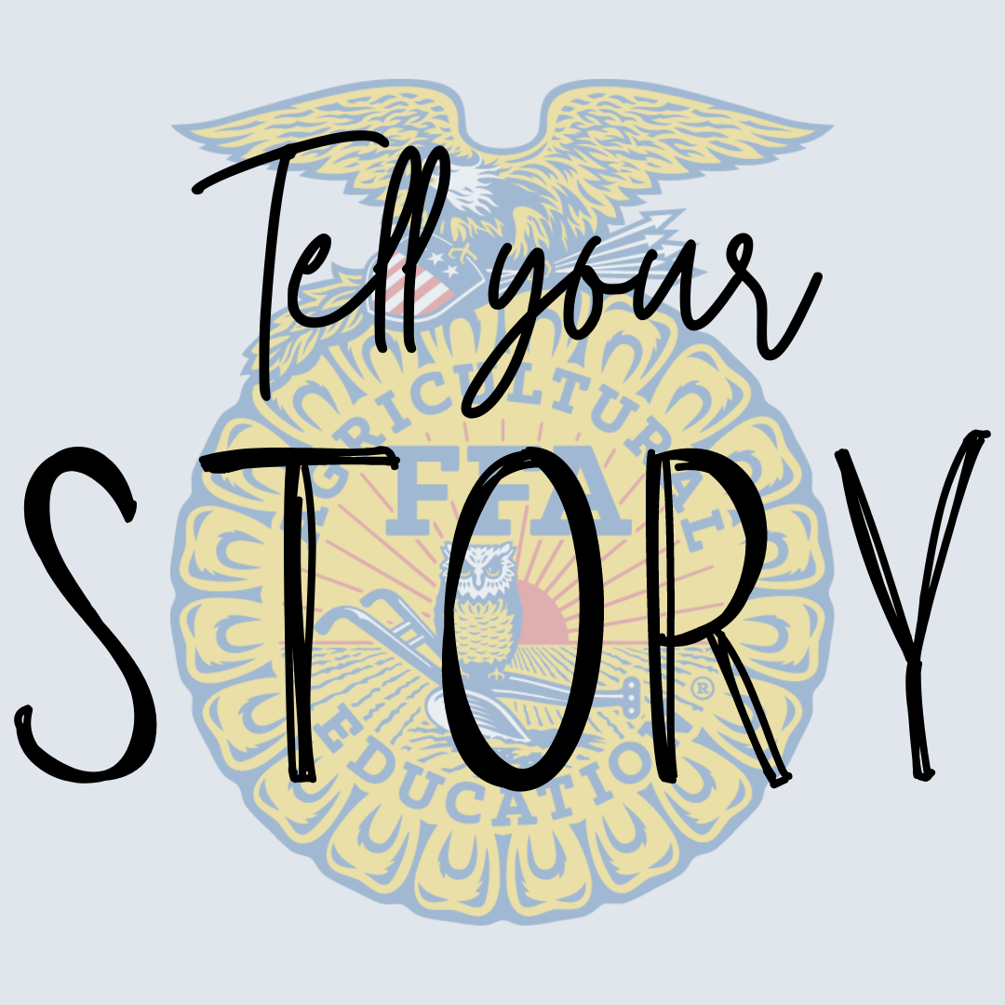

Social Media Post Examples

MOST importantly, every member and every chapter have an important FFA story. Don’t be afraid to share yours — we know it will be interesting!
Ready to plan your whole week of social media posts? Use the National FFA Week on Social Media 2026 planning guide!
Use this space to brainstorm a list of photos and videos that could be used. Don’t have any that will work? Brainstorm pictures and videos that can be taken!
If someone is being vulgar, bullying or posting unrelated comments on your posts, hide them. It’s good practice to have user guidelines on your page in the About section. Ours is on the National FFA website: FFA.org/social-media-user-policy/
Compose some guidelines that you could include to help avoid vulgarity, bullying or posting of unrelated comments.
In your posts, use the highest-quality photos and videos you have access to. These tell the best stories and generate the most engagement.
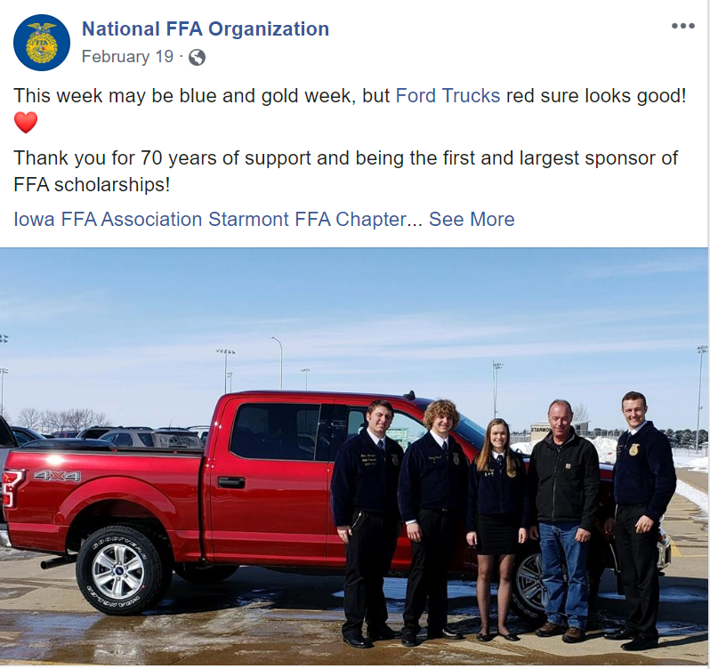
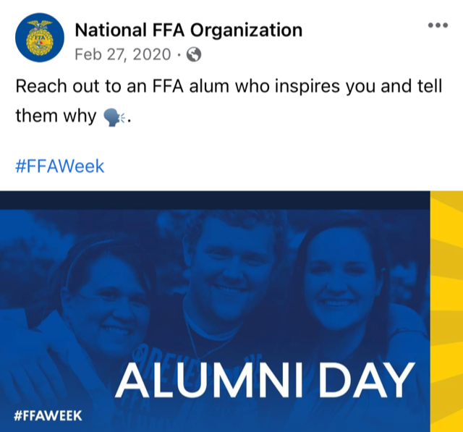
Sample Facebook Posts

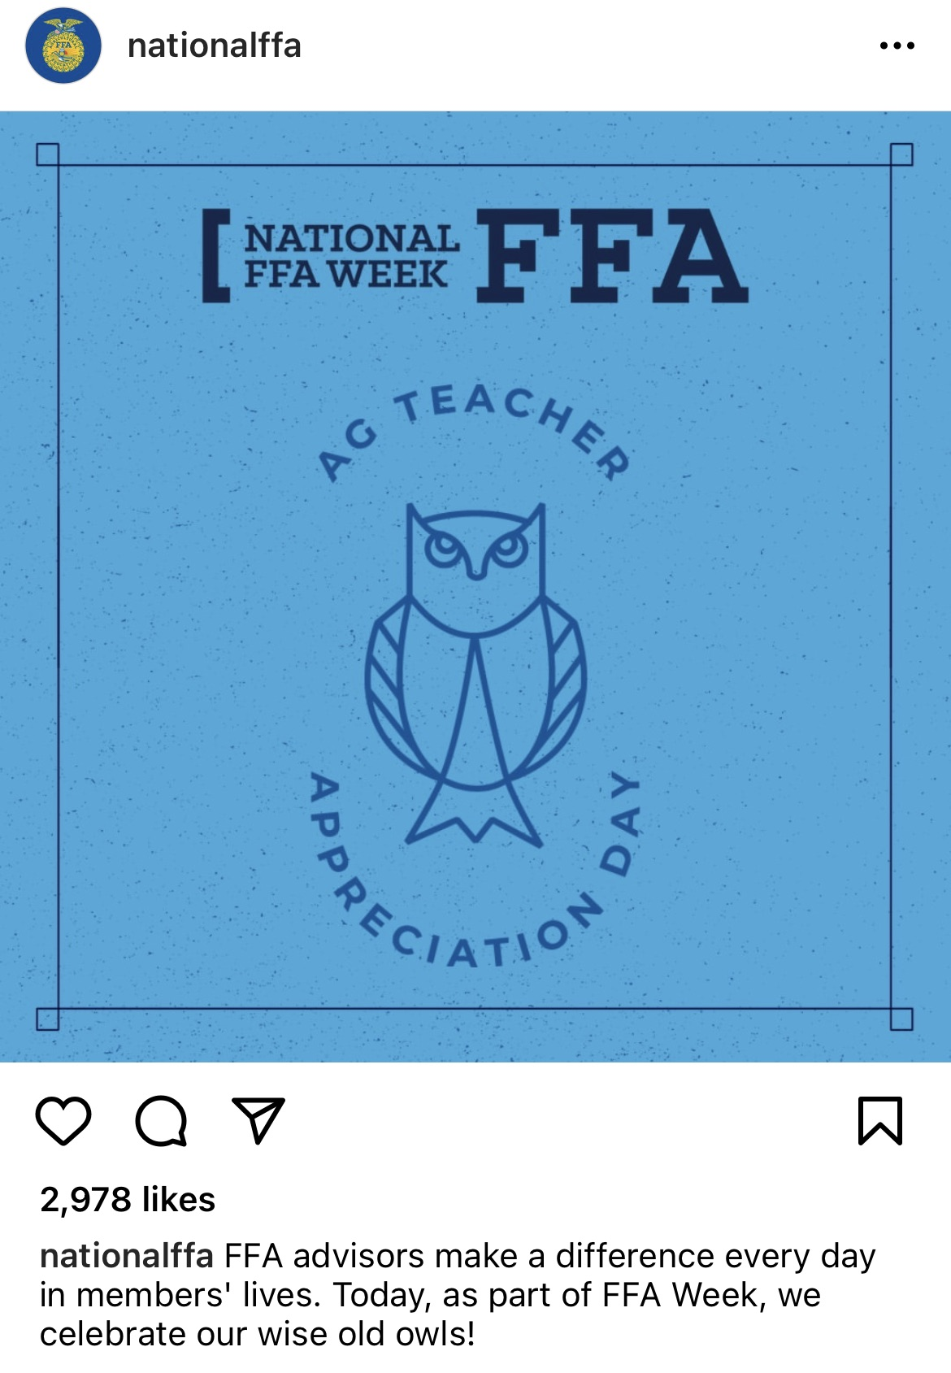
Sample Instagram Posts
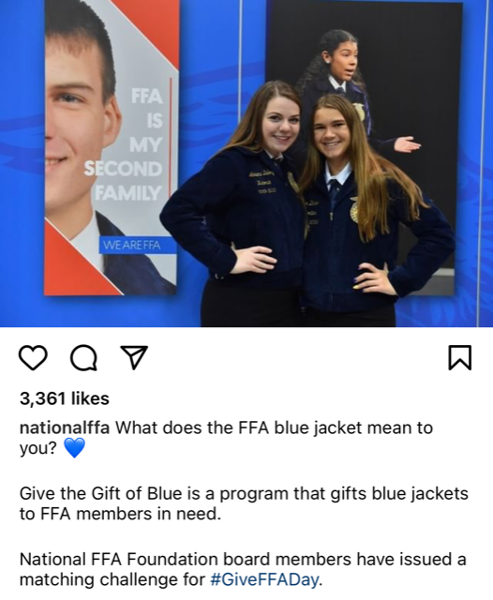

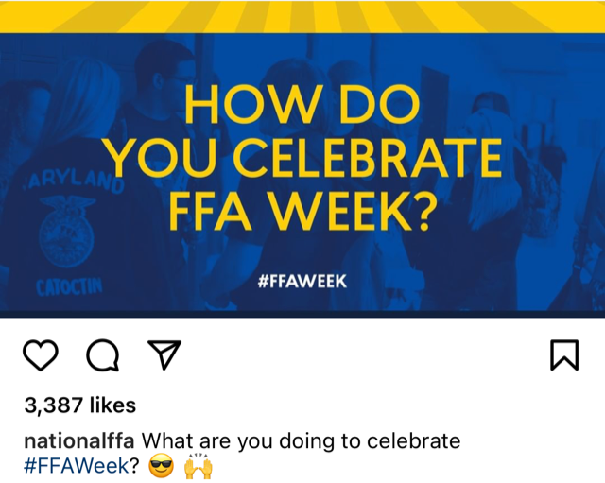
National FFA Week on Social Media 2026
Directions:
Use this template to create your social media plan for the week and get approval from the chapter advisor and school administration. Ideas and special events for each day are bulleted. Need examples? Use these examples to guide your plan. Make sure to tag @NationalFFA and use #FFAWeek.
______________________________________________________________________________________________________________________________________________________________________________________________________
- Post how your chapter will be celebrating #FFAWeek!
Sat. 21
@NationalFFA


______________________________________________________________________________________________________________________________________________________________________________________________________
- Share a photo and your SAE story! #SAESunday
Sun. 22

______________________________________________________________________________________________________________________________________________________________________________________________________
- Share what your chapter is doing to serve your community.
Mon. 23

______________________________________________________________________________________________________________________________________________________________________________________________________
- Connect with FFA alumni who inspire you and tell them why. #FFAalumni
Tues. 24


______________________________________________________________________________________________________________________________________________________________________________________________________
- Share how an agriculture teacher or FFA advisor has impacted your life! #TeachAg
Wed. 25
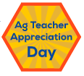

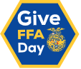
______________________________________________________________________________________________________________________________________________________________________________________________________
- Encourage friends and family to give to FFA today! #GiveFFADay
Thurs. 26

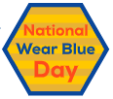
______________________________________________________________________________________________________________________________________________________________________________________________________
- Post a selfie of you wearing blue today!
Fri. 27

______________________________________________________________________________________________________________________________________________________________________________________________________
- Share photos of your #FFAWeek celebration!
Sat. 28



Date:

Date:

Date:

Date:

News Release Template
CONTACT
Contact name
Contact email
Contact phone

Headline goes here

CITY/STATE of EVENT, (Day, date, year/Company/Alumni/FFA chapter name) – XXXXX

National FFA Week always runs from Saturday to Saturday and encompasses Feb. 22, George Washington's birthday. This year, the week kicks off on Feb. 21 and culminates on Saturday, Feb. 28.

The National FFA Board of Directors designated the weeklong tradition, which began in 1948, recognizing Washington's legacy as an agriculturist and farmer. A group of young farmers founded FFA in 1928, and the organization has been influencing generations that agriculture is more than planting and harvesting — it involves science, business and more.

The National FFA Organization is a school-based national youth leadership development organization of more than 1,042,245 student members as part of 9,407 local FFA chapters in all 50 states, Puerto Rico and the U.S. Virgin Islands.

# # #

About National FFA Organization
The National FFA Organization is a school-based national youth leadership development organization of more than 1,042,245 student members as part of 9,407 local FFA chapters in all 50 states, Puerto Rico and the U.S. Virgin Islands. The FFA mission is to make a positive difference in the lives of students by developing their potential for premier leadership, personal growth and career success through agricultural education. For more, visit the National FFA Organization online at FFA.org and on Facebook, Instagram, LinkedIn and Twitter.

About National FFA Foundation
The National FFA Foundation builds partnerships with industry, education, government, other foundations and individuals to secure financial resources that recognize FFA member achievements, develop student leaders and support the future of agricultural education. A separately registered nonprofit organization, the foundation is governed by a board of trustees that includes the national FFA president, educators, business leaders and individual donors. For more, visit FFA.org/Give.

Find an editable version here.

Public Service Announcement Scripts
Utilize these public service announcement scripts and the morning announcement script to help you share your National FFA Week story with the radio community and school.

PSA: 30-Second Radio
National FFA Week
Feb. 21-28, 2026

Hello! I’m (name). As a proud member of the (chapter name) FFA Chapter, I am excited for the many opportunities to get involved during National FFA Week. Whether it’s National Wear Blue Day, Give FFA Day, hosting a community service event or all the above — together, we can make a lasting difference. Imagine the impact we can each have by showing our support. Visit FFA dot org today for more information. Let’s keep our FFA community strong!

PSA: 30-Second Radio
National FFA Week
Feb. 21-28, 2026

Hello! I’m (name). As a proud member of the (chapter name) FFA Chapter, I invite you to join us during National FFA Week to celebrate FFA and show your support of agricultural education and the future of agriculture. This week — and every week — we recognize the impact our members and supporters have on our chapters, communities and agriculture. By doing just one positive action, each and every one of us can make a difference. Are you ready? Visit FFA dot org today to learn how you can get involved.

Morning Announcement for School
Good morning (insert school name)! This week is National FFA Week, a time to celebrate and learn about agriculture and FFA. Did you know that the National FFA Organization has more than one million members in all 50 states, Puerto Rico and the U.S. Virgin Islands? As our FFA chapter celebrates agriculture and FFA this week, we want everyone to get involved here at school! This week we will have (list any important events, dress-up days, etc.). During this week, we hope to see each of you learn and engage with us to help celebrate! Talk to an officer or our agriculture teacher (insert agriculture teacher name) about how to join FFA.

Sample Congressional Letter

[Insert Date]
The Honorable [Insert Representative/Senator’s Name]
Office Address
United States House of Representatives/United States Senate
City, State, Zip

Dear Rep./Sen. [Insert Last Name]:

My name is [Insert Your Name], and I am a constituent of the [Insert Chapter Name] FFA Chapter located at [Insert Your School Address] in [Insert Your City], [Insert Your State].

I am writing you during National FFA Week (Feb. 21-28, 2026) to let you know the importance of the National FFA Organization and the impact it makes on our local community. FFA is a national organization made up of 1,042,245 agricultural education students from all 50 states, Puerto Rico and the U.S. Virgin Islands. We focus on developing our potential for premier leadership, personal growth and career success through agricultural education. As FFA members, we have the opportunity to participate in career and leadership development events that range from livestock evaluation to floriculture.

I participate in FFA by [insert information about your CDE/LDE, SAE or brief FFA story.] At the local level, we make a difference in our communities through numerous community service projects.

We would love for Rep./Sen. [Insert Last Name] to continue his/her/their support of the National FFA Organization and the next generation of agriculturists. Agriculture needs a strong and skilled workforce, and we are the future farmers, biologists, chemists, veterinarians, engineers and entrepreneurs who will fill these roles. We invite Rep./Sen. [Insert Last Name] to visit our program when he is/she is/they are in the area so that we can show him/her/them what we offer students. We would also love to schedule a call next month on National Ag Day to continue the conversation about what we are doing.

Thank you for your time and for considering my request.

Sincerely,

[Insert Your Name]
[Insert Phone Number]
[Insert Email Address]

Find an editable version here.

National FFA Week Proclamation

Whereas, FFA and agricultural education provide a strong foundation for the youth of America and the future of food, fiber and natural resources systems; and

Whereas, FFA promotes premier leadership, personal growth and career success among its members; and

Whereas, agricultural education and FFA ensure a steady supply of young professionals to meet the growing needs in the science, business and technology of agriculture; and

Whereas, the FFA motto — “Learning to Do, Doing to Learn, Earning to Live, Living to Serve” — gives direction and purpose to these students who take an active role in succeeding in agricultural education; and

Whereas, FFA promotes citizenship, volunteerism, patriotism and cooperation.

Therefore, I do hereby designate the week of Feb. 21-28, 2026, as National FFA Week.

______________________________________________ _____________________
Signature Date


FFA Facts
Sharing FFA trivia can be a great way to help educate others about the organization while creating a fun and engaging activity that can be used in the classroom or any time during National FFA Week.
Q: Which five states have the highest membership?

A: Texas, California, Georgia, Illinois, North Carolina
Q: What are the two official colors of the National FFA Organization?

A: National blue, corn gold
Q: In what year was the signature blue-and-gold jacket adopted as the organization’s Official Dress?

A: 1933
Q: Prior to African Americans being accepted into the FFA, what organization did African American members belong to?

A: New Farmers of America
Q: The National FFA emblem consists of five meaningful symbols. Which symbol represents unity and is the foundation of the emblem?

A: Cross-section of ear of corn
Q: The National FFA emblem consists of five meaningful symbols. Which symbol signifies labor, the backbone of agriculture?

A: Blue plow
Q: The National FFA emblem consists of five meaningful symbols. Which symbol represents progress and opportunity?

A: Red rising sun
Q: The National FFA emblem consists of five meaningful symbols. Which symbol represents the wisdom and knowledge required for success in agriculture?

A: The owl
Q: The National FFA emblem consists of five meaningful symbols. Which symbol serves as a reminder of our freedom?

A: The eagle
Q: In what year were females accepted into FFA as members?

A: 1969
Q: In what year were African Americans accepted as FFA members?

A: 1965
Q: Which of the following celebrities were FFA members?

- Walt Disney
- Eric Church
- Taylor Swift
- Wayne Brady
Q: Today, membership dues for National FFA are $7. What were membership dues in 1928?

A: 10 cents per year
Consider sharing an FFA fact during the school announcements each morning!

Need more trivia? Take a look at some more National FFA history and explore FFA.org.

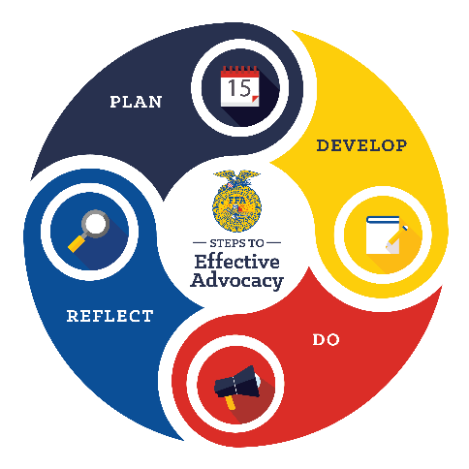
Planning for Advocacy
Advocating is an important and essential role needed in agriculture. And what better week to advocate for agriculture, agricultural education and FFA than FFA Week!
The Agricultural Literacy and Advocacy Model consists of four steps: plan, develop, do and reflect. This model can be used to complete advocacy experiences with different audiences, including those encountered during FFA week: elected officials, peers, community members and elementary students.

As your chapter plans activities, encourage students to plan an advocacy activity. With each potential audience, think about the following steps.

- Plan — Establish the overall question you want to investigate in this step. Each guiding question below will help determine the main question.
  - Define your issue:
What is the challenge we are facing?
Example: Idea that brown cows give chocolate milk
What is the vital information we need to know, and where can we find it?
  - Analyze:
Example: What age group has the greatest misunderstanding?

  - Understand the audience:
Who are we trying to influence?
Example: Elementary children aged K-3rd grade

- Develop — Now that you have analyzed the situation and identified the target audience, it’s time to develop materials, messages and resources. The following questions help guide you.
  - Write objectives:
What do we want to accomplish?
Example: Educate students about agriculture.

  - Identify SMART goals:
How are we going to accomplish this goal?
Example: We will increase knowledge about agriculture for 20 elementary school students. We will do this by hosting an ag day. This will be accomplished in one month.

  - Determine key messages:
What are our important talking points for our defined audience?
Example: Agriculture is present in all areas of our lives.

  - Develop a plan:
What are the steps we need to take to achieve our objectives?
Example: Identify school, animals and a lesson.

- Do — Once students have successfully planned and developed resources, it’s time to act. What are the next steps? Collaborate, execute and raise awareness! Use the following guiding questions to assist in the activity completion.
  - Collaborate:
How can we partner with others to strengthen our advocacy efforts?
Example: Find area experts that can provide animals or lessons.
How are we using what we know?
  - Execute:
Example: What did we learn in our agriculture classes that we can share?

  - Raise awareness:
How do we promote our advocacy efforts and gain support?
Example: Reach out to the newspaper to highlight the activity.

- Reflect — Once the activity is over, it’s time to reflect on what happened and what can be changed and/or improved. Use these questions to reflect on what you just accomplished.
What information can we collect that will demonstrate impact?
  - Monitor:
Example: What are the students’ perceptions before and after our activity?
How well did we achieve our objectives?
  - Review:
Example: Share how you met, exceeded or did not meet your expectations during this event.
What changes can we make to improve?
  - Adapt:
Example: Change lesson we provided to
be more relatable for age.

#SpeakAg Showcase

Work with your students or FFA members to create a short digital promotion showcasing agriculture in your state and/or chapter. This digital promotion should be one to 2.5 minutes long. Use the suggestions, examples and planning space below.

Suggestions
- Showcase the top commodities for your state.
- Showcase the variety of agriculture (row crops, cattle ranches, forestry, etc.).
- Highlight successful FFA members, their supervised agricultural experiences (SAEs) and their impact on your state.
- Highlight agriculture-based careers in your state and their economic impact.

Examples
Check out some examples from past digital promotions here.

Planning Space
Names of students working on this project:

List top commodities in your state. | List the different varieties of agriculture in your state.
List members with great SAEs. | List agriculture-based careers in your state.
Use this space to plan your digital promotion using one of the brainstormed topics from the chart above.

Awards and Recognition
Recognizing people in the community, business world and school is an important component of celebrating National FFA Week as it allows a chapter the opportunity to thank those individuals for their continued support, and by showing recognition, a chapter can continue to increase support.
- Recognize Community Members and Local Businesses
  - It is always important to recognize those outside of your school for their help and support throughout the school year. Through recognition methods, you can show gratitude and increase support for future events. Utilize these ideas for recognition of community members and local businesses or brainstorm unique ideas of your own.
- Recognize Supporters in the School (Ex. superintendent, teachers, all school staff)
  - It is always important to recognize people within the school who help and support your FFA chapter. Through recognition methods, you can show gratitude and increase support for future events. Utilize these ideas for recognition of those within your school or brainstorm unique ideas of your own.
- Family and Personal Support Recognition
  - Students have supporters in their lives, such as family, friends, teachers or other professionals both in and out of the school building. Taking the time to give recognition to these individuals becomes important for letting them know the impact they have had.
- Student Recognition
  - National FFA Week provides a great opportunity to recognize students, both members and nonmembers. Through recognition, you can share the value and accomplishments that members have made, which can aid in recruitment and retention within the program.
- Certificate of Recognition
  - Present this certificate to different individuals to thank them for their time, service or support throughout the year.
- Career, Trade School, College and/or Member Signing Day
  - Recognizing accomplishments and successes is a wonderful way to bring members closer and recognize hard work. As a way to do this, try an official Signing Day during National FFA Week!
- ShopFFA award and recognition products can be found here. If you’re hosting a banquet, ShopFFA banquet supplies can be found here.

Recognition of Community Members and Local Businesses

It is always important to recognize those outside of your school for their help and support throughout the school year. Through recognition methods, you can show gratitude and increase support for future events. Below are some ideas for recognition of community members and local businesses.
Plan a trip to visit companies and businesses that support the chapter.
(Ex. local Ford or John Deere dealerships and local agricultural companies)



Invite a supportive business or company to speak in the agricultural classroom or during a special career chat.
(Ex. local Dodge dealership owner, local seed salesperson, local chemist, floral shop owner/worker)


Display and promote local internship opportunities. Need help finding opportunities? Reach out to your guidance counselor and/or extension educator.


Host a breakfast and invite those both inside and outside of the school who support FFA. To help make this happen, host a potluck, have alumni donate their time or supplies or have students make pancakes.


Recognize those that have helped with an event, provided resources, been extra supportive, etc. throughout the year by presenting them with a certificate or a handwritten note from students.

Host and invite community members and local businesses to an ice cream social. Each topping can be located at a different station that highlights a different program component. Or host a virtual “brown bag” luncheon and have community members and supporters share about themselves and experiences in the agriculture industry.
(Ex. SAE, classes offered, CDEs/LDEs, etc.)


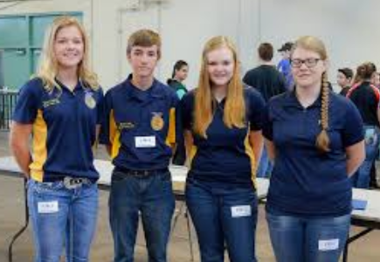
Encourage involvement or add these individuals to the alumni and supporters chapter for your FFA chapter. Want to start an alumni and supporters chapter? Use the following resource to get started: https://FFA.box.com/s/o8lqm0bi52u3igotvs7zkcoaw2ufp3ys

Have members interview an alumni or supporter, in person or on video. Put together a video of several interviews to show what FFA has meant to alumni or why they support FFA.
  - Videos can be used on a webpage or in social media.
  - Take pictures and write the story of the impact, then share it.
  - Interview sponsors and have them share more about their businesses.

Recognition of Supporters in the School
It is always important to recognize people within the school who help and support your FFA chapter. Through recognition methods, you can show gratitude and increase support for future events. Below are some ideas for recognition of those within your school.

Visit and present at a school board meeting to share the chapter’s story of what members are doing in the community, classroom and FFA.

Provide shirts, cups or pins to help others show support during National FFA Week. Invite staff and administration to bring in their FFA jackets if they are former members.

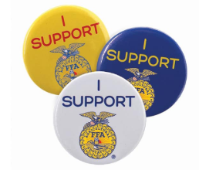

Provide snacks or treats for teachers, administrators, support staff, etc. to enjoy. Include a note to add an extra personal touch!
- Serve cookies or cupcakes with FFA written in blue and gold colors.
- Have members, alumni and supporters or a local business make pie and deliver a slice to each person.

Host a breakfast and invite those both inside and outside of the school who support FFA. To help make this happen, host a potluck, have alumni donate their time or supplies or have students make pancakes.


Recognize those that have helped with an event, provided resources, been extra supportive, etc. throughout the year by presenting them with a certificate or a handwritten note.


Host and invite individuals to an ice cream social. Each topping can be located at a different station that highlights a different program component.
(Ex. SAE, classes offered, CDEs/LDEs, etc.)
Family and Personal Support Recognition
Students have supporters in their lives, such as family, friends, teachers or other professionals both in and out of the school building. Taking the time to give recognition to these individuals becomes important for letting them know the impact they have had.

Recognize those that have helped with an event, provided resources, been extra supportive, etc. throughout the year by presenting them with a certificate or a handwritten note.

Host a breakfast and invite those both inside and outside of the school who support FFA. To help make this happen, host a potluck, have alumni donate their time or supplies or have students make pancakes.



Encourage involvement or add these individuals to the alumni and supporters chapter for your FFA chapter. Want to start an alumni and supporters chapter? Use the following resource to get started:
Alumni and Supporters Resource



Student Recognition
Host and invite individuals to an ice cream social. Each topping can be located at a different station that highlights a different program component.
(Ex. SAE, classes offered, CDEs/LDEs, etc.). Or, host a virtual “brown bag” luncheon, invite family or personal support individuals and have students share how FFA has impacted them.
Present these individuals with small gifts that are products from an SAE or class project. (Ex. plants grown in the greenhouse, products made through an SAE, such as soap, etc.)
National FFA Week provides a great opportunity to recognize students, both members and nonmembers. Through recognition, you can share the value and accomplishments that members have made, which can aid in recruitment and retention within the program.
Recognize SAE programs in each class and have that student share what they have learned.




Recognize members with outstanding record books by having them share their experiences in class, with alumni and supporters or at an in-person or virtual school board meeting.


Recognize student career goals and highlight agriculture career opportunities with career fairs, industry tours or presentations in class or to the school board.




Recognize student leadership successes in class, whether it is gained through FFA or another organization.
Hold an agriscience or science fair within your classroom. Students solve a problem using the scientific method and create a display board to show the project process and findings.
Hold a mock competition or a portion of one to show off student skills related to topics covered in classroom instruction. (Ex. develop a new way to package a food item; students create a flower arrangement using the elements of design and display items in the school/community).
Have students demonstrate skills learned through their SAEs, class projects, in-class jobs or chapter meeting presentations and events.
Recognize students by sharing their FFA stories in the school newsletter/blog, in class or in the local newspaper. Example prompt: How has FFA impacted your life?

C

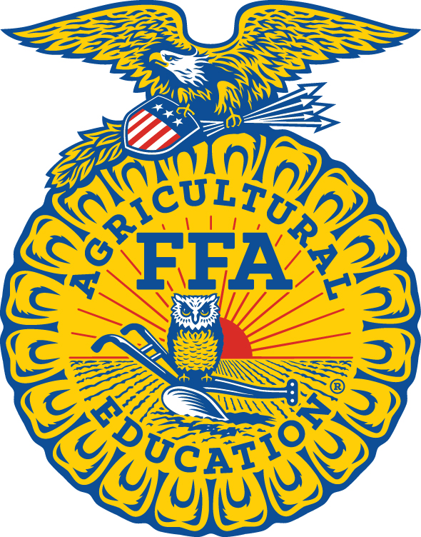

In recognition of your continuing support we hereby present

__________________________________________________________________________________

with this certificate of appreciation from the _____________________________________________________ Chapter.

__________________________________ __________________________________
Chapter President Chapter Secretary

____________________________
date

Certificate of Appreciation

Career, Trade School, College and/or Member Signing Day
Recognizing accomplishments and successes is a wonderful way to bring members closer and recognize hard work. As a way to do this, try an official Signing Day during National FFA Week! Signing days are typically used when students have made a decision or are becoming a part of something new that will advance them personally or in their careers. Use the following to celebrate students committing to colleges, careers, joining the FFA or Greenhand ceremonies, just to name a few examples!
- Have the student fill this out prior to the event:
Student Name: ___________________________________

Where they are headed (i.e., workforce, trade school, college or new FFA member)

Student quote about the accomplishment and/or why they are excited

What led the student to this accomplishment?


- Planning:
  - Start by discussing the event with students and explaining its importance.
  - Gain access to a larger table with chairs and decorate with balloons or special backdrop (this is where the “signing” will take place).
  - Find a large area (shop, large classroom, gymnasium) where the signing table can be set, along with space for attendees to gather and watch.
  - Invite other students from the chapter, agricultural class or school assembly to attend and watch the event.
  - Create a poster for each student that includes their picture, background, future plans, etc. so attendees at the signing event can view them while they are waiting for the event to start.
  - Find someone to take pictures.
  - Invite future employers or someone to recognize each student specifically (can be a guidance counselor, principal, coach, etc.).
  - Gain permission and time for the presentation from administration.
  - Consider something that can be handed to each student. Examples: a hat with the trade school logo, a company hat or shirt, etc. If this is a member signing day, consider giving students a piece of official dress or a pin if these are new Greenhand members.
  - Print signing certificates for each student.
  - Consider snacks and water/lemonade for a reception after the signing ceremony. Be sure to determine the location and decorations.
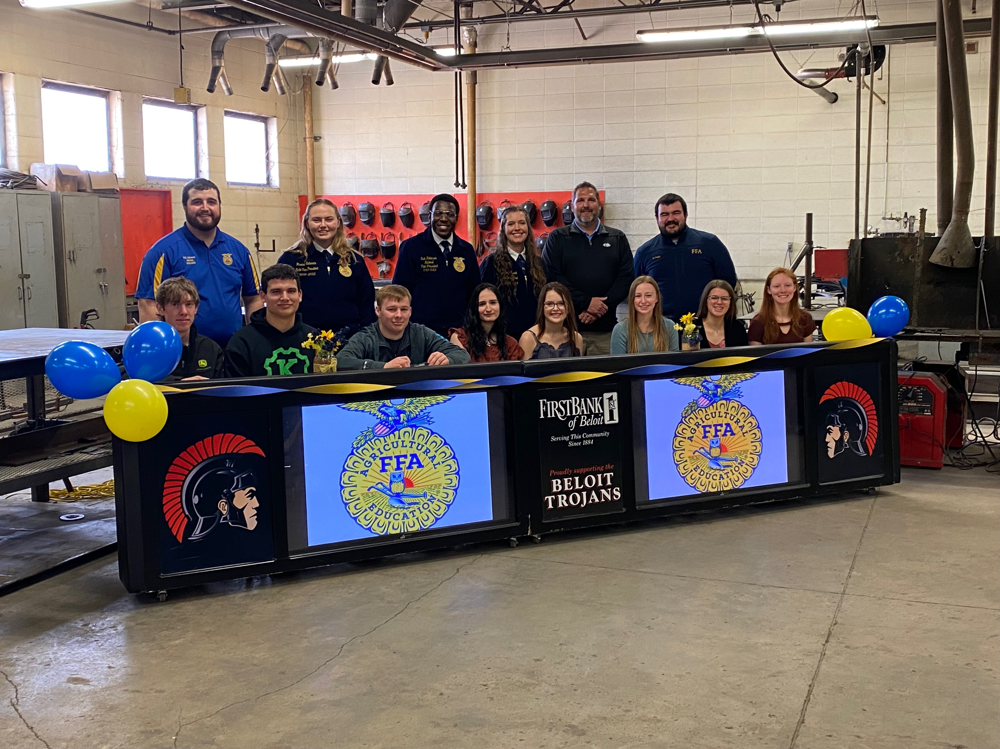
  - Invite administration, advisory board, parents, etc.


- Set Up:
  - Set up or hang a plain backdrop or one with school logos.
  - Cover the table with a tablecloth.
  - Ensure that future employers or the person recognizing each student specifically has arrived (can be a guidance counselor, principal, coach, etc.).
  - Ensure there is an item for each student to be handed.
  - Ensure there is a certificate to sign for each student.
  - Set up the reception area with snacks, tablecloths, decorations, etc.

- Run of Show
  - Welcome:
    - Welcome to the [insert school name/FFA Chapter] Career and Trade School Signing Day. We are excited to recognize and celebrate these students on their success in school and choosing their path. Please join me in congratulating each student as they officially sign.
  - Student Presentation
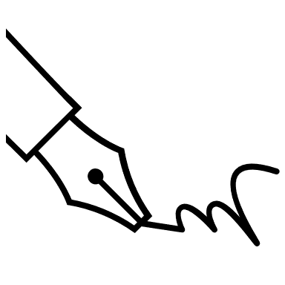
    - Call each student up one at a time and have the student sit behind the table. Have the student’s representative come up as well. Announce students’ names, where they are going and the quote the student shared in the form. Have the representative present students with their signing certificates. Or, you can have multiple students sign at once and then have them individually tell the crowd about their future plans.
    - While the student is signing, have the photographer take pictures. After signing, the student can stand with the representative and do an exchange of the item (ex. Hold the shirt up to the student, etc.). Be sure lots of pictures are taken of the exchange.
    - Announce: Congratulations to [Student name] on his/her/their commitment to [career/trade school name, joining FFA]. We are excited to see you continue to excel!
  - Conclusion
    - As we send these students onto their next big step in life, may we remember the important role they will play and the impact they will make.
  - After the Signing Ceremony
    - Invite guests and students to join you for a celebratory reception.
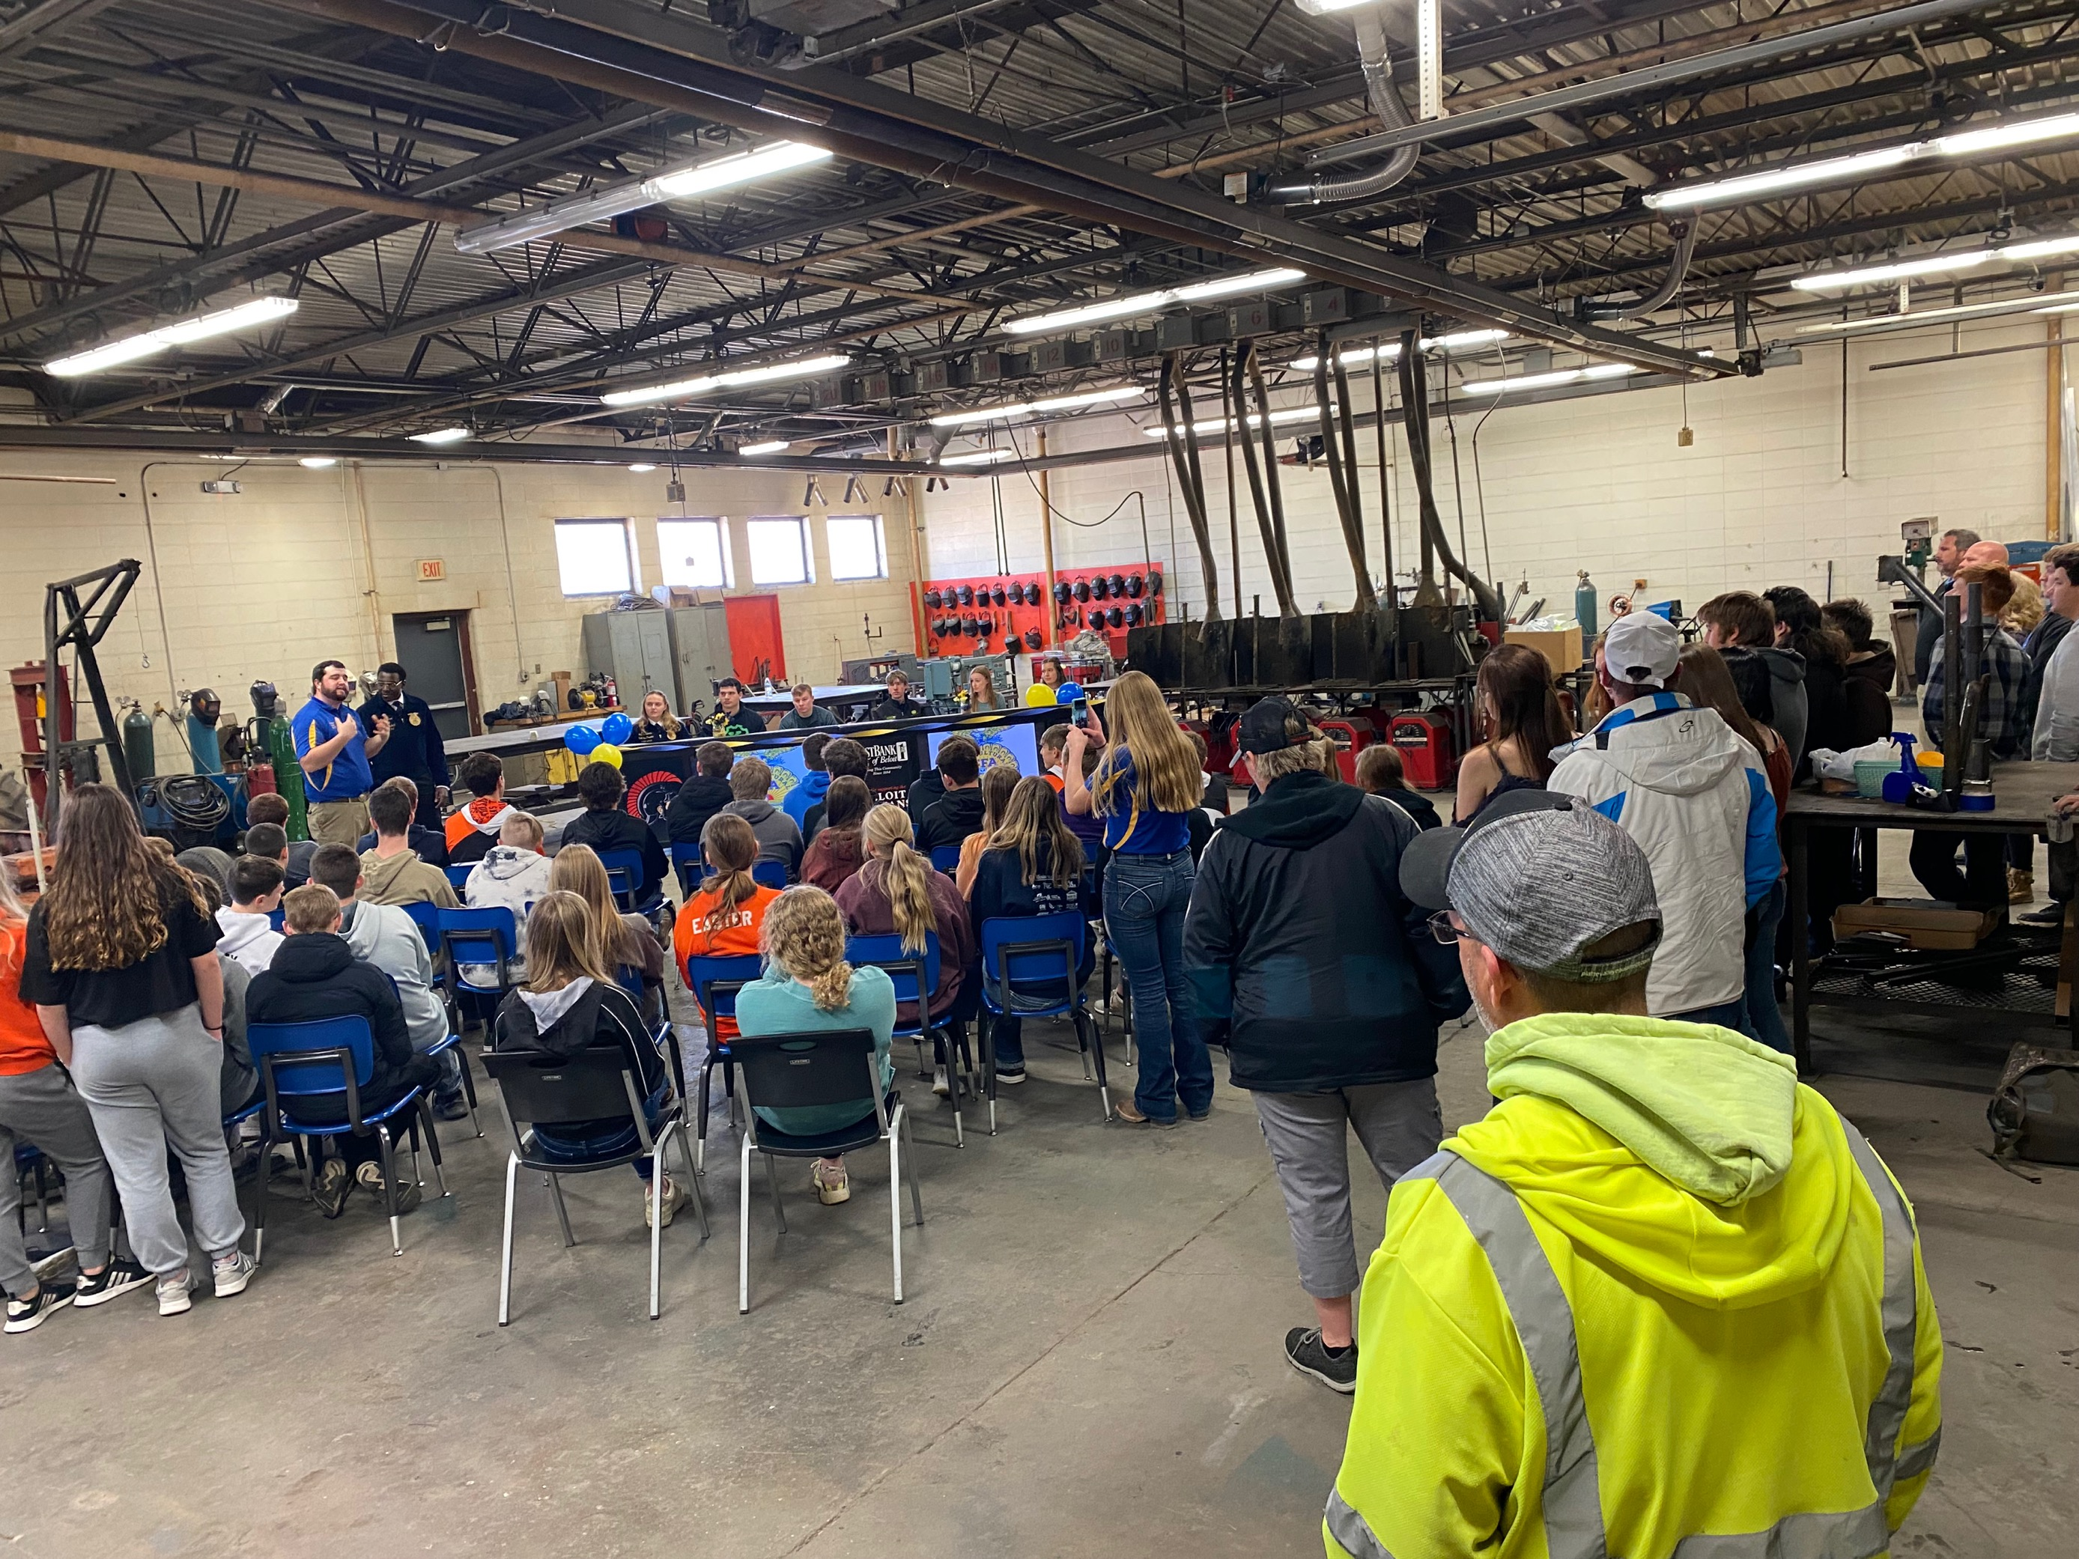
Certificate of Intent
The [Insert School Name] congratulates

_______________________________________________________________________
[Student Name on Line]

For making the decision to commit to [insert commitment].

[Insert logo of company, school, chapter]

Congratulations on your commitment to continue on your path to success!

________________________________________________________________
Student Signature

_________________________ _________________________ Principal Guidance Counselor

Classroom Educational Materials
FFA is embedded in every agriculture class from agricultural mechanics to veterinary science. Include these turn-key lessons in your class to share FFA with all your students.
- FFA Fundamentals Choice Board
  - The “FFA Fundamentals Choice Board” is designed to help students quickly learn FFA basics while exploring FFA.org. This is the perfect activity for an FFA unit or for Discovery and Greenhand FFA Degree candidates.
- Living the Legacy: The Impact of FFA on Agriculture and Leadership (middle school lesson)
  - This lesson will guide middle school students through how FFA contributes to agriculture and leadership.
- Student Handbook Lessons
  - Use the most up to date Student Handbook (in English and Spanish) as well as the PowerPoints that are ready to teach with. The accompanying Student Handbook Workbook makes learning about FFA easy!
- Ag Ed Academy
  - Use these online learning modules designed around the seven keys of local program success, which include FFA, instruction, SAE, program planning, partnerships, marketing and professionalism.
- Use Minecraft Education to create a new world that solves a real-life issue.
  - Lessons: https://education.minecraft.net/class-resources/lessons
  - Get started: https://education.minecraft.net/get-started. If your school has Microsoft Office 365, you may have free access.
- Play Journey 2050 in class and challenge your students.
- ShopFFA instructional materials can be found here.
FFA Fundamentals Choice Board
Student Learning Objectives:
After completing the FFA Fundamentals Choice Board, students will …
- Utilize resources and activities to discover opportunities available in FFA.
- Develop a foundational understanding of FFA basics.
- Maximize interests in FFA.

Resources: FFA.org

Equipment and Supplies Needed:
- A copy of the choice board for each student
- Internet access for students at least on a weekly basis

Use This Guide To:
- Introduce your students to the basics of FFA.
- Supplement current coursework with select activities and tools available on FFA.org.

Standards Alignment:
These activities were created with consideration given to the following educational standards:

FFA Precept
- FFA.PL-A.Action: Assume responsibility and take the necessary steps to achieve the desired results, no matter what the goal or task at hand.
- FFA.PL-C.Vision: Visualize the future and how to get there.
- FFA.PL-D.Character: Conduct oneself appropriately in relation to others regardless of the situation.
- FFA.PL-E.Awareness: Understand personal vision, mission and goals.
- FFA.PG-I.Professional Growth: Assume responsibility for attaining and improving upon the skills needed for career success.
- FFA.PG-J.Mental Growth: Embrace cognitive and intellectual development relative to reasoning, thinking and coping.
- FFA.CS-M.Communication: Effectively interact with others in personal and professional settings.
Common Core — Reading: Informational Text
- CCSS.ELA-Literacy.RI.9-10.4 Determine the meaning of words and phrases as they are used in a text, including figurative, connotative and technical meanings; analyze the cumulative impact of specific word choices on meaning and tone (e.g., how the language of a court opinion differs from that of a newspaper).
Common Core — Writing
- CCSS.ELA-Literacy.W.9-10.2 Write informative/explanatory texts to examine and convey complex ideas, concepts and information clearly and accurately through the effective selection, organization and analysis of content.
Common Core — Speaking and Listening
- CCSS.ELA-Literacy.SL.9-10.1 Initiate and participate effectively in a range of collaborative discussions (one-on-one, in groups and teacher-led) with diverse partners on grades 9-10 topics, texts and issues, building on others’ ideas and expressing their own clearly and persuasively.
Common Core — Literacy in Science & Technical Subjects: Writing
- CCSS.ELA-Literacy.WHST.9.10.4 Produce clear and coherent writing in which the development, organization and style are appropriate to task, purpose and audience.
AFNR Career Ready Practices
- CRP.02. Apply appropriate academic and technical skills. Career-ready individuals readily access and use the knowledge and skills acquired through experience and education to be more productive.
- CRP.04. Communicate clearly, effectively and with reason. Career-ready individuals communicate thoughts, ideas and action plans with clarity, whether using written, verbal and/or visual methods.
- CRP.07. Employ valid and reliable research strategies. Career-ready individuals are discerning in accepting and using new information to make decisions, change practices or inform strategies.
- CRP.08. Utilize critical thinking to make sense of problems and persevere in solving them. Career-ready individuals readily recognize problems in the workplace, understand the nature of the problem and devise effective plans to solve the problem.
- CRP.11. Use technology to enhance productivity. Career-ready individuals find and maximize the productive value of existing and new technology to accomplish workplace tasks and solve workplace problems.
Partnership for 21st Century Skills
- Communication
- Critical Thinking and Problem Solving
- Flexibility and Adaptability
- Information Literacy
- Initiative and Self-Direction
- Leadership and Responsibility

Implementation:

FFA Fundamentals
The “FFA Fundamentals Choice Board” is designed to help students quickly learn FFA basics while exploring FFA.org. This is the perfect activity for an FFA unit or for Discovery and Greenhand FFA Degree candidates.

- Suggested Use: If you have ample time to complete an FFA unit, then these activities could be stretched over two or more weeks. Some activities require more work than others. If your time is limited, you could put students into groups of four. Each group member would be responsible for completing one block from the “Remember/Understand” row and one block from the “Apply/Analyze/Evaluate” row. Group members would then teach the other group members what they learned. The group would work together to complete the items in the “Create” row.

- Grading: How you determine if a student has completed the tasks depends on your preference and what resources are available to you. Suggestions include having them email or print something that proves they completed a task or for them to write a brief summary paragraph of a video they watched or article they read.
  - Work can be collected weekly or every few weeks for grading.
  - Tip: Count the entire choice board grade (each is worth 100 points) as a test or project grade or have it count twice.
FFA Fundamentals
DIRECTIONS:
You will explore FFA.org to complete the tasks listed below. Some of the tasks will take longer than others, but you can complete them in any order you choose. Your due date for completion of this board is . Shade or color in each block below as you complete it. The board is worth a total of 100 points. The maximum point value for each activity is at the bottom of each block.
Remember/ Understand | Who are the National FFA Officers?  President: Secretary: Eastern Region VP:  Western Region VP:  Southern Region VP:  Central Region VP:  Who is the National FFA Advisor?  (Hint: This is the National FFA leadership.) | What is the FFA mission statement?  What is the FFA motto?  (Hint: Learn more about us.) | How many FFA members are there?  What states and territories have FFA chapters?  How many FFA chapters are across the nation?  (Hint: This is the basics of our membership.) | List five National FFA Career and Leadership Development Events.
 | 5 points | 5 points | 5 points | 5 points
Apply/Analyze/ Evaluate | Write a one-paragraph response to these questions: Does your FFA involvement have to end when you graduate high school? Why or why not? How can you remain involved?  (Hint: Alumni and supporters are important to FFA.) | Write a three-paragraph analysis of the symbols that make up the FFA emblem and explain how they tell the story of FFA.  (Hint: Check out the Official FFA Manual.) | Write a one-paragraph response explaining what a supervised agricultural experience (SAE) program is and the benefits of having an SAE. | What is FFA?  Choose one of the following methods to answer the question:  - Write a summary paragraph.  - Draw a cartoon that summarizes the facts.  - Write a song or poem that summarizes the facts.
 | 5 points | 10 points | 5 points | 10 points
Create | Read the FFA Creed. (FFA.org/about/FFA-creed/) Write a letter to E.M. Tiffany, and discuss the parts of the Creed you believe are still relevant to FFA members today and those parts that might need to be changed to better reflect the modern FFA member. | Imagine you’ve been asked to plan a service project for your chapter. What steps do you take? Use the “Interactive Service Planning Guide” to complete the first step in planning a service project.  (Hint: FFA members build stronger communities by “Living to Serve.”) | Explore the events and conferences offered by National FFA. Compile the skills and experiences gained through these programs.  Choose one of the following methods to share:  - Write a two-page paper discussing the skills/experiences.  - Create a collage (digital or poster board) that displays all the skills. | Team up with one or two classmates. Create a pictorial timeline of FFA history. The timeline should have at least 10 events that span from the year FFA was founded to the current decade.  Required events:  - FFA founded  - FFA and NFA merged  - Girls granted membership  - FFA changed its name
 | 5 points | 10 points | 15 points | 20 points
Rubric: FFA Choice Board
5-POINT TASKS
Criteria | Points Available | Points Received
Work shows understanding and knowledge of the topic. | 2
Work shows good effort and is of high quality. | 1
Student followed all instructions for the task. | 1
Work was turned in on time. | 1
Total
10-POINT TASKS
Criteria | Points Available | Points Received
Work shows understanding and knowledge of the topic. | 4
Work shows good effort and is of high quality. | 2
Student followed all instructions for the task. | 2
Work was turned in on time. | 2
Total

15-POINT TASKS
Criteria | Points Available | Points Received
Work shows understanding and knowledge of the topic. | 6
Work shows good effort and is of high quality. | 3
Student followed all instructions for the task. | 3
Work was turned in on time. | 2
Total

20-POINT TASKS
Criteria | Below Average  (0–1 points) | Average  (2–3 points) | Above Average  (4–5 points)
Knowledge | Work shows little to no understanding of the topic. | Work shows some understanding of the topic. | Work shows excellent understanding of the topic.
Quality | Work is very low quality with little evidence of effort. | Work shows some effort and is mostly neat. | Work shows excellent effort and is of high quality.
Instructions | Student did not follow instructions for the task. | Student followed some of the instructions. | Student followed all instructions for the task.
Timeliness | Work was submitted more than one day late. | Work was one day late. | Work was submitted on time.

Living the Legacy: The Impact of FFA on Agriculture and Leadership
Created: 09/2025 by the National FFA Organization
Description of Lesson: This lesson will guide middle school students through how FFA contributes to agriculture and leadership.
Student Learning Objectives:
After completing these activities, students will …
- Identify key ways FFA contributes to agriculture and leadership.
- Reflect on how FFA has impacted their personal growth or community.
- Collaborate to design a mini project that promotes agricultural awareness.

Suggested Grade Level:
Grades 6-8 (This lesson is written so instructors can scale up or down based on class needs.)

Suggested Time: 45 minutes (*Time requirements may vary based upon student understanding and class schedule.)
Resources/References:
- Indiana Grow With Us, https://indiana.growwithus.ag/
Related Resources:
- FFA Student Handbook, https://FFA.box.com/s/lz6iokwfsxwx9u5u5to0c48gtokxvitj

Equipment and Supplies Needed:
- A copy of the “The Legacy and Impact of FFA” worksheet for each student
- Projector or screen for video
- Markers
- Poster paper
- Whiteboards
- Sticky notes
- Timer or stopwatch
- Internet access to play the video in real time or embed it in a PowerPoint ahead of time

Vocabulary:
- Agriculture
- Awareness
- Leadership
- Legacy
Cross-Curricular Connections:
English/Language Arts | Technology
-Create a mini campaign. | -Create support items for mini campaign.

SAE and FFA Connections
National FFA Week
Agricultural Communications LDE

Lesson Plan:
- Bell Ringer: Hand each student a sticky note when they enter the classroom. On the sticky note, each student should write one thing they love about FFA. Once all students are done have them place their sticky note in a designated spot that has been labeled “Legacy Wall.” Once all students have added their sticky note, discuss responses as a class.

- Introduction: FFA can have a big impact on individuals, the community and agriculture. Today, we are going to explore this impact.

- Activity: Each student needs a copy of the worksheet “The Legacy and Impact of FFA.”
  - Part 1: Have students visit the following website, https://indiana.growwithus.ag/, and watch the video and read to learn about agricultural education and FFA. While exploring, have students complete the questions. Once all students have completed the questions, have them find two or three other students in the classroom to share their thoughts with and have a conversation.
  - Part 2: Divide students up into small groups of three or four. In each group, students will create a mini FFA Week campaign to promote agricultural awareness in their school or community. Students must include at least two of the following: poster, social media post mock-up, three school announcements, two or three FFA Week event ideas or a brochure. Each group will share in two-minutes or less at the end.
  - Part 3: Students will now take time to complete a silent reflection over how FFA has or could impact them and one goal they have for the future. Consider creating a wall of all the FFA goals shared by students.

- Follow-up: Have students coordinate an event for National FFA Week celebrations.

- Exit Ticket: Have students share their reflections.

The Legacy and Impact of FFA
Part 1
Directions:
Watch the video and read about agricultural education and FFA on the following site: https://indiana.growwithus.ag/. While you explore, complete the questions below.


What is agricultural education?



What impact does/can agricultural education/FFA have on a person?

What impact can/does agricultural education/FFA have on a community?

What interests/excites you the most about FFA?

Identify at least two leadership skills you can gain by being involved in agricultural education and FFA.



Using the space provided, draw a picture of where you will be in five years. Identify three ways that future could be impacted by being actively involved in agricultural education and FFA.
Part 2
In your group, you will be responsible for creating a mini National FFA Week campaign to promote agricultural awareness in your school or community. You must include at least two of the following:
- Poster
- Social media post mock-up
- Three school announcements
- Two or three FFA Week event ideas
- Brochure
Each group will share in two minutes or less once all groups are finished. Use the space provided below to plan out your ideas.
Part 3
Independently, compete the following reflection questions.

- What is one thing that you have learned or could learn from being in FFA?

- How has, or could, FFA help you grow as a leader?

- What is one goal you have for your future in agriculture or FFA?

- What is one way you can serve your community through agriculture?
KEY: The Legacy and Impact of FFA
Part 1
Directions:
Watch the video and read about agricultural education and FFA on the following site: https://indiana.growwithus.ag/. While you explore, complete the questions below.

What is agricultural education?

Agricultural education is a three-part model that combines work-based opportunities, leadership opportunities and classroom-based knowledge gain to give students leadership, career and personal growth skills.

What impact does/can agricultural education/FFA have on a person?

Answers will vary.
Example: Agricultural education can give students opportunities to grow as a leader while fostering learning and growing in agricultural literacy.

What impact can/does agricultural education/FFA have on a community?
Answers will vary.
Example: Agricultural education and FFA give back to the community through service, careers/employment and creating strong leaders to serve.

What interests/excites you the most about FFA?
Answers will vary.

Identify at least two leadership skills you can gain by being involved in agricultural education and FFA.

Answers will vary.

Using the space provided, draw a picture of where you will be in five years. Identify three ways that future could be impacted by being actively involved in agricultural education and FFA.
Answers will vary.
Part 2
In your group, you will be responsible for creating a mini National FFA Week campaign to promote agricultural awareness in your school or community. You must include at least two of the following:
- Poster
- Social media post mock-up
- Three school announcements
- Two or three FFA Week event ideas
- Brochure
Each group will share in two minutes or less once all groups are finished. Use the space provided below to plan out your ideas.
Answers will vary.
Part 3
Independently, compete the following reflection questions.

- What is one thing that you have learned or could learn from being in FFA?
Answers will vary.
- How has, or could, FFA help you grow as a leader?
Answers will vary.

- What is one goal you have for your future in agriculture or FFA?
Answers will vary.
- What is one way you can serve your community through agriculture?

Answers will vary.

Living to Serve: FFA Week National Days of Service
Service is more important now than ever. During National FFA Week, we call attention to FFA and what we do as an organization. What better way to celebrate FFA Week than through a service project! We are encouraging FFA chapters across the country to report a service event to be hosted in the month of February to be a part of the FFA Week National Days of Service.

- Service Opportunities and Resource
  - Get tips for planning a service project for FFA week and learn how to report your impact to National FFA.
  - Use these tools to help plan and execute your Living to Serve project.
- National Days of Service Project Examples
  - Check out examples of projects based on their category.
- FFA has created an FFA Week National Days of Service Interactive Toolkit to help get you started. Use the four steps to investigate, plan, serve and evaluate your project.
- Your chapter can apply for an FFA Day of Service Mini-Grant. This grant provides alumni or middle and high school chapters with up to $400 to conduct a one-time service event.
- Help support FFA chapters across the country by promoting the sale of the FFA Paper Emblem, available through Tractor Supply Company stores and online. Funds raised support the Grants for Growing program.

Service Opportunities and Resources
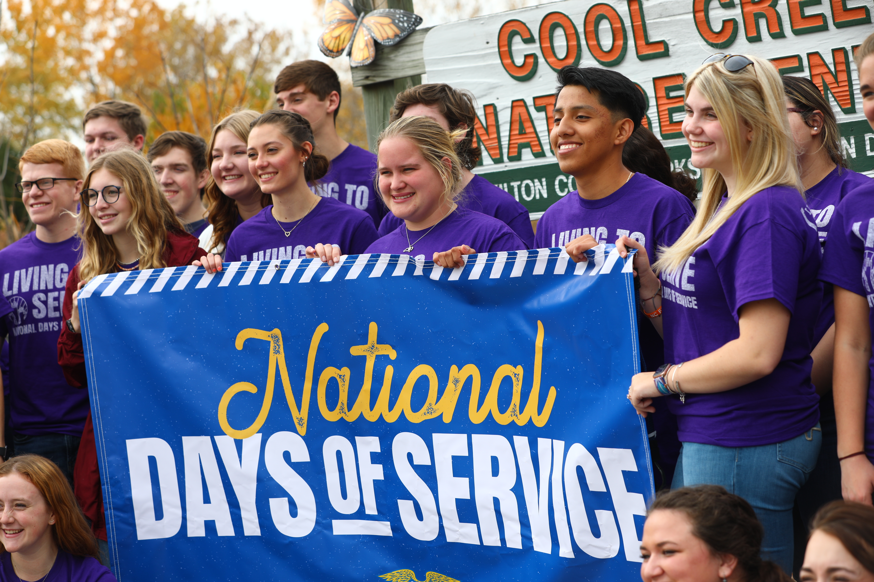

Living to Serve is the last line of the FFA motto, and service is an important part of National FFA Week. During National FFA Week, we call attention to FFA and what we do as an organization. What better way to celebrate than through a service project?

Be a Part of the Annual FFA Week National Days of Service Event
- In honor of FFA Week, we are encouraging FFA chapters across the country to host a service event in February to be part of the annual FFA Week National Days of Service! Report your impacts to be included in an interactive map that shares pictures and descriptions of your project to help inspire others to serve.
- Choose to construct sensory bottles to donate to children in your community. The supplemental project guide includes everything you need to know from start to finish!
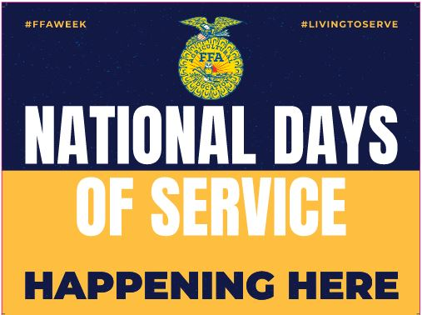

Tools to Help Plan an FFA Week National Days of Service Event
- To plan your chapter’s service event, FFA has created an FFA Week National Days of Service Interactive Toolkit to help get you started. Use the four steps of investigate, plan, serve and evaluate to ensure the success of your project.
- Choose to construct travel book pillows to donate to children in your community. The supplemental project guide includes everything you need to know from start to finish!
- Did you know your chapter can apply for an FFA Day of Service Mini-Grant? This grant provides alumni or middle and high school chapters with up to $400 to conduct a one-time service event.
  - The application is easy to complete, and you can add collaborators to help you complete the process. In the application, share how your FFA Week service event will meet a need in the community based on the four focus areas.

When applying for an FFA Day of Service Mini-Grant, you will need to identify what focus area the service activity falls under. Below are the focus areas that need to be identified when applying for the funds to support your FFA Week National Days of Service event:
 | Community Safety | Addresses concerns regarding the safety of community members and the preparation, response and recovery efforts that relate to emergency preparedness and natural disasters
 | Hunger, Health and Nutrition | Addresses unmet food insecurity needs, increasing physical activity and improving healthy habits to promote physical and mental well-being of the community
 | Community Engagement | Addresses matters related to heritage and traditions, connections between community members and civic responsibility throughout the community
 | Environmental Responsibility | Addresses issues regarding air and water quality, energy and water efficiency, at-risk ecosystems and conservation to protect and sustain the natural systems upon which all life depends

National Days of Service Project Examples
Across the country, FFA chapters are making an impact in their communities through service events. Below are a few examples of service projects to inspire your FFA chapter to participate in the FFA Week National Days of Service event.

To be eligible to receive funding through the FFA Day of Service Mini-Grant, service events must meet an actual/authentic community need. For example, hosting a thank-you breakfast for community members or farmers during FFA Week would not be funded under the grant guidelines. Serving a breakfast at the local soup kitchen would be funded as they can demonstrate a strong need.

Below are samples of National Days of Service events held during October. For more inspiration, visit FFA.org/LivingToServe to view interactive service maps.


Prairie View FFA, KS
Prairie View FFA members looked at community safety from a couple lenses — environmental and public safety. During the month of October, the FFA chapter hosted a community clean up to remove trash around the community as well as hosted a safe-driving day at their school and distributed Drive Safe Emergency Vehicle kits.


Clay FFA, FL
The Clay FFA Chapter addressed hunger access issues by partnering with local farmers and the various community gardens to glean produce. Community members also assisted in these efforts, and all donations were given to the local food bank.


El Centro FFA, CA
Members of El Centro FFA found that during the pandemic local animal shelters were becoming overpopulated and were in dire need of resources for the various animals. The chapter set up collection sites around the community to collect much-needed resources and then delivered them to the local shelter.


Parkside FFA, MD
FFA members from the Parkside FFA spent one busy day focusing on all things environmental. Members provided several opportunities for community members to learn and serve. Members held a demonstration at their school garden on cover crops, worked on a local rooftop garden, cleaned up the pocket meadow project and worked on restoring a floating wetland.

If you have questions about the Living to Serve Mini-Grant application or participating in the FFA Week National Days of Service event, email LTS@FFA.org.

Help Support Grants for Growing During FFA Week
Your chapter can help support FFA chapters across the country by promoting the sale of the FFA Paper Emblem during FFA Week at local Tractor Supply Company (TSC) locations. Just ask friends and family to either visit their local TSC store or purchase an item online, and during checkout, they can choose to donate to support the program! Funds raised support the Grants for Growing program.

Grants for Growing is a competitive grant program for middle and high school FFA chapters that are developing and improving project-based or experiential learning opportunities for students. FFA chapters may apply for up to $5,000 to help grow their classroom, grow their FFA chapter or grow agriculture awareness. Connect with your local TSC and make a plan to promote FFA and the sale of the FFA Paper Emblem.
