Careers with Animals: Processing and Products
Created: 08/2018 by the National FFA Organization

Student Learning Objectives:
After completing these activities, students will …
- Describe the skills and information necessary for a career in processing and products.
- Develop a new product that will be used within the animal industry.

Time Required: 45 minutes
Resources:
- Video: “For the Love of Bacon,” www.ispot.tv/ad/7JKr/farmland-bacon-the-love-of-bacon?autoplay=1
- Video: “Salma Hayek Commercial Got Milk?” https://youtu.be/yfnEyL93CHE?si=0pL-svgInVH-VtR7
- Video: “Blue Bunny TV Commercial w/ Robert O-Mara,” https://youtu.be/Uh6YCQSSJ_U?si=R2YQ6qZNULWISBDH
- Video: “Beef: Rethink the Ranch – We See Beef,” https://youtu.be/jWZcTvLkwJM?si=khs8hLS_XJ62OOn6
- Video: “Pork Be Inspired TV Commercial, 'Night Time Grilling,’” www.youtube.com/watch?v=R_UDq9tpX0w
- Video: “Turkey Farm and Processing Plant Tour: Temple Grandin,” www.youtube.com/watch?v=852zxDEAR-Q

Equipment and Supplies Needed:
- A copy of the “Turkey Farm and Processing Plant Tour: Temple Grandin” worksheet for each student
- A copy of the “Animal Processing Timeline” worksheet for each student or pair of students
- A copy of the “Innovation: My New Animal Product Idea” worksheet for each student
- Internet access to play the videos in real time or embed it in a PowerPoint ahead of time
- Computer access, ideal for students to work in pairs or small groups
- Scissors, glue sticks or tape

This quick lesson plan would work well as:
- As a component of an animal science career unit.
- As a complement to a food science unit on animal processing and products.

These activities are aligned to the following standards:
AFNR Performance Element
- AS.02. Utilize best-practice protocols based upon animal behaviors for animal husbandry and welfare.
FFA Precept
- FFA.PL-A.Action: Assume responsibility and take the necessary steps to achieve the desired results, no matter what the goal or task at hand.
- FFA.PG-J.Mental Growth: Embrace cognitive and intellectual development relative to reasoning, thinking and coping.
- FFA.CS-M.Communication: Effectively interact with others in personal and professional settings.
- FFA.CS-N.Decision Making: Analyze a situation and execute an appropriate course of action.
Common Career Technical Core
- AG-ANI2: Utilize best-practice protocols based upon animal behaviors for animal husbandry and welfare.
NASDCTEc
- AGPC01.02: Recognize and interpret animal behaviors and execute protocols for safe handling to facilitate safety for both animals and humans.
Common Core–Writing
- CCSS.ELA-Literacy.W.9-10.2: Write informative/explanatory texts to examine and convey complex ideas, concepts, and information clearly and accurately through the effective selection, organization, and analysis of content.
Common Core–Speaking and Listening
- CSS.ELA-Literacy.SL.9-10.1 Initiate and participate effectively in a range of collaborative discussions (one-on-one, in groups, and teacher-led) with diverse partners on grades 9-10 topics, texts, and issues, building on others' ideas and expressing their own clearly and persuasively.
- CCSS.ELA-Literacy.SL.9-10.2: Integrate multiple sources of information presented in diverse media or formats (e.g., visually, quantitatively, orally) evaluating the credibility and accuracy of each source.
Common Core–Math Practices
- CCSS.MP1: Make sense of problems and persevere in solving them.
- CCSS.MP5: Use appropriate tools strategically.
- CCSS.MP6: Attend to precision.
AFNR Career Ready Practices
- CRP.02: Apply appropriate academic and technical skills. Career-ready individuals readily access and use the knowledge and skills acquired through experience and education to be more productive.
- CRP.04: Communicate clearly, effectively, and with reason. Career-ready individuals communicate thoughts, ideas and action plans with clarity, whether using written, verbal and/or visual methods.
- CRP.05: Consider the environmental, social and economic impact of decisions. Career-ready individuals understand the interrelated nature of their actions and regularly make decisions that positively impact and/or mitigate negative impact on other people, organizations and the environment.
- CRP.06: Demonstrate creativity and innovation. Career-ready individuals regularly think of ideas that solve problems in new and different ways, and they contribute those ideas in a useful and productive manner to improve their organization.
Partnership for 21st Century Skills
- Communication
- Critical Thinking and Problem Solving
- Flexibility and Adaptability
- Initiative and Self-direction
- Leadership and Responsibility
- Think Creatively

Lesson Plan:
- Bell Ringer: Favorite food-animal products poll. Have students pick up an index card as they arrive or place one at each student seat. Ask students to vote on their favorite animal product. If desired, play commercials listed below as students vote.
  - “For the Love of Bacon,” www.ispot.tv/ad/7JKr/farmland-bacon-the-love-of-bacon?autoplay=1
  - “Salma Hayek Commercial Got Milk?” https://youtu.be/yfnEyL93CHE?si=0pL-svgInVH-VtR7
  - “Blue Bunny TV Commercial w/ Robert O-Mara,” https://youtu.be/Uh6YCQSSJ_U?si=R2YQ6qZNULWISBDH
  - “Beef: Rethink the Ranch – We See Beef,” https://youtu.be/jWZcTvLkwJM?si=khs8hLS_XJ62OOn6
  - “Pork Be Inspired TV Commercial, 'Night Time Grilling,’” www.youtube.com/watch?v=R_UDq9tpX0w

- Introduction: Begin a discussion with the class about how these products get from the farm to our plate. Ask students if they know the steps in this process and have them share what they think they might know with the class. Discuss with the class the impact of animal welfare, health, genetics and nutrition on animal products and quality. Identify any gaps in knowledge or questions the class might have.

- Activity 1: As a class, view the second part of the “Turkey Farm and Processing Plant Tour: Temple Grandin“ video beginning at time stamp 4:29. The direct url is www.youtube.com/watch?v=852zxDEAR-Q. Have students capture notes about the processing aspect of animal products on the corresponding “Turkey Farm and Processing Plant Tour: Temple Grandin” worksheet. **Please note, there are some images in this video that could be uncomfortable to some students. View video in advance and determine if it is appropriate for your students. Overall, the video is done very tastefully and is much less graphic than many other videos of this kind.

- Activity 2: Provide students with the opportunity to work individually or in pairs to complete the “Animal Processing Timeline” worksheet. Students will cut answers from the answer bank and paste them in the correct section of the worksheet. Most information was covered in the video; however, some information is new, and students may need to conduct an online search or use deductive reasoning to complete the timeline.

- Activity 3: Students should work individually to plan a new animal product. Students will identify a new animal product they think would be successful. Encourage students to be creative and stretch their thinking. Students should use the time remaining in class to complete the “Innovation: My New Animal Product Idea” worksheet. If students need more time to complete it, it can be assigned as homework and collected later.

- Follow-up: After completing Activity 2, have students share insights and collaborate on the “Animal Processing Timeline” worksheet. As a class, determine the best fit for answers on the timeline.

- Leveling Up:
  - Hold a new animal product fair where students can make marketing materials and showcase their innovative new product idea with their classmates. Marketing materials could include commercials, billboards (i.e., posters), flyers, coupons, advertisements, etc.
  - Consider doing a taste-test of new animal products and voting on areas such as most creative, best taste, best marketing strategy, etc.

- Exit Ticket: On index cards, have students create an Instagram post, tweet, or snapchat post about their favorite animal-derived food product and the producer that raises it. This supports the idea that consumers want a “face” for their food. This can be done with images or words.

Turkey Farm and Processing Plant Tour: Temple Grandin
Aligned to the following standards:
AS.02; FFA.PL-A; FFA.PG-J; FFA.CS-M; FFA.CS-N; AG-ANI2; AGPC01.02; CCSS.ELA.W.9-10.2; CCSS.ELA.SL.9-10.1; CCSS.ELA.SL.9-10.2; MP1; MP5; MP6; CRP.02; CRP.04; CRP.05; CRP.06
Directions:
Answer the following questions while watching the video.

- When the truck arrives at the plant, the following happens:

- How is proper care of animals maintained when waiting to be unloaded at the plant?

- What two types of stunning methods are used at this plant?

- What happens at the USDA inspection station during processing?

- What does Dr. Grandin note about using all parts of the animal?

- Write any other notes and/or questions about processing you have after watching the video.

Animal Processing Timeline
Aligned to the following standards:
AS.02; FFA.PL-A; FFA.PG-J; FFA.CS-M; FFA.CS-N; AG-ANI2; AGPC01.02; CCSS.ELA.W.9-10.2; CCSS.ELA.SL.9-10.1; CCSS.ELA.SL.9-10.2; MP1; MP5; MP6; CRP.02; CRP.04; CRP.05; CRP.06
Directions:
Using the word bank on the next page, find the best fit for the information about processing of animals. Cut out the answer and paste it in the correct location.
Careers with Animals: Processing & Products
Complete the animal processing timeline diagram shown below.

Animal Processing Timeline
Aligned to the following standards:
AS.02; FFA.PL-A; FFA.PG-J; FFA.CS-M; FFA.CS-N; AG-ANI2; AGPC01.02; CCSS.ELA.W.9-10.2; CCSS.ELA.SL.9-10.1; CCSS.ELA.SL.9-10.2; MP1; MP5; MP6; CRP.02; CRP.04; CRP.05; CRP.06
Word Bank
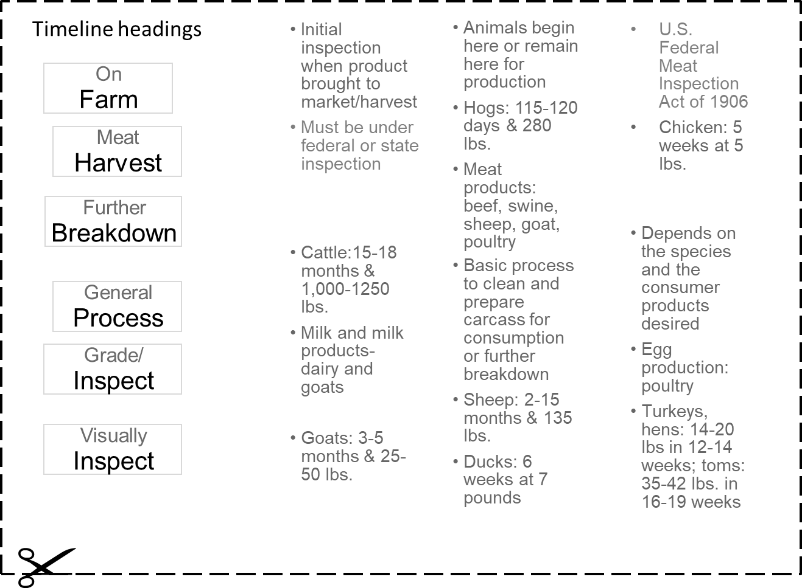

Innovation: My New Animal Product Idea
Aligned to the following standards:
AS.02; FFA.PL-A; FFA.PG-J; FFA.CS-M; FFA.CS-N; AG-ANI2; AGPC01.02; CCSS.ELA.W.9-10.2; CCSS.ELA.SL.9-10.1; CCSS.ELA.SL.9-10.2; MP1; MP5; MP6; CRP.02; CRP.04; CRP.05; CRP.06
Directions:
Identify a new animal product that would be successful. Explain your new animal product idea using images, pictures and words. Describe the intended consumers, the cost and how the product will be marketed.

KEY — Turkey Farm and Processing Plant Tour: Temple Grandin
Aligned to the following standards:
AS.02; FFA.PL-A; FFA.PG-J; FFA.CS-M; FFA.CS-N; AG-ANI2; AGPC01.02; CCSS.ELA.W.9-10.2; CCSS.ELA.SL.9-10.1; CCSS.ELA.SL.9-10.2; MP1; MP5; MP6; CRP.02; CRP.04; CRP.05; CRP.06
Directions:
Answer the following questions while watching the video.

- When the truck arrives at the plant, the following happens:
Answers could include visual inspection, weighing, record keeping, etc.

- How is proper care of animals maintained when waiting to be unloaded at the plant?
Animals are monitored and kept comfortable with proper temperature control. (Fans/misters in the summer and closed trailers in the winter.)

- What two types of stunning methods are used at this plant?
Two stunning methods used at this plant are controlled atmosphere stunning and electric water-bath stunning.

- What happens at the USDA inspection station during processing?
The innards (internal organs) of the bird are inspected.

- What does Dr. Grandin note about using all parts of the animal?
How important it is to use all parts and not waste product.

- Write any other notes and/or questions about processing you have after watching the video.

Answers will vary.

KEY — Animal Processing Timeline
Aligned to the following standards:
AS.02; FFA.PL-A; FFA.PG-J; FFA.CS-M; FFA.CS-N; AG-ANI2; AGPC01.02; CCSS.ELA.W.9-10.2; CCSS.ELA.SL.9-10.1; CCSS.ELA.SL.9-10.2; MP1; MP5; MP6; CRP.02; CRP.04; CRP.05; CRP.06
