Lesson Two: Floral Design Concepts
Created: 05/2017 by the National FFA Organization

Student Learning Objectives:
After completing these activities students will…
- Identify the principles used in floral design.
- Identify the elements used in floral design.
- Critique the use of design concepts in floral arrangements.
- Analyze how color creates a theme in floral arrangements.

Time Required: 90 minutes
Resources:
- Principles of Floral Design – CEV
- Floriculture CDE Handbook
- Norah T. Hunter (2013) The Art of Floral Design (3rd Edition) Clifton Park, NY: Delmar Cengage Learning.

Equipment and Supplies Needed:
- “Floral Design Concepts” PowerPoint
- A copy of the “Design Concepts” packet for each student
- Floral magazines
- Coloring material
- Scissors
- Glue

previous knowledge recommended for this lesson:
- None

These activities are aligned to the following standards:
AFNR Performance Element
- PS.04. Apply principles of design in plant systems to enhance an environment (e.g., floral, forest, landscape and farm).
FFA Precept
- FFA.PG-J.Mental Growth: Embrace cognitive and intellectual development relative to reasoning, thinking and coping.
Common Career Technical Core
- AG-PL4 Apply principles of design in plant systems to enhance an environment (e.g., floral, forest, landscape and farm).
NASDCTEc
- AGPB01.04 Exercise elements of design common to professionals in plant systems to enhance an environment for a variety of purposes (e.g., floral, forest, landscape, farm).
Common Core- Reading: Informational Text
- CCSS.ELA-Literacy.RI.9-10.3 Analyze how the author unfolds an analysis or series of ideas or events, including the order in which the points are made, how they are introduced and developed, and the connections that are drawn between them.
Common Core- Math Practices
- CCSS.MP2: Reason abstractly and quantitatively.
- CCSS.MP3: Construct viable arguments and critique the reasoning of others.
AFNR Career Ready Practices
- CRP.04. Communicate clearly, effectively, and with reason. Career-ready individuals communicate thoughts, ideas and action plans with clarity, whether using written, verbal and/or visual methods.
- CRP.06. Demonstrate creativity and innovation. Career-ready individuals regularly think of ideas that solve problems in new and different ways, and they contribute those ideas in a useful and productive manner to improve their organization.
Partnership for 21st Century Skills
- Implement Innovations
- Information Literacy
- Think Creatively
- Work Creatively with Others

Lesson Plan:
- Introduction (suggested time 5-10 minutes): Refer to slides 1 and 2 of the “Floral Design Concepts” PowerPoint to present lesson objectives and complete the introduction activity.

Can you describe the color, balance and texture in each of these works of art? Are there any similarities between the floral arrangement and Van Gogh’s “Starry Night”?

Design concepts such as color, balance and texture can be applied to art, fashion and floral design. These concepts come from the principles and elements of design and can be viewed in many art forms. Colors in both examples use a cool blue hue and a contrasting warm yellow. Both have a sense of balance, neither side appears too busy. The texture of paint used in “Starry Night” appears consistently heavy and rough, whereas the arrangement uses a combination of small, coarse petals and large, smooth petals.

There is no question that Vincent Van Gogh was an artist; and it may seem hard, at first, to consider such a common floral arrangement as art next to his “Starry Night.” But all art follows the same concepts of design, and in that way we can compare these two art forms. In the lesson, we will look at the principles and elements of design and see how they are applied to floral arrangements.

- Lecture (suggested time 30 minutes per section): “Floral Design Concepts” are a component of both the “General Knowledge Exam” and the “Floral Arrangement Rubrics” in the floriculture CDE. This lesson covers balance, depth, [focal] emphasis, line, scale (or proportion) and unity, which are listed specifically in the “Floral Arrangement Practicum Rubric,” as well as other concepts which will aid in the composition of arrangements during the practicums.

Refer to slides 3-17 of the “Floral Design Concepts” PowerPoint to discuss the principles and elements of floral design.

The concepts we will discuss today can be related to all art forms. However, the principles and elements of design in this lesson are shown specifically for floral design. As we go through the PowerPoint use the information to fill in the “Design Concepts” packet.

Each student will need a copy of the “Design Concepts” packet to fill in the blanks and make any additional notes. At the end of the lecture, the students will use the packet for the activity. Review the slides and identify the design concepts as they apply to floral design.

- Activity (suggested 30 minutes): Refer to slide 18 of the “Floral Design Concepts” PowerPoint to present the application activity.

To help us further understand how these concepts are used in floral design, find examples to include in your design packets. Use images of floral arrangements found in magazines to demonstrate your examples by cutting and pasting them in the correct image box. Make sure a correct example is used and all questions have been answered.

Students should find examples for balance, proportion, emphasis, rhythm, harmony/unity, line, form, texture and color. Some examples will ask for specific information or an explanation. The color wheel can be filled in with images from the magazine or colored in using crayon, marker or colored pencil.

- Reflection (suggested 10-15 minutes): Refer to slide 19 of the “Floral Design Concepts” PowerPoint to present the reflection activity.

We identified several floral design concepts in this lesson, each with its own unique importance in creating a floral arrangement. Reflect on the principles and elements we discussed and answer the following questions on a piece of paper as your ticket out the door:
- Name a concept you found new or interesting.
- Name a concept you had heard of before, and explain where it was mentioned (art, music, fashion, etc.)
- All the concepts are important, but when you look at a flower arrangement, what stands out the most to you?

Have students complete the questions as an exit ticket on a notecard or sheet of paper. Students can turn this in for a daily grade and/or formative review. Be sure to review the responses before moving on to the next lesson.

- Leveling Up: Have students create an art portfolio or Pinterest board of floral arrangements they find interesting, creative and would like to try. For each arrangement, have them identify the concepts discussed in this lesson. Each page should consist of an image and explanation of principles and elements of design. Arrangements could be categorized by events and holidays, color schemes or shape. When students create their own arrangements, images and descriptions of their work can be added.

Design Concepts
Aligned to the following standards:
PS.04; FFA.PG-J; AG-PL4; AGPB01.04; CCSS.RI.9-10.3; MP2, MP3; CPR.04, CPR.06
Directions:
Describe the following concepts from the “Floral Design Concepts” lesson. Then, using magazines, find examples of design elements and principles listed on the worksheet and cut and paste them into the “insert image here” boxes.

Balance
Balance gives a sense of _________________ to a floral arrangement.

Balance should be both ________________ and __________________.

Is this arrangement symmetrical or asymmetrical?
Insert Image Here

Proportion
Proportion or _______________ controls the ________________ of materials being used.

Arrangement heights should be ____________________ times the size of the container.

Arrangement size should be proportionate to its _____________________.

Insert Image Here
Is the arrangement proportionate to the container?

What kind of surroundings is the arrangement meant for?

Emphasis
Emphasis is where the viewer looks ______________.

Where is the emphasis in the arrangements?

Insert Image Here
Insert Image Here

Rhythm
Rhythm refers to the movement of your _____________ from the ________________ out to the rest of the arrangement.

Insert Image Here
Describe the rhythm of movement in the arrangement.

Harmony
Harmony is how __________________ parts come together in an __________________ pleasing arrangement.

Theme or style is __________________ to a harmonious design.

Unity
Insert Image Here
Explain how unity differs from harmony.

How does the arrangement show both harmony and unity?
Line
Aligned to the following standards:
PS.04; FFA.PG-J; AG-PL4; AGPB01.04; CCSS.RI.9-10.3; MP2, MP3; CPR.04, CPR.06
Lines in floral design give ___________________ and __________________ to an arrangement.

________________ is greatly influenced by lines.

Insert Image Here

What kind of directional lines are in the floral arrangement?

Form
Form refers to the shape of the _______________________.

Form is made up of ___________________ and ______________________ space.

What form is represented in the arrangements?

Insert Image Here
Insert Image Here

Depth
Arrangements with depth avoid looking _____________ or two-dimensional.

____________ lines and _______________ are both techniques that help portray depth.
Texture
Texture refers to the ______________ physical __________________ of objects in an arrangement.

Successful arrangements _______________ textures while still maintaining _________________ and _________________.

Describe the textures used in the arrangement.

Insert Image Here

Color
______________ is the proper term for color
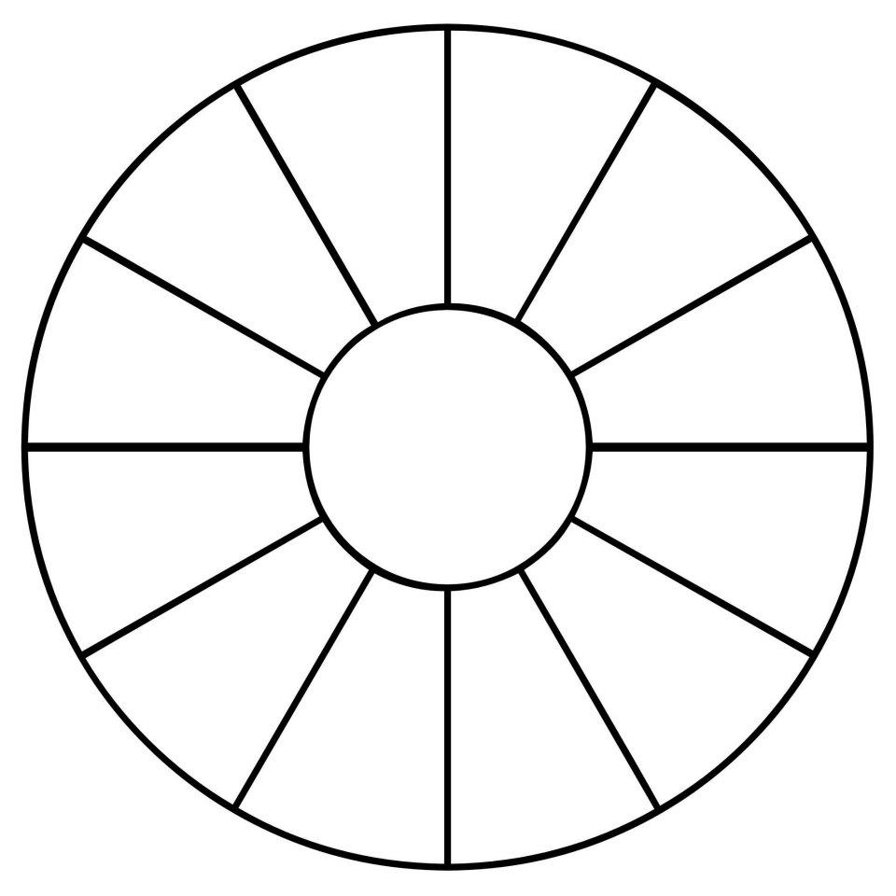
The color wheel has ___________ hues.

Identify the primary, secondary and tertiary colors.

Describe the color schemes used in the arrangements.

Insert Image Here
Insert Image Here

