Floral Retail Catalog
directions:
Use the items listed in this catalog to price a $30 arrangement on your “Floral Arrangement Itemized List of Costs” worksheet. All materials are shown in bulk at a retail price; no markups need to be added.

Hard Goods – Mechanics

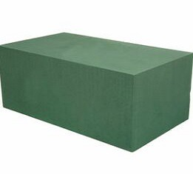
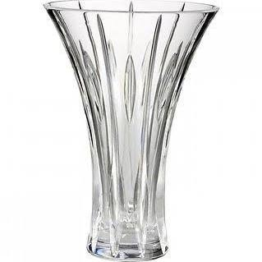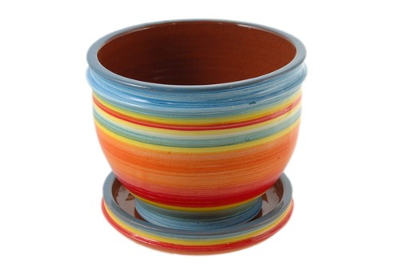

Ceramic Container
All Colors Available
$34.99 per case (12 per case)

Glass Vase 4” high
$19.95 per case (24 per case)
Floral Foam Block 9” X 4”
$22.50 per block

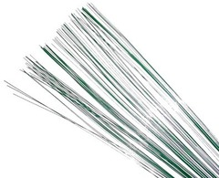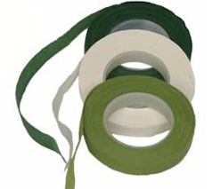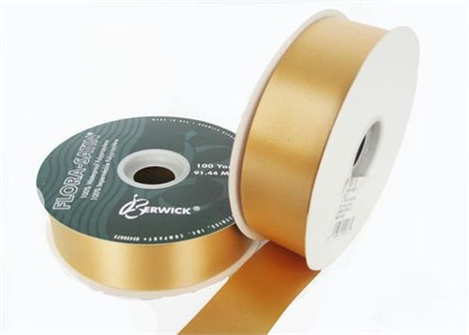

#9 Satin Ribbon (100 yards)
All Colors Available
$4.99 per roll
28-gauge Floral Wire
50 18” strands per bag
$6.49 per bag
Floral Tape (60 feet)
$2.75 per roll

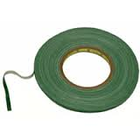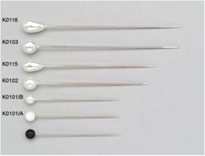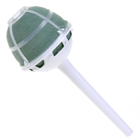

Nosegay Holder
White Plastic w/ Dry Foam
24.50 per case (10 per case)

Assorted Decorative Pins
50 per box
$3.99 per box
Water Proof Container Tape
100 yards
3.97 per roll

Fresh Goods – Flowers and Foliage
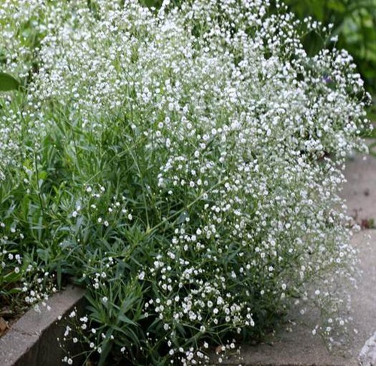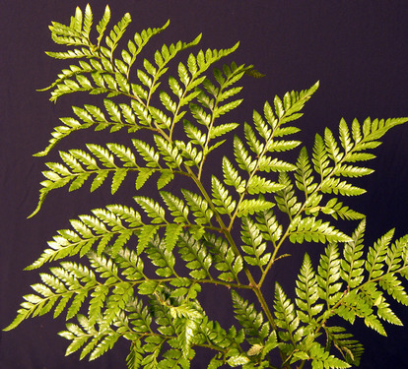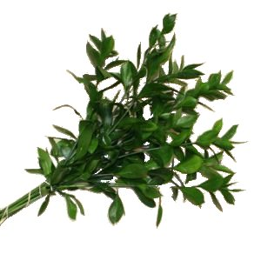
Ruscus aculeatus
Ruscus
6.99 per bunch (15 stems)
Rumohra adiantiformis
Leatherleaf Fern
$2.95 per bunch (20 stems)
Gypsophila elegans cv.
Baby's Breath
$3.49 per bunch (10 stems)

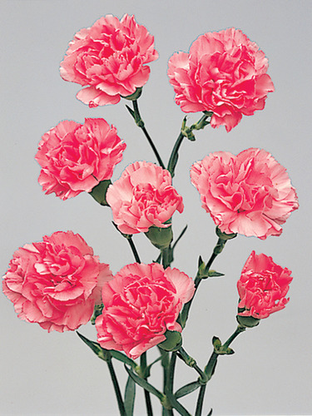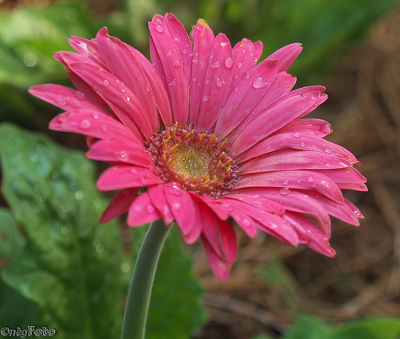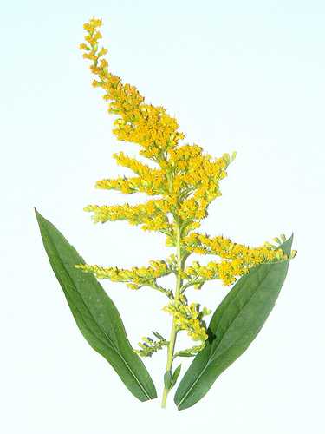
Solidago hybrid cv.
Solidago
$9.99 per bunch (25 stems)
Gerbera jamesonii
Gerber Daisy
$10.95 per bunch (20 stems)
Dianthus caryophyllus cv.
Carnation
$13.99 per bunch (15 stems)

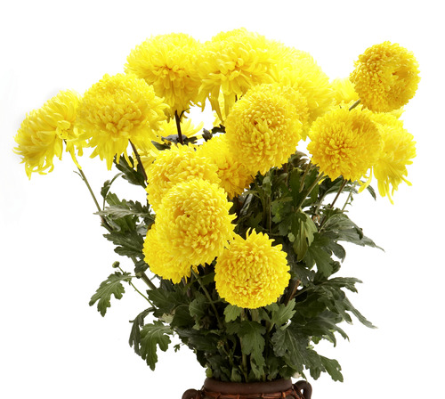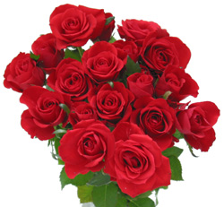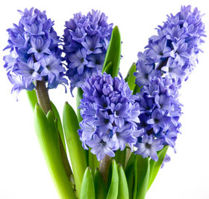

Rosa cv.
Sweetheart Rose
$16.99 per bunch (25 stems)
Hyacinthus cv.
Hyacinth
$34.95 per bunch (15 stems)
Chrysanthemum x morifolium
Florist's Chrysanthemum
$6.99 per bunch (10 stems)

