Careers with Animals: Animal Agribusiness
Created: 08/2018 by the National FFA Organization

Student Learning Objectives:
After completing these activities, students will …
- Examine the opportunities within animal agribusiness.
- Identify the demand for careers in animal agribusiness.

Time Required: 45 minutes
Resources:
- AgExplorer, https://agexplorer.ffa.org/
- Video: Cargill Science Behind Your Food, a virtual field trip on AgExplorer, https://agexplorer.ffa.org/virtual-field-trip/archive/2017-cargill

Equipment and Supplies Needed:
- A copy of the “Careers with Animals: Is This Animal Agribusiness?” worksheet for each student
- A copy of the ”USDA Employment Opportunities for College Graduates” article for each student
- Internet access to play the video in real time or embed it in a PowerPoint ahead of time

This quick lesson plan would work well as:
- A component in an animal science careers unit.
- As a complement to any agricultural careers unit.

These activities are aligned to the following standards:
AFNR Performance Element
- CS.01: Analyze how issues, trends, technologies and public policies impact systems in the Agriculture, Food & Natural Resources Career Cluster.
- CS.02: Evaluate the nature and scope of the Agriculture, Food & Natural Resources Career Cluster and the role of agriculture, food and natural resources (AFNR) in society and the economy.
FFA Precept
- FFA.PL-A.Action: Assume responsibility and take the necessary steps to achieve the desired results, no matter what the goal or task at hand.
- FFA.PL-C.Vision: Visualize the future and how to get there.
- FFA.PG-I.Professional Growth: Assume responsibility for attaining and improving upon the skills needed for career success.
- FFA.PG-J.Mental Growth: Embrace cognitive and intellectual development relative to reasoning, thinking and coping.
- FFA.CS-M.Communication: Effectively interact with others in personal and professional settings.
- FFA.CS-N.Decision Making: Analyze a situation and execute an appropriate course of action.
Common Career Technical Core
- AG1: Analyze how issues, trends, technologies and public policies impact systems in the Agriculture, Food & Natural Resources Career Cluster.
- AG2: Evaluate the nature and scope of the Agriculture, Food & Natural Resources Career Cluster and the role of agriculture, food and natural resources (AFNR) in society and the economy.
Common Core–Reading: Informational Text
- CCS.ELA-Literacy.RI.9-10.2: Determine a central idea of text and analyze its development over the course of the text, including how it emerges and is shaped and refined by specific details; provide an objective summary of the text.
- CCSS.ELA-Literacy.RI.9-10.4: Determine the meaning of words and phrases as they are used in a text, including figurative, connotative, and technical meanings; analyze the cumulative impact of specific word choices on meaning and tone (e.g. how the language of the court opinion differs from that of a newspaper).
Common Core–Writing
- CCSS.ELA-Literacy.W.9-10.9b: Apply grades 9-10 reading standards to literary nonfiction (e.g., "Delineate and evaluate the argument and specific claims in a text, assessing whether the reasoning is valid and the evidence is relevant and sufficient; identify false statements and fallacious reasoning").
Common Core–Speaking and Listening
- CCSS.ELA-Literacy.SL.9-10.1.D: Respond thoughtfully to diverse perspectives, summarize points of agreement and disagreement, and, when warranted, qualify or justify their own views and understanding and make new connections in light of the evidence and reasoning presented.
- CCSS.ELA-Literacy.SL.9-10.2: Integrate multiple sources of information presented in diverse media or formats (e.g., visually, quantitatively, orally) evaluating the credibility and accuracy of each source.
Common Core–Math Practices
- CCSS.MP1: Make sense of problems and persevere in solving them.
- CCSS.MP3: Construct viable arguments and critique the reasoning of others.
- CCSS.MP5: Use appropriate tools strategically.
- CCSS.MP6: Attend to precision.
AFNR Career Ready Practices
- CRP.02. Apply appropriate academic and technical skills. Career-ready individuals readily access and use the knowledge and skills acquired through experience and education to be more productive.
- CRP.04. Communicate clearly, effectively, and with reason. Career-ready individuals communicate thoughts, ideas and action plans with clarity, whether using written, verbal, and/or visual methods.
Partnership for 21st Century Skills
- Communication
- Leadership and Responsibility
- Initiative and Self-direction
- Flexibility and Adaptability
Lesson Plan:
- Bell Ringer: Write the following on the board or project on the screen: What do these tweets have in common? (Answer: they are all #AgFacts, i.e., agriculture facts.) These were put out in 2017 by the American Farm Bureau Federation.
  - “Many of the products we use in our everyday lives are byproducts of food produced by American farmers and ranchers.”
  - “Of the 10% of disposable income Americans spend on food, 50% is food eaten at home and 50% is food eaten out.”
  - “Farmers will have to grow 70% more food than what is currently produced to feed the world’s population by 2050.”

- Introduction: As a class watch Chapter 5 (until timestamp 3:00) of the virtual field trip Cargill: Science Behind Your Food on AgExplorer. The direct url is https://agexplorer.ffa.org/virtual-field-trip/archive/2017-cargill. After the video, discuss, as a class, what careers were touched on in the video segment that might fit into the animal agribusiness category.

- Activity 1: Give the “Careers with Animals: Is This Animal Agribusiness?” worksheet to each student. Students are to work individually to identify which career profiles are considered animal agribusiness careers. As students finish, they should discuss their findings in pairs.

- Activity 2: Hand out the “USDA Employment Opportunities for College Graduates” article. Have students highlight/underline key take-a-ways and “aha” moments as they read the article. After they are done, on the back of the article, have students summarize their thoughts in one word.

- Follow-up: After completing both activities, lead a class discussion on findings from the “Careers with Animals: Is This Animal Agribusiness?” worksheet and the USDA article. Additionally, create a “word wall” where students can post their one-word summary to describe the future of careers with animals.

- Leveling Up:
  - Have students write a job description or job posting of an animal agribusiness career.
  - Hold a “job fair” where half the class represents the job posting created above and half the class “interviews” for a potential job. Then, have the class switch roles, and now those searching for jobs become the potential employers.

- Exit Ticket: Have students write on index cards, sticky notes or blank paper an agriculture fact/tweet about careers in animal agribusiness.

Careers with Animals: Is This Animal Agribusiness?
Aligned to the following standards:
CS.01; CS.02; FFA.PL-A; FFA.PL-C; FFA.PG-I; FFA.PG-J; FFA.CS-M; FFA.CS-N; AG1; AG2; CCSS.ELA.RI.9-10.2; CCSS.ELA.RI.9-10.4; CCSS.ELA.W.9-10.9b; CCSS.ELA.SL.9-10.1D; CCSS.ELA.SL.9-10.2; MP1; MP3; MP5; MP6; CRP.02; CRP.04
Directions:
Read each job posting. Determine if the job is an animal agribusiness career, and circle the appropriate answer.
Youth Program Animal Science Specialist: Animal Agribusiness? Y or N

Description:
Employee will serve as a member of a team committed to enhancing the youth development program. Works with staff and animal industry stakeholders to develop, implement, deliver, and evaluate programs and learning experiences for youth. Create, design, teach and evaluate staff development programs.
Sales Associate/Customer Service: Animal Agribusiness? Y or N

Description:
Employee should be comfortable with multi-tasking in a fast-paced environment. Provide excellent customer service and information on products. Process in-store and delivery transactions, assist with receiving inventory, stocking shelves and maintaining inventory. Prior experience, education or training related to animal feed and husbandry, pet food supplies and local agriculture is required.
Animal Protein Procurement Associate Position: Animal Agribusiness? Y or N

Description:
Associate will be trained in a number of areas to succeed in a procurement leadership role. After training, associate will be placed in a territory to manage. Employee needs to understand meat processing production, including process flow, yields, variances, USDA regulations and requirements, accounting and information technologies.
Credit Analyst: Animal Agribusiness? Y or N

Description:
Function as a member of a team providing credit support, monitoring and analysis of loans maintained within the swine portfolio. Responsible for the risk-assessment, underwriting, structuring and approval of loans. Activities include assembly, consolidation, calculation, documentation and communication of financial condition of the customer.
Cattle Buyer: Animal Agribusiness? Y or N

Description:
Will be responsible for procuring available market-ready cattle. Duties also include transferring pertinent information to all scale house coordinators for price reporting and scheduling purposes. Must stay informed on market conditions and monitor available cattle supply and is responsible for decisions regarding cattle pricing. Must develop and maintain strong working relationships with all customers, scale house coordinators and upper management.

USDA Employment Opportunities for College Graduates
Aligned to the following standards:
CS.01; CS.02; FFA.PL-A; FFA.PL-C; FFA.PG-I; FFA.PG-J; FFA.CS-M; FFA.CS-N; AG1; AG2; CCSS.ELA.RI.9-10.2; CCSS.ELA.RI.9-10.4; CCSS.ELA.W.9-10.9b; CCSS.ELA.SL.9-10.1D; CCSS.ELA.SL.9-10.2; MP1; MP3; MP5; MP6; CRP.02; CRP.04
Directions:
Read the article and highlight or underline key take-a-ways.

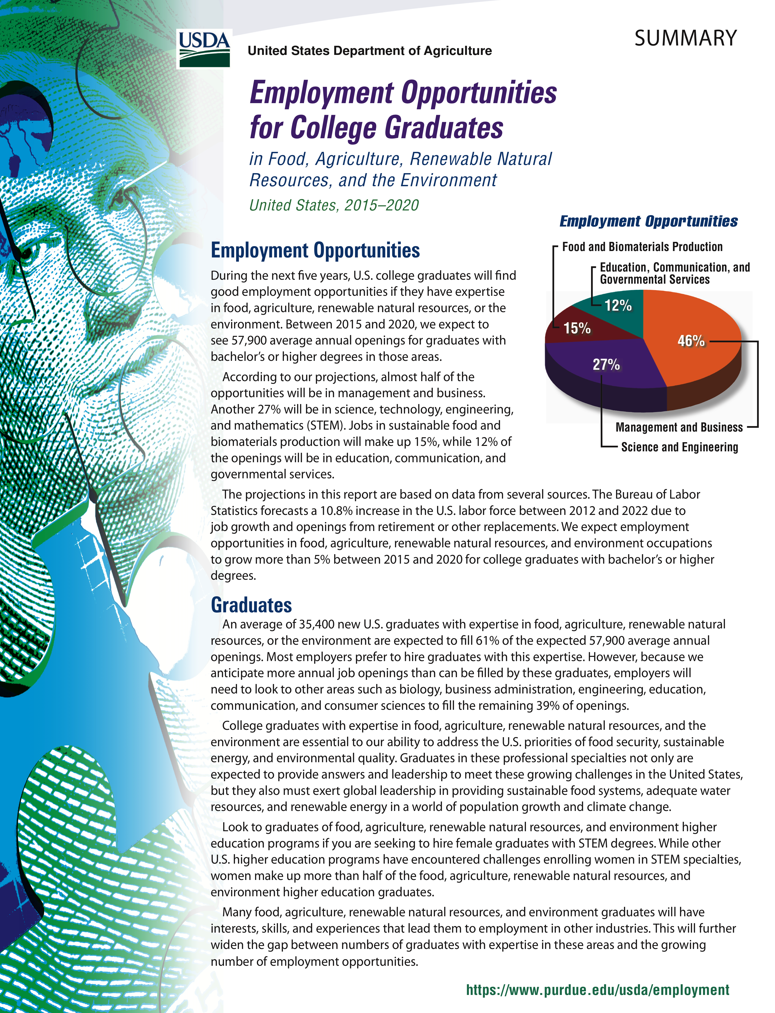

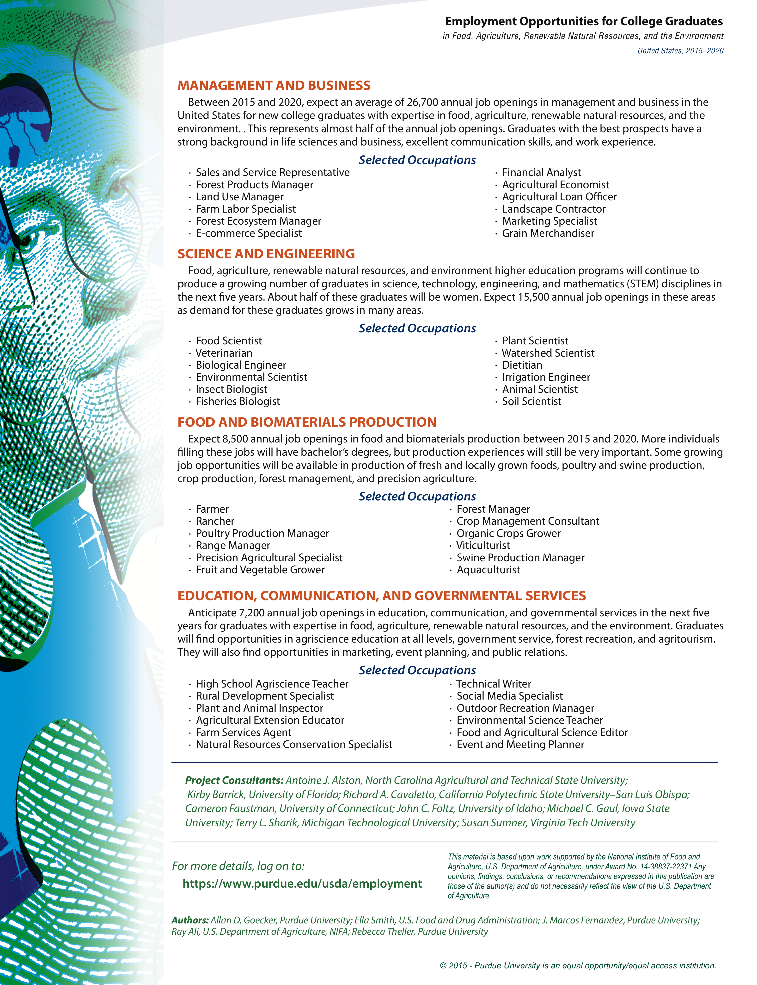
Key — Careers with Animals: Is This Animal Agribusiness?
Aligned to the following standards:
CS.01; CS.02; FFA.PL-A; FFA.PL-C; FFA.PG-I; FFA.PG-J; FFA.CS-M; FFA.CS-N; AG1; AG2; CCSS.ELA.RI.9-10.2; CCSS.ELA.RI.9-10.4; CCSS.ELA.W.9-10.9b; CCSS.ELA.SL.9-10.1D; CCSS.ELA.SL.9-10.2; MP1; MP3; MP5; MP6; CRP.02; CRP.04
Directions:
Read each job posting. Determine if the job is an animal agribusiness career, and circle the appropriate answer.
Description:
Employee will serve as a member of a team committed to enhancing the youth development program. Works with staff and animal industry stakeholders to develop, implement, deliver, and evaluate programs and learning experiences for youth. Create, design, teach and evaluate staff development programs.
Youth Program Animal Science Specialist: Animal Agribusiness? Y or N

Sales Associate/Customer Service: Animal Agribusiness? Y or N

Description:
Employee should be comfortable with multi-tasking in a fast-paced environment. Provide excellent customer service and information on products. Process in-store and delivery transactions, assist with receiving inventory, stocking shelves and maintaining inventory. Prior experience, education or training related to animal feed and husbandry, pet food supplies and local agriculture is required.
Animal Protein Procurement Associate Position: Animal Agribusiness? Y or N

Description:
Associate will be trained in a number of areas to succeed in a procurement leadership role. After training, associate will be placed in a territory to manage. Employee needs to understand meat processing production, including process flow, yields, variances, USDA regulations and requirements, accounting and information technologies.
Description:
Function as a member of a team providing credit support, monitoring and analysis of loans maintained within the swine portfolio. Responsible for the risk-assessment, underwriting, structuring and approval of loans. Activities include assembly, consolidation, calculation, documentation and communication of financial condition of the customer.
Credit Analyst: Animal Agribusiness? Y or N

Description:
Will be responsible for procuring available market-ready cattle. Duties also include transferring pertinent information to all scale house coordinators for price reporting and scheduling purposes. Must stay informed on market conditions and monitor available cattle supply and is responsible for decisions regarding cattle pricing. Must develop and maintain strong working relationships with all customers, scale house coordinators and upper management.
Cattle Buyer: Animal Agribusiness? Y or N

