Lesson 1: Preparing to Impress No Matter What!
Created: 04/2018 by the National FFA Organization

Student Learning Objectives:
After completing these activities, students will …
- Compare and contrast different types of interviews: individual, phone, video and group/panel.
- Construct ideas on how to be successful in any type of interview.

Time Required: 45 minutes
Resources:
- FFA.org
- Infographic: “How to Handle 04 Different Types of Interviews,” https://mycareerbuilderindia.wordpress.com/2015/10/21/the-ultimate-cheat-sheet-to-handle-4-different-types-of-interviews-infographic/

Equipment and Supplies Needed:
- A copy of the “How to Handle 04 Different Types of Interviews” infographic
- Internet to access the infographic, download it before class begins or make copies of Appendix A
- A copy of the worksheet “I Might Have to Do What?”

These activities are aligned to the following standards:
FFA Precept
- FFA.PL-A.Action: Assume responsibility and take the necessary steps to achieve the desired results, not matter what the goal or task at hand.
- FFA.PL-E.Awareness: Understand personal vision, mission and goals.
- FFA.PG-J.Mental Growth: Embrace cognitive and intellectual development relative to reasoning, thinking and coping.
- FFA.CS-M.Communication: Effectively interact with others in personal and professional settings.
- FFA.CS-N.Decision Making: Analyze a situation and execute an appropriate course of action.
Common Core - Speaking and Listening
- CCSS.ELA-Literacy.SL.9-10.1: Initiate and participate effectively in a range of collaborative discussions (one-on-one, in groups, and teacher-led) with diverse partners on grades 9-10 topics, texts, and issues, building on others’ ideas and expressing their own clearly and persuasively.
- CCSS.ELA-Literacy.SL.9-10.4: Present information, findings, and supporting evidence clearly, concisely, and logically such that listeners can follow the line of reasoning and the organization, development, substance, and style are appropriate to purpose, audience and task.
AFNR Career Ready Practices
- CRP.02: Apply appropriate academic and technical skills. Career-ready individuals readily access and use the knowledge and skills acquired through experience and education to be more productive.
- CRP.04: Communicate clearly, effectively, and with reason. Career-ready individuals communicate thoughts, ideas and action plans with clarity, whether using written, verbal and/or visual methods.
Partnership for 21st Century Skills
- Information, Communications, and Financial Literacy
- Think Creatively

Lesson Plan:
- Bell Ringer: What types of interview formats could you encounter when going to interview for a job (ex. One-on-one in person)? List as many as possible.

- Introduction: After time is over, create a list on the board and have a discussion about each of the responses given. Then, review the important components of an interview (ex. arrive on time, dress professionally, smile, firm hand shake, eye contact, etc.)
- Activity: Each student needs a copy of the worksheet “I Might Have to Do What?”
  - Have students access the infographic “How to Handle 04 Different Types of Interviews” https://mycareerbuilderindia.wordpress.com/2015/10/21/the-ultimate-cheat-sheet-to-handle-4-different-types-of-interviews-infographic/ (also found in Appendix A). Students need to determine the items to “prep and impress” for each of the four identified interview types. Students will apply this information to individual interviews. After this, students will create an acrostic poem to help students remember the important steps to succeed in any type of job interview they may encounter.

- Follow-up: Have students create a list of questions they would ask during a phone interview. Next, have students work with a partner, sitting back to back, to conduct a phone interview.

- Leveling Up: Invite members from the school, community or agricultural education advisory board and allow students to go through a group interview process.

- Exit Ticket: Independently, on your own paper, use a Venn diagram to compare and contrast two different types of interview structures of your choice.

I Might Have to Do What?
Aligned to the following standards:
FFA.PL-A; FFA.PL-E; FFA.PG-J; FFA.CS-M; FFA.CS-N; CCSS.SL.9-10.1; CCSS.SL.9-10.4; CRP.02; CRP.04
Directions:
Answer the following three prompts to see what you already know from your experiences and/or previous lessons and to identify what questions still remain.
What Do I Know? | Questions?

Identify 3 characteristics that lead to a positive job interview. | Identify 3 characteristics that would lead to a poor job interview. | Identify 3 questions you still have about the job interview process.
- _________________________  _________________________  _________________________  - _________________________  _________________________  _________________________  - _________________________  _________________________  _________________________ | - _________________________  _________________________  _________________________  - _________________________  _________________________  _________________________  - _________________________  _________________________  _________________________ | - _________________________  _________________________  _________________________  - _________________________  _________________________  _________________________  - _________________________  _________________________  _________________________
Directions:
View the infographic “How to Handle 04 Different Types of Interviews” (https://mycareerbuilderindia.wordpress.com/2015/10/21/the-ultimate-cheat-sheet-to-handle-4-different-types-of-interviews-infographic/). Complete the following activities by using the infographic and applying your previous knowledge about interviews.

Directions:
Aligned to the following standards:
FFA.PL-A; FFA.PL-E; FFA.PG-J; FFA.CS-M; FFA.CS-N; CCSS.SL.9-10.1; CCSS.SL.9-10.4; CRP.02; CRP.04
Using your previous experiences and what you’ve learned, identify how the four interview formats analyzed today compare to an individual interview. How would you prep and impress for a one-on-one interview format?

Directions:
Ensuring success can be easy in any situation you may encounter for a job interview if you remember to prepare and prep!
- Create a “cheat sheet” of rules that apply to ALL types of interviews (i.e. phone, video, group, panel and in person one-on-one) that you can reference and remember.
- To do this, create an acrostic poem. To create an acrostic poem, take each letter of a single word and come up with a word or phrase for each letter that will help you to remember a concept.
- Today, create an acrostic poem using the word “succeed” to help you remember the keys to being successful in any interview situation.
S___________________________________
U___________________________________
C___________________________________
C___________________________________
E___________________________________
E___________________________________
D___________________________________

KEY: I Might Have to Do What?
Aligned to the following standards:
FFA.PL-A; FFA.PL-E; FFA.PG-J; FFA.CS-M; FFA.CS-N; CCSS.SL.9-10.1; CCSS.SL.9-10.4; CRP.02; CRP.04
Directions:
Answer the following three prompts to see what you already know from your experiences and/or previous lessons and to identify what questions still remain. Answers will vary.

What Do I Know? | Questions?

Identify 3 characteristics that lead to a positive job interview. | Identify 3 characteristics that would lead to a poor job interview. | Identify 3 questions you still have about the job interview process.
- _________________________  _________________________  _________________________  - _________________________  _________________________  _________________________  - _________________________  _________________________  _________________________ | - _________________________  _________________________  _________________________  - _________________________  _________________________  _________________________  - _________________________  _________________________  _________________________ | - _________________________  _________________________  _________________________  - _________________________  _________________________  _________________________  - _________________________  _________________________  _________________________
Directions:
View the infographic “How to Handle 04 Different Types of Interviews” (https://mycareerbuilderindia.wordpress.com/2015/10/21/the-ultimate-cheat-sheet-to-handle-4-different-types-of-interviews-infographic/). Complete the following activities by using the infographic and applying your previous knowledge of interviews.

Directions:
Using your previous experiences and what you’ve learned, identify how the four interview formats analyzed today compare to an individual interview. How would you prep and impress for a one-on-one interview format?

Directions:
Ensuring success can be easy in any situation you may encounter for a job interview if you remember to prepare and prep!
- Create a “cheat sheet” of rules that apply to ALL types of interviews (i.e. phone, video, group, panel, and in person one-on-one) that you can reference and remember.
- To do this, create an acrostic poem. To create an acrostic poem, take each letter of a single word and come up with a word or phrase for each letter that will help you to remember a concept.
- Today, create an acrostic poem using the word “succeed” to help you remember the keys to being successful in any interview situation. Answers will vary.

S___________________________________
U___________________________________
C___________________________________
C___________________________________
E___________________________________
E___________________________________
D___________________________________

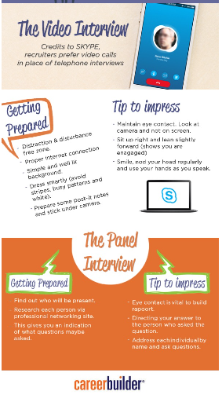
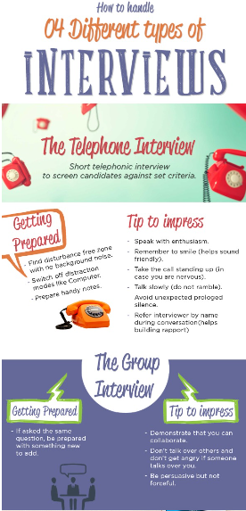
Appendix A:

