Prepping for a Career with Animals
Created: 08/2018 by the National FFA Organization

Student Learning Objectives:
After completing these activities, students will …
- Explain how to prepare for a career with animals.
- Create a plan and action steps to prepare for a career with animals.

Time Required: 45 minutes
Resources:
- AgExplorer, https://agexplorer.ffa.org/

Equipment and Supplies Needed:
- A copy of the “Careers with Animals” worksheet for each student
- Copies of the “Careers with Animals Cards,” one set for each pair of students
- A copy of the “My Interest in a Career with Animals” worksheet for each student
- Internet access to play the video in real time or embed it in a PowerPoint ahead of time
- Computer access, ideal for students to work in pairs or small groups

This quick lesson plan would work well as:
- Part of a careers with animals unit.
- A complement to any career preparation lesson or unit.

These activities are aligned to the following standards:
AFNR Performance Element
- AS.01: Analyze historic and current trends impacting the animal systems industry.
- CS.01: Analyze how issues, trends, technologies and public policies impact systems in the Agriculture, Food & Natural Resources Career Cluster.
- CS.02: Evaluate the nature and scope of the Agriculture, Food & Natural Resources Career Cluster and the role of agriculture, food and natural resources (AFNR) in society and the economy.
FFA Precept
- FFA.PL-A.Action: Assume responsibility and take the necessary steps to achieve the desired results, no matter what the goal or task at hand.
- FFA.PL-C.Vision: Visualize the future and how to get there.
- FFA.PL-E.Awareness: Understand personal vision, mission and goals.
- FFA.PL-F.Continuous Improvement: Accept responsibility for learning and personal growth.
- FFA.PG-J.Mental Growth: Embrace cognitive and intellectual development relative to reasoning, thinking and coping.
- FFA.CS-M.Communication: Effectively interact with others in personal and professional settings.
- FFA.CS-N.Decision Making: Analyze a situation and execute an appropriate course of action.
Common Career Technical Core
- AG1: Analyze how issues, trends, technologies and public policies impact systems in the Agriculture, Food & Natural Resources Career Cluster.
- AG2: Evaluate the nature and scope of the Agriculture, Food & Natural Resources Career Cluster and the role of agriculture, food and natural resources (AFNR) in society and the economy.
Common Career Technical Core
- AG-ANI1: Analyze historic and current trends impacting the animal systems industry.
Common Core–Reading: Informational Text
- CCSS.ELA-Literacy.RI.9-10.4: Determine the meaning of words and phrases as they are used in a text, including figurative, connotative, and technical meanings; analyze the cumulative impact of specific word choices on meaning and tone (e.g., how the language of a court opinion differs from that of a newspaper).
Common Core–Writing
- CCSS.ELA-Literacy.W.9-10.9b: Apply grades 9-10 reading standards to literary nonfiction (e.g., "Delineate and evaluate the argument and specific claims in a text, assessing whether the reasoning is valid and the evidence is relevant and sufficient; identify false statements and fallacious reasoning").
Common Core–Speaking and Listening
- CCSS.ELA-Literacy.SL.9-10.1: Initiate and participate effectively in a range of collaborative discussions (one-on-one, in groups, and teacher-led) with diverse partners on grades 9-10 topics, texts, and issues, building on others' ideas and expressing their own clearly and persuasively.
Common Core–Math Practices
- CCSS.MP1: Make sense of problems and persevere in solving them.
- CCSS.MP5: Use appropriate tools strategically.
- CCSS.MP6: Attend to precision.

AFNR Career Ready Practices
- CRP.02. Apply appropriate academic and technical skills. Career-ready individuals readily access and use the knowledge and skills acquired through experience and education to be more productive.
- CRP.04. Communicate clearly, effectively, and with reason. Career-ready individuals communicate thoughts, ideas and action plans with clarity, whether using written, verbal and/or visual methods.
Partnership for 21st Century Skills
- Communication
- Flexibility and Adaptability
- Initiative and Self-direction
- Leadership and Responsibility

Lesson Plan:
- Bell Ringer: On a blank piece of paper, have students brainstorm colleges, universities, training and certification programs and SAEs available to support careers with animals.

- Introduction: Have students look up the definition of a land-grant university and answer these questions: What role do land-grant universities play in preparing for an animal science career? What schools in the U.S. are land-grant universities?

- Activity 1: In pairs or small groups, have students review the “Careers with Animals Cards” and capture information on the “Careers with Animals” worksheet. The focus is on job requirements and necessary skills.

- Activity 2: Each student should work individually to answer the questions on the “My Interest in a Career with Animals” worksheet. As students complete this worksheet, it’s important to help students understand they will be identifying three career options that are all potential opportunities for them as future careers.

- Follow-up: After students complete Activity 2, meet individually to review the worksheet and the options for each plan. Answer questions and offer guidance as needed.

- Leveling Up:
  - Consider bringing in a guidance counselor to provide additional resources, counseling and feedback to each student.
  - Have students contact an advisor at a college or university for career and/or course advice.
  - Have students research scholarship opportunities that would support a career with animals. National FFA scholarships would be a great place to start!

- Exit Ticket: Have students answer the following question on a blank piece of paper or index card: What skills do I have that align with an animal science career?

Careers with Animals Cards
Aligned to the following standards:
AS.01; CS.01; CS.02; FFA.PL-A; FFA.PL-C; FFA.PL-E; FFA.PL-F; FFA.PG-J; FFA.CS-M; FFA.CS-N; AG1; AG2; AG-ANI1; CCSS.ELA.RI.9-10.4; CCSS.ELA.W.9-10.1b; CCSS.ELA.SL.9-10.1; MP1; MP5; MP6; CRP.02; CRP.04
Directions:
The teacher/instructor should cut these cards out and provide each group of students with a set of these cards. These career profiles are courtesy of AgCareers.com (www.agcareers.com/infographics/top-agricultural-careers-in-animal-science-infographic-29.cfm).
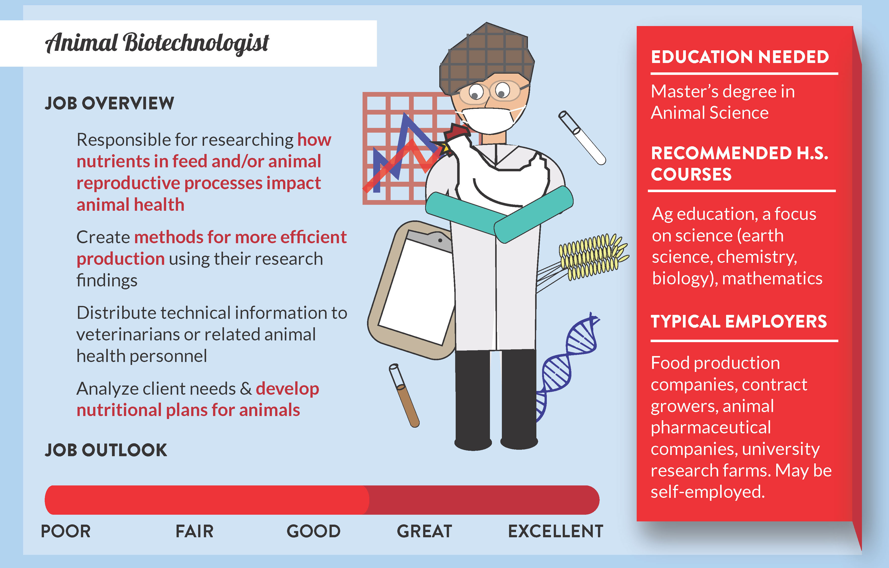

www.agcareers.com/infographics/top-agricultural-careers-in-animal-science-infographic-29.cfm

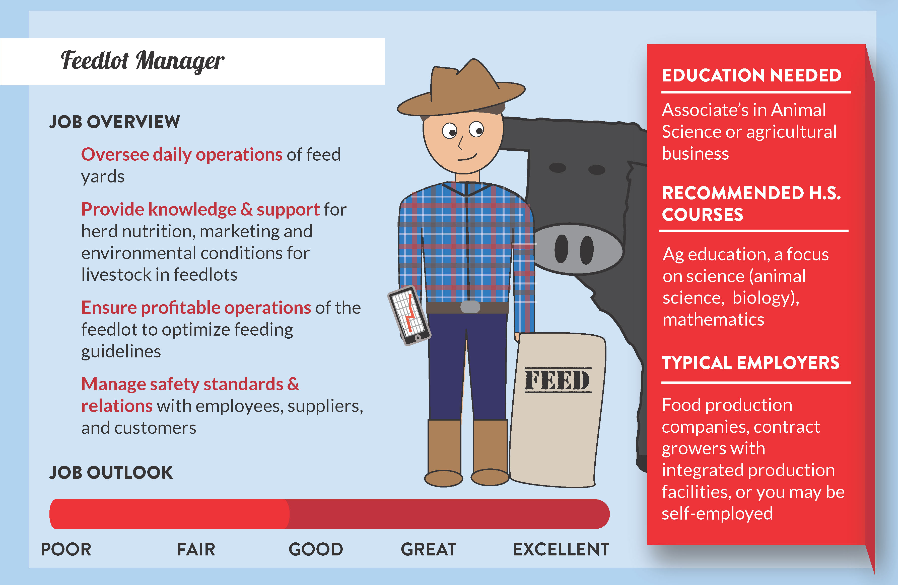
www.agcareers.com/infographics/top-agricultural-careers-in-animal-science-infographic-29.cfm
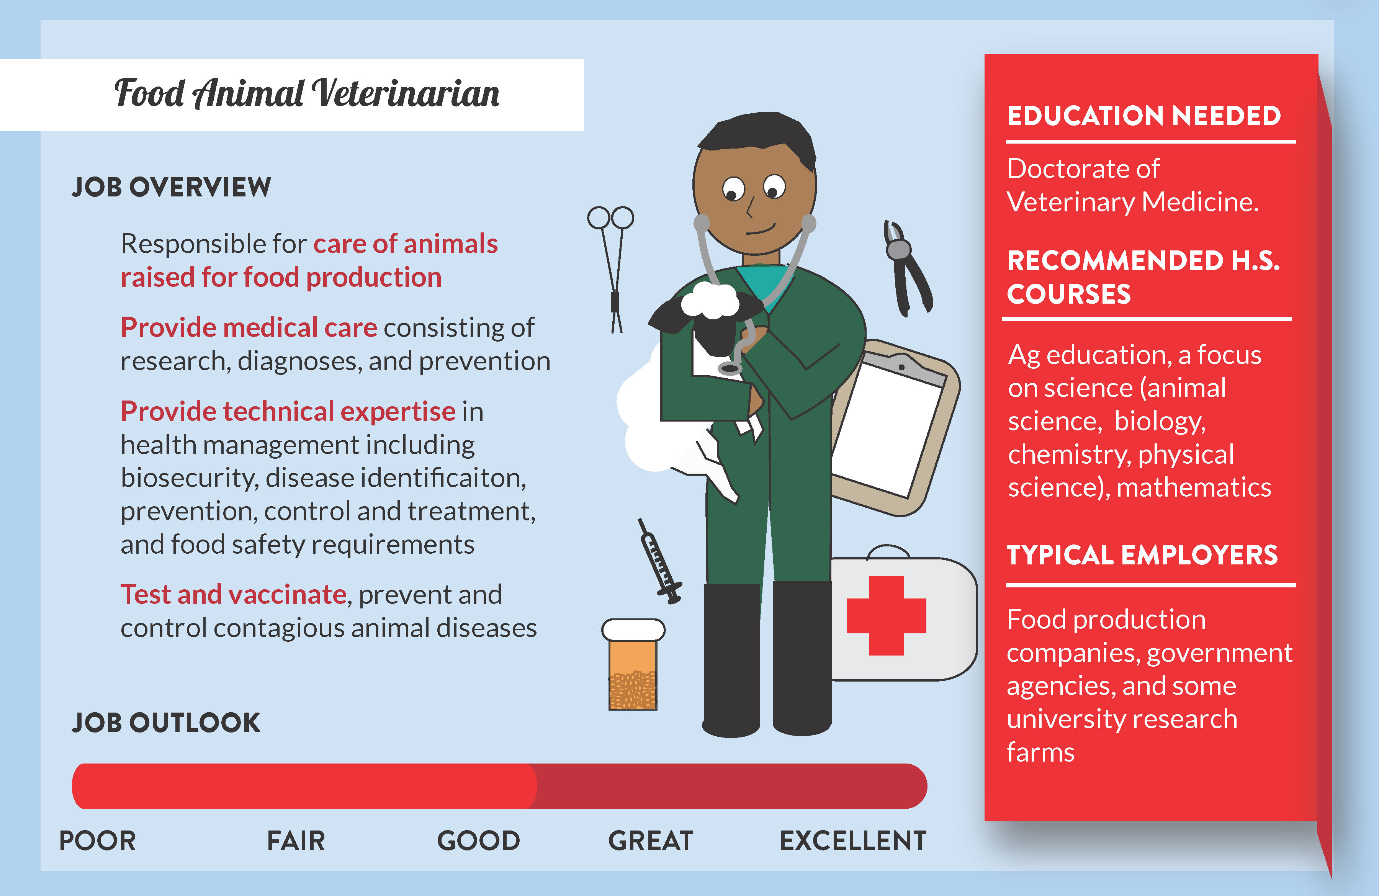
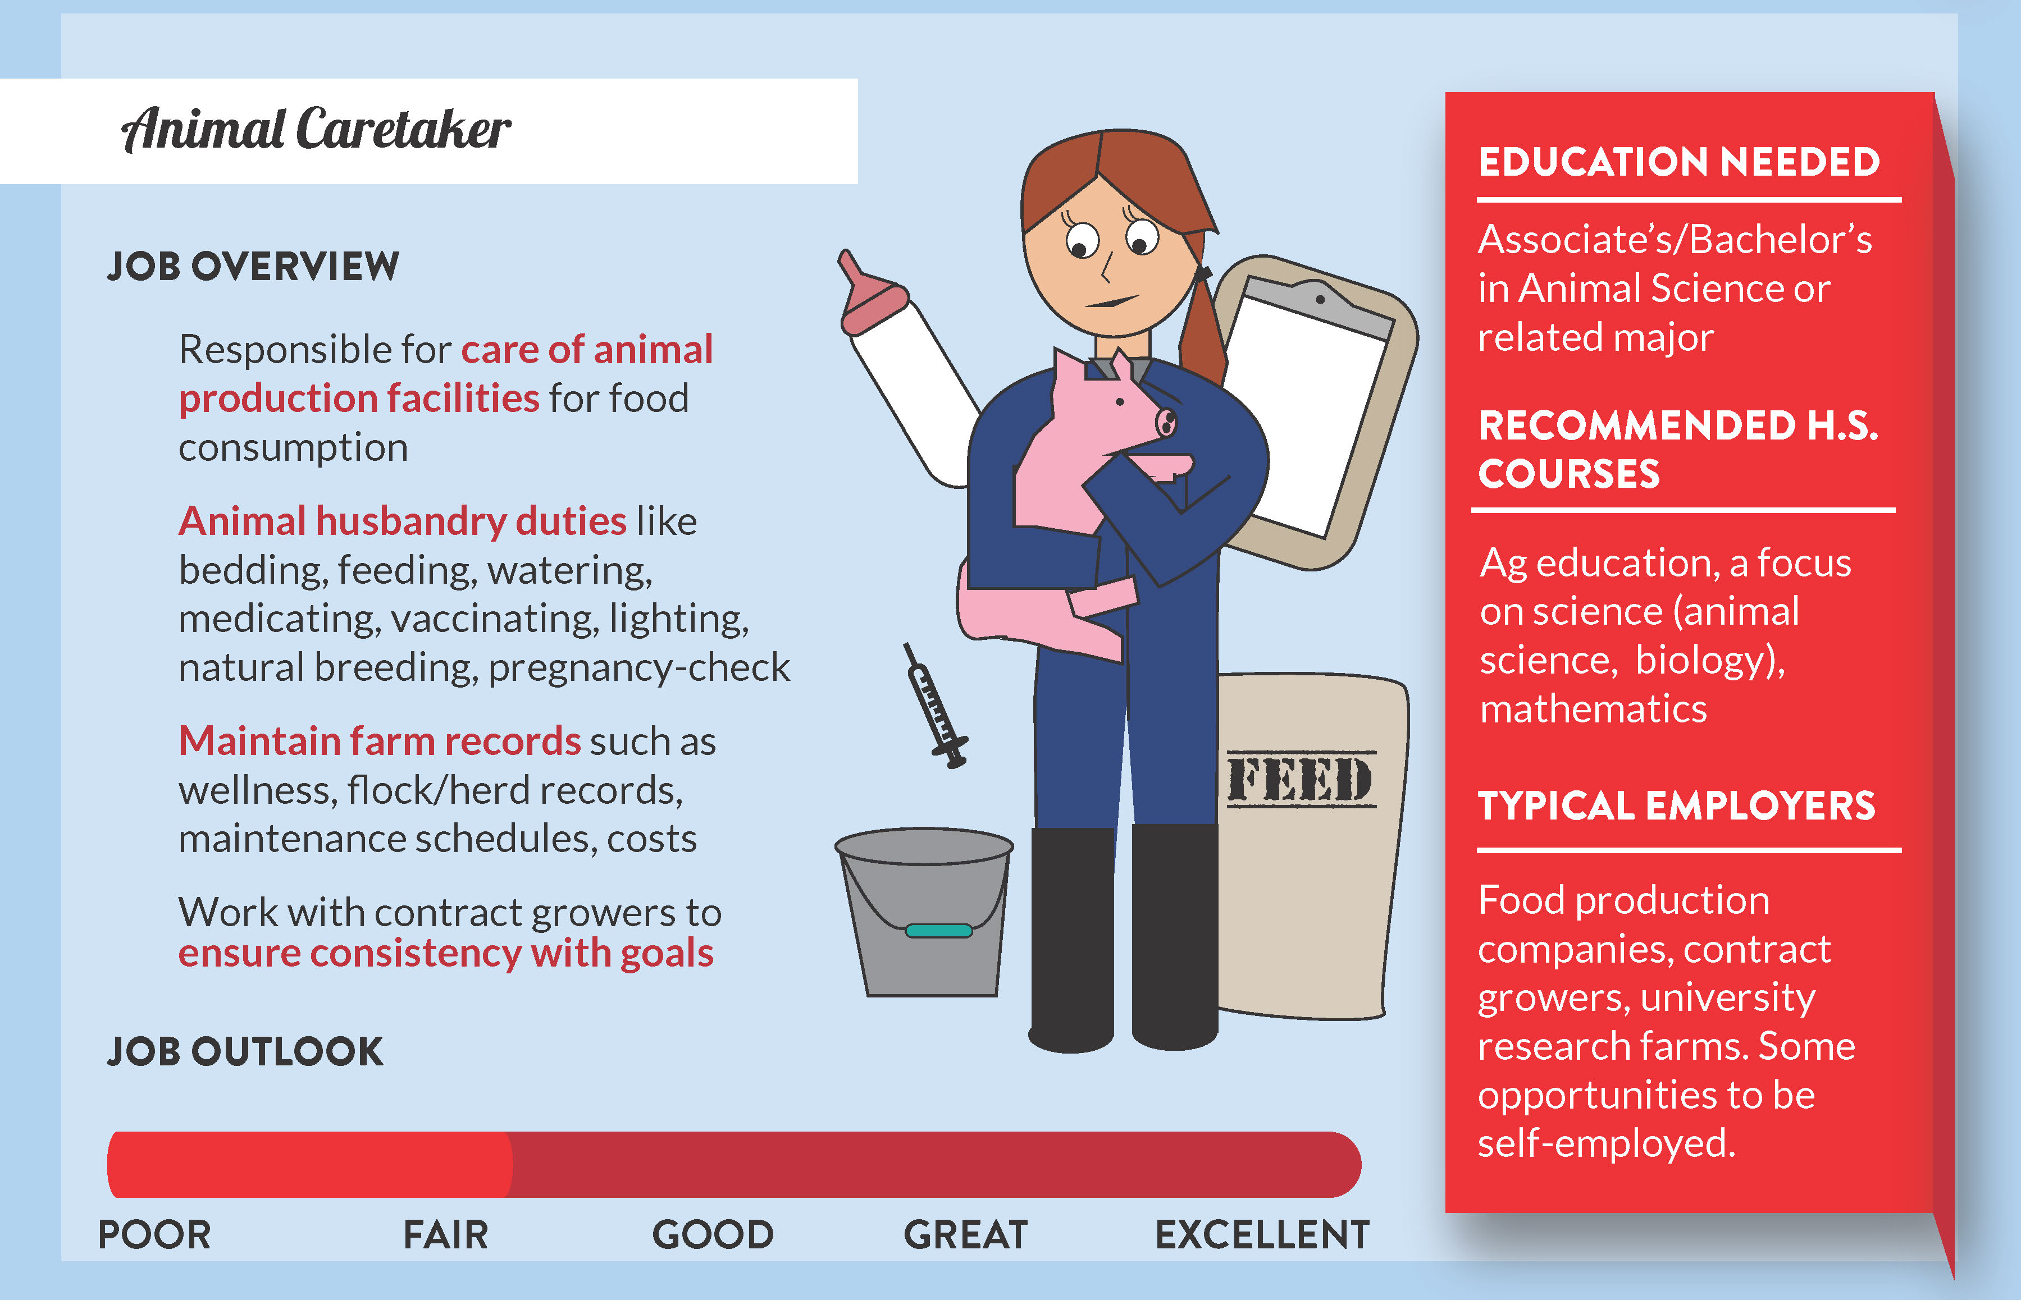

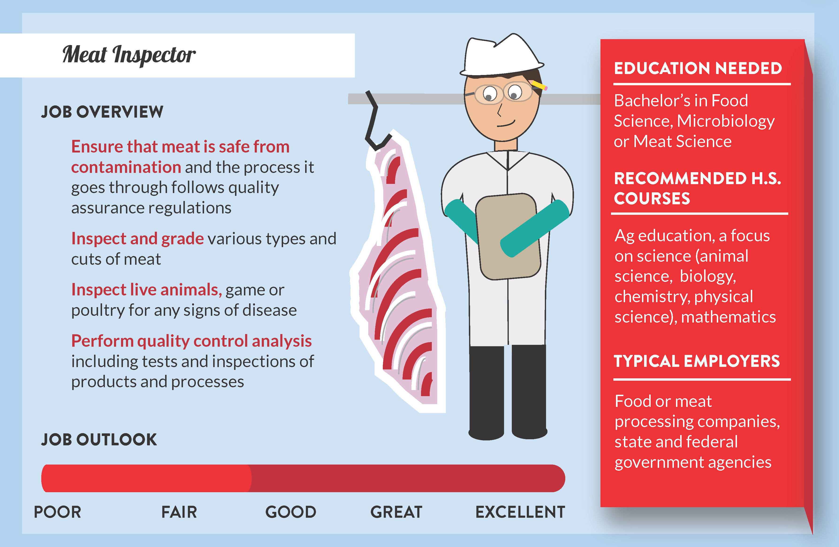

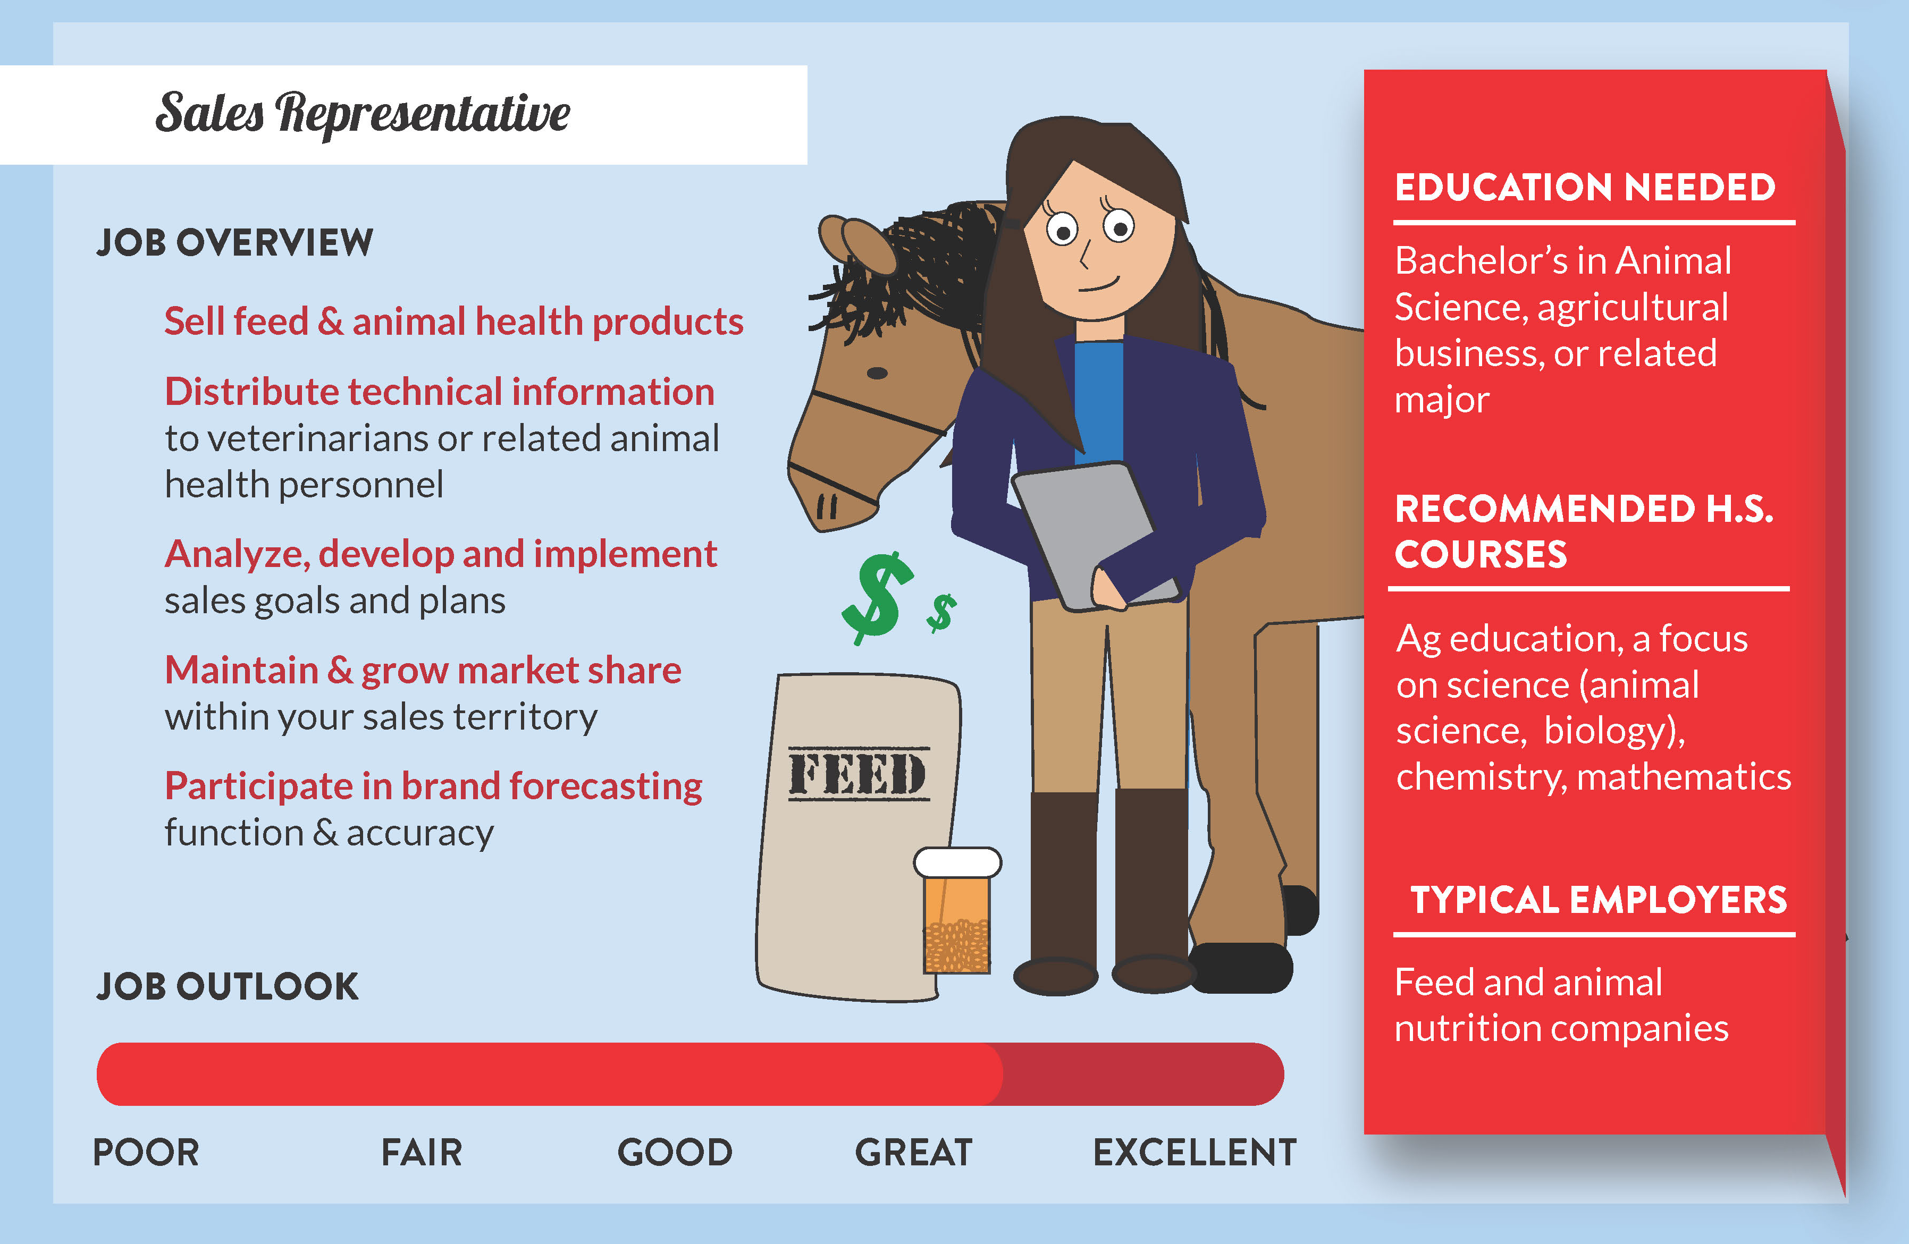

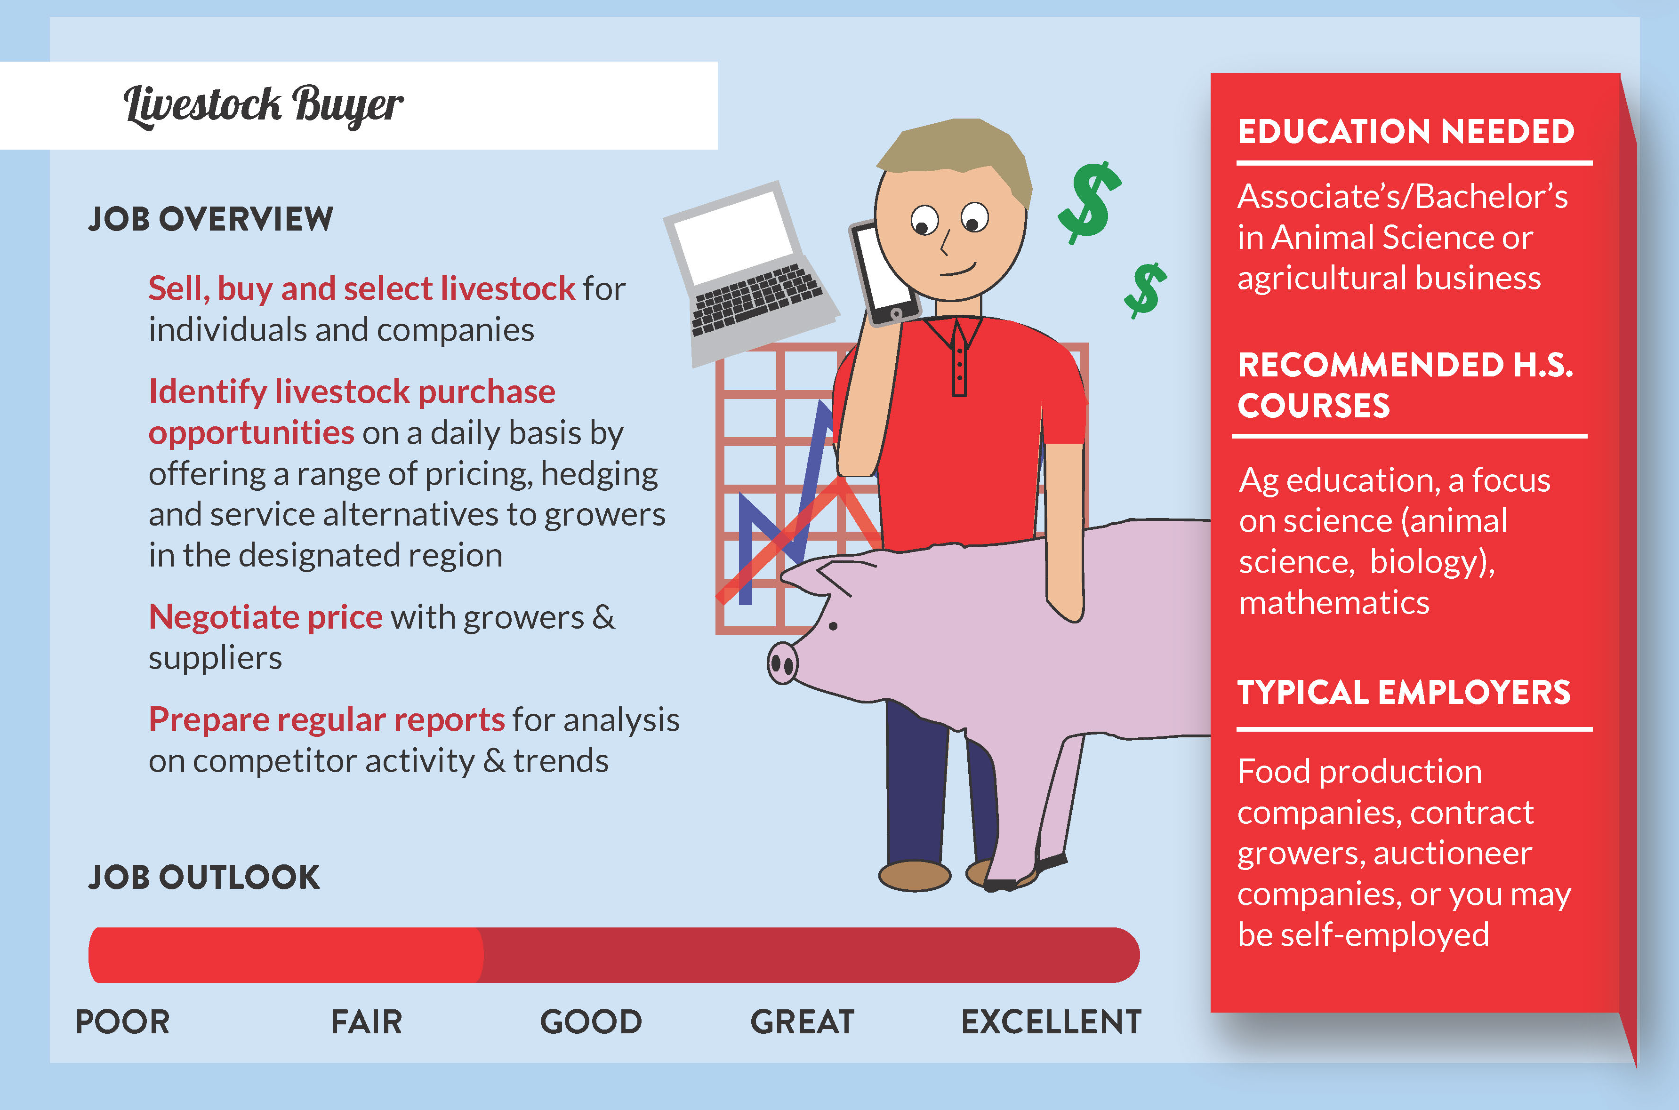
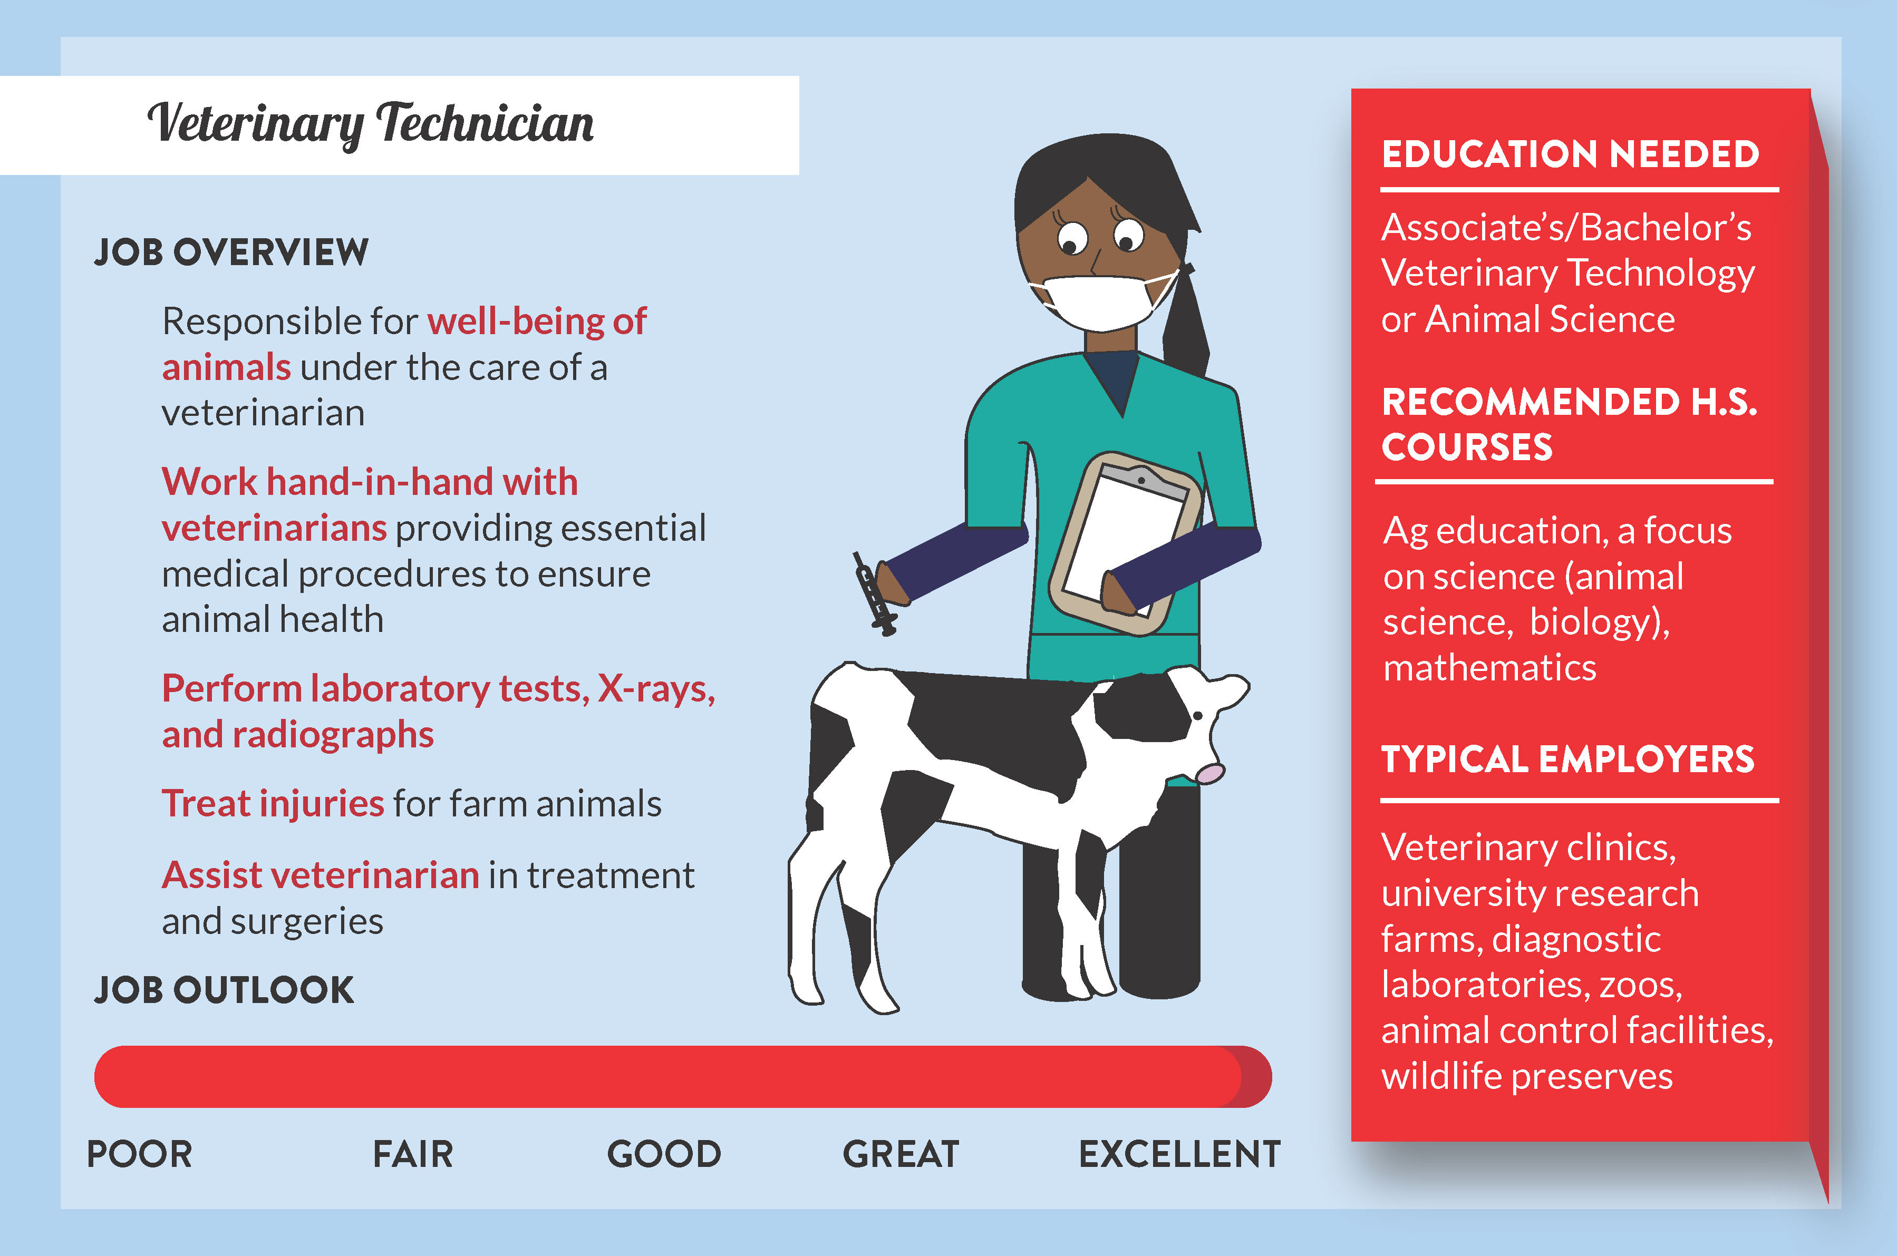
Careers with Animals
Aligned to the following standards:
AS.01; CS.01; CS.02; FFA.PL-A; FFA.PL-C; FFA.PL-E; FFA.PL-F; FFA.PG-J; FFA.CS-M; FFA.CS-N; AG1; AG2; AG-ANI1; CCSS.ELA.RI.9-10.4; CCSS.ELA.W.9-10.1b; CCSS.ELA.SL.9-10.1; MP1; MP5; MP6; CRP.02; CRP.04
Directions:
Complete this worksheet with information from the “Careers with Animals Cards.”

Career | Description | Requirements | Potential Skills Needed

My Interest in a Career with Animals
Aligned to the following standards:
AS.01; CS.01; CS.02; FFA.PL-A; FFA.PL-C; FFA.PL-E; FFA.PL-F; FFA.PG-J; FFA.CS-M; FFA.CS-N; AG1; AG2; AG-ANI1; CCSS.ELA.RI.9-10.4; CCSS.ELA.W.9-10.1b; CCSS.ELA.SL.9-10.1; MP1; MP5; MP6; CRP.02; CRP.04
Directions:
Follow the prompts on this page to help “map out” a potential career with animals plan.

List 3
Potential
careers with
animals in which
you are interested.
What type of experiences can I have now that will help me with these skills and careers?
What type of skills are essential for this career?
What type of education is required for this career?
What might impact your level of education?

