Lesson 2: Fielding Job Offers
Created: 05/2018 by the National FFA Organization

Student Learning Objectives:
After completing these activities, students will …
- Collect information about a job offer.
- Negotiate a job offer.
- Develop questions to ask based on a written job offer.
- Identify FFA activities and opportunities related to the National FFA Employment Skills Leadership Development Event.

Time Required: 120 minutes
Resources:
- FFA.org
- Article: “40 Questions to Ask Before You Accept a Job Offer,” https://www.theladders.com/career-advice/job-offer-questions
- Video: “5 Tips to Negotiating Benefits,” https://youtu.be/7M23KSvGWNs
- National FFA Employment Skills LDE, https://www.ffa.org/participate/ldes/employment-skills

Equipment and Supplies Needed:
- Internet access for the article “40 Questions to Ask Before You Accept a Job Offer.”
- Internet access to watch the video or embed it in a PowerPoint prior to class.
- Copies of the “What to Ask Before Accepting a Job Offer” worksheet
- Copies of the “What to Do Before Accepting a Job Offer Crossword” worksheet
- Copies of the “Negotiating a Job Offer” worksheet
- Copies of the “Written Job Offer” worksheet
- Copies of the “Telephone Job Offer Rubric” worksheet

These activities are aligned to the following standards:
FFA Precept
- FFA.PL-A.Action: Assume responsibility and take the necessary steps to achieve the desired results, no matter what the goal or task at hand.
- FFA.PL-E.Awareness: Understand personal vision, mission and goals.
- FFA.PG-J.Mental Growth: Embrace cognitive and intellectual development relative to reasoning, thinking and coping.
- FFA.CS-M.Communication: Effectively interact with others in personal and professional settings.
- FFA.CS-N.Decision Making: Analyze a situation and execute an appropriate course of action.
Common Core - Speaking and Listening
- CCSS.ELA-Literacy.SL.9-10.1: Initiate and participate effectively in a range of collaborative discussions (one-on-one, in groups, and teacher-led) with diverse partners on grades 9-10 topics, texts, and issues, building on others’ ideas and expressing their own clearly and persuasively.
- CCSS.ELA-Literacy.SL.9-10.4: Present information, findings, and supporting evidence clearly, concisely, and logically such that listeners can follow the line of reasoning and the organization, development, substance, and style are appropriate to purpose, audience and task.
Common Core-Literacy in Science & Technical Subjects: Writing
- CCSS.ELA-Literacy.WHST.9.10.6: Use technology, including the Internet to produce, publish, and update individual or shared writing products, taking advantage of technology’s capacity to link to other information and to display information flexibly and dynamically.
AFNR Career Ready Practices
- CRP.02: Apply appropriate academic and technical skills. Career-ready individuals readily access and use the knowledge and skills acquired through experience and education to be more productive.
- CRP.04: Communicate clearly, effectively, and with reason. Career-ready individuals communicate thoughts, ideas and action plans with clarity, whether using written, verbal and/or visual methods.
Partnership for 21st Century Skills
- Communication
- Critical Thinking and Problem Solving
- Financial, Economic, Business, and Entrepreneurial Literacy
- Technology Literacy
- Think Creatively

Lesson Plan:
- Bell Ringer: What should you do when you receive a job offer? Do you just yell “YES!”? Why or why not?

- Introduction: After time is up, create a list on the board and have a discussion about each of the responses given.

- Activity 1: Each student needs a copy of the worksheet “What to Do Before Accepting a Job Offer.”
  - Break students into four separate groups. Each group will focus on one of the four parts of the article (“40 Questions to Ask Before You Accept a Job Offer,” available at https://www.theladders.com/career-advice/job-offer-questions). Have every student complete the worksheet utilizing the article. Give groups seven minutes to complete their portion.
  - After the seven minutes are up, each group will present its findings to the rest of the class. The other students will take notes in the provided spot.
  - Hand out the “What to Do Before Accepting a Job Offer Crossword” worksheet to each student. Students will independently complete the crossword using what they just learned to review important components of questions that should be asked (all based on the article) when looking at a job offer.

Activity 2: Each student needs a copy of the “Negotiating a Job Offer” worksheet.
  - Have students watch the video “5 Tips to Negotiating Benefits,” https://youtu.be/7M23KSvGWNs. During the video, students need to complete the first part of the worksheet.
  - Students will then take what they have learned and brainstorm the appropriate questions they would need to ask during a conversation to gain all needed knowledge about the job being offered. Each student will need a copy of the “Written Job Offer” worksheet.

- Follow-up: Each student needs a copy of the “Telephone Job Offer Rubric.” Students will pair up, sitting with their backs to each other, and take turns being the person making the job offer and the one fielding the job offer. Students will critique each other during the activity using the rubric provided.

- Leveling Up: Invite members from the school, community or agricultural education advisory board and allow students to go through a group interview process.

- Exit Ticket: Create a list of five questions that you feel are most important to ask when offered a job.

What to Do Before Accepting a Job Offer
Aligned to the following standards:
FFA.PL-A; FFA.PL-E; FFA.PG-J; FFA.CS-M; FFA.CS-N; CCSS.SL.9-10.1; CCSS.SL.9-10.4; CCSS.WHST.9.10.6; CRP.02; CRP.04
Directions:
The class will be split into four groups to learn about what you need to consider and ask prior to accepting or rejecting a job offer. Working with your group, you are going to identify the following: (1) the purpose of the category assigned; (2) the 3 most important questions to consider from the category and why each is important; and (3) a creative way to share the types of questions that should be considered and asked to the class. Use the resource “40 Questions to Ask Before You Accept a Job Offer” (https://www.theladders.com/career-advice/job-offer-questions). When your classmates are sharing what they learned, you will record their information in the appropriate location below.



The Role
Overall purpose of category: ________________________________________________________________________________________________________________________________

Question:
- _________________________________
  - Purpose: ______________________________________________________________________________
- _________________________________
  - Purpose: ______________________________________________________________________________
- _________________________________
  - Purpose: ______________________________________________________________________________

Overall purpose of category: ________________________________________________________________________________________________________________________________
The Team
Question:
- ________________________________
  - Purpose: ______________________________________________________________________________
- ________________________________
  - Purpose: ______________________________________________________________________________
- _________________________________
  - Purpose: ______________________________________________________________________________

Aligned to the following standards:
FFA.PL-A; FFA.PL-E; FFA.PG-J; FFA.CS-M; FFA.CS-N; CCSS.SL.9-10.1; CCSS.SL.9-10.4; CCSS.WHST.9.10.6; CRP.02; CRP.04

Salary & Benefits
Overall purpose of the category:
________________________________________________________________________________________________________________________________________________________

Question:
- _________________________________
  - Purpose: ________________________________________________________________________________________________________________
- _________________________________
  - Purpose: ________________________________________________________________________________________________________________
- _________________________________
  - Purpose: __________________________________________________________________________________________________________________

Company Culture

Question:
- ______________________________________________________
  - Purpose: ______________________________________________________________________________________________________________
- ______________________________________________________
  - Purpose: ______________________________________________________________________________________________________________
- ______________________________________________________
  - Purpose: ______________________________________________________________________________________________________________

Overall purpose of the category:
______________________________________________________________________________________________________________________________________________________

What to Do Before Accepting a Job Offer Crossword
Aligned to the following standards:
FFA.PL-A; FFA.PL-E; FFA.PG-J; FFA.CS-M; FFA.CS-N; CCSS.SL.9-10.1; CCSS.SL.9-10.4; CCSS.WHST.9.10.6; CRP.02; CRP.04
Directions:
Use the resource “40 Questions to Ask Before You Accept a Job Offer” (https://www.theladders.com/career-advice/job-offer-questions) to independently complete the crossword below.
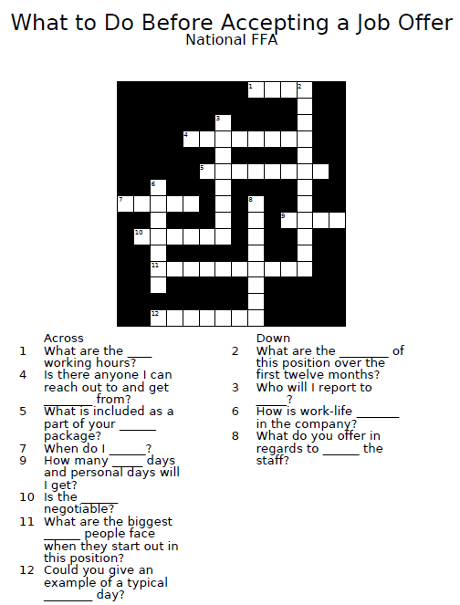
*Amoredpenguin.com used for the creation of this puzzle.

Negotiating a Job Offer
Aligned to the following standards:
FFA.PL-A; FFA.PL-E; FFA.PG-J; FFA.CS-M; FFA.CS-N; CCSS.SL.9-10.1; CCSS.SL.9-10.4; CCSS.WHST.9.10.6; CRP.02; CRP.04
Part 1
Directions:
Watch the video “5 Tips to Negotiating Benefits.” The URL is https://youtu.be/7M23KSvGWNs. Complete all parts of questions one and two while you watch the video.


- What is your job offer salary based on?
- __________________________________
- __________________________________
- __________________________________
- __________________________________

- You can always ask if base pay is negotiable. However, when negotiating base pay is not an option, you can try to negotiate the benefits. What are the 5 most common benefits you can negotiate for?
- _________________________
- _________________________
- _________________________
- _________________________
- _________________________




Part 2
Directions:
Now that you have learned what should be considered before accepting a job offer, as well as how to negotiate, read the attached job offer that has been sent to you. Develop 8 questions that you would ask when you receive your call to discuss the offer.
5.
1.
Why do you need to know how to negotiate an offer?

6.
2.

What should be the first thing you say when a company calls to offer you a job?
7.
3.

4.
8.

Written Job Offer
Aligned to the following standards:
FFA.PL-A; FFA.PL-E; FFA.PG-J; FFA.CS-M; FFA.CS-N; CCSS.SL.9-10.1; CCSS.SL.9-10.4; CCSS.WHST.9.10.6; CRP.02; CRP.04
Date: May 20, 2018
Address: 6060 FFA Drive
Indianapolis, IN 46278
Dear (write your name) __________________________________:
It is my pleasure to extend the following offer of employment to you on behalf of Big Bang Ag Production. This offer is contingent upon your passing our mandatory drug screen, our receipt of your academic transcripts and any other contingencies you may wish to state.
Title: Production Manager
Reporting Relationship: The position will report to Max Woodendall.
Job Description is attached.
Base Salary: Will be paid in bi-weekly installments of $1,023, which is equivalent to $24,552 on an annual basis and is subject to deductions for taxes and other withholdings as required by law or the policies of the company.
Bonus Potential: Effective upon satisfactory completion of the first 90 days of employment, and based upon the goals and objectives agreed to in the performance development planning process with your manager, you may be eligible for a bonus.
Non-Compete Agreement: Our standard non-compete agreement must be signed prior to your start date.
Benefits: The current, standard company health, life, disability and dental insurance coverage are generally supplied per company policy.
Eligibility for other benefits, including the 401(k) and tuition reimbursement, will generally take place per company policy. Employee contribution to payment for benefit plans is determined annually.
Vacation and Personal Emergency Time Off: Vacation is accrued at 6.15 hours per pay period.
Start Date: June 4, 2018
Your employment with Big Bang Ag Production is at-will and either party can terminate the relationship at any time with or without cause and with or without notice.
You acknowledge that this offer letter, (along with the final form of any referenced documents), represents the entire agreement between you and Big Bang Ag Production and that no verbal or written agreements, promises or representations that are not specifically stated in this offer are or will be binding upon Big Bang Ag Production.
If you are in agreement with the above outline, please sign below. This offer is in effect for five business days.
Signature: __________________________________________________________
Print Name: __________________________________________________________

Date: ______________
*Job offer template sourced from thebalancecareers.com
Telephone Job Offer Rubric
Aligned to the following standards:
FFA.PL-A; FFA.PL-E; FFA.PG-J; FFA.CS-M; FFA.CS-N; CCSS.SL.9-10.1; CCSS.SL.9-10.4; CCSS.WHST.9.10.6; CRP.02; CRP.04
Directions:
Use the following rubric to evaluate a classmate on their ability to handle a job offer appropriately based upon what we have just learned. You will each have the opportunity to make the offer and field the offer. You will be sitting back to back for this activity. You will evaluate each other using the rubric below.

Category | Very strong evidence of skill present  (5-4 pts) | Moderate evidence of skill present  (3-2 pts) | Weak evidence of skill present  (1-0 pts) | Points Earned
Response to Offer | Expressed appreciation; upbeat, sincere; shows excitement for the offer | Seemed caught off guard; attempted to be sincere and show excitement for the offer | Unengaged, insincere, shows little excitement for the offer
Gathered Appropriate Information | Provisions for follow-up expressed; posed appropriate questions (start time, date, who to report to); got contact information | Somewhat expressed provisions for follow-up; attempted to pose appropriate questions (start time, date, who to report to); asked for contact information | Poorly expressed provisions for follow up; did not pose appropriate questions (start time, date, who to report to); did not ask for contact information
Negotiating Points | Negotiating points appropriate; exhibited appropriate poise and professionalism while negotiating points; accepted results with an appropriate response and maturity | Negotiating points were posed but were a little inappropriate; exhibited some poise and professionalism while negotiating points; accepted results with a response | Negotiating points were inappropriate/none were stated; did not exhibit appropriate poise and professionalism; was disgruntled with results
Overall Impression | Exhibited poise; was pleasant, professional, courteous; ended call appropriately | Exhibited poise with some nervousness and attempted to be pleasant and courteous; Ended call with a thank you or just said bye | Seemed nervous; forced conversation; just hung up
Total Points: _____/20 points
Three positive comments about the ability to field a job offer:

Three comments about how to improve the ability to field a job offer:

KEY: What to Do Before Accepting a Job Offer Crossword
Aligned to the following standards:
FFA.PL-A; FFA.PL-E; FFA.PG-J; FFA.CS-M; FFA.CS-N; CCSS.SL.9-10.1; CCSS.SL.9-10.4; CCSS.WHST.9.10.6; CRP.02; CRP.04
Directions:
Use the resource “40 Questions to Ask Before You Accept a Job Offer” (https://www.theladders.com/career-advice/job-offer-questions) to independently complete the crossword below.
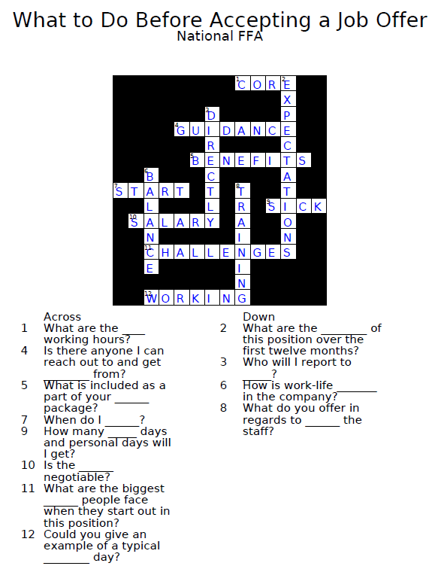
*Amoredpenguin.com used for the creation of this puzzle.
KEY: Negotiating a Job Offer
Aligned to the following standards:
FFA.PL-A; FFA.PL-E; FFA.PG-J; FFA.CS-M; FFA.CS-N; CCSS.SL.9-10.1; CCSS.SL.9-10.4; CCSS.WHST.9.10.6; CRP.02; CRP.04
Part 1
Directions:
Watch the video “5 Tips to Negotiating Benefits.” The URL is https://youtu.be/7M23KSvGWNs. Complete all parts of questions one and two while you watch the video.

- What is your job offer salary based upon?
- Size of the company
- Your professional level
- Previous work experience
- Skills you bring to the job

- You can always ask if base pay is negotiable. However, when negotiating base pay is not an option, you can try to negotiate the benefits. What are the 5 most common benefits you can negotiate for?
- Hiring bonus
- Vacation time
- Early review
- Relocation expenses
- Flexible work schedule

Part 2
Directions:
Now that you have learned what should be considered before accepting a job offer, as well as how to negotiate, read the attached job offer that has been sent to you. Develop 8 questions that you would ask when you receive your call to discuss the offer.
5.
1.
Why do you need to know how to negotiate an offer? So that you can ensure both parties are happy, that you are getting what you feel is right and that you are happy in your new position.

6.
2.

What should be the first thing you say when a company calls to offer you a job? Thank them for the job offer—show gratitude!
7.
3.

4.
8.

