93rd National FFA Convention & Expo Implementation Guide

This implementation guide is a resource for advisors to pre-plan and engage all students and various chapter stakeholders during the virtual 93rd National FFA Convention & Expo.

*To access all areas of the National FFA Convention & Expo with the exception of the live general session, you will need to be a registered attendee. To register you and your chapter, click here.
* All students, FFA members, and stakeholders from your chapter may attend the 93rd National FFA Convention & Expo. A student does not have to be an approved FFA member to attend.
*Direct Links:
Implementation Guide (Word) (PDF)
Student Activity Sheets (Folder) (Google Documents/Slides)

Table of Contents:
Below you will find links to resources that will accompany the major sections for the national convention and expo. (Once you are taken to each area, look for the home button to come back to this page).
Convention FAQ
Have questions about the national convention and expo? Check out the FAQ section of the convention website.
Pre-Planning/Welcome/Alignment to Educational Standards
Resources and letters to validate convention attendance and help you prepare for the event (letter to administration, technology requirements, etc).
Planning
Resources and tips to help design your chapter’s convention experience, such as ideas for how to participate and plan your schedule.
Choice Board
Overall activity board for all students to experience every aspect of convention.
Main Sessions
Experience the retiring addresses from the 2019-20 National FFA Officers and recognition of FFA members and their accomplishments. Find activity sheets for students to process what they hear.
Media
Resources and activities to showcase your experiences and stories to your family, friends and community using social media.
Workshops
Teacher and student workshops are on demand when convention goes live. Each workshop will vary in length from 15 to 60 minutes. To see a full listing of student and teacher workshops, visit the workshop page (hyperlink when available).
FFA Blue Room
Resources to guide attendees through the FFA Blue Room experience to learn about technology innovation and sustainability across the Agriculture Food and Natural Resource (AFNR) Value Chain.
Exposition Hall
Resources to discover the vast array of individuals involved in the agriculture industry from innovative companies to educational institutions.
Student Connection Rooms
Opportunities for students to meet, connect and learn from FFA members across the country. These rooms will cover a variety of different topics.
Awards and Recognition
Resources to learn about the different programs in which we recognize students for their hard work and achievements.
Service
Resources to help plan a service project for your community during the month of convention as well as prepare for one during National FFA Week in February 2021.
Alumni and Supporters
Resources to learn about the opportunities available for development in this area.
Other Activities
Activities for students to learn and discover more about FFA and make connections with fellow members from across the country.
Reflection/Post-Convention Thoughts
Activities for students to reflect on their experiences during convention.
**Once convention goes live and you are a registered attendee, you will have access to the following from October 27 until the end of 2020: workshops, FFA Blue Room and expo. (Any scheduled events will become available on demand at the conclusion of the event.)

Pre-Planning 
Items included in this section are meant to welcome you to the 93rd National FFA Convention & Expo as well as provide some materials that may be useful as you plan to attend.
- Welcome Letter

This letter from Dr. Woodard explains the importance and relevancy of attending the National FFA Convention & Expo from a national advisor purview. Give this letter to teachers/colleagues, administrators, parents/guardians, advisory board, etc.

- Administration Letter

This letter from Christine White explains the educational relevancy of convention and the social-emotional development of students after experiencing the opportunities provided by attending the National FFA Convention & Expo. Use this letter with teachers/colleagues, administrators, parents/guardians, advisory board, etc.

- Educational Standards

This document serves as a guideline to assist advisors in planning, attending and implementing pre- and post-convention processing and work. Educational standards for the National FFA Convention & Expo are suggested standards based on the projected central theme, objectives, content and activities of main events. Share this document with administrators to show the educational relevancy of the National FFA Convention & Expo.
- Technology
With the National FFA Convention & Expo going virtual, we want to ensure you and your students are prepared with the appropriate access to technology. In this section, you will find a list of white list websites needed to experience convention, learn how you can test your technology prior to the start of convention and discover what to do if you do not have access.
- Get FFA Members Featured During Convention
Seeking: Member Videos
We want to feature members during the 2020 national convention! If you want to see yourself on the convention mainstage, select the prompt you want to answer and upload a 30-second video or a picture for the chance to be featured during convention.
- Convention T-shirts!

Order convention T-shirts for your FFA chapter for giveaways, or pass along the link to students so they can order their own.



Welcome Letter
This letter from Dr. Woodard explains the importance and relevancy of attending the National FFA Convention & Expo from a national advisor purview. Use this PDF to share the letter with teachers/colleagues, administrators, parents/guardians, advisory board, etc.

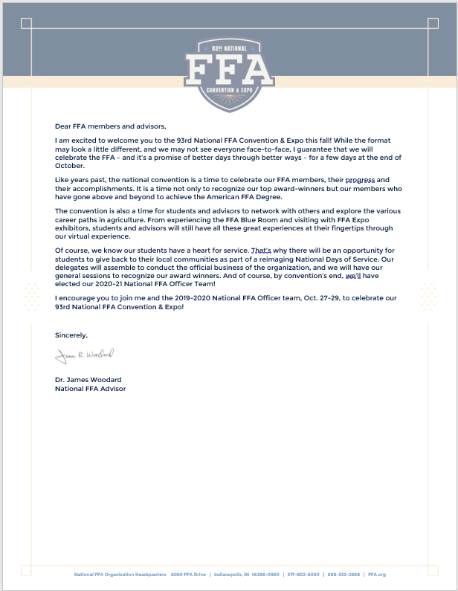

Administration Letter
This letter from Christine White explains the educational relevancy of convention and the social-emotional development of students after experiencing the opportunities provided by attending the National FFA Convention & Expo. Use this PDF to share the letter with teachers/colleagues, administrators, parents/guardians, advisory board, etc.

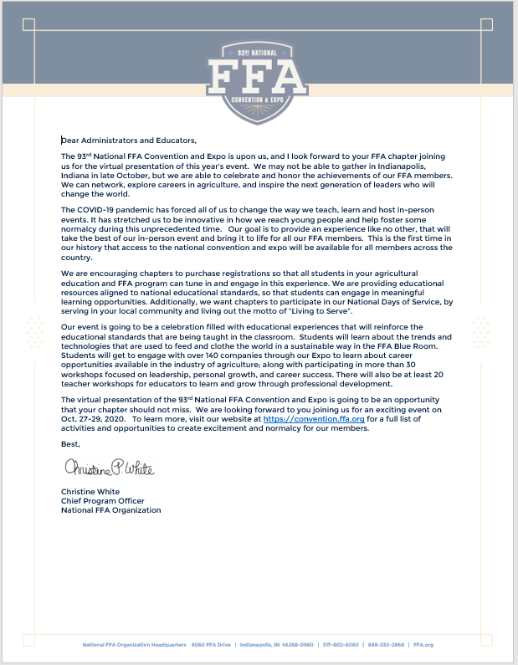

Educational Standards Alignment

This document serves as a guideline to assist advisors in planning, attending and implementing pre- and post-convention processing and work. Educational standards for the National FFA Convention & Expo are suggested standards based on the projected central theme, objectives, content and activities of main events. While every standard listed may not be covered during each individual portion of the convention and expo, these lists should serve as a guideline to validate and actualize educational relevancy for attending the National FFA Convention & Expo.

OVERALL STUDENT LEARNING OBJECTIVES

After completing these activities, students will …

1. Discover and experience premier leadership, personal growth and career success.

2. Demonstrate and explore leadership and career skills.
3. Network with FFA members and various stakeholders.
4. Identify emerging technologies, innovations and leaders within the agriculture industry.

MAJOR ACTIVITIES CONSIDERED

This is not a complete list of all National FFA Convention & Expo activities, but rather a list of major events throughout the week.

1. Workshops

2. General Sessions

3. Awards and Recognition/Challenges

4. Exposition Hall (Agricultural Companies and Colleges)

5. Student Connection Rooms

6. National Days of Service

7. FFA Blue Room

THESE ACTIVITIES ARE ALIGNED TO THE FOLLOWING STANDARDS:

AFNR Performance Element
•CS.01. Analyze how issues, trends, technologies and public policies impact systems in the Agriculture, Food & Natural Resources Career Cluster.
•CS.02. Evaluate the nature and scope of the Agriculture, Food & Natural Resources Career Cluster and the role of agriculture, food and natural resources (AFNR) in society and the economy.
•CS.03. Examine and summarize the importance of health, safety and environmental management systems in AFNR workplaces.
•CS.04. Demonstrate stewardship of natural resources in AFNR activities.
•CS.05. Describe career opportunities and means to achieve those opportunities in each of the Agriculture, Food & Natural Resources career pathways.
•CS.06. Analyze the interaction among AFNR systems in the production, processing and management of food, fiber and fuel and the sustainable use of natural resources.

FFA Precept
•FFA.PL-A.Action: Assume responsibility and take the necessary steps to achieve the desired results, no matter what the goal or task at hand.
•FFA.PL-C.Vision: Visualize the future and how to get there.
•FFA.PL-E.Awareness: Understand personal vision, mission and goals.
•FFA.PL-F.Continuous Improvement: Accept responsibility for learning and personal growth.
•FFA.PG-I.Professional Growth: Assume responsibility for attaining and improving upon the skills needed for career success.
•FFA.PG-J.Mental Growth: Embrace cognitive and intellectual development relative to reasoning, thinking and coping.
•FFA.CS-M.Communication: Effectively interact with others in personal and professional settings.
•FFA.CS-N.Decision Making: Analyze a situation and execute an appropriate course of action.

Common Career Technical Core
•AG1 Analyze how issues, trends, technologies and public policies impact systems in the Agriculture, Food & Natural Resources Career Cluster.
•AG2 Evaluate the nature and scope of the Agriculture, Food & Natural Resources Career Cluster and the role of agriculture, food, and natural resources (AFNR) in society and the economy.
•AG3 Examine and summarize the importance of health, safety, and environmental management systems in AFNR businesses.
•AG5 Describe career opportunities and means to achieve those opportunities in each of the Agriculture, Food & Natural Resources Career Pathways.
•AG6 Analyze the interaction among AFNR systems in the production, processing, and management of food, fiber, and fuel and the sustainable use of natural resources.

NASDCTEc
•AGC02.02 Employ the use of technical information effectively to maintain and communicate records and reporting procedures commonly used in the AFNR cluster.
•AGC05.02 Identify how key organizational systems affect organizational performance and the quality of products and services to demonstrate an understanding of how AFNR systems are managed and improved.
•AGC08.01 Demonstrate workplace ethics specific to AFNR occupations in order to reflect effective stewardship of resources.
•AGC09.02 Select, research and examine critical aspects of career opportunities in one or more AFNR career pathways in order to gain an understanding of the breadth of occupations within this cluster.
•AGC10.03 Compare and contrast issues affecting the AFNR industry including biotechnology, employment, safety, environmental and animal welfare to demonstrate an understanding of the trends and issues important to careers in this industry.
•AGC10.04 Envision emerging technology and globalization and project its influence on widespread markets to demonstrate an understanding of technologies and trends that will impact the AFNR industry.

Common Core – Reading: Informational Text
•CCSS.ELA-Literacy.RI.9-10.3 Analyze how the author unfolds an analysis or series of ideas or events, including the order in which the points are made, how they are introduced and developed, and the connections that are drawn between them.

Common Core – Speaking and Listening
•CCSS.ELA-Literacy.SL.9-10.1 Initiate and participate effectively in a range of collaborative discussions (one-on-one ,in groups, and teacher-led) with diverse partners on grades 9-10 topics, texts, and issues, building on others' ideas and expressing their own clearly and persuasively.
•CCSS.ELA-Literacy.SL.9-10.2 Integrate multiple sources of information presented in diverse media or formats (e.g. visually, quantitatively, orally) evaluating the credibility and accuracy of each source.
•CCSS.ELA-Literacy.SL.9-10.4 Present information, findings, and supporting evidence clearly, concisely, and logically such that listeners can follow the line of reasoning and the organization, development, substance, and style are appropriate to purpose, audience, and task.
•CCSS.ELA-Literacy.SL.11-12.1 Initiate and participate effectively in a range of collaborative discussions (one-on-one, in groups, and teacher-led) with diverse partners on grades 11-12 topics, texts, and issues, building on others' ideas and expressing their own clearly and persuasively.

Common Core – Language
•CCSS-ELA-Literacy.L.9-10.3 Apply knowledge of language to understand how language functions in different contexts, to make effective choices for meaning or styles, and to comprehend more fully when reading or listening.

Common Core – Literacy in Science & Technical Subjects: Writing
•CCSS.ELA-Literacy.WHST.9.10.6 Use technology, including the Internet, to produce, publish, and update individual or shared writing products, taking advantage of technology's capacity to link to other information and to display information flexibly and dynamically.

Next Generation Science
•HS-ETS1-3 Evaluate a solution to a complex real-world problem based on prioritized criteria and trade-offs that account for a range of constraints, including cost, safety, reliability, and aesthetics as well as possible social, cultural, and environmental impacts.

Green/Sustainability Knowledge and Skill Statements
•AFNR Career Cluster, Statement 7 Demonstrate an understanding of green and sustainability trends that are impacting processes and markets in AFNR.

AFNR Career Ready Practices
•CRP.04. Communicate clearly, effectively, and with reason. Career-ready individuals communicate thoughts, ideas and action plans with clarity, whether using written, verbal and/or visual methods.
•CRP.05. Consider the environmental, social and economic impact of decisions. Career-ready individuals understand the interrelated nature of their actions and regularly make decisions that positively impact and/or mitigate negative impact on other people, organizations and the environment.
•CRP.08. Utilize critical thinking to make sense of problems and persevere in solving them. Career-ready individuals readily recognize problems in the workplace, understand the nature of the problem, and devise effective plans to solve the problem.

Partnership for 21st Century Skills
•Communication
•Critical Thinking and Problem Solving
•Financial, Economic, Business, and Entrepreneurial Literacy
•Flexibility and Adaptability
•Information, Communications, and Technology Literacy
•Initiative and Self-Direction
•Leadership and Responsibility
•Global Awareness
•Technology Literacy
•Think Creatively

Technology
With the National FFA Convention & Expo going virtual, we want to ensure you and your students are prepared with the appropriate access to technology. Below you will find a list of white list websites needed to experience convention, learn how you can test your technology prior to the start of convention and discover what to do if you do not have access.

List of Websites (Whitelist)
The websites below will be used during the National FFA Convention & Expo. We encourage you and your students to test them prior to the start of convention.
- https://live.FFA.org
*After completing your registration and establishing your password, we would encourage you to visit this site to make sure you can log in and test your technology.
- convention.FFA.org
- FFA.org
- https://FFA.box.com
- https://vimeo.com
*If Vimeo is blocked by school district, we recommend you ask your school district to temporarily allow access for a period of time. Additionally, you may provide your district IT department these instructions so they may still block Vimeo, yet allow embedded videos to play on the virtual convention site.
- https://zoom.us
* If you access https://zoom.us/test, you may join a Zoom meeting to test your audio/video capabilities of your computer.

If you can access all links:
- You are ready for the start of convention.
If you cannot access one or multiple links:
- Reach out to your district IT department for help to get the websites unblocked for use during the National FFA Convention & Expo.

planning
This section will include information on the following:
- What to expect at your virtual National FFA Convention & Expo. Watch this short video from the 2019-20 National FFA Officers to gain insight into what you can expect from your convention experience.

- Brief background information on the National FFA Convention & Expo, including the following:
  - History of National FFA Convention & Expo.
  - Delegate process.
  - National FFA Officer election process.

- Tips on how to participate in the virtual national convention and expo.

- Template to make your own schedule and/or schedule for the students.

- Student Activity Sheets: Direct access to the individual student activity sheets for easy upload to learning management systems or printing for classwork can be found here.

- Interactive Toolkit for National Days of Service: Click here to access the interactive toolkit.

How to utilize the interactive toolkit with students: Give the toolkit to your chapter members to plan a day of service project during convention week. Divide your students into small groups and task them with creating a service project during October. Then, students can present their service project ideas and the class/FFA chapter can vote on which one they want to implement. Give students the “Living to Serve: interactive Toolkit” worksheet to complete while reviewing/completing the toolkit.

Background of National FFA Convention & Expo

Brief History of the National FFA Convention & Expo
Why do we have a national convention each year?
Each fall, nearly 65,000 FFA members, advisors, educators, supporters and guests from across the country come together to participate in sessions, competitive events, career success and educational tours, and student and teacher leadership workshops and to experience an expo and shopping mall, to volunteer and to network. The convention is an event where members not only compete, network, volunteer and have fun, but they also learn about the diverse careers that are available in the industry of agriculture and are recognized for their achievements.

The first national convention was held in Kansas City, Missouri, with 33 delegates from 18 states.
During each convention, official business is conducted by the national officers and member delegates.
The National FFA Delegate Experience ensures that the National FFA Organization remains a grassroots organization that serves students at the local level.
Due to the COVID-19 pandemic, the 93rd National FFA Convention & Expo will be held virtually and will include live main sessions, on-demand teacher and student workshops, virtual expo and much more. To learn more about the National FFA Convention & Expo, visit https://convention.FFA.org/.

Convention Delegates
The delegate experience brings together 475 student leaders from across the nation. Students share ideas and perspectives that propel the organization forward. Delegates come from each of the organization’s 52 state associations, with delegation sizes determined by each association’s percent of overall organizational membership. The National FFA Delegate Experience has been an FFA tradition since 1928. For more information on the delegate process, visit FFA.org/delegates.

Election of National FFA Officers
How are the National FFA Officers elected?
Each year, six student members are selected to represent the National FFA Organization as National FFA Officers. Members must have received an American FFA Degree and be selected by their state association to be eligible for national office. National officers travel more than 100,000 miles during their year of service representing the organization. To learn more about the process of becoming a national officer, visit FFA.org/national-ffa-officers/.
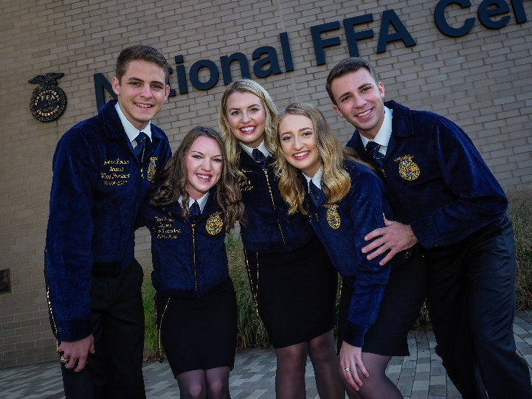

How to participate in National FFA Convention
Schedule: Utilize this template to schedule your convention week. Additionally, students can utilize it and/or the convention app. Click here for more information about the convention app.
Utilize this live convention schedule and on-demand activities to complete your schedule.
Need ideas on how your chapter members can participate in convention? Check these out!
In-person ideas:
- Have a watch party with your classes!
- Have a watch party with neighbouring chapters! (Be sure you are following appropriate social distancing guidelines.)
- Rent a local movie theatre, Lions/VFW hall, community center or watch in your school gymnasium.
Distance learning students:
- Have students watch the live sessions. Afterward, you can host a class discussion (in-person and virtual) to discuss and reflect on the sessions.
- Assign students different parts of convention to experience and then join together on a meeting platform to discuss what everyone experienced and learned.
- Set up a GroupMe (or other type of chatting platform) where students can chat with one other about the live sessions and/or Zoom (or other type of meeting platform) where students can discuss their convention experiences.
Hybrid:
- Students can participate in the watch parties and/or watch live sessions at a distance.

How to interact with other chapters:
- Host a joint watch party with neighbouring chapters.
- Participate in the student connection rooms to network with other FFA members.
- Students can share their experience via social media.
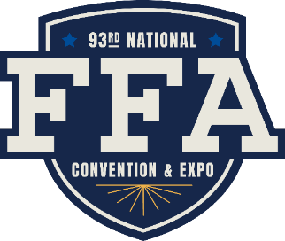

Make Your Own Schedule
Utilize the convention live schedule and on-demand activities to personalize your own schedule for convention week, and encourage students to customize their own utilizing this template and/or the convention app.
Don’t forget to check out the teacher and student workshops! (link coming soon).
Thursday, Oct. 29
Morning:

Afternoon:

Evening:
Wednesday, Oct. 28
Morning:

Afternoon:

Evening:
Tuesday, Oct. 27
Morning:

Afternoon:

Evening:

National FFA Convention & Expo Activity Board
Directions: The National FFA Convention & Expo provides FFA members with the opportunity to network and have new experiences. Learn about opportunities available at national convention by completing the following activities.
Complete each of the tasks below in any order you like. The due date for this board is .
National FFA Convention & Expo Overall Activity Board
Participate in at least three student connection rooms during convention and complete a worksheet for each experience. | Tune in to a live main session (or watch on demand) to watch a National Officer Retiring Address and complete one of the activity sheets (1) (2) (3). | Experience the FFA Blue Room: Attend a live session and complete the live presentation activity sheet and exploration worksheet. | Meet fellow FFA members from across the country. As you join in the convention activities, complete this map activity sheet.
Visit the virtual expo and visit at least one companies/organizations in each area. As you explore and interact, complete the worksheet for each stop on your journey. | Get to know educational institutions in the expo. Find three that interest you and complete the worksheet. | Share your FFA story and experiences. Utilize the media materials to plan social media posts. #FFA20 | The 2020-21 National FFA Officers are elected during the final session on October 29. Get to know them by completing the activity sheet.
Attend a minimum of two student workshops and complete the accompanying activity guide | Test your FFA knowledge! Get your chapter or class together and play FFA Experience Jeopardy! | Everyone loves a good T-shirt! Express your creative side and design a T-shirt based on your convention experience using the design template. | Design your personal cover of FFA New Horizons. Utilize the template provided.
Use the interactive toolkit to plan a service project for you chapter to complete during convention and/or FFA Week. Use this activity sheet. | Discover the various awards and recognition opportunities available with National FFA. Develop a plan for future participation using this activity sheet. | Use this worksheet to discover more about Alumni and Supporters and how you can be involved with FFA after high school. | Now that convention has come to a close, reflect on your experiences by completing this worksheet.

Main Sessions
The main live sessions can be viewed on the convention website or RFD-TV. This section includes the session schedule and generic worksheets that can be utilized during the retiring addresses and/or keynote addresses.
All main sessions will be available on demand after the original air date and time.

Schedule:
Tuesday, Oct. 27 Wednesday, Oct. 28 Thursday, Oct. 29
11 a.m. Kickoff Session 2 p.m. Session 3 2 p.m. Session 5
2 p.m. Session 1 7 p.m. Session 4 7 p.m. Session 6
7 p.m. Session 2 10:30 p.m. Session 4 10:30 p.m. Session 6
(West Coast Replay) (West Coast Replay)
10:30 p.m. Session 2
(West Coast Replay)

2020 Retiring Address Worksheets
Utilize the worksheets below to reflect on the national officer retiring addresses.
- Making an Impact (1)
- Making an Impact (2)
- Making an Impact (3)
Direct access to the individual student activity sheets for easy upload to learning management systems or printing for classwork can be found here.

Former National Officer Retiring Addresses
Now that students have watched the retiring addresses from this year’s convention, let’s explore the addresses from the past.
Lesson Plans: Lesson plans with student activity sheets and answer keys for former national officer retiring addresses.
Student Activity Sheets: This folder contains the activity sheets for students in individual files separate from the lesson plan.
On-Demand Videos: Video library of former national officer retiring addresses.

Making an Impact

Directions: Complete the following activity about a national FFA officer’s retiring address or a keynote speaker’s comments from the National FFA Convention & Expo.
What do these two quotes/statements mean to you?
In one sentence, what is the overarching message?
In three or more sentences, describe how you will apply this message in your life, your school and your community.

Speaker Name:
In each cloud, write down one quote or statement from the presentation that is meaningful or inspirational to you.
Message Title:

Making an Impact
Directions: Complete the following activity about a national FFA officer’s retiring address or a keynote speaker’s comments from the National FFA Convention & Expo.
Write down one quote/phrase from the presentation that is meaningful or inspirational to you. Explain why or how it impacts you.
What is the main subject of the retiring address or keynote speaker’s message?

What are three things you have learned or taken away from this message?

How would you summarize this message to explain it to your friends?

How can you apply what your learned from the message in your life today?

In the future?
Create a hashtag for this message.

Making an Impact
Directions: Complete the following activity about a national FFA officer’s retiring address or a keynote speaker’s comments from the National FFA Convention & Expo.
What is your initial reaction after watching this message?

Message Title:

Summarize the message in two sentences.
What is a quote/statement from the speech that resonated with you? Explain why.

What do you think is the key takeaway from this message?

How can you apply it in your own life?

What does this message make you think about regarding your own personal growth?

Media, Promotion and Advocacy
Use the following resources during the 93rd National FFA Convention & Expo to have your students share your chapter’s story and their experiences during the event.
Social Media Tips and Tricks Guide: Tell the world about FFA! Thousands of voices spreading the message across social media elevates awareness of FFA, and that’s where you come in. Your chapter’s story is important in helping others learn who we are, what we do and about the diversity of FFA across the country. Implement these top five tips for using your voice on social media to promote your chapter and FFA during the national convention and expo.
Social Media Challenge: Challenge your students to post on social media during convention week. Have students take pictures of their social media posts and have classes/FFA chapters choose their favorite one. You can also post the pictures around the room to showcase their convention experiences.
Social Media Post Examples: Utilize these examples to help plan your social media posts for the national convention and expo.
Press Release Template: Use this template to share your chapter’s plans for participating in the 93rd National FFA Convention & Expo.
Student Activity Sheets: Direct access to the individual student activity sheets for easy upload to learning management systems or printing for classwork can be found here.

Social Media Tips and Tricks Guide
Tell the world about FFA! Thousands of voices spreading the FFA message across social media elevates awareness of FFA, and that’s where you come in. Your chapter’s story is important in helping others learn who we are, what we do and about the diversity of FFA across the country.
Pick one or two social platforms to concentrate on. Don’t spread yourself too thin. It’s better to be in one place with great stories than everywhere with mediocre stories.
Which social platforms will you concentrate on?
- ___________________________

- ___________________________


Brainstorm: Before convention, plan your posts. You can even write some of them ahead of time. Planning will save time during convention week so that you can enjoy the celebration too! Just leave some room for spontaneity. In the boxes below, compose two posts for each social platform you selected above. Read the tips below to help you plan!
Social platform 2: _______________________________
1.

2.

Social platform 1: ________________________________
1.

2.

Here are our top five tips for using your voice on social media to elevate your chapter and FFA during the National FFA Convention & Expo!
Tip 1: Use #FFA20 and tag @NationalFFA on all your social posts so people can find it and National FFA can share the amazing stories you’re telling.
Tip 5
Try ending your social post with a question or ask others to share their stories in the comments. This will help create engagement and conversation amongst your followers.
Tip 4:
Use Instagram/Facebook stories to tell stories. For instance, your story could be an ongoing “scrapbook” of that day’s FFA Week activities.
Tip 3:
Remember your FFA voice — a positive, respectful and inspirational tone. If individuals comment on your posts with unkind words, resist the urge to argue with negative comments. You won’t change any minds and it will just ruin your day. We like to say, “Hug Your Haters.”
Tip 2:
Share what you and your chapter are doing during FFA Week, but don’t forget the rest of the year. Does someone in your chapter have an interesting or unique SAE? Share it! Does your chapter have a Living to Serve project? Share it! And of course, share your FFA Week activities too!
Tip 1:
Use #FFAWeek and tag @NationalFFA on all your social posts so people can find and National FFA can share the amazing stories you’re telling.
Tip 2: Share what you and your chapter are doing during convention, but don’t forget the rest of the year. Does someone in your chapter have an interesting or unique SAE? Share it! Does your chapter have a Living to Serve project? Share it! And of course, share your FFA convention week activities too!
Tip 3: Remember your FFA voice — a positive, respectful and inspirational tone. If individuals comment on your posts with unkind words, resist the urge to argue with negative comments. You won’t change any minds, and it will just ruin your day. We like to say, “Hug Your Haters.”
Tip 4: Use Instagram/Facebook stories to tell stories. For instance, your story could be an ongoing “scrapbook” of that day’s FFA convention week activities.
Tip 5: Try ending your social post with a question or ask others to share their stories in the comments. This will help create engagement and conversation among your followers.


Brainstorm: Use this space to brainstorm a list of photos and videos that could be used. Don’t have any that will work? Brainstorm pictures and videos that can be taken!
Use the highest quality photos and videos you have access to in your posts. These tell the best stories and generate the most engagement.

If someone is being vulgar, bullying or posting unrelated comments on your posts, hide them. It’s good practice to have user guidelines on your page in the About section. Ours is at https://www.facebook.com/pg/nationalffa/about/ under general information.
Compose some guidelines that you could include to help avoid vulgarity, bullying or posting of unrelated comments.

MOST important: Every member and every chapter has an important FFA story. Don’t be afraid to share yours. We know it will be interesting!

Social Media Challenge
Directions: Use the template on the following page to create your social media plan for convention, and get approval from the chapter advisor and school administration. As you post, take pictures and share with your chapter/class and advisor. See below for examples.
Use #FFA20 when posting on social media about the national convention and expo.
Examples:
Twitter: “Can’t wait to participate in this year’s virtual convention! #FFA20”
Facebook: “I’m pumped for this year’s 93rd National FFA Convention & Expo. Even though convention
looks different this year, what are you most excited for? Comment below! #FFA20”

Instagram Story: “Wearing my new convention tee for #FFA20. Who else is wearing theirs?”

Snapchat: Share a picture of you participating in a student connection room. Caption: “Love meeting new FFA members from across the country!”

Other Examples:

- During convention, post a picture of yourself watching a student workshop or main live session, experiencing the FFA Blue room or repping in your FFA gear!
- Counting down the days to convention? Post a countdown and what you are looking forward to.
- After convention, post a reflection about your experience.

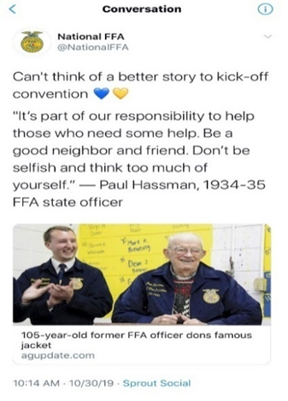
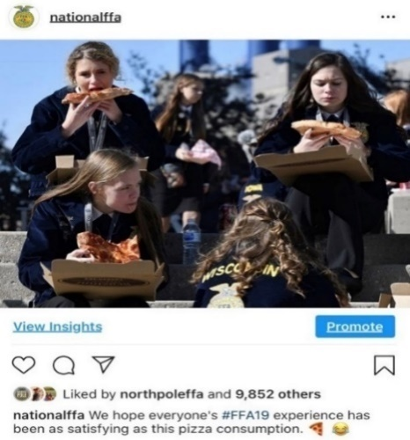

Tues.
27
Wed.
28
_______________________________________________________________________________________________________________________________________________________________________________________________________________________________________________________________________________________________________________________________________________________________________________________________________

Thurs.29
_______________________________________________________________________________________________________________________________________________________________________________________________________________________________________________________________________________________________________________________________________________________________________________________________________

_______________________________________________________________________________________________________________________________________________________________________________________________________________________________________________________________________________________________________________________________________________________________________________________________________

Post-Convention
Pre- Convention
_______________________________________________________________________________________________________________________________________________________________________________________________________________________________________________________________________________________________________________________________________________________________________________________________________

_______________________________________________________________________________________________________________________________________________________________________________________________________________________________________________________________________________________________________________________________________________________________________________________________________

Press Release (For USe Prior to Convention)

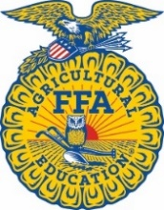
CONTACT
Advisor Name
Advisor Contact Information

Student Leaders Prepare for the 93rd National FFA Convention & Expo

INDIANAPOLIS (Thursday, Oct. 1, 2020/National FFA Organization) — In a few weeks, FFA members and supporters from across the country will celebrate agricultural education and agriculture during the 93rd National FFA Convention & Expo, Oct. 27-29.
This time-honored tradition will look a little different this year, as it will be held virtually.
FFA members representing all 50 states, Puerto Rico and the U.S. Virgin Islands are expected to participate in the virtual event. It is an opportunity for students to be exposed to new career paths and opportunities while celebrating the accomplishments these future leaders have made over the past year.
Throughout the week, national convention and expo attendees will also experience the FFA Blue Room, which showcases cutting-edge technology, research and innovation in agriculture. Through experiential learning and specific focus on the most critical challenges facing our communities — from respecting the planet to feeding the world — the FFA Blue Room will inspire and equip students to activate their potential. The expo will also be available in live and on-demand sessions, where participants can learn more in live chats. In addition, attendees can participate in student and teacher workshops, which will be available on demand.
Even though the convention will be virtual, FFA members will still connect with others via Zoom through a member experience room. And in October, FFA members across the country will participate in National Days of Service in their local communities.
General convention sessions will be aired live on RFD-TV and The Cowboy Channel. FFA members and supporters can tune in and watch gavel-to-gavel coverage of the event. To learn more, visit convention.FFA.org.
The National FFA Organization is a school-based national youth leadership development organization of more than 760,000 student members as part of 8,700 local FFA chapters in all 50 states, Puerto Rico and the U.S. Virgin Islands.
# # #
About National FFA Organization
The National FFA Organization is a school-based national youth leadership development organization of more than 760,000 student members as part of 8,700 local FFA chapters in all 50 states, Puerto Rico and the U.S. Virgin Islands. The FFA mission is to make a positive difference in the lives of students by developing their potential for premier leadership, personal growth and career success through agricultural education. For more, visit the National FFA Organization online at FFA.org and on Facebook and Twitter.
About National FFA Foundation
The National FFA Foundation builds partnerships with industry, education, government, other foundations and individuals to secure financial resources that recognize FFA member achievements, develop student leaders and support the future of agricultural education. A separately registered nonprofit organization, the foundation is governed by a board of trustees that includes the national FFA president, educators, business leaders and individual donors. For more, visit FFA.org/Give.

Convention Workshops
The 2020 convention workshops will be pre-recorded and available on demand when convention goes live. Each workshop will vary in length from 15 to 60 minutes. To see a full listing of student and teacher workshops, visit the workshop page.
Teacher Workshops: Workshops have been designed to be engaging and provide professional development for teachers on various topics to aid in the classroom and FFA chapter. Workshops will be organized via career pathway. Each teacher workshop is accompanied with a note sheet and professional development document.
- Note Sheet: to help you capture your thoughts during each workshop
Student Workshops: Workshops have been designed to be engaging and interactive. They will be organized via the three pillars of the FFA mission (premier leadership, personal growth and career success). Each student workshop is accompanied with a reflection guide that can be implemented by teachers in the classroom or given to students who are distance learning.
After students have participated in virtual workshops, have them develop a mini-workshop or speech about a topic they feel passionate about using the “Develop a Mini-Workshop/Speech” activity sheet and rubric. Students can choose to complete this activity digitally using a resource like FlipGrid or another of your choice. They can also complete this in person if your school is in session.

What Workshops Interest Me? Have students read over the workshop titles and descriptions on the convention website and select the top five that seem interesting and inspiring to them. Have students complete the activities on the “What Workshops Interest Me?” activity sheet.

Student Activity Sheets: Direct access to the individual student activity sheets for easy upload to learning management systems or printing for classwork can be found here.

Which Workshops INterest Me?
Directions: Read over the workshop titles and descriptions on the convention website, and select the top five that seem interesting and inspiring to you. Record the workshop titles in the box below.
Which workshops interest you?
Record the titles of the workshops that you attended.
What interests you about your chosen workshops?

Develop a Mini-Workshop/Speech
Develop a mini-workshop or speech about a topic you feel passionate about and submit through FlipGrid. Use the space below to develop your mini-workshop or speech. (The lines are for what you will say, and the box is what your visual aid will contain/look like; the mini-workshop or speech should last ten minutes.) Reference the Rubric: Mini-workshop/Speech handout for requirements.

What ideas do you have for a title and description for your mini-workshop/speech? (The title should grab people’s attention.)
Key Points: What key points will you include in the mini-workshop/speech?

Introduction: How will you introduce the mini-workshop/speech?

Conclusion: How will you wrap up your mini-workshop/speech?

Rubric: Mini-Workshop/Speech
Qualification | Very strong evidence of skill is present.  (5–4 points) | Moderate evidence of skill is present.  (3–2 points) | Weak evidence of skill is present.  (1–0 points) | Total Points  (20 possible)
Engaging title and description: description refers to title | Title and description are engaging and attention grabbing; description refers to title. | Title and description are mediocre; description somewhat refers to title. | Title and description are very weak; description does not refer to title.
Presentation Skills | Thorough and maintains eye contact | Somewhat professional; depends on the presentation | No evidence of preparation
Grammar/Punctuation/  Spelling | Spelling, grammar and punctuation are extremely high quality with two or less errors in the document. | Spelling, grammar and punctuation are adequate with three to five errors in the document. | Spelling, grammar and punctuation are less than adequate with six or more errors in the document.
Time | Ten minutes | Between five and ten minutes | Under five minutes
Overall Impression | Presentation was consistent and appropriately highlighted a topic of the presenter’s choosing that they feel passionate about. | Presentation was consistent and generally highlighted a topic of the presenter’s choosing that they feel passionate about. | The presentation was not consistent and did not highlight a topic of the presenter’s choosing that they feel passionate about.
 |  |  | Total | /20 points

FFA Blue Room
The FFA Blue Room is a one-of-a-kind space where students can learn about technology and innovations that are solving for sustainability across the AFNR value chain. Students will learn about new careers they did not know existed or were associated with agriculture. Students will be inspired by how the technology, innovations and people showcased in the FFA Blue Room are ensuring a sustainable future for all.
Students can explore the FFA Blue Room at any time during the national convention and expo. For the best experience, join during one of the 12 live sessions. Live sessions will feature one of our innovators taking the stage in a Ted-X style presentation, and industry professionals will be available via text and video chat to connect with students.

Attend a Live Session
Live sessions are hosted daily at 11:30 a.m., 1 p.m., 3:30 p.m. and 5 p.m. (All time are in EDT)! Register to attend a session at https://form.jotform.com/stateofficers/blueroomlive.
There will be 12 scheduled sessions. Each live session will be an hour in length. *Classes can watch the speaker’s presentation together and then individually explore the room.
Part 1 (20 minutes): Attendees will explore the Welcome Room, where they will explore how Microsoft technologies and AgriNovus careers of the future are shaping agriculture. If attendees complete all of the activities in the Welcome Room, they will be entered into a sweepstakes to win one of 12 Xboxes and other prizes. If attendees want to be eligible for the sweepstakes, they must be prepared with their FFA ID.
Part 2 (15-20 minutes): Attendees will watch a presentation from an industry representative with a question and answer period. Speaker topics are listed on the registration page. This experience will have a live host to facilitate interaction between the speaker and the attendees.
Each student will need a copy of the “Live Presentation/On-Demand Video Activity Sheet.”
Part 3 (20 minutes): Attendees will spend the remaining time during the live session exploring the room. Industry representatives will have space where they showcase new, innovative technology and careers they are using to create sustainable solutions across the value chain.
Each student will need one copy of the “FFA Blue Room Exploration” worksheet for each space you would like them to visit during this time.
During this time, industry representatives will be available to answer questions from attendees.
Once the live session has concluded, have student complete the “FFA Blue Room Reflections” worksheet.

Watching On Demand — A La Carte
If you are unable to attend a live session, you can still explore the various spaces within the room to discover the new and innovative technology that is being used to create sustainable solutions across the value chain.
Each student will need one copy of the “FFA Blue Room Exploration” worksheet for each space you would like them to visit during this time.
Once students are finished exploring, have student complete the “FFA Blue Room Reflections” worksheet.
Student Activity Sheets: Direct access to the individual student activity sheets for easy upload to learning management systems or printing for classwork can be found here.

Live Presentation/On-Demand Video Activity Sheet
Directions: As you watch the live presentation/video on demand, complete the following activities.
The presentation topic is …
The company or business this speaker represents is …
The speaker specializes in …

Draw a picture that represents his or her specialty area.
Two potential careers related to this presentation are …
Summarize the presentation in one word.
Three facts I heard were …
The technologies or innovations discussed in the presentation are …
The information in the presentation is important to me because …

Three classes, FFA activities and/or SAE opportunities I should participate in to prepare me for a career related to this presentation are …

Draw one picture that summarizes the presentation.

As you watch the presentation, develop two questions you could ask the presenter.

FFA Blue Room Exploration
Directions: Choose a space to explore within the FFA Blue Room and complete the following activities for each space.
Company/Organization:
Draw and label the logo of the company/organization.

Career Focus Area Value Chain Segment
What technology/innovation is featured?

How does/will it impact the agriculture industry?
What careers are featured?

What skills are needed?
LIVE Session
Question and Answers: Ask at least one question via the live chat. Record your questions and the answer below.
Q:

A:
Click for bank of career focus areas and value chain icons.

ON-DEMAND Session
List two questions you would like to ask about what you experienced.
Q1:

Q2:

FFA Blue Room Exploration, Continued

Reflect on your time in this space and answer the questions below.
- Describe your overall thoughts after visiting this booth.

- How does the technology/innovation you learned about impact your life?

- Summarize your experience in one word.

FFA Blue Room Exploration, Continued

Career Focus Areas
Agribusiness Systems | 
Agricultural Education | 
Animal Systems | 
Biotechnology Systems | 
Environmental Service Systems | 
Food Products and Processing Systems | 
Natural Resources Systems | 
Plant Systems | 
Power, Structural and Technical Systems | 

AFNR Value Chain
R&D | 
Pre-Production | 
Production | 
Supply Chain | 
End Product | 
Sales, Service and Support | 
Consumers | 

FFA Blue Room Reflections
Summarize your overall experience in three to five sentences.

What can you do in your community to advance sustainability and technology? (Brainstorm your ideas here.)
What is the most interesting thing you experienced in the Blue Room?

ExpoSition Hall
The exposition hall is a space to discover the vast array of individuals involved in the agriculture industry from innovative companies to educational institutions. Access the exposition hall here.
- Companies and Organizations
Logo Activity: Have students match company logos to the agricultural pathway they represent.
Get to Know Us: Have students visit a minimum of two companies/organizations per pathway and complete the “Get to Know Agricultural Companies and Organizations” worksheet. Student will need a worksheet for each one they visit.
- Educational Institutions: Have students visit a minimum of three educational institutions and complete the “Educational Institutions” worksheet.

- Student Activity Sheets: Direct access to the individual student activity sheets for easy upload to learning management systems or printing for classwork can be found here.

- Exhibitor Live Chats: There will be a live chat feature available in each exhibitor’s booth throughout the duration of convention. We encourage participants to take advantage of the opportunity to engage with our exhibitors, especially during the times below.

Schedule (all times in EDT):
Tuesday, Oct. 27 Wednesday, Oct. 28 Thursday Oct. 29
10:30 a.m. 10:30 a.m. 10:30 a.m.
1:30 p.m. 1:30 p.m. 1:30 p.m.
2:30 p.m. 2:30 p.m. 2:30 p.m.
6:30 p.m. 6:30 p.m. 6:30 p.m.

Logo Activity
Directions: Match the company logo to the agricultural pathway they represent. Cut out the logos below and paste in the provided table. If you don’t have access to print this activity, you can click on the logo and cut and paste in the table or write the company names in the tab.*Some companies might fit in multiple pathways, so choose the one that fits best.

Logos

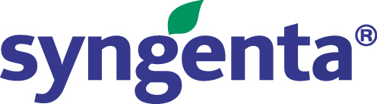

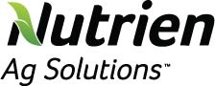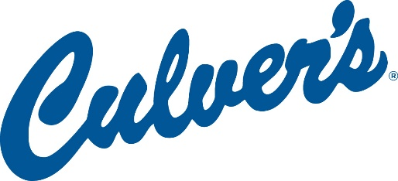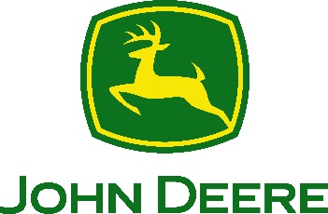

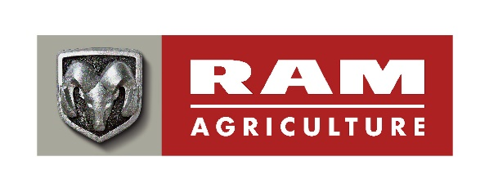



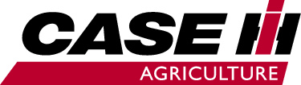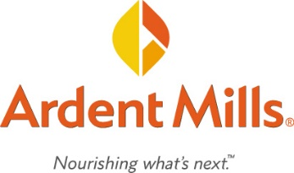
Agribusiness Systems | Animal Systems | Biotechnology Systems | Environmental Service Systems
Food Products and Processing Systems | Natural Resources Systems | Plant Systems | Power, Structural and Technical Systems

AFNR Pathway Explanation
Agribusiness Systems: Companies that connect the business world with agriculture by determining how to effectively use resources for profit and contribute to successful agriculture production. This can include crop production, farm equipment, seed supply, marketing, natural resources and animal services.

Animal Systems: Companies that work directly with animals or work with products that comes from animals. Can treat diseased or injured animals and work to keep them healthy or study research and genetics, nutrition and the development of the animals they work with. Others develop more efficient ways of producing and processing meat, poultry, eggs and dairy products.

Biotechnology Systems: Companies that use biotechnology to enhance plants, animals and microorganisms and to solve global issues, working to increase the world’s access to safe and affordable food and clean water. Often investigate methods of creating fuel from agricultural byproducts and use a range of tools to better understand the basic biology of life.

Environmental Service Systems: Companies that focus on preventing the harmful effects of human activities, may be involved with recycling, water and air pollution control, waste disposal and public health issues. Use knowledge of science and engineering to meet environmental regulations and develop new methods to prevent accidents or dangerous situations.

Food Products and Processing Systems: Companies that study the physical, biological and chemical makeup of foods to improve food safety, create better processes, enhance the nutritional value and shelf-life of foods and develop new flavors. May focus on diet, health and food safety by ensuring the quality of foods or work to develop new packaging, new products and new sales opportunities.

Natural Resources Systems: Companies that work to develop, maintain and manage natural environments. Work to protect wildlife, maintain parks, consult with research groups and keep green areas.

Plant Systems: Companies that study plants and how they impact our world. Monitor the quality and safety of our food and help consumers make sensible nutritional decisions, solve problems by developing crops that are resistant to insects and improve models to grow more food with less space. Others work to conserve our natural resources.

Power, Structural and Technical Systems: Companies that apply knowledge of engineering, hydraulics, pneumatics, electronics, power, structures and controls to the field of agriculture. Also create efficient processes to conserve natural resources and build solutions that impact people around the globe.

Get to Know Agricultural Companies and Organizations
Directions: Choose a company or organization featured in the “National FFA Foundation Top Tier Sponsors” expo hall that you are interested in learning about, and complete the questions below.
Pathway:
Company/Organization

Why did you choose them?

What do they do?

What career opportunities are available with the company/organization?

What skills are needed for these careers? (If you need help finding this, utilize AgExplorer.ffa.org.)

How would you describe this company/organization to your best friend in one word?

Would you be interested in working for this company? Why or why not?

Directions: Choose a company or organization featured in the “Form Connections” expo hall that you are interested in learning about, and complete the questions below.
Pathway:
Company/Organization:

Why did you choose them?

What do they do?

What career opportunities are available with the company/organization?

What skills are needed for these careers? (If you need help finding this, utilize AgExplorer.ffa.org.)

How would you describe this company/organization to your best friend in one word?

Would you be interested in working for this company? Why or why not?

Directions: Choose a company or organization featured in the “Grow Opportunities” expo hall that you are interested in learning about, and complete the questions below.
Pathway:
Company/Organization:

Why did you choose them?

What do they do?

What career opportunities are available with the company/organization?

What skills are needed for these careers? (If you need help finding this, utilize AgExplorer.ffa.org.)

How would you describe this company/organization to your best friend in one word?

Would you be interested in working for this company? Why or why not?

Educational Institutions
Directions: Visit a minimum of three educational institutions, and complete the questions below (there is one sheet for each educational institution).
School Name:

Location:
What agricultural majors do they offer?

Develop two questions to ask the school representative that will help you learn about the school.
1.

2.
Draw a picture of the school’s mascot.
After visiting this school, are you interested in attending? Why or why not?

What is one interesting fact you learned about the school?


Shade in the state where this school is located.

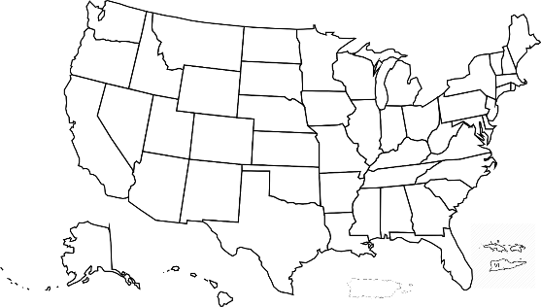

School Name:

Location:
What agricultural majors do they offer?

Develop two questions to ask the school representative that will help you learn about the school.
1.

2.
Draw a picture of the school’s mascot.
After visiting this school, are you interested in attending? Why or why not?

What is one interesting fact you learned about the school?

Shade in the state where this school is located.

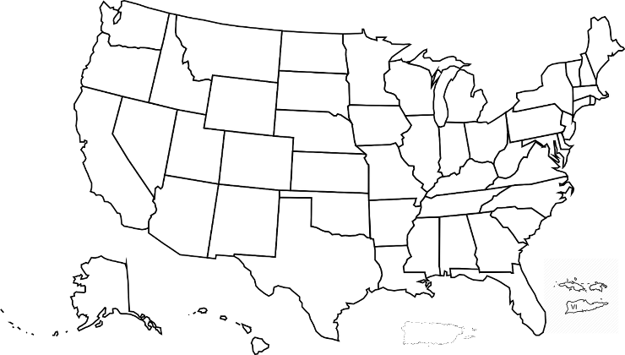

School Name:

Location:
What agricultural majors do they offer?

Develop two questions to ask the school representative that will help you learn about the school.
1.

2.
Draw a picture of the school’s mascot.
After visiting this school, are you interested in attending? Why or why not?

What is one interesting fact you learned about the school?

Shade in the state where this school is located.

Student Connection Rooms
Students will have the opportunity to participate in connection room experiences during convention. These rooms will cover many different topic areas and will give students the chance to meet, connect and learn from FFA members from across the country. Access the student connection rooms here.
If your students are unable to make it to a live student connection room, you can recreate a networking activity in your classroom or in a virtual meeting. Utilize the “Get to Know Me!” activity sheet to facilitate your own student connection room.
How to Implement with Students:
- Have students choose a topic area that interests them from the list below. All topic areas will be available during each time frame.

- Have student complete the “Student Connection Room” worksheet as they interact in the room. Direct access to the individual student activity sheets for easy upload to learning management systems or printing for classwork can be found here.

- Everyone loves to meet new people and make meaningful connections during national convention. This activity can be used in these connection rooms.

Schedule:
(all times in EDT)
Tuesday, Oct. 27 Wednesday, Oct. 28 Thursday, Oct. 29
11:30 a.m. – 1:30 p.m. 8:30 – 10:00 a.m. 8:30 – 10:30 a.m.
3:30 – 5:30 p.m. 11:30 a.m. – 1:30 p.m. 11:30 a.m. – 1:30 p.m.
3:30 – 5:30 p.m. 3:30 – 5:30 p.m.
8:00 – 10:00 p.m.

Room Topics:
- Career Success and Sponsor Career Roundtable
Covered topics include information on interview skills and job shadowing, as well as ways to find that perfect internship. Members will also be able to chat with National FFA sponsors about what it is like to work for their company, how they got started and tips for transitioning from high school to post-secondary education and beyond in terms of employment.
- Life After High School
FFA members will have the chance to talk about exploring majors, going into non-traditional agriculture majors, application tips, and advice on whether or not a technical school, associate degree, bachelor’s or beyond is perfect for the student’s career aspirations.
- CDEs/LDEs
FFA members will be able to share about their favorite events while learning more about CDEs and LDEs. Topics covered could include preparing for and how to study for the competitions, state and local activities and more.
- Application-based Activities (Proficiency, Agriscience Fair, American Degree)
Not all FFA competitive events are judging contests! This session will provide FFA members with the chance to learn and share about agriscience fair from tips to interviewing and how to find great topics to learning how to take an SAE and turn it into a successful proficiency application and tips and tricks for State and American Degree applications.
- Networking — 4 Rooms (one per FFA Region — East, Central, South and West)
Each FFA region will have its own room. This will make it easy for students to get to know other students, fill out the coveted U.S. map from the activity book, and participate in ice breakers and various get-to-know-you activities.
- SAE for All
FFA members will be able to learn more about SAE for All while sharing their wins and challenges and how these skills are helping in their everyday lives to prepare them for their next steps.
- Chapter Officers
Want to learn more about how to be a chapter officer and how can you be the best officer for your chapter? Check out this room for idea sharing and learning!
- Communication and Conversation Skills
Members will learn tips and tricks to improve communication and conversation skills from being social media conscious to interacting with people face-to-face.
- Advocacy
Agricultural advocacy is becoming more and more important. FFA members who want to learn more about advocating and connecting with consumers will learn about using social media, working with the local media, and tips to interacting with elected officials and peers.
- POA/National Chapter
Having a strong Program of Activities (POA) helps chapters be active in their school and community. A POA also completes a national chapter application to earn recognition on a state or national level. Learn about activities from past winners and how to fill out the application. Members will share their favorite and most impactful activities.
- Living to Serve
FFA members will share service projects they have done, explain how to identify a community need and learn about other service projects. Members can find out more about Living to Serve grant opportunities and share stories about unique projects from previous grant winners.
- Meeting Ideas
Are you looking for ways to engage your chapter members? Are you thinking about recruiting and other ways to improve attendance? FFA members will even learn about how to run chapter meetings of various sizes and how to bring shy members out of their shell!
- Team/Chapter Building
Even the most successful chapters can struggle with team building. Members in this room will learn and share about team building activities and games. With the impact of COVID-19, some schools have developed other ways to stay connected — learn about relationship building within your chapter and maybe even with a neighboring chapter.
- Alumni and Supporters
As FFA members, once you graduate, did you know you can still stay involved? Learn more about the alumni and supporters’ efforts. Perhaps your chapter is looking to start an alumni chapter or even involve local supporters for sponsorships and mentorships. Learn about the new Forever Blue Network and more in the Alumni room.
- Fun Room
Are you looking for a place to have fun? This room will offer members the chance to play trivia, go on scavenger hunts and do karaoke. On Wednesday night, we’ll have a dance party with a DJ!

Student Connection Room
Directions: Reflect on your recent experience in the student connection room, and answer the following questions.
What are your key takeaways from your experience?
Topic Area:

What interests you about this area?

IT’S ALL ABOUT CONNECTIONS

Name some of the states represented by other FFA members during the connection times.

Draw an emoji that represents your feelings after participating in this experience. Explain your choice.

How can you take what you learned during this experience and apply it to your life today?

In the future?



Get to Know Me!
Directions: Participate in the student connection activity with your fellow chapter members or agriculture class. After the activity, complete the questions below.
Draw an emoji that represents your feelings after participating in this experience. Explain your choice.
What are your key takeaways from your experience?

IT’S ALL ABOUT CONNECTIONS

How can you take what you learned during this experience and apply it to your life today?

In the future?

Awards and Recognition
Every year at convention, we recognize students for their hard work and achievements in many programs, including the agriscience fair, agricultural proficiency awards, American FFA Degrees, American Stars, career and leadership development events and the National Chapter Award Program.
- All About Awards and Recognition: Have students use this worksheet to learn about the various opportunities available for student participation. After students have learned about all the areas, they will choose one to create an action plan for future participation.

- Student Activity Sheets: Direct access to the individual student activity sheets for easy upload to learning management systems or printing for classwork can be found here.

Challenges
New for 2020! Career and Leadership Challenges are designed for the individual member to explore, create and have fun while they compete with skills learned in the areas of Agriculture, Food and Natural Resources. Challenges are not a replacement for career and leadership development events, but they complement them. They are designed to be student led. Top entries will be recognized publicly, and throughout the challenges, there will be opportunities to win FFA SWAG!

all About Awards and Recognition
Part 1: Complete the first two columns in the chart below.
K: What you already know about the award area
W: What you want to know about the award area
L: *Will be completed in Part 4 below.
K | W | L
Agriscience Fair | Agriscience Fair | Agriscience Fair
Agricultural Proficiency | Agricultural Proficiency | Agricultural Proficiency
National Chapter | National Chapter | National Chapter
American FFA Degree | American FFA Degree | American FFA Degree
Career and Leadership Development Events | Career and Leadership Development Events | Career and Leadership Development Events
Part 2: Follow the links below by clicking on the title to learn about each program area and answer the questions below.

Agriscience Fair
Description
Ways to Participate
How could this program area develop your future career skills?

Agricultural Proficiency
Description
Ways to Participate
How could this program area develop your future career skills?

National Chapter
Description
Ways to Participate
How could this program area develop your future career skills?

American FFA Degree
Description
How to Earn
How could this program area develop your future career skills?

Career and Leadership Development Events
Description
Ways to Participate
How could this program area develop your future career skills?

Challenges
This year, everyone has the opportunity to participate in career and leadership challenges to showcase your skills in the areas of Agriculture, Food and Natural Resources. Explore the challenges available, and select one to participate in.
Explore the challenges here.
After exploring the challenges, which challenge have you selected?

What skills will you be showcasing/developing with this challenge?
Why did you choose this challenge?

Part 3: Now that you have learned about each of the program areas, choose one that you want to participate in and develop an action plan using the prompts below.
Program Area:

What interests you about your selected program area?

Goal 1
Steps to achieve Goal 1

Goal 2
Steps to achieve Goal 2

Goal 3
Steps to achieve Goal 3

Part 4: Revisit the KWL chat from Part 1 of this activity. Complete the L (what you learned) column of the chart. Take a second look at the W column and see if you have any lingering questions.


Living to Serve: National Days of Service Resources and Opportunities
Community service is a large part of FFA and is a great way to involve the community and call attention to the needs in your own community. Looking for a way to have your chapter members participate in a service project during convention week? The Local Engagement Team has developed a toolkit to aid you in planning a service project during October. If the service project is conducted during October, it will count toward the National FFA Days of Service.
Interactive Toolkit for National Days of Service: Click here to access the interactive toolkit.
How to utilize the interactive toolkit with students: Give the toolkit to your chapter members to plan a day of service project during convention week and/or for National FFA Week in February. Divide your students into small groups and task them with creating a service project for October and/or for National FFA Week in February. Then, students can present their service project ideas, and the class/FFA chapter can vote on which one they want to implement. Give the students the “Living to Serve: interactive Toolkit” worksheet to complete while reviewing/completing the toolkit.
Have students log the service event to be included on an interactive map to help inspire others to take action and serve their communities. Once the project is completed, share the impacts, pictures or videos, and your chapter may be highlighted during convention! For more information, visit convention.FFA.org/national-days-of-service/.
All About Service: Give this worksheet to your students to learn about past National FFA service projects/events. In this activity, students will choose one of the articles (FFA Response to WWII, Food For America, Building Our American Communities [BOAC], FFA Impact on Rural Communities and Seeds of Hope Campaign) available here and answer the questions below to learn about the FFA history of service.
Living to Serve Day of Service Mini-Grant: It’s not too late to apply for a Living to Serve Day of Service Mini-Grant to help offset costs for your service project during October. Your FFA chapter can apply for up to $400 and funds will be reimbursed after impacts are submitted. Need examples? Here are some Living to Serve Day of Service Mini-Grant events that were funded through the grant program.
Plan Ahead for National FFA Week: FUNDING TO SUPPORT YOUR FFA WEEK SERVICE EVENT. Your chapter can also apply for a Living to Serve Day of Service Mini-Grant for up to $400 to host a day of service during National FFA Week. The application is easy to complete and can be found at FFA.org/LivingtoServe/Grants. In the application, share how your FFA Week service event will meet a need in the community based on the four focus areas.
Student Activity Sheet: Direct access to the individual student activity sheets for easy upload to learning management systems or printing for classwork can be found here.

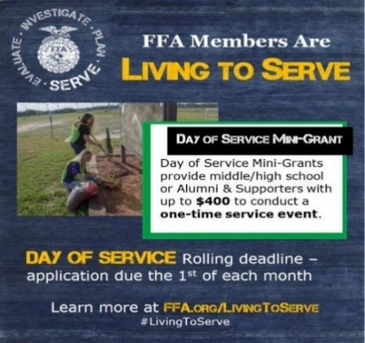
Did you know that your chapter could apply for a grant to support your FFA Week service activity?

You can apply for a Living to Serve Day of Service Mini-Grant for up to $400 to host a day of service event.

The application is easy to complete and can be found at HERE.

Living to Serve: National Days of Service Resources and Opportunities, Continued
When applying for a Living to Serve Day of Service Mini-Grant, you will need to identify what focus area the service activity falls under. Below are the focus areas that need to be identified when applying for the funds.
 | Community Safety | Addresses concerns regarding the safety of community members and the preparation, response and recovery efforts that relate to emergency preparedness and natural disasters
 | Hunger, Health and Nutrition | Addresses unmet food insecurity needs, increasing physical activity and improving healthy habits to promote physical and mental well-being of the community
 | Community Engagement | Addresses matters related to heritage and traditions, connections between community members and civic responsibility throughout the community
 | Environmental Responsibility | Addresses issues regarding air and water quality, energy and water efficiency, at-risk ecosystems and conservation to protect and sustain the natural systems upon which all life depends

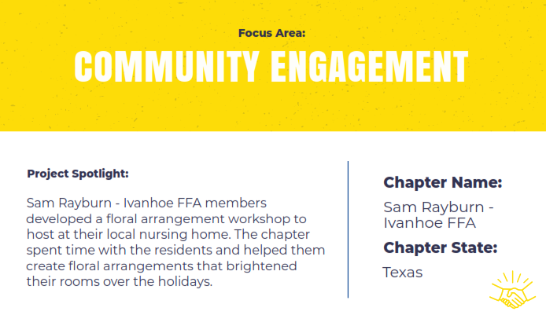
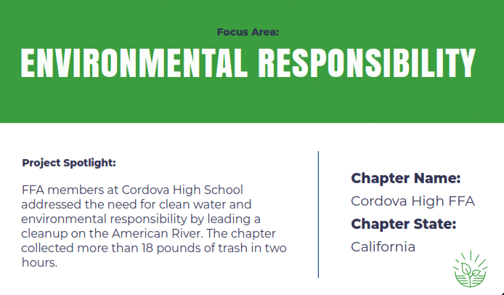
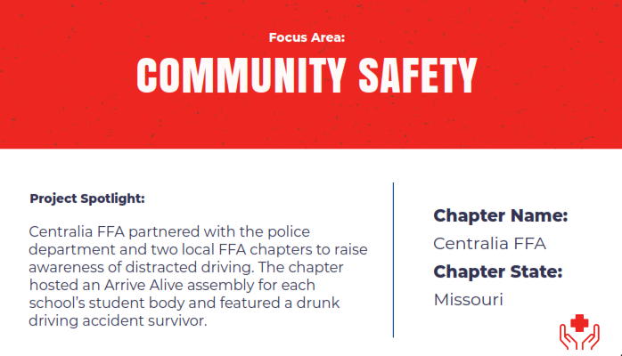
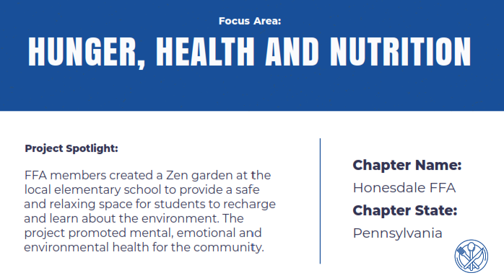
Living to Serve: Day of Service Grant Examples


Living to Serve: Interactive Toolkit

Directions: Reference the interactive toolkit as you complete this worksheet.
- What steps need to be completed to prepare for the service project?
- What are your ideas for a service project for your school and/or community?

What service projects have chapters across the country done in the past? Use this website to aid in your research: FFA.org/livingtoserve/.
Choose one of the service projects you identified above: ________________________

How could that service project be adapted/implemented in your school or community?

All About Service!
Directions: Choose one of the articles available here (FFA Response to WWII, Food For America, Building Our American Communities [BOAC], FFA Impact on Rural Communities and Seeds of Hope Campaign) and answer the questions below to learn about the FFA history of service.

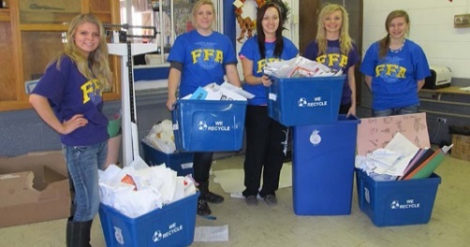
- In the past, what specific service projects/events (or types) do you think FFA has participated in?
- What article did you choose?
- Summarize the article in three to five sentences.
- How can you apply what you have read and learned to your own FFA chapter (or school) and community? What aspects would be the same? What would be different about the service project?
- What does “Living to Serve” mean to you?


FFA Alumni and Supporters
How to Get Involved
Tips and Tricks for Involvement: Engage with FFA Alumni and Supporters during the National FFA Convention & Expo. If you are hosting watch parties, you could invite local FFA Alumni and Supporters to watch with you or send them the link to register.
Don’t have an FFA Alumni and Supporters chapter? Check out information and resources on how to get one started today.
Forever Blue Network: Encourage your students to join the Forever Blue Network (currently only seniors or graduates are approved to join). The Forever Blue Network gives FFA members, alumni and supporters the opportunity to come together no matter where they are. Click here for more information on the Forever Blue Network and how to join.
Convention Workshops Available:
Alumni and Supporters Convention Workshops:
- Forever Blue Network for You: Discover how you can utilize the Forever Blue Network's events, groups, directories and more!
Josh Rusk, National FFA Alumni and Supporters Executive Director
- Supporter Successes: Hear success stories from other FFA Alumni and Supporter chapters across the country along with tips and tricks for awards, grants, fundraising and successfully running a chapter.
Allie Ellis, National FFA Alumni Development Specialist
- Young Alumni Involvement: Learn more about how young FFA Alumni members can be engaged at the local, state and national levels. Hear success stories from young alumni, Collegiate FFA Alumni and Supporters chapters and those that work with associate members.
Allie Ellis, National FFA Alumni Development Specialist
- Serving a Purpose During the Pandemic: Covid-19 has changed our country and world. Find out how FFA Alumni and Supporters are overcoming challenges to continue to help students, teachers and their communities.
Allie Ellis, National FFA Alumni Development Specialist

Teacher Workshop:
- Building a Better Chapter with Alumni and Supporters: Discover ways that alumni and supporters can help your chapter through grants, time, talents and other resources.
Allie Ellis, National FFA Alumni and Supporters

Student Workshops:
- Serve Where You Are: Discover how your passions and interests can converge with the needs in your school or community. By partnering with FFA Alumni and Supporters within community organizations, FFA members will establish an action plan for a life of service.
David Townsend, National FFA Alumni and Supporters

For More Information:
Want to know more about FFA Alumni and Supporters?
Learn more about the various roles as an FFA Alumni and Supporter by watching this short video.
- Have student complete the “National FFA Alumni and Supporters” worksheet.
- Additionally, learn about life membership by watching this video.

Student Activity Sheets: Direct access to the individual student activity sheets for easy upload to learning management systems or printing for classwork can be found here.

National FFA Alumni and Supporters
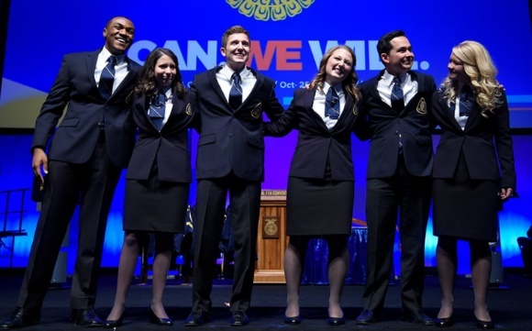
Directions: Watch the video about the various roles of an FFA Alumni and Supporter and answer the questions below. The video can be found at https://FFA.box.com/s/ij0u32qbtrvzjwr5t2tu2qtrkifgpmd8.
- Based on the video linked above, what are the various types of roles of an FFA Alumni and Supporter?

- What do you think it means to be an Alumni and Supporter?

2. What are the different types of alumni and supporter grants? FFA.org/alumni-and-supporters/chapter-opportunities/
- Does your chapter have an Alumni and Supporter group? If yes, explain how they support your agricultural education program/FFA chapter? If no, are their other support/booster groups in your school? How do they provide additional support to their programs?

- What are ways that you can stay connected to your agricultural education program/FFA chapter after graduation?

KEY: National FFA Alumni and Supporters
Directions: Watch the video about the various roles of a FFA Alumni and Supporter and answer the questions below. The video can be found at https://FFA.box.com/s/ij0u32qbtrvzjwr5t2tu2qtrkifgpmd8.
- Based on the video linked above, what are the various types of roles of an FFA Alumni and Supporter?
Volunteer, advocate, mentor, fan, donor
- What do you think it means to be an Alumni and Supporter?
Answers will vary.
2. What are the different types of alumni and supporter grants? FFA.org/alumni-and-supporters/chapter-opportunities/
Give Back to Your Roots, Legacy
- Does your chapter have an Alumni and Supporter group? If yes, explain how they support your agricultural education program/FFA chapter? If no, are their other support/booster groups in your school? How do they provide additional support to their programs?
Answers will vary.
- What are ways that you can stay connected to your agricultural education program/FFA chapter after graduation?
Answers will vary but may include volunteering with your local agricultural education program/FFA chapter and joining your local FFA Alumni and Supporters chapter.

Other Activities
- FFA Experience Jeopardy! Game: Interactive Jeopardy! game that allows student to test their FFA knowledge with categories like FFA History, FFA Meeting Room, FFA Creed, FFA Jackets and Pins, Women in FFA and Famous Alumni.
FFA Experience Jeopardy! Game
Answer Key
- Get to Know the 2020-21 National Officer Team: Every year at the final session, the new National FFA Officer Team is elected. Use this activity sheet to capture information about the new team.
- Making Meaningful Connections: Everyone loves to meet new people and make connections during national convention. Here is an activity to do in the virtual space using this activity sheet to record those you meet along your convention journey.
Student Activity Sheets: Direct access to the individual student activity sheets for easy upload to learning management systems or printing for classwork can be found here.

Get to KNow the 2020-21 National FFA Officers
Directions: Once the new officer team is announced on October 29, research and fill out the information below.
 SENTINEL

Name:

Region: State:
 REPORTER

Name:

Region: State:
 TREASURER

Name:

Region: State:
VICE PRESIDENT

Name:

Region: State:
SECRETARY

Name:

Region: State:
 PRESIDENT

Name:

Region: State:

MAke SOme Meaningful COnnections
Directions: Utilize the various opportunities to live chat and meet via student connection rooms to make meaningful connections with your fellow FFA members.
As you meet FFA members during convention, collect the following information and record it on the respective state’s space. After recording the information, shade in the state on the map.
- Name
- Chapter
- State Product

Alabama ______________________
Alaska ________________________
Arizona _______________________
California ______________________
Colorado ______________________
Connecticut ____________________
Delaware ______________________
Florida _______________________
Georgia ______________________
Hawaii _______________________
Idaho ________________________
Illinois _______________________
Indiana ______________________
Iowa ________________________
Kansas _______________________
Kentucky _____________________
Louisiana _____________________
Maine _______________________
Maryland _____________________
Massachusetts _________________
Michigan _____________________
Minnesota ____________________
Mississippi ____________________
Missouri ______________________
Montana _____________________
Nebraska _____________________
Nevada ______________________
New Hampshire ________________
New Jersey ___________________
New Mexico ___________________
New York _____________________
North Carolina _________________
North Dakota __________________
Ohio ________________________
Oklahoma ____________________
Oregon ______________________
Pennsylvania __________________
Puerto Rico ___________________
Rhode Island __________________
South Carolina __________________
South Dakota ___________________
Tennessee _____________________
Texas _________________________
Utah _________________________
Vermont ______________________
Virginia _______________________
Virgin Islands ___________________
Wisconsin _____________________
Wyoming _____________________

Post-Convention/Reflections
Now that convention is over, it is important to reflect on your experiences and determine how you can apply what you have learned to your life.
- FFA T-shirt Design: Have students be creative and design a convention T-shirt. You can have class competitions or a chapter competition, and if funds allow, create the and sell the winning design.
- FFA New Horizons Magazine Cover - Utilize the cover template to design and create your very own FFA New Horizons magazine cover based on your convention experience.

- Post-Convention Reflection: Use this worksheet to collect your thoughts and feelings about your convention experiences.

- Student Activity Sheets: Direct access to the individual student activity sheets for easy upload to learning management systems or printing for classwork can be found here.

FFA T-Shirt Design

Directions: Use this template to sketch out design ideas for a custom shirt based on your National FFA Convention & Expo experience!

FRONT
BACK

Create your own FFA New Horizons magazine cover
Utilize the magazine cover template to design and create your very own FFA New Horizons magazine cover to represent and summarize your convention experience. If you want to design your cover digitally, you can use the postermywall website.
Items to include in your design:
- Picture
- Three or four story titles (like in example covers below)
- Design should be colorful. Be creative!
Example of past covers:
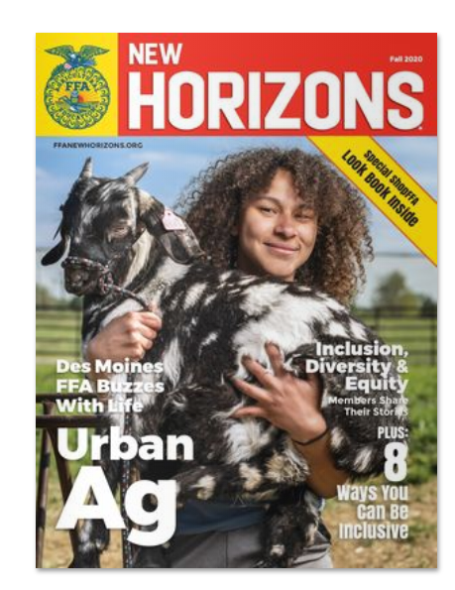
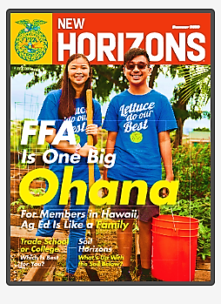
After you design your cover, answer these questions to reflect.
How does this convention experience influence some of your future behaviors and decisions?
Explain why you chose the stories and images you did.
Looking back at your completed magazine cover, which activity that you experienced during convention was your most enjoyable and why?

Post-Convention Reflection
Directions: Reflect on your experiences during the 93rd National FFA Convention & Expo by completing the activities below.
- Five-minute free write: Use the space below to share your thoughts and feelings about your convention experience.

- Choose one word that represents your convention experience, and create an acrostic poem using your chosen word.
Example:
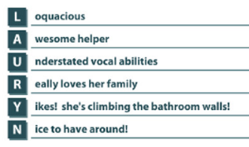

- What one thing in your personal life and in school will you take from your experience, and how will you implement it in your life?
School
Personal

- What was your most interesting discovery during this experience?

