98th National FFA Convention & Expo Implementation Guide

This implementation guide is a resource for advisors to pre-plan and engage all students and various chapter stakeholders during the 98th National FFA Convention & Expo.
The 98th National FFA Convention & Expo has in-person and virtual opportunities available. All students, FFA members and stakeholders from your chapter may attend the virtual portion of the 98th National FFA Convention without a paid registration. See the table below for a complete list of the in-person and virtual opportunities.
In-Person Events | Virtual Events
General Sessions | Live Streaming of General Sessions
American FFA Degree Ceremony | Live Streaming of American FFA Degree Ceremony
Competitive Events | Past Student Workshops
National FFA Expo and Shopping Mall | FFA Live! Streaming Broadcast
Career Success Tours | Award Programs
National Days of Service | Awards and Events Final Presentations and Award Programs
Entertainment | Student Showcase Stage
Delegate Sessions | Delegate Sessions
Student, Teacher, and Alumni and Supporter Workshops
Band, Chorus and Talent
National FFA Officer Selection Process
Courtesy Corps
Student Showcase Stage
Administrator Track
Alumni and Supporters Events
Awards and Events Final Presentations and Award Programs
Agriscience Fair Research Expo
*Direct Links:
Implementation Guide Google
Student Activity Sheets Box

Table of Contents
Below you will find links to resources that accompany the major components of the national convention and expo. (Some links will take you to website resources while other links will take you to specific sections of this document. In each section of this document, look for the home button to come back to this page.)

Convention FAQ
Have questions about the national convention and expo? Check out the convention section of the FFA Help Center.
Pre-Planning/Welcome/Alignment to Educational Standards
Resources and letters to validate convention attendance and help you prepare for the event (letter to administration, technology requirements, etc.).
Planning
Resources and tips to help design your chapter’s convention experience, such as ideas for how to participate and plan your schedule.
Choice/Activity Board
There are two choice/activity boards — one that includes activities that must be completed while at the convention and one that includes activities that can be completed virtually if students are not at the convention. Find all the student activity sheets that go with the Choice Boards in this Box folder.
General Sessions
Experience the retiring addresses from the 2024-25 National FFA Officers and recognition of FFA members and their accomplishments. Find activity sheets that will help students process what they hear.
Media
Resources and activities to showcase your experiences and stories to your family, friends and community using social media.
Workshops
Teacher, student, and alumni and supporters workshops are in person with previously held student workshops archived to use virtually. Links to previously held student workshop videos and accompanying reflection worksheets are provided. Each workshop will vary in length from 15 to 60 minutes.
Exposition Hall Highlights
Resources to discover the vast array of individuals involved in the agriculture industry from innovative companies to educational institutions.
Awards and Recognition
Resources to learn about the different programs through which we recognize students for their hard work and achievements.
Service
Resources to help plan a service project for your community during the month of convention as well as prepare for one during National FFA Week in February 2026.

Alumni and Supporters
Resources to learn about the opportunities available for development in this area. See a list of in-person events for alumni members attending convention. Also, find student worksheets that help students explore alumni opportunities and the Forever Blue Network.
New Farmers of America 90th
Celebrate 90 years of the New Farmers of America through a fun worksheet activity! The NFA was founded in 1935 and created to serve Black vocational agriculture students in segregated Southern schools. Before merging with FFA, NFA thrived with its own traditions, leadership and impact. Join us in celebrating 90 years of history and leadership.
Other Activities
Activities for students to learn and discover more about FFA and make connections with fellow members from across the country.
Post-Convention Thoughts and Reflections
Activities to help students reflect on their experiences during convention.

**You will have access to the virtual components of convention and workshop materials after convention, which are housed through Box. You can find these resources at FFA.org/my-toolbox/instructor/educator-resources/.

Pre-Planning 
Items included in this section are meant to welcome you to the 98th National FFA Convention & Expo as well as provide some materials that may be useful as you plan to attend.
- Administration Letter
This letter from National FFA Chief Program Officer Christine White explains the educational relevancy of convention and the social-emotional development of students after experiencing the opportunities provided by attending the National FFA Convention & Expo. Use this letter with teachers/colleagues, administrators, parents/guardians, advisory boards, etc.

- Competitive Events Letter
This letter from National FFA Chief Program Officer Christine White explains the educational relevancy of competitive events for students who have the opportunity to compete at the National FFA Convention & Expo. Use this letter with teachers/colleagues, administrators, parents/guardians, advisory boards, etc.

- Code of Conduct
FFA Code of Ethics: FFA members should always conduct themselves to be a credit to the organization, chapter, school, community and family.

- Emergency Card
In an emergency, many things can happen at once, and critical areas of the assessment may be left out. Use this template to prepare.

- Educational Standards
This document serves as a guideline to assist advisors in planning and implementing pre- and post-convention processing and work. Educational standards for the National FFA Convention & Expo are suggested standards based on the projected central theme, objectives, content and activities of main events. Share this document with administrators to show the educational relevancy of the National FFA Convention & Expo.
- Technology for Virtual Access
With the National FFA Convention & Expo going virtual, we want to ensure you and your students are prepared with the appropriate access to technology. In this section, you will find a list of whitelist websites needed to experience convention, learn how you can test your technology prior to the start of convention and discover what to do if you do not have access.

- School Administrator Track
Bringing administrators with you to convention? Register your principal, CTE director or other administrator for the School Administrator Track to receive red carpet treatment from National FFA Staff.

- Convention T-shirts!
Order convention T-shirts for your FFA chapter for giveaways or pass along the link to students so they can order their own.
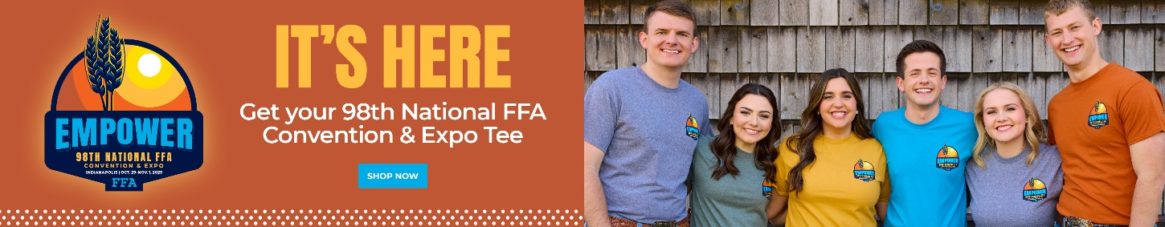


Administration Letter
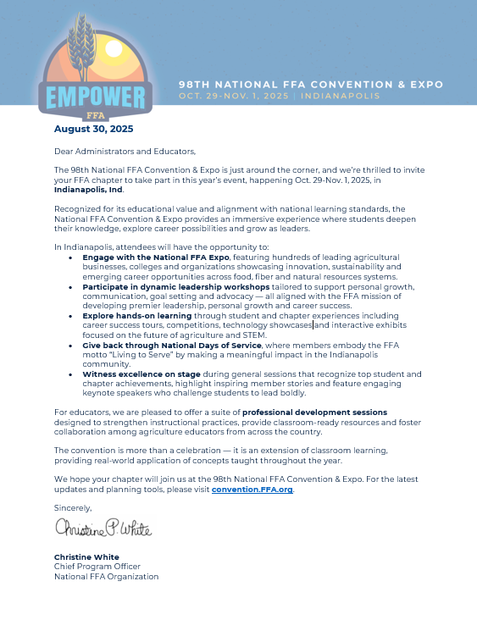
This letter from National FFA Chief Program Officer Christine White explains the educational relevancy of convention and the social-emotional development of students after experiencing the opportunities provided by attending the National FFA Convention & Expo. Be sure to refer to the Health and Safety protocols for attending convention in person.

Competitive Events Letter
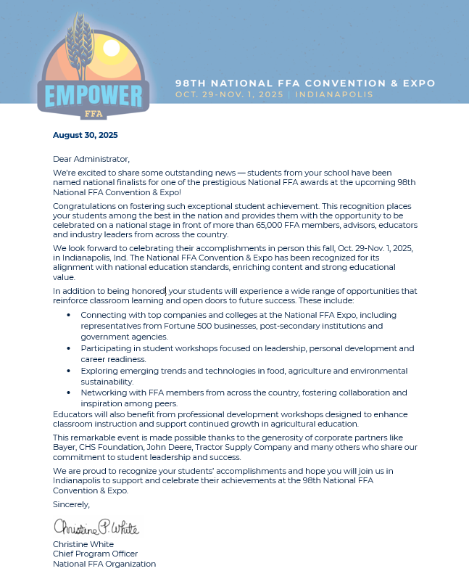
This letter from National FFA Chief Program Officer Christine White explains the educational relevancy of competitive events for students who have the opportunity to compete at the National FFA Convention & Expo. Use this letter with teachers/colleagues, administrators, parents/guardians, advisory board, etc.

School Administrator Track
Do you have an administrator attending the 98th National FFA Convention with you? An administrator could be your principal, assistant principal, CTE director, career development coordinator, curriculum and instructional management coordinator, etc. Give them the red-carpet treatment with National FFA staff as they offer two sessions at convention just for administrators.
The School Administrator Track includes two sessions to choose from:
- Wednesday, Oct. 29, 10 a.m. - 12 p.m.
- Thursday, Oct. 30, 10 a.m. - 12 p.m.
Sessions will provide administrators with a short reception, welcome, networking time with other administrators and an explanation of the educational relevance of the national convention and expo. There will also be a behind-the-scenes tour of the general session floor in Lucas Oil Stadium.
Advisors can register their administrators for one of the sessions during regular registration for the 98th National FFA Convention.



pERSONAL CODE OF CONDUCT

98TH NATIONAL FFA CONVENTION & EXPO
FFA Code of Ethics
By attending or participating in the National FFA Convention & Expo, you agree to abide by the Code of Conduct and the FFA Code of Ethics. FFA members always conduct themselves to be a credit to the organization, chapter, school, community and family. As an FFA member, I pledge to:
- Develop my potential for premier leadership, personal growth and career success.
- Make a positive difference in the lives of others.
- Dress neatly and appropriately for the occasion.
- Respect the rights of others and their property.
- Be courteous, honest and fair with others.
- Communicate in an appropriate, purposeful and positive manner.
- Demonstrate good sportsmanship by being modest in winning and generous in defeat.
- Make myself aware of FFA programs and activities and be an active participant.
- Conduct and value a supervised agricultural experience program.
- Strive to establish and enhance my skills through agricultural education in order to enter a successful career.
- Appreciate and promote diversity in our organization.
Code of Conduct
All convention and expo participants are expected to obey all local, state and federal laws. Participants shall abstain from abusive, disruptive or inappropriate behavior before, during or after the event in all forms, including in-person attendance, digital or social media interaction and any other form of communication. The National FFA Organization may act in its discretion to address any attendee(s), group(s) or participant(s) it believes fail to uphold the criteria of the FFA Code of Ethics or Code of Conduct, including but not limited to revoking event access without refund or reduction of any fees paid or payable, removal from participation in awards and recognition programs, and revocation of awards and recognition earned. Please contact the Control Center (Indiana Convention Center (ICC) Room 116) if you’ve observed or experienced a violation of the FFA Code of Ethics or Code of Conduct.

How can you help in an emergency?
In an emergency, many things can happen at once, and critical areas of the assessment may be left out. To help avoid this, many emergency medical technicians use an acronym to help them remember the important questions to ask. This acronym is known as a SAMPLE history. The acronym helps identify six immediate pieces of information about a patient to aid them in determining their next course of action. Below is a card we highly recommend that you have on file for each student.
There are two recommended ways to use the S.A.M.P.L.E. card. One, keep a copy with you. Second, have students keep a copy of their specific card in their wallets or the inside pocket of their FFA jackets. This will be of great help should you not be in the immediate area in case of an emergency.
Here is a direct link to an editable file with the S.A.M.P.L.E. card below: Word, PDF
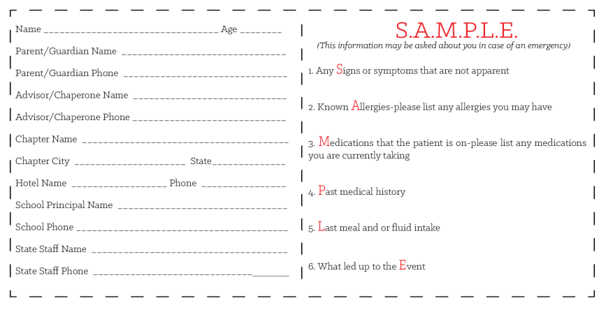

Educational Standards Alignment

This document serves as a guideline to assist advisors in planning and implementing pre- and post-convention processing and work. Educational standards for the National FFA Convention & Expo are suggested standards based on the projected central theme, objectives, content and activities of main events. While every standard listed may not be covered during each individual portion of the convention and expo, these lists should serve as a guideline to validate and actualize educational relevancy for attending the National FFA Convention & Expo.

OVERALL STUDENT LEARNING OBJECTIVES

After completing these activities, students will …

1. Discover and experience premier leadership, personal growth and career success.

2. Demonstrate and explore leadership and career skills.
3. Network with FFA members and various stakeholders.
4. Identify emerging technologies, innovations and leaders within the agriculture industry.

MAJOR ACTIVITIES CONSIDERED

This is not a complete list of all National FFA Convention & Expo activities but rather a list of major events throughout the week.

1. Workshops

2. General Sessions

3. Awards and Recognition

4. Exposition Hall (Agricultural Companies and Colleges)

5. National Days of Service

THESE ACTIVITIES ARE ALIGNED TO THE FOLLOWING STANDARDS:

AFNR Performance Element
•CS.01. Analyze how issues, trends, technologies and public policies impact systems in the Agriculture, Food & Natural Resources Career Cluster.
•CS.02. Evaluate the nature and scope of the Agriculture, Food & Natural Resources Career Cluster and the role of agriculture, food and natural resources (AFNR) in society and the economy.
•CS.03. Examine and summarize the importance of health, safety and environmental management systems in AFNR workplaces.
•CS.04. Demonstrate stewardship of natural resources in AFNR activities.
•CS.05. Describe career opportunities and means to achieve those opportunities in each of the Agriculture, Food & Natural Resources career pathways.
•CS.06. Analyze the interaction among AFNR systems in the production, processing and management of food, fiber and fuel and the sustainable use of natural resources.

FFA Precept
•FFA.PL-A. Action: Assume responsibility and take the necessary steps to achieve the desired results, no matter what the goal or task at hand.
•FFA.PL-C. Vision: Visualize the future and how to get there.
•FFA.PL-E. Awareness: Understand personal vision, mission and goals.
•FFA.PL-F. Continuous Improvement: Accept responsibility for learning and personal growth.
•FFA.PG-I. Professional Growth: Assume responsibility for attaining and improving upon the skills needed for career success.
•FFA.PG-J. Mental Growth: Embrace cognitive and intellectual development relative to reasoning, thinking and coping.
•FFA.CS-M. Communication: Effectively interact with others in personal and professional settings.
•FFA.CS-N. Decision Making: Analyze a situation and execute an appropriate course of action.

Common Career Technical Core
•AG1 Analyze how issues, trends, technologies and public policies impact systems in the Agriculture, Food & Natural Resources Career Cluster.
•AG2 Evaluate the nature and scope of the Agriculture, Food & Natural Resources Career Cluster and the role of agriculture, food, and natural resources (AFNR) in society and the economy.
•AG3 Examine and summarize the importance of health, safety, and environmental management systems in AFNR businesses.
•AG5 Describe career opportunities and means to achieve those opportunities in each of the Agriculture, Food & Natural Resources Career Pathways.
•AG6 Analyze the interaction among AFNR systems in the production, processing, and management of food, fiber, and fuel and the sustainable use of natural resources.

NASDCTEc
•AGC02.02 Employ the use of technical information effectively to maintain and communicate records and reporting procedures commonly used in the AFNR cluster.
•AGC05.02 Identify how key organizational systems affect organizational performance and the quality of products and services to demonstrate an understanding of how AFNR systems are managed and improved.
•AGC08.01 Demonstrate workplace ethics specific to AFNR occupations in order to reflect effective stewardship of resources.
•AGC09.02 Select, research and examine critical aspects of career opportunities in one or more AFNR career pathways in order to gain an understanding of the breadth of occupations within this cluster.
•AGC10.03 Compare and contrast issues affecting the AFNR industry including biotechnology, employment, safety, environmental and animal welfare to demonstrate an understanding of the trends and issues important to careers in this industry.
•AGC10.04 Envision emerging technology and globalization and project its influence on widespread markets to demonstrate an understanding of technologies and trends that will impact the AFNR industry.

Common Core – Reading: Informational Text
•CCSS.ELA-Literacy.RI.9-10.3 Analyze how the author unfolds an analysis or series of ideas or events, including the order in which the points are made, how they are introduced and developed, and the connections that are drawn between them.

Common Core – Speaking and Listening
•CCSS.ELA-Literacy.SL.9-10.1 Initiate and participate effectively in a range of collaborative discussions (one-on-one, in groups, and teacher-led) with diverse partners on grades 9-10 topics, texts, and issues, building on others’ ideas and expressing their own clearly and persuasively.
•CCSS.ELA-Literacy.SL.9-10.2 Integrate multiple sources of information presented in diverse media or formats (e.g., visually, quantitatively, orally) evaluating the credibility and accuracy of each source.
•CCSS.ELA-Literacy.SL.9-10.4 Present information, findings, and supporting evidence clearly, concisely, and logically such that listeners can follow the line of reasoning and the organization, development, substance, and style are appropriate to purpose, audience, and task.
•CCSS.ELA-Literacy.SL.11-12.1 Initiate and participate effectively in a range of collaborative discussions (one-on-one, in groups, and teacher-led) with diverse partners on grades 11-12 topics, texts, and issues, building on others' ideas and expressing their own clearly and persuasively.

Common Core – Language
•CCSS-ELA-Literacy.L.9-10.3 Apply knowledge of language to understand how language functions in different contexts, to make effective choices for meaning or styles, and to comprehend more fully when reading or listening.

Common Core – Literacy in Science & Technical Subjects: Writing
•CCSS.ELA-Literacy.WHST.9.10.6 Use technology, including the Internet, to produce, publish, and update individual or shared writing products, taking advantage of technology's capacity to link to other information and to display information flexibly and dynamically.

Next Generation Science
•HS-ETS1-3 Evaluate a solution to a complex real-world problem based on prioritized criteria and trade-offs that account for a range of constraints, including cost, safety, reliability, and aesthetics as well as possible social, cultural, and environmental impacts.

Green/Sustainability Knowledge and Skill Statements
•AFNR Career Cluster, Statement 7 Demonstrate an understanding of green and sustainability trends that are impacting processes and markets in AFNR.

AFNR Career Ready Practices
•CRP.04. Communicate clearly, effectively, and with reason. Career-ready individuals communicate thoughts, ideas and action plans with clarity, whether using written, verbal and/or visual methods.
•CRP.05. Consider the environmental, social and economic impact of decisions. Career-ready individuals understand the interrelated nature of their actions and regularly make decisions that positively impact and/or mitigate negative impact on other people, organizations and the environment.
•CRP.08. Utilize critical thinking to make sense of problems and persevere in solving them. Career-ready individuals readily recognize problems in the workplace, understand the nature of the problem, and devise effective plans to solve the problem.

Partnership for 21st Century Skills
•Communication
•Critical Thinking and Problem Solving
•Financial, Economic, Business, and Entrepreneurial Literacy
•Flexibility and Adaptability
•Information, Communications, and Technology Literacy
•Initiative and Self-direction
•Leadership and Responsibility
•Global Awareness
•Technology Literacy
•Think Creatively

Technology for virtual access
With the National FFA Convention & Expo having both an in-person and a virtual component, we want to ensure you and your students are prepared with the appropriate access to technology if you are joining virtually. Below is a list of websites to whitelist to experience the virtual convention and information to help you test your technology prior to the start of convention and discover what to do if you do not have access.

List of Websites to Whitelist
The websites below will be used during the National FFA Convention & Expo. We encourage you and your students to test them prior to the start of convention.
- convention.FFA.org
- FFA.org
- https://FFA.box.com
- https://vimeo.com
*If Vimeo is blocked by the school district, we recommend you ask your school district to temporarily allow access. Additionally, you may provide your district IT department with these instructions so they may still block Vimeo yet allow embedded videos to play on the virtual convention site.

If you can access all links:
- You are ready for the start of the virtual component of convention.
If you cannot access one or multiple links:
- Reach out to your district IT department for help to get the websites unblocked for use during the National FFA Convention & Expo.

planning
This section will include information to help you plan an engaging convention experience for students in person and virtually. You will find a planning template as well as information on the background of convention as well as the pin challenge and service events.
- Brief background information on the National FFA Convention & Expo, including the following:
  - History of the National FFA Convention & Expo.
  - Delegate process.
  - National FFA Officer election process.

- Review of the components of convention, including what is offered in person and virtually.

- Tips on how to participate in the virtual component of the national convention and expo.
  - Discover FFA Live!

- Template to make your own schedule and/or a schedule for students.

- Student Challenge: Collectible Lapel Pins

- Student Activity Sheets: Direct access to the individual student activity sheets for easy upload to learning management systems or printing for classwork can be found here.

- National Day of Service Events at Convention: Schedule

- Interactive Toolkit for National Days of Service: Click here to access the interactive toolkit.

  - How to utilize the interactive toolkit with students: Give the toolkit to your chapter members to plan a day of service project during convention week. Divide your students into small groups and task them with creating a service project during October. Then, students can present their service project ideas, and the class/FFA chapter can vote on which one they want to implement. Give students the “Living to Serve: Interactive Toolkit” worksheet to complete.

Background of National FFA Convention & Expo

Brief History of the National FFA Convention & Expo
Why do we have a national convention each year?
Each fall, more than 70,000 FFA members, advisors, educators, supporters and guests from across the country come together to participate in sessions, competitive events, career success tours, educational tours, and student and teacher leadership workshops, to experience an expo and shopping mall, to volunteer and to network. The convention is an event where members not only compete, network, volunteer and have fun, but they also learn about the diverse careers in the industry of agriculture and are recognized for their achievements.

The first national convention was held in Kansas City, Mo., with 33 delegates from 18 states.

During each convention, official business is conducted by the national officers and member delegates.
The National FFA Delegate Experience ensures the National FFA Organization remains a grassroots organization that serves students at the local level.

Convention Delegates
The delegate experience brings together 475 student leaders from across the nation. Students share ideas and perspectives that propel the organization forward. Delegates come from each of the organization’s 52 state associations, with delegation sizes determined by each association’s percent of overall organizational membership. The National FFA Delegate Experience has been an FFA tradition since 1928. For more information on the delegate process, visit FFA.org/delegates.

Election of National FFA Officers
How are the National FFA Officers elected?
Each year, six student members are selected to represent the National FFA Organization as National FFA Officers. Members must have received an American FFA Degree and be selected by their state association to be eligible for national office. National officers travel more than 100,000 miles during their year of service representing the organization. To learn more about the process of becoming a national officer, visit FFA.org/national-ffa-officers/.
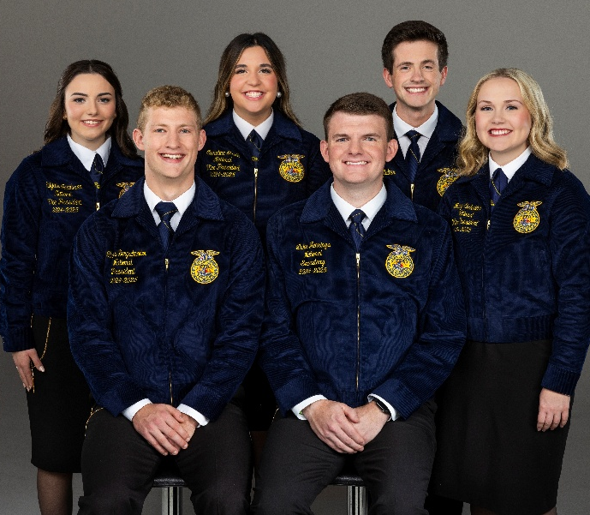

Convention Components
For the 98th National FFA Convention & Expo, students, advisors and guests will be able to engage in both virtual and in-person events. Below are the components that will be available during the in-person convention experience versus what will be available in a virtual format for any registered student, advisor or guest to experience.
Schedule: Utilize this template to schedule your convention week. Additionally, students can utilize it alone or with the convention app. Click here for more information about the convention app.
Utilize this convention schedule and virtual on-demand activities to complete your schedule.
In-Person Events
- General Sessions
- American Degree Ceremony
- Awards and Events
- National FFA Expo and Shopping Mall
- Career Success Tours
- National Days of Service
- Entertainment
- Delegate Sessions
- Student, Teacher, and Alumni and Supporters Workshops
- Band, Chorus and Talent
- National FFA Officer Selection Process
- Courtesy Corps
- Student Showcase Stage
- Alumni and Supporters Events
- Agriscience Fair Research Expo

Virtual Events
- FFA Live! streaming broadcast, featuring:
General Sessions
American FFA Degree Ceremony
Member Presentations
Award Programs
Awards and Events Final Presentations and Award Programs
Past Student Workshops
Stories from the convention and expo
- National Days of Service

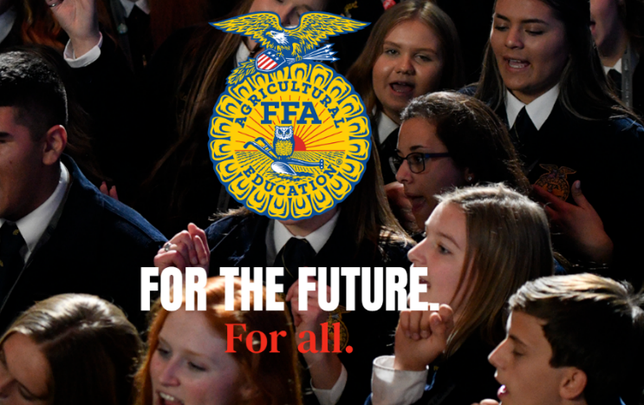

How to participate in the National FFA Convention from a distance
Can’t attend convention in Indianapolis? Need ideas on how your chapter members can participate in the convention virtually? Check these out!
- Have a watch party with your classes! Afterward, you can host a class discussion to discuss and reflect on the sessions.
- Have a watch party with neighboring chapters!
- Rent a local movie theatre, Lions/VFW hall, community center or watch in your school gymnasium.
- Watch previously held student workshops that are available virtually. Use the provided student activity sheets with the workshops. Students can complete these in class, at a chapter meeting or individually.
- Student Workshop Activity Worksheets
- Student Workshop Videos
- Watch retiring address videos from last year’s officer team and complete the lessons that go with them. Find those here.
How to interact with other chapters:
- Host a joint watch party with neighboring chapters.
- Students can share their experience via social media.

FFA Live!
Watch the National FFA Convention & Expo like never before on FFA Live!, our streaming broadcast that begins with the first drop of the gavel on Wednesday, Oct. 29, and ends with the election of the 2025-26 National FFA Officers on Saturday, Nov. 1. In between, you’ll see the national convention and expo in action with live broadcasts of each general session, Awards and Events Finals presentations, historical footage, interviews and information about the FFA member experience. Prepare to be engaged, educated and entertained whether you’re at home, in the classroom or in Indianapolis.
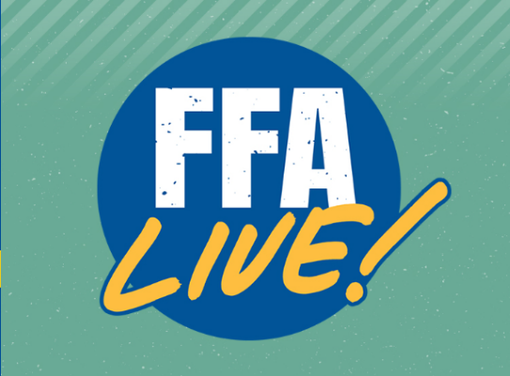
Click the picture below to be taken to FFA Live!
**Looking for an activity to share with your students about those recognized on stage? Check out this activity!
Make Your Own Schedule
Utilize the convention schedule and on-demand activities to personalize your own schedule for convention week, and encourage students to customize their own utilizing this template (Word, PDF) and/or the convention app.
Don’t forget to check out the teacher and student workshops!
Wednesday, Oct. 29
Morning:

Afternoon:

Evening:
Thursday, Oct. 30
Morning:

Afternoon:

Evening:
Friday, Oct. 31
Morning:

Afternoon:

Evening:
Saturday, Nov. 1
Morning:

Afternoon:

Evening:

Collectible Lapel Pins
As your students enjoy the 98th National FFA Convention & Expo, they will have the opportunity to collect five one-of-a-kind lapel pins (the apple pin is for advisors only). These pins will be limited in quantity and only available this year.
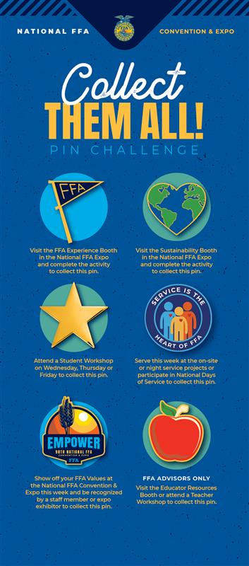

National FFA Convention & Expo Activity Board
Directions: The National FFA Convention & Expo provides FFA members with the opportunity to network and have new experiences. Learn about national convention, while you are there, by completing the following activities.
Complete each of the tasks below in any order you like. The due date for this board is .
National FFA Convention & Expo In-Person Activity Board
Serve as a newsroom reporter for convention. Watch a general session in person, and write a news article describing everything that was learned and experienced. Use the Extra! Extra! Read All About It! activity sheet. | Attend a general session to watch a national officer retiring address and complete one of the activity sheets (1) (2) (3). | Visit the Agriscience Fair Research Exposition set up in Hall K to learn more about student research and gather ideas for your next agriscience project. Complete this exploration worksheet to learn more about these opportunities within FFA. | Meet fellow FFA members from across the country. As you join in the convention activities, complete this activity sheet.
Visit the expo to identify corporate partners of FFA and visit at least one company/organization in each area. As you explore and interact, complete the worksheet for each stop on your journey. | Use the interactive toolkit to plan a service project for your chapter to complete during convention and/or FFA Week. Use this activity sheet. | Use this worksheet to discover more about Alumni and Supporters and how you can be involved with FFA after high school. Be sure to stop by the FFA Alumni and Supporters booth in the expo for a professional head shot! | Everyone loves a good T-shirt! Express your creative side by using this template to design a T-shirt based on your convention experience. Be sure to visit the FFA Experience Booth to grab your exclusive convention tee!
Get to know higher education institutions in the expo. Find three that interest you and complete the worksheet. | Test your FFA knowledge. Take a break and get your convention group together to play FFA Experience Jeopardy! | The 2025-26 National FFA Officers are elected during the final general session on Nov. 1. Get to know them by completing the activity sheet. | Design your personal cover of FFA New Horizons. Utilize the template provided.
Attend a minimum of two student workshops and complete the accompanying activity guide.  PDF | Word | Discover the various awards and recognition opportunities available with National FFA. Develop a plan for future participation using this activity sheet. | Share your FFA story and experiences. Utilize the media materials to plan social media posts. #FFA25 | Now that convention has come to a close, reflect on your experiences by completing this worksheet.
Stop by the FFA Service Experience Booth in the expo to complete a service project during convention! | Don’t forget to swing by the Scholarship booth in the expo for a selfie! | Visit the sustainability booth to learn more about the different aspects of sustainability! | Swing by the student showcase stage to support students’ agriscience fair research and SAEs.

National FFA Convention & Expo Activity Board
Directions: The National FFA Convention & Expo provides FFA members with the opportunity to network and have new experiences. Learn about national convention, virtually, by completing the following activities. Remember to catch the action all week on the FFA Live! streaming broadcast.
Complete each of the tasks below in any order you like. The due date for this board is .
National FFA Convention & Expo Virtual Activity Board
Serve as a newsroom reporter for convention. Watch a general session on demand, and write a news article describing everything that was learned and experienced. Use the Extra! Extra! Read All About It! activity sheet.  General Sessions on Demand | Watch a general session to see a national officer retiring address and complete one of the activity sheets (1) (2) (3).  General Sessions on Demand | Visit the agriscience fair site to learn more about student research and gather ideas for your next agriscience project. Complete this exploration worksheet to learn more about these opportunities within FFA. | Meet fellow FFA members from across the country. Check out the student-made videos for the #SpeakAg State Showcase and complete this activity sheet for 10 states.
Virtually visit the expo by identifying corporate partners of FFA and visit at least one company/organization in each area. Zoom in on the map and click on them for their website. As you explore and interact, complete the worksheet for each stop on your journey. | Get to know educational institutions in the expo or in your state/neighboring state. Use this link to get to the 2025 floorplan. Zoom in on Collegiate Connection. Find three institutions that interest you, click on them for their website link and complete the worksheet. | Share your FFA story and experiences. Utilize the media materials to plan social media posts. #FFA25 | The 2025-26 National FFA Officers are elected during the final general session on Nov. 1. Get to know them by completing the activity sheet.
View a minimum of two pre-recorded workshops and complete the accompanying activity guide for your selections, found here. | Test your FFA knowledge. Get your chapter or class together and play FFA Experience Jeopardy! | Everyone loves a good T-shirt! Express your creative side by using this template to design a T-shirt based on your convention experience. | Design your personal cover of FFA New Horizons. Utilize the template provided.
Use the interactive toolkit to plan a service project for your chapter to complete during convention and/or FFA Week. Use this activity sheet. | Discover the various awards and recognition opportunities available with National FFA. Develop a plan for future participation using this activity sheet. | Use this worksheet to discover more about Alumni and Supporters and how you can be involved with FFA after high school. | Now that convention has come to a close, reflect on your experiences by completing this worksheet.

General Sessions
The live general sessions can be viewed on the FFA Live! streaming broadcast on FFA.org. The convention website includes the session schedule. The generic worksheets that can be used during the retiring addresses and/or keynote addresses can be found below.
All general sessions will be available on demand after the original air date and time.

Schedule
Wednesday, Oct. 29 | Thursday, Oct. 30 | Friday, Oct. 31 | Saturday, Nov. 1
Opening Session 1A: 3:30 p.m. | Opening Session 1B: 8 a.m. | Fourth General Session: 8 a.m. | American Degree Ceremony: 7:30 a.m.
 | Second General Session: 2 p.m. | Fifth General Session: 2:30 p.m. | Seventh General Session: 12 p.m.
 | Third General Session: 6 p.m. | Sixth General Session: 7 p.m.
*For a detailed session schedule, check here.

2025 Retiring Address Worksheets
Utilize the worksheets below to reflect on the national officer retiring addresses.
- Making an Impact (1)
- Making an Impact (2)
- Making an Impact (3)
- Empower
Direct access to the individual student activity sheets for easy upload to learning management systems or printing for classwork can be found here.

Former National Officer Retiring Addresses
Now that students have watched the retiring addresses from this year’s convention, let’s explore the addresses from the past.
Lesson Plans: Lesson plans with student activity sheets and answer keys for former national officer retiring addresses.
Student Activity Sheets: This folder contains the generic activity sheets for students in individual files separate from the lesson plan.
On-Demand Videos: Video library of former national officer retiring addresses.

FFA Live!
During award sessions check out the off-stage interviews of those being recognized for their accomplishments. Check out the FFA Live! The Story Before and After the Stage activity.
Making an Impact

Directions: Complete the following activity about a National FFA Officer’s retiring address or a keynote speaker’s comments from the National FFA Convention & Expo.
In each cloud, write down one quote or statement from the presentation that is meaningful or inspirational to you.
What do these two quotes/statements mean to you?
In one sentence, what is the overarching message?
In three or more sentences, describe how you will apply this message in your life, your school and your community.

Speaker Name:
Message Title:

Making an Impact
Directions: Complete the following activity about a National FFA Officer’s retiring address or a keynote speaker’s comments from the National FFA Convention & Expo.
Write down one quote/phrase from the presentation that is meaningful or inspirational to you. Explain why or how it impacts you.
What is the main subject of the retiring address or keynote speaker’s message?

What are three things you have learned or taken away from this message?

How would you summarize this message to explain it to your friends?

How can you apply what your learned from the message in your life today?

In the future?
Create a hashtag for this message.

Making an Impact
Directions: Complete the following activity about a National FFA Officer’s retiring address or a keynote speaker’s comments from the National FFA Convention & Expo.
What is your initial reaction after watching this message?

Message Title:

Summarize the message in two sentences.
What is a quote/statement from the speech that resonated with you? Explain why.

What do you think is the key takeaway from this message?

How can you apply it in your own life?

What does this message make you think about in relation to your own personal growth?

Empower
Directions: Feel empowered through your journey at the 98th National FFA Convention & Expo. Complete the following activity after watching a National FFA Officer’s retiring address or a keynote speaker’s comments from the National FFA Convention & Expo.
Part 1
- What is the speaker’s name?

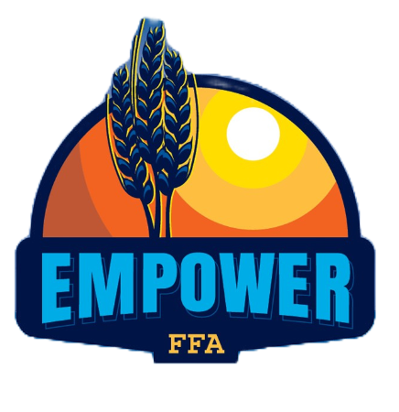
- Explain how this retiring address/keynote is connected to the FFA values statements, mission, vision or code of ethics.

- How do retiring addresses/keynote speakers inspire and motivate FFA members?

- What was the overall message or lesson? How can you apply this to your own life and FFA involvement?

- Reflect on your own experience while listening to or watching this speech. What resonated with you the most, and why?

- What visual elements accompany this speech, such as stage setup, lighting or images?

  - How do these elements enhance the message?

- What did you learn about the speaker?

  - Why did this stand out?

- Create a list of three vocabulary words from this speech and define them.

- Create an image that summarizes the speech and then explain your drawing in three sentences

Part 2
After watching a National FFA Officer’s retiring address or a keynote speaker’s comments from the National FFA Convention & Expo, you will plan your own. Imagine yourself delivering a retiring address or keynote speech at a future National FFA Convention. What message would you convey, and why? Use the mind map below to brainstorm your ideas, and then create a rough draft.
Title:
- Topic or theme of your speech
Introduction:
- Get the audience’s attention (hook).
- Brief introduction of the topic
- Share a brief story or example that directly relates to the theme/topic.
- Your “why”
Body points (three):
- Main points of your message
- Use transitional phrases or words such as again, and then, finally, next, lastly, what's more, in addition, first (second, etc.)
- Use stories, personal experiences or humor to add interest and reinforce each point
- Use descriptive words (adjectives) to help the audience visualize what you say and keep them interested
Conclusion:
- Summarize what you said
- Why should the audience care?
- Call to action
For the mind map, you will begin with the main concept or topic; this will serve as the main bubble. From there, create subtopics that will branch off the main idea. These tend to be your three body points. Once your subtopics are complete, start including support points. These will be the details of your body points. See the example below:
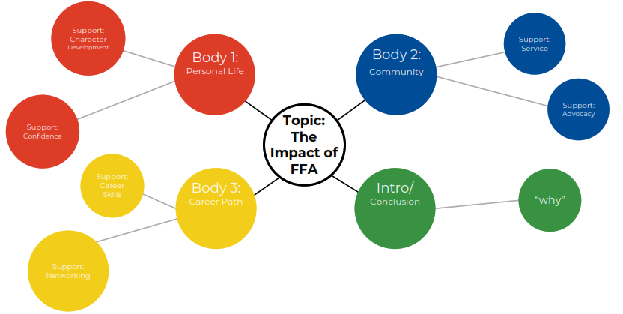
Use the space on the next page to create your own mind map! You can use the template provided or create your own.
Support:

Support:

Support:

Body 1:
Title:
Body 2:

Support:

Support:

Support:

Conclusion

Support:

Support:

Support:

Support:

Support:

Support:

Introduction

Support:

Support:

Support:

Body 3:

Keynote/Retiring Address Outline Draft
Directions: After completing your mind map brainstorming, use the space below to expand on your retiring address or keynote speech to create a rough draft of your outline.

Speech Topic: ______________________________________________________________

Introduction:

Body Point 1 (briefly explain):

Body Point 2 (briefly explain):

Body Point 3 (briefly explain):

Conclusion:

Rubric: Draft and Speech
Qualification | Very strong evidence of skill is present.  (5–4 points) | Moderate evidence of skill is present.  (3–2 points) | Weak evidence of skill is present.  (1–0 poi5nts) | Total Points  (30 possible)
Engaging Title and Description (Description Refers to Title) | Title and description are engaging and attention grabbing; description refers to title. | Title and description are mediocre; description somewhat refers to title. | Title and description are very weak; description does not refer to title.
Sections Completed | The introduction, body points one to three and conclusion are detailed. | The introduction, body points one to three and conclusion are somewhat detailed. | The introduction, body points one to three and conclusion are lacking information.
Presentation Skills | Thorough and maintains eye contact | Somewhat professional; depends on the presentation | No evidence of preparation
Grammar/Punctuation/  Spelling | Spelling, grammar and punctuation are extremely high quality with two or less errors in the document. | Spelling, grammar and punctuation are adequate with three to five errors in the document. | Spelling, grammar and punctuation are less than adequate with six or more errors in the document.
Time | 10 minutes | Between five and 10 minutes | Under five minutes
Overall Impression | Presentation was consistent and appropriately highlighted a topic of the presenters’ choosing that they feel passionate about. | Presentation was consistent and generally highlighted a topic of the presenters’ choosing that they feel passionate about. | The presentation was not consistent and did not highlight a topic of the presenters’ choosing that they feel passionate about.
 |  |  | Total | /30 points

FFA Live! The Story Before and After the Stage

Directions:
Watch live or select a video of one student who is being recognized on the National FFA stage at a general session and watch their FFA Live! interview while completing questions in Part 1. Once done, continue to Part 2 to learn more.
Part 1
What is the FFA member’s name? _______________________________
Where is the FFA member from (chapter and state)? _________________________________
Describe why the FFA member is being recognized.
What is something you learned about this student member’s accomplishment that you found interesting?

What is something you learned or heard that you could apply to your own FFA journey?

Part 2
During the FFA Live! Interview, you learned about the FFA member’s accomplishments and can see the pride beaming from the FFA member. Let’s take a deeper look at the opportunity the member experienced. Using FFA.org, explore the award you just learned about and complete the activity below.
What are three steps needed for success for this accomplishment?

In the space provided, draw a picture of what success would look like for you.

Extra, Extra! Read All About It!

Directions:
Write a two-paragraph news release/article about a general session during convention highlighting the speakers, messages and major happenings. Use the tips below to help you construct your article/news release.

______________________________________________________________________________________________________________________________________________________________________________________________________________________________________________________________________________________________________________________________________________________________________________________________________________________________________________________________________________________________________________________________________________________________________________________________________________________________________________________________________________________________________________________________________________________________________________________________________________________________________________________________________________________________________________________________________________________________________________________________________________________________________________________________________________________________________________________________________________________________________________________________________________________________________________________________________________________________________________________________________________________________________________________________________________________________________________________________________________________________________________________________________________________________________________________________________________________________________________________________________________________________________________________________________________________________________________________________________________________________________________________________________________________________________________________________________________________________________________________________________________________________________________________________________________________________________________________________________________________________________________________________________________________________________________________________________________________________________________________________________________________________________________________________________________________________________________________________________________________________________________________________________________________________________________________________________________________________________________________________________________=
TIPS for a successful article:

- Address the who, what, when, where and why.
- Start off with a catchy first sentence.
- Quote important information.
- Be straightforward.
- Use appropriate/correct vocabulary.
Picture:
Picture

Media, Promotion and Advocacy
Use the following resources during the 98th National FFA Convention & Expo to have your students share your chapter’s story and their experiences during the event.
Social Media Tips and Tricks Guide: Tell the world about FFA! Thousands of voices spreading the message across social media elevates awareness of FFA, and that’s where you come in. Your chapter’s story is important in helping others learn who we are, what we do and about the diversity of FFA across the country. Implement these top five tips for using your voice on social media to promote your chapter and FFA during the national convention and expo.
Social Media Challenge: Challenge your students to post on social media during convention week. Have students take pictures of their social media posts and have classes or the FFA chapter choose their favorite one. You can also post the pictures around the room to showcase their convention experiences.
Social Media Post Examples: Utilize these examples to help plan your social media posts for the national convention and expo.
Press Release Template: Use this template to share your chapter’s plans for participating in the 98th National FFA Convention & Expo. An editable version of the press release can be found here.
Student Activity Sheets: Direct access to the individual student activity sheets for easy upload to learning management systems or printing for classwork can be found here.

Social Media Tips and TricKs Guide
Tell the world about FFA! Thousands of voices spreading the FFA message across social media elevates awareness of FFA, and that’s where you come in. Your chapter’s story is important in helping others learn who we are, what we do and about the diversity of FFA across the country.
Pick one or two social platforms to concentrate on. Don’t spread yourself too thin. It’s better to be in one place with great stories than everywhere with mediocre stories.
Which two social platforms will you concentrate on?

- ___________________________

- ___________________________



Brainstorm: Before convention, plan your posts. You can even write some of them ahead of time. Planning will save time during convention week so that you can enjoy the celebration too! Just leave some room for spontaneity. In the boxes below, compose two posts for each social platform you selected above. Read the tips below to help you plan!
Social Platform 2: ___________________________
1.

2.

Social Platform 1: ______________________________
1.

2.

Here are our top five tips for using your voice on social media to elevate your chapter and FFA during the National FFA Convention & Expo!
Tip 1: Use #FFA25 and tag @NationalFFA on all your social posts so people can find it and National FFA can share the amazing stories you’re telling.
Tip 5
Try ending your social post with a question or ask others to share their stories in the comments. This will help create engagement and conversation amongst your followers.
Tip 4:
Use Instagram/Facebook stories to tell stories. For instance, your story could be an ongoing “scrapbook” of that day’s FFA Week activities.
Tip 3:
Remember your FFA voice — a positive, respectful and inspirational tone. If individuals comment on your posts with unkind words, resist the urge to argue with negative comments. You won’t change any minds and it will just ruin your day. We like to say, “Hug Your Haters.”
Tip 2:
Share what you and your chapter are doing during FFA Week, but don’t forget the rest of the year. Does someone in your chapter have an interesting or unique SAE? Share it! Does your chapter have a Living to Serve project? Share it! And of course, share your FFA Week activities too!
Tip 1:
Use #FFAWeek and tag @NationalFFA on all your social posts so people can find and National FFA can share the amazing stories you’re telling.
Tip 2: Share what you and your chapter are doing during convention, but don’t forget the rest of the year. Does someone in your chapter have an interesting or unique SAE? Share it! Does your chapter have a Living to Serve project? Share it! And of course, share your FFA convention week activities too!
Tip 3: Remember your FFA voice — a positive, respectful and inspirational tone. If individuals comment on your posts with unkind words, resist the urge to argue with negative comments. You won’t change any minds, and it will just ruin your day. We like to say, “Hug your haters.”
Tip 4: Use Instagram/Facebook stories to tell stories. For instance, your story could be an ongoing “scrapbook” of that day’s FFA convention week activities.
Tip 5: Try ending your social post with a question or ask others to share their stories in the comments. This will help create engagement and conversation among your followers.
Brainstorm: Use this space to brainstorm a list of photos and videos that could be used. Don’t have any that will work? Brainstorm pictures and videos that can be taken!
Use the highest quality photos and videos you have access to in your posts. These tell the best stories and generate the most engagement.




If someone is being vulgar, bullying or posting unrelated comments on your posts, hide them. It’s good practice to have user guidelines on your page in the About section. Ours is on the National FFA website found here: FFA.org/social-media-user-policy/
Compose some guidelines that you could include to help avoid vulgarity, bullying or posting of unrelated comments.

MOST importantly, every member and every chapter have a valuable FFA story. Don’t be afraid to share yours. We know it will be interesting!

Social Media Challenge
Directions: Use the template on the following page to create your social media plan for convention and get approval from the chapter advisor and school administration. As you post, take pictures and share with your chapter/class and advisor. See below for examples.
Use #FFA25 when posting on social media about the national convention and expo.
Examples:
Facebook: “I’m pumped for this year’s 98th National FFA Convention & Expo. What are you most excited about? Comment below! #FFA25”

Instagram Story: “Wearing my new convention tee for #FFA25. Who else is wearing theirs?”

Snapchat: Share a picture of you participating in a student workshop. Caption: “Love learning with members across the country!”

TikTok: Create a video highlighting your favorite parts of convention. Caption: “#FFA25 Best National Convention EVER!”

Other Examples:

- During convention, post a picture of yourself watching a student workshop or live general session, experiencing the expo hall or repping in your FFA gear!
- Counting down the days to convention? Post a countdown and what you are looking forward to.
- After convention, post a reflection about your experience.
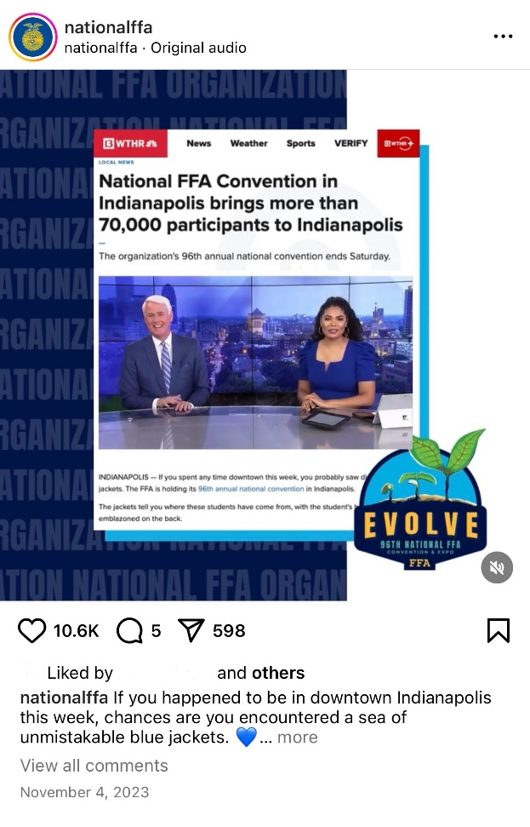

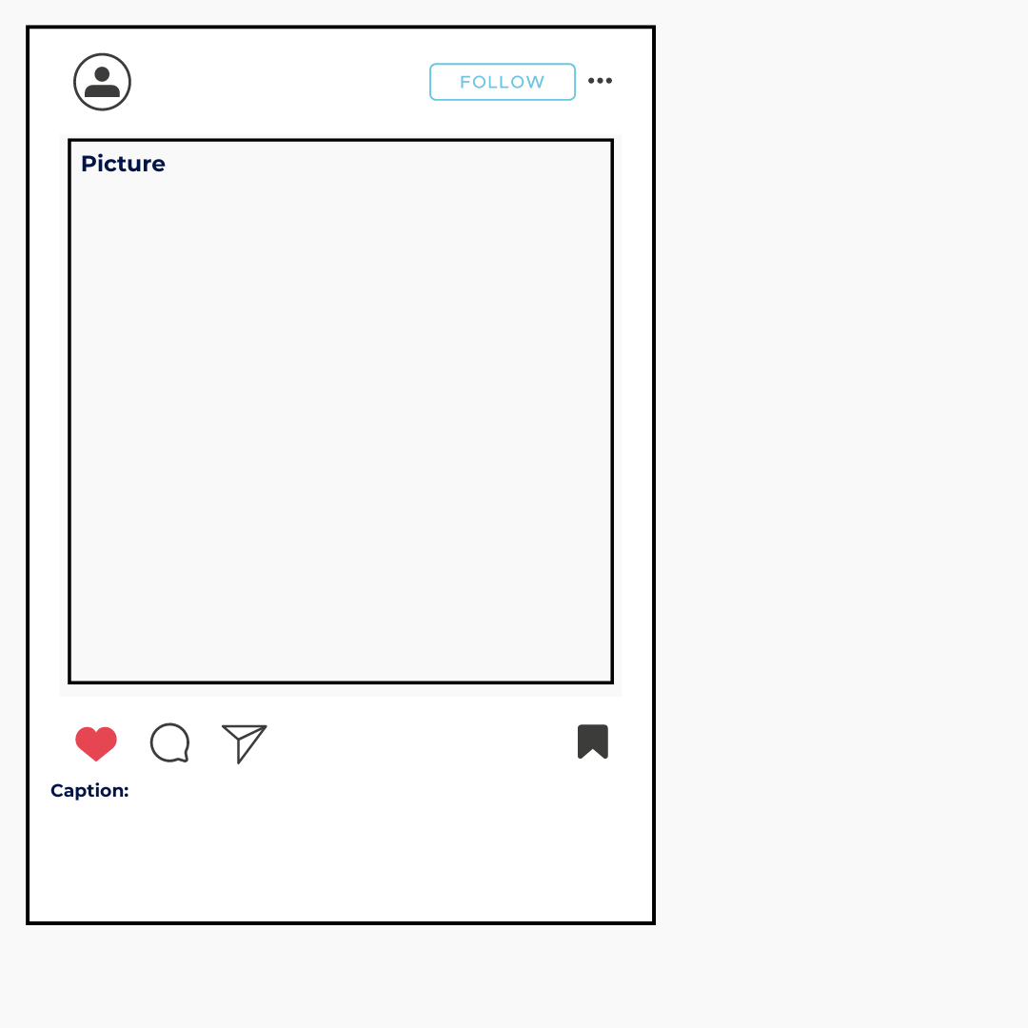

Day 1:

Pre-convention:

Day 2:

Post-convention:
Day 2: [Grab your reader’s attention with a great quote from the document or use this space to emphasize a key point. To place this text box anywhere on the page, just drag it.]

Press Release (For USe Prior to Convention)

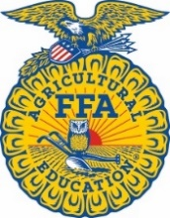
CONTACT
Advisor Name
Advisor Contact Information

Student Leaders Prepare for the 98th National FFA Convention & Expo

INDIANAPOLIS (Monday, Oct.6, 2025/National FFA Organization) — In a few weeks, FFA members and supporters from across the country will celebrate agricultural education and agriculture during the 98th National FFA Convention & Expo, Oct. 29-Nov. 1.
This time-honored tradition will be in person and hosted by the city of Indianapolis.
It’s an opportunity for students to be exposed to new career paths and opportunities while celebrating the accomplishments these future leaders have made over the past year. Throughout the week, students will attend general convention sessions where they will be inspired by their peers and, in the expo, explore various career paths. In addition, attendees can participate in career success tours and student and teacher workshops. Those in attendance can also participate in a service event while FFA members across the country can join the National Days of Service in their local communities.
General convention sessions will be aired live on the FFA Live! streaming broadcast. FFA members and supporters can tune in and watch gavel-to-gavel coverage of the event. To learn more, visit convention.FFA.org.
The National FFA Organization is a school-based national youth leadership development organization of more than 1,027,273 student members as part of 9,235 local FFA chapters in all 50 states, Puerto Rico and the U.S. Virgin Islands.
# # #
About National FFA Organization
The National FFA Organization is a school-based national youth leadership development organization of more than 1,027,273 student members as part of 9,235 local FFA chapters in all 50 states, Puerto Rico and the U.S. Virgin Islands. The FFA mission is to make a positive difference in the lives of students by developing their potential for premier leadership, personal growth and career success through agricultural education. For more, visit the National FFA Organization online at FFA.org and on Facebook, Instagram and LinkedIn.
About National FFA Foundation
The National FFA Foundation builds partnerships with industry, education, government, other foundations and individuals to secure financial resources that recognize FFA member achievements, develop student leaders and support the future of agricultural education. A separately registered nonprofit organization, the foundation is governed by a board of trustees that includes the national FFA president, educators, business leaders and individual donors. For more, visit FFA.org/Give.

Convention Workshops
The 2025 convention workshops will be available during convention in the convention center as well as some pre-recorded workshops from previous years. Each pre-recorded workshop is from a previous national convention and will vary in length from 15 to 30 minutes. All in-person workshops will be one hour in length. To see a full listing of in-person student and teacher workshops, visit the workshops page.
Teacher Workshops: Workshops are designed to be engaging and provide professional development for teachers on various topics to aid in the classroom and FFA chapter. Workshops will be organized by career pathway. Feel free to download the notes sheet for each workshop to help you gather your thoughts in one place.
- Notes Sheet: to help you capture your thoughts during each workshop
Student Workshops: Workshops are designed to be engaging and interactive. They will be organized into the following categories: Advocacy, Service, Careers, Leadership and Social/Emotional Health. Students can use this note sheet to help them reflect on the workshops they choose to attend.
After students have participated in an in-person or virtual workshop, have them develop a mini-workshop or speech about a topic they feel passionate about using the “Develop a Mini-Workshop/Speech” activity sheet and rubric. Students can choose to complete this activity digitally using a resource of your choice.

New this year: There will be new and additional pins offered this year for the pin challenge!

What Workshops Interest Me? Have students read over the workshop titles and descriptions on the convention website and select the top three that seem interesting and inspiring to them. Have students complete the activities on the “Which Workshops Interest Me?” activity sheet.

Student Activity Sheets: Direct access to the individual student activity sheets for easy upload to learning management systems or printing for classwork can be found here.

Collectible Lapel Pins: When students attend a student workshop, they will receive a Gold Star Lapel Pin. This year, students can collect five lapel pins by being involved in convention. See more information here.

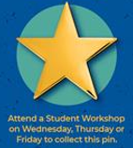

Which Workshops INterest Me?
Directions: Read over the workshop titles and descriptions on the convention website, and select the top three that seem interesting and inspiring to you. Record the workshop titles in the box below. *Note: If attending convention virtually, only select those that are pre-recorded. If you are attending in person, choose from in-person or pre-recorded workshops.
Which workshops interest you?
Record the titles of the workshops that you attended in person AND/OR virtually.
What interests you about your chosen workshops?

Develop a Mini-Workshop
Develop a mini-workshop about a topic you feel passionate about. Use the space below to develop your mini-workshop. (The lines are for what you will say, and the box is what your visual aid will contain/look like. The mini-workshop should take 10 minutes.) Reference the “Rubric: Mini-Workshop” handout for requirements.
What ideas do you have for a title and description for your mini-workshop? (The title should grab people’s attention.)
Key Points: What key points will you include in the mini-workshop?

Introduction: How will you introduce the mini-workshop?

Conclusion: How will you wrap up your mini-workshop?

Rubric: Mini-Workshop
Qualification | Very strong evidence of skill is present.  (5–4 points) | Moderate evidence of skill is present.  (3–2 points) | Weak evidence of skill is present.  (1–0 points) | Total Points  (25 possible)
Engaging Title and Description (Description Refers to Title) | Title and description are engaging and attention grabbing; description refers to title. | Title and description are mediocre; description somewhat refers to title. | Title and description are very weak; description does not refer to title.
Presentation Skills | Thorough and maintains eye contact | Somewhat professional; depends on the presentation | No evidence of preparation
Grammar/Punctuation/  Spelling | Spelling, grammar and punctuation are extremely high quality with two or less errors in the document. | Spelling, grammar and punctuation are adequate with three to five errors in the document. | Spelling, grammar and punctuation are less than adequate with six or more errors in the document.
Time | 10 minutes | Between five and 10 minutes | Under five minutes
Overall Impression | Presentation was consistent and appropriately highlighted a topic of the presenters’ choosing that they feel passionate about. | Presentation was consistent and generally highlighted a topic of the presenters’ choosing that they feel passionate about. | The presentation was not consistent and did not highlight a topic of the presenters’ choosing that they feel passionate about.
 |  |  | Total | /25 points

ExpoSition Hall Highlights
The exposition hall is a space to discover the vast array of individuals involved in the agriculture industry from innovative companies to educational institutions.
- FFA Experience Booth:
  - Students who visit the FFA Experience Booth in the National FFA Expo will have a chance to see the FFA Student Handbook come to life with interactive activities, life-size officer paraphernalia, jacket displays and informational panels just for them! While visiting the booth, complete the FFA Flag activity in the corner of the booth to earn your FFA Flag lapel pin. Also, be sure to grab a Connect Four Challenge card from the information desks. Once the activity is completed, students can redeem it for a one-of-a-kind FFA T-shirt! NEW THIS YEAR – learn how the National Officers are creating an engaging, supportive, growth-focused and welcoming organization, and make your commitment to help. Also, learn more about agriculture careers and famous FFA alumni in our new and improved alumni corner!

- Ed Resources Booth:
  - Teachers who visit the Ed Resources Booth located in “teachers world” will learn more about the free resources the National FFA provides. While visiting the booth, complete the activity to receive a free T-shirt and new teacher’s lapel pin!

- Sustainability Booth:
  - Students who visit the sustainability booth will learn about the different aspects of sustainability through interactive activities. After completing the process, students will receive a lapel pin!

- Alumni and Supporters Booth:
  - Want to know more about FFA Alumni and Supporters? Swing by the booth to receive more information and free professional headshots.

- Living to Serve Booth:
  - Join in on the service project going on during convention expo hours to receive a Living to Serve lapel pin.

- Companies and Organizations:
  - Logo Activity: Have students match company logos to the agricultural pathway they represent. This can be done virtually or in the expo.

  - Get to Know Us: Have students visit a minimum of two companies/organizations per pathway and complete the “Get to Know Agricultural Companies and Organizations” worksheet. Students will need a worksheet for each one they visit. If attending virtually, students will explore company websites.

- NEW! “Where in the Agriscience Fair Research Expo are the National Officers?”
  - This year’s Agriscience Fair Research Expo features a fun, interactive scavenger hunt! Put on your Carmen Sandiego detective hat and find the National Officers hidden among the posters! Discover their involvement in the Agriscience Fair Award program, learn about their research and see how their projects can spark your own ideas. Finish the scavenger hunt for a chance to win!

- Educational Institutions: Have students visit a minimum of three educational institutions either in the expo or online (if attending virtually) and complete the “Educational Institutions” worksheet.

- Student Activity Sheets: Direct access to the individual student activity sheets for easy upload to learning management systems or printing for classwork can be found here.

Logo Activity
Directions: Match the company logo to the agricultural pathway they represent. Cut out the logos below and paste in the provided table. If you don’t have access to a printer, you can click on the logo and cut and paste in the table or write the company names in the table. (Each logo is also linked to the company website if you need more information on the company.)
*Some companies might fit in multiple pathways, so choose the one that fits best.

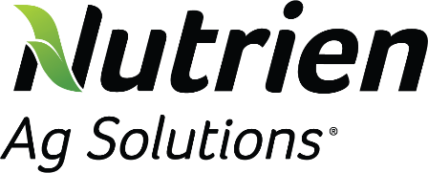
Logos



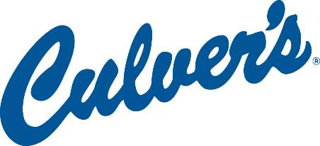

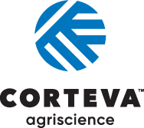













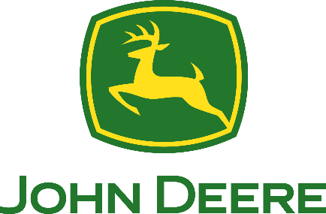
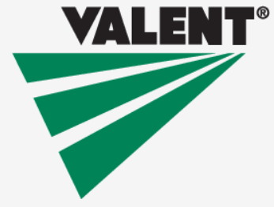
Agribusiness Systems | Animal Systems | Biotechnology Systems | Environmental Service Systems
Food Products and Processing Systems | Natural Resources Systems | Plant Systems | Power, Structural and Technical Systems

AFNR Pathway Explanation
Agribusiness Systems includes companies that connect the business world with agriculture by determining how to effectively use resources for profit and contribute to successful agriculture production. This can include crop production, farm equipment, seed supply, marketing, natural resources and animal services.

Animal Systems includes companies that work directly with animals or work with products that come from animals. Some companies treat diseased or injured animals and work to keep them healthy or study research and genetics, nutrition and the development of the animals they work with. Others develop more efficient ways of producing and processing meat, poultry, eggs and dairy products.

Biotechnology Systems includes companies that use biotechnology to enhance plants, animals and microorganisms and to solve global issues, working to increase the world’s access to safe and affordable food and clean water. These companies often investigate methods of creating fuel from agricultural byproducts and use a range of tools to better understand the basic biology of life.

Environmental Service Systems includes companies that focus on preventing the harmful effects of human activities, and they may be involved with recycling, water and air pollution control, waste disposal and public health issues. These companies use knowledge of science and engineering to meet environmental regulations and develop new methods to prevent accidents or dangerous situations.

Food Products and Processing Systems includes companies that study the physical, biological and chemical makeup of foods to improve food safety, create better processes, enhance the nutritional value and shelf-life of foods and develop new flavors. These companies may focus on diet, health and food safety by ensuring the quality of foods or work to develop new packaging, new products and new sales opportunities.

Natural Resources Systems includes companies that work to develop, maintain and manage natural environments. These companies work to protect wildlife, maintain parks, consult with research groups and keep green areas.

Plant Systems includes companies that study plants and how they impact our world. They monitor the quality and safety of our food and help consumers make sensible nutritional decisions, solve problems by developing crops that are resistant to insects and improve models to grow more food with less space. Others work to conserve our natural resources.

Power, Structural and Technical Systems includes companies that apply knowledge of engineering, hydraulics, pneumatics, electronics, power, structures and controls to the field of agriculture. These companies also create efficient processes to conserve natural resources and build solutions that impact people around the globe.

Get to Know Agricultural Companies and Organizations
Directions: Choose a company or organization featured in the National FFA Expo (look at the floor plan) that you are interested in learning about and complete the questions below.
Pathway:
Company/Organization:

Why did you choose this company?
What does the company do?
What career opportunities are available with the company/organization?

What skills are needed for these careers? (If you need help finding this, utilize AgExplorer.FFA.org.)
How would you describe, in one word, this company/organization to your best friend?

Would you be interested in working for this company? Why or why not?

Directions: Choose a company or organization featured in National FFA Convention Expo that you are interested in learning about and complete the questions below.

Directions: Choose a company or organization featured in the National FFA Expo (look at the floor plan) that you are interested in learning about and complete the questions below.

Company/Organization:

Why did you choose this company?
Pathway:

What career opportunities are available with the company/organization?

What skills are needed for these careers? (If you need help finding this, utilize AgExplorer.FFA.org.)
What does the company do?

How would you describe, in one word, this company/organization to your best friend?

Would you be interested in working for this company? Why or why not?

Directions: Choose a company or organization featured in the National FFA Expo (look at the floor plan) that you are interested in learning about and complete the questions below.
Company/Organization:

Why did you choose this company?
Pathway:

What career opportunities are available with the company/organization?

What skills are needed for these careers? (If you need help finding this, utilize AgExplorer.FFA.org.)
What does the company do?

How would you describe, in one word, this company/organization to your best friend?

Would you be interested in working for this company? Why or why not?

Educational Institutions
Directions: Visit a minimum of three educational institutions in Collegiate Connection and complete the questions below (there is one sheet for each educational institution).

School Name:

Location:
What agriculture majors does the school offer?

Develop two questions to ask the school representative that will help you learn about the school.
1.

2.
Draw a picture of the school’s mascot.
After visiting this school, are you interested in attending? Why or why not?

What is one interesting fact you learned about the school?

Shade in the state where this school is located.

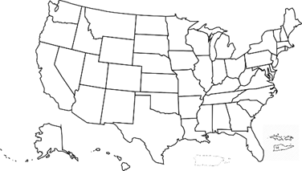


School Name:

Location:
What agriculture majors does the school offer?

Develop two questions to ask the school representative that will help you learn about the school.
1.

2.
Draw a picture of the school’s mascot.
After visiting this school, are you interested in attending? Why or why not?

What is one interesting fact you learned about the school?

Shade in the state where this school is located.


School Name:

Location:
What agriculture majors does the school offer?

Develop two questions to ask the school representative that will help you learn about the school.
1.

2.
Draw a picture of the school’s mascot.
After visiting this school, are you interested in attending? Why or why not?

What is one interesting fact you learned about the school?

Shade in the state where this school is located.

Awards and Recognition
Every year at convention, we recognize students for their hard work and achievements in many programs, including the agriscience fair, agricultural proficiency awards, American FFA Degrees, American Stars, career and leadership development events and the National Chapter Award Program.
- All About Awards and Recognition: Have students use this worksheet to learn about the various opportunities available for student participation. After students have learned about all the areas, they will choose one and create an action plan for future participation.

- Agriscience Fair Expo: Have students use this worksheet to explore the Agriscience Fair Research Exposition and learn more about the opportunities within the agriscience fair. Be sure to complete the scavenger hunt for a chance to win a prize!

- Student Activity Sheets: Direct access to the individual student activity sheets for easy upload to learning management systems or printing for classwork can be found here.

Agriscience Fair Research Exposition
The National Finalists’ research experience will be an in-person, interactive, networking-style exposition where students will interact with researchers, scientists and industry professionals to engage in meaningful dialogue about their projects and be asked questions by individuals with backgrounds and experiences in unique agriscience fields.
Display
All national finalists for the agriscience fair participate in the Agriscience Fair Research Exposition. The purpose of this event is to connect students and their research to industry. The student’s work will be displayed, and the student will be present at an assigned time for the symposium.

Awards and Events Finals
See FFA members in action as they compete for national honors while showcasing the skills they have learned in the areas of agriculture, food and natural resources. Awards and Events Finals presentations are open to all convention and expo participants and guests. Events will also be streamed on FFA Live! streaming broadcast accessed on FFA.org. All events will take place on the first floor of ICC in the five different finals presentation rooms. Check out finals hall here.

Student Showcase Stage
During the 2025 National FFA Convention & Expo, National FFA will feature students and chapters that have excelled in their areas of interest. Students will have the opportunity to present their agriscience fair research and their supervised agricultural experiences. Additionally, look for #SpeakAg Showcase videos and National Chapter and Living to Serve spotlights. FFA talent will also receive time at this location.

all About Awards and Recognition
Part 1: Complete the first two columns in the chart below.
K: What you already know about the award area
W: What you want to know about the award area
L: *Will be completed in Part 4
K | W | L
Agriscience Fair | Agriscience Fair | Agriscience Fair
Agricultural Proficiency | Agricultural Proficiency | Agricultural Proficiency
National Chapter | National Chapter | National Chapter
American FFA Degree | American FFA Degree | American FFA Degree

Part 2: Follow the links below by clicking on the title to learn about each program area and then answer the questions.

Agriscience Fair
Description
Ways to Participate
How could this program area develop your career skills?

Agricultural Proficiency Awards
Description
Ways to Participate
How could this program area develop your career skills?

National Chapter Award
Description
Ways to Participate
How could this program area develop your chapter’s future success?

American FFA Degree
Description
How to Earn
How could this program area develop your career skills?

Part 3: Now that you have learned about each of the program areas, choose one that you want to participate in and develop an action plan using the prompts below.
Program Area:

What interests you about your selected program area?

Goal 1
Steps to Achieve Goal 1
Goal 2
Steps to Achieve Goal 2

Goal 3
Steps to Achieve Goal 3

Part 4: Revisit the KWL chat from Part 1 of this activity. Complete the L (what you learned) column of the chart. Take a second look at the W column and see if you have any lingering questions.

Agriscience FAIR Research exposition

Directions:
View the national finalists research displays in Hall K at national convention. Select one project from each of the six categories to learn more about the research. These links may be helpful: AgExplorer, SAEforAll, and the SAE video library.
Category | Research Topic/Title | Interesting Fact or Statistic | FFA Connection  List an SAE that ties to this project. | Career Connection  List an agriculture career that ties to this project.
Animal Systems
Environmental Services/Natural Resources Systems
Food Products and Processing Systems
Plant Systems
Power, Structural and Technical Systems
Social Systems

*Which category within the agriscience fair are you most interested in? Explain why.

*Which agriscience research project was your favorite? Explain why.


Living to Serve: National Days of Service Resources and Opportunities
Community service is a large part of FFA and is a great way to involve others and call attention to the needs in your own community. Looking for a way to have your chapter members participate in a service project during convention week? The Grants, Scholarships and Service Team has developed a toolkit to aid you in planning a service project during October.
In-Person Service Opportunities: Attendees at the National FFA Convention & Expo have two opportunities to participate in the on-site service project! Learn more here.
Interactive Toolkit for National Days of Service: Click here to access the 2025 interactive toolkit.
How to utilize the interactive toolkit with students: Give the toolkit to your chapter members, divide your students into small groups and task them with creating a service project for October and/or for National FFA Week in February. Then, students can present their service project ideas, and the class/FFA chapter can vote on which one they want to implement. Give students the “Living to Serve: Interactive Toolkit” worksheet to complete.
Show Off Your Chapter’s Service Project!
Has your FFA chapter completed a meaningful service project? Fill out a quick form to tell us about it! Your project could be featured on the FFA website. Don’t miss the chance to share your story and inspire others!
All About Service: Give this worksheet to your students to learn about past National FFA service projects/events. In this activity, students will choose one of the articles (FFA Response to WWII, Food For America, Building Our American Communities [BOAC], FFA Impact on Rural Communities and Seeds of Hope Campaign) available here and complete the worksheet to learn about the FFA history of service.
Living to Serve Day of Service Mini-Grant: Are your students excited about serving during convention or serving in your local community? Your FFA chapter can apply for up to $500, and funds will be reimbursed after impacts are submitted. Need examples? Here are some Living to Serve Day of Service Mini-Grant events that were funded through the grant program.
Plan Ahead for National FFA Week: Get funding to support your FFA week service event. Your chapter can also apply for a Living to Serve Day of Service Mini-Grant for up to $500 to host a day of service during National FFA Week. The application is easy to complete and can be found at FFA.org/LivingtoServe/Grants. In the application, share how your FFA Week service event will meet a need in the community based on the four focus areas.
Student Activity Sheet: Direct access to the individual student activity sheets for easy upload to learning management systems or printing for classwork can be found here.
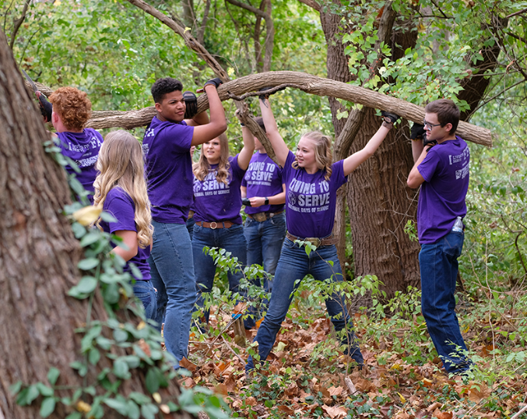

Living to Serve: National Days of Service Resources and Opportunities, Continued
When applying for a Living to Serve Day of Service Mini-Grant, you will need to identify what focus area the service activity falls under. Below are the focus areas that need to be identified when applying for the funds.
 | Community Safety | Addresses concerns regarding the safety of community members and the preparation, response and recovery efforts that relate to emergency preparedness and natural disasters
 | Hunger, Health and Nutrition | Addresses unmet food insecurity needs, increasing physical activity and improving healthy habits to promote physical and mental well-being of the community
 | Community Engagement | Addresses matters related to heritage and traditions, connections between community members and civic responsibility throughout the community
 | Environmental Responsibility | Addresses issues regarding air and water quality, energy and water efficiency, at-risk ecosystems and conservation to protect and sustain the natural systems upon which all life depends

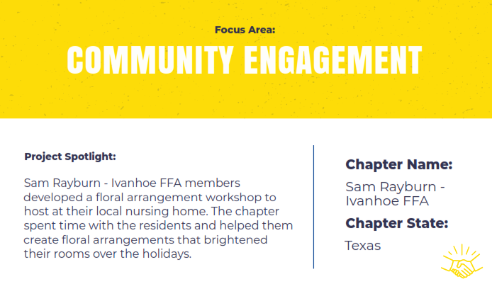
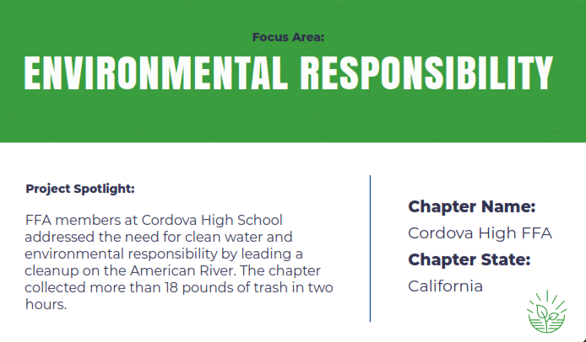
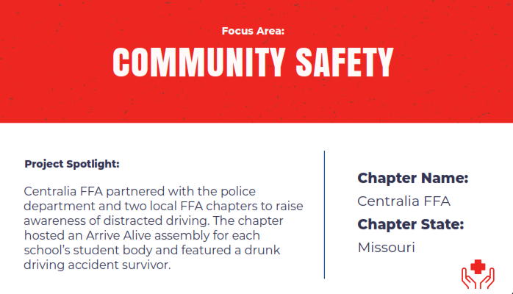
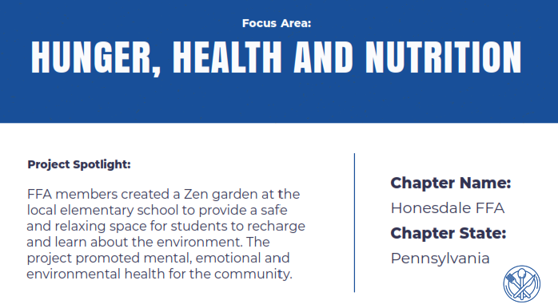
Living to Serve: Day of Service Grant Examples


Living to Serve: Interactive Toolkit

Directions: Reference this interactive toolkit as you complete this worksheet.
- What steps need to be completed to prepare for the service project?
- What are your ideas for a service project for your school and/or community?

What service projects have chapters across the country done in the past? Use this website to aid in your research: FFA.org/livingtoserve/.
Choose one of the service projects you identified above: ________________________

How could that service project be adapted/implemented in your school or community?

All About Service!
Directions: Choose one of the articles available here (FFA Response to WWII, Food For America, Building Our American Communities [BOAC], FFA Impact on Rural Communities and Seeds of Hope Campaign) and answer the questions below to learn about the FFA history of service.
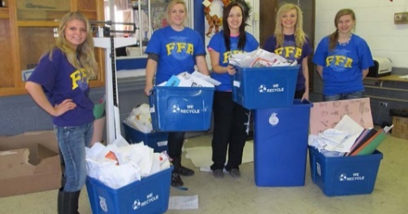
- In the past, what specific service projects/events (or types) do you think FFA has participated in?
- What article did you choose?
- Summarize the article in three to five sentences.
- How can you apply what you have read and learned to your own FFA chapter (or school) and community? What aspects would be the same? What would be different about the service project?
- What does “Living to Serve” mean to you?

FFA Alumni and Supporters
How to Get Involved
Tips and Tricks for Involvement: Engage with FFA Alumni and Supporters during the National FFA Convention & Expo. If you are hosting watch parties, you could invite local FFA Alumni and Supporters to watch with you or send them the link to register.
Don’t have an FFA Alumni and Supporters chapter? Check out information and resources on how to get one started today.
Convention Workshops Available
**Note: All FFA Alumni and Supporters workshops will be in-person only.

Alumni and Supporters Convention Workshops: See online pdf version here.

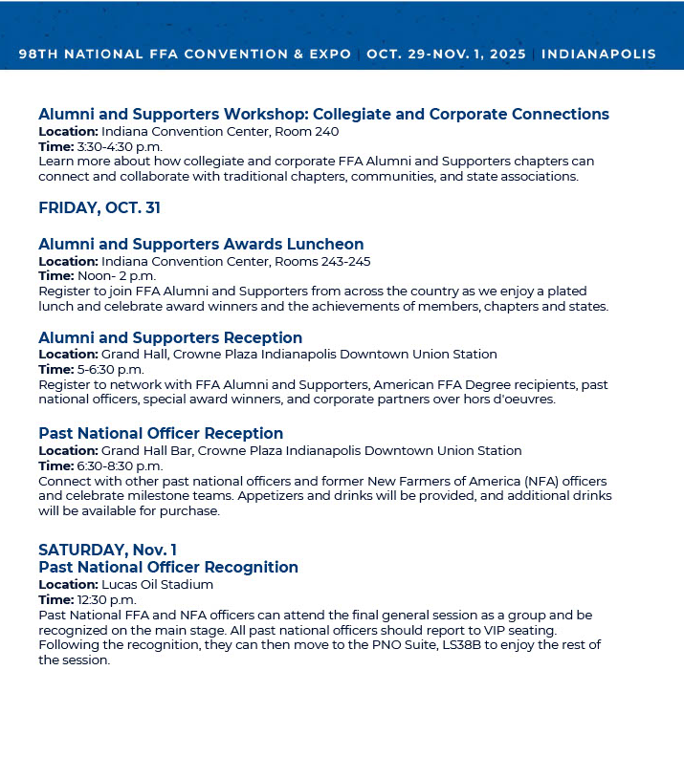
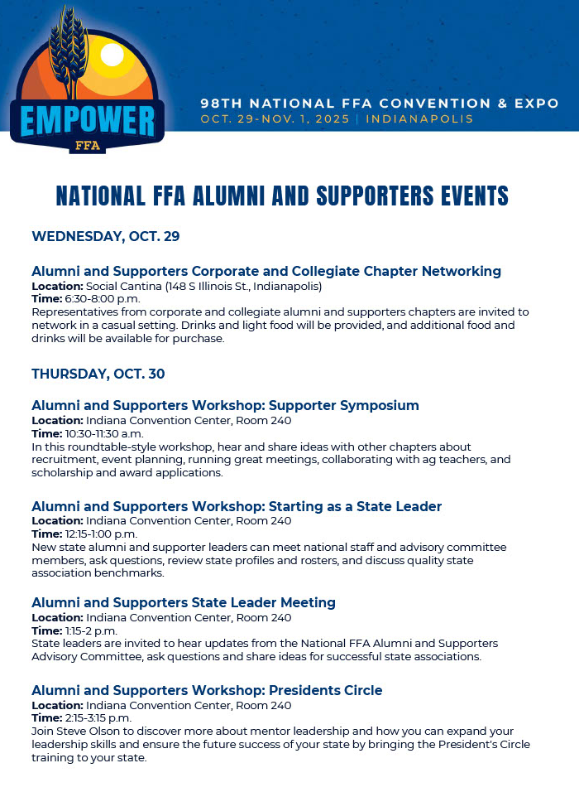

For More Information
Want to know more about FFA Alumni and Supporters?
Learn more about the various roles as an FFA Alumni and Supporter by watching this short video.
- Have students complete the “National FFA Alumni and Supporters” worksheet.
- Additionally, learn about life membership by watching this video.

Student Activity Sheets: Direct access to the individual student activity sheets for easy upload to learning management systems or printing for classwork can be found here.
Forever Blue Network
Encourage your students to join the Forever Blue Network (currently only seniors or graduates are approved to join). The Forever Blue Network gives FFA members, alumni and supporters the opportunity to come together no matter where they are. Click here to watch a video about why students should join. Click here to join the Forever Blue Network.
Forever Blue Network WebQuest: The Forever Blue Network is an opportunity for networking and professional and personal development. Using this WebQuest, enroll and engage juniors and seniors in the Forever Blue Network. Click here for the WebQuest worksheet. The PDF version can be found here.

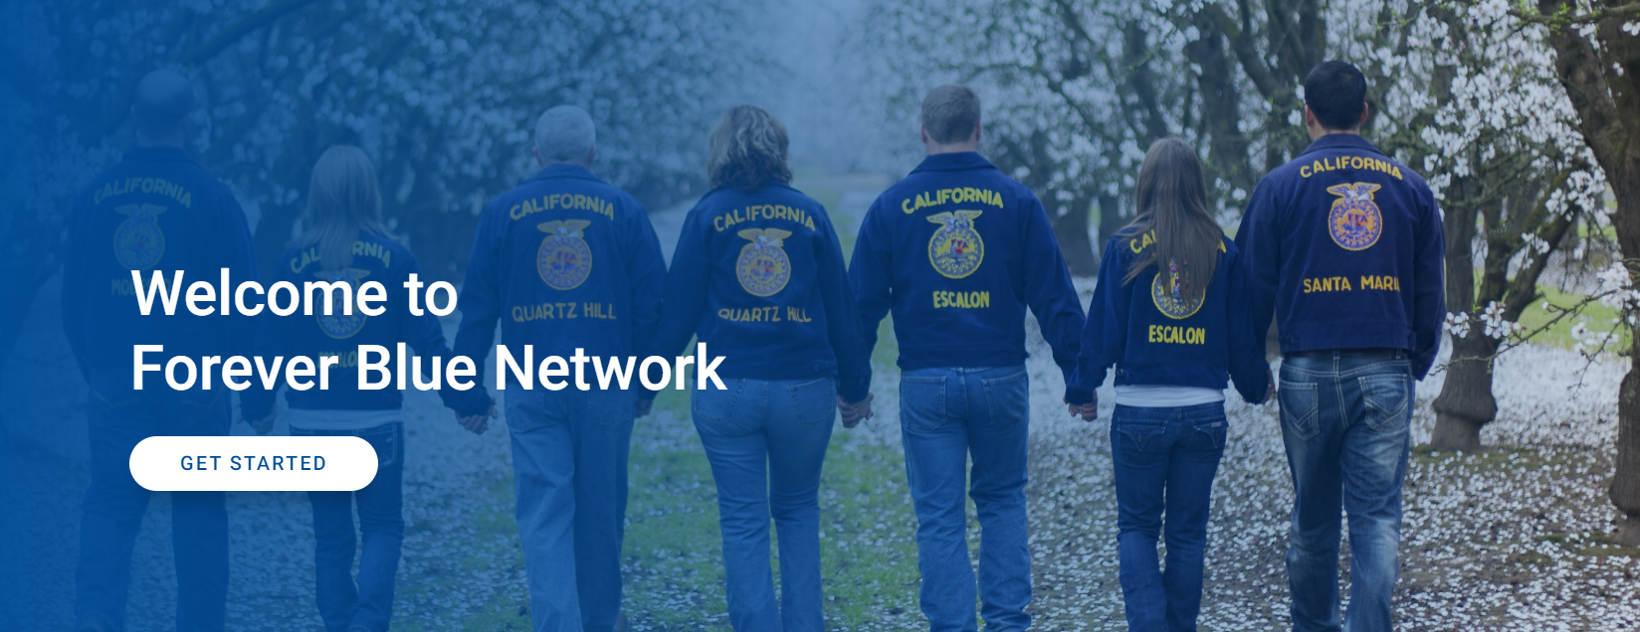
National FFA Alumni and Supporters
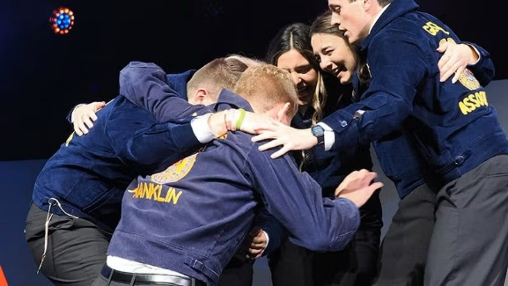
Directions: Watch the video about the various roles of FFA Alumni and Supporters and answer the questions below. The video can be found at https://FFA.box.com/s/ij0u32qbtrvzjwr5t2tu2qtrkifgpmd8.
- Based on the video linked above, what are the various roles of FFA Alumni and Supporters?

- What do you think it means to be an alumni and supporter?

2. What are the different types of alumni and supporter grants? FFA.org/alumni-and-supporters/chapter-opportunities/
- Does your chapter have an alumni and supporters group? If yes, explain how the group supports your agricultural education program/FFA chapter. If no, are their other support/booster groups in your school? How do they provide additional support to their programs?

- What are ways you can stay connected to your agricultural education program/FFA chapter after graduation?

KEY: National FFA Alumni and Supporters
Directions: Watch the video about the various roles of FFA Alumni and Supporters and answer the questions below. The video can be found at https://FFA.box.com/s/ij0u32qbtrvzjwr5t2tu2qtrkifgpmd8.
- Based on the video linked above, what are the various roles of FFA Alumni and Supporters?
Volunteer, advocate, mentor, fan, donor
- What do you think it means to be an alumni and supporter?
Answers will vary.
2. What are the different types of alumni and supporter grants? FFA.org/alumni-and-supporters/chapter-opportunities/
Nutrien Ag Solutions, Legacy
- Does your chapter have an alumni and supporters group? If yes, explain how the group supports your agricultural education program/FFA chapter. If no, are their other support/booster groups in your school? How do they provide additional support to their programs?
Answers will vary.
- What are ways you can stay connected to your agricultural education program/FFA chapter after graduation?
Answers will vary but may include volunteering with your local agricultural education program/FFA chapter and joining your local FFA Alumni and Supporters chapter.

NFA 90th Celebration Activity
Directions:
It’s your turn to research and commit to preserving the history of NFA by recognizing its historical significance. Use the following link to access a full collection of digitized archives created by students and faculty at North Carolina Agricultural and Technical State University: https://digital.library.ncat.edu/nfa/. You will create a poster or flyer around the prompts below using the link provided. For the poster or flyer, you will need an additional sheet of paper. You can find the answers by exploring the documents, photos and records in the archives. Once you have completed your poster, answer the reflection questions at the end.
Find a document that references the year the NFA was founded.

What year was it established, and where was the first meeting held?
Find a photo in the archives that stands out to you.

Describe the photo and its historical significance.

Locate a document or photo that displays the NFA emblem.

How does the emblem reflect the values and mission of the organization?
Find a document highlighting a major event in NFA history.

Summarize the event in two or three sentences.
Identify a specific chapter or school featured in the archives.

Share one interesting fact or accomplishment about this chapter.
Find a document or article referencing the merger of the NFA and FFA.

What year did the merger happen, and why was it significant?
Find a document highlighting a major event in NFA history.

Summarize the event in two or three sentences.
Identify at least one key leader in the NFA mentioned in the archives.

What role did the person serve, and what is that person’s legacy?

Find a letter that was exchanged between two people.

Share the contents of the letter and its historical significance.
- What did you learn about the history of the NFA and its significance within agricultural education?

- What steps can your chapter take to ensure you are preserving the history of your chapter?
Other Activities
- FFA Experience Jeopardy! Game: Interactive Jeopardy! game that allows students to test their FFA knowledge with categories like FFA History, FFA Meeting Room, FFA Creed, FFA Jackets and Pins, Women in FFA and Famous Alumni.
FFA Experience Jeopardy! Game
Answer Key
- Get to Know the 2025-26 National Officer Team: Every year during the final general session, the new National FFA Officer Team is elected. Use this activity sheet to capture information about the new team.
- Making Meaningful Connections: Everyone loves to meet new people and make connections during national convention. Here is an activity to do in person using this activity sheet to record those you meet along your convention journey.
Student Activity Sheets: Direct access to the individual student activity sheets for easy upload to learning management systems or printing for classwork can be found here.

Get to KNow the 2025-26 National FFA Officers
Directions: Once the new officer team is announced on Nov. 1, research and fill out the information below.
 SENTINEL

Name:

Region: State:
 REPORTER

Name:

Region: State:
 TREASURER

Name:

Region: State:
VICE PRESIDENT

Name:

Region: State:
SECRETARY

Name:

Region: State:
 PRESIDENT

Name:

Region: State:

MAking Meaningful COnnections
Directions: Utilize the various opportunities to meet in person to make meaningful connections with your fellow FFA members. Or if you are not at convention, watch the #SpeakAg State Showcase videos.
As you meet FFA members during convention, collect the following information and record it on the respective state’s space. If attending convention virtually, check out the videos in the #SpeakAg State Showcase found on the convention website to learn about products grown in each state. These videos will be student made!
- Name
- Chapter
- State Product

Alabama ______________________
Alaska ________________________
Arizona _______________________
Arkansas _______________________
California ______________________
Colorado ______________________
Connecticut ____________________
Delaware ______________________
Florida _______________________
Georgia ______________________
Hawaii _______________________
Idaho ________________________
Illinois _______________________
Indiana ______________________
Iowa ________________________
Kansas _______________________
Kentucky _____________________
Louisiana _____________________
Maine _______________________
Maryland _____________________
Massachusetts _________________
Michigan _____________________
Minnesota ____________________
Mississippi ____________________
Missouri ______________________
Montana _____________________
Nebraska _____________________
Nevada ______________________
New Hampshire ________________
New Jersey ___________________
New Mexico ___________________
New York _____________________
North Carolina _________________
North Dakota __________________
Ohio ________________________
Oklahoma ____________________
Oregon ______________________
Pennsylvania __________________
Puerto Rico ___________________
Rhode Island __________________
South Carolina __________________
South Dakota ___________________
Tennessee _____________________
Texas _________________________
Utah _________________________
Vermont ______________________
Virginia _______________________
Virgin Islands ___________________
Washington _______________________
West Virginia _______________________
Wisconsin _____________________
Wyoming _____________________

Post-Convention Thoughts and Reflections
Now that convention is over, it is important to reflect on your experiences and determine how you can apply what you have learned to your life.
- FFA T-shirt Design: Have students be creative and design a convention T-shirt. You can have class competitions or a chapter competition, and if funds allow, create the shirt and sell the winning design. (Word, PDF)
- FFA New Horizons Magazine Cover: Have students utilize the cover template (Word, PDF) to design and create their very own FFA New Horizons magazine cover based on their convention experiences.

- Post-Convention Reflection: Give students this worksheet (Word, PDF) to collect their thoughts and feelings about their convention experiences.

- Student Activity Sheets: Direct access to the individual student activity sheets for easy upload to learning management systems or printing for classwork can be found here.

Relive the action on FFA Live! streaming broadcast on FFA.org and through the 2025 Proceedings, which will be updated on FFA.org as events happen at convention starting this year. You can watch the general sessions, news segments, the awards, Finals Presentations — everything that is recorded. And of course, you can check out the FFA Video Center to find on-demand videos.

FFA T-Shirt Design

Directions: Use this template to sketch design ideas for a custom shirt based on your National FFA Convention & Expo experience!

FRONT
BACK

Create your own FFA New Horizons magazine cover
Utilize the magazine cover template (Word, PDF) to design and create your very own FFA New Horizons magazine cover to represent and summarize your convention experience. If you want to design your cover digitally, you can use the PosterMyWall website.
Items to include in your design:
- Picture
- Three or four story titles (like in example covers below)
- Design should be colorful. Be creative!
Examples of past covers:
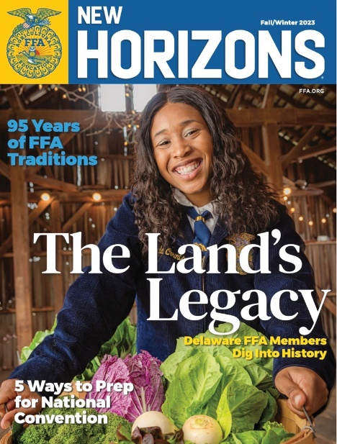
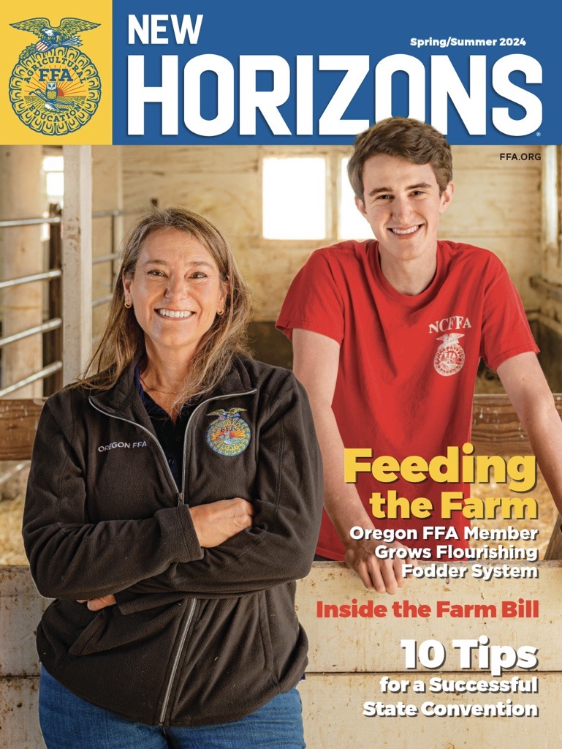
After you design your cover, answer these questions to reflect.
How will this convention experience influence some of your future behaviors and decisions?
Explain why you chose the stories and images you did.
Looking back at your completed magazine cover, which activity that you experienced during convention was your most enjoyable and why?

Post-Convention Reflection
Directions: Reflect on your experiences during the 98th National FFA Convention & Expo by completing the activities below.
- Five-minute free write: Use the space below to share your thoughts and feelings about your convention experience.

- Choose one word that represents your convention experience and create an acrostic poem using your chosen word.
Example:
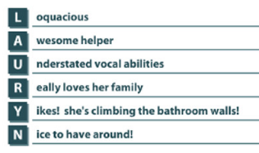

- What is one thing from your convention experience that you can apply in your personal life and in school?
School
Personal

- What was your most interesting discovery during this experience?

