A History of
Parliamentary Procedure
and the
Future Farmers of America

January 2024

Dr. James J. Connors
Associate Dean


A History of Parliamentary Procedure
and the Future Farmers of America

Dr. James J. Connors

Introduction

The use of parliamentary procedure in agricultural education and the Future Farmers of America goes back to the very beginning of formal instruction in agriculture. Even before the FFA was founded in 1928, agricultural education students were being taught the principles of parliamentary procedure in agricultural education classes. Teaching of parliamentary procedure was already being conducted in 1906 at the New York State school of agriculture located at the St. Lawrence University at Canton. The two-year vocational course in agriculture included instruction in parliamentary law (Stimson and Lathrop,1942).

Parliamentary procedure played a vital role from the very beginning of the Future Farmers of America. Delegates who attended the first National Agricultural Education Congress in Kansas City, Missouri used parliamentary procedure to reach key decisions which would forever affect agricultural education and the FFA organization (Future Farmers of America, 1956a; Teeney,1977).

Along with a copy of the FFA Manual, newly elected national FFA officers were provided with
copies of Howe's Handbook of Parliamentary Usage immediately after taking office (National FFA Organization, 1932).
The minutes of the November 1932 FFA Advisory Committee explicitly stated that "The new national officers should start immediately to study parliamentary procedure and continue this study throughout the year in order to be ready to handle the Sixth National Convention (National FFA Organization, 1932).

As the young organization grew, parliamentary procedure started to play an increasingly important role. During the eighth National FFA Convention in 1935, the Plain Dealing FFA chapter from Louisiana presented a demonstration parliamentary procedure contest to the delegates (Future Farmers of America, 1935). The proceedings of the convention state,

Considerable interest was shown in two new F.F.A. events added this year - the demonstration extemporaneous public speaking contest and the demonstration parliamentary procedure contest which was conducted by a champion team of the Plain Dealing, Louisiana Chapter of F.F.A...Members of the Plain Dealing group paid their own way to Kansas City in order to give the group present the benefit of their experience. They were accompanied by their local adviser and Superintendent of Schools. The names of those participating are as follows: (p.42)

Parliamentary Procedure
Vance Corbin
J.D. Griggs
Travis McClellan
Roy Hillburn
Paris Nugent
Paul Robert

At the 9th National FFA Convention, the delegates had parliamentary procedure on their minds. Delegate Annis of Idaho moved that Henry Groseclose be designated as the National Parliamentarian for the FFA organization. The motion was adopted.
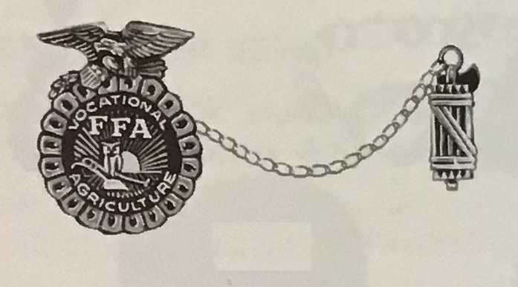

FFA Parliamentarian Officer Pin with faces – symbol of parliamentary authority
An article in the History of Agricultural Education of Less Than College Grade in the United States (Stimson and Lathrop,1942) also discussed the Plain Dealing parliamentary demonstration team when it was written:

Each year since 1934-35 the parliamentary procedure contest for F.F.A. members has been held in Louisiana. All members of the Louisiana association participate in this contest. Parliamentary procedure is another way of aiding in the development of competent and aggressive rural leadership. Knowledge of parliamentary procedure is needed by everyone. Besides its common use in all types of meetings, it teaches organization, cooperation, discipline, quick thinking, and good citizenship. The Plain Dealing chapter demonstrated parliamentary procedure activities at the National FFA. Convention in Kansas City in 1936 under the direction of Mr. Robinson, vocational agriculture teacher at the time. p. 166).

Another reference to parliamentary procedure contests was contained in a document titled Interpretations of Minimum Qualification Requirements for the American Farmer Degree (National Advisory Council, l941). This document stated that "a candidate must show outstanding ability in leadership and cooperation." It stated that a candidate for the American Farmer Degree would not have shown outstanding ability in leadership unless he "has participated in and been declared a first place individual or member of a winning team in some local county, district, area, or State contest that is recognized as a bona fide vocational agriculture contest such as public speaking, parliamentary procedure..." (p. 5). This reference to the qualifications for the American Farmer degree show that even though there was no national interest for parliamentary procedure, it had definitely become an important component of local agricultural education programs and FFA chapters.

Parliamentary Procedure Competitive Events

Numerous pieces of evidence exist to show the prevalence of parliamentary procedure instruction, demonstrations and contests through the years. A reference to a state parliamentary procedure contest is found in Agricultural Education magazine from 1937, when FFA was only nine years old. In an article titled Point of Order, Edwards wrote,

“Parliamentary procedure. Could anything sound more dull? That is what you think. But wait until I tell you about fifty farm boys from high schools in eastern Oregon, engaged in the first state contest in parliamentary procedure held in the United States” (p. 16).

The article claims that the first FFA contest in parliamentary procedure ever held was organized by Oregon agriculture teachers at Enterprise, Halfway, Imbler, Ontario, Pendleton, Union, and Walla Walla. The Oregon FFA adopted the event as a state contest in 1936. The author wrote that:

As the boys talked, I thought, “Why here” – the conviction came suddenly to me – “here are the leaders of tomorrow in the making. That boy would make an officer for his Grange, even a state master, this boy a county official; that one a member of his fair board or his country commission; school boards, leaders in civic and rural enterprise, representatives to the state legislature, Farm boys all – boys who feed pigs and milk cows and have chores to do, and know the way to lead their problems thru [sic] the mazes of legislative organization from the Grange to the United State [sic] Senate.

Robinson (1944) and Stewart (1951) reported the existence of a Chapter Procedure Contest in Ohio sponsored by the Townsend Agricultural Education Society at Ohio State University. Stewart reported the results of a study he conducted with boys who had participated on Chapter Procedure Teams. The study asked the boys to rate eight benefits as either a l-superior benefit, 2-average benefit, or 3-minor benefit of participation. The item rated as a superior benefit most often was "The ability to participate correctly in business meetings."

In 1945, Robert Zinn described the relationship between parliamentary procedure and the FFA when he wrote:

Before the time that F.F.A. chapters started their systematic study of the Rules of Order, very little, if any, serious instruction was given to young people in parliamentary law...What can be done to give our F.F.A. members greater opportunity to develop adequate parliamentary ability? It seems to me that one of the most worthwhile means to this end is the use of parliamentary procedure contests. (p. 1l6).

Over the years, parliamentary procedure continued to be an important component of local, state and national FFA activities. During the decades between 1940 and 1970 state FFA associations increased their emphasis on parliamentary procedure by starting statewide parliamentary procedure contests (Graham and Strubinger,1940; Lofton, 1948; McMillen, 1948; Kelly, 1948).

These contests often required chapters to win preliminary contests at the district, area, or regional level to win the right to represent their geographical area in state competition. These statewide parliamentary procedure contests usually differed widely between states with no common rules or procedures.

An agricultural teacher from Dadeville, Missouri wrote "My favorite method of developing leadership in vocational agricultural students is through teaching parliamentary procedure" (Hankins, 1952, p.132). He went on to report the success of his parliamentary procedure teams by writing "Our teams' winning in five consecutive contests include one State championship, one first in the district, five firsts in the sub-district, third two times in the district and second two times in the district. The district represents more than 60 schools" (p. 136).

Ziegler (1955) wrote in The Agricultural Education Magazine, "FFA parliamentary training is providing that step in many communities in Washington today. Future Farmers are putting on parliamentary drills or demonstrations for keenly interested members of Granges, Farm Bureaus, P.T.A., and other groups" (p. 134). Ziegler estimated that most of the 143 chapters in Washington state entered preliminary contests at the district, sub-state and final state championship events. He stated that "scattered contests have been held throughout the State for many years but it was only nine years ago that they were started on a statewide basis" (p. 134).

The Proceedings of the 28th National Convention - October l0-13, 1955 (Future Farmers of America, 1955) under the Program of Activities section on leadership addressed the importance of parliamentary procedure for local FFA chapters. The national organization outlined the importance of local chapters including parliamentary procedure in their local programs of activities. Figure 1 shows the goal of conducting chapter meetings according to parliamentary procedure and suggested ways and means of reaching that goal for local FFA chapters.

4. Parliamentary  Procedure | Goals | Ways & Means
4. Parliamentary  Procedure | Conduct meetings  according to parliamentary  procedure | A. Provide parliamentary training.  B. Enter parliamentary procedure contest  C. Provide each member with a booklet  on parliamentary procedure  D. Elect a chapter parliamentarian

Figure l. Suggested local chapter program of activities - 1955.

Additional evidence of the importance of parliamentary procedure can be found in the Proceedings of the 29th National Convention held on October 15-18, 1956 (Future Farmers of America, 1956b). In a report of local activities, it was stated that 8,365 local FFA chapters were using an accepted form of parliamentary procedure in conducting their chapter meetings.

In 1957, Cornell reported the existence of a Chapter Meeting Contest in New York state. Cornell wrote, "I refer especially to the Chapter Meeting Contest as an opportunity for every Chapter member to participate in one of the outstanding leadership training activities of the FFA" (p. 181) and "The correct use of parliamentary procedure and the skill displayed in handling these items of business is decisive in the outcome of the Contest" (p. 182).

Ernest Muncrief, an agriculture teacher from Marlow, Oklahoma, saw the benefits of FFA members learning parliamentary procedure. Muncrief (1959) stated, "...the most important item in connection with the study of parliamentary practices comes in the improvement of the local chapter meetings" (P. 206).

Another research study on parliamentary procedure was conducted by Cardozier in 1964. Cardozier wrote that "A study conducted several years ago by this writer, raised serious doubt as to the values being generated in vocational agriculture pupils by the study of parliamentary procedure" (p. 88). Cardozier wrote "Few would question the fact that former FFA members usually know parliamentary procedure better than most other members of groups. Through the use of their knowledge of parliamentary procedure, they are often virtually able to control meetings" (p. 55). However, based on his research he concluded that "there were no significant differences in attitudes toward democracy between pupils who had studied parliamentary procedure in vocational agriculture and an equal group of pupils in each of eight schools who had not studied parliamentary procedure" (p. 88).

Calls for a National Parliamentary Procedure Contest

Interest in a national FFA parliamentary procedure contest started less than 10 years after the Future Farmers of American was established in 1928. In 1935, the delegates at the National FFA Convention heard a report of the Committee on Extemporaneous Speaking and Parliamentary Procedure contests presented by Dobson, a delegate from Idaho. After some discussion, the recommendation of the committee was rejected. Although during the discussion, it was apparent that the sentiment of the delegates was to establish a parliamentary procedure contest. Delegate Fisher of Kansas then moved that this matter be left to the Board of Trustees, which was adopted. (Future Farmers of America, 1935, p. 13)

At the 1936 National FFA Convention, the same issue was on the agenda as unfinished business. Delegate Malouf of Utah requested that the report of the Extemporaneous Speaking and Parliamentary Procedure Contests be read to the assembly. However, the report was not ready to be read. Subsequently, delegate Hagman of Kentucky urged that such contests be held next year [1937] in connection with the national convention. The minutes read, “In the discussion which followed, it was pointed out that, although such events were splendid devices for teaching members to think on their feet, attention might be diverted from the regular Public Speaking Contest.” Ironically, it was then moved by delegate Poucher of Florida, seconded, and carried that the entire matter be tabled for the present. Which according to Robert’s Rules of Order Newly Revised is out of order unless there is more urgent business to be taken up.

A proposal to create a national parliamentary procedure contest was first discussed at the 8th National FFA Convention in 1935. The proceedings of the convention state that,

The report of the Committee on Extemporaneous Speaking and Parliamentary Procedure contests presented by Dobson of Idaho was rejected after some discussion. Sentiment, however, apparently favored the parliamentary procedure demonstration. Fisher of Kansas then moved and the motion was seconded and passed that this matter be left to the Board of Trustees.

At the April 1936 National FFA Board of Trustees meeting a “Motion was made, seconded and carried that the matter of continuing the Parliamentary Procedure Contests at the national conventions should be tabled until next fall.” It is not clear why these minutes state “…continuing the Parliamentary Procedure Contests…” because there is no record that a national contest had been held in the past.

Another parliamentary procedure issue not related to establishing a contest was also discussed at the 1936 convention. It was moved by delegate Annis of Idaho, that Henry Groseclose be designated as national parliamentarian for he FFA organization. The motion was adopted. Henry Groseclose, commonly known as the “Father of FFA” was therefore the first official national FFA parliamentarian.

The delegates to national convention continued to propose a national contest in parliamentary procedure. In 1949, “Howard of North Carolina moved that the National Advisory Council and Board of Trustees take under consideration the possibility of having a parliamentary procedure contest on a national basis and give a report at the 1950 convention favorable or unfavorable for the approval of the delegates; motion seconded by Meron of Massachusetts and carried.”

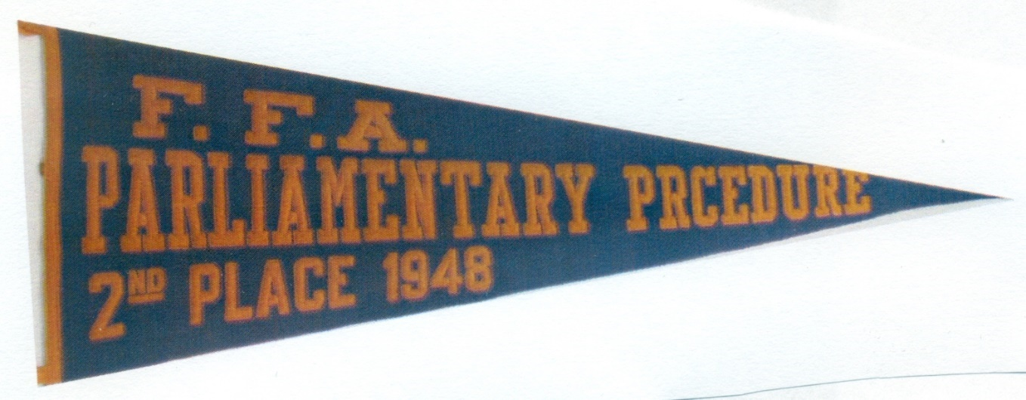

At the 1957 National FFA Convention, the delegates discussed the issue of a national parliamentary procedure contest. The minutes read:

Nels Smith presented the report of the Program of Work Committee and moved its adoption; motion seconded by Thoren of Wyoming. Jim Sinclair of North Carolina moved to amend the report and add “that the National Board of Directors and National Board of Student Officers consider the advisability of raising the parliamentary procedure contest to the national level.” Bob Helms of Alabama seconded the motion. After considerable discussion the motion as amended carried.”

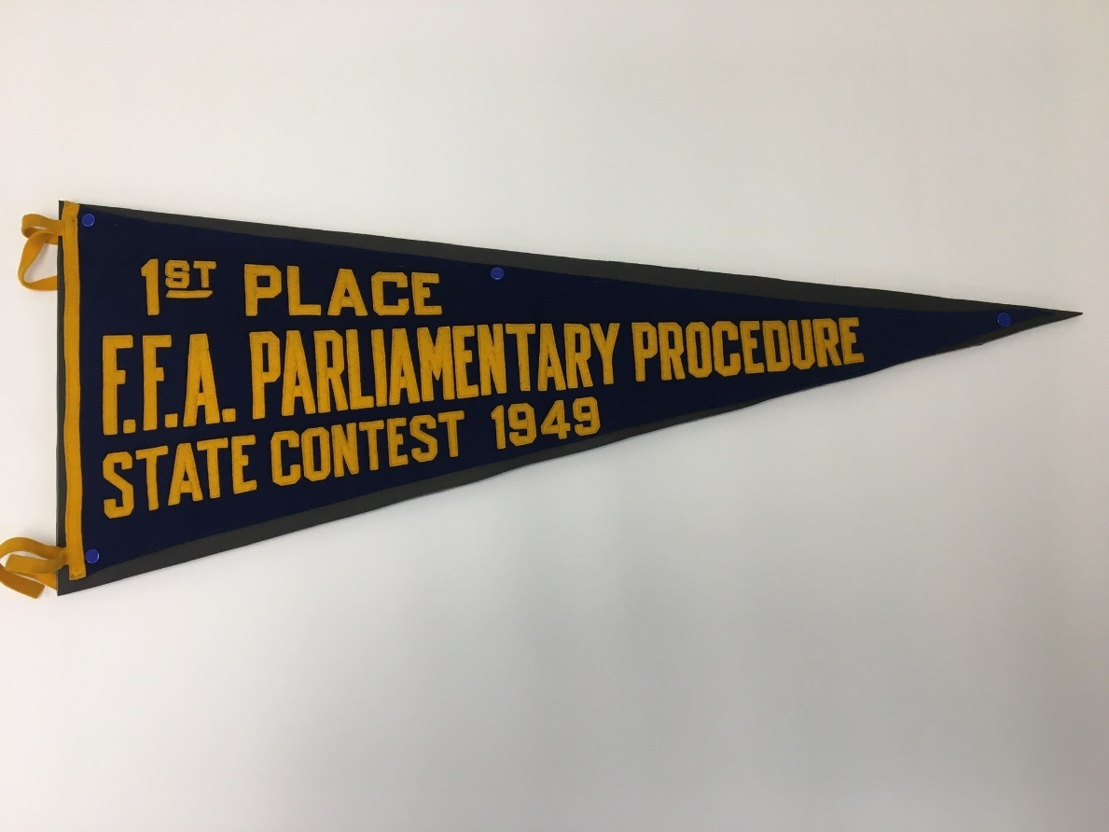

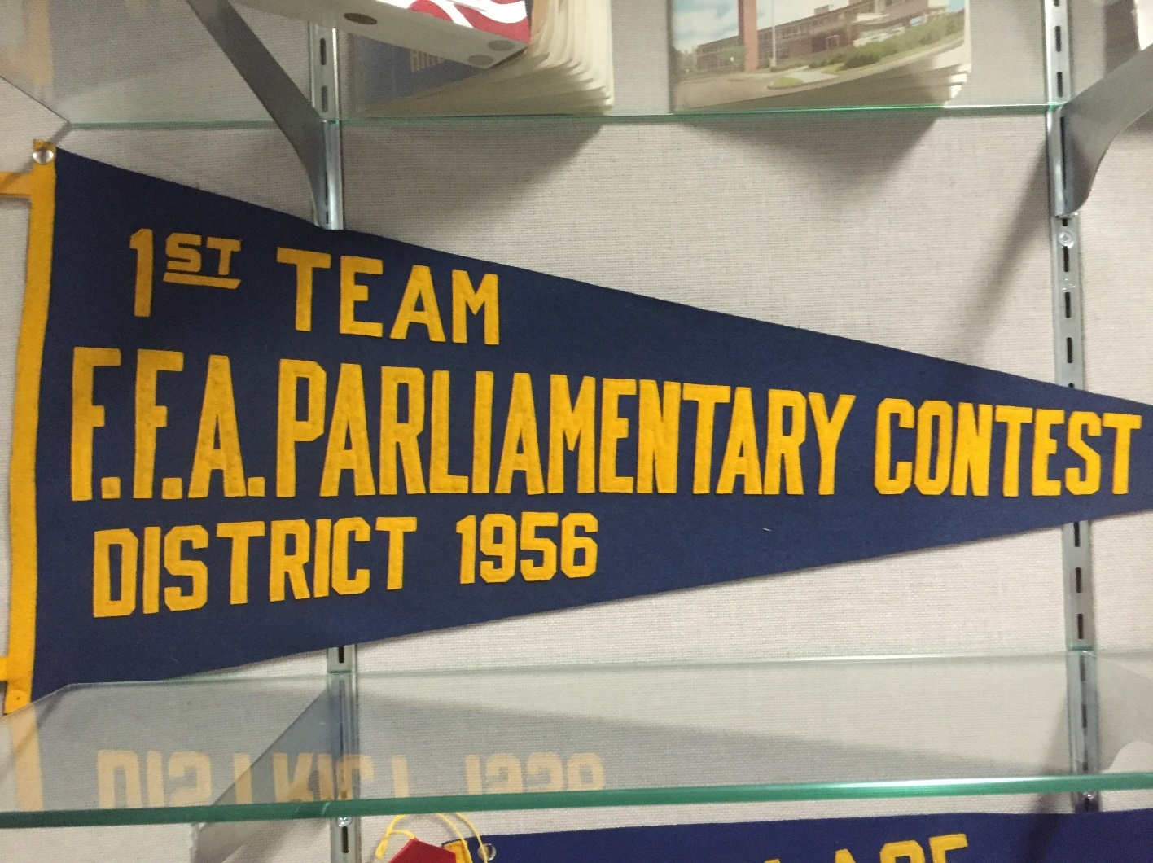

While no national parliamentary procedure contest was started, chapters continued to present parliamentary procedure demonstrations at national convention. The Palatka FFA chapter from Florida gave a demonstration on parliamentary procedure at the 1960 National FFA Convention.

At the 1972 National FFA Convention the Convention Committee recommended that a professional parliamentarian be secured for the business session. This is a practice National FFA has followed ever since. The Convention Committee also recommended at the National Center provide a copy of Robert’s Rules of Order for each state delegation. It is not known if this recommendation was followed or for how long.

The issue of starting a national parliamentary procedure would come up again in 1973. Delegate Dan Sample of Idaho moved that a special committee be appointed by the Boards of National FFA Officers and Directors to check the feasibility of having a Parliamentary Procedure Contest on the national level, hopefully starting in 1974. The motion was seconded by delegate Johnson of Idaho and carried. At the same convention, the National Contests committee recommended that the possibility of a national parliamentary procedure contest be considered. The very same recommendation was proposed by the same National Contests committee the next year, at the 1975 national convention.

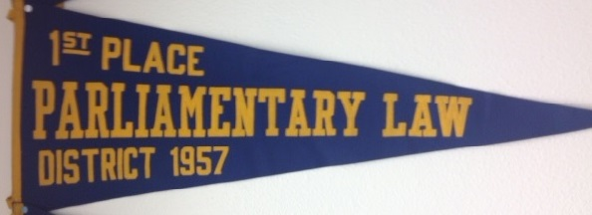

National Parliamentary Law Contest - Carthage, Missouri

As membership in the Future Farmers of America reached its peak in the late 1970s, there was a new call for a parliamentary procedure contest on the national level. It was at this time that Jim Honey and Jerry Crownover, agriculture teachers at Carthage, Missouri, and their FFA members saw a need for a national parliamentary procedure event. The Carthage FFA chapter had won the Missouri state FFA parliamentary procedure contest but did not have a national contest in which to participate.

In an article in The Agricultural Education Magazine (Crownover, 1980) wrote, “The study and practice of parliamentary procedure is another way that leadership abilities can be developed. The Carthage FFA Chapter in Southwest Missouri has started something that may give rise to a new area of national-level participation - an Invitational National Parliamentary Procedure Contest (p. 23).

In the fall of 1978, the Carthage FFA chapter established the National Parliamentary Law Contest. The contest was an invitational event where the state winning parliamentary procedure teams from across the country were invited to participate. The first contest included six teams.

A unique feature of the contest was the logistics. The event was held immediately prior to the National FFA Convention in Kansas City, MO. Carthage, MO is just 120 miles south of Kansas City. The event was held over two days. The first day included the written exam and tours of local agribusinesses and the event banquet. The second day includes the demonstration portion of the event and the awards lunch. After lunch chapters departed for the short drive to Kansas City for the National FFA Convention. Crownover explained the situation when he wrote,

“Visiting team members stay as guests in the homes of Carthage FFA members and all participants are treated to an excellent banquet and program courtesy of Midcontinent Farmers Association” (p. 23).

The Carthage event averaged 20 teams per year (National FFA, l99la). During the 13 years between 1978 and 1990, 1,348 FFA members from 194 chapters in 34 states participated in the Parliamentary Law Contest and were guests of the Carthage FFA.

Appendix C contains the program from the 14th Annual National Parliamentary Law Contest held November 11 & 12, 1991 in Carthage, MO. These historical documents were provided by Justin Heupel, agriculture teacher at Flathead FFA Chapter in Kalispell, Montana. In 1991, Justin was a member of the Culbertson FFA chapter from Montana that participated in the event.
The event was sponsored by the following organizations:

Carthage FFA Chapter
Carthage FFA Alumni Association
National Council for Farmer Cooperatives - Washington, DC

The two photographs below are from the 3rd annual contest in the fall of 1980 (Their Own Contest, 1981). Table 1 lists the winning teams from the 14 years the National Parliamentary Law Contest was held in Carthage, MO.

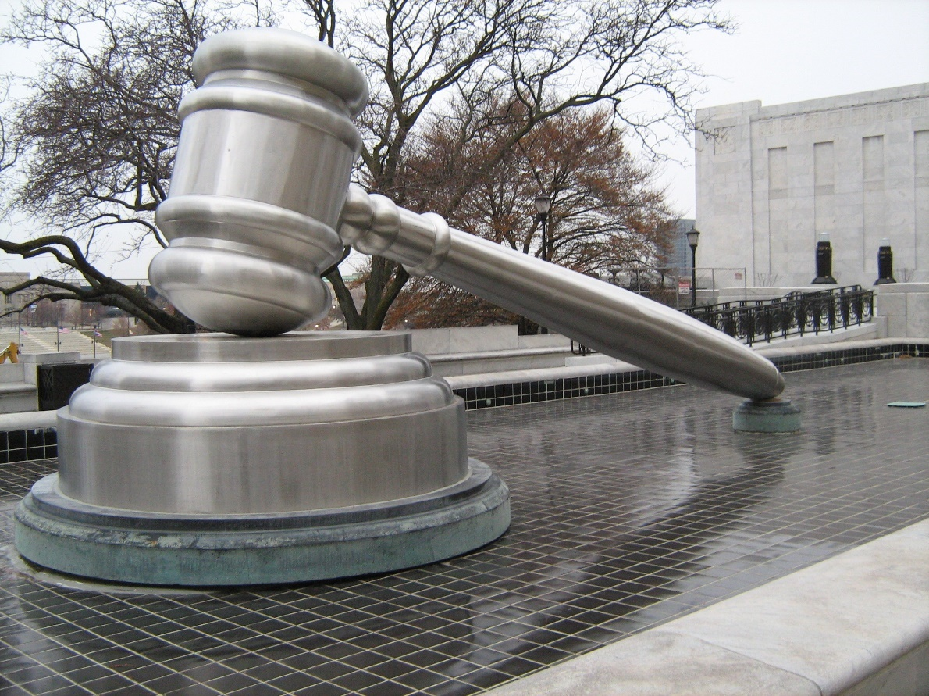
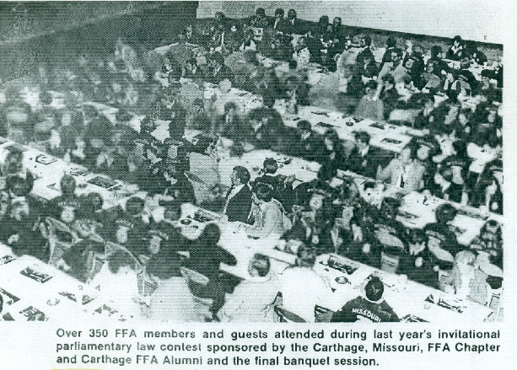
Table 1
Ohio State Supreme Court Building – Columbus, OH

National Parliamentary Law Contest Results (1978-1991)

Year | Chapter | State | Placing
1978 | Carthage  Indian Village  Hill City | Missouri  Ohio  Kansas | 1st  2nd  3rd
1979 | Colton  Mansfield  Waverly | Washington  Missouri  Nebraska | 1st  2nd  3rd
1980 | Ozark  Mariner | Missouri  Washington | 1st  3rd
1981 | Mariner  Plant City  Waverly | Washington  Florida  Nebraska | 1st  2nd  3rd
1982 | Bradley | Tennessee | 1st
1983 | Cresent City  Katy  Aimsworth | Florida  Texas  Nebraska | 1st  2nd  3rd
1984 | Waverly  Carthage  Marbury | Nebraska  Missouri  Tennessee | 1st  2nd  3rd
1985 | Stockton  Liberty - Spangle  Blounstown | Missouri  Washington  Florida | 1st  2nd  3rd
1986 | Whitehouse  Gainsville  Leigh | Tennessee  Missouri  Nebraska | 1st  2nd  3rd
1987 | Liberty - Spangle  Gainsville  Chipley | Washington  Missouri  Florida | 1st  2nd  3rd
1988 | Robert E. Lee - Baytown  Gainsville  Ritzville | Texas  Missouri  Washington | 1st  2nd  3rd
1989 | Centre  Halls  Lehi | Kansas  Tennessee  Utah | 1st  2nd  3rd
1990 | Carthage | Missouri | 1st
1991 | Mossyrock  Stephenson  Troy | Washington  Michigan  Idaho | 1st  2nd  3rd

National FFA Parliamentary Procedure Contest Proposed

At the July 1979 Board of Directors Meeting (Future Farmers of America, 1979) the Connecticut Association recommended that:

The Board of Directors and National Officers accept the Connecticut Amendment to the Constitution pertaining to adding the Parliamentarian under Article XI, Sections A and B, and also a change pertaining to the Parliamentarian in the Opening and Closing Ceremony; and that these items be presented to the delegates at the 52nd National FFA Convention.

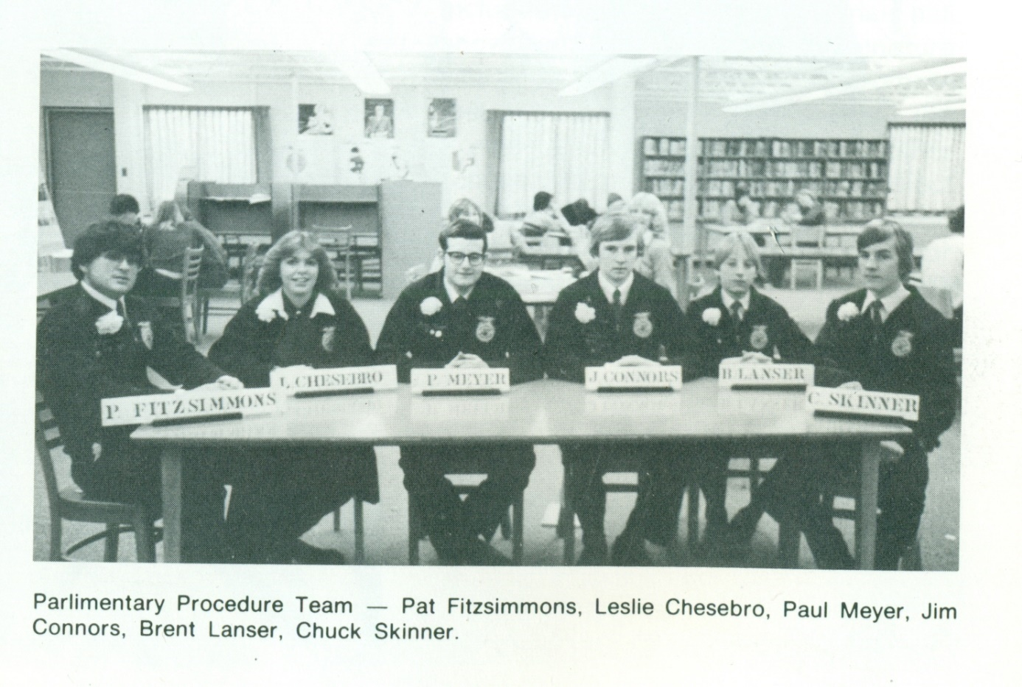
This constitutional amendment was eventually defeated by the delegate body at the November 1979 National FFA Convention (Future Farmers of America,1979). However, at that very same convention the delegate committee on contests drafted a recommendation that a committee be implemented for the purpose of investigating the feasibility and acceptance of a national parliamentary procedure contest. The committee stated that the rationale for a national contest was that parliamentary procedure is a basic fundamental skill of our organization and thus we need to propagate the skills and to provide state winners the chance to continue on to a higher objective.

Caledonia FFA Chapter (Michigan) Parliamentary Procedure Team (1979)

Only two months later, the National FFA Board of Directors would reach a decision that would have a significant effect on parliamentary procedure on the national level. The Board of Directors discussed a National Parliamentary Procedure Contest Proposal. The minutes of the January 1980 Board of Directors meeting state, "It was recommended to the Board of Directors that only those contests listed in Bulletin #4 and held at the National Convention be recognized as an Official National FFA Contest. This is to be communicated to all states by the National Advisor" (Future Farmers of America, 1980). This recommendation, as approved, was probably initiated as a result of the Carthage FFA Chapter in Carthage, Missouri starting its Parliamentary Law Contest and their desire to see a national FFA contest in parliamentary procedure.

At the 1981 National FFA Convention the National Contests committee once again recommended that the National Board of Directors develop a special committee to study the feasibility of developing a National Parliamentary Procedure Contest using the same rationale that the committee had suggested in their 1979 recommendation. At the same convention, the National Program of Activities committee approved a similar recommendation that advised the Board of Directors to look into having national parliamentary procedure contest and greenhand creed contest for ninth and tenth graders.

In l982, the National FFA once again addressed the issue of holding a national FFA parliamentary procedure contest. At its January 1982 meeting, the Board of Directors recommended that "the National FFA Advisor appoint a committee to study the feasibility of the implementation of a National Parliamentary Procedure and Forestry Contest" (Future Farmers of America, 1982). The committee did in fact report back to the board with a recommendation to start a forestry contest. However, the report to the board did not include any reference to, nor a recommendation suggesting, a national parliamentary procedure contest be established.

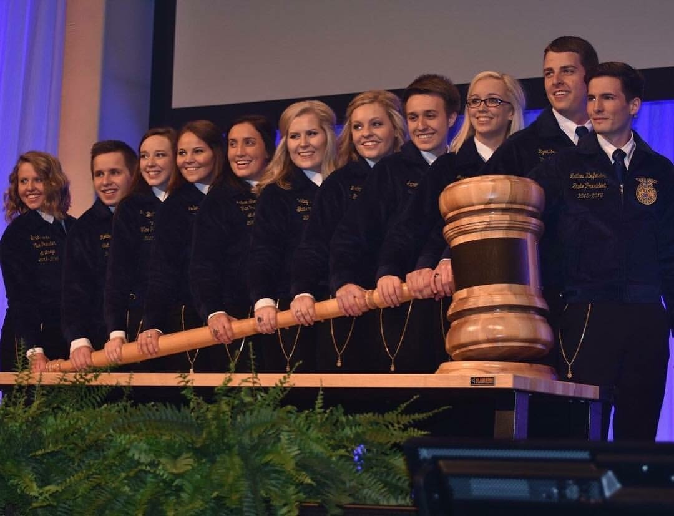

There did seem to be a growing desire for a national contest to teach parliamentary procedure skills. At the November 1983 Board of Directors meeting held just prior to the National FFA Convention the topic of a national contest was addressed once again (Future Farmers of America,
1983). In their final report to the Board of Directors, the 1982-83 National FFA Officers suggested that the Board, "strongly look at the implementation of a group of contests that develop competencies and proficiencies in the areas of parliamentary procedure, dairy and poultry'' (p.2)

Over the course of the next year, the National Vocational Agriculture Teachers Association (NVATA) got involved in the debate. At the FFA Board of Directors meeting in January 1985, NVATA President Thompson reviewed items of concern that were discussed at the NVATA meeting in December 1984 in New Orleans, Louisiana. Mr. Thompson's report stated that "the National FFA Board be made aware of the NVATA's continuing support of a National Parliamentary Contest" (Future Farmers of America, 1985). Mr. Thompson went on to state that there was an NVATA committee working on this that will meet in the spring [1985].

As a probable result of these initiatives, as well as the 1982 call for a committee to study the feasibility of a national contest, a task force was finally appointed in 1985. A National FFA Parliamentary Procedure Study Committee met in Kansas City, Missouri, July 2-3,1985 (Future Farmers of America, 1985). The committee included the following representatives:

Table 2

National FFA Parliamentary Procedure Study Committee Members

Name | Position | State
Paul M. Day  Mike Banett  Jim Honey  Clarence Pearson  Marion D. Fletcher  Joe Raunikar  Lee A. Traver  W. Schuh  Paul Vaughn | Chair  FFA Vice President  Vo-Ag Teacher  Vo-Ag Teacher  Assistant Supervisor  New York Education Dept.  NVATA President  AATEA President | Minnesota  Carthage, MO  Oakville, WA  Arkansas  Stillwater, OK  New York  Bow, WA  Las Cruces, NM

Prior to the study committee meeting, a nationwide survey on the need for a national parliamentary procedure contest was sent to all State FFA Advisors and Executive Secretaries. The study committee reviewed responses to a survey from 36 states. The reasons for, and against, a national parliamentary procedure contest were identified as follows:
Reasons for a National Parliamentary Procedure Contest (PRO)

- Provide an opportunity for more FFA members to be involved in the National
Convention.
- Provide additional recognition for state associations, local chapters and individual members.

- Promote uniformity in state contests.

- Serve as motivation for increased chapter participation in Parliamentary Procedure activities.

- Increase incentive for individuals (students) to learn Parliamentary Procedure.

- One of the leadership areas that can be taught on a nationwide basis in all option areas.

- Enhance the image of and generate increased support of Vo Ag/FFA from non-Agricultural and Agricultural publics because of the member's knowledge of Parliamentary Procedure.

Reasons Against a National Parliamentary Procedure Activity (CON)

- Adequate proficiency in Parliamentary Procedure can be developed at the state level.
- Parliamentary Procedure Contests above the state level would become more theatrical or canned.
- Increased pressure on states to participate because there is a National Contest (activity).
- Additional costs incurred by state associations, chapters, and individuals participating in a national activity.
- Loss of instructional contact time for students competing above the state level.

When asked if they support the addition of a National FFA Parliamentary Procedure Contest the
respondents were evenly split, l8 responded "yes," and responded "no." Some of the
comments written by respondents included:

“I am opposed to proliferating national contests - this activity is not closely related to the idea of integral to instruction.”

“Parliamentary Procedure has been an integral part of vo-ag curriculum and an outlet for recognition should be provided above the state level.”

“The contest is a natural outgrowth of the instructional process in Missouri...The concept that knowledge and use of parliamentary procedure is a life long skill is supported and noted frequently by business, industry, and alumni.”

“I see no educational benefit in a parliamentary procedure contest beyond the state level.”

“The educational value of contests past the district, sectional and state level is minimal.”

“This is an integral part of the instructional program and an important phase of leadership training in our state.”

As a result of the survey, the study committee, by a 6-2 vote, approved the following
recommendations for the National FFA Board of Directors:

- Establishment of a National FFA Recognition Program for voluntary use at the state level. The activity should include:

  - Emphasis in the National Chapter Award Program; and

  - Appropriate Recognition (certificate, trophy, plaque) for State Contest winners.

- Not to establish a National FFA Parliamentary Procedure Contest.

- A National Activity/Contest in Parliamentary Procedure should be included in the National Program of Activities, of the National FFA Organization for the use of Human and Financial Resources.

In addition, the committee unanimously recommends that the Board of Directors:

- Include Vocational Agriculture instructors in future surveys and Base Data Collection Activities, and

- Commend the Carthage FFA Chapter, its advisors, members and the Alumni affiliate for initiating and sponsoring a National Parliamentary Law Contest and urge the Chapter to continue this invitational activity.

The study and recommendations were discussed by the Board. Walt Schuh, President, NVATA, pointed out that the NVATA passed a resolution in support of a National FFA Parliamentary Procedure Contest.

It was moved by Mike Barrett (Mr. Paxton), seconded by Nanci Mason (Mr. Traver) and carried to commend the Carthage, Missouri FFA Chapter, its advisors, members and FFA Alumni affiliate for initiating and sponsoring a National Parliamentary Law Contest and urge the chapter to continue this invitational activity.

The issue of a national parliamentary procedure contest resurfaced at the July 1987 FFA Board of Directors Meeting. During the meeting, “Mr. Reese next asked permission of the Board for the Alumni Council to conduct inquiry into the feasibility of the Council managing a national invitational parliamentary procedure contest when the Carthage, Missouri, sponsors choose to stop featuring this event (which he understood would be this year). Considerable discussion ensued” (Future Farmers of America, 1987).

It was moved by Jayme Feary, seconded by Jones Loflin that the National Board of Directors go on record to congratulate the FFA Alumni for showing interest in conducting an independent invitational national Parliamentary Procedure Contest not at all included and associated with the National FFA Organization's contests and awards programs. However the motion failed (Future Farmers of America, 1987).

In November 1989, the National Organization Development Committee at national convention reported that, “We recommend exploring the possibility of creating a national interest in the following areas through the initiation of national contests in those areas: 1. Parliamentary procedure.”

During the July 1990 Board of Directors meeting it was "moved by Brad Lewis (Dr. Heiman), seconded by Dan Schroer (Dr. Coffey) and carried the [sic] we determine the eligibility for establishing a National Parliamentary Procedure Law contest as part of GOAL 3 in the National FFA Organization's Tactical Plan" (National FFA Organízation,1990)

During the same board meeting it was moved by Scott Crouch (Mr. Michael), seconded by Brad Lewis (Dr. Heiman) and carried that each year the Board of National FFA Officers select one official parliamentarian along with two consultants for the business sessions of the National FFA Convention. These individuals are subject to the approval of the National FFA Executive Secretary (National FFA Organization, 1990). Mr. Jim Honey served in this capacity for several years. This practice is continued to this day. The National FFA contracts the services of a professional parliamentarian to serve as a consultant to the National FFA President during delegate business sessions at each national FFA convention.

At both the 1989 and 1990 National FFA Conventions the National Contests committee weighted in on the issue. Both years the committee approved the recommendation that:

We strongly recommend that a national parliamentary procedure contest be developed to increase the proper use of parliamentary procedure, which is extremely important to efficient communication and decision making. The criteria for establishing new national contests include a requirement that at least 50 percent of the states participate. Currently more than 90 percent of the states conduct a parliamentary procedure contest.

National FFA Parliamentary Procedure Contest Approved

After many decades of discussing and studying the issue of a national FFA parliamentary procedure contest, the FFA Board of Directors took action in 1991. During their January 1991 board meeting the following motions were presented for deliberation. The records provide no evidence of the order in which these motions were presented. It appears that the motion to refer the main motion to the Contest and Awards Committee failed and the main motion was amended to add clarification language. (National FFA Organizatíon,1991b)

It was moved by Julie Classen (Dr. Coffey), seconded by Matt Lohr (Mr. McClimon) and carried that a national taskforce of National FFA Officers, NVATA, AAAE, or NASAE members be established to develop the objectives, skills, competencies and format for a National FFA Parliamentary Law Contest. This taskforce is to report back to the Contest and Awards Committee at the July 1991 Board of Directors Meeting.

It was further moved by Julie Classen, seconded by Matt Lohr to refer the above motion to the Contest and Awards Committee for consideration at a later time.

It was moved by Matt Lohr and seconded by Lesa Ann King that a National Taskforce of qualified individuals whom are either NVATA, AAAE, or NASAE members from the four FFA regions meet to establish objectives, skills, competencies and format to implement a National FFA Parliamentary Law Contest and to request funding from the National FFA Foundation Special Committees Budget Function Code 498 for the taskforce and request the foundation to seek industry support.

Finally, a motion introduced by National FFA Officer Danny Grellner proposed creating a National FFA Parliamentary Law contest. The board minutes read, "It was moved by Danny Grellner (Dr. Heiman), seconded by Ben Nessmith (Mr. Muller) and carried to establish a National FFA Parliamentary Law contest" (National FFA Organization, l99lc).

The National FFA Parliamentary Procedure Task Force reported back to the board at their June 1991 meeting. The minutes report that, "It was moved by Danny Grellner (Jamie Cano), seconded by Matt Lohr (Everett Harris) and carried to change the name of the National FFA Parliamentary Law Contest to National FFA Parliamentary Procedure Contest as recommended by the National FFA Parliamentary Procedure Task Force" (National FFA Organization, l99lc)

It was also moved at the same meeting to request funding for the contest and make minor changes to the contest rules. The minutes state, "It was moved by Julie Classen and seconded by Danny Grellner to approve the implementation plans for the National Parliamentary Procedure Contest and request special project funding through the National FFA Foundation with the following amendments" (National FFA Organization, 1991c). One of the changes was to adopt Robert's Rules of Order Newly Revised as the recommended reference for the contest.

Another motion was introduced that proposed funding the 1991 pilot test for the contest. The minutes of the June 1991 board meeting read "It was moved by Lesa Ann King and seconded by Matt Lohr to request funding of up to $2,500 to assist in the operation of the 1991 field test of the National FFA Parliamentary Procedure contest format as proposed to the Board of Directors and for travel for four members of the National Parliamentary Procedure Taskforce to participate as officials. The funds would come from the Special Committees Foundation budget" (National FFA Organization, 1991c).

It appears the main motion was amended to delete the words "and for travel for four members of the National Parliamentary Procedure Task Force to participate as officials." The minutes then read that it was, "moved by Danny Grellner (Dewey Stewart), seconded by Lesa Ann King (Les Thompson) and carried to amend the above motion to read as follows: To request funding of up to $2,500 to assist in the operation of the l99l field test of the National FFA Parliamentary Procedure contest format as proposed to the Board of Directors. The funds would come from the Special Committees Foundation budget" (National FFA Organization, 1991c).

After the field test of the National FFA Parliamentary Procedure Contest in 1991 the official event started at the 1992 National FFA Convention in Kansas City, Missouri. During the first event, teams were give three possible discussion topics. The topics for the first event were:

Regional realignment
National award selection
A name change for the organization

The winner was announced at the Friday night session of the convention. After Ritzville FFA chapter was announced as the winner of the first national contest, they presented a demonstration on stage for the convention audience.

The National FFA eventually changed the name of competitive events from “contests” to “career development events.”

At the National FFA Convention in 2003, the Issue Committee: Expansion and Diversification of Career Development Events took a look at the parliamentary procedure CDE. One of the committee’s recommendations included “Expanding Parliamentary Procedure to include Opening Ceremonies.” Apparently, national FFA never took any action on this recommendation because the rules of the CDE were not changed to add opening and closing ceremonies.

During national FFA’s rules revision process in 2015, competitive events were divided into Career Development Events (CDE) and Leadership Development Events (LDE). The parliamentary procedure event changed its name again to become a leadership development event.

From 1992 to present, the National FFA Parliamentary Procedure event continued to grow in size and stature. The event annually attracts between 43 and 45 state-winning parliamentary procedure teams consisting of roughly 270 FFA members. In total numbers of FFA members, advisors, judges, officials, and volunteers the National FFA Parliamentary Procedure CDE is the largest competitive event held during the annual national FFA convention.

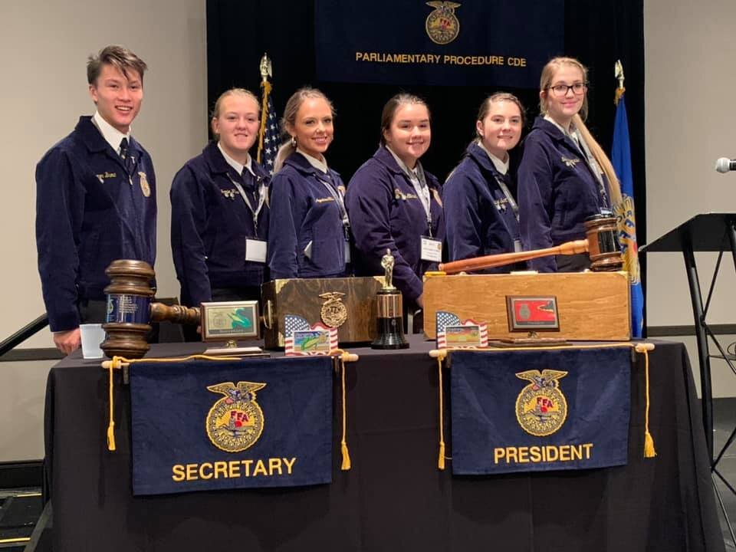
National FFA Parliamentary Procedure Event Officials

Mr. Jim Honey, agriculture teacher from Carthage, Missouri and Dr. Jerry Crownover, teacher educator, from Southwest Missouri State University served as the Superintendents for the national contest from its inception in 1992 to 1996. Many agricultural education professionals have volunteered their time and energy to make the event a success over the years. Individuals have served as Superintendent, Associate Superintendent, Committee Members, Judges, Timekeepers, Doorkeepers, etc. College students from Southwest Missouri State University (SMSU), Missouri State University (MSU), the University of Idaho, and Pennsylvania State University have all helped to run the event over the years. Table 3 contains a list of event officials.

Table 3

National FFA Parliamentary Procedure CDE Officials

Name | State | Title | Years of Service
Mr. Jim Honey | Missouri | Superintendent | 1992-2000
Dr. Jerry Crownover | Missouri | Assistant Superintendent | 1992-1997
Dr. Dan Kercher | Missouri | Senior Judge | 1992-2018
Dr. James Connors | Ohio & Idaho | Assistant Superintendent  Superintendent | 1997-1999  2000-2016
Mr. Roger Wolf | Missouri | Assistant Superintendent | 2001-2005
Dr. Roger Hanshaw | West Virginia | Senior Judge | 2005-present
Dr. Daniel Foster | Pennsylvania | Assistant Superintendent  Superintendent | 2009-2014  2016-2021
Will Fett | Oregon | Superintendent | 2021-present

National FFA Constitution - Parliamentary Authority

The strong relationship of the National FFA Organization with parliamentary procedure continues to this day. Even though the FFA is 75 years old, its Constitution has never contained a reference to which parliamentary authority the organization uses for conducting official business during board of directors meetings or delegate sessions at the annual national FFA convention

In December 2001, Dr. Connors proposed a Constitutional amendment to the National FFA Board of Directors Constitution and Bylaws committee (see Appendix A). The proposed amendment reads:
The rules contained in the current edition of Robert's Rules of Order Newly Revised shall govern the National FFA Organization in all cases to which they are applicable and in which they are not inconsistent with this constitution and bylaws, any special rules of order the National FFA Organization may adopt, and any statutes applicable to this organization that do not authorize the provisions of this constitution and bylaws to take precedence.

The amendment was supported by the Constitution and Bylaws committee and approved by the National FFA Board of Directors at its January 1992 meetíng (National FFA Organization, 1992). In a letter dated February 26,2002, Dr. Larry Case, National FFA Advisor, submitted the proposed amendment to all state associations (See Appendix B). The delegates at the 2002 National FFA Convention passed the proposed constitutional amendment unanimously to include the new article in the National FFA Constitution.

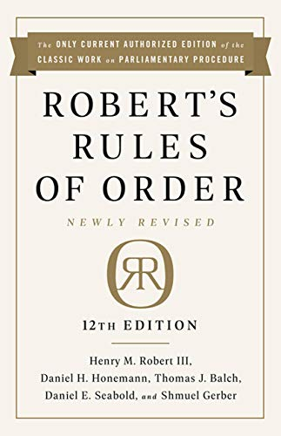

During the 2003 National FFA Convention the Issue Committee: Expansion and Diversification of Career Development Events recommended that the Parliamentary Procedure CDE should be expanded to include Opening Ceremonies. This was probably a result of many state-level parliamentary procedure events including opening and closing ceremonies. This recommendation was never implemented and opening and closing ceremonies were never included in the parliamentary procedure CDE.

Novice Parliamentary Procedure Events

For many years, numerous state FFA associations had been offering novice parliamentary procedure events for 7th, 8th, and 9th grade FFA members. These novice events introduced FFA members to the official FFA meeting ceremonies and introductory parliamentary procedure skills. In 2008, the National FFA organized a 7th-9th Grade Member Opportunities Task Force. The Task Force met on September 26-27, 2008 in Indianapolis, IN. The Task Force included two subcommittees: Parliamentary Conduct of Meetings and Agriculture Quiz Bowl. The Parliamentary Conduct of Meetings Sub-Committee was made up of the following individuals

The task force proposed the establishment of a Parliamentary Conduct of Meetings event for 7th, 8th, and 9th grade FFA members. However, the National FFA and National FFA Foundation was never able to secure funding to support this proposed activity.

Nothing happened for four years. In 2012, the Society for Agricultural Education Parliamentarians (SAEP) asked the National FFA for permission to organize a Novice Parliamentary Procedure Event in conjunction with the National FFA Convention. National FFA leaders approved the request. However, because the novice event was not an official FFA competitive event, National FFA insisted that it be held the day before National FFA Convention began.

Table 4

National FFA 7th-9th Grade Member Opportunities Task Force - Parliamentary Conduct of Meetings Sub-Committee Members

Sub-Committee Member | State
Kari Williams  Thomas Piekarski  Holly Hufford  Chad Lyons  Nita McLeod  Jim Connors  Bill Butcher  Chris Carroll  Andy Seibel  Travis Bradshaw  Mike Honeycutt  Christine White  Jessica Scholer  Steve Brown | Arizona  Connecticut  Delaware  Florida  Georgia  Idaho  Michigan  Oklahoma  Virginia  Oklahoma  National FFA - Indianapolis  National FFA - Indianapolis  National FFA - Indianapolis  National FFA Executive Sec. - Washington DC

Society for Agricultural Education Parliamentarians

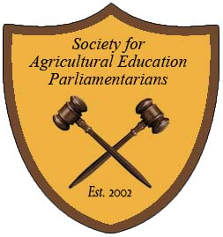

Also at the 2002 National FFA Convention, an organizational meeting was held to form the Society for Agricultural Education Parliamentarians. According to the bylaws of this new organization the purpose is to “Promote the study and use of parliamentary procedure in agricultural education programs and other secondary career and technical education programs throughout the United States" (Society for Agricultural Education Parliamentarians, 2002, pg 5).

The SAEP established the following levels of membership; Member, Accredited Parliamentarian (AP), and Professional Accredited Parliamentarian (PAP). The organization offered professional development workshops at the National FFA Convention. FFA members, advisors, alumni, and parents were all invited to take the Accredited Parliamentarian exam to become a credentialed parliamentarian. Accredited Parliamentarians (AP) could add to their professional development by completing a workshop to be recognized as a Professional Accredited Parliamentarian (PAP). The AP exams and PAP workshops were offered by SAEP officers periodically at the National FFA Convention.

In 2012, the Society for Agricultural Education Parliamentarians organized the first annual SAEP Invitational Novice Parliamentary Procedure Competitive Event. It was held for five years from 2012 to 2017. The SAEP logo is a shield with the name of the organization, 2002 date it was established, and two crossed gavels.

Table 5

SAEP Invitational Novice Parliamentary Procedure Competitive Event Results (2012-2015)

Year | Chapter | State | Placing
2012 | San Luis Obispo  Asotin  Paxton-Buckley-Loda  Eastern Hancock  Millennium  White County | California  Washington  Illinois  Indiana  Arizona  Georgia | 1st  2nd  3rd  4th  5th  6th
2013 | San Luis Obispo  Tonasket  Wamogo  Lafayette  Eldon  Cassopolis | California  Washington  Connecticut  Florida  Missouri  Michigan | 1st  2nd  3rd  4th  5th  6th
2014 | San Luis Obispo  Sandra Day O’Connor  Eldon  South Lake JHS  Holton  Stephens County Middle School | California  Texas  Missouri  Florida  Kansas  Georgia | 1st  2nd  3rd  4th  5th  6th
2015 | Sandra Day O’Connor  Sierra  Garfield-Palouse  Springport  Chandler  Mount Vernon | Texas  California  Washington  Michigan  Arizona  Missouri | 1st  2nd  3rd  4th  5th  6th
2016 | Labette County  San Luis Obispo  Prosser  Lafayette  Bellville  Paxton-Buckley-Loda | Kansas  California  Washington  Florida  Texas  Illinois | 1st  2nd  3rd  4th  5th  6th

National FFA Parliamentary Procedure LDE Changes

The National FFA Parliamentary Procedure event has gone through numerous changes throughout its 25 year history. Every five years the event rules are reviewed and amended to meet changing needs and goals for competitive events. The following sections describe some of the most significant changes.

Event Components

For many years the parliamentary procedure event included a written exam, demonstration, oral questions, and meeting minutes. The written exam consisted of a 25 question multiple-choice exam. Originally the exam was hand scored by collegiate students from Southwest Missouri State University. Eventually the use of computerized scoring using Scantron sheets was adopted.
In 2012, the National FFA was encouraging competitive events to adopt industry validated evaluations that would led to credentials for FFA members. The Parliamentary Procedure CDE adopted the Society for Agricultural Education Parliamentarians’ (SAEP) Accredited Parliamentarian exam as the event exam. This exam consisted of 45 multiple-choice test questions and five research questions. The research questions included five direct quotes from Robert’s Rules of Order Newly Revised (RONR). FFA participants used copies of RONR to find the exact page number and line number for each quote. This change encouraged team members to read and study RONR and understand how to find specific information in the parliamentary authority.

Another change to the event components was the elimination of written minutes of the demonstration in the semi-final and final rounds. The teams that advanced from the preliminary round to the semi-finals and finals no longer recorded the written minutes from the demonstration. In their place, teams took part in a new Team Problem Solving Practicum. All six team members would be given a written scenario that described a problem within a meeting or organization. The team would use Robert’s Rules of Order Newly Revised (RONR) to solve the problem and provide sections, quotes, page numbers, etc. that justify their solution to the problem.

During the 2017 revision, the Parliamentary Procedure LDE Committee decided to eliminate written minutes entirely from the event. However, so as not to discount the importance of minutes for organizations, a new Minutes Practicum was added. In the past only the President and Secretary were involved with preparing the written minutes for the demonstration. The new practicum followed the National Association of Parliamentarians’ (NAP) Body of Knowledge for parliamentarians. All team members would take part in a minutes practicum that would test their knowledge of minutes and other organization documents (officer reports, treasurer’s report, etc.).

Also beginning in 2017, all teams in the preliminary round completed the Team Problem Solving Activity. As a result of this change, all teams completed all components of the event: written exam, minutes practicum, demonstration, oral questions, and team problem solving practicum.

Seeding Process

When the parliamentary procedure event began, teams were randomly assigned to one of the six preliminary rounds. Teams would draw a number out of a hat and be placed in of the six rounds. As a result, some rounds would be very competitive with well-prepared teams, while other rounds would be less competitive with many average teams.

After considerable research, event officials incorporated a seeding process in the preliminary rounds. Based on the team’s average exam scores, teams would be placed in one of the six preliminary rooms. This resulted in each of the six preliminary rounds (A-F) including high scoring teams, average scoring teams, and low scoring teams. This mirrored the NCAA Basketball Tournament seeding process where the #1 seeded team competes against the #16th seeded team. The new seeding process resulted in teams having a better content knowledge and team demonstrations advancing to the semi-final and final rounds of the event.

Event Awards

For the first decade of the event, the only awards given to teams were gold, silver, and bronze team plaques and individual medals. From the 12 gold teams, the final four teams received 1st, 2nd, 3rd, and 4th place plaques and individual medals.

It was decided to add a number of team and individual “specialty” awards to the event. The following awards have been added since 2005.

Outstanding Chair - recognized the best chair in the event. In most cases this individual comes from the final four teams. However, in a few years, the Outstanding Chair has been recognized from a gold award team that did not advance to the finals.

Outstanding Secretary - recognized the best Secretary in the event. This was decided by adding the Secretaries minutes scores and their individual exam scores.

Outstanding Member - recognized the best team member based on their quality of motions made and convincing debate.

High Average Team Score - this award recognizes the team with the highest average team score on the written exam.

High Problem Solving Team - recognized the best team based on their written solution to the Team Problem Solving Activity.

Outstanding Minutes Practicum Team - recognizes the best team based on their Minutes Practicum scores.

Another way that event officials have tried to recognize individual and team success has been the addition of event trophies.

Champion’s Gavel - The first item added to the event was a Champion’s Gavel that included the national winning chapter’s name and state engraved on the gavel band. This gavel is held by the National FFA and does not travel with the winning team. The gavel is approximately 3 feet long.

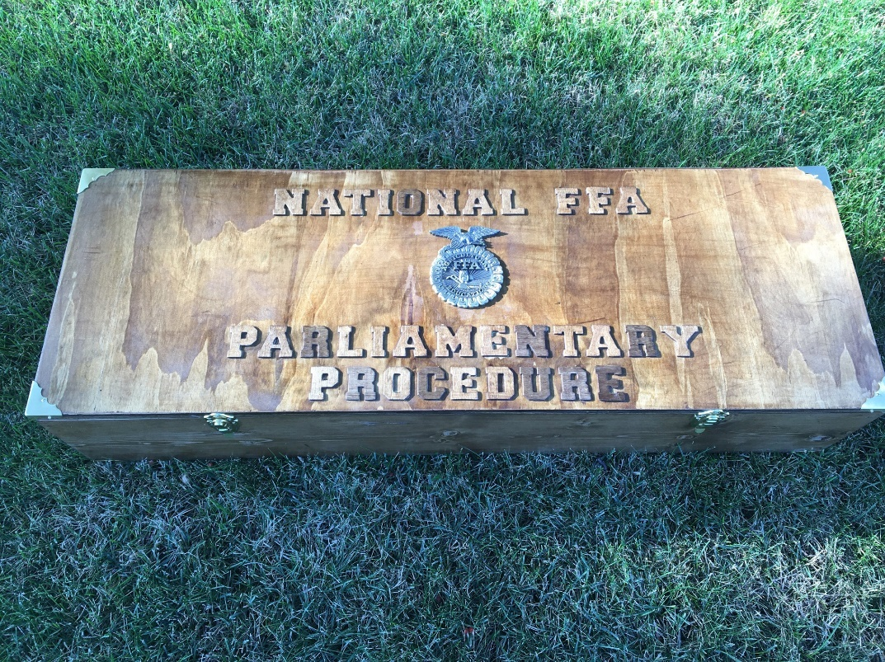

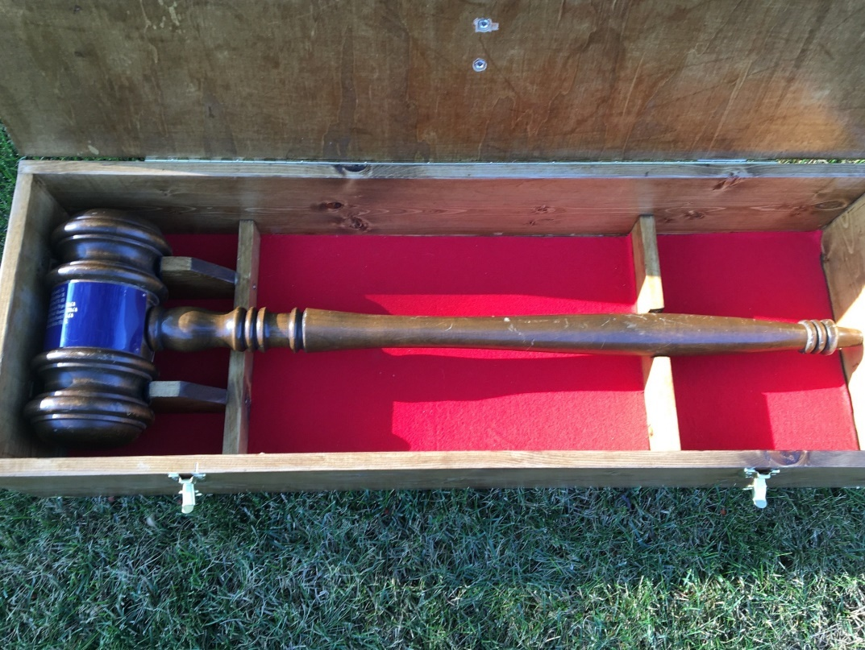

Traveling Champion’s Gavel - A smaller, 2 foot long, Traveling Champion’s Gavel and Box are given to the national winning team to hold for the year. Winning teams keep and display the gavel the year after they were crowned champions.

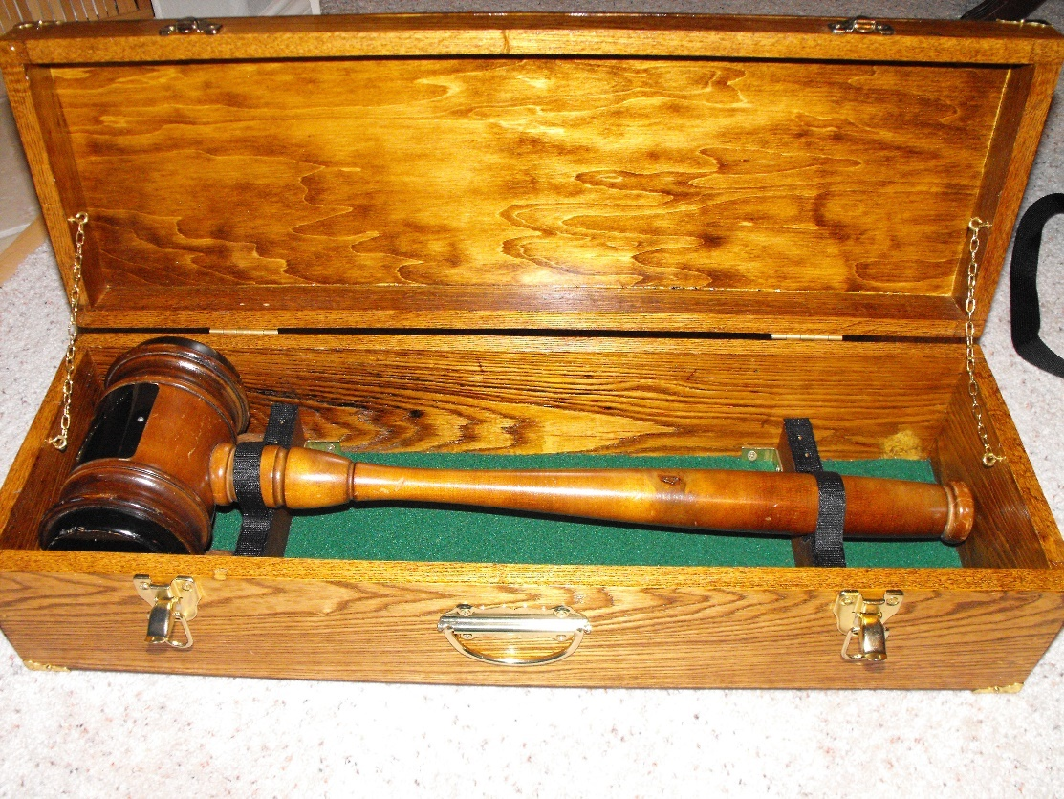

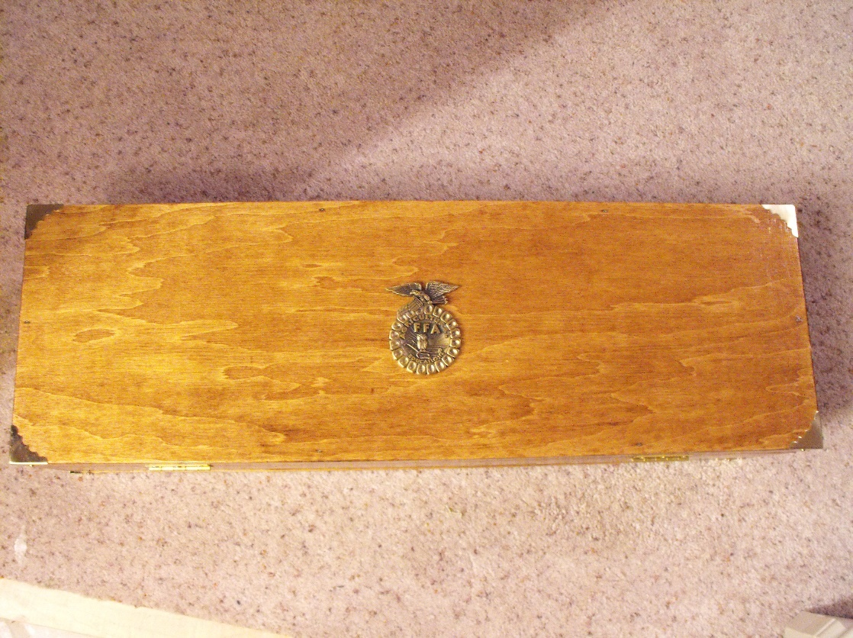

Traveling Outstanding Member’s Trophy - a Traveling Outstanding Member’s Trophy and Case were added in 2016. The Outstanding Member keeps the trophy for the year and returns it for the next convention.

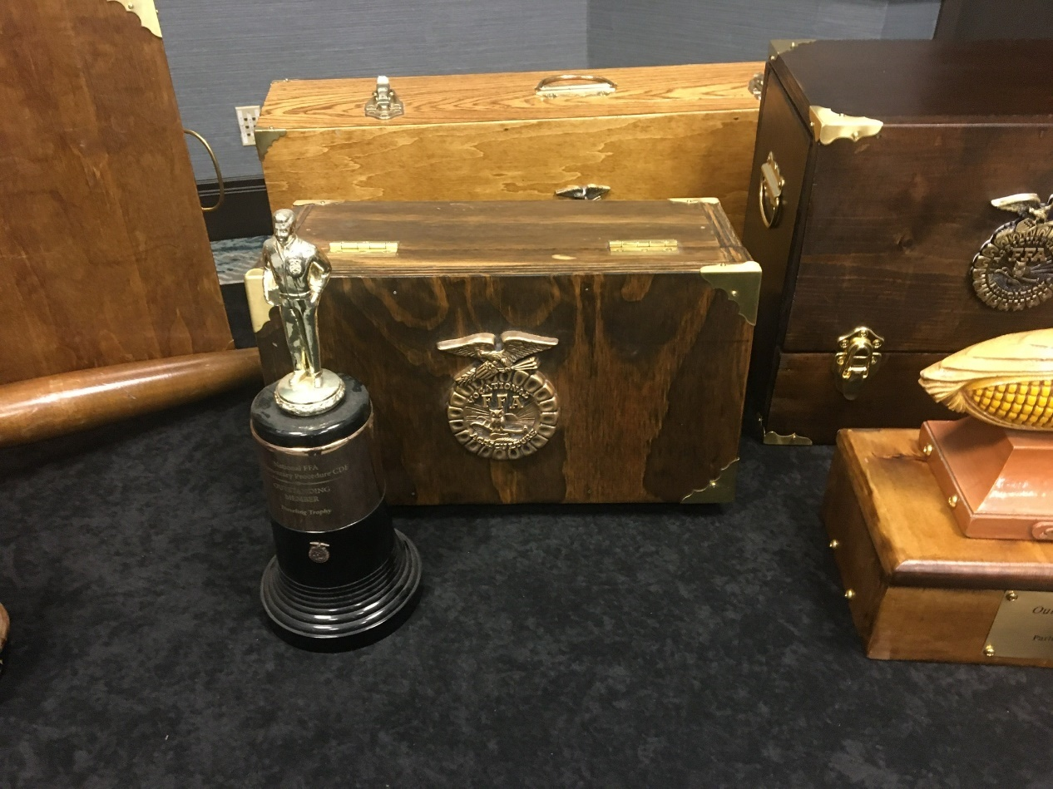

Traveling Outstanding Secretary Trophy – a Traveling Outstanding Secretary’s Trophy and Case were added in 2021. The Outstanding Secretary keeps the trophy for the year and returns it for the next convention. The trophy is an antique Secretary’s station marker (ear of corn) that sits on top of the National FFA Parliamentary Procedure LDE Time Capsule.

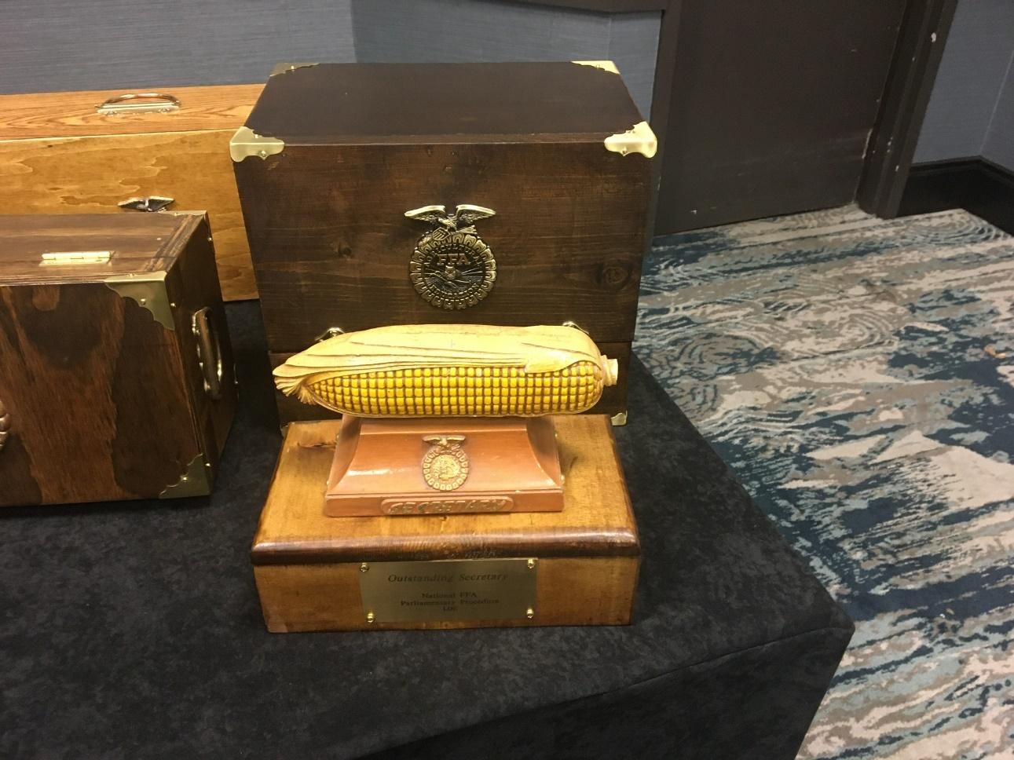

National FFA Parliamentary Procedure LDE Time Capsule is a small box that contains over 60 historical items related to FFA, parliamentary procedure, and the national event. The time capsule was closed at the 94th National FFA Convention in 2021 and is scheduled to be opened after 25 years at the 2046 National FFA Convention.

Judges

The Parliamentary Procedure LDE uses a large number of judges during the three rounds of the event. In the past, judges have mainly come from the agricultural teacher ranks. Secondary agriculture teachers who had a good knowledge of parliamentary procedure or trained successful teams were utilized as event judges.

Over the years the pool of qualified judges has expanded to include university teacher educators who teach college-level parliamentary procedure courses, state supervisors, FFA alumni members, state legislators, and agricultural industry professionals. A concerted effort has been made to collaborate with the two national professional parliamentarian organizations to recruit judges. Credentialed leaders and members of the National Association of Parliamentarians (NAP) and the American Institute of Parliamentarians (AIP) have been used to judge the event in the past few years.

Coaches and Judges Webinars

Improved electronic meeting technology has allowed event officials to begin offering Coaches and Judges webinars prior to National FFA Convention. In the past the event rules and schedules would be reviewed at the Coaches meeting immediately before the event began. Beginning in 2015, event officials offered an on-line webinar for team coaches one month before convention. The event is open to any FFA advisor or team coach. It is also recorded and made available to coaches unable to participate in the live webinar.

Event Judges also participate in an on-line webinar to review event schedules, rules, and discuss potential rules interpretations. Both webinars have improved the transparency of the event and communications between event officials, FFA advisors, team coaches, and judges.

Conclusions

Parliamentary Procedure has been an integral part of agricultural education and the FFA organization for over 100 years. Since the beginning of the Future Farmers of America in 1928, parliamentary procedure has been taught in classrooms, used in chapter, state, and national FFA meetings. Competitive parliamentary procedure teams have competed on the local, district, regional, state, and national levels for over 70 years.

The importance of parliamentary procedure skills for developing future agricultural leaders is clearly evident. Parliamentary Procedure is a body of knowledge and skills that will benefit any FFA member, regardless of the career field they choose.

Table 5 lists the chronological development of FFA related parliamentary procedure events. A continuum of instruction and competitions from middle school agricultural education classes to “novice” and “senior” parliamentary procedure competitive events, to collegiate courses and competitions has been established.

Table 6

National FFA Related Parliamentary Procedure Events

Events | Year Established
National Parliamentary Law Contest - Carthage FFA, Carthage, MO | 1978
National FFA Parliamentary Procedure Career Development Event (CDE) | 1992
Alpha Tau Alpha (ATA) Parliamentary Procedure Contest | No Date
Society for Agricultural Education Parliamentarians (SAEP) | 2002
SAEP Novice Parliamentary Procedure Event | 2012
National FFA Parliamentary Procedure Leadership Development Event (LDE) | 2017
National FFA Conduct of Chapter Meetings (CCM) Leadership Development Event (LDE) | 2017

Over the past century, many individuals have promoted parliamentary procedure within agricultural education and the FFA. Parliamentary Procedure has become an important component of school-based agricultural education instruction and FFA business meetings.
The National FFA Parliamentary Procedure and Conduct of Chapter Meetings Leadership Development Events (LDEs) will continue to promote the study and use of parliamentary procedure among FFA members, advisors, alumni, and agricultural professionals.



Authority Consults the Written Law (Constantino Brumidi – c. 1875) Senate Wing – U.S. Capital, Washington DC. Enthroned Authority, robed in red, holds a sword and wears her attribute, a wreath of the three-pointed leaf. Figure on left holds a mace and scales of justice.
References

Cardozier, V.R, (1964). Parliamentary law and the democratic concept. The Agricultural Education Magazine, 37(4),p. 88.

Cornell, P. (1957). "Chapter meeting" contest is effective. The Agricultural Education Magazine, 29(8), p. I 8 1-l 82.

Crownover, J. (1980). National parliamentary contest - A real possibility. The Agricultural Education Magazine, 52(8), p. 23.

Future Farmers of America (1932). Minutes November 1932 Board of Directors Meeting. National FFA Archives. Indianapolis: Indiana University ~ Purdue University Indianapolis Library.

Future Farmers of America (1935). Proceedings of the 8th National FFA Convention. National FFA Archives. Indianapolis: Indiana University-Purdue University Indianapolis Library.

Future Farmers of America (1936). Proceedings of the 9th National FFA Convention. National FFA Archives. Indianapolis: Indiana University-Purdue University Indianapolis Library.

Future Farmers of America (1955). Proceedings of the 28th National FFA Convention - October 10-13, 1955. National FFA Archives. Indianapolis: Indiana University-Purdue University Indianapolis Library.

Future Farmers of America (1956a). FFA at 25. National FFA Archives. Indianapolis: Indiana University-Purdue University Indianapolis Library.

Future Farmers of America (1956b). Proceedings of the 29th National FFA Convention - October 15-18, 1956. National FFA Archives. Indianapolis: Indiana University-Purdue University Indianapolis Library.

Future Farmers of America (1972). Proceedings of the 45th National FFA Convention. National FFA Archives. Indianapolis: Indiana University-Purdue University Indianapolis Library.

Future Farmers of America (1973). Proceedings of the 46th National FFA Convention. National FFA Archives. Indianapolis: Indiana University-Purdue University Indianapolis Library.

Future Farmers of America (1975). Proceedings of the 48th National FFA Convention. National FFA Archives. Indianapolis: Indiana University-Purdue University Indianapolis Library.

Future Farmers of America (1979), Proceedings of the 52th National FFA Convention - November 1979. National FFA Archives. Indianapolis: Indiana University-Purdue University Indianapolis Library.

Future Farmers of America (1980). Minutes of the January 1980 Board of Directors Meeting. National FFA Archives. Indianapolis: Indiana University-Purdue University Indianapolis Library.

Future Farmers of America (1981). Proceedings of the 54th National FFA Convention. National FFA Archives. Indianapolis: Indiana University-Purdue University Indianapolis Library.

Future Farmers of America (1982). Minutes of the January 1982 Board of Directors Meeting. National FFA Archives. Indianapolis: Indiana University-Purdue University Indianapolis Library.

Future Farmers of America (1983). Minutes of the November 1983 Board of Directors Meeting. National FFA Archives. Indianapolis: Indiana University-Purdue University Indianapolis Library.

Future Farmers of America (1985a). Minutes of the January 1985 Board of Directors Meeting. National FFA Archives. Indianapolis: Indiana University-Purdue University Indianapolis Library.

Future Farmers of America (1985b). Minutes of the July 1985 Board of Directors Meeting. National FFA Archives. Indianapolis: Indiana University-Purdue University Indianapolis Library.

Future Farmers of America (1987). Minutes of the July 1987 Board of Directors Meeting. National FFA Archives. Indianapolis: Indiana University-Purdue University Indianapolis Library.

Graham, B. & Strubinger, H.M. (1940). Parliamentary procedure contests. The Agricultural Education Magazine, 13(6), p. 117.

Hankins, C.W. (1952). Parliamentary training develops leadership. The Agricultural Education Magazine, 25(6), p.132 & 136.

Humphreys, L.R. (1937). Point of Order. The Agricultural Education Magazine, 10(1), p. 16.

Kelly, L.H. (1948). Michigan association F.F.A. sponsors awards program. The Agricultural Education Magazine, 20(9),p. 177.

Lofton, V.T. (1948). More about state F.F.A. conventions. The Agricultural Education Magazine, 20(11), p. 218.

McMillen, S.D. (1948). Leadership training emphasized at West Virginia F.F.A. convention. The Agricultural Education Magazine, 20(10), p. 184-185

Muncrief, E. (1959). Training a chapter meeting team. The Agricultural Education Magazine, 31(9), p.206 &,210.

National Advisory Council (1941). Interpretation of Minimum Qualification Requirements for the American Farmer Degree Contained in Section E of the National FFA Constitution. National FFA A¡chives. Indianapolis: Indiana University-Purdue University Indianapolis Library.

National FFA Organization (1990). Minutes of the July 1990 Board of Directors Meeting. National FFA Archives. Indianapolis: Indiana University-Purdue University Indianapolis Library.

National FFA Organization (l99la). National Parliamentary Contest to become a reality. FFA Times. November 14, 1991,p.2.

National FFA Organization (1991b). Minutes of the January 1991 Board of Directors Meeting. National FFA Archives. Indianapolis: Indiana University-Purdue University Indianapolis Library.

National FFA Organization (1991c). Minutes of the July 1991 Board of Directors Meeting. National FFA Archives. Indianapolis: Indiana University-Purdue University Indianapolis Library.

Robinson, D.B. (1944). A state contest in chapter procedure. The Agricultural Education Magazine, 16(10), p. 190.

Society for Agricultural Education Parliamentarians (2002). Bylaws. Columbus, OH: Department of Human and Community Resource Development, Ohio State University.

Stewart, W.F. (1951). Benefits from parliamentary procedure contests. The Agricultural Education Magazine, 24(4), p. 85-86.

Stimson, R.W. & Lathrop, F.V. (1942). History of agricultural education of less than college grade in the United States. Washington, D.C.: U.S. Government Printing Office.

Teeney, A.W. (1977). FFA at 50. National FFA Archives. Indianapolis: Indiana University- Purdue University Indianapolis Library.

Their Own Contest (1981). The Future Farmer, 29(6), p. 34. Alexandria, VA: Future Farmers of America.

Ziegler, G. (1955). Parliamentary procedure improves public relations. The Agricultural Education Magazine, 28(6), p. 134.

Zinn, R. (1945). I rise to a point of order. The Agricultural Education Magazine, 17(6), p. 116-
117.

Appendix A

Letter to the National FFA Board of Directors
Constitution and Bylaws Committee

December 27,2001

Dr. Jacquelyn Deeds
Department of Agricultural Information Science and Education
Mississippi State University
202 Ballew Hall
P.O. Box 9731
Mississippi State, MS 39762

Dear Dr. Deeds:

I am writing to you in your capacity as Chair of the Policy, Constitution and Bylaws Committee of the National FFA Board of Directors. As we discussed in New Orleans, I serve as the Superintendent of the National FFA Parliamentary Procedure CDE and am an active parliamentarian who is a member of the National Association of Parliamentarians (NAP).

My concern is that the National FFA organization operates based on the rules outlined in its Constitution and Bylaws. However, nowhere in either the Constitution or Bylaws does it state which parliamentary authority the organization follows. As a parliamentarian, you understand the importance of officially identifying the parliamentary authority in an organization's constitution or bylaws.

Therefore, I would like to recommend to the Policy, Constitution, and Bylaws Committee that an amendment to the Constitution should be considered to add the following Article:

Proposed Constitutional Amendment

The rules contained in the current edition of Robert's Rules of Order Newly Revised shall govern the National FFA Organization in all cases to which they are applicable and in which they are not inconsistent with this constitution and bylaws, any special rules of order the National FFA Organization may adopt, and any statutes applicable to this organization that do not authorize the provisions of this constitution and bylaws to take precedence.

I base this proposed amendment on Robert's Rules of Order Newly Revised (2000) pages 561- 562 and 569. By adopting this amendment the delegates would be making a clear statement to FFA members, officers, and advisors which parliamentary authority the National FFA Organization has adopted and follows in all business meetings.

Page 2
Dr. Jacquelyn Deeds
December 27, 2001

I appreciate you and your committee considering this proposal. If I can provide you with any additional information or rationale for my proposal please feel free to contact me at any time. Again, thank you for your attention to this suggested amendment to the National FFA Constitution and Bylaws.

Sincerely,

James J. Connors, Superintendent
National FFA Parliamentary Procedure CDE

cc: Dr. Larry Case
Mr. Bernie Staller

Appendix B

Letter from Dr. Larry Case, National FFA Advisor
to State Associations

MEMORANDUM

Date: February 26,2002

To: All State FFA Associations (Advisors and Executive Secretaries)

From: Larry Case, National FFA Advisor

Re: Constitutional Amendment for Consideration by the Delegates to the 75th National FFA
Convention in Louisville, Kentucky in October 2002

As National FFA Advisor, I am required to submit all constitutional amendments to the states by March l. (Article 16 Amendments) Likewise, as per Article 16, amendments must be submitted by January I for review by the National FFA Board of Directors at their January meeting. These provisions have been met and the Board has asked that the delegates consider the following constitutional amendment this October. The following is proposed as a new Article 16. The current Article 16 would become Article 17.

Article 16 - Parliamentary Authority

The rules contained in the current edition of Robert's Rules of Order Newly Revised shall govern the National FFA Organization in all cases to which they are applicable and in which they are not inconsistent with this constitution and bylaws, any special rules of order the National FFA Organization may adopt, and any statutes applicable to this organization that do not authorize the provisions of this constitution and by laws to take precedence.

The purpose of this amendment is to officially include in the constitution, the parliamentary authority of the organization. It is general practice for organizations to include this provision in their constitution. It is important to note that this is not a change. The FFA has always operated under Robert's Rules and this is also the parliamentary authority followed in the Parliamentary Procedure Career Development Event. Dr. James J. Connors, Superintendent of the National FFA Parliamentary Procedure CDE, made this recommendation to the National FFA Board of Directors.

We encourage your discussion of this amendment at upcoming association executive meetings and at your state FFA conventions. It will also be important to inform your voting delegates to the convention this Fall.

Appendix C

National Parliamentary Law Contest
Carthage, MO

14th Annual National Parliamentary Law Contest Teams (1991)

Chapter | State
Geraldine | Alabama
Mayer | Arizona
Springdale | Arkansas
Camden | Delaware
Troy | Idaho
Annawan | Illinois
Trafalgar | Indiana
Stephenson | Michigan
Lakefield | Minnesota
Rolling Fork | Mississippi
Sweet Springs | Missouri
Culbertson | Montana
Waverly | Nebraska
Portales | New Mexico
Anna | Ohio
Prague | Oklahoma
Menno | South Dakota
Woodbury | Tennessee
Clearfield | Utah
Dry Fork | Virginia
Marion County | West Virginia
Mossyrock | Washington
Pulaski | Wisconsin

Appendix D

National FFA Parliamentary Procedure
Career Development Event
Results

1992 National FFA Parliamentary Procedure CDE Results

State | Chapter | Placing
Washington  New Mexico  Arkansas  Wisconsin  Michigan | Ritzville  Portales  Lincoln  Clear Lake  Unionville-Sebewing Area | 1st Place - Gold  2nd Place - Gold  Gold  Gold  Silver

1993 National FFA Parliamentary Procedure CDE Results

State | Chapter | Placing
Missouri  Washington  West Virginia  Oklahoma  Michigan | Troy  Ritzville  Hundred  Kingfisher  Lakewood | 1st Place - Gold  2nd Place - Gold  3rd Place - Gold  4th Place - Gold  Gold

1994 National FFA Parliamentary Procedure CDE Results

State | Chapter | Placing
Missouri  Utah  Michigan | Carthage  Roosevelt  Montague | 1st Place - Gold  2nd Place - Gold  Silver

1995 National FFA Parliamentary Procedure CDE Results

State | Chapter | Placing
Missouri  Oklahoma  California  Arkansas  Michigan | Carthage  Kingfisher  Galt  Nettleton  Alma | 1st Place - Gold  2nd Place - Gold  3rd Place - Gold  4th Place - Gold  Silver

1996 National FFA Parliamentary Procedure CDE Results

State | Chapter | Placing
Missouri  Arkansas  Washington  West Virginia  Michigan | Carthage  Nettleton  Ritzville  Hundred  Cassopolis-Ross Beatty H.S. | 1st Place - Gold  2nd Place - Gold  3rd Place - Gold  4th Place - Gold  Silver

1997 National FFA Parliamentary Procedure CDE Results

State | Chapter | Placing
Washington  Nevada  Texas  Arkansas  California  Kansas  Minnesota  Missouri  Montana  Oklahoma  South Dakota  West Virginia  Alabama  Arizona  Connecticut  Florida  Georgia  Idaho  Iowa  Michigan  Nebraska  New Mexico  North Dakota  Ohio  Oregon  Tennessee  Utah  Virginia  Wyoming  Delaware  Illinois  Indiana  Louisiana  Maryland  Massachusetts  Mississippi  New Hampshire  New Jersey  New York  North Carolina  Pennsylvania  Rhode Island  Wisconsin | Ritzville  Diamond Mountain  Klein Oak  Mt. Holly  Bear River  Anderson County  HLOL  North Shelby  Shields Valley  Hennessey  Menno  Roane  Geraldine  Flowing Wells  Woodbury  Sebring  Emanuel County  Meridian  Anamosa  Montague  Norris  Kirkland  Rugby  Hillsdale  Days Creek  Dyersburg  UBATC-Union  Fort Defiance  Laramie  Lake Forest  Valmeyer  Fairfield  Choudrant  Southern Garrett  Essex  South Panola  Pinkerton Academy  Penns Grove  Greenwich  Rosewood  Northern Lebanon  Ponaganset  Marshfield | 1st Place - Gold  2nd Place - Gold  3rd Place - Gold  4th Place - Gold  Gold  Gold  Gold  Gold  Gold  Gold  Gold  Gold  Silver  Silver  Silver  Silver  Silver  Silver  Silver  Silver  Silver  Silver  Silver  Silver  Silver  Silver  Silver  Silver  Silver  Bronze  Bronze  Bronze  Bronze  Bronze  Bronze  Bronze  Bronze  Bronze  Bronze  Bronze  Bronze  Bronze  Bronze
1998 National FFA Paliamentary Procedure CDE Results

State | Chapter | Placing
California  New Mexico  Missouri  Nevada  Idaho  New Jersey  Oklahoma  North Carolina  Utah  Wisconsin  Wyoming  Arkansas  Arizona  Colorado  Georgia  Indiana  Kansas  Kentucky  Michigan  Minnesota  Nebraska  New Hampshire  Oregon  Pennsylvania  Tennessee  Texas  Virginia  Washington  West Virginia  Alabama  Alaska  Connecticut  Delaware  Florida  Illinois  Louisiana  Maine  Maryland  Mississippi  New York  Ohio  Rhode Island  South Dakota  South Carolina | Bear River  Texico  North Shelby  Spring Creek  Fruitland  Woodstown  Cushing  Clinton  Morgan  Stratford  East High School  Greenbriar  Chino Valley  Valley  Morgan County  Southem Wells  Marysville  Central Hardin  Alma  Dawson-Boyd  Wilber-Clatonia  Tilton  Myrtle Point  Fort Cherry  McEwen  Midlothian ISD  Tunstall  Ferndale  Hundred  Marbury  Palmer  Regam #1  Ceasar Rodney  Taylor  Mt. Carroll  Starks  Caribou  Harford Technical  West Jones  Northem Adirondack  Miami Trace  Chariho  Newell  Abbeville | 1st Place - Gold  2nd Place - Gold  3rd Place - Gold  4th Place - Gold  Gold  Gold  Gold  Gold  Gold  Gold  Gold  Gold  Silver  Silver  Silver  Silver  Silver  Silver  Silver  Silver  Silver  Silver  Silver  Silver  Silver  Silver  Silver  Silver  Silver  Bronze  Bronze  Bronze  Bronze  Bronze  Bronze  Bronze  Bronze  Bronze  Bronze  Bronze  Bronze  Bronze  Bronze  Bronze
1999 National FFA ParliamentaryProcedure CDE Results

State | Chapter | Placing
Missouri  New Mexico  Kansas  Utah  Idaho  Montana  Nebraska  Nevada  Texas  Washington  Wisconsin  Wyoming  Arizona  Arkansas  California  Colorado  Connecticut  Florida  Illinois  Indiana  Iowa  Kentucky  Louisiana  Michigan  Minnesota  New Hampshire  North Dakota  North Carolina  Ohio  Tennessee  Virginia  Alabama  Delaware  Georgia  Maryland  Mississippi  New York  New Jersey  Oregon  Pennsylvania  South Carolina  South Dakota  West Virginia | Troy  Portales  Holton  Dixie  Meridian  Cascade  Pender  Silver Sage  Klein Forest  Colfax  Loyal  Cheyenne  Payson  Nettleton  Elk Grove  Valley  Suffield  Sebring  Cisne  Owen Valley  Benton  Breckinridge County  Choudrant  Centreville  Battle Lake  Pinkerton Academy  Rugby  Barlett-Yancey  Hillsdale  Munford  Tumer Ashby  Marbury  Lake Forest  Stephens County HS  Walkersville  Neshoba Cenhal  Sherman  Woodstown  Oakland  North Lebanon  Manning  Lemmon  Roane County | 1st Place - Gold  2nd Place - Gold  3rd Place - Gold  4th Place - Gold  Gold  Gold  Gold  Gold  Gold  Gold  Gold  Gold  Silver  Silver  Silver  Silver  Silver  Silver  Silver  Silver  Silver  Silver  Silver  Silver  Silver  Silver  Silver  Silver  Silver  Silver  Silver  Bronze  Bronze  Bronze  Bronze  Bronze  Bronze  Bronze  Bronze  Bronze  Bronze  Bronze  Bronze
2000 National FFA Parliamentary Procedure CDE Results

State | Chapter | Placing
Wyoming  Missouri  Califomia  Kansas  Colorado  Kentucky  Michigan  New Mexico  Ohio  South Dakota  Tennessee  Texas  Georgia  Iowa  Idaho  Illinois  Indiana  Minnesota  North Carolina  Nebraska  Nevada  New York  Oklahoma  Oregon  Utah  Virginia  Washington  Wisconsin  West Virginia  Alaska  Alabama  Arkansas  Connecticut  Delaware  Florida  Louisiana  Massachusettes  Maryland  Mississippi  North Dakota  New Hampshire  Pennsylvania  South Carolina | Cheyenne  Eldon  Bear River  Holton  Flagler  Central Hardin  Cassopolis  Carlsbad  Northwestern  Menno  Dyersburg  White Deer  Stephens County  Linn-Mar  Payette  Valmeyer  Southern Wells  Battle Lake  Bartlett-Yancey  Imperial  Diamond Mountain  Greenwich  Cushing  Vale  Morgan  Turner Ashby  Asotin  Stevens Point  Hundred  Palmer  Isabella  Weiner  Southington  Smyma  South Sumter  Choudrant  Bristol Co Ag HS  Linganore  South Delta  Rugby  Region 9  Cedar Crest  Manning | 1st Place - Gold  2nd Place - Gold  3rd Place - Gold  4th Place - Gold  Gold  Gold  Gold  Gold  Gold  Gold  Gold  Gold  Silver  Silver  Silver  Silver  Silver  Silver  Silver  Silver  Silver  Silver  Silver  Silver  Silver  Silver  Silver  Silver  Silver  Bronze  Bronze  Bronze  Bronze  Bronze  Bronze  Bronze  Bronze  Bronze  Bronze  Bronze  Bronze  Bronze  Bronze

2001 National FFA Parliamentary Procedure CDE Results

State | Chapter | Placing
Califomia  Missouri  Wyoming  Idaho  Arizona  Kansas  Michigan  Montana  North Dakota  North Ca¡olina  Tennessee  Utah  Alabama  Arkansas  Colorado  Florida  Georgia  Illinois  Kentucky  Louisiana  Nevada  New Mexico  New York  Ohio  Oregon  South Dakota  Virginia  Washington  West Virginia  Wisconsin  Connecticut  Delaware  Indiana  Iowa  Maryland  Massachusetts  Minnesota  Nebraska  New Hampshire  New Jersey  Pennsylvania  South Carolina  Vermont | Sierra  Stockton  Burns  Kuna  Peoria  Arkansas City  Centerville  Clyde Park  Napoleon  Yanceyville  Munford  St. George  Hackleburg  Jonesboro  Kersey  Lake Butler  Wrightsville  Sullivan  Harned  Ruston  Eureka  Alamogordo  Ellenburg Depot  Hillsdale  Days Creek  Elkton  Fort Defiance  Asotin  Spencer  Mayville  Falls Village  Smyrna  Denver  Harlan  Bel Air  Dighton  Pipestone  Pender  Tilton  Cameys Point  New Holland  Manning  Middlebury | 1st Place - Gold  2nd Place - Gold  3rd Place - Gold  4th Place - Gold  Gold  Gold  Gold  Gold  Gold  Gold  Gold  Gold  Silver  Silver  Silver  Silver  Silver  Silver  Silver  Silver  Silver  Silver  Silver  Silver  Silver  Silver  Silver  Silver  Silver  Silver  Bronze  Bronze  Bronze  Bronze  Bronze  Bronze  Bronze  Bronze  Bronze  Bronze  Bronze  Bronze  Bronze

2002 National FFA Parliamentary Procedure CDE Results

State | Chapter | Placing
California  Washington  Wyoming  Georgia  Arkansas  Idaho  Illinois  Kansas  Minnesota  Montana  North Carolina  Ohio  Alabama  Alaska  Arizona  Connecticut  Florida  Indiana  Kentucky  Louisiana  Michigan  Nebraska  Nevada  New York  North Dakota  Oregon  Pennsylvania  Tennessee  Utah  Wisconsin  Delaware  South Carolina  Texas  West Virginia  Maryland  Colorado  Virginia  New Hampshire  Mississippi  Oklahoma  Iowa  South Dakota  Massachussets | Bear River  Ritzville  Cheyenne  Stevens County  Nettleton  Meridian  Sullivan  Holtan  Battle Lake  Shields Valley  Bartlett Yancey  Hillsdale  Marbury  Palmer  Chandler  Woodbury  Sebring  Southern Wells  Lyon County  Winnfield  Cassopolis  Imperial  Wells  Cuba-Rushford Cenhal  Kenmare  Baker  Cedar Crest  Dyersburg  Dixie  Stevens Point  Lake Forest  Manning  Katy  Tyler  Hartford Technical HS  McClave  Buffalo Gap  Fall Mountain Regional  N Panola Vo Tech  Ripley  Harlan Comm.  Willow Lake  Essex Ag & Technical Institute | 1st Place - Gold  2nd Place - Gold  3rd Place - Gold  4th Place - Gold  Gold  Gold  Gold  Gold  Gold  Gold  Gold  Gold  Silver  Silver  Silver  Silver  Silver  Silver  Silver  Silver  Silver  Silver  Silver  Silver  Silver  Silver  Silver  Silver  Silver  Silver  Bronze  Bronze  Bronze  Bronze  Bronze  Bronze  Bronze  Bronze  Bronze  Bronze  Bronze  Bronze  Bronze

2003 National FFA Parliamentary Procedure CDE Results

State | Chapter | Placing
California  Wyoming  Kansas  Washington  Arkansas  Georgia  Idaho  New Mexico  North Dakota  South Carolina  South Dakota  Tennessee  Colorado  Connecticut  Florida  Illinois  Kentucky  Louisiana  Missouri  Montana  Nebraska  Nevada  North Carolina  Ohio  Oklahoma  Pennsylvania  Utah  Virginia  West Virginia  Wisconsin  Alabama  Arizona  Delaware  Indiana  Iowa  Maryland  Massachusetts  Michigan  Minnesota  Mississippi  New Jersey  New York  Texas  Vermont | Bear River  Cheyenne  Chapman  Ritzville  Swifton  Stephens County  Kuna  Texico  Turtle Lake-Mercer  Manning  Harrisburg  Munford  Flagler  Killingly  Flagler-Bunnell  Sullivan  Nelson County  Rouston  Dadeville R-2  Sheridan  Leigh Comm.  Silver Sage  Bartlett Yancey  Buckeye Trail  Kingfisher  Cedar Crest  Morgan  Fort Defiance  Roane Co.  Bloomer Senior  Marbury  Safford  Smyrna  Tri-County  Harlan Community  Linganore  Norfolk Co.  Alma  Litchfield  Potts Camp  Penns Grove  Pioneer  Wazahachie  Middlebury Union | 1st Place - Gold  2nd Place - Gold  3rd Place - Gold  4th Place - Gold  Gold  Gold  Gold  Gold  Gold  Gold  Gold  Gold  Silver  Silver  Silver  Silver  Silver  Silver  Silver  Silver  Silver  Silver  Silver  Silver  Silver  Silver  Silver  Silver  Silver  Silver  Bronze  Bronze  Bronze  Bronze  Bronze  Bronze  Bronze  Bronze  Bronze  Bronze  Bronze  Bronze  Bronze  Bronze

2004 National FFA Parliamentary Procedure CDE Results

State | Chapter | Placing
Wyoming  Texas  California  Florida  Arizona  Colorado  Connecticut  Georgia  Idaho  Michigan  Tennessee  Utah  Alabama  Arkansas  Illinois  Indiana  Louisiana  Minnesota  Missouri  Montana  Nevada  New Mexico  North Dakota  Ohio  Oklahoma  Pennsylvania  South Dakota  Virginia  Washington  West Virginia  Alaska  Delaware  Iowa  Kansas  Kentucky  Maryland  Massachussettes  Mississippi  Nebraska  New Hampshire  New Jersey  New York  North Carolina  Oregon  South Carolina  Wisconsin | Cheyenne  Klondike  Pierce - Arbuckle  Union County - Lake Butler Chandler  Douglas County  Woodbury  Stephens County  Kuna  Centreville  Dyersburg  Dixie  Marbury  Quitman  Amboy  Southern Wells  Sumner  Battle Lake  Troy  Cascade  Sierra Nevada  Carlsbad  Napoleon  Hillsdale  Atoka  Northern Lebanon  Beresford  Turner Ashby  Asotin  Hundred  Palmer  Lake Forest  Osage  Mission Valley  Trigg County  Linganore  Norfolk County  Pine Grove  Franklin  Pinkerton  Allentown  Clymer  South Rowan  Baker City  Manning  Mayville | 1st Place - Gold  2nd Place - Gold  3rd Place - Gold  4th Place - Gold  Gold  Gold  Gold  Gold  Gold  Gold  Gold  Gold  Silver  Silver  Silver  Silver  Silver  Silver  Silver  Silver  Silver  Silver  Silver  Silver  Silver  Silver  Silver  Silver  Silver  Silver  Bronze  Bronze  Bronze  Bronze  Bronze  Bronze  Bronze  Bronze  Bronze  Bronze  Bronze  Bronze  Bronze  Bronze  Bronze  Bronze

2005 National FFA Parliamentary Procedure CDE Results

State | Chapter | Placing
New Mexico  Oklahoma  Missouri  Washington  Alabama  Kansas  Wyoming  Utah  Arkansas  Montana  California  Idaho  Arizona  Colorado  Florida  Illinois  Indiana  Nebraska  Nevada  North Dakota  Ohio  Pennsylvania  South Dakota  Tennessee  Texas  Virginia  West Virginia  Wisconsin  Connecticut  Delaware  Iowa  Kentucky  Maryland  Massachusetts  Michigan  North Carolina  South Carolina | Moriarty  Kingfisher  Eldon  Ritzville  Marbury  Winfield  Cheyenne East  Dixie  Nettleton  Sheridan-Ruby Valley  Bear River  Meridian  Safford  Weld Central  Durant  East Richland  Shenandoah  Waverly  Smith Valley  Napoleon  Elmwood  Cedar Crest  Willow Lake  White House  Madisonville  Fort Defiance  Taylor County  Mayville  Southington  Smyrna  Anamosa Community  Carlisle County  Linganore  Norfolk County Ag. School  Lakers  South Rowan  Manning | 1st Place - Gold  2nd Place - Gold  3rd Place - Gold  4th Place - Gold  Gold  Gold  Gold  Gold  Gold  Gold  Gold  Gold  Silver  Silver  Silver  Silver  Silver  Silver  Silver  Silver  Silver  Silver  Silver  Silver  Silver  Silver  Silver  Silver  Bronze  Bronze  Bronze  Bronze  Bronze  Bronze  Bronze  Bronze  Bronze

2006 National FFA Parliamentary Procedure CDE Results

State | Chapter | Placing
Missouri  California  Idaho  Kansas  Georgia  Illinois  Nebraska  New Mexico  North Dakota  Oklahoma  Tennessee  Texas  Alabama  Arizona  Arkansas  Colorado  Michigan  Minnesota  Montana  Nevada  New Hampshire  New York  Ohio  Oregon  Pennsylvania  South Dakota  Utah  Washington  Wyoming  Connecticut  Delaware  Florida  Indiana  Iowa  Kentucky  Maryland  Massachusetts  Mississippi  New Jersey  North Carolina  South Carolina  Virginia  West Virginia  Wisconsin | Stockton  Fall River  Troy  Holton  McArthur  Farmington  Pender  Carlsbad  Napoleon  Jenks  Munford  Midlothian  Geraldine  Willcox  Quitman  McClave  Harbor Beach  Battle Lake  Shepherd  Spring Creek  Tilton  Adams  Hillsdale  Phoenix  Fredericksburgh  Beresford  Morgan  Lynden  Cheyenne  Woodbury  Smyrna  Williston  Poneto  Anamosa  Glasgow  Frederick  Hathorne  Ripley  Carneys Point  Marshall  Abbeville  Abingdon  Farmington  Amery | 1st Place - Gold  2nd Place - Gold  3rd Place - Gold  4th Place - Gold  Gold  Gold  Gold  Gold  Gold  Gold  Gold  Gold  Silver  Silver  Silver  Silver  Silver  Silver  Silver  Silver  Silver  Silver  Silver  Silver  Silver  Silver  Silver  Silver  Bronze  Bronze  Bronze  Bronze  Bronze  Bronze  Bronze  Bronze  Bronze  Bronze  Bronze  Bronze  Bronze  Bronze  Bronze

2007 National FFA Parliamentary Procedure CDE Results

State | Chapter | Placing
California  Washington  Wyoming  Colorado  Arizona  Georgia  Idaho  Kansas  Missouri  Oklahoma  Tennessee  Utah  Arkansas  Florida  Indiana  Kentucky  Minnesota  Montana  Nebraska  Nevada  New Mexico  North Dakota  Ohio  Oregon  Pennsylvania  South Carolina  Texas  Virginia  West Virginia  Wisconsin  Alabama  Alaska  Connecticut  Illinois  Iowa  Louisiana  Maryland  Michigan  Mississippi  New Jersey  New Hampshire  New York  North Carolina  South Dakota  Vermont | Foothill  Prosser  Burns  Douglas County  Chandler  Crawford County  Kuna  Arkansas City  Troy  Atoka  Glenn Ross  Dixie  Nettleton  East Ridge  Southern Wells  Central Hardin  Dassel Cokato  Joliet  Norris  Spring Creek  Elida  Wyndmere  Marysville  North Clackamas  Cedar Crest  Manning  Sandra Day O’Connor  Fort Defiance  Tyler County  Marshfield  Marbury  Palmer  Nonnewaug - Woodbury  Valmeyer  Osage  Choudrant  Catoctin  Ogemaw Heights  Biggersville  Woodstown  Kingswood  Pioneer  West Rowan  Newell  Vergennes Union | 1st Place - Gold  2nd Place - Gold  3rd Place - Gold  4th Place - Gold  Gold  Gold  Gold  Gold  Gold  Gold  Gold  Gold  Silver  Silver  Silver  Silver  Silver  Silver  Silver  Silver  Silver  Silver  Silver  Silver  Silver  Silver  Silver  Silver  Silver  Silver  Bronze  Bronze  Bronze  Bronze  Bronze  Bronze  Bronze  Bronze  Bronze  Bronze  Bronze  Bronze  Bronze  Bronze  Bronze

2008 National FFA Parliamentary Procedure CDE Results

State | Chapter | Placing
Arizona  Michigan  Missouri  Oklahoma  New Mexico  California  Florida  Kansas  North Dakota  Virginia  Washington  West Virginia  Alabama  Arkansas  Colorado  Georgia  Idaho  Illinois  Louisiana  Minnesota  Montana  New Hampshire  North Carolina  Ohio  South Dakota  Tennessee  Texas  Utah  Wyoming  Connecticut  Delaware  Indiana  Iowa  Kentucky  Maryland  Massachusetts  Nebraska  New Jersey  New York  Oregon  Pennsylvania  South Carolina  Wisconsin | Millennium  Cassopolis-Ross Beatty  Eldon  Kingfisher  Las Vegas  Cottonwood-West Valley  Union County - Lake Butler  Winfield  Rugby  Carroll County  Lynden  Roane County  Marbury  Greenbrier  McClave  Stephens County  Kuna  Amboy  Winnfield  Battle Lake  Big Sky- Missoula  Winnisquam Regional Madison County  Hillsdale  Lennox Sundstrom  White House  Klondike  Dixie  Cheyenne East- Frontier  Killingly  Lake Forest  Columbia City  Pleasantville  Nelson County  Linganore  Norfolk Co Ag School  Kimball  Phillipsburg  Warwick Valley Central  Molalla  North Lebanon  Manning  Mayville | 1st Place - Gold  2nd Place - Gold  3rd Place - Gold  4th Place - Gold  5th Place - Gold  Gold  Gold  Gold  Gold  Gold  Gold  Gold  Silver  Silver  Silver  Silver  Silver  Silver  Silver  Silver  Silver  Silver  Silver  Silver  Silver  Silver  Silver  Silver  Silver  Bronze  Bronze  Bronze  Bronze  Bronze  Bronze  Bronze  Bronze  Bronze  Bronze  Bronze  Bronze  Bronze  Bronze

2009 National FFA Parliamentary Procedure CDE Results

State | Chapter | Placing
Illinois  Wyoming  Idaho  Florida  Arizona  California  Connecticut  New Mexico  South Dakota  Tennessee  Washington  West Virginia  Alabama  Arkansas  Texas  Georgia  Colorado  Montana  Ohio  Iowa  Kansas  Virginia  Puerto Rico  Kentucky  Missouri  Nevada  Wisconsin  North Dakota  Utah  Minnesota  Nebraska  North Carolina  Louisiana  Maryland  Michigan  Massachusetts  Delaware  New York  Oklahoma  South Carolina  Pennsylvania  Oregon  Indiana | Sullivan  Cheyenne East - Frontier Meridian  Meridian  Williston  Basha  Bear River  Nonnewaug HS - Woodbury  Carlsbad  Harrisburg  Munford  Prosser  Taylor Co. Tech Center  Geraldine  Greenbrier  Sandra Day O’Connor  Murray County  Platte Valley  Shields Valley  Hillsdale  Wapsie Valley  Holton  Blacksburg  SU Antonia Serrano Gonzalez  Spencer Co  Troy  Silver Sage  Amery  Napoleon  Payson  Forest Lake  Franklin  Bartlett Yancey  Choudrant  Urbana  Standish-Sterling  Norfolk Co Ag School  Sussex Central  Tri Valley Central  Burlington  Manning  Cedar Crest  North Clackamas  North Miami | 1st Place - Gold  2nd Place - Gold  3rd Place - Gold  4th Place - Gold  Gold  Gold  Gold  Gold  Gold  Gold  Gold  Gold  Silver  Silver  Silver  Silver  Silver  Silver  Silver  Silver  Silver  Silver  Silver  Silver  Silver  Silver  Silver  Silver  Silver  Bronze  Bronze  Bronze  Bronze  Bronze  Bronze  Bronze  Bronze  Bronze  Bronze  Bronze  Bronze  Bronze  Bronze

2010 National FFA Parliamentary Procedure CDE Results

State | Chapter | Placing
Missouri  California  Texas  Arizona  Georgia  Idaho  New Mexico  Oklahoma  South Carolina  Washington  West Virginia  Wyoming  Arkansas  Delaware  Indiana  Iowa  Kansas  Louisiana  Michigan  Minnesota  Mississippi  Montana  Nevada  New Hampshire  North Carolina  North Dakota  Ohio  Oregon  South Dakota  Tennessee  Utah  Virginia  Alabama  Colorado  Connecticut  Florida  Kentucky  Maryland  Massachusetts  Nebraska  New Jersey  New York  Pennsylvania  Puerto Rico  Vermont  Wisconsin | Eldon  Cottonwood - West Valley  Bellville  Millennium  White County  Kuna  Las Vegas  Kingfisher  Manning  Lynden  Tyler  Cheyenne East - Frontier  Newport  Milford  Southern Wells  Pleasantville  Mission Valley  Springfield  Centreville  Dassel-Cokato  Starkville  Flathead  Silver Sage  Winnisquam  Madison  Napoleon  Waterford  North Clackamas  McCook Central  McEwen  Uintah  Fort Defiance  Marbury  Windsor  Wamogo  Durant  Caldwell County  Linganore  Norfolk  Stuart  Phillipsburg  Pioneer  Captain Jack  Padre Anibal Reyes  Vergennes  Mayville | 1st Place - Gold  2nd Place - Gold  3rd Place - Gold  4th Place - Gold  Gold  Gold  Gold  Gold  Gold  Gold  Gold  Gold  Silver  Silver  Silver  Silver  Silver  Silver  Silver  Silver  Silver  Silver  Silver  Silver  Silver  Silver  Silver  Silver  Silver  Silver  Silver  Silver  Bronze  Bronze  Bronze  Bronze  Bronze  Bronze  Bronze  Bronze  Bronze  Bronze  Bronze  Bronze  Bronze  Bronze

2011 National FFA Parliamentary Procedure CDE Results

State | Chapter | Placing
California  Washington  Louisiana  Wyoming  Idaho  Michigan  Missouri  Nevada  Pennsylvania  Tennessee  Texas  West Virginia  Arizona  Florida  Georgia  Illinois  Iowa  Kansas  Montana  Nebraska  New Mexico  North Dakota  Ohio  Oregon  South Carolina  Utah  Virginia  Wisconsin  Alabama  Arkansas  Colorado  Connecticut  Delaware  Indiana  Kentucky  Maryland  Minnesota  Mississippi  New Jersey  New York  North Carolina  Oklahoma  Puerto Rico  South Dakota | Nevada Union  Tonasket  Elton  Burns  Kuna  Cassopolis Ross Beatty  Eldon  Wells  Greenwood  Munford  Sandra Day O’Connor  Marion County  Basha  East Ridge  Jeff Davis County  Paxton-Buckley-Ioda  Wapsie Valley  Winfield  Shields Valley  Imperial  Robertson  Wishek  Elmwood  Silverton Union  Manning  Uintah  Buffalo Gap  Marshfield  Enterprise  Greenbrier  Platte Valley  Wamogo Regional  Sussex Central  Shenandoah  Nelson County  Catoctin  Sauk Centre  Biggersville  Allentown  Tri Valley Central  North Johnston  Eufaula  S U Manuel Ruiz Gandia  Willow Lake | 1st Place - Gold  2nd Place - Gold  3rd Place - Gold  4th Place - Gold  Gold  Gold  Gold  Gold  Gold  Gold  Gold  Gold  Silver  Silver  Silver  Silver  Silver  Silver  Silver  Silver  Silver  Silver  Silver  Silver  Silver  Silver  Silver  Silver  Bronze  Bronze  Bronze  Bronze  Bronze  Bronze  Bronze  Bronze  Bronze  Bronze  Bronze  Bronze  Bronze  Bronze  Bronze  Bronze

2012 National FFA Parliamentary Procedure CDE Results

State | Chapter | Placing
California  Missouri  Idaho  Tennessee  Florida  Georgia  Kansas  Louisiana  Pennsylvania  Texas  Washington  Wyoming  Arizona  Arkansas  Colorado  Illinois  Indiana  Iowa  Michigan  Minnesota  Nebraska  Nevada  New Mexico  North Dakota  Ohio  South Carolina  Utah  West Virginia  Wisconsin  Alabama  Connecticut  Kentucky  Maryland  Mississippi  Montana  New Hampshire  New York  New Jersey  North Carolina  Oklahoma  Oregon  South Dakota  Vermont  Virginia | Minarets  Eldon  Meridian  Munford  Lake Butler  North Murray  Holton  Denham Springs  West Perry  Bellville  Elma  Casper  Millennium  Newport  Weld Central  Valmeyer  North Miami  Wapsie Valley  Byron  Dassel Cokato  Central  Spring Creek  Texico  Max  Miami Trace  Manning  Dixie  Taylor County  Darlington  Marbury  Killingly  Calloway County  Frederick  Ackerman  Missoula  Winnisquam  Pioneer  Allentown  North Johnston  Madill  Bonanza  McCook Central  Vergennes Union  Holston | 1st Place - Gold  2nd Place - Gold  3rd Place - Gold  4th Place - Gold  Gold  Gold  Gold  Gold  Gold  Gold  Gold  Gold  Silver  Silver  Silver  Silver  Silver  Silver  Silver  Silver  Silver  Silver  Silver  Silver  Silver  Silver  Silver  Silver  Silver  Bronze  Bronze  Bronze  Bronze  Bronze  Bronze  Bronze  Bronze  Bronze  Bronze  Bronze  Bronze  Bronze  Bronze  Bronze

2013 National FFA Parliamentary Procedure CDE Results

State | Chapter | Placing
Oklahoma  Arizona  Florida  Utah  California  Georgia  Louisiana  Minnesota  Missouri  Pennsylvania  Tennessee  West Virginia  Arkansas  Colorado  Connecticut  Idaho  Illinois  Iowa  Kansas  Maryland  Michigan  Nebraska  Nevada  North Dakota  South Dakota  Texas  Washington  Wyoming  Alabama  Delaware  Indiana  Kentucky  Massachusetts  Mississippi  Montana  New Jersey  New York  Oregon  South Carolina  Virginia  Wisconsin | Kingfisher  Millennium  Kathleen  North Summit  Liberty Ranch  Franklin County  Denham Springs  Howard Lake  Eldon  Cumberland Valley  Glenn Ross  Wirt County  Greenbrier  Windsor  Nonnewaug - Woodbury  Fruitland  Amboy  Wapsie Valley  Winfield  Urbana  Cassopolis Ross Beatty  Pender  Wells  Rugby  Lennox Sundstrom  Mission  Lynden  Burns  Enterprise  Lake Forest  North Miami  Rockcastle County  Essex Ag & Tech Institute  Mantachie  Joliet  Phillipsburgh  Greenwich Central  North Clackamas SD Land Lab  Manning  Strasburgh  Amery | 1st Place - Gold  2nd Place - Gold  3rd Place - Gold  4th Place - Gold  Gold  Gold  Gold  Gold  Gold  Gold  Gold  Gold  Silver  Silver  Silver  Silver  Silver  Silver  Silver  Silver  Silver  Silver  Silver  Silver  Silver  Silver  Silver  Silver  Bronze  Bronze  Bronze  Bronze  Bronze  Bronze  Bronze  Bronze  Bronze  Bronze  Bronze  Bronze  Bronze

2014 National FFA Parliamentary Procedure CDE Results

State | Chapter | Placing
Missouri  Arizona  Nebraska  California  Idaho  Kentucky  New Mexico  North Dakota  Ohio  Tennessee  Utah  Washington  Connecticut  Georgia  Illinois  Iowa  Kansas  Louisiana  Minnesota  Nevada  Oregon  Pennsylvania  Texas  Virginia  West Virginia  Wisconsin  Wyoming  Colorado  Florida  Indiana  Maryland  Michigan  Mississippi  Montana  New York  North Carolina  Oklahoma  South Carolina  South Dakota | Eldon  Chandler  Imperial  Nevada Union  Kuna  Breckinridge County  Carlsbad  Kindred  Miami Trace  Mundord  Dixie  Prosser  Nonnewaug - Woodbury  Madison County  Paxton-Buckley-Loda  Wapsie Valley  Holton  Elton  Zumbrota Mazeppa  Silver Sage  Phoenix  Greenwood  Klondike  Buffalo Gap  Tyler  Mayville  Burns  Platte Valley  Durant  Eastern Hancock  Catoctin  Springport  Mantachie  Ruby Valley  Pioneer  Rosewood  Coalgate  Manning  Hyde County | 1st Place - Gold  2nd Place - Gold  3rd Place - Gold  4th Place - Gold  Gold  Gold  Gold  Gold  Gold  Gold  Gold  Gold  Silver  Silver  Silver  Silver  Silver  Silver  Silver  Silver  Silver  Silver  Silver  Silver  Silver  Silver  Silver  Silver  Bronze  Bronze  Bronze  Bronze  Bronze  Bronze  Bronze  Bronze  Bronze  Bronze  Bronze

2015 National FFA Parliamentary Procedure CDE Results

State | Chapter | Placing
California  Oklahoma  Arizona  Wyoming  Georgia  Idaho  Illinois  Iowa  Kansas  Louisiana  Texas  Washington  Arkansas  Colorado  Connecticut  Indiana  Michigan  Minnesota  Missouri  Montana  Nebraska  North Carolina  North Dakota  Tennessee  Utah  Virginia  West Virginia  Alabama  Delaware  Kentucky  Maryland  Mississippi  New York  New Hampshire  Ohio  Oregon  Pennsylvania  South Dakota  South Carolina  Wisconsin | San Luis Obispo  Kingfisher  AAEC-Estrella Mountain  Casper  White County  Meridian  Olney  Wapsie Valley  Marysville  Denham Springs  Bellville  Asotin  Greenbrier  Menno  Wamogo Regional  Southern Wells  Cassopolis Ross Beatty  Grand Meadow  Eldon  Shepherd  Waverly  Madison  Wishek  Munford  Uintah  Lord Botetourt  Hundred  Enterprise  Smyrna  Mercer  Frederick  Kossuth  Greenwich Central  Winnisquam  Lakeland-Harrison Central  North Clackamas  West Perry  Lennox Sundstrom  Manning  Amery | 1st Place - Gold  2nd Place - Gold  3rd Place - Gold  4th Place - Gold  Gold  Gold  Gold  Gold  Gold  Gold  Gold  Gold  Silver  Silver  Silver  Silver  Silver  Silver  Silver  Silver  Silver  Silver  Silver  Silver  Silver  Silver  Silver  Bronze  Bronze  Bronze  Bronze  Bronze  Bronze  Bronze  Bronze  Bronze  Bronze  Bronze  Bronze  Bronze

2016 National FFA Parliamentary Procedure CDE Results

State | Chapter | Placing
California  Missouri  Wisconsin  Florida  Arizona  Colorado  Georgia  Minnesota  Tennessee  Texas  Washington  West Virginia  Alabama  Arkansas  Connecticut  Idaho  Illinois  Indiana  Kansas  Louisiana  Michigan  Nebraska  New Mexico  North Dakota  Ohio  Oregon  Pennsylvania  Puerto Rico  South Dakota  Utah  Wyoming  Delaware  Iowa  Kentucky  Maryland  Mississippi  Montana  Nevada  New Hampshire  New Jersey  New York  South Carolina  Virginia | O’Neals-Minarets  Linn  Amery  Lake Butler  Chandler  Platte Valley  Gilmer County  Howard Lake-Waverly-Winsted  McEwen  Stephensville  Tonasket  West Virginia  Brantley  Mountain Home  Woodbury  Fruitland  Amboy  South Putnam  Marysville  Ruston  Springport  Gothenburg  Hobbs  Harvey  Hillsdale  Dayton  Greenwood  Jose Emilio Lugo Adjuntas  Highmore  Westlake  Buffalo  Lake Forest  Clarinda  Boyle County  Linganore  Mantachie  Flathead  Silver Sage  Winnisquam  North Burlington  South Jefferson  Calhoun Falls  Fort Defiance | 1st Place - Gold  2nd Place - Gold  3rd Place - Gold  4th Place - Gold  Gold  Gold  Gold  Gold  Gold  Gold  Gold  Gold  Silver  Silver  Silver  Silver  Silver  Silver  Silver  Silver  Silver  Silver  Silver  Silver  Silver  Silver  Silver  Silver  Silver  Silver  Silver  Bronze  Bronze  Bronze  Bronze  Bronze  Bronze  Bronze  Bronze  Bronze  Bronze  Bronze  Bronze

2017 National FFA Parliamentary Procedure LDE Results

State | Chapter | Placing
California  Missouri  Florida  Idaho  Colorado  Indiana  Louisiana  Minnesota  Montana  Nebraska  Ohio  Wyoming  Arkansas  Arizona  Georgia  Iowa  Illinois  Kansas  Kentucky  Michigan  New Mexico  New York  North Carolina  North Dakota  Oklahoma  Pennsylvania  Texas  Virginia  Washington  Wisconsin  West Virginia  Alabama  Connecticut  Delaware  Maryland  Mississippi  New Hampshire  New Jersey  Nevada  Oregon  Puerto Rico  South Carolina  South Dakota  Tennessee  Utah  Vermont | Liberty Ranch  Eldon  Kathleen  Kuna  Windsor  Tri-County  Elton  Dassel-Cokato  Joliet  Imperial  Eaton Miami Valley CTC  Casper  Greenbrier  Millennium  White County  Wapsie Valley  Olney  Clay Center  Rockcastle County  Byron  Clovis  Pioneer  Madison  Napoleon  Kingfisher  Newport  Lubbock Cooper  Strasburg  Prosser  Stanley-Boyd  Taylor County  Enterprise  Woodbury  Milford  Urbana  Kossuth  Paradice  Allentown  Smith Valley  Sutherlin  Superior Urbana Aguas Buenas  Manning  Harrisburg  Station Camp  Beaver  Vergennes | 1st Place - Gold  2nd Place - Gold  3rd Place - Gold  4th Place - Gold  Gold  Gold  Gold  Gold  Gold  Gold  Gold  Gold  Silver  Silver  Silver  Silver  Silver  Silver  Silver  Silver  Silver  Silver  Silver  Silver  Silver  Silver  Silver  Silver  Silver  Silver  Silver  Bronze  Bronze  Bronze  Bronze  Bronze  Bronze  Bronze  Bronze  Bronze  Bronze  Bronze  Bronze  Bronze  Bronze  Bronze

2018 National FFA Parliamentary Procedure LDE Results

State | Chapter | Placing
Florida  Arizona  Illinois  Minnesota  California  Idaho  Iowa  Louisiana  Missouri  Texas  Washington  Colorado  Connecticut  Georgia  Michigan  Montana  Nebraska  New Mexico  New York  North Dakota  South Dakota  Tennessee  Utah  Virginia  West Virginia  Wisconsin  Delaware  Kansas  Kentucky  Maryland  Mississippi  North Carolina  Ohio  Pennsylvania  Puerto Rico  South Carolina | Lake Butler  AAEC Estrella Mountain  Paxton Buckley Loda  Howard Lake - Weverly- Winsted  Bear River  Fruitland  Wapsie Valley  Calvin  Tipton  Bellville  Asotin  Platte Valley  Wamogo Regional FFA  Gilmer County  Mason  Kalispell  Pender  Logan  Warwick Valley  Max  McCook Central  McEwen  Mountain Crest  Holston  Tyler  Pardeeville  Sussex  Holton  Locust Trace  Oakland  Mantachie  Watauga  Miami Trace  Blue Juanita  Superior Urbana Aguas Buenas  Abbeville | 1st Place - Gold  2nd Place - Gold  3rd Place - Gold  4th Place - Gold  Gold  Gold  Gold  Gold  Gold  Gold  Gold  Silver  Silver  Silver  Silver  Silver  Silver  Silver  Silver  Silver  Silver  Silver  Silver  Silver  Silver  Silver  Bronze  Bronze  Bronze  Bronze  Bronze  Bronze  Bronze  Bronze  Bronze  Bronze

2019 National FFA Parliamentary Procedure LDE Results

State | Chapter | Placing
Nebraska  Texas  California  Washington  Oklahoma  Arizona  South Dakota  Florida  Illinois  Louisiana  Michigan  Wisconsin  Alaska  Arkansas  Delaware  Georgia  Idaho  Indiana  Kansas  Kentucky  Minnesota  Missouri  Montana  New Mexico  Ohio  Pennsylvania  Puerto Rico  South Carolina  Tennessee  Utah  Wyoming  Alabama  Colorado  Connecticut  Iowa  Maryland  Mississippi  New York  North Carolina  Oregon  Virginia  West Virginia | Imperial  Sandra Day O’Connor  O’Neals-Minarets  Tonasket  Kingfisher  Chandler  Menno  Cottondale  Olney  Winnfield  Cassopolis  Denmark  Midnight Sun  Greenbrier  Sussex Central  Tift County  Madison  North Miami  Mission Valley  Boyle County  Litchfield  Troy  Broadwater  Texico  Hillsdale  Greenwood  Superior Urbana Aguas Buenas  Crestwood  Munford  Uintah  Burns  Cherokee  Windsor  Woodbury  North Fayette Valley  Linganore  East Central  Pioneer  Lakewood  Dayton  Turner Ashby  Wirt County | 1st Place - Gold  2nd Place - Gold  3rd Place - Gold  4th Place - Gold  Gold  Gold  Gold  Gold  Gold  Gold  Gold  Gold  Silver  Silver  Silver  Silver  Silver  Silver  Silver  Silver  Silver  Silver  Silver  Silver  Silver  Silver  Silver  Silver  Silver  Silver  Silver  Bronze  Bronze  Bronze  Bronze  Bronze  Bronze  Bronze  Bronze  Bronze  Bronze  Bronze
2021 National FFA Parliamentary Procedure LDE Results

State | Chapter | Placing
California  Nebraska  Ohio  Missouri  Arizona  Georgia  Illinois  Montana  New Mexico  Oklahoma  Idaho  Wyoming  Arkansas  Colorado  Iowa  Kansas  Louisiana  Michigan  Minnesota  North Carolina  North Dakota  Oregon  Pennsylvania  Tennessee  Wisconsin  West Virginia  Arkansas  Alabama  Delaware  Indiana  Kentucky  Mississippi  New York  South Carolina  South Dakota  Texas  Utah  Virginia  Washington | Galt-Liberty Ranch  Imperial  Felicity-Franklin  Troy  AAEC – Estrella Mountain  Gilmer County  Paxton-Buckley-Loda  Kalispell  Artesia  Kingfisher  Kuna  Cheyenne High Plains  Greenbrier  Platte Valley  East Buchanan  Royal Valley  Elton  Mason  Howard Lake – Waverly- Winstead  Madison  Killdeer  North Clackamas  Newport  Munford  Amery  Tyler  Delta Junction  Cherokee  Smyrna  North Miami  Western Hills  Newton County  South Jefferson  Calhoun Falls  Highmore  Harmony  Roosevelt  Buffalo Gap  Clarkston | 1st Place - Gold  2nd Place - Gold  3rd Place - Gold  4th Place - Gold  Gold  Gold  Gold  Gold  Gold  Gold  Gold  Gold  Silver  Silver  Silver  Silver  Silver  Silver  Silver  Silver  Silver  Silver  Silver  Silver  Silver  Silver  Bronze  Bronze  Bronze  Bronze  Bronze  Bronze  Bronze  Bronze  Bronze  Bronze  Bronze  Bronze  Bronze

2022 National FFA Parliamentary Procedure LDE Results

State | Chapter | Placing
Florida  West Virginia  Troy  Louisiana  California  Idaho  Illinois  Indiana  Nebraska  Pennsylvania  Texas  Wyoming  Arizona  Colorado  Michigan  North Dakota  New Mexico  Ohio  Oregon  South Dakota  Tennessee  Utah  Virginia  Washington  Wisconsin  Alabama  Arkansas  Connecticut  Delaware  Georgia  Kentucky  Maryland  Mississippi  Montana  New Jersey  New York  North Carolina  Oklahoma  South Carolina | Lafayette  Gilmer County  Missouri  Winnfield  Galt-Liberty  Fruitland  Cisne  North Putnam  Imperial  Greenwood  LaVernia  Cheyenne High Plains  Chandler  Platte Valley  New Lothrop  Napoleon  Carlsbad  New Lexington  Joseph  Belle Fourche  Munford  Uintah  Sherando  Asotin  Menomonie  Cherokee  Clinton  Wamogo Regional  Lake Forest  Jeff Davis County  Taylor County  Linganore  Mantachie  Broadwater  Freehold  Greenwich  West Craven  Westville  Carvers Bay | 1st Place - Gold  2nd Place - Gold  3rd Place - Gold  4th Place - Gold  Gold  Gold  Gold  Gold  Gold  Gold  Gold  Gold  Silver  Silver  Silver  Silver  Silver  Silver  Silver  Silver  Silver  Silver  Silver  Silver  Silver  Bronze  Bronze  Bronze  Bronze  Bronze  Bronze  Bronze  Bronze  Bronze  Bronze  Bronze  Bronze  Bronze  Bronze

2023 National FFA Parliamentary Procedure LDE Results

State | Chapter | Placing
California  Florida  Idaho  Missouri  Arizona  Colorado  Georgia  Kansas  Kentucky  New Mexico  Ohio  South Dakota  Indiana  Louisiana  Michigan  Minnesota  Nebraska  Oklahoma  Oregon  Tennessee  Texas  Utah  Virginia  Washington  Wyoming  Alabama  Connecticut  Delaware  Illinois  Iowa  Mississippi  Montana  New Jersey  New York  North Carolina  Pennsylvania  South Carolina  Wisconsin  West Virginia | Galt-Liberty Ranch  Durant  American Falls  North Shelby  Chandler  Greeley  Gilmer County  Mission Valley  Locust Trace  Artesia  Bloom-Carrol  Scottland  Rushville  Elton  Ithica  Litchfield  Central  Coalgate  Hermiston  McEwen  Ag. Sci. & Tech. Academy  Mountain Crest  Holston  Asotin  Casper  Cherokee  Southington  Odessa  Olney  Brokaw  Hamilton  Bainville  Freehold  Stockbridge Valley  Southern Nash  Northern Lebanon  Palmetto  Shullsburg  Taylor County | 1st Place - Gold  2nd Place - Gold  3rd Place - Gold  4th Place - Gold  Gold  Gold  Gold  Gold  Gold  Gold  Gold  Gold  Silver  Silver  Silver  Silver  Silver  Silver  Silver  Silver  Silver  Silver  Silver  Silver  Silver  Bronze  Bronze  Bronze  Bronze  Bronze  Bronze  Bronze  Bronze  Bronze  Bronze  Bronze  Bronze  Bronze  Bronze

2024 National FFA Parliamentary Procedure LDE Results

State | Chapter | Placing
California  Florida  North Dakota  Oregon  Arizona  Idaho  Kansas  Louisiana  Missouri  Washington  Wyoming  Arkansas  Georgia  Indiana  Minnesota  Montana  Nebraska  Ohio  Oklahoma  Pennsylvania  South Dakota  Texas  Utah  West Virginia  Wisconsin  Alabama  Colorado  Connecticut  Delaware  Illinois  Iowa  Kentucky  Maryland  Michigan  Mississippi  Nevada  New Jersey  New York  North Carolina  South Carolina  Tennessee  Vermont  Virginia | Galt-Liberty Ranch  Lafayette  Killdeer  Hermiston  Chandler  Madison  Chapman  Jennings  Troy  Liberty  Snowy Range  Greenbrier  Stephens County  Caston  Howard Lake - Waverly  Kalispell  Pender  Cardington  Meeker  Cedar Crest  Willow Lake  Sealy  Delta  Ripley  Denmark  Cherokee  Holyoke  Woodbury  Smyrna  Olney  Brokaw  Lincoln County  Liganore  Mason  Mantachie  Silver Sage  Salem Tech  Grennwich  North Buncombe  Loris  Crockett County  Vergennes  Buffalo Gap | 1st Place - Gold  2nd Place - Gold  3rd Place - Gold  4th Place - Gold  Gold  Gold  Gold  Gold  Gold  Gold  Gold  Silver  Silver  Silver  Silver  Silver  Silver  Silver  Silver  Silver  Silver  Silver  Silver  Silver  Silver  Bronze  Bronze  Bronze  Bronze  Bronze  Bronze  Bronze  Bronze  Bronze  Bronze  Bronze  Bronze  Bronze  Bronze  Bronze  Bronze  Bronze  Bronze
Outstanding Chairs

Year | Chair | Chapter | State
2009 | Carly Koontz | Bear River | California
2010 | Payton Atteberry | Eldon | Missouri
2011 | Ashley Rogers | Cassopolis - Ross Beatty | Michigan
2011 | Maddison Easley | Nevada Union | California
2012 | Joseph Courter | Denham Springs | Louisiana
2013 | Leah Thimgan | Millennium | Arizona
2014 | Kristin White | Carlsbad | New Mexico
2015 | Julia Todderud | Asotin | Washington
2016 | Shelby Meryl | Gilmer County | Georgia
2017 | Chloe Wilson | Eldon | Missouri
2018 | Hannah Pohlmeyer | AAEC-Estrella Mountain | Arizona
2019 | Katherine Reiley | Sandra Day O’Connor | Texas
2021 | Mayce Gibson | Kingfisher | Oklahoma
2022 | Alex Castro | Galt-Liberty Ranch | California
2023 | Elijah Farren | Galt-Liberty Ranch | California
2024 | Trey Galbraith | Lafayette FFA | Florida

Outstanding Secretary

Year | Chair | Chapter | State
2009 | Tyler Brooks | Williston | Florida
2010 | Rachael Ashley | Kuna | Idaho
2011 | Jessie Kiner | Greenwood | Pennsylvania
2011 | Katelyn Butcher | Munford “Big Boll” | Tennessee
2011 | Hannah Deubner | Cassopolis - Ross Beatty | Michigan
2012 | Elizabeth Allen | Holton | Kansas
2013 | Hannah Eichman | Millennium | Arizona
2014 | Melinda Groves | Eldon | Missouri
2015 | Augustus Gill | Merino | Colorado
2015 | Mara Basich-Pease | San Luis Obispo | California
2016 | Rachel Silverthorn | Tonasket | Washington
2017 | Bree Taylor | Kingfisher | Oklahoma
2018 | Sydney Ferguson  Canute Janish | Calvin  Bellville | Louisiana  Texas
2019 | Joseph Jackson | Cottondale | Florida
2021 | Sarah Turner | Cheyenne High Plains | Wyoming
2022* | Seth Abbott  Eduardo Mendoza  Jaley Moseley  Lauren Poole  McKenzie Winburn | Galt-Liberty Ranch  Galt-Liberty Ranch  Lafayette  Winnfield  Lafayette | California  California  Florida  Louisiana  Florida
2023 | Aliyah Scarlato | Galt-Liberty Ranch | California
2024 | Vanessa Iturriaga | Galt-Liberty Ranch | California
*Five way tie with perfect scores

Outstanding Members

Year | Chair | Chapter | State
2011 | Joel Byrne | Elton | Louisiana
2012 | Breanna Cairns | Minarets | California
2013 | Katie Lippoldt | Kingfisher | Oklahoma
2014 | Maxie Holmberg-Douglas | Nevada Union | California
2015 | Charlie Teaford | San Luis Obispo | California
2016 | Sienna Pillsbury | O’Neals-Minarets | California
2017 | Hannah Edwards | Liberty Ranch | California
2018 | Cameron Decker | AAEC-Estrella Mountain | Arizona
2019 | Jozie Schilke | Imperial | Nebraska
2021 | Luke Powers | Galt-Liberty | California
2022 | James Mohr | Gilmer County | West Virginia
2023 | Austin Wilson | North Shelby | Missouri
2024 | Joey O’Neal | Galt-Liberty Ranch | California

High Average Team Score

Year | Chapter | State | Score
2009 | Prosser | Washington
2010 | Bellville | Texas
2011 | East Ridge | Florida
2012 | Lake Butler | Florida
2013 | Kathleen | Florida
2014 | Madison County | Georgia
2015 | Kingfisher | Oklahoma
2016 | O’Neals-Minarets | California
2017 | Kingfisher | Oklahoma | 180.67/200 (90%)
2018 | Bellville | Texas | 184.00/200 (92%)
2019 | O’Neals-Minarets | California | 185.33/200 (93%)
2021 | Felicity-Franklin | Ohio | 189.5/200 (95%)
2022 | Lafayette | Florida | 193.3/200 (97%)
2023 | North Shelby | Missouri
2024 | Lafayette | Florida | 184.67/200 (92%)

High Individual Exam Scores

Year | Member | State | Chapter | Score
2017 | Bailey Farris  Katelyn Greene  Katelyn Hettinga | Missouri  Washington  Idaho | Eldon  Prosser  Kuna | 192/200 (96%)
2018 | Catherine Renner  Matt Long  Hannah Miller  Owen Schmidt  Rebecca Schmidt  Amber Rivera  Jillian Simpson  Carmen Eggleston  Nicholus Spencer | Bear River  Gilmer County  Wapsie Valley  Tipton  Tipton  Logan  McEwan  Asotin  Tyler | California  Georgia  Iowa  Missouri  Missouri  New Mexico  Tennessee  Washington  West Virginia | 172/200 (86%)
2019 | Joseph Jackson  Harrison Themer | Cottondale  Kingfisher | Texas  Oklahoma | 200/200 (100%)
2021 | Emily Hardewig  Evan Heupel  Haley Hunsel  Teddy Lopez  Brooklyn Lowe  Sarah Turner | Felicity-Franklin  Kalispell  Troy  Galt-Liberty Ranch  Kuna  Turner | Ohio  Montana  Missouri  California  Idaho  Wyoming | 200/200 (100%)
2022 | Seth Abbott  Eduardo Mendoza  Jaley Moseley  Lauren Poole  McKenzie Winburn | Galt-Liberty Ranch  Galt-Liberty Ranch  Lafayette  Winnfield  Lafayette | California  California  Florida  Louisiana  Florida | 200/200 (100%)
2023
2024 | Vanessa Iturriaga  Trey Galbraith  Amelia Strauss | Galt-Liberty Ranch  Lafayette  Chapman | California  Florida  Kansas | 196/200 (98%)

Minutes Practicum High Average Team Score

Year | Chapter | State | Score
2017 | Napoleon | North Dakota | 45/50 (90%)
2018 | Bellville | Texas | 43.3/50 (86.6%)
2019 | Sandra Day O’Connor | Texas
2021 | Cheyenne High Plains | Wyoming
2024 | Howard Lake – Waverly-Winsted | Minnesota | 42.67/50 (85.3%)

High Individual Minutes Practicum Score

Year | Name | Chapter | State | Score
2017 | Bree Taylor  Shaylee Heathers  Teresa Wald  Veronica Schwartzenberger | Kingfisher  Imperial  Napoleon  Napoleon | Oklahoma  Nebraska  North Dakota  North Dakota | 50/50 (100%)  50/50 (100%)  50/50 (100%)  50/50 (100%)
2018 | Tanner Acor | Fruitland | Idaho
2019 | John Trent  Cole Lawerence | Greenbrier  Litchfield | Arkansas  Minnesota | 45/50 (90%)  45/50 (90%)
2024 | Vanessa Iturriaga | Galt-Liberty Ranch | California | 46/50 (92%)

Outstanding Critical Thinking Team

Year | Chapter | State
2012 | Eldon | Missouri
2013 | Kathleen | Florida
2014 | Chandler | Arizona
2015 | Casper | Wyoming
2016 | Linn | Missouri
2017 | Liberty Ranch | California
2018 | AAEC-Estrella Mountain | Arizona
2019 | Sandra Day O’Connor | Texas
2021 | Galt-Liberty Ranch | California
2022 | Winnifred | Louisiana
2023 | Bloom-Carroll | Ohio
2024 | Lafayette | Florida

National FFA Parliamentary Procedure LDE Locations and Participation (1992-2015)

Year | Event | Location | Teams | Participants
1992 | 1st | Kansas City | ----- | -----
1993 | 2nd | Kansas City | ----- | -----
1994 | 3rd | Kansas City | ----- | -----
1995 | 4th | Kansas City | ----- | -----
1996 | 5th | Kansas City | ----- | -----
1997 | 6th | Kansas City | 43 | 258
1998 | 7th | Kansas City | 44 | 264
1999 | 8th | Louisville | 43 | 258
2000 | 9th | Louisville | 43 | 258
2001 | 10th | Louisville | 43 | 258
2002 | 11th | Louisville | 43 | 258
2003 | 12th | Louisville | 44 | 264
2004 | 13th | Louisville | 46 | 276
2005 | 14th | Louisville | 37 | 222
2006 | 15th | Indianapolis | 44 | 264
2007 | 16th | Indianapolis | 45 | 270
2008 | 17th | Indianapolis | 45 | 270
2009 | 18th | Indianapolis | 43 | 258
2010 | 19th | Indianapolis | 43 | 258
2011 | 20th | Indianapolis | 46 | 276
2012 | 21st | Indianapolis | 44 | 264
2013 | 22nd | Louisville | 41 | 246
2014 | 23rd | Louisville | 39 | 234
2015 | 24th | Louisville | 40 | 240

National FFA Parliamentary Procedure LDE Locations and Participation (2016-Present)

Year | Event | Location | Teams | Participants
2016 | 25th | Indianapolis | 43 | 258
2017 | 26th | Indianapolis | 46 | 276
2018 | 27th | Indianapolis | 38 | 228
2019 | 28th | Indianapolis | 42 | 252
2021 | 29th | Indianapolis | 39 | 234
2022 | 30th | Indianapolis | 41 | 246
2023 | 31st | Indianapolis | 39 | 234
2024 | 32nd | Indianapolic | 44 | 264

Note: Mean # Teams = 42.5
Mean # Participants = 254.8

