A Vineyard for a Classroom
Created: 04/2021 by the National FFA Organization
Description of Lesson: When September rolls around, it’s all hands on deck for the Yamhill-Carlton FFA annual harvest. Learn about grape production and how they incorporate it into their FFA program.

Student Learning Objectives:
After completing these activities, students will …
- Identify the economic impact of grape production.
- Discover the work and process required to make grapevine wreaths.
- Examine how to select grape varieties and how to care for grape plants.
- Examine the tasks that must be completed throughout the year to care for grapes.
- Create a grapevine wreath.

Required Time: 180 minutes

Resources/References:
- Article: A Vineyard for a Classroom, FFA.org/news/a-vineyard-for-a-classroom/
- Video: “Grapevine Wreaths SAE | Chloe Jones,” https://vimeo.com/377181367
- Video “How to Make a Wreath – The Home Depot” found at https://youtu.be/V-7QVb3T-jI.
- Website: Growing Grapes in the Home Garden, https://extension.umn.edu/fruit/growing-grapes-home-garden
- Website: AgExplorer, AgExplorer.FFA.org
- Website: Agricultural Marketing Resource Center, https://www.agmrc.org/commodities-products/fruits/grapes

Equipment and Supplies Needed:
- A copy of the “A Vineyard for a Classroom” worksheet for each student
- A copy of the “All About the Vine” worksheet for each student
- A copy of the “Have You Got Any Grapes?” worksheet for each student
- Internet access to play the video in real time or embed it in a PowerPoint ahead of time

Vocabulary:
- Cultivation
- Harvesting
- Pruning
- Vineyard
- Viticulture
- Winery

Cross-Curricular Connections:
Science | English/Language Arts | Mathematics
- Develop a flow chart to depict the grape production process.  - Examine the water, fertilizer and pruning requirements of grapes. | Write a task list. | Develop a bar graph to represent total production.

Virtual Instruction Ideas:
Students can create a wreath with items in their home.

Student Activity Sheets:
Direct access to student activity sheets without lesson plan or answer key for easy upload to a learning management system or printing for classwork.

https://ffa.box.com/s/gvgov79bje8go503brggztnrqa08uam2 (Word)
https://ffa.box.com/s/jmk94b5x1ccxtqzzlhg9lzld3buzuydw (PDF)

These Activities are Aligned to the Following Standards:
AFNR Performance Element
- PS.03. Propagate, culture, and harvest plants and plant products based on current industry standards.
FFA Precept
- FFA.PL-A.Action: Assume responsibility and take the necessary steps to achieve the desired results, no matter what the goal or task at hand.
- FFA.PG-J.Mental Growth: Embrace cognitive and intellectual development relative to reasoning, thinking and coping.
- FFA-CS-M.Communication: Effectively interact with others in personal and professional settings.
Common Career Technical Core
- AG-PL3 Propagate, culture, and harvest plants and plant products based on current industry standards.
NASDCTEc
- AGPB01.03 Examine and apply fundamentals of production and harvesting when producing plants to demonstrate plant management and production techniques.
Common Core – Reading: Informational Text
- CCSS.ELA-Literacy.RI.9-10.1 Cite strong and thorough textual evidence to support analysis of what the text says explicitly as well as inferences drawn from the text.
Common Core – Speaking and Listening
- CCSS.ELA-Literacy.SL.9-10.4 Present information, findings, and supporting evidence clearly, concisely, and logically such that listeners can follow the line of reasoning and the organization, development, substance, and style are appropriate to purpose, audience, and task.
Common Core – Science & Technical Subjects
- CCSS.ELA-Literacy.RST.9-10.4 Determine the meaning of symbols, key terms, and other domain-specific words and phrases as they are used in a specific scientific or technical context relevant to grades 9-10 texts and topics.
Common Core – Literacy in Science & Technical Subjects: Writing
- CCSS.ELA-Literacy.WHST.9-10.4 Produce clear and coherent writing in which the development, organization, and style are appropriate to task, purpose, and audience.
- CCSS.ELA-Literacy.WHST.9-10.7 Conduct short as well as more sustained research projects to answer a question (including a self-generated question) or solve a problem; narrow or broaden the inquiry when appropriate; synthesize multiple sources on the subject, demonstrating understanding of the subject under investigation.
- CCSS.ELA-Literacy.WHST.9-10.9 Draw evidence from informational texts to support analysis, reflection, and research.
AFNR Career Ready Practices
- CRP.02. Apply appropriate academic and technical skills. Career-ready individuals readily access and use the knowledge and skills acquired through experience and education to be more productive.
- CRP.04. Communicate clearly, effectively, and with reason. Career-ready individuals communicate thoughts, ideas and action plans with clarity, whether using written, verbal and/or visual methods.
- CRP.07. Employ valid and reliable research strategies. Career-ready individuals are discerning in accepting and using new information to make decisions, change practices or inform strategies.
- CRP.08. Utilize critical thinking to make sense of problems and persevere in solving them. Career-ready individuals readily recognize problems in the workplace, understand the nature of the problem, and devise effective plans to solve the problem.
Partnership for 21st Century Skills
- Communication
- Information Literacy
- Initiative and Self-Direction
- Productivity and Accountability
Lesson Plan:
- Bellringer: What is viticulture?

- Introduction: Viticulture, also known as grape production, plays a large role in the agricultural economy. Today, we are going to learn about grape production and the role it plays.

- Activity 1: Each student needs a copy of the worksheet “A Vineyard for a Classroom.”
  - Part 1: Have students read the article “A Vineyard for a Classroom,” available at FFA.org/news/a-vineyard-for-a-classroom/, and answer the questions.
  - Part 2: Grape production is a large component of the agriculture industry. Have students complete the activities to learn more about grape production and the industry. Students will begin by circling the products that contain grapes. Next, students will create a bar graph to represent the data presented on the number of grapes used for canned, dried, juices and wine production.
  - Part 3: Students will now learn about table-grape production and the many steps required to ensure a useable product. Students will use the resource from Grapes from California (History), https://www.grapesfromcalifornia.com/community-outreach/grapes-in-the-classroom/#lesson-plans, to study the provided steps in the production process and place them in the correct order to reflect the production process. Students will need to sketch a picture to represent each step.
- Activity 2: Each student needs a copy of the “Do You Have Any Grapes?” worksheet. Students will use an informative, easy-to-understand resource from University of Minnesota Extension to learn how to grow grapes at home. The worksheet will guide them through the website as they gather information about choosing varieties, caring for young plants and harvesting them.
- Activity 3: Each student needs a copy of the worksheet “All About the Vine.” Students will complete the worksheet as they watch the video “Grapevine Wreaths SAE | Chloe Jones,” available at https://vimeo.com/377181367.
- Activity 4: Now that students know how a grapevine wreath is made, let’s make a wreath for students to take home. Have students watch the video “How to Make a Wreath – The Home Depot” found at https://youtu.be/V-7QVb3T-jI. During and after the video, students will complete the activity sheet to plan out their wreath.

- Follow-up: Have students hang their wreaths around the school to be displayed for others to see.

- Optional – Extended Learning Opportunities (Not factored into time requirement):
  - If you have the resources, have your classes work together to start growing grapes. This could expand into school-based enterprise SAEs for your students, and it is something that students could benefit from year after year.
  - Consider creating and selling grapevine wreaths.
- Exit Ticket: What role does the viticulture industry have in the economy?

A Vineyard for a Classroom
Aligned to the following standards:
PS.03; PL-A.; PG-J.; CS-M.; AG-PL3; AGPB01.03; CCSS.RI.9-10.1; CCSS.SL.9-10.4; CCSS.RST.9.10.4; CCSS.WHST.9.10.4; CCSS.WHST.9.10.7; WHST.9.10.9; CRP.02; CRP.04; CRP.07; CRP.08
Part 1
Directions:
Read the article “A Vineyard for a Classroom,” available at FFA.org/news/a-vineyard-for-a-classroom/, and answer the following questions.
What four tasks do students complete in their vineyard?

- _________________________________
- _________________________________
- _________________________________
- _________________________________

What does viticulture mean?

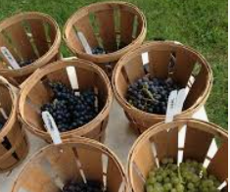
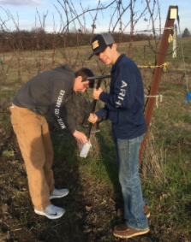
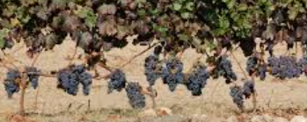
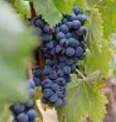
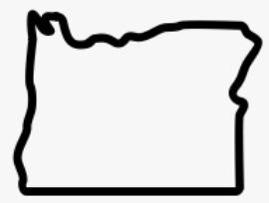
Part 2
Using AgExplorer.FFA.org, identify three careers you could have if you want to enter the viticulture industry and how that career fits.

- _____________________________________
  - How:

- _____________________________________
  - How:

- _____________________________________
  - How:
Think of a program you are currently a part of or have been in the past that has had a similar impact on you. Why did it impact you?

What impact has this program had on students who go through the Yamhill-Carlton agriculture program?

What role does the viticulture program play in the Yamhill-Carlton FFA?

How many bottles of wine are produced each year from the grapes the chapter produces?

- 120
- 976
- 1,440
- 1,468
What do students test to determine when they should harvest the grapes?

- ___________________
- ___________________

How large is the chapter’s vineyard?

- 1 acre
- 2 acres
- 3 acres
- 4 acres

The Yamhill-Carlton FFA chapter is in what state?

- Oregon
- Washington
- Maine
- California

Directions:
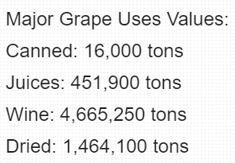
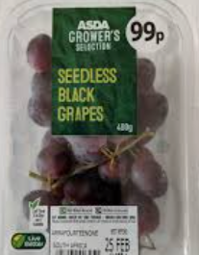
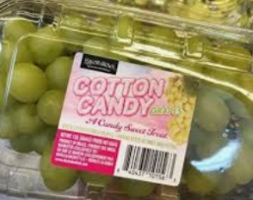
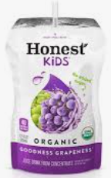
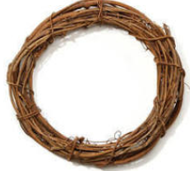
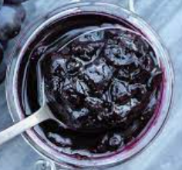
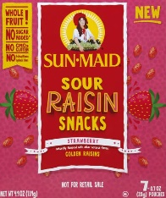
Grape production is a large component of the agriculture industry. Complete the following activities to learn more about grape production and the industry.
What surprises you about the use of grapes, as represented in your graph? Why?
The USDA National Agricultural Statistics Service (NASS) reported that the U.S. had 1,000,700 acres of grapes. Using the information below, develop a bar graph to visually represent the value of the most common grape uses. Be sure to label each axis.
Title: _____________________________________________
What impact do you think grape production has on the agriculture industry?
Circle the products below that come from the grape industry.
Part 3
Directions:
Table-grape production is a unique process with many steps required to ensure a useable product. Using the resource from Grapes from California (History), https://www.grapesfromcalifornia.com/community-outreach/grapes-in-the-classroom/#lesson-plans, study the steps in the production process and, in the space below, place them in the correct order to reflect the production process. Sketch a picture to represent each step.
Prune the vines

Buds swell and green leaves appear

Mean temperature rises

Sugar accumulation

Pick grape bunches

Shoots begin growing one or more inches per day.

Flowers bloom

Color change/translucency begins

Shipped
Flowers shatter

Tiny green grapes ripen into clusters

Ripening grapes begin to soften

Inspection

Placed in a cooled environment

Packed by hand
Do You Have Any Grapes?
Aligned to the following standards:
PS.03; PL-A.; PG-J.; CS-M.; AG-PL3; AGPB01.03; CCSS.RI.9-10.1; CCSS.SL.9-10.4; CCSS.RST.9.10.4; CCSS.WHST.9.10.4; CCSS.WHST.9.10.7; WHST.9.10.9; CRP.02; CRP.04; CRP.07; CRP.08
Directions:
To grow her SAE, Chloe had to learn how to grow, care for, and harvest grapes and grapevines. Complete the worksheet by examining the suggested resource and answering the questions below.
Suggested Resource:
- Growing Grapes in the Home Garden, https://extension.umn.edu/fruit/growing-grapes-home-garden

- List five facts about grapes.



- What should you consider when choosing what grape variety to grow?

- How much water do young grapes require? How do water needs change as the plants mature?

- Why should you reduce watering young grapes in the fall?
  - They are not growing so they do not need water.
  - It encourages the plant to harden-off.
  - It prevents the roots from freezing during the winter.
  - You should not reduce watering in the fall.

- What are the fertilizer needs of grape vines?

- True or False. Mulching around the base of the vine is beneficial. (If false, explain why.)

- Why is weeding around grape vines so important?

- What steps should you follow to harvest grapes?
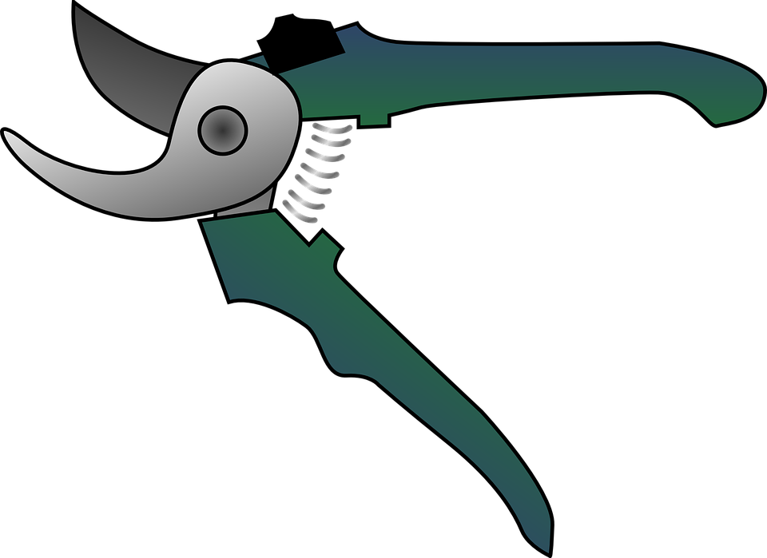

- How do you properly store grapes?

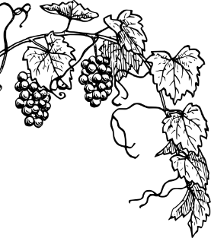

- Grape vines require care throughout the year. Complete the task chart below.

Month | Tasks
March
April, May
April – June
April – August
April – October
May, June
September, October
September, October
October, November

All About the Vine
Aligned to the following standards:
PS.03; PL-A.; PG-J.; CS-M.; AG-PL3; AGPB01.03; CCSS.RI.9-10.1; CCSS.SL.9-10.4; CCSS.RST.9.10.4; CCSS.WHST.9.10.4; CCSS.WHST.9.10.7; WHST.9.10.9; CRP.02; CRP.04; CRP.07; CRP.08
Part 1
Directions:
Answer the questions below as you watch the video “Grapevine Wreaths SAE | Chloe Jones,” available at https://vimeo.com/377181367.

What is a supervised agricultural experience?

What does Chloe do in the summer and in the winter to create her grapevine wreaths?
How does Chloe’s SAE impact her community?



What daily tasks is she responsible for?

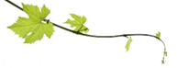
What things must be considered when decorating the wreath?

How do you make a grapevine wreath?

How has Chloe’s SAE grown?

What did she have to learn so she could grow her SAE?

Part 2
Directions:
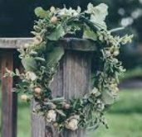
Now that you know how a grapevine wreath is made, let’s make our own wreath to take home! Watch the video “How to Make a Wreath – The Home Depot” found at https://youtu.be/V-7QVb3T-jI. During and after the video, complete the following activity sheet to plan out your wreath.
What would you do differently if you made a second wreath?
What did you enjoy about making your wreath?
What was the biggest challenge you experienced? Why?
Draw an image to help plan out your wreath. Be sure to include all the flowers, greenery and other supplies you listed in your Supplies list.
Supplies:

Tools/supplies:
- Grapevine wreath

Fresh Materials:
- Flowers:

- Greenery:

Develop a numbered procedure list to follow.
KEY: A Vineyard for a Classroom
Aligned to the following standards:
PS.03; PL-A.; PG-J.; CS-M.; AG-PL3; AGPB01.03; CCSS.RI.9-10.1; CCSS.SL.9-10.4; CCSS.RST.9.10.4; CCSS.WHST.9.10.4; CCSS.WHST.9.10.7; WHST.9.10.9; CRP.02; CRP.04; CRP.07; CRP.08
Part 1
Directions:
Read the article “A Vineyard for a Classroom,” available at FFA.org/news/a-vineyard-for-a-classroom/, and answer the following questions.
What four tasks do students complete in their vineyard?

- Trimming vines
- Testing soil
- Pruning
- Harvesting

What does viticulture mean?
Cultivating grape vines

The Yamhill-Carlton FFA chapter is in what state?

- Oregon
- Washington
- Maine
- California

How large is the chapter’s vineyard?

- 1 acre
- 2 acres
- 3 acres
- 4 acres

How many bottles of wine are produced each year from the grapes the chapter produces?

- 120
- 976
- 1,440
- 1,468
Using AgExplorer.FFA.org, identify three careers you could have if you want to enter the viticulture industry and how that career fits. Answers will vary.

- _____________________________________
  - How:

- _____________________________________
  - How:

- _____________________________________
  - How:
Think of a program you are currently a part of or have been in the past that has had a similar impact on you. Why did it impact you?
Answers will vary.

What impact has this program had on the students that go through the Yamhill-Carlton agriculture program?
Gives students skills and insight into an industry they may want to enter into in their future

What role does the viticulture program play in the Yamhill-Carlton FFA?
It teaches students about the cultivation and harvesting of grapes. This type of program can also be used in a chapter’s program of activities.

What do students test to determine when they should harvest the grapes?

- Test pH
- Test sugar levels

Part 2
Directions:
Grape production is a large component of the agriculture industry. Complete the following activities to learn more about grape production and the industry.
Canned Juices Wine Dried
5,000,000

1,000,000

500,000

100,000

50,000

10,000

0
Tons
What surprises you about the use of grapes, as represented in your graph? Why?
Answers will vary.
The USDA National Agricultural Statistics Service (NASS) reported that the U.S. had 1,000,700 acres of grapes. Using the information below, develop a bar graph to visually represent the value of the most common grape uses. Be sure to label each axis.
Title: Answers will vary.
What impact do you think grape production has on the agriculture industry? Answers will vary.
Circle the products below that come from the grape industry.
Directions:
Table grape production is a unique process with many steps required to ensure a useable product. Using the resource from Grapes from California (History), https://www.grapesfromcalifornia.com/community-outreach/grapes-in-the-classroom/#lesson-plans, study the steps in the production process and, in the space below, place them in the correct order to reflect the production process. Sketch a picture to represent each step. Images will vary.
Prune the vines

Buds swell and green leaves appear

Mean temperature rises

Sugar accumulation

Pick grape bunches

Shoots begin growing one or more inches per day.

Flowers bloom

Color change/translucency begins

Shipped
Flowers shatter

Tiny green grapes ripen into clusters

Ripening grapes begin to soften

Inspection

Placed in a cooled environment

Packed by hand

Prune the vines

Buds swell and green leaves appear

Mean temperature rises

Shoots begin growing one or more inches per day

Flowers bloom

Flowers shatter

Tiny green grapes ripen into clusters

Ripening grapes begin to soften

Color change/translucency begins

Sugar accumulation

Pick grape bunches

Inspection

Packed by hand

Placed in a cooled environment

Shipped

Do You Have Any Grapes?
Aligned to the following standards:
PS.03; PL-A.; PG-J.; CS-M.; AG-PL3; AGPB01.03; CCSS.RI.9-10.1; CCSS.SL.9-10.4; CCSS.RST.9.10.4; CCSS.WHST.9.10.4; CCSS.WHST.9.10.7; WHST.9.10.9; CRP.02; CRP.04; CRP.07; CRP.08
Directions:
To grow her SAE, Chloe had to learn how to grow, care for, and harvest grapes and grapevines. Complete the worksheet by examining the suggested resource and answering the questions below.
Suggested Resource:
- Growing Grapes in the Home Garden, https://extension.umn.edu/fruit/growing-grapes-home-garden

- List five facts about grapes.
Answers will vary, but could include the following:
Grapes are woody perennial vines.
Plant in full sun to provide the heat required to ripen the fruit.
Each vine needs about six feet of space.
Flowers and fruit develop on new shoots called canes.
It is possible to get fruit one year after planting.
Flowers are pollinated by wind and insects.
Vines can be trained to many decorative forms.
Annual pruning is very important to keep growth healthy each year.
Prune in spring before leaves emerge.

- What should you consider when choosing what grape variety to grow?
You need to consider what you want to do with the grapes: cover an arbor, make grape juice and jelly, eat fresh grapes or make wine. Once you know what you want to do with the grapes, then you examine the varieties and determine what will grow in your area.

- How much water do young grapes require? How do water needs change as the plants mature?

Young grapes require about 1/2 to 1 inch of water per week, depending on rainfall, for the first two years during the growing season. By the end of the second growing season, a trunk should be established, and your vine is likely to not need additional watering unless specific soil conditions (sandy, well drained) or prolonged drought dictate the need.

- Why should you reduce watering young grapes in the fall?
  - They are not growing so they do not need water.
  - It encourages the plant to harden-off.
  - It prevents the roots from freezing during the winter.
  - You should not reduce watering in the fall.

- What are the fertilizer needs of grape vines?
The first two or three years, each early spring, apply compost around the base of the vines. Grape vines grow vigorously and might need a nutrient boost each year. You may not have to do this as the vines mature; it all depends on what you observe. If the vines look vigorous and healthy, you might not need any fertilizer.

- True or False. Mulching around the base of the vine is beneficial. (If false, explain why.)
Mulching around the base keeps the soil too cool. Grapevine roots like to be warm.

- Why is weeding around grape vines so important?
This allows the soil to heat up early in the spring and maintain higher soil temperatures to encourage growth. When plants grow under vines, the soil temperature stays cooler. With grapes, this will delay growth in the spring.
- What steps should you follow to harvest grapes?

Clip full clusters off the vine with pruning shears or heavy scissors.

Handle clusters carefully.

Remove any discolored, injured or undesirable berries.

Cool them as soon as they are picked.

- How do you properly store grapes?
Store grapes in a refrigerator in a steady, consistent temperature. Cover grape clusters loosely with plastic to reduce moisture loss. Most grapes can be stored in the refrigerator for up to a week or two.
- Grape vines require care throughout the year. Complete the task chart below.

Month | Tasks
March | For existing vines, prune before growth starts.
April, May | Plant bare root grapevines as soon as soil can be worked.
April – June | Rub off any shoots that start growing lower down on the trunk.
April – August | Tie new growth to trellis as needed.
April – October | Inspect vines throughout the season to catch disease and insect problems.
May, June | Plant potted grapevines after threat of frost has passed.
September, October | As fruit ripens, watch for bird damage and cover with netting if needed.
September, October | Harvest fruit based on color and flavor.
October, November | Clean up all fallen leaves, fruit and debris.

All About the Vine
Aligned to the following standards:
PS.03; PL-A.; PG-J.; CS-M.; AG-PL3; AGPB01.03; CCSS.RI.9-10.1; CCSS.SL.9-10.4; CCSS.RST.9.10.4; CCSS.WHST.9.10.4; CCSS.WHST.9.10.7; WHST.9.10.9; CRP.02; CRP.04; CRP.07; CRP.08
Part 1
Directions:
Answer the questions below as you watch the video “Grapevine Wreaths SAE | Chloe Jones,” available at https://vimeo.com/377181367.

What is a supervised agricultural experience? An opportunity to gain hands on experience and skills.

What does Chloe do in the summer and in the winter to create her grapevine wreaths?
When the grapes have stopped growing, she cuts the grapevine, makes wreathes and decorates them.
Removes (harvests) the grapes
How does Chloe’s SAE impact her community?
When she harvests extra fruit, she gives it to the community. She also sells the wreaths in her community. She sells on social media, to neighbors and sometimes at the farmers market.

What daily tasks is she responsible for?
Waters if it is too dry

Mows if needed, making sure not to knock off fruit

Rakes under the vines to keep area clean and prevent disease

Picks the fruit when it is ripe

Cuts the vines and removes all the leaves

What things must be considered when decorating the wreath?
Some customers specify what they want on their wreaths, but mostly you need to bring your own ideas. You should play around with different decorative items and place them (without gluing) on the wreath to see how it looks.

How do you make a grapevine wreath? Twist the vines and wrap them together to make a circle

Keep wrapping the vines until you have the desired thickness

How has Chloe’s SAE grown?
When she started, she only decorated wreaths — she didn’t grow the vines and grapes herself.

What did she have to learn so she could grow her SAE?

She had to learn everything about grapes and grape vines. She has to know when to harvest the grapes and when the vines have stopped growing so she can cut them.

Part 2
Directions:
Now that you know how a grapevine wreath is made, let’s make our own wreath to take home! Watch the video “How to Make a Wreath – The Home Depot” found at https://youtu.be/V-7QVb3T-jI. During and after the video, complete the following activity sheet to plan out your wreath.
What would you do differently if you made a second wreath? Answers will vary.
What was the biggest challenge you experienced? Why? Answers will vary.
What did you enjoy about making your wreath?
Answers will vary.
Draw an image to help plan out your wreath. Be sure to include all of the flowers, greenery and other supplies you listed in your Supplies list. Answers will vary.
Supplies:

Tools/supplies:
- Grapevine wreath
- Wire
- Wire cutters

Fresh Materials:
- Flowers:
Answers will vary.

- Greenery:
Answers will vary.
Develop a numbered procedure list to follow.

Answers will vary but should contain these basic concepts.

- Gather your materials.
- Select a base for your wreath.
- Trim fresh materials down.
- Make fresh material into bundles.
- Attach bundles using wire.
- Decorate.
- Attach a ribbon bow to hang.

