Listen Closely
Created: 04/2017 by the National FFA Organization

Student Learning Objectives:
After completing these activities, students will…
- Compare and contrast listening and hearing.
- Develop a plan for becoming a good listener.

Time Required: 50 minutes
Resources:
- FFA.org
- 2015-2016 National FFA Vice President Abrah Meyer’s Retiring Address, https://vimeo.com/188320297
3. TED Blog - http://www.ted.com/talks/julian_treasure_5_ways_to_listen_better

Equipment and Supplies Needed:
- A copy of the “Listening > Hearing” worksheet for each student.
- A copy of the “Listening Takes Action!” worksheet for each student.
- Pencil
- Internet access to view the video.

This quick lesson plan would work well as:
- An activity to have students compare and contrast listening and hearing.
- A personal growth development activity.

Student Activity Sheets:
Direct access to student activity sheets without lesson plan or answer key for easy upload to learning management systems or printing for classwork.
https://ffa.box.com/s/vsrycfjxypy9k1jafugk8eovdh2sdi08 (Word)
https://ffa.box.com/s/ww5x8a6p7ryzlalw3t6z7mtctmvrq4kn (Non-Designed)
https://ffa.box.com/s/zutidqmbj8we3fzv05hw9jr21n139g06 (PDF)

These activities are aligned to the following standards:
FFA Precept
- FFA.PL-A.Action: Assume responsibility and take the necessary steps to achieve the desired results, no matter what the goal or task at hand.
- FFA.PL-D.Character: Conduct oneself appropriately in relation to others regardless of the situation.
- FFA.PL-F.Continuous Improvement: Accept responsibility for learning and personal growth.
- FFA.PG-K.Emotional Growth: Share and express healthy feelings and emotions.
- FFA.CS-M.Communication: Effectively interact with others in personal and professional settings.
- FFA.CS-O.Flexibility/Adaptability: Be flexible in various situations and adapt to change.
Common Core – Writing
- CCSS.ELA-Literacy.W.9-10.2 Write informative/explanatory texts to examine and convey complex ideas, concepts, and information clearly and accurately through the effective selection, organization, and analysis of content.
Common Core - Speaking and Listening
- CCSS.ELA-Literacy.SL.9-10.1 Initiate and participate effectively in a range of collaborative discussions (one-on-one, in groups, and teacher-led) with diverse partners on grades 9-10 topics, texts, and issues, building on others' ideas and expressing their own clearly and persuasively.
- CCSS.ELA-Literacy.SL.9-10.4 Present information, findings, and supporting evidence clearly, concisely, and logically such that listeners can follow the line of reasoning and the organization, development, substance, and style are appropriate to purpose, audience, and task.
AFNR Career Ready Practices
- CRP.04. Communicate clearly, effectively, and with reason. Career-ready individuals communicate thoughts, ideas and action plans with clarity, whether using written, verbal and/or visual methods.
Partnership for 21st Century Skills
- Communication
- Critical Thinking and Problem Solving
- Initiative and Self-direction
- Leadership and Responsibility
- Social and Cross-Cultural Skills
- Think Creatively

Lesson Plan:
- Introduction: To help introduce the students to this lesson, play this activity game.
  - Introduce the activity by stating: “Today we are going to focus on listening and hearing. This introductory activity will help you to learn the importance of listening and will show you why selective listening can be a bad habit. Selective listening is the act of hearing and interpreting only parts of a message that seem relevant to you while ignoring the rest. Selective listeners sometimes form opinions or arguments before they have listened to the whole story. (https://blog.udemy.com/listening-skills-exercises/)
  - Activity: Compose a list of random objects or ideas, all similar in theme. For example: turkey, lettuce, tomato, etc. The list should be long, maybe 15-20 words, and have some repeated words. The moderator should read this list to the group, and then allot them 30 seconds to write down as many words as they can remember. Most people will remember the word that was repeated the most, and a notable amount will most likely write down words that were obvious but not actually stated in the list. For example: break, sandwich or food. (https://blog.udemy.com/listening-skills-exercises/)

- Activity 1: Each student needs a copy of the handout “Listening > Hearing.”
Show the video Retiring Address: Abrah Meyer. The direct URL is https://vimeo.com/188320297.
  - Have students reflect on the video by completing the worksheet.

- Activity 2: Each student needs a copy of the handout “Listening Takes Action!”
  - This activity can be completed after the video and “Listening > Hearing” worksheet have been completed. This activity is meant to help students dig deeper and to develop a plan to become a good listener.

4. Follow Up: Have students reflect on the lesson by responding to the following questions:
1. What are three facts you learned from today’s lesson?
2. How can you take what you have learned today and apply it in your future career?

5. Leveling Up: To dive deeper into the meaning of the lesson, have the students watch the Julian Treasure: 5 ways to listen better video on the TED Blog “8 talks on the importance of listening, and how to do a much better job of it.” The direct link to the video is http://www.ted.com/talks/julian_treasure_5_ways_to_listen_better. Have students reflect on the video by answering the following questions:
1. What are the 5 ways to listen better?
2. What are some specific examples from your daily activities where you can improve your listening skills?

Listening > Hearing
Directions:
Part 1
Pair with a partner to complete the worksheet. Read each quote aloud and discuss each other’s interpretations of the quotes. Listen to what your partner is saying and respond below.

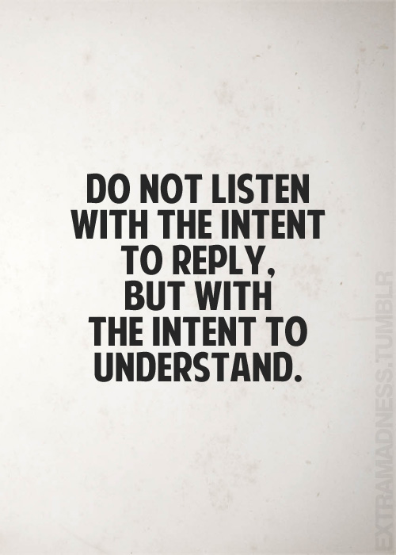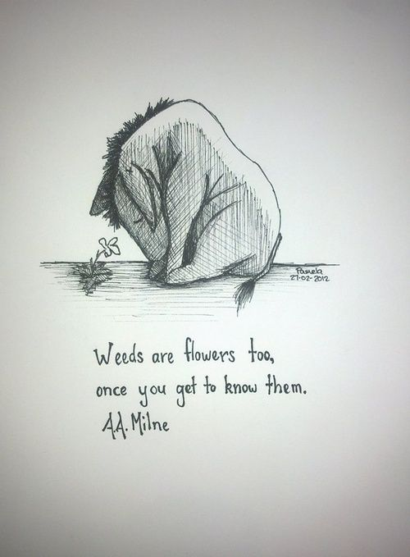

Aligned to the following standards:
FFA.PL-A.; FFA.PL-E.; FFA.PG-J.; FFA.CS-M.; CRP.04.; CCSS.ELA.W.9-10.2;CCSS.ELA.SL.9-10.4;

Part 2
With your partner, compare and contrast listening and hearing. Identify and explain 3 reasons for each.

Listening and Hearing

Alike: Different:

Aligned to the following standards:
FFA.PL-A.;FFA.PL-D.;FFA.PL-F.;FFA.PG-K.;FFA.CS-M.;FFA.CS-O.; CRP.04.;CCSS.ELA-W.9-10.2.;CCSS.SL.9-10.1.;CCSS.SL.9-10.4.;MP1;

Part 2 Answer Key (Possible answers)
With your partner, compare and contrast listening and hearing. Identify and explain 3 reasons for each.

Listening and Hearing

Alike: Different:

-Both build communication -Our brains can process between 350 and 500
words per minute. We only listen to 20 percent
of those words.

-We are quick to respond and slow to listen.

-Listening builds relationships.

-When you listen, you learn.

-Hearing is an act of courtesy; listening is an act of
love.

-Listening requires action.

-Listening is more than hearing.

Aligned to the following standards:
FFA.PL-A.;FFA.PL-D.;FFA.PL-F.;FFA.PG-K.;FFA.CS-M.;FFA.CS-O.; CRP.04.;CCSS.ELA-W.9-10.2.;CCSS.SL.9-10.1.;CCSS.SL.9-10.4.;MP1;

Aligned to the following standards:
FFA.PL-A.;FFA.PL-D.;FFA.PL-F.;FFA.PG-K.;FFA.CS-M.;FFA.CS-O.; CRP.04.;CCSS.ELA-W.9-10.2.;CCSS.SL.9-10.1.;CCSS.SL.9-10.4.;MP1;

Listening Takes Action!
directions:
With a partner, develop a plan to become a better communicator and listener. Answer the questions below.

Part 1: Answer the first two questions to help you brainstorm components of your plan.

1) Why it is important to be a good listener? Answer in at least 3-4 sentences.

2. What are qualities of a good listener? Identify at least 5, and explain why you think they are good qualities.

Part 2: Develop your plan.
1. What are steps to being a good listener? 2. How can you practice being a good listener?

