Achieve Your Wildest Dreams!
Created: 02/2017 by the National FFA Organization

Student Learning Objectives:
After completing these activities, students will…
- Recongize the importance of effective creativity and self-motivation.
- Demonstrate self-motivation.
- Demonstrate creativity.

TIME REQUIRED: 30 minutes
Resources:
- FFA.org
Equipment and Supplies Needed:
- Search engine of your choice
- Poster board or construction paper
- Markers or crayons
- Glue
- Scissors
- Magazines that the photos can be cut out

This quick lesson plan would work well with:
- Team-building activities
- Communication activities

These activities are aligned to the following standards:

FFA Precept
- FFA.CS-M.Communication: Effectively interact with others in personal and professional settings.
- FFA.CS-N.Decision Making: Analyze a situation and execute an appropriate course of action.
Common Core - Language
- CCSS.ELA-LITERACY.L.9-10.6 Acquire and use accurately general academic and domain-specific words and phrases, sufficient for reading, writing, speaking, and listening at the college and career readiness level; demonstrate independence in gathering vocabulary knowledge when considering a word or phrase important to comprehension or expression.
Next Generation Science Standards
- HS-ETS1-3 Evaluate a solution to a complex real-world problem based on prioritized criteria and trade-offs that account for a range of constraints, including cost, safety, reliability, and aesthetics as well as possible social, cultural, and environmental impacts.
AFNR Career Ready Practices
- CRP.01. Act as a responsible and contributing citizen and employee. Career-ready individuals understand the obligations and responsibilities of being a member of a community, and they demonstrate this understanding every day through their interactions with others.
- CRP.04. Communicate clearly, effectively, and with reason. Career-ready individuals communicate thoughts, ideas and action plans with clarity, whether using written, verbal and/or visual methods.
Partnership for 21st Century Skills
- Collaboration
- Communication
- Social and Cross-Cultural Skills
- Work Creatively with Others

Activity:
Introduction: As professionals in the workplace, it is important to dream about your future. What are some of your dreams? If you had zero limitations, what would you do with your life? Today, we will create dream boards. A dream board is something that you can organize your dreams on, through the use of photos and words. This can be done digitally or on paper and should reflect what you are striving to achieve. Many individuals place completed dream boards in places where they can be seen everyday to remind them of what they are trying to achieve.

- Activity #1: Creating a Dream Board
  - Have the students design their dream boards reflecting their dreams and desires in life.
  - Have the students each create a digital or paper dream board and post it where they can see it daily.
    - If they create a digital dream board, they can utilize PowerPoint or Google slides to organize their ideas.
    - If they create a paper version, suggest making it locker-size so they can hang it in their lockers and see it each day.
  - Have the students search for online photos or photos in magazines that show others doing what they dream to do. There are examples posted below.
  - Have each student explain their dream board to peers during a class discussion.

- Activity #2: Conversations
  - Have the students compare their dream boards.
  - Ask the following questions:
    - What are your dreams?
    - How can you achieve these dreams?
    - Are your dreams realistic?
    - If your dreams aren’t realistic, what can you do to close the gap?

Leveling Up: To add another dimension to the activities, have the students show you a photo of their dream boards being used in their daily lives. Ask them how they are working to achieve the dreams they have displayed.

Conclusion: Each of us has dreams and aspirations that we are constantly striving to achieve. It is easier to make these dreams a reality if we are constantly being reminded of what we are striving for.

Example Dream Boards
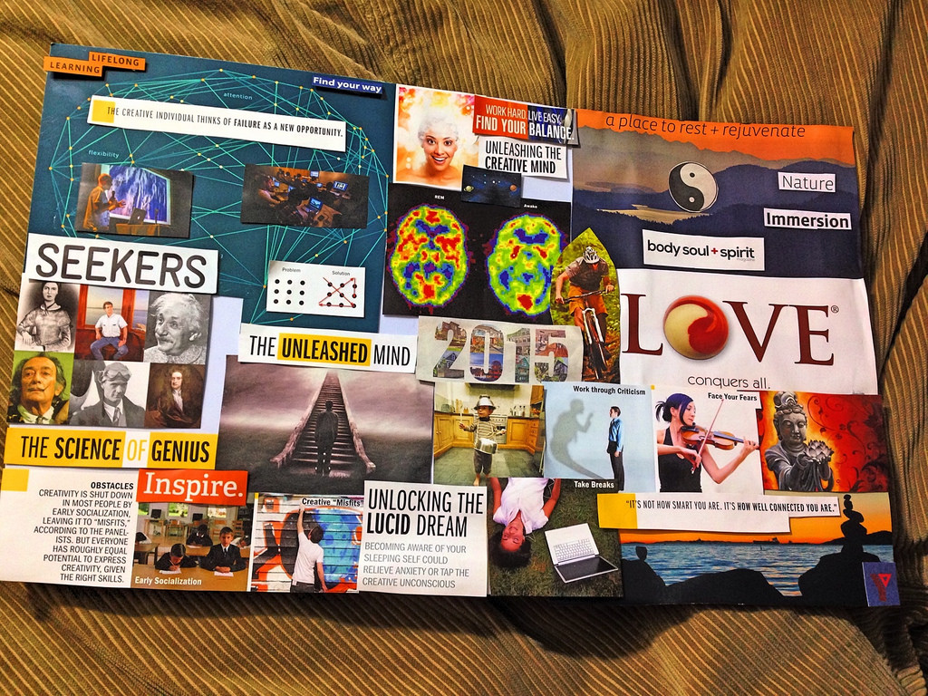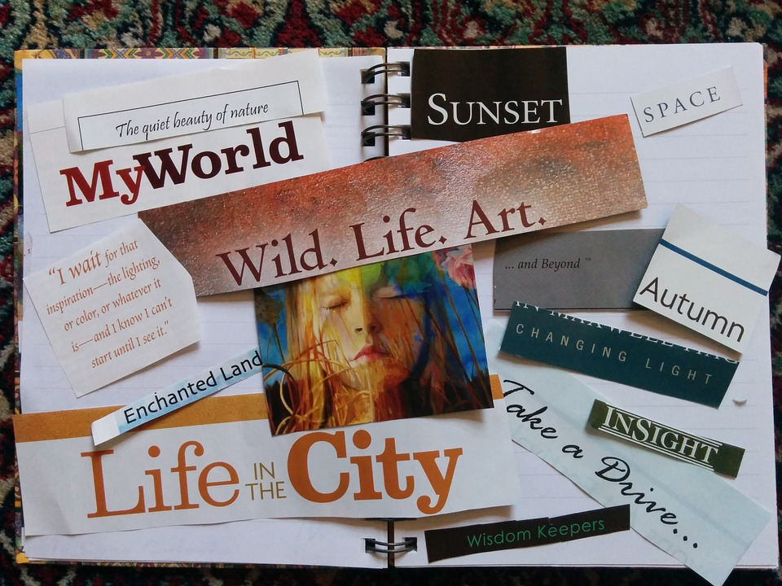

Exit Slip: Achieving Your Wildest Dreams!

NAME: ___________________________________________________________________

- What are three dreams you had on your dream board?

- What words did you put on your dream board?

- Where are you planning to post your dream board?

- What did two of your classmates have on their dream boards?

- What was one major takeaway you had from today’s class?

