
Activity 12: How Everyone Contributes
Directions:
Watch and/or read each story below and complete the activities.

Story | Synthesis | Reflections and Thoughts
Read the article “FFA Alumna Shares Her Mental Health Struggle.” | - What did Maddison do when she felt helpless?  - What is the second leading cause of death in individuals aged 10 to 24? ____________________  - What has helped Maddison through her struggles?
Watch the video “Dairy Heifers SAE | Jonathan Jones.” | - How does Jonathan communicate?  - What challenges do you think arise?  - What skills has Jonathan gained from his SAE?
Read the article “Differently Abled, Similarly Involved.” | - What observance happens on December 3 each year?  - What is the purpose of this observance?  - How has the agriculture industry impacted each of these individuals?
Read the article “FFA Member Enjoys the Show.” | - Where does Caroline live?  - How has Caroline become involved in the agriculture industry?  - What impact has the agriculture industry had on Caroline?


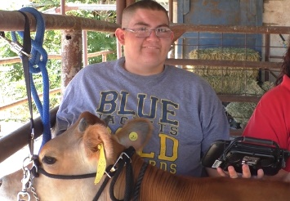
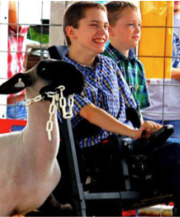



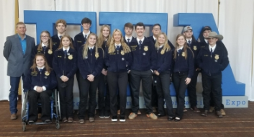
How are each of the individuals similar?

How has each of the individuals above contributed to agriculture in their own way?
How would society and the agriculture industry be different if individuals from all backgrounds, abilities and professional experiences were not a part of the industry?
What are three things you learned through this activity?

What are two things you will share will a friend or family member about what you have learned?

Summarize what you have learned in one word.
How does your unique perspective and/or background contribute to the agriculture industry?

