
Activity 13: Gaining a Global Perspective
Directions:
Today, you will assume the role of a country. Your class will turn into a global summit meeting during this activity. All countries will meet together on ______________ (date due). It is your job to make sure your opinion on the essential question is understood by others attending the summit. Your group will research the essential question and prepare a presentation that represents the stance of the role you have been assigned. This presentation will be shared at the summit. You will then ask questions of the other groups. Using the diagram provided below, fill in your notes to prepare for the summit meeting. Be sure to use reputable sources and think about the essential question from all angles to prepare yourself for the questions you may receive. You will be required to speak for three to five minutes. You must cover the following topics as they relate to the essential question: plants, animals, food and the environment.
Essential Question:
Which country should direct the future of the agriculture industry for our entire world?
How do you, as a country, feel about this question? (Use the stakeholder profile sheet to help answer this question.)
Describe how agriculture impacts the environment and local ecosystems.
What does animal production in your country look like?
What is the overall crop and plant production in your country?
How is food produced and packaged in your country?
Other Notes:
Country:
____________________
Describe the consumers in your country. How many are there? What food trends, preferences and regulations exist?

Directions:
Using the boxes below, record information, research points, questions, etc. that you can use to guide your questions for other countries, your responses to other countries and your overall understanding of each country. (Put yourself in that country’s “shoes” when researching information for the boxes.)
Country 1: _________________

Country 5: _________________
Country 4: _________________
Country 2: ________________

Country 3: ___________________

Country 6: __________________
Country 7: _____________________
Summarize your thoughts here by answering the essential question.
Who Decides at the Global Level? Profile Sheet
France
Commodities: wheat, corn, barley, oats

Government Structure:
Who do they trade with?

Culture Description:
Brazil
Commodities: coffee, soybeans, wheat, rice, corn, sugar cane, cocoa, citrus, beef

Government Structure:
Who do they trade with?

Culture Description:
Democratic Republic of Congo
Commodities: cassava, plantains, maize, coffee, sugar cane, cocoa, rice, rubber

Government Structure:
Who do they trade with?

Culture Description:
Philippines
Commodities: rice, corn, coconut, sugar cane, bananas, pineapple, coffee, mangoes, tobacco

Government Structure:
Who do they trade with?

Culture Description:
Russia
Commodities: wheat, barley, sunflower seed, oats potatoes, rye

Government Structure:
Who do they trade with?

Culture Description:

India
Commodities: milk, pulses, jute, rice, sugar cane, cotton, spices

Government Structure:
Who do they trade with?

Culture Description:

Turkey
Commodities: hazelnuts, chestnuts, apricots, figs, cherries, olives, quinces, tobacco, tea

Government Structure:
Who do they trade with?

Culture Description:
Japan
Commodities: rice, soybeans, wheat, barley

Government Structure:
Who do they trade with?

Culture Description:

Australia
Commodities: beef, wool, cotton, wheat, mutton, lamb

Government Structure:
Who do they trade with?

Culture Description:
China
Commodities: rice, millet, barley, cotton, potatoes, sugar beets, oilseeds, soybeans, corn

Government Structure:
Who do they trade with?

Culture Description:

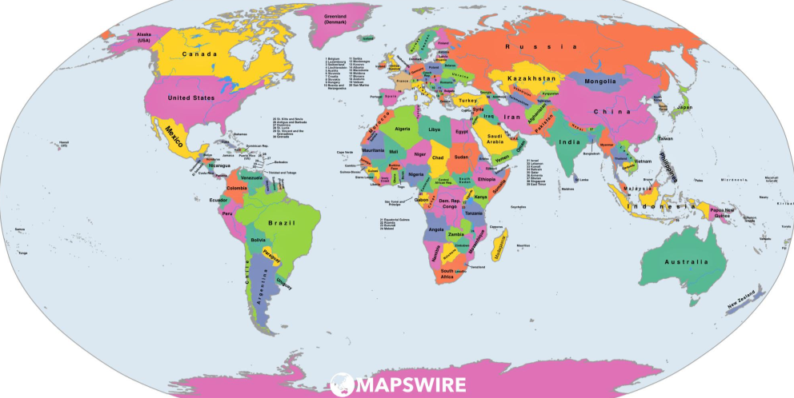
Where Do We Go from Here?
Directions:
After going through the forum, complete the following activity. Be ready to share your responses with the class!





- Circle, in green, how you felt throughout this experience.
- Circle, in blue, how you feel at the conclusion of this experience.

3. Record two key thoughts you had during this process.
What was your group’s greatest accomplishment during this experience? Why?
What was your group’s greatest challenge during this experience? Why?
Describe why you had these thoughts and feelings during the activity and why you feel as you do now.
What, specifically, will you take away from this experience? How will you use this in the future?
Answer the essential question and explain the thought process behind your answer. Which country should direct the future of the agriculture industry?

Activity Rubric
Category | Excellent  (20–15 points) | Good  (14–10 points) | Needs Improvement  (9–5 points) | Poor  (5–0 points) | Points Earned
Information | A minimum of five facts per category was presented clearly and accurately and covered animals, food, plants and the environment. | A minimum of four facts per category was presented accurately and covered animals, food, plants and the environment but lacked clarity. | A minimum of three facts for each category was presented. Information lacked accuracy and clarity. One of the required categories (food, animals, plants or the environment) was missing. | Less than three facts for each category were presented. Information significantly lacked clarity and accuracy. Multiple required categories (animal, plant, food and the environment) were left out.
Organization | All information is clearly tied to an idea and organized in a tight and logical fashion. | 75% of the discussion points were clearly tied to an idea and organized in a tight, logical fashion. | 50% of the discussion points were clearly tied to an idea but had limited organization. | Less than 50% of the discussion points were tied to an idea, and all arguments lacked organization.
Participation | Participated throughout the meeting by presenting and asking and answering questions; engaged in final discussion | Participated throughout the experience but responses were short and somewhat limited | Participated in many of the aspects of the meeting but did not participate in one of the parts (presentation, questioning, discussion) | Little to no participation in two or more components (presentation, questioning, discussion) of the meeting
Effectiveness of Presentation  (Creativity, quality and power, clear with right pace and word pronunciation, no distractions, appropriate gestures, poised) | Preparation is very evident with little distraction from content due to hand gestures, posture or word pronunciation. | Some preparation is evident. Some distracting hand gestures, posture or word pronunciation was used. | Little preparation is evident. Distracting hand gestures, posture and word pronunciation were used throughout the presentation. | No preparation is evident.  Many distracting hand gestures, postures and word pronunciations were used.
Time: Two to five minutes | Presented for four to five minutes | Presented for three to four minutes | Presented for two to three minutes | Presented for less than two minutes
Respect | All statements, body language and responses were respectful. Presenters used appropriate language. | Statements and responses were respectful. Presenters used appropriate language, but once or twice body language was not appropriate. | Most statements and responses were respectful. Presenters used appropriate language, but there was one sarcastic remark. | Statements, responses and/or body language were borderline appropriate. Some sarcastic remarks were made.
Questions  - Appropriate response  - Knowledge based on facts/research  - Appropriate questions asked of others | Responses and questions were clear, concise and based on facts, showing research had been done. | Responses and questions were clear and concise; however, facts and research may have been lacking. | Responses and questions were not quite clear or concise. Little to no research-based facts were utilized. | Responses were very vague. Responses utilized little to no research-based facts to support statements.
Total: ____________
Comments:

