What’s the Difference?
Aligned to the following standards:
FFA.PL-A; FFA.PL-C; FFA.PL-E; FFA.PL-F; FFA.PG-J; FFA.CS_N; CCSS.ELA.SL.9.10.1; CCSS.ELA.RST.9-10.7; CCSS.ELA.WHST.9.10.4; CCSS.ELA.RST.9.10.7; MP1; MP5; MP6; CRP.02; CRP.04; CRP.06; CRP.07; CRP.08
Part 1
Directions:
Watch the video “Discussion vs. Conclusion: Know the Difference,” available at https://youtu.be/CI2YZtLLXZI. While watching the video, complete the following activities.
- The discussion section requires you to think about the ___________________ of what you have done.

- An effective discussion section tells the reader what your study _______________ and why it is ___________________.

- Where does the discussion section go in a scientific research paper?

- What should be included in your discussion section to make it engaging and effective?

- A conclusion is a _____________________ of everything that you have ________________ thus far.

- In the conclusion section, we ___________________the reader of what they just read.

- What should be included in a conclusion section?

Using your own words, compare and contrast the results, discussion and conclusion section of another research paper.




Part 2
Directions:
At this point, we are going to develop a discussion and conclusion for your own scientific research study. Follow the steps below.
Discussion Section:
- What do your results mean?

- What was important about your study, and what were the major findings?

- How do these findings relate to what others have done? (Hint: Refer to your introduction and literature review!)

- What are the limitations (weaknesses) of your study?

- Were there any surprises with your results?

- What suggestions do you have for future research?

Now Put It All Together: Discussion
Conclusion Section:
- What is your research question(s) and hypothesis?

- What are the major findings?

- What contribution does your study make to the industry?

- What recommendations would you make for future research?
What was the easiest part of writing the discussion? Why?
What was the hardest part of writing the discussion? Why?

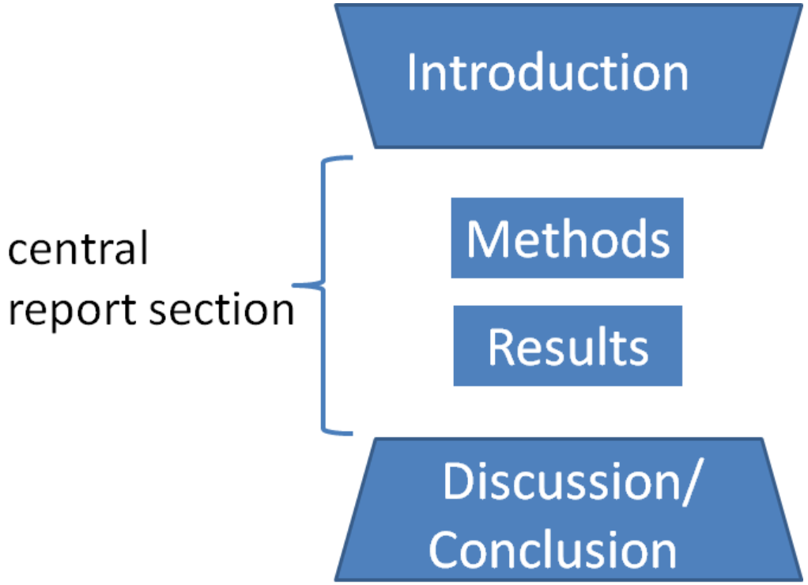

Now Put It All Together: Conclusion
Overall, what are the major components of a discussion and conclusion section of a scientific research study?

Overall, what is the purpose of a discussion and conclusion? Why are these two components required in a research paper?

