Activity Templates: Create Your Brand-Personal Development
Created: 03/2016 by the National FFA Organization

Student Learning Objectives
After completing these activities students will…
- Develop a personal brand/slogan to use when setting goals.
- Demonstrate confidence when speaking in front of a group of people.
- Explore brands, logos and slogans of major companies.
Time Required: 30 minutes
Resources:
- FFA.org
- http://www.hongkiat.com/blog/77-catchy-and-creative-slogans/
Equipment and Supplies Needed:
- Each student should have access to paper and a writing utensil.

Suggested Use:
Incorporate any of these activities into the class curriculum before and during the following:
- Team building activities
- Collaborative or group projects

These activities are aligned to the following standards:

FFA Precept
- FFA.PL-E.Awareness: Understand personal vision, mission and goals.
Common Core- Speaking and Listening
- CCSS.ELA-LITERACY.SL.9-10.1 Initiate and participate effectively in a range of collaborative discussions (one-on-one, in groups, and teacher-led) with diverse partners on grades 9-10 topics, texts, and issues, building on others' ideas and expressing their own clearly and persuasively.
AFNR Career Ready Practices
- CRP.01. Act as a responsible and contributing citizen and employee. Career-ready individuals understand the obligations and responsibilities of being a member of a community, and they demonstrate this understanding every day through their interactions with others.
- CRP.04. Communicate clearly, effectively, and with reason. Career-ready individuals communicate thoughts, ideas and action plans with clarity, whether using written, verbal and/or visual methods.
- CRP.12. Work productively in teams while using cultural/global competence. Career-ready individuals positively contribute to every team, whether formal or informal.
Partnership for 21st Century Skills
- Collaboration
- Communication
- Social and Cross-Cultural Skills
- Work Creatively with Others

activities:
Companies develop a brand that helps drive them into the future and establish credibility among the general public. This brand is often seen in the form of a logo or slogan and is carried throughout the way the company does business. It is how the company is reconigzed and makes it easily identifiable.

Just as a company has a brand, it is important for individuals to develop a personal brand. This brand can help an individual set goals and direction for their life, and also portray a good image when interacting with others.

Activity #1: Guess the Slogan
- Using the slogans below, read them aloud and have students write down which company has that slogan. You can expand on this by having students complete the “Slogan/Logo Match” worksheet.
    - “It’s finger lickin’ good!” (KFC)
    - “Think small” (Volkswagon)
    - “Outwit. Outplay. Outlast.” (Survivor TV Series)
    - “Save Money. Live Better.” (Walmart)
    - “Innovation” (3M)
    - “Live in your world. Play in ours.” (PlayStation2)
    - “The happiest place on earth.” (Disneyland)
    - “Impossible is nothing.” (Adidas)
    - “Share moments. Share life.” (Kodak)
    - “I’m lovin’ it.” (McDonalds)
    - “Just do it.” (Nike)
    - “Eat fresh” (Subway)
    - “Good to the last drop.” (Maxwell House)
    - “Have it your way.” (Burger King)
    - “Melts in your mouth, not in your hands.” (M&M’s)
    - “Because you’re worth it.” (L’Oreal)
    - “Fly the friendly sky.” (United Airlines)
    - “Can you hear me now?” (Verizon)
    - “Bet you can’t eat just one.” (Lays Potato Chips)
    - “There are some things money can’t buy. For everything else, there’s ____.” (MasterCard)
  - After reading the list of slogans, go through and say the correct answer. Have students determine how many they got correct.
  - At the bottom of their piece of paper, have students write down the importance of a company having a slogan. Additionally, have them add what makes some slogans more memorable than others.
  - With a partner, have the students share their answers.

Activity #2: Create Your Own Slogan
  - On a piece of paper, have students brainstorm ideas for their own personal slogan. This slogan should refelect who they are as an individual.
  - Beyond the slogan, students should write down how they want to be perceived by others, which may help them think of a personal slogan.
  - Using some of the guidelines below, have students develop their own slogan.
    - Keep it simple.
    - Keep it short (five words or less, ideally).
    - Be honest (should be a good reflection of who you are).
    - Make it exciting.

“Leveling Up” Activity: Using the Slogan
Some companies make their slogan well-known, while others do not publicize it nearly as much. Either way, every company has a mission or a purpose, often portrayed in their slogan. As individuals, it is just as important to have guiding principles that help move us into the future. A slogan is something that can easily be remembered, but holds a lot of weight.

- Ask for a few examples of slogans from the class.
- Have students share their slogan with at least five other students.
- As a class, brainstorm ideas on how you can use your personal slogan when interacting with others, when applying for jobs, and in professional settings.
    - Guiding ideas: Put your slogan on your business card, incorporate it into a cover letter, use it during a job interview when they ask to describe yourself.
- What does this mean for social media?
    - Class discussion on how a personal slogan could be used on social media.
- Exit ticket: Students write down their slogan on a notecard or post-it and hand it in on their way out the door.

Name __________________________

Create Your Brand: Slogan/Logo Match
Match the logo with the correlating slogan.


1. a. “Just Do it.”
b. “Finger Lickin’ Good!”
c. “Go Further.”
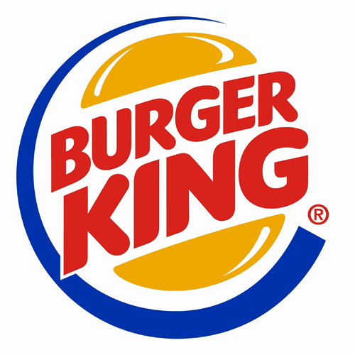
2. d. “Let’s Go places.”
E. “Happiest Place on earth.”
F. “I’m Lovin It.”

3. G. “Bet You Can’t Have just one.”
H. “Think different.”
I. “Have it your way.”

4. J. “Impossible is nothing.”

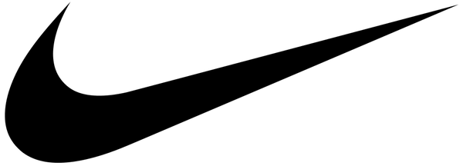
5.

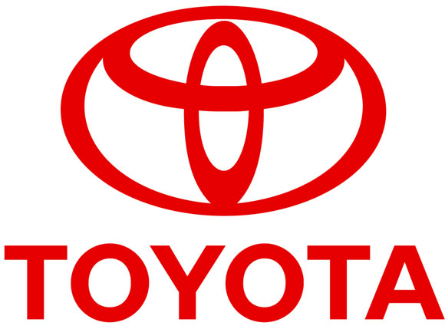
6.


7.


8.


9.

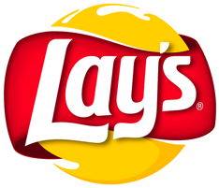
10.

Name ____KEY________

Create Your Brand: Slogan/Logo Match
Match the logo with the correlating slogan.

1. a. “Just Do it.”
b. “Finger Lickin’ Good!”
c. “Go Further.”
2. d. “Let’s Go places.”
E. “Happiest Place on earth.”
F. “I’m Lovin It.”
3. G. “Bet You Can’t Have just one.”
H. “Think different.”
I. “Have it your way.”
4. J. “Impossible is nothing.”

5.

Key:
- J
- I
- C
- H
- A
- D
- E
- B
- F
- G
6.

7.

8.

9.

10.

