Food Products and Processing SAEs
Created: 04/2026 by the National FFA Organization
Description of Lesson: Addison Kennon processes jalapenos as part of her supervised agricultural experience (SAE). She grows and sells jalapenos locally, focusing on food safety and proper canning techniques she learned from her mother. Students will watch a video on Addison’s SAE and explore how they could begin their own food processing SAE.
Student Learning Objectives:
After completing these activities, students will …
- Examine the components of a jalapeno food products and processing SAE.
- Brainstorm crops that could be grown and processed into food products locally.
- Create a plan for a new food product processing SAE.

Suggested Grade Level:
Grades 9 and 10 (This lesson is written so instructors can scale up or down based on class needs.)

Suggested Time: 60 minutes (*Time requirements may vary based upon student understanding and class schedule.)
Resources/References:
- Video: "Growing and Processing Jalapenos SAE," https://vimeo.com/1148063426
Related Resources:
- Food Science and Technology CDE Classroom Resource, https://FFA.app.box.com/folder/49054216573?s=44or7l2ixkkxypfyaubcz2si9di0bxtf
- SAE Video, "Lindsay, Eric and Kailey Lipka - School Garden and Food Dishes," https://FFA.box.com/s/znit188rt5o0gz2stdvcpqm8wr3smv02
- Food Products and Processing SAE Idea Cards (2025 Version), https://FFA.box.com/s/4f4qjc22yw751avj36vb8dv7j6r2kqgf
- Food Products and Processing SAE Idea Cards (2018-24 Version), https://FFA.box.com/s/omi0y5emg3j6ohwx8mv5ym1g7obbit5a
- AgExplorer Culver's Virtual Field Trip, AgExplorer.FFA.org/virtual-field-trips/fresh-frozen-custard-careers-from-dairy-to-dish/
- AgExplorer Cargill Virtual Field Trip, AgExplorer.FFA.org/virtual-field-trips/the-science-behind-your-food/

Equipment and Supplies Needed:
- A copy of the “Pepper Processing” student activity sheet for each student
- A copy of the “Processing Plan” student activity sheet for each student
- Internet access to play the video in real time or embed it in a PowerPoint ahead of time

Vocabulary:
- Brine
- Food Safety
- Pressure-canning
- Processing
- SAE
- Sterile
Cross-Curricular Connections:
Science | English/Language Arts
Explore the process of turning a raw agricultural product into a food product. | Create a written plan for starting a new food product and processing SAE.

SAE and FFA Connections
- Food Science and Technology CDE, FFA.org/participate/cdes/food-science-and-technology/
- Proficiency Areas: Agricultural Processing, Agriscience Research - Food Products and Processing Systems Research, Vegetable Production, FFA.org/participate/awards/proficiencies/
- Foundational SAE Connections: Career Exploration and Planning, Workplace Safety, Agricultural Literacy
Student Activity Sheets:
Direct access to student activity sheets without lesson plan or answer key for easy upload to a learning management system or printing for classwork.

Link (Word) https://ffa.box.com/s/xepvz62vurc1mq49nix0m2zrgi8bfvvm
Link (PDF) https://ffa.box.com/s/a73xb3r90y5fohyiowkb9ugj8rkroary
Link (Google) https://docs.google.com/document/d/1mxzN-gDTbC0JKVnq3fEfZIlthQegYT5EujovvhwcG8k/copy

These Activities Are Aligned to the Following Standards:
AFNR Performance Element
- FPP.01. Develop and implement procedures to ensure safety, sanitation and quality in food product and processing facilities.
- FFPP.03. Select and process food products for storage, distribution and consumption.
- FPS.05. Describe career opportunities and means to achieve those opportunities in each of the Agriculture, Food and Natural Resources career pathways.
FFA Precept
- FFA.PL-A.Action A1. Work independently and in groups to get things done.
- FFA.PL-A.Action A3. Plan effectively.
- FFA.PL-A.Action A4. Identify and use resources.
- FFA.PL-A.Action A5. Communicate effectively with others.
- FFA.PL-A.Action A8. Evaluate and reflect on actions taken and make appropriate modifications.
- FFA.PL-B.Relationships B5. Participate effectively as a team member.
- FFA.PL-C.Vision C1. Contemplate the future.
- FFA.PL-C.Vision C4. Adapt to opportunities and obstacles.
- FFA.PL-F.Continuous Improvement F3. Use innovative problem-solving strategies.
- FFA.PL-F.Continuous Improvement F5. Acquire new knowledge.
- FFA.PG-J.Mental Growth J1. Think critically.
- FFA.PG-J.Mental Growth J2. Think creatively.
- FFA.CS-M.Communication M1. Demonstrate technical and business writing skills.
- FFA.PG-J.Mental Growth J4. Solve problems.
Common Career Technical Core
- AG5 Describe career opportunities and means to achieve those opportunities in each of the Agriculture, Food & Natural Resources Career Pathways.
NASDCTEc
- AGC09.02 Select, research and examine critical aspects of career opportunities in one or more AFNR career pathways in order to gain an understanding of the breadth of occupations within this cluster.
AFNR Cluster Skills
- FPP.01. Develop and implement procedures to ensure safety, sanitation and quality in food product and processing facilities.
- FFPP.03. Select and process food products for storage, distribution and consumption.
- FPS.05. Describe career opportunities and means to achieve those opportunities in each of the Agriculture, Food and Natural Resources career pathways.

Common Core – Reading: Informational Text
- CCSS.ELA-LITERACY.RI.9-10.1. Cite strong and thorough textual evidence to support analysis of what the text says explicitly as well as inferences drawn from the text.
- CCSS.ELA-LITERACY.RI.9-10.4. Determine the meaning of words and phrases as they are used in a text, including figurative, connotative and technical meanings; analyze the cumulative impact of specific word choices on meaning and tone (e.g., how the language of a court opinion differs from that of a newspaper).
Common Core – Writing
- CCSS.ELA-LITERACY.W.9-10.2. Write informative/explanatory texts to examine and convey complex ideas, concepts and information clearly and accurately through the effective selection, organization and analysis of content.
- CCSS.ELA-LITERACY.W.9-10.4. Produce clear and coherent writing in which the development, organization and style are appropriate to task, purpose and audience.
- CCSS.ELA-LITERACY.W.9-10.7. Conduct short as well as more sustained research projects to answer a question (including a self-generated question) or solve a problem; narrow or broaden the inquiry when appropriate; synthesize multiple sources on the subject, demonstrating understanding of the subject under investigation.
Common Core – Speaking and Listening
- CCSS.ELA-LITERACY.SL.9-10.1. Initiate and participate effectively in a range of collaborative discussions (one-on-one, in groups and teacher-led) with diverse partners on grades 9-10 topics, texts and issues, building on others’ ideas and expressing their own clearly and persuasively.
- CCSS.ELA-LITERACY.SL.9-10.2. Integrate multiple sources of information presented in diverse media or formats (e.g., visually, quantitatively, orally) evaluating the credibility and accuracy of each source.
Common Core – Language
- CCSS.ELA-LITERACY.L.9-10.6. Acquire and use accurately general academic and domain-specific words and phrases, sufficient for reading, writing, speaking and listening at the college and career-readiness level; demonstrate independence in gathering vocabulary knowledge when considering a word or phrase important to comprehension or expression.
Common Core – Science & Technical Subjects
- CCSS.ELA-LITERACY.RST.11-12.9. Synthesize information from a range of sources (e.g., texts, experiments, simulations) into a coherent understanding of a process, phenomenon or concept, resolving conflicting information when possible.
Next Generation Science
- HS-ETS1-2. Design a solution to a complex real-world problem by breaking it down into smaller, more manageable problems that can be solved through engineering.
AFNR Career Ready Practices
- CRP.02. Apply appropriate academic and technical skills.
- CRP.04. Communicate clearly, effectively and with reason.
- CRP.06. Demonstrate creativity and innovation.
- CRP.07. Employ valid and reliable research strategies.
- CRP.11. Use technology to enhance productivity.
Partnership for 21st Century Skills
- Collaboration
- Communication
- Critical Thinking and Problem Solving
- Flexibility and Adaptability
- Implement Innovations
- Information Literacy
- Initiative and Self-Direction
- Productivity and Accountability
- Think Creatively
Lesson Plan:
- Bell Ringer: Do you like spicy foods? Why or why not?

- Introduction: Imagine you want to start a small home-based food business. What foods could you make using crops that grow locally or are easily available? What If you both grew the crops and also processed them into a food product for people in your local community? Today, we're going to meet a student from Arkansas who does exactly that. Let's watch this video and learn about her pepper processing business.

- Activity 1: Each student needs a copy of the student activity sheet “Pepper Processing.”
  - Play the video “Growing and Processing Jalapenos SAE” available at https://vimeo.com/1148063426. Students will watch the video and answer the questions on the student activity sheet as they follow along. You may choose to show the video to the entire class or have students view It individually on their own devices.

- Activity 2: Each student needs a copy of the student activity sheet “Processing Plan.”
  - Part 1: Divide students into groups of three or four. Have them brainstorm and list agricultural products produced in your region. These should be products they already produce or could start producing at home or at school. As they brainstorm, they should also list food products that they could process those agricultural products into (like Addison and her canned jalapenos). They will record these items on their student activity sheets.
  - Part 2: Students will work individually or in pairs to identify a product they could produce through a food processing project. They will research this product to determine the equipment needed to begin this project, the steps involved in processing it, the safety concerns they should consider and the steps they need to take to get started.

- Follow-up: Have students/pairs share with the class or in small groups what they learned about processing agricultural products into new food products. Talk about the variety of different products and processes and explore the similarities and differences within them. Emphasize the importance of food safety and proper procedures.

- Optional – Extended Learning Opportunities (Not factored into time requirement):
  - Choose one or two of the products and processes and get the materials for them (or have students bring them in), complete the process together as a class and have a taste test of your processed food products.

- Exit Ticket: If you were going to make the product you researched today, what’s the first step you would take?

Pepper Processing
Aligned to the following standards:
FPP.01; FFPP.03; FPS.05; FFA.PL-A1; FFA.PL-A3; FFA.PL-A4; FFA.PL-A5; FFA.PL-A8; FFA.PL-B5; FFA.PL-C1; FFA.PL-C4; FFA.PL-F3; FFA.PL-F5; FFA.PG-J1; FFA.PG-J2; FFA.CS-M1; FFA.PG-J4; AG5; CCSS.ELA-RI.9-10.1; CCSS.ELA-RI.9-10.4; CCSS.ELA-W.9-10.2; CCSS.ELA-W.9-10.4; CCSS.ELA-W.9-10.7; CCSS.ELA-SL.9-10.1; CCSS.ELA-SL.9-10.2; CCSS.ELA-L.9-10.6; CCSS.ELA-RST.11-12.9; HS-ETS1-2; CRP.02; CRP.04; CRP.06; CRP.07; CRP.11
Directions: Answer the questions below as you watch the video “Growing and Processing Jalapenos SAE,” available at https://vimeo.com/1148063426.
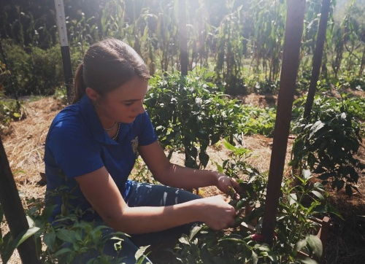
- Describe Addison’s SAE in two or three sentences.

- Describe what Addison does during the different seasons for her SAE.

- About how many pounds of peppers does Addison process in a day?
- Arrange Addison’s pepper processing steps listed below in the correct order by writing the numbers 1-4 in the blank spaces next to each step.

Put the peppers in the brine and boil them.
Pressure can the cooked peppers in the jars.
Cut up all the peppers.
Get the jars sanitized and ready for canning.

- How did Addison get started in her SAE?

- What safety precautions does Addison take with her SAE?

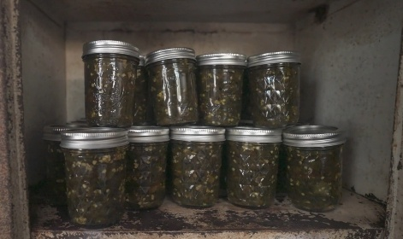
- What information does Addison have to include on the labels for her peppers? Why is this information important to include?

- Why is record keeping an important part of Addison’s SAE?

Processing Plan
Aligned to the following standards:
FPP.01; FFPP.03; FPS.05; FFA.PL-A1; FFA.PL-A3; FFA.PL-A4; FFA.PL-A5; FFA.PL-A8; FFA.PL-B5; FFA.PL-C1; FFA.PL-C4; FFA.PL-F3; FFA.PL-F5; FFA.PG-J1; FFA.PG-J2; FFA.CS-M1; FFA.PG-J4; AG5; CCSS.ELA-RI.9-10.1; CCSS.ELA-RI.9-10.4; CCSS.ELA-W.9-10.2; CCSS.ELA-W.9-10.4; CCSS.ELA-W.9-10.7; CCSS.ELA-SL.9-10.1; CCSS.ELA-SL.9-10.2; CCSS.ELA-L.9-10.6; CCSS.ELA-RST.11-12.9; HS-ETS1-2; CRP.02; CRP.04; CRP.06; CRP.07; CRP.11
Part 1
Directions: Using the table below, brainstorm at least 10 agricultural products that could be produced in your area on the left side and the food products they could be processed into on the right side. Then, answer the questions at the bottom.
Agricultural Products | Food Products
Example: Oranges | Example: Orange juice, orange extract, orange peel oil, etc.

- Which product ideas seem most realistic to make at home? Why?

- Which product ideas seem least realistic? What challenges do you notice?

- What crops surprised you when researching and brainstorming? Why?

Part 2
Directions: Use the prompts below to pick one product from Part 1 to research and see how you could make an SAE out of growing and processing that product.
- What one product from your brainstormed list is most interesting to you to grow and process?

- What basic equipment or materials would you need in order to grow and process this product?

- What additional ingredients would be required to process your agricultural product into the final food product?

- Research the processing steps to make your final food product. List the step-by-step process below.

- What safety considerations would you need to take into account when producing this product?

- How would you market and sell your product? Be as specific as possible.

Reflection Questions:
- What did you learn about food processing that you didn’t know before?

- What are two or three ways you could set your product apart from other similar products?

- How could using locally grown crops benefit your community?

- What questions do you still have about producing this product?

- After researching, would you keep this product idea or choose a different one? Explain.

- If you could ask Addison one question about her experiences building her SAE/business, what would that question be?

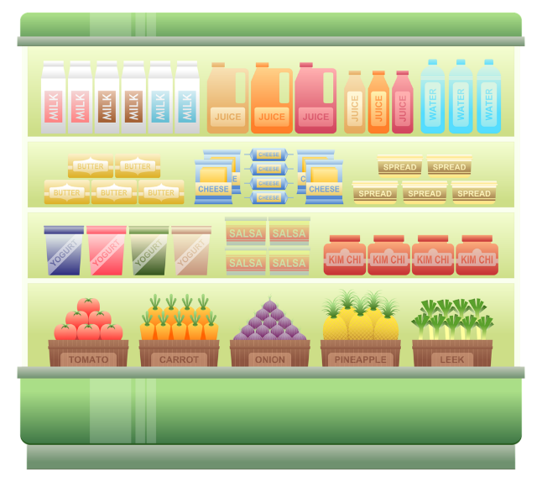
KEY: Pepper Processing
Aligned to the following standards:
NRS.01; AGPE01.01; CCSS.RI.9-10.3; CCSS.SL.9-10.1; RST.9.10.1; RST.9.10.2; RST.9.10.4; RST.9.10.5; RST.9.10.9; RST.9.10.10; WHST.9.10.7; WHST.9.10.9; MP3; MP6; AG-NR2; HS-LS2-6; HS-LS2-7
Directions: Answer the questions below as you watch the video “Growing and Processing Jalapenos SAE,” available at https://vimeo.com/1148063426.

- Describe Addison’s SAE in two or three sentences.
Answers will vary.

- Describe what Addison does during the different seasons for her SAE.

Spring: Starting to prepare for peppers and planting
Summer: Planting and growing her peppers
Late summer/Fall: Picking peppers, preparing them and getting them sold

- About how many pounds of peppers does Addison process in a day?
30 pounds in a day
- Arrange Addison’s pepper processing steps listed below in the correct order by writing the numbers 1-4 in the blank spaces next to each step.

2 | Put the peppers in the brine and boil them.
4 | Pressure can the cooked peppers in the jars.
1 | Cut up all the peppers.
3 | Get the jars sanitized and ready for canning.

- How did Addison get started in her SAE?

Her mom would make canned jalapenos as gifts and to take to family reunions and Addison would help her make them.

- What safety precautions does Addison take with her SAE?

She wears gloves due to the spice in the peppers and avoids touching her eyes, nose and mouth. She also takes food safety into consideration and keeps her peppers at constant temperatures during the prep and canning process.

- What information does Addison have to include on the labels for her peppers? Why is this information important to include?
- Her name
- Address of where it was produced
- Ingredients in the right order
- USDA number
- This meets all the requirements of her state.
- Why is record keeping an important part of Addison’s SAE?

The Arkansas Food and Freedom Act requires her to keep a log of every batch she produces.

KEY: Processing Plan
Aligned to the following standards:
NRS.01; AGPE01.01; CCSS.RI.9-10.3; CCSS.SL.9-10.1; RST.9.10.1; RST.9.10.2; RST.9.10.4; RST.9.10.5; RST.9.10.9; RST.9.10.10; WHST.9.10.7; WHST.9.10.9; MP3; MP6; AG-NR2; HS-LS2-6; HS-LS2-7
Part 1
Directions: Using the table below, brainstorm at least 10 agricultural products that could be produced in your area on the left side and the food products they could be processed into on the right side. Then, answer the questions at the bottom.
Agricultural Products | Food Products
Example: Oranges  Answers will vary. | Example: Orange juice, orange extract, orange peel oil, etc.  Answers will vary.

- Which product ideas seem most realistic to make at home? Why?

Answers will vary.

- Which product ideas seem least realistic? What challenges do you notice?
Answers will vary.
- What crops surprised you when researching and brainstorming? Why
Answers will vary.
Part 2
Directions: Use the prompts below to pick one product from Part 1 to research and see how you could make an SAE out of growing and processing that product.
- What one product from your brainstormed list is most interesting to you to grow and process?
Answers will vary.

- What basic equipment or materials would you need in order to grow and process this product?

Answers will vary.

- What additional ingredients would be required to process your agricultural product into the final food product?

Answers will vary.

- Research the processing steps to make your final food product. List the step-by-step process below.

Answers will vary.

- What safety considerations would you need to take into account when producing this product?

Answers will vary.

- How would you market and sell your product? Be as specific as possible.

Answers will vary.

Reflection Questions:
- What did you learn about food processing that you didn’t know before?

Answers will vary.

- What are two or three ways you could set your product apart from other similar products?

Answers will vary.

- How could using locally grown crops benefit your community?

Answers will vary.

- What questions do you still have about producing this product?

Answers will vary.

- After researching, would you keep this product idea or choose a different one? Explain.

Answers will vary.

- If you could ask Addison one question about her experiences building her SAE/business, what would that question be?

Answers will vary.

