Advocacy Chat with Dr. Tim Fredricks — Bayer
Directions:

Watch the video “Advocacy Chat with Dr. Tim Fredricks — Bayer,” found at https://vimeo.com/535631786/45d24244cc, and complete the following activities.
Why should we care about pollinators?
How do pollinators impact you every day?

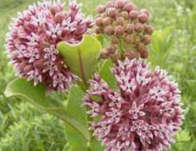


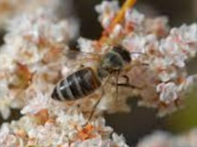
Using the following resource from Bayer Crop Science, https://www.cropscience.bayer.com/people-planet/biodiversity/pollinators, identify four food products that you enjoy regularly that depend on pollinators.

- _______________________ (3) _______________________

- _______________________ (4) _______________________

Three tips to create a pollinator space in any size area are:

- U____________________ your space.
- Choose plants that b__________________ across different time periods.
- Find an area you don’t use r_____________________________.
In one sentence, summarize what you have learned through this advocacy chat.
Brainstorm three places you could place a pollinator garden in your community.

Why would this spot work?

Why would this spot work?

Why would this spot work?
What are the three basic needs of bees?

Where can we place environments that are pollinator friendly? Give an example.
Using the space provided, draw a small pollinator garden that would be beneficial for pollinators, especially monarch butterflies. Be sure to include the names of a minimum of three specific plants you would use. Tip: One monarch beneficial plant was mentioned in the video.

