Life Without Trains
Created: 04/2016 by the National FFA Organization

Student Learning Objectives
After completing these activities students will…
- Define the importance of informative and persuasive tactics in advocacy.
- Develop abilities to simplify and share information.
- Have a better understanding of rail infrastructure.
Time Required: 30 minutes
Resources: FFA.org
Local Motive - http://www.mnn.com/csxlocalmotive/trains/#
Equipment and Supplies Needed:
- A copy of the “Life Without Trains” worksheet for each student.
- Internet access to explore the interactive website.

This quick lesson plan would work well as:
- Supplemental activity to an agribusiness curriculum
- For an introductory agriculture course
- Supplemental activity to an ag mechanics curriculum

These activities are aligned to the following standards:

FFA Precept
- FFA.PG-J.Mental Growth: Embrace cognitive and intellectual development relative to reasoning, thinking and coping.
Common Career Technical Core
- AG1 Analyze how issues, trends, technologies and public policies impact systems in the Agriculture, Food & Natural Resources Career Cluster.
AFNR Cluster Skills
- CS.01. Analyze how issues, trends, technologies and public policies impact systems in the Agriculture, Food & Natural Resources Career Cluster
- CS.02. Evaluate the nature and scope of the Agriculture, Food & Natural Resources Career Cluster and the role of agriculture, food and natural resources (AFNR) in society and the economy.
- CS.06. Analyze the interaction among AFNR systems in the production, processing and management of food, fiber and fuel and the sustainable use of natural resources.
Common Core- Reading: Informational Text
- CCSS.ELA-Literacy.RI.9-10.1 Cite strong and thorough textual evidence to support analysis of what the text says explicitly as well as inferences drawn from the text.
- CCSS.ELA-Literacy.RI.9-10.2 Determine a central idea of a text and analyze its development over the course of the text, including how it emerges and is shaped and refined by specific details; provide an objective summary of the text.
- CCSS.ELA-Literacy.RI.9-10.8 Delineate and evaluate the argument and specific claims in a text, assessing whether the reasoning is valid and the evidence is relevant and sufficient; identify false statements and fallacious reasoning.
Common Core- Writing
- CCSS.ELA-Literacy.W.9-10.2 Write informative/explanatory texts to examine and convey complex ideas, concepts, and information clearly and accurately through the effective selection, organization, and analysis of content.
Common Core- Science & Technical Subjects
- CCSS.ELA-Literacy.RST.9-10.7 Translate quantitative or technical information expressed in words in a text into visual form (e.g., a table or chart) and translate information expressed visually or mathematically (e.g., in an equation) into words.
Common Core- Math Practices
- CCSS.MP1: Make sense of problems and persevere in solving them.
- CCSS.MP3: Construct viable arguments and critique the reasoning of others.
- CCSS.MP6: Attend to precision.
AFNR Career Ready Practices
- CRP.04. Communicate clearly, effectively, and with reason. Career-ready individuals communicate thoughts, ideas and action plans with clarity, whether using written, verbal and/or visual methods.
- CRP.08. Utilize critical thinking to make sense of problems and persevere in solving them. Career-ready individuals readily recognize problems in the workplace, understand the nature of the problem, and
devise effective plans to solve the problem.
Partnership for 21st Century Skills
- Information, Communications, and Technology Literacy
- Communication
- Critical Thinking and Problem Solving

Lesson Plan:
- Introduction:

Companies are finding innovative ways to share information with consumers. CSX has established the LocalMotive webpage to guide users through a visual representation of how important trains are to agriculture and other important parts of our daily lives.

Exploring this webpage will help us better understand how experiences like these connect with audiences. This will provide some insight into how we can use similar applications to advocate for other agricultural topics.

- Activity: Each student needs a copy of the handout “Life Without Trains.”
  - Have students spend some time exploring the LocalMotive webpage. Encourage them to relate the visual cues to the factual information shared. The direct URL is http://www.mnn.com/csxlocalmotive/trains/#.

- Follow-up:

Have students share how they have applied what they learned in this lesson about informative and persuasive devices in other classes.

Ask if students can identify any other webpages that use similar visual elements to represent facts.

4. Level Up:

Encourage students to do research on the effectiveness and efficiency of other transportation methods. Have them develop an infographic or other visual representation of the information they found.
Life Without Trains
Directions:
Explore the webpage LocalMotive, http://www.mnn.com/csxlocalmotive/trains/# . Fill in the blanks below with what you learn.

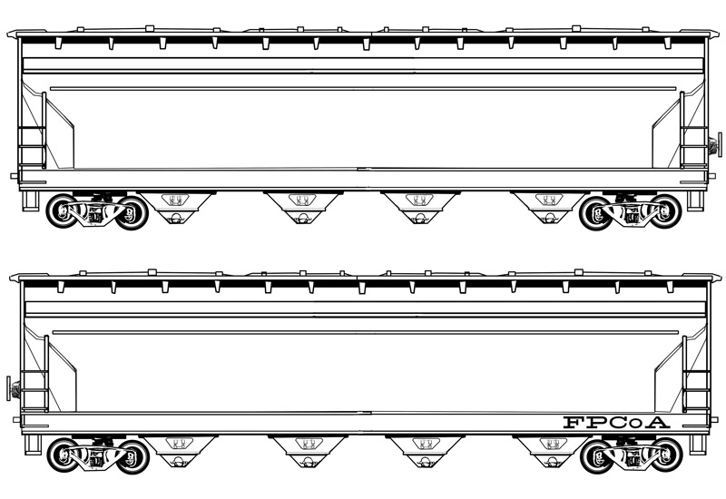
Rail transportation can move 1 ton of freight ______ miles on 1 gallon of fuel.
One intermodal load can replace:
________ Trucks ________Cars
_________ carloads of consumer goods are transported by CSX annually.
_________ carloads of forest products are transported by CSX annually.
_____ % of ethanol is transported by rail.

How does the LocalMotive webpage use these types of communication to share the CSX story?

Give a short explanation of what it means to be informative in communication.

Give a short explanation of what it means to be persuasive in communication.
Aligned to the following standards: FFA.PG-J, AG1, CS.01, CS.02, CS.06, CCSS.ELA-Literacy.RI.9-10.1, CCSS.ELA-Literacy.RI.9-10.2, CCSS.ELA-Literacy.RI.9-10.8, CCSS.ELA-Literacy.W.9-10.2, CCSS.ELA-Literacy.RST.9-10.7, CCSS.MP1, CCSS.MP3, CCSS.MP6, CRP.04, CRP.08

Why are persuasive and informative communication important for agricultural advocacy?

