My Ag Story
Created: 12/2015 by the National FFA Organization

Student Learning Objectives
After completing these activities students will…
- Identify ways to advocate with tools they have.
- Understand their responsibility to advocate.
- Develop a concise message.

Time Required: 30 minutes
Resources: FFA.org
Video: Donnie Smith, Tyson CEO: #myAgstory (2014 National FFA Convention)
https://vimeo.com/148258748
Equipment and Supplies Needed:
- A copy of the “My Ag Story” worksheet for each student.
- Internet access to play the video in real time or embed it in a PowerPoint ahead of time.

This quick lesson plan would work well as:
- Class opener
- Supplement to ag communications curriculum
These activities are aligned to the following standards:

AFNR Performance Element
- CS.01. Analyze how issues, trends, technologies and public policies impact systems in the Agriculture, Food & Natural Resources Career Cluster.
FFA Precept
- FFA.PL-A.Action: Assume responsibility and take the necessary steps to achieve the desired results, no matter what the goal or task at hand.
- FFA.CS-M.Communication: Effectively interact with others in personal and professional settings.
Common Core- Writing
- CCSS.ELA-LITERACY.W.9-10.4 Produce clear and coherent writing the development, organization, and style are appropriate to task, purpose, and audience.
- CCSS.ELA-LITERACY.W.9-10.6 Use technology, including the Internet, to produce, publish, and update individual or shared writing products, taking advantage of technology's capacity to link to other information and to display information flexibility and dynamically.
Common Core- Speaking and Listening
- CCSS.ELA-LITERACY.SL.9-10.5 Make strategic use of digital media (e.g., textual, graphical, audio, visual, and interactive elements) in presentations to enhance understanding of findings, reasoning, and evidence and to add interest.
Common Core- Math Practices
- CCSS.MP1: Make sense of problems and persevere in solving them.
- CCSS.MP3: Construct viable arguments and critique the reasoning of others.
- CCSS.MP6: Attend to precision.
AFNR Career Ready Practices
- CRP.01. Act as a responsible and contributing citizen and employee. Career-ready individuals understand the obligations and responsibilities of being a member of a community, and they demonstrate this understanding every day through their interactions with others.
- CRP.04. Communicate clearly, effectively, and with reason. Career-ready individuals communicate thoughts, ideas and action plans with clarity, whether using written, verbal and/or visual methods.
Partnership for 21st Century Skills
- Civic Literacy
- Collaboration
- Communication
- Flexibility and Adaptability
- Information, Communications and Technology Literacy

Lesson Plan:
- Introduction: Donnie Smith, CEO of Tyson Foods spoke during a general session at the 2014 National FFA Convention. His inspiring call to action lead to #myAgstory to be the #1 trending hashtag on Twitter in the US. His words inspired and taught us to believe that a collective group of small voices can make a big impact.

- Activity: Each student needs a copy of the handout “My Ag Story.”
  - Show the video #myAgstory. The direct url is https://vimeo.com/148258748
  - Have each student watch the video, complete the worksheet and do the associated activities.

- Follow-up:
  - Have students track their post and the number of people it reaches.

#MyAgStory
Directions:
Watch the video #myAgstory at https://vimeo.com/148258748

Use the internet to find answers to factual questions.

How many monthly active users does each social media site have?

Twitter | Instagram | Facebook | Snapchat

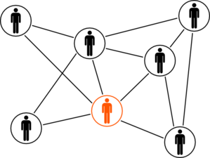

If you had the attention of all of these social media users simultaneously for 1 minute, what would you tell them about agriculture?

Reflect 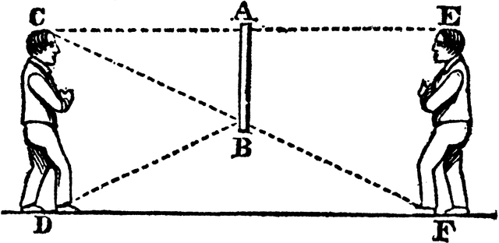
Aligned to the following standards:
CS.01, FFA.PL-A, FFA.CS-M, CCSS.ELA-LITERACY.W.9-10.4, CCSS.ELA-LITERACY.W.9-10.6, CCSS.ELA-LITERACY.SL.9-10.5, CCSS.MP1, CCSS.MP3, CCSS.MP6, CRP.01, CRP.04

What groups might distribute misguided or uninformed information about agriculture?

Why is it important for you to advocate in the same space as these groups?

