Ten Steps to AgVocation
Created: 10/2017 by the National FFA Organization

Student Learning Objectives:
After completing these activities, students will…
- Determine the steps needed to advocate for agriculture.
- Distinguish the need for advocating for agriculture.
- Create their own plans for advocating for agriculture.

Time Required: 45 minutes
Resources:
- FFA.org
- Bayer’s AgVocacy website: https://www.cropscience.bayer.us/our-commitment/agvocate
Equipment and Supplies Needed:
- A copy of the “Ten Steps to AgVocation” worksheet for each student
- Internet access for students

This quick lesson plan would work well as Part Of:
- A unit about agricultural advocacy.
- A lesson on communication.

These activities are aligned to the following standards:

FFA Precept
- FFA.PL-A.Action: Assume responsibility and take the necessary steps to achieve the desired results, no matter what the goal or task at hand.
- FFA.PG-I.Professional Growth: Assume responsibility for attaining and improving upon the skills needed for career success.
- FFA.PG-J.Mental Growth: Embrace cognitive and intellectual development relative to reasoning, thinking and coping.
- FFA.CS-M.Communication: Effectively interact with others in personal and professional settings.
AFNR Cluster Skills
- CS.01. Analyze how issues, trends, technologies and public policies impact systems in the Agriculture, Food & Natural Resources Career Cluster.
Common Core - Writing
- CCSS.ELA-LITERACY.W.9-10.2 Write informative/explanatory texts to examine and convey complex ideas, concepts, and information clearly and accurately through the effective selection, organization, and analysis of content.
- CCSS.ELA-LITERACY.W.9-10.4 Produce clear and coherent writing in which the development, organization, and style are appropriate to task, purpose, and audience.
Common Core - Speaking and Listening
- CCSS.ELA-LITERACY.SL.9-10.1 Initiate and participate effectively in a range of collaborative discussions (one-on-one, in groups, and teacher-led) with diverse partners on grades 9-10 topics, texts, and issues, building on others' ideas and expressing their own clearly and persuasively.
- CCSS.ELA-LITERACY.SL.9-10.4 Present information, findings, and supporting evidence clearly, concisely, and logically such that listeners can follow the line of reasoning and the organization, development, substance, and style are appropriate to purpose, audience, and task.
Common Core - Language
- CCSS.ELA-LITERACY.L.9-10.6 Acquire and use accurately general academic and domain-specific words and phrases, sufficient for reading, writing, speaking, and listening at the college and career readiness level; demonstrate independence in gathering vocabulary knowledge when considering a word or phrase important to comprehension or expression.
Common Core - Math Practices
- CCSS.MP3: Construct viable arguments and critique the reasoning of others.
- CCSS.MP6: Attend to precision.
- CCSS.MP7: Look for and make use of structure.
AFNR Career Ready Practices
- CRP.02. Apply appropriate academic and technical skills. Career-ready individuals readily access and use the knowledge and skills acquired through experience and education to be more productive.
- CRP.04. Communicate clearly, effectively, and with reason. Career-ready individuals communicate thoughts, ideas and action plans with clarity, whether using written, verbal and/or visual methods.
- CRP.05. Consider the environmental, social and economic impact of decisions. Career-ready individuals understand the interrelated nature of their actions and regularly make decisions that positively impact and/or mitigate negative impact on other people, organizations and the environment.
- CRP.06. Demonstrate creativity and innovation. Career-ready individuals regularly think of ideas that solve problems in new and different ways, and they contribute those ideas in a useful and productive manner to improve their organization.
- CRP.08. Utilize critical thinking to make sense of problems and persevere in solving them. Career-ready individuals readily recognize problems in the workplace, understand the nature of the problem, and devise effective plans to solve the problem.
Partnership for 21st Century Skills
- Civic Literacy
- Communication
- Critical Thinking and Problem Solving
- Information Literacy
- Information, Communications, and Technology Literacy
- Initiative and Self-direction
- Media Literacy

Lesson Plan:
- Introduction: Start the lesson or class by having students define advocacy. You can allow them to use a dictionary or the internet. After they agree on a definition as a class have them further define agricultural advocacy.

Examples: Advocacy is the act or process of supporting a cause or proposal. Agricultural advocacy is the act or process of supporting a cause or proposal connected to agriculture or an agriculture topic.

- Activity: Each student needs a copy of the handout “Ten Steps to AgVocation.” Have students work in class to do all the steps that Bayer suggests are necessary for AgVocation.

- Follow Up: Have students share the plans they came up with for AgVocation. Ensure that they have a strategy that will allow them to enact these plans to make a difference. Ask them the following: How are you going to utilize the plans that you have created? Who is going to hold you accountable for using these plans?

- Leveling Up: Have students research five different topics for which they would like to become an AgVocate and develop a plan on how they will influence others in those topics. After the research is complete, have the students debate on the topics using the information that they have learned from the 10 tips.

Another option for leveling up is using Habitudes in conjunction with what the students have learned here. To order a free classroom set visit shopffa.org and search Habitudes. Add it to your cart as you normally would and complete your order.

Ten Steps to AgVocation
FFA.PL-A., FFA.PG-I., FFA.PG-J., FFA.CS-M., CS.01., CCSS. W.9-10.2, W.9-10.4, SL.9-10.1, SL.9-10.4, L.9-10.6, MP3, MP6, MP7, CRP.02., CRP.04., CRP.05., CRP.06., CRP.08.

Directions:
Answer the questions below as you complete the tasks associated with Bayer’s Ten Ways to AgVocate.


List 3 Facebook groups that you joined:

- ________________________

- ________________________

- ________________________
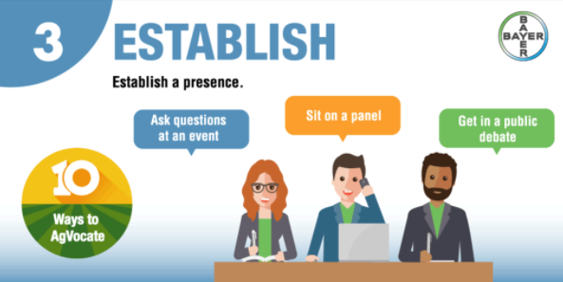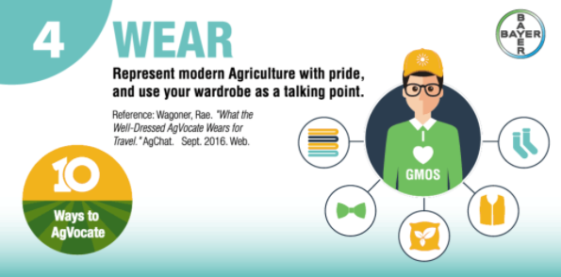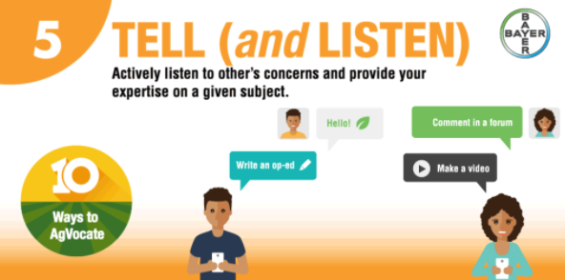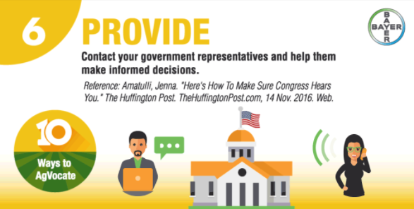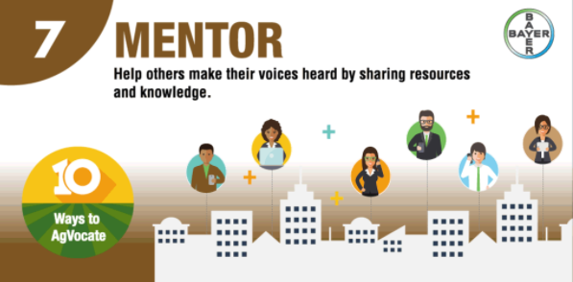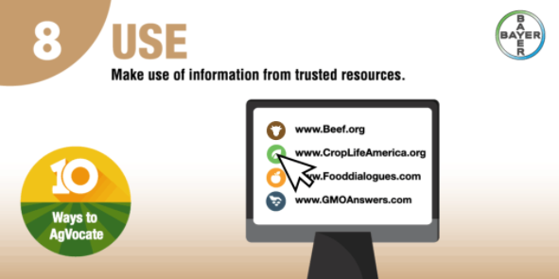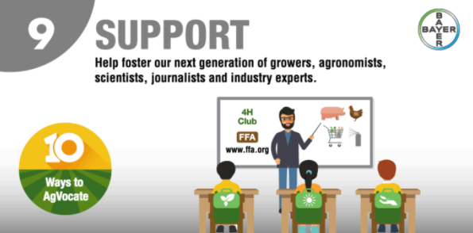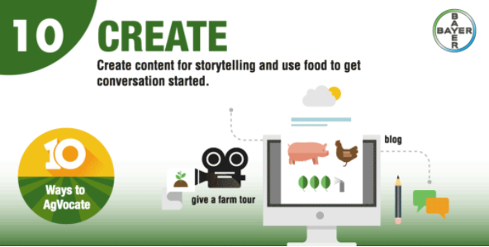
Design a T-shirt for your cause:

If you need more room, use a blank sheet of paper and attach it to this worksheet.
Find three opportunities to be an advocate for agriculture in your community and list them here:

- ______________________________________________________________
- ______________________________________________________________
- ______________________________________________________________

Which social media platforms do you plan on using and why?

Have a conversation with a classmate about a topic for which you will advocate:

Topic: __________________________

Classmate’s Signature:

Please sign to signify that you participated in a conversation with a classmate about advocating for a specific topic in agriculture.
Send a letter to your government representatives. Attach the letter to this worksheet, and write the street address or email address of one of the representatives below. Google should be a help to find this information.

Find one way that you can mentor others by sharing resources and write it here:

Find three reputable resources that will help you advocate for your agricultural topic and write them below:

Find three classmates that are advocating for a different topic that you would also like to support:

- __________________________________________________
- __________________________________________________
- __________________________________________________
Create a blog, video or lesson that will help you in advocating for the topic of your choice within agriculture. Use the space below to plan the blog, video or lesson.

