AgCareers.com Agriculture and Food Career Guide Implementation Guide
Created: 10/2022 by the National FFA Organization

Description of Lesson: Guide students to career success using the tools and resources in the AgCareers.com Agriculture and Food Career Guide.

Student Learning Objectives:
After completing these activities, students will …
- Discover the tools and resources available to be prepared for a future career.
- Demonstrate the importance of being prepared for career fairs, interviews, and other career related activities.
- Research the endless opportunities of potential agricultural careers.

Suggested Grade Level:
Grades 9 and 10 (This lesson is written so instructors can scale up or down based on class needs.)

Suggested Time: 240 minutes (*Time requirements may vary based upon student understanding and class schedule.)

Resources/References:
- Online Magazine: AgCareers.com, https://www.agcareers.com/career-guide/2022/US/
  - Note: This source is used frequently and each article is broken down for every activity in the choice board.
- Website: AgCareers.com Profiles, https://www.agcareers.com/career-profiles/
- Website: AFA Website, https://www.agfuture.org/
  - Note: This website is broken down by each section of the website for the AFA activity.
- Website: Job Advertisement, https://www.thebalance.com/how-to-decode-a-job-advertisement-2061002
- Website: Forever Blue Network, https://foreverbluenetwork.org/
- Website: What to Bring to an Interview, http://blog.agcareers.com/career-cultivation/what-to-bring-to-an-interview/

Related Resources:
- Employment Skills LDE, FFA.org/participate/ldes/employment-skills/
- Employment Skills Lesson Series, https://FFA.app.box.com/folder/52461866668?s=m8kzzy2wrmjtsis4x4uqosn1ws3wga7y

Equipment and Supplies Needed:
- A copy of the “Careers Article Analysis” worksheet for each student
- A copy of the “Choice Board” and corresponding activity sheets for each student
- Optional: hard copy or PDF of the “AgCareers.com Agriculture and Food Career Guide. Link is listed above in the resources.
- Internet access to view various websites

Cross-Curricular Connections:
English/Language Arts
-Develop goals for career preparation and readiness.
-Read and synthesize articles on career readiness.
-Write and/or edit a resume.

Virtual Instruction Ideas:
*All resources can be utilized in a virtual setting to meet your classroom needs.

Student Activity Sheets:
Direct access to student activity sheets without lesson plan or answer key for easy upload to a learning management system or printing for classwork.

Link (Word) https://ffa.box.com/s/v7k8xzllyidxhurkbldm3jkz5kjtae7u
Link (PDF) https://ffa.box.com/s/v7k8xzllyidxhurkbldm3jkz5kjtae7u
Link (Google)https://drive.google.com/drive/folders/1LG95PHYat7DcJIZJ1mRHupYuPkP-kSoW?usp=sharing

These Activities are Aligned to the Following Standards:
AFNR Performance Element
- CS.05. Describe career opportunities and means to achieve those opportunities in each of the Agriculture, Food & Natural Resources career pathways.
FFA Precept
- FFA.PL-A. Action: Assume responsibility and take the necessary steps to achieve the desired results, no matter what the goal or task at hand.
- FFA.PG-J. Mental Growth: Embrace cognitive and intellectual development relative to reasoning, thinking and coping.
- FFA.CS-M. Communication: Effectively interact with others in personal and professional settings.
- FFA.CS-N. Decision Making: Analyze a situation and execute an appropriate course of action.
Common Career Technical Core
- AG5 Describe career opportunities and means to achieve those opportunities in each of the Agriculture, Food & Natural Resources Career Pathways.
NASDCTEc
- AGC08.01 Demonstrate workplace ethics specific to AFNR occupations in order to reflect effective stewardship of resources.
- AGC09.01 Explain written organizational policies, rules and procedures common to AFNR workplaces to ensure employees perform job functions effectively.
- AGC09.02 Select, research and examine critical aspects of career opportunities in one or more AFNR career pathways in order to gain an understanding of the breadth of occupations within this cluster.
Common Core – Reading: Informational Text
- CCSS.ELA-Literacy.RI.9-10.2 Determine a central idea of a text and analyze its development over the course of the text, including how it emerges and is shaped and refined by specific details; provide an objective summary of the text.
- CCSS.ELA-Literacy.RI.9-10.4 Determine the meaning of words and phrases as they are used in a text, including figurative, connotative, and technical meanings; analyze the cumulative impact of specific word choices on meaning and tone (e.g., how the language of a court opinion differs from that of a newspaper).
Common Core – Writing
- CCSS.ELA-Literacy.W.9-10.1 Write arguments to support claims in an analysis of substantive topics or texts, using valid reasoning and relevant and sufficient evidence.
- CCSS.ELA-Literacy.W.9-10.2 Write informative/explanatory texts to examine and convey complex ideas, concepts, and information clearly and accurately through the effective selection, organization, and analysis of content.
Common Core – Speaking and Listening
- CCSS.ELA-Literacy.SL.9-10.1 Initiate and participate effectively in a range of collaborative discussions (one-on-one, in groups, and teacher-led) with diverse partners on grades 9-10 topics, texts, and issues, building on others' ideas and expressing their own clearly and persuasively.
Common Core – Science & Technical Subjects
- CCSS.ELA-Literacy.RST.9.10.8 Assess the extent to which the reasoning and evidence in a text support the author’s claim or a recommendation for solving a scientific or technical problem.
- CCSS.ELA-Literacy.RST.9.10.9 By the end of grade 10, read and comprehend science/technical texts in the grades 9-10 text complexity band independently and proficiently.
Common Core – Literacy in Science & Technical Subjects: Writing
- CCSS.ELA-Literacy.WHST.9.10.1 Write arguments focused on discipline-specific content.
- CCSS.ELA-Literacy.WHST.9.10.2 Write informative/explanatory texts, including the narration of historical events, scientific procedures/ experiments, or technical processes.
- CCSS.ELA-Literacy.WHST.9.10.4 Produce clear and coherent writing in which the development, organization, and style are appropriate to task, purpose, and audience.
- CCSS.ELA-Literacy.WHST.9.10.6 Use technology, including the Internet, to produce, publish, and update individual or shared writing products, taking advantage of technology's capacity to link to other information and to display information flexibly and dynamically.
AFNR Career Ready Practices
- CRP.02. Apply appropriate academic and technical skills. Career-ready individuals readily access and use the knowledge and skills acquired through experience and education to be more productive.
- CRP.04. Communicate clearly, effectively, and with reason. Career-ready individuals communicate thoughts, ideas, and action plans with clarity, whether using written, verbal and/or visual methods.
- CRP.07. Employ valid and reliable research strategies. Career-ready individuals are discerning in accepting and using new information to make decisions, change practices or inform strategies.
- CRP.08. Utilize critical thinking to make sense of problems and persevere in solving them. Career-ready individuals readily recognize problems in the workplace, understand the nature of the problem, and devise effective plans to solve the problem.
- CRP.10. Plan education and career path aligned to personal goals. Career-ready individuals take personal ownership of their own educational and career goals, and they regularly act on a plan to attain these goals.
- CRP.11. Use technology to enhance productivity. Career-ready individuals find and maximize the productive value of existing and new technology to accomplish workplace tasks and solve workplace problems.
Partnership for 21st Century Skills
- Communication
- Critical Thinking and Problem Solving
- Flexibility and Adaptability
- Initiative and Self-direction
- Leadership and Responsibility

Lesson Plan:
- Introduction: What is the AgCareers.com Agriculture and Food Career Guide?
The purpose of the guide is career education and connecting people to the varied and numerous careers in the agriculture and food industries.

The Agriculture and Food Career Guide is a supplemental piece developed to be a resource guide for students and young professionals to compare businesses within the agriculture and food industry and their opportunities for internships and employment. The guide also contains a variety of beneficial articles to add shelf life to the guide and truly help the guide act as a resource for students as they go about their career search. Example articles from this year’s guide include: “Stand Out Answers to Everyday Interview Questions,” “Building Your Productivity IQ” and “Beginner Vs. Experienced Resumes.”

This lesson series is more ideal for juniors and seniors but could be modified for younger students. It is geared toward preparing for career success and the steps to reach success. It is recommended that you download the Career Guide in the PDF format and have it easily available to your students to access. They are able to access it online and flip through the guide.

- Activity: Careers Article Analysis: This is a generic worksheet to be used for any of the articles in the career guide.

- Activity: Choice Board: This allows students to guide their learning through personal choice of activities. This can be completed as a whole, or you can assign each activity at your discretion. Each activity relates to the Agriculture and Food Career Guide articles published by AgCareers.com. The length of each activity on the choice board varies in the length of time needed to complete it.

- Optional – Extended Learning Opportunities (Not factored into time requirement):
  - Invite a guest speaker such as a human resources (HR) director to talk with your students about their future careers and how to be prepared for success.

Choice Board
Directions:
Complete each of the tasks under the direction of your teacher. The listed page numbers reference the page the corresponding article from the Career Guide can be found on.

Complete the Employer Pathway Connections activity. | Complete the Career Pathways: Which Are You Most Interested in? activity. | Complete the Design Time activity. | Complete the AFA WebQuest activity.
Complete the Advice for All activity.  (p. 5) | Complete the Fine Tune Your Resume Skills activity.  (p. 9) | Complete the Listen and Learn activity.  (p. 13) | Complete the Navigating Career Fairs activity.  (p. 15)
Complete the Internships: What’s in It for You? Activity.  (p. 18) | Complete the Preparing for the Next Phase of Life activity.  (p. 21) | Complete the Diving Into an Agriculture Career with No Ag Background activity.  (p. 24) | Complete the Play to Win When It Comes to Networking activity.  (p. 26)
Complete the My First Job Offer: What Do I Do? Activity.  (p. 29) | Complete the Mastering a Job Interview activity.  (p. 32) | Complete the Let’s Talk Money activity.  (p. 35) | Complete the Marketing Your Favorite Career Pathway activity.

Aligned to the following standards: CS.05. , FFA.PL-A. , FFA.PG-J., FFA.CS-M. , FFA.CS-N., AG5, AGC08.01, AGC09.01, AGC09.02, CRP.02., CRP.04, CRP.07., CRP.08, CRP.10. CRP.11.
Careers Article Analysis
Part 1
Directions:
Read one of the articles in the 2022-23 U.S. 16th Edition of the AgCareers.com Agriculture and Food Career Guide (https://www.agcareers.com/career-guide/2022/US/) to complete this worksheet.

- Article Title

- Focus of Article

3. Why is this topic important to you as a high school student?

4. What are three key takeaways from the article?

5. What are three things you could do to help you with the identified focus (answer from Question 2) as you progress through your education?

6. Identify two people that could help with the identified focus (answer from Question 2) as you prepare for your future career.

- Identify your strengths and weaknesses related to the focus identified in Question 2.

Strengths | Weaknesses

- What questions do you still have about the focus of this article?

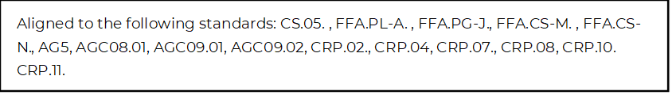
Employer Pathway Connections
Directions:
Complete this worksheet by utilizing each of the companies’ websites and the Career Guide on the AgCareers.com website. For each of the companies, identify which career focus areas their organization aligns with by shading each box red. Additionally, add the logo for each company that is missing.
Company: Bayer |  |   Logo:
Agribusiness Systems | Agricultural Education | Agriculture Technology | Animal Systems
Biotechnology Systems | Environmental Service Systems | Food Products and Processing Systems | Natural Resources Systems
Plant Systems | Power, Structural and Technical Systems | Skilled Trades | Sustainability

Company: Becks |  | Logo:
Agribusiness Systems | Agricultural Education | Agriculture Technology | Animal Systems
Biotechnology Systems | Environmental Service Systems | Food Products and Processing Systems | Natural Resources Systems
Plant Systems | Power, Structural and Technical Systems | Skilled Trades | Sustainability

Company: CLAAS |  | 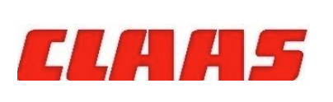  Logo:
Agribusiness Systems | Agricultural Education | Agriculture Technology | Animal Systems
Biotechnology Systems | Environmental Service Systems | Food Products and Processing Systems | Natural Resources Systems
Plant Systems | Power, Structural and Technical Systems | Skilled Trades | Sustainability

Company: Consolidated Grain and Barge |  | Logo:
Agribusiness Systems | Agricultural Education | Agriculture Technology | Animal Systems
Biotechnology Systems | Environmental Service Systems | Food Products and Processing Systems | Natural Resources Systems
Plant Systems | Power, Structural and Technical Systems | Skilled Trades | Sustainability

Company: Corteva Agriscience |  | 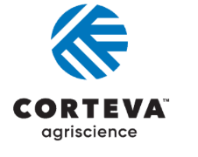  Logo:
Agribusiness Systems | Agricultural Education | Agriculture Technology | Animal Systems
Biotechnology Systems | Environmental Service Systems | Food Products and Processing Systems | Natural Resources Systems
Plant Systems | Power, Structural and Technical Systems | Skilled Trades | Sustainability

Company: Didion |  | Logo:
Agribusiness Systems | Agricultural Education | Agriculture Technology | Animal Systems
Biotechnology Systems | Environmental Service Systems | Food Products and Processing Systems | Natural Resources Systems
Plant Systems | Power, Structural and Technical Systems | Skilled Trades | Sustainability

Company: Hartung Brothers Inc. |  | Logo:
Agribusiness Systems | Agricultural Education | Agriculture Technology | Animal Systems
Biotechnology Systems | Environmental Service Systems | Food Products and Processing Systems | Natural Resources Systems
Plant Systems | Power, Structural and Technical Systems | Skilled Trades | Sustainability

Company: Lallemand |  | Logo:
Agribusiness Systems | Agricultural Education | Agriculture Technology | Animal Systems
Biotechnology Systems | Environmental Service Systems | Food Products and Processing Systems | Natural Resources Systems
Plant Systems | Power, Structural and Technical Systems | Skilled Trades | Sustainability

Company: Oxbo Inc |  | Logo:
Agribusiness Systems | Agricultural Education | Agriculture Technology | Animal Systems
Biotechnology Systems | Environmental Service Systems | Food Products and Processing Systems | Natural Resources Systems
Plant Systems | Power, Structural and Technical Systems | Skilled Trades | Sustainability

Company: Simplot |  | Logo:
Agribusiness Systems | Agricultural Education | Agriculture Technology | Animal Systems
Biotechnology Systems | Environmental Service Systems | Food Products and Processing Systems | Natural Resources Systems
Plant Systems | Power, Structural and Technical Systems | Skilled Trades | Sustainability

Company: Syngenta |  | 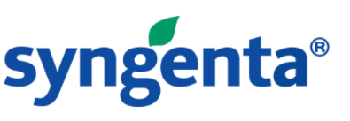  Logo:
Agribusiness Systems | Agricultural Education | Agriculture Technology | Animal Systems
Biotechnology Systems | Environmental Service Systems | Food Products and Processing Systems | Natural Resources Systems
Plant Systems | Power, Structural and Technical Systems | Skilled Trades | Sustainability

Company: Wilbur-Ellis |  |   Logo:
Agribusiness Systems | Agricultural Education | Agriculture Technology | Animal Systems
Biotechnology Systems | Environmental Service Systems | Food Products and Processing Systems | Natural Resources Systems
Plant Systems | Power, Structural and Technical Systems | Skilled Trades | Sustainability

*Which career focus area do you think could be applicable to all the companies in the activity? ________________________

*Pick four of the companies from the first part of this activity above to discover more about career opportunities with these organizations and complete the tables below.

Name of Company: | Headquarters Location:
**Identify two current job openings this company has and answer the questions below about each

Job Opening 1  Title of Position: ________________________________________  Educational Requirements: ____________________________  Salary Range: __________________________________  Location of Job: _________________________  Primary Responsibilities of Position | Job Opening 2  Title of Position: ________________________________________  Educational Requirements: ____________________________  Salary Range: __________________________________  Location of Job: _________________________  Primary Responsibilities of Position

Name of Company: | Headquarters Location:
**Identify two current job openings this company has and answer the questions below about each.

Job Opening 1  Title of Position: ________________________________________  Educational Requirements: ____________________________  Salary Range: __________________________________  Location of Job: _________________________  Primary Responsibilities of Position | Job Opening 2  Title of Position: ________________________________________  Educational Requirements: ____________________________  Salary Range: __________________________________  Location of Job: _________________________  Primary Responsibilities of Position

Name of Company: | Headquarters Location:
**Identify two current job openings this company has and answer the questions below about each.

Job Opening 1  Title of Position: ________________________________________  Educational Requirements: ____________________________  Salary Range: __________________________________  Location of Job: _________________________  Primary Responsibilities of Position | Job Opening 2  Title of Position: ________________________________________  Educational Requirements: ____________________________  Salary Range: __________________________________  Location of Job: _________________________  Primary Responsibilities of Position

Name of Company: | Headquarters Location:
**Identify two current job openings this company has and answer the questions below about each.

Job Opening 1  Title of Position: ________________________________________  Educational Requirements: ____________________________  Salary Range: __________________________________  Location of Job: _________________________  Primary Responsibilities of Position | Job Opening 2  Title of Position: ________________________________________  Educational Requirements: ____________________________  Salary Range: __________________________________  Location of Job: _________________________  Primary Responsibilities of Position

*Which of these companies do you think you would be most interested in a potential career with? Explain your choice.

Career Pathways: Which Are You Most Interested In?
Directions:
Using the AgCareers.com Career Profiles website found at https://www.agcareers.com/career-profiles/, view all of the seven career pathways to learn more about potential careers in each of them. Select two pathways that you are most interested in and complete the questions below.

Career Pathway:

List five potential careers that you find interesting in this pathway.
Include the future job market/outlook for each career below the name.

What are the recommended high school courses for these careers?

Identify at least three places you could work within this career pathway and list them below.

1.
2.
3.

Career Pathway:

List five potential careers that you find interesting in this pathway.
Include the future job market/outlook for each career below the name.

What are the recommended high school courses for these careers?

Identify at least three places you could work within this career pathway and list them below.

1.
2.
3.

*Which of the seven career pathways are you least interested in for a potential career? Why?

Design Time
Directions
AgCareers.com needs your help with designing its next publication. AgCareers.com wants you to design the front and back covers of the next career guide. The focus is on how to attract students not involved in agriculture to the career guide. Follow the steps below to plan your design. Turn in your finished product according to your teacher’s instructions.

Brainstorm: Title and Front Cover Text (What message are you trying to convey?)

Brainstorm: Back Cover Wording (What message are you trying to convey?)

*Sketch your plans for each of the covers below. Think about sizing and scale. Remember the career guide is the same size as a piece of printer paper.

Front Cover | Back Cover

- What influence do the combination of images and text have on those that could potentially learn more from a publication?

- What do you think is the key to attracting students not involved in agriculture to an agricultural publication?

AFA WebQuest
Directions:
Use the Agriculture Future of America (AFA) website, found at https://www.agfuture.org/, to explore the opportunities available to young people wishing to pursue a career in the agriculture industry.

**Check out the About section (https://www.agfuture.org/about) of the website to complete the following questions.

Why does AFA exist? | What does AFA do? | How does AFA do it? | Who is AFA’s work for?

Look at the AFA Competencies (https://www.agfuture.org/about/afa-competencies) to learn more about the organization’s work of making transformational leaders. In the table below, identify the six themes or skills (called competencies) that employers are seeking in future employees.

Building and fostering healthy relationships | Innovatively influencing systems through critical thinking and problem solving | Working effectively with others toward a common goal
Performing well in diverse environments, with an inclusive bias | Relating to others with sensitivity and influence; a built-in bias toward leading and learning | Using exploration, feedback and reflection to manage yourself and your teams

*Head to the Partners section (https://www.agfuture.org/partners/industry) of the AFA website to learn more about who the organization has partnered with to support its career development and scholarship programs. List twelve partners below.

*Browse the Scholarships section (https://www.agfuture.org/scholarships) of the AFA website to discover those opportunities. Identify five key pieces of information you learned from reading this section of the website.
1.
2.
3.
4.
5.

*Diversity, Equity and Inclusion are an important part of the AFA’s mission. Review that section of the website (https://www.agfuture.org/about/diversity-equity-inclusion) to learn more about those efforts. Name three key things that AFA is committed to doing in the realm of diversity, inclusion and equity.
1.
2.
3.

*After learning more about what AFA has to offer, how do these opportunities personally benefit you and your future? Identify and explain two ways; be specific in your answer.
1.
2.

*Using an emoji, rate how useful you think the Agriculture Future of America organization could be to you in the future.
Advice for All
Directions
Using the article “8 Pieces of Advice Every Young Professional Should Know” (https://www.agcareers.com/career-guide/2022/US/#4), complete the activity below.

1. Before reading the article, identify — in words and pictures — what comes to mind when you hear the term “young professional.”

2. Brainstorm at least two ideas that could help you to take notes (how, where to store, etc.).
Idea 1 | Idea 2

3. Develop two meaningful questions you could ask a potential employer. (Be prepared to discuss and share these questions with your classmates.)
Q1:

Q2:

4. Reflect on your current daily life and all that you are involved in. Do you do a good job having routine “off time”? Circle the answer choice that best describes you.
Daily “off time” | I have “off time” a couple times a week. | I have “off time” once a week. | I have “off time” once a month. | I have “off time” sporadically. | I never have “off time.”

*How could you improve upon your answer choice above? _____________________________________________________________

5. What is one reason why you would choose to leave a job? How would you inform your employer?

6. On a scale of 1 to 10, how do you handle change?
1 | 2 | 3 | 4 | 5 | 6 | 7 | 8 | 9 | 10

*How can you improve in this area? ________________________________________________________________________

7. Identify two ways you could better utilize feedback given to you.
1. | 2.

8. Take a moment and reflect on your high school experience thus far. Identify three things you would like to do or improve upon by the time you graduate.
1.

2.

3.

9. In the box below, come up with your own eight pieces of advice to give middle school students to use during their time in high school.
1.
2.
3.
4.
5.
6.
7.
8.

10. What is the most important thing you have learned from this article? ______________________________________________ _______________________________________________________________________________________________________________________

Fine Tune Your Resume Skills
Directions:
Using the article “Tailoring Your Resume” (https://www.agcareers.com/career-guide/2022/US/#8), complete the activities below.

Pre-Reading Questions
1. Do you have a resume? ___________________
2. Why do you need a resume in high school? _____________________________________________________________
Post-Reading Questions
1. What is the purpose of a resume? ___________________________________________________________________________________

2. Pick the three most important tips from the article and explain how you can use them on a personal level.

A.

B.

C.

3. Read the article “How to Decode a Job Advertisement.” This article is available at https://www.thebalance.com/how-to-decode-a-job-advertisement-2061002. Identify the parts of a job description and what is included in each part. Record your answers below.

Part of Job Description | What Is Included

4. Review the job posting below and then review the sample resumes provided to determine which candidate is more ideal for this job based on their resume.

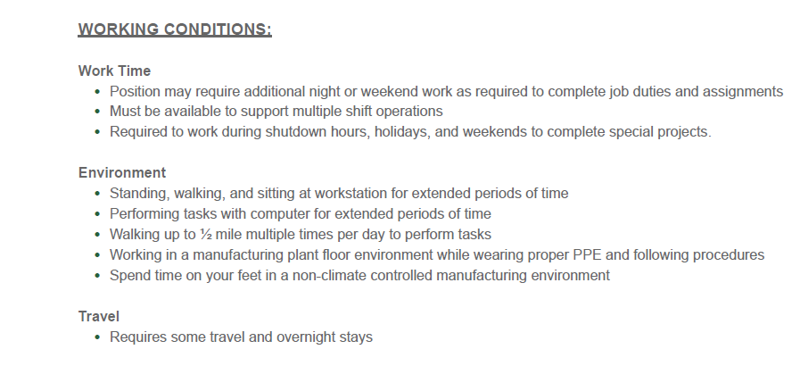
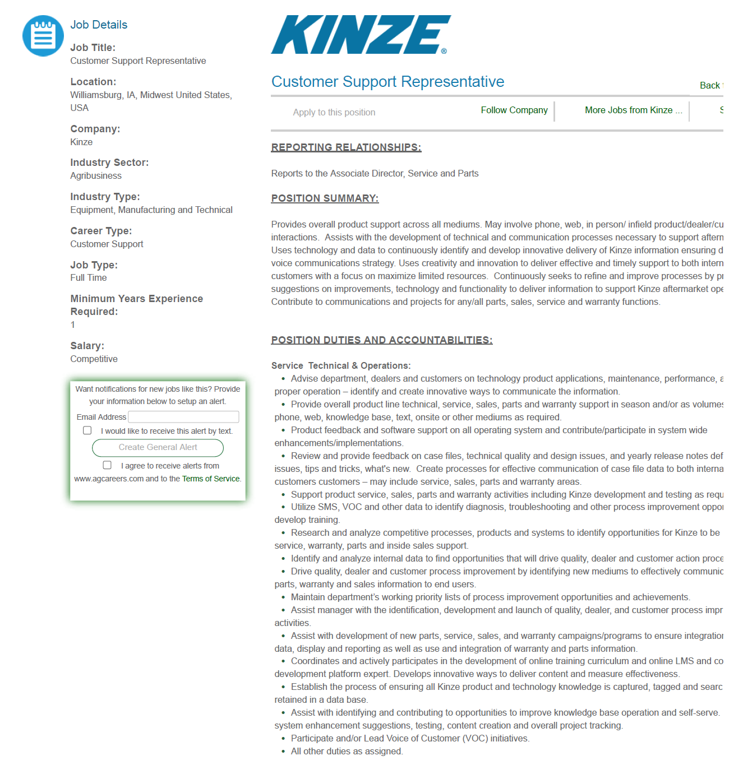

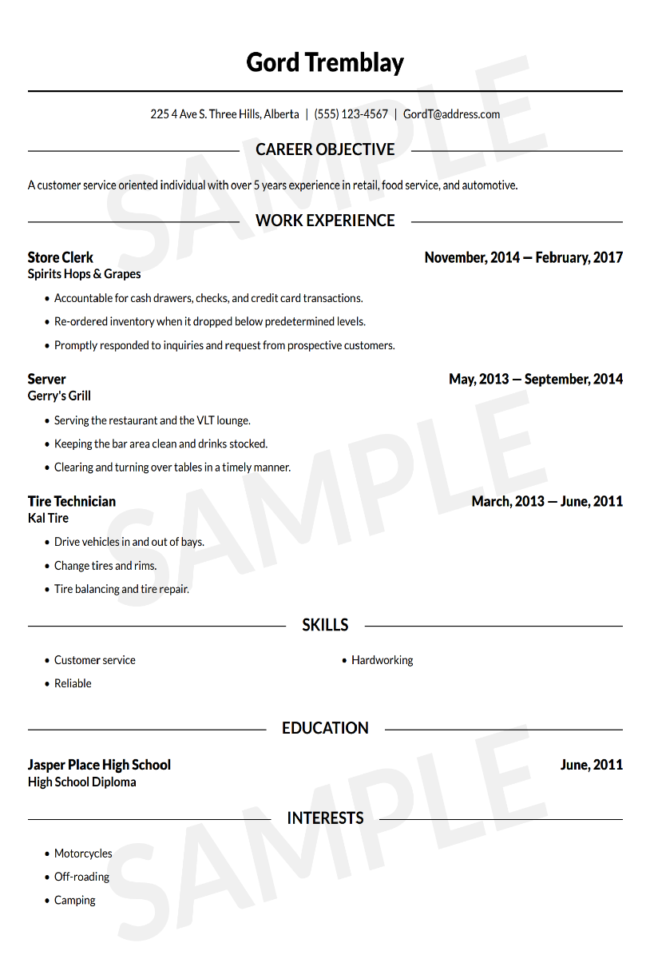
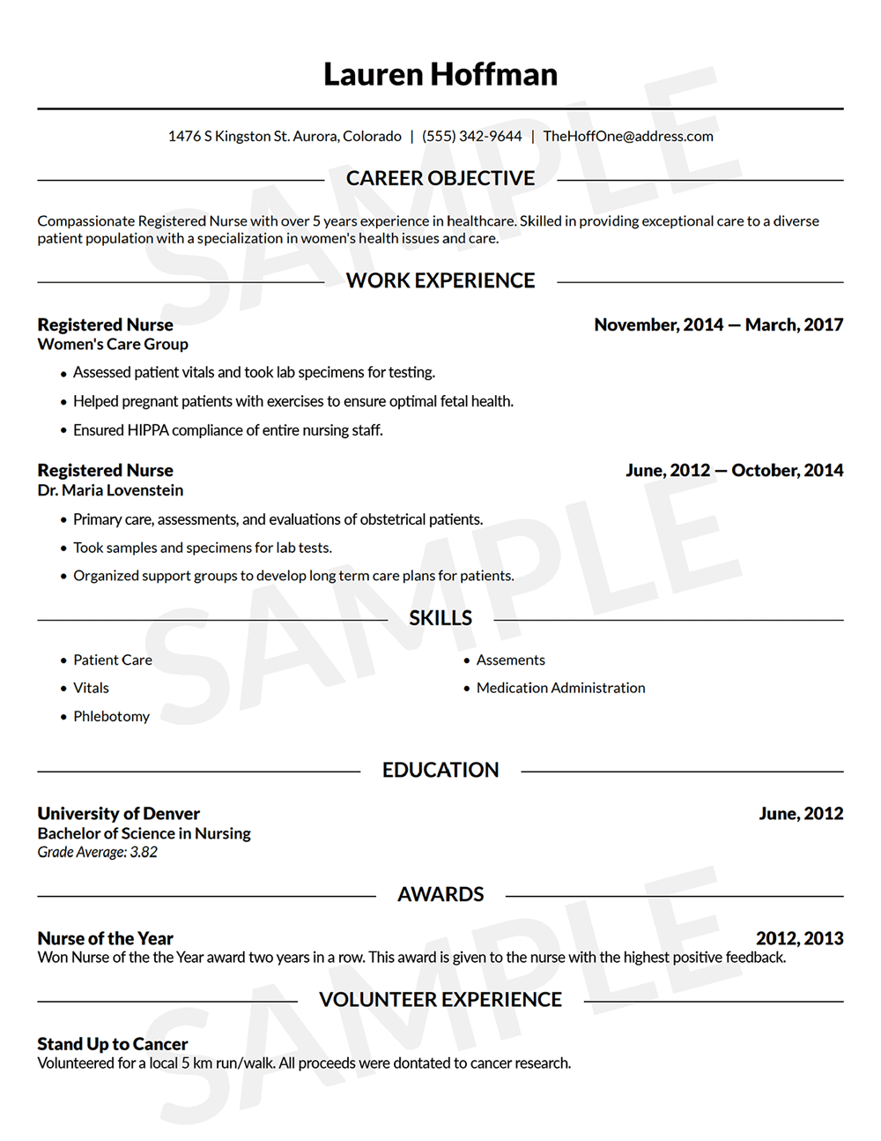
A. At first glance, which candidate is more ideally aligned with the job posting? ________________________________

B. Upon reviewing the job posting, do you feel either candidate is completely unqualified for the job posting? Explain your answer.

______________________________________________________________________________________________________________________ ______________________________________________________________________________________________________________________ ______________________________________________________________________________________________________________________
C. Identify two areas in which each resume could be improved to align to the job posting more closely.

Gord Tremblay | Lauren Hoffman

D. How can you use what you learned from this activity to improve your own resume? _________________________________ _______________________________________________________________________________________________________________________
Listen and Learn
Directions:
Complete the activities below by utilizing the article “Listen and Learn: Do You Know It All Yet?” available at https://www.agcareers.com/career-guide/2022/US/#12.

1. Being honest with yourself, rate your listening skills on a scale of 1 to 10 by shading your answer in BLUE. Give supporting evidence for your rating.

1 | 2 | 3 | 4 | 5 | 6 | 7 | 8 | 9 | 10

Evidence: _____________________________________________________________________________________________________________

2. Compare your rating with two of your classmates’ ratings. How do you rank? Based on your experiences with peers, do you think the results are accurate?

______________________________________________________________________________________________________________________ ______________________________________________________________________________________________________________________
3. The article references “hard skills” and “soft skills.” Familiarize yourself with these meanings and then identify three examples of each type of skill.

Hard Skills | Soft Skills

4. Put a * by the skill you believe is your strongest skill. Put a - by the skill you believe is your weakest. Identify how you could improve on your weakest skill.

__________________________________________________________________________________________________

5. Active listening is said to be one of the most imperative soft skills sought by employers. Describe this skill in your own words.

6. Based on your career interests, select a potential employer and do some research about the company. Identify ten things about the company that could be useful to know as a potential employee and list them below.
Company: ______________________________________________

1.

2.

3.

4.

5.

6.

7.

8.

9.

10.

7. What is the biggest takeaway for you from this article? ______________________________________________________________

8. How can you apply what you learned from this article in the future? ________________________________________________

Navigating Career Fairs
Directions:
Utilize the article “Lessons Learned from Virtual Career Fairs” (https://www.agcareers.com/career-guide/2022/US/#14) to complete this activity.

The Lesson: The Speed of Connection Is Faster Than Ever
Why is it important to build in breaks at an in-person career fair?

Identify one way you can help yourself remember to complete follow-up correspondence.

The Lesson: Digital Resources Are Important

How can you digitally provide your resume to an employer at an in-person career fair?

Why should you take printed copies of your resume with you to an in-person career fair?

The Lesson: Career Fair Platforms Impact the Time Available
Why should you plan out your time spent at a career fair? Identify two examples.

Identify two ideas that could help set you apart and be a better use of your time.

The Lesson: The Health and Well-being of All Is a Top Priority
How can you respect the comfort level of others at in-person career fairs?

What are two rules of thumb to always follow?

The Lesson: Virtual Career Fairs Are Not Going Away
What are two positives of virtual career fairs for both employers and potential employees?

How can you best prepare for both types of career fairs?

Wrap It Up
*What are the three most important items to do at a college/career fair?

*Explain to another student why it is important to attend a college/career fair.

Internships: What’s in It for You?
Directions:
Utilize the article “How to Choose the Right Internship” (https://www.agcareers.com/career-guide/2022/US/#18) to learn more about future opportunities and complete the activities below.

1. Identify two benefits of completing an internship.

2. Why is it suggested you start looking for internships early in your freshman year?

3. What are recruiters looking for when it comes to club involvement of potential interns and employees?

4. What should you do about internships if you are unclear about your career path?

5. Why is it important to keep an open mind when approaching your career path and choices?

6. Check out the Forever Blue Network, https://foreverbluenetwork.org/, and learn more about the benefits of this program. Match the benefits with the correct descriptions.

By fully integrating with social networks, and cultivating a culture of helping and giving back, you will be amazed how vibrant and powerful our FFA community is!
Forever Blue Network allows you to reconnect with old friends you may have made at FFA conferences or events and enables you to utilize the trusted FFA environment to expand your professional network.
Find and reminisce with fellow FFA Alumni and Supporters, see what they have been up to and stay in touch.
Leverage your professional network to get introduced to people you should know.

Introduce, employ and offer to act as a mentor, coach or volunteer for our newest alum, other fellow FFA Alumni and Supporters, FFA advisors, chapters or state associations.

Word Bank
Connect Expand Give Back Reconnect With Old Friends Your FFA Community

7. Set three SMART goals for yourself about pursuing internships in the future.
Preparing for the Next Phase of Life
Directions:
Read the article “Life Past College: How Do I Handle This Full-Time Job?” (https://www.agcareers.com/career-guide/2022/US/#20) to complete this activity.

*Identify two key takeaways from each of the five topics covered in the article.

Go In With an Open Mind

Set Your Boundaries Early

Don’t Get Too Comfortable

You Actually Have Been Preparing

Keep Dreaming

Now, think about life after high school. Identify at least two things that …

Excite You

Worry/Concern You

You Feel Most Prepared for

You Feel Least Prepared for

You Hope to Achieve in the Next Four Years

Diving Into an Agriculture Career With No Ag Background
Directions:
Read the article “Working in Agricultural Jobs Without an Agricultural Background” (https://www.agcareers.com/career-guide/2022/US/#24) to complete this activity.

*After reading the article, develop a one-page infographic that could be used to interest people not involved in agriculture into looking for a career in the agriculture industry.

What to Include:
-Title
-Two or more pictures
-Why should they look at careers in agriculture
-Example careers they could do without an agriculture background
Remember to keep it visually appealing!

*Use the spaces below to help you plan your infographic.
Picture Ideas
Title Ideas

Career Ideas

Why should they look at careers in agriculture?

Facts or Statistics to Draw Interest
Key Info From Article

Play to Win When It Comes to Networking
Directions:
Utilize the article “To Play or Not to Play. It’s Not Really a Question” (https://www.agcareers.com/career-guide/2022/US/#26) to complete this activity.

Pre-Reading Questions
1. In your own words, describe what the term “networking” means to you.

2. Who would you consider to be in your personal network?

Post-Reading Questions
1. Why is networking so important when pursuing career success?

2. Identify two ways you can build relationships with coworkers.
-

-

3. What should not be the outcome/result of attending a networking event?

4. How can you benefit professionally from volunteering?

5. Identify three keys to having success at a networking event.
-

-

-

Now, think about your future and building professional connections. Set three goals for yourself in terms of networking and building professional connections in the next year. List those goals below.

1.

2.

3.

My First Job Offer: What Do I Do?
Directions:
Utilize the article “How to Handle Your First Job Offer” (https://www.agcareers.com/career-guide/2022/US/#28) to complete this activity.

Pre-Reading
Complete the K and W of the KWL chart prior to reading this article. Then come back and complete the L after you read the article.

K  What do you know about job offers? | W  What do you want to know about job offers? | L  What did you learn about job offers from this activity?

Post-Reading
*What surprised you the most in this article about accepting a job offer?

*Develop your ideal job offer using the outline below. Remember, this would be a job offer right out of college or upon completion of your training/certification. Look at current job postings similar to what you wish to do.

Title of Position
Location
Salary/Wages
Work Schedule (Days of the Week)
PTO (Paid Time Off)
Sick Days
Company Vehicle
Cell Phone Reimbursement
Internet Reimbursement for Home Office
Relocation Expenses
Bonus (How It’s Earned, How Much)
Tuition Reimbursement
Insurance | Health:  Life:  Accident:  Short-Term Disability:  Long-Term Disability:
Other Benefits

**Don’t forget to go back and complete the L of the KWL chart at the beginning of this activity.

Mastering a Job Interview
Directions:
Utilize the article “Unwritten Rules of the Interview Process” (https://www.agcareers.com/career-guide/2022/US/#32) to complete this activity.

Pre-Reading
1. How do you feel about your interviewing skills? Circle the emoji that best describes your skills.

 |  |  |  | 

Explain your answer choice. ___________________________________________________________________________________________

2. Identify two areas of interviewing that you feel you need to improve upon.
-

-

3. Identify two areas of interviewing that you feel are your strengths.
-

-

Post-Reading
- Identify the five most important tips you gained from reading this article.

- What questions do you still have about job interviews?

What Do I Bring?

Directions:
Use the article “What and What Not to Bring to an Interview,” available at http://blog.agcareers.com/career-cultivation/what-to-bring-to-an-interview/, to complete the chart.

Item | Bring or Don’t Bring | Explanation (in Your Own Words)

Let’s Talk Money
Directions:
Utilizing the article “How to Ask for a Raise” (https://www.agcareers.com/career-guide/2022/US/#34), complete this activity.

- What surprised you most while reading this article?

- Do you feel the approach discussed in the article is appropriate for a part-time job you may now hold as a high school student? Why or why not?

- What is one question you still have about asking for a raise?

What do you think justifies a raise? Select from the list below all the reasons you feel are appropriate for asking for a raise.

You do more than your job requires. | You show initiative. | You have to travel more.
Poor life choices | You develop new skills | Seniority
You have brought in new business. | Your coworker makes more money than you do. | Perfect attendance at work
You took on more job responsibilities. | You have another job offer. | Changed family status  (getting married, new child on the way, etc.)

Take Action and Get Your Raise

Business Situation: Budgets are expected to be tighter in the upcoming year. But, keeping our dedicated employees in mind, we want to give everyone the chance for a raise as we are aware of inflation and the increased cost of living. If you wish to receive a raise, please be prepared to present your case and explain why you deserve this raise.

Employee Scenario: You have surpassed your sales goal for the year by 12.5%, have added four new customers and have multiple other new potential customers in the works. Unfortunately, you have gone over your budget on a couple of projects. You are mentoring one of the new sales managers in another territory. Your mentee is responding well and seems to be on track for increasing sales in that territory for the next year.

Task: Develop a step-by-step plan to present to your boss about why you deserve the raise. Follow the steps and advice in the article. Use the table below to help you plan each step and develop your formal presentation. Follow the instructions of your teacher to create your final presentation.

Step | Plans/Needs/Ideas
Step 1: Do Your Research

Step 2: Book a Meeting

Step 3: Prepare

Step 4: Be Patient

Step 5: Handling Rejection

Step 6: Keeping a Positive Attitude

Marketing Your Favorite Career Pathway
Directions:
Utilize the AgCareers.com website (https://www.agcareers.com/career-profiles/%20) to complete this activity. You have been contracted by AgCareers.com to develop a billboard that can be used to attract potential job applicants to its website to check out the thousands of job opportunities in agriculture. The billboards are 14 feet high and 48 feet wide, providing 672 square feet of space.

Objective: Design a billboard to portray one of the seven agricultural career pathways of your choosing. This billboard will be placed along the highways and interstates of some of the largest cities in the USA. Use the tools below to help you plan your billboard.

AgCareers.com Pathway Billboard Planning

Career Pathway:

Who is your audience?

How do you gain and engage your audience’s attention?

What message do you want to share with the targeted audience?

Images: What are inclusive images that depict this career pathway?

Landing Spot
Where do you want them to go for more information? How do you share that information?

Theme/Color Patterns
Will you use a theme or certain colors (patterns) to attract attention? Remember this billboard will be in busy areas and needs to attract the attention of job seekers.

Sketch Time
Use the space below to sketch your billboard design. Include a scale that depicts how big your text, images and other content will be on the actual billboard.
*With your teacher’s approval, turn your rough draft design into the final draft in the format directed by your teacher.

Answer Key: Employer Pathway Connections
Directions:
Complete this worksheet by utilizing each of the companies’ websites and the Career Guide on the AgCareers.com website. For each of the companies, identify which career focus areas their organization aligns with by shading each box red. Additionally, some companies are missing their logos; add the missing logo for those companies .
Company: Bayer |  | Logo:
Agribusiness Systems | Agricultural Education | Agriculture Technology | Animal Systems
Biotechnology Systems | Environmental Service Systems | Food Products and Processing Systems | Natural Resources Systems
Plant Systems | Power, Structural and Technical Systems | Skilled Trades | Sustainability

Company: Becks |  | Logo:  Logo may vary based on image selected by student.
Agribusiness Systems | Agricultural Education | Agriculture Technology | Animal Systems
Biotechnology Systems | Environmental Service Systems | Food Products and Processing Systems | Natural Resources Systems
Plant Systems | Power, Structural and Technical Systems | Skilled Trades | Sustainability

Company: CLAAS |  | Logo:
Agribusiness Systems | Agricultural Education | Agriculture Technology | Animal Systems
Biotechnology Systems | Environmental Service Systems | Food Products and Processing Systems | Natural Resources Systems
Plant Systems | Power, Structural and Technical Systems | Skilled Trades | Sustainability

Company: Consolidated Grain and Barge |  | Logo:  Logo may vary based on image selected by student.
Agribusiness Systems | Agricultural Education | Agriculture Technology | Animal Systems
Biotechnology Systems | Environmental Service Systems | Food Products and Processing Systems | Natural Resources Systems
Plant Systems | Power, Structural and Technical Systems | Skilled Trades | Sustainability

Company: Corteva |  | Logo:
Agribusiness Systems | Agricultural Education | Agriculture Technology | Animal Systems
Biotechnology Systems | Environmental Service Systems | Food Products and Processing Systems | Natural Resources Systems
Plant Systems | Power, Structural and Technical Systems | Skilled Trades | Sustainability

Company: Didion |  | Logo:  Logo may vary based on image selected by student.
Agribusiness Systems | Agricultural Education | Agriculture Technology | Animal Systems
Biotechnology Systems | Environmental Service Systems | Food Products and Processing Systems | Natural Resources Systems
Plant Systems | Power, Structural and Technical Systems | Skilled Trades | Sustainability

Company: Hartung Brothers Inc. |  | Logo:  Logo may vary based on image selected by student.
Agribusiness Systems | Agricultural Education | Agriculture Technology | Animal Systems
Biotechnology Systems | Environmental Service Systems | Food Products and Processing Systems | Natural Resources Systems
Plant Systems | Power, Structure, and Technical Systems | Skilled Trades | Sustainability

Company: Lallemand |  | Logo:  Logo may vary based on image selected by student.
Agribusiness Systems | Agricultural Education | Agriculture Technology | Animal Systems
Biotechnology Systems | Environmental Service Systems | Food Products and Processing Systems | Natural Resources Systems
Plant Systems | Power, Structural and Technical Systems | Skilled Trades | Sustainability

Company: Oxbo Inc |  | Logo:  Logo may vary based on image selected by student.
Agribusiness Systems | Agricultural Education | Agriculture Technology | Animal Systems
Biotechnology Systems | Environmental Service Systems | Food Products and Processing Systems | Natural Resources Systems
Plant Systems | Power, Structural and Technical Systems | Skilled Trades | Sustainability

Company: Simplot |  | Logo:  Logo may vary based on image selected by student.
Agribusiness Systems | Agricultural Education | Agriculture Technology | Animal Systems
Biotechnology Systems | Environmental Service Systems | Food Products and Processing Systems | Natural Resources Systems
Plant Systems | Power, Structural and Technical Systems | Skilled Trades | Sustainability

Company: Syngenta |  | Logo:
Agribusiness Systems | Agricultural Education | Agriculture Technology | Animal Systems
Biotechnology Systems | Environmental Service Systems | Food Products and Processing Systems | Natural Resources Systems
Plant Systems | Power, Structural and Technical Systems | Skilled Trades | Sustainability

Company: Wilbur-Ellis |  | Logo:
Agribusiness Systems | Agricultural Education | Agriculture Technology | Animal Systems
Biotechnology Systems | Environmental Service Systems | Food Products and Processing Systems | Natural Resources Systems
Plant Systems | Power, Structural and Technical Systems | Skilled Trades | Sustainability

*Which career focus area do you think could be applicable to all the companies in this activity? Agribusiness Systems

*Pick four of the companies from the first part of this activity to discover more about career opportunities with these organizations and complete the tables below.

Name of Company: Answers will vary. | Headquarters Location:
**Identify two current job openings this company has and answer the questions below about each.

Job Opening 1  Title of Position: ________________________________________  Educational Requirements: ____________________________  Salary Range: __________________________________  Location of Job: _________________________  Primary Responsibilities of Position | Job Opening 2  Title of Position: ________________________________________  Educational Requirements: ____________________________  Salary Range: __________________________________  Location of Job: _________________________  Primary Responsibilities of Position

Name of Company: Answers will vary. | Headquarters Location:
**Identify two current job openings this company has and answer the questions below about each.

Job Opening 1  Title of Position: ________________________________________  Educational Requirements: ____________________________  Salary Range: __________________________________  Location of Job: _________________________  Primary Responsibilities of Position | Job Opening 2  Title of Position: ________________________________________  Educational Requirements: ____________________________  Salary Range: __________________________________  Location of Job: _________________________  Primary Responsibilities of Position

Name of Company: Answers will vary. | Headquarters Location:
**Identify two current job openings this company has and answer the questions below about each.

Job Opening 1  Title of Position: ________________________________________  Educational Requirements: ____________________________  Salary Range: __________________________________  Location of Job: _________________________  Primary Responsibilities of Position | Job Opening 2  Title of Position: ________________________________________  Educational Requirements: ____________________________  Salary Range: __________________________________  Location of Job: _________________________  Primary Responsibilities of Position

Name of Company: Answers will vary. | Headquarters Location:
**Identify two current job openings this company has and answer the questions below about each.

Job Opening 1  Title of Position: ________________________________________  Educational Requirements: ____________________________  Salary Range: __________________________________  Location of Job: _________________________  Primary Responsibilities of Position | Job Opening 2  Title of Position: ________________________________________  Educational Requirements: ____________________________  Salary Range: __________________________________  Location of Job: _________________________  Primary Responsibilities of Position

*Which of these companies do you think you would be most interested in a potential career with? Explain your choice.

Answers will vary.

Career Pathways: Which Are You Most Interested In?
Directions:
Using the AgCareers.com Career Profiles website found at https://www.agcareers.com/career-profiles/, view all of the seven career pathways to learn more about potential careers in each of them. Select two pathways that you are the most interested in and complete the questions below.

Career Pathway: Answers will vary

List five potential careers that you find interesting in this pathway.
Include the future job market/outlook for each career below the name.

Answers will vary. | Answers will vary. | Answers will vary. | Answers will vary. | Answers will vary.

What are the recommended high school courses for these careers?

Answers will vary.

Identify at least three places you could work within this career pathway and list them below.

Answers will vary.

Career Pathway: Answers will vary.

List five potential careers that you find interesting in this pathway.
Include the future job market/outlook for each career below the name.

Answers will vary. | Answers will vary. | Answers will vary. | Answers will vary. | Answers will vary.

What are the recommended high school courses for these careers?

Answers will vary.

Identify at least three places you could work within this career pathway and list them below.

Answers will vary.

*Which of the seven career pathways are you least interested in for a potential career? Why?
Answers will vary.

Design Time
Directions
AgCareers.com needs your help with designing its next publication. AgCareers.com wants you to design the front and back covers of the next career guide. The focus is on how to attract students not involved in agriculture to the career guide. Follow the steps below to plan your design. Turn in your finished product according to your teacher’s instructions.

Brainstorm: Title and Front Cover Text (What message are you trying to convey?)
Answers will vary.

Brainstorm: Back Cover Wording (What message are you trying to convey?)
Answers will vary.

*Sketch your plans for each of the covers below. Think about sizing and scale. Remember the career guide is the same size as a piece of printer paper.

Front Cover  Answers will vary. | Back Cover  Answers will vary.

- What influence does the combination of images and text have on those that could potentially learn more from a publication?
Answers will vary.

- What do you think is the key to attracting students not involved in agriculture to an agricultural publication?
Answers will vary.

AFA WebQuest
Directions:
Using the Agriculture Future of America (AFA) website, found at https://www.agfuture.org/, to explore the opportunities available to young people wishing to pursue a career in the agriculture industry.

**Check out the About section (https://www.agfuture.org/about) of the website to complete the following questions.

Why does AFA exist? | What does AFA do? | How does AFA do it? | Who is AFA’s work for?
To shape transformational leaders in food and agriculture who make a positive impact | Foster professionalism, entrepreneurialism and intellectualism | Through programs that promote professional development, career exploration and networking | The agriculture, food and natural resources industries — from small farms to multinational corporations

*Look at the AFA Competencies (https://www.agfuture.org/about/afa-competencies) to learn more about the organization’s work of making transformational leaders. In the table below, identify the six themes or skills (called competencies) that employers are seeking in future employees.

Relationship Development | Systems Thinking | Collaboration
Building and fostering healthy relationships | Innovatively influencing systems through critical thinking and problem solving | Working effectively with others toward a common goal.
Cultural EQ | Interpersonal IQ | Career Management
Performing well in diverse environments, with an inclusive bias | Relating to others with sensitivity and influence; a built-in bias toward leading and learning | Using exploration, feedback and reflection to manage yourself and your teams

*Head to the Partners section (https://www.agfuture.org/partners/industry) of the website to learn more about who the organization has partnered with to support its career development and scholarship programs. List twelve partners below. Below are examples of answers, not all possible answers are included.

Cargill | CHS Foundation | R.C. Kemper Charitable Trust | Sunderland Foundation
ADM | Bayer | Bunge | Corteva
Enid and Crosby Kemper Foundation | Farm Credit | Arvin Gottlieb Charitable Foundation | BASF
Coca-Cola | FMC | Farm Journal | Growmark
John Deere | Land O’Lakes | Merck | Syngenta

*Browse the Scholarships section (https://www.agfuture.org/scholarships) of the website to discover those opportunities. Identify five key pieces of information you learned from reading this section of the website.
1. Answers will vary.
2.
3.
4.
5.

*Diversity, Equity and Inclusion are an important part of the AFA’s mission. Review that section of the website (https://www.agfuture.org/about/diversity-equity-inclusion) to learn more about those efforts. Name three key things that AFA is committed to doing in the realm of diversity, inclusion and equity.
1. Answers will vary.
2.
3.

*After learning more about what AFA has to offer, how do these opportunities personally benefit you and your future? Identify and explain two ways; be specific in your answer.
1. Answers will vary.
2.

*Using an emoji, rate how useful you think the Agriculture Future of America organization could be to you in the future.
Answers will vary.
Advice for All
Directions
Using the article “8 Pieces of Advice Every Young Professional Should Know” (https://www.agcareers.com/career-guide/2022/US/#4), complete the activity below.

- Before reading the article, identify — in words and pictures — what comes to mind when you hear the term “young professional.”

Answers will vary.

- Brainstorm at least two ideas that could help you to take notes (how, where to store, etc.).

Idea 1  Answers will vary. | Idea 2  Answers will vary.

- Develop two meaningful questions you could ask a potential employer. (Be prepared to discuss and share these questions with your classmates.)

Q1: Answers will vary.

Q2: Answers will vary.

- Reflect on your current daily life and all that you are involved in. Do you do a good job having routine “off time”? Circle the most answer choice that best describes you.

Daily “off time” | I have “off time” a couple times a week. | I have “off time” once a week. | I have “off time” once a month. | I have “off time” sporadically. | I never have “off time.”

*How could you improve upon your answer choice above? ____ Answers will vary. _____________________________________

- What is one reason why you would choose to leave a job? How would you inform your employer?

Answers will vary.

- On a scale of 1 to 10, how do you handle change?

1 | 2 | 3 | 4 | 5 | 6 | 7 | 8 | 9 | 10

*How can you improve in this area? _ Answers will vary. ____________________________________________________

- Identify two ways you could better utilize feedback given to you.

- Answers will vary. | 2. Answers will vary.

- Take a moment and reflect on your high school experience thus far. Identify three things you would like to do or improve upon by the time you graduate.

- Answers will vary.

- Answers will vary.

- Answers will vary.

9. In the box below, come up with your own eight pieces of advice to give middle school students to use during their time in high school.

Answers will vary.

10. What is the most important thing you have learned from this article? ___ Answers will vary. __________ _______________________________________________________________________________________________________________________

Fine Tune Your Resume Skills
Directions:
Using the article “Tailoring Your Resume” (https://www.agcareers.com/career-guide/2022/US/#8), complete the activities below.

Pre-Reading Questions
1. Do you have a resume? ___ Answers will vary. ______
2. Why do you need a resume in high school? ________ Answers will vary. ______________________________
Post-Reading Questions
- What is the purpose of a resume? It is a quick summary of your experience and demonstrates your writing skills.

- Pick the three most important tips from the article and explain how you can use them on a personal level.

- Answers will vary.

B. Answers will vary.

- Answers will vary.

- Read the article “How to Decode a Job Advertisement.” This article is available at https://www.thebalance.com/how-to-decode-a-job-advertisement-2061002. Identify the parts of a job description and what is included in each part. Record your answers below.

Part of Job Description | What Is Included
Job Title | Look to the job title for clues about the experience required for the position, the level of responsibility involved, the salary and the nature of the work.
Qualifications | Also sometimes called “requirements” or “experience,” this section of a job description details the accomplishments and skills an applicant should have. Here’s where you’ll find details on the background the employer is looking for, including prior experience and accomplishments at other jobs, education, and soft and hard skills.
Responsibilities | This section describes what you would do at the job.
About Us | Most job postings will provide background on the company.
Benefits and Pay | While hourly salaries are often explicit, companies tend to be coy when it comes to salaried positions. You may see phrases like “salary commensurate with experience” or “competitive salary,” which do not reveal too much. When it comes to benefits, however, companies will generally be direct since all employees typically receive the same benefits.
Experience Level | Whether in terms of years or career level, sometimes postings will include details about the experience level. You may want to review this alongside the job title.

- Review the job posting below and then review the sample resumes provided to determine which candidate is more ideal for this job based on the resume.

A. At first glance, which candidate is more ideally aligned with the job posting? _____Gord Tremblay_________

B. Upon reviewing the job posting, do you feel either candidate is completely unqualified for the job posting? Explain your answer.

_____Answers will vary. _______________________________________________________________________________________________ ______________________________________________________________________________________________________________________
- Identify two areas in which each resume could be improved to align to the job posting more closely.

Gord Tremblay | Lauren Hoffman
Answers will vary. | Answers will vary.
Answers will vary. | Answers will vary.

- How can you use what you learned from this activity to improve your own resume? Answers will vary.
_______________________________________________________________________________________________________________________
Listen and Learn
Directions:
Complete the activities below by utilizing the article “Listen and Learn: Do You Know It All Yet?” available at https://www.agcareers.com/career-guide/2022/US/#12.

- Being honest with yourself, rate your listening skills on a scale of 1 to 10 by shading your answer in BLUE. Give supporting evidence for your rating.

1 | 2 | 3 | 4 | 5 | 6 | 7 | 8 | 9 | 10

Evidence: _ Answers will vary. ______________________________________________________________________________________

- Compare your rating with two of your classmates’ ratings. How do you rank? Based on your experiences with these peers, do you think the results are accurate?

_ Answers will vary.______________________________________________________________________________________________ ______________________________________________________________________________________________________________________
- The article references “hard skills” and “soft skills.” Familiarize yourself with these meanings and then identify three examples of each type of skill.

Hard Skills | Soft Skills
Answers will vary. | Answers will vary.
Answers will vary. | Answers will vary.
Answers will vary. | Answers will vary.

- Put a * by the skill you believe is your strongest skill. Put a – by the skill you believe is your weakest. Identify how you could improve on your weakest skill.

___ Answers will vary._____________________________________________________________________________

- Active listening is said to be one of the most imperative soft skills sought by employers. Describe this skill in your own words.
Answers will vary.

6.Based on your career interests, select a potential employer and do some research about the company. Identify ten things about the company that could be useful to know as a potential employee and list them below.
Company: ___ Answers will vary.___________________________________________
1.

2.

3.

4.

5.

6.

7.

8.

9.

10.

- What is the biggest takeaway for you from this article? ___ Answers will vary.__________________________________

- How can you apply what you learned from this article in the future? ________________________________________________

Navigating Career Fairs
Directions:
Utilize the article “Lessons Learned from Virtual Career Fairs” (https://www.agcareers.com/career-guide/2022/US/#14) to complete this activity.

The Lesson: The Speed of Connection Is Faster Than Ever
Why is it important to build in breaks at an in-person career fair?
To pause and connect with professionals on LinkedIn, send a thank you message or email a digital version of your resume while still on-site

Identify one way you can help yourself remember to complete follow up correspondence.
Answers will vary.

The Lesson: Digital Resources Are Important

How can you digitally provide your resume to an employer at an in-person career fair?

QR Code, email, online portfolio, LinkedIn profile

Why should you take printed copies of your resume with you to an in-person career fair?

To be able to hand it directly to a recruiter

The Lesson: Career Fair Platforms Impact the Time Available
Why should you plan out your time spent at a career fair? Identify two examples.
Answers will vary.

Identify two ideas that could help set you apart and be a better use of your time.
Answers will vary.

The Lesson: The Health and Well-being of All Is a Top Priority
How can you respect the comfort level of others at in-person career fairs?
Communicate and ask their requests

What are two rules of thumb to always follow?
Only attending if you are healthy and feeling well; keep space between others; asking before shaking hands

The Lesson: Virtual Career Fairs Are Not Going Away
What are two positives of virtual career fairs for both employers and potential employees?

Lowering costs of travel to an in-person event; less time requirements

How can you best prepare for both types of career fairs?
Answers will vary.

Wrap It Up
*What are the three most important items to do at a college/career fair? Answers will vary.

*Explain to another student why it is important to attend a college/career fair. Answers will vary.

Internships: What’s in It for You?
Directions:
Utilize the article “How to Choose the Right Internship” (https://www.agcareers.com/career-guide/2022/US/#18) to learn more about future opportunities and complete the activities below.

- Identify two benefits of completing an internship.
Discover new roles | See if an industry or company is a right fit

- Why is it suggested you start looking for internships early in your freshman year?
To have time to explore all the options out there and to have a chance to try out multiple internships by the end of college

- What are recruiters looking for when it comes to club involvement of potential interns and employees?
Candidates that are active and hold leadership roles in a few clubs instead of being a “member” of lots of clubs

- What should you do about internships if you are unclear about your career path?
Seek advice from recruiters and professionals

- Why is it important to keep an open mind when approaching your career path and choices?
Stay open-minded as you never know where you may end up

- Check out the Forever Blue Network, https://foreverbluenetwork.org/, and learn more about the benefits of this program. Match the benefits with the correct descriptions.

Your FFA Community | By fully integrating with social networks, and cultivating a culture of helping and giving back, you will be amazed how vibrant and powerful our FFA community is!
Reconnect With Old Friends | Forever Blue Network allows you to reconnect with old friends you may have made at FFA conferences or events and enables you to utilize the trusted FFA environment to expand your professional network.
Connect | Find and reminisce with fellow FFA Alumni and Supporters, see what they have been up to and stay in touch.
Expand | Leverage your professional network to get introduced to people you should know.
Give Back | Introduce, employ and offer to act as a mentor, coach or volunteer for our newest alum, other fellow FFA Alumni and Supporters, FFA advisors, chapters or state associations.

Word Bank
Connect Expand Give Back Reconnect With Old Friends Your FFA Community

- Set three SMART goals for yourself about pursuing internships in the future.
Answers will vary.
Preparing for the Next Phase of Life
Directions:
Read the article “Life Past College: How Do I Handle This Full-Time Job?” (https://www.agcareers.com/career-guide/2022/US/#20) to complete this activity.

*Identify two key takeaways from each of the five topics covered in the article.

Go In With an Open Mind | Answers will vary.

Set Your Boundaries Early | Answers will vary.

Don’t Get Too Comfortable | Answers will vary.

You Actually Have Been Preparing | Answers will vary.

Keep Dreaming | Answers will vary.

*Now, think about life after high school. Identify at least two things that …

Excite You | Answers will vary.

Worry/Concern You | Answers will vary.

You Feel Most Prepared for | Answers will vary.

You Feel Least Prepared for | Answers will vary.

You Hope to Achieve in the Next Four Years | Answers will vary.

Diving Into an Agriculture Career With No Ag Background
Directions:
Read the article “Working in Agricultural Jobs Without an Agricultural Background” (https://www.agcareers.com/career-guide/2022/US/#24) to complete this activity.

*After reading the article, develop a one-page infographic that could be used to interest people not involved in agriculture into looking for a career in the agriculture industry .

What to Include:
-Title
-Two or more pictures
-Why should they look at careers in agriculture
-Example careers they could do without an agriculture background
Remember to keep it visually appealing!

*Use the spaces below to help you plan your infographic.
Picture Ideas

Answers will vary.
Title Ideas

Answers will vary.

Career Ideas

Answers will vary.

Why should they look at careers in agriculture?

Answers will vary.

Facts or Statistics to Draw Interest

Answers will vary.

Key Info From Article

Answers will vary.

Play to Win When It Comes to Networking
Directions:
Utilize the article “To Play or Not to Play. It’s Not Really a Question” (https://www.agcareers.com/career-guide/2022/US/#26) to complete this activity.

Pre-Reading Questions
- In your own words, describe what networking means to you. Answers will vary.

- Who would you consider to be in your personal network? Answers will vary.

Post-Reading Questions
- Why is networking so important when pursuing career success? Helps us to grow professionally and advance in our careers, teaches us valuable lessons, leads us to new opportunities, forces us to take big, brave risks

2. Identify two ways you can build relationships with coworkers.
- Answers will vary.

-

- What should not be the outcome/result of attending a networking event? Hang out with colleagues you already know, overindulge in alcohol or enjoy the most expensive dinner on the menu

- How can you benefit professionally from volunteering? Develop professional connections

5. Identify three keys to having success at a networking event.
-Pay attention to your appearance

-First impressions are everything

-Listen to people, ask about them and leave the hard selling out of it.

Now, think about your future and building professional connections. Set three goals for yourself in terms of networking and building professional connections in the next year. List those goals below.

- Answers will vary.

2.

3.

My First Job Offer: What Do I Do?
Directions:
Utilize the article “How to Handle Your First Job Offer” (https://www.agcareers.com/career-guide/2022/US/#28) to complete this activity.

Pre-Reading
Complete the K and W of the KWL chart prior to reading this article. Then come back and complete the L after you read the article.

K  What do you know about job offers? | W  What do you want to know about job offers? | L  What did you learn about job offers from this activity?
Answers will vary. | Answers will vary. | Answers will vary.

Post-Reading
*What surprised you the most in this article about accepting a job offer? Answers will vary.

*Develop your ideal job offer using the outline below. Remember, this would be a job offer right out of college or upon completion of your training. Look at current job postings similar to what you wish to do.

Title of Position | Answers will vary.
Location | Answers will vary.
Salary/Wages | Answers will vary.
Work Schedule (Days of the Week) | Answers will vary.
PTO (Paid Time Off) | Answers will vary.
Sick Days | Answers will vary.
Company Vehicle | Answers will vary.
Cell Phone Reimbursement | Answers will vary.
Internet Reimbursement for Home Office | Answers will vary.
Relocation Expenses | Answers will vary.
Bonus (How It’s earned, How Much) | Answers will vary.
Tuition Reimbursement | Answers will vary.
Insurance | Health: Answers will vary.  Life:  Accident:  Short-Term Disability:  Long-Term Disability:
Other Benefits | Answers will vary.

**Don’t forget to go back and complete the L of the KWL chart at the beginning of this activity.

Mastering a Job Interview
Directions:
Utilize the article “Unwritten Rules of the Interview Process” (https://www.agcareers.com/career-guide/2022/US/#32) to complete this activity.

Pre-Reading
- How do you feel about your interviewing skills? Select the emoji that best describes your skills.

Explain your answer choice. __ Answers will vary. _______________________________________________________________________

2. Identify two areas of interviewing that you feel you need to improve.
- Answers will vary.

-

3. Identify two areas of interviewing that you feel are your strengths.
- Answers will vary.

-

Post-Reading
- Identify the five most important tips you gained from reading this article.
  - Answers will vary.

- What questions do you still have about job interviews?
Answers will vary.

What Do I Bring?

Directions:
Use the article “What and What Not to Bring to an Interview,” available at http://blog.agcareers.com/career-cultivation/what-to-bring-to-an-interview/, to complete the chart.

Item | Bring or Don’t Bring | Explanation (in Your Own Words)
Bad attitude | Don’t bring | Don’t let outside stress affect you. Your body language and tone can tell a lot about you.
Extra copy of your resume | Bring | Never assume you know the number of people interviewing you. They may not need them, but it is always good to be prepared.
Food/Drinks | Don’t bring | It can be a distraction. Also, think about the smell if you do have a snack before the interview.
Pen and paper | Bring | In case you need to make note of anything, this will show that you are prepared and serious about the position.
Extra baggage | Don’t bring | Only bring what is necessary. Too many things can affect a proper handshake.
A list of your references | Bring | Have this for them if they haven’t previously asked for them. Make sure your references have agreed and are prepared for a potential call.
Backup | Don’t bring | Don’t bring anyone with you. This can make the employer question your capability.
Folder/Portfolio/Briefcase | Bring | This is to hold all of your materials. You want to look professional and clean.
Phone/Tablet | Don’t bring | It can be a distraction, and it would be embarrassing if it went off during the interview.
List of questions | Bring | This will help you remember what you want to ask if you get nervous.

Let’s Talk Money
Directions:
Utilizing the article “How to Ask for a Raise” (https://www.agcareers.com/career-guide/2022/US/#34) to complete this activity.

- What surprised you most while reading this article? Answers will vary.

- Do you feel the approach discussed in the article is appropriate for a part-time job you may now hold as a high school student? Why or why not?

Answers will vary.
- What is one question you still have about asking for a raise? Answers will vary.
What do you think justifies a raise? Select from the list below all the reasons you feel are appropriate for asking for a raise.

You do more than your job requires. | You show initiative. | You have to travel more.
Poor life choices | You develop new skills | Seniority
You have brought in new business. | Your coworker makes more money than you do. | Perfect attendance at work
You took on more job responsibilities. | You have another job offer. | Changed family status  (getting married, new child on the way, etc.)

Take Action and Get Your Raise

Business Situation: Budgets are expected to be tighter in the upcoming year. But, keeping our dedicated employees in mind, we want to give everyone the chance for a raise as we are aware of inflation and the increased cost of living. If you wish to receive a raise, please be prepared to present your case and explain why you deserve this raise.

Employee Scenario: You have surpassed your sales goal for the year by 12.5%, have added four new customers and have multiple other new potential customers in the works. Unfortunately, you have gone over your budget on a couple of projects. You are mentoring one of the new sales managers in another territory. Your mentee is responding well and seems to be on track for increasing sales in that territory for the next year.

Task: Develop a step-by-step plan to present to your boss about why you deserve the raise. Follow the steps and advice in the article. Use the table below to help you plan each step and develop your formal presentation. Follow the instructions of your teacher to create your final presentation.

Step | Plans/Needs/Ideas
Step 1: Do Your Research | Answers will vary.
Step 2: Book a Meeting | Answers will vary.
Step 3: Prepare | Answers will vary.
Step 4: Be Patient | Answers will vary.
Step 5: Handling Rejection | Answers will vary.
Step 6: Keeping a Positive Attitude | Answers will vary.

Marketing Your Favorite Career Pathway
Directions:
Utilize the AgCareers.com website (https://www.agcareers.com/career-profiles/) to complete this activity. You have been contracted by AgCareers.com to develop a billboard that can be used to attract potential job applicants to its website to check out the thousands of job opportunities in agriculture. The billboards are 14 feet high and 48 feet wide, providing 672 square feet of space.

Objective: Design a billboard to portray one of the seven agricultural career pathways of your choosing. This billboard will be placed along the highways and interstates of some of the largest cities in the USA. Use the tools below to help you plan your billboard.

AgCareers.com Pathway Billboard Planning

Career Pathway: Answers will vary.

Who is your audience?  How do you gain and engage your audience’s attention? | Answers will vary.
What message do you want to share with the targeted audience?

Answers will vary.

Images: What are inclusive images that depict this career pathway?

Answers will vary.

Landing Spot
Where do you want them to go for more information? How do you share that information?

Answers will vary.

Theme/Color Patterns
Will you use a theme or certain colors (patterns) to attract attention? Remember this billboard will be in busy areas and needs to attract the attention of job seekers.

Answers will vary.

Sketch Time
Use the space below to sketch your billboard design. Include a scale that depicts how big your text, images and other content will be on the actual billboard.
Answers will vary.

*With your teacher’s approval, turn your rough draft design into the final draft in the format directed by your teacher.

