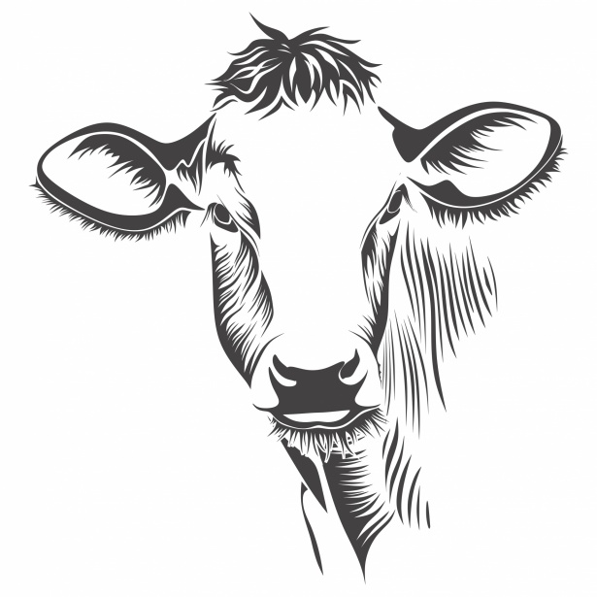
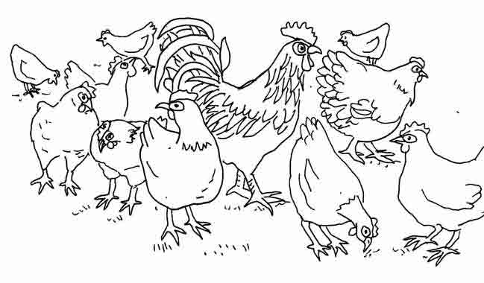
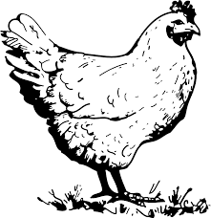
A male chicken is a rooster.
A female chicken is a hen.
Chickens give us eggs and meat.



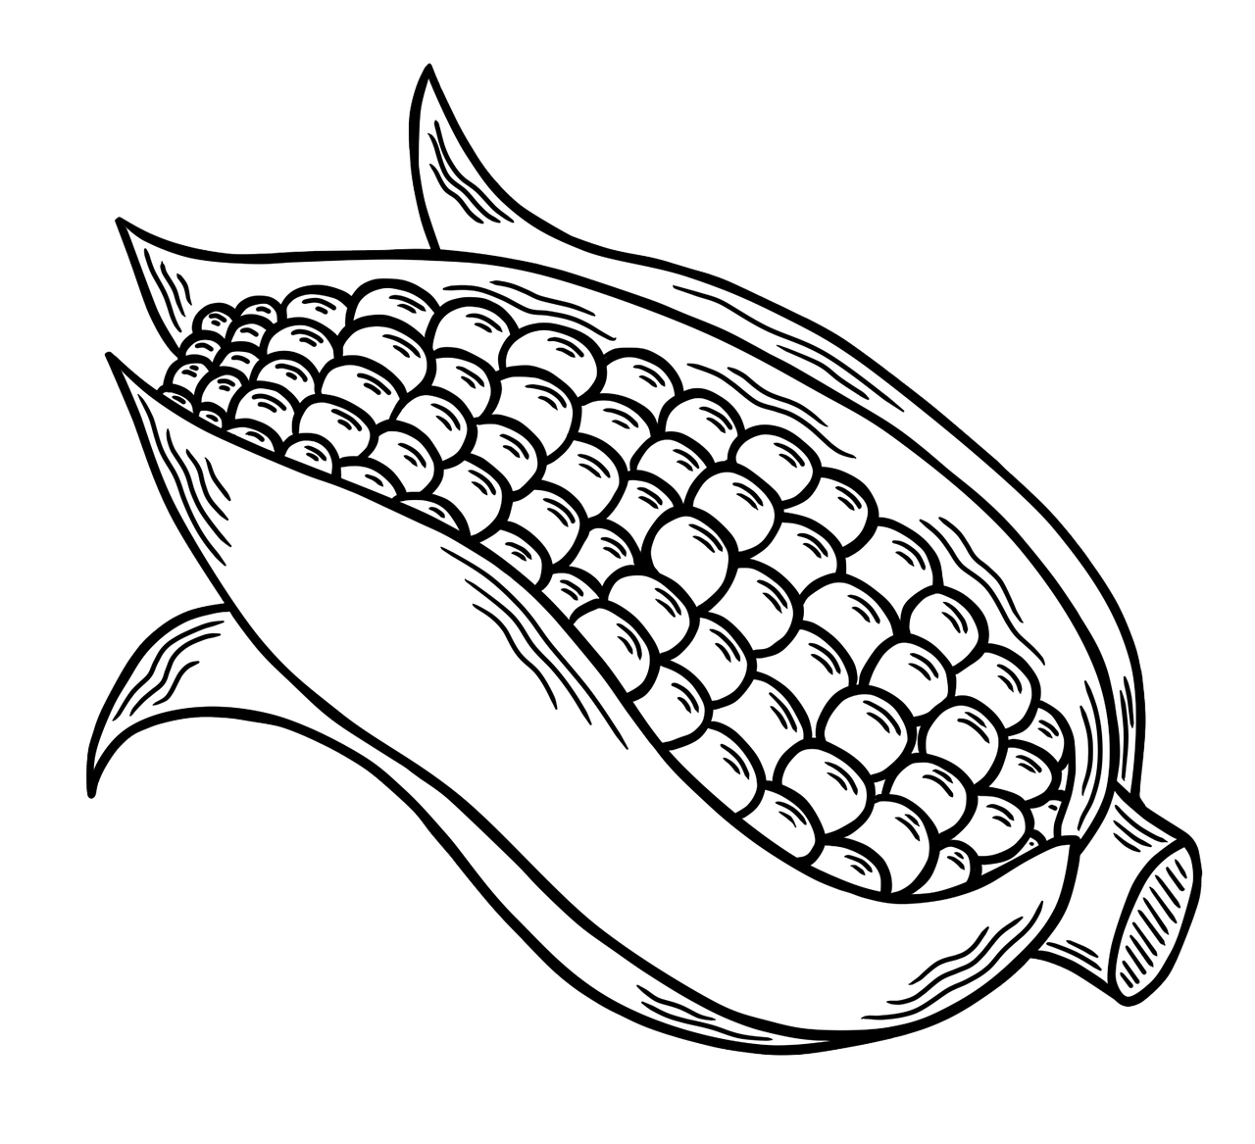
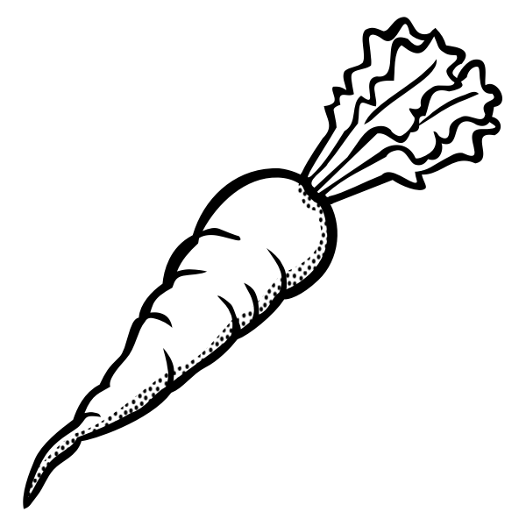

Farmers all over America grow our fruits and vegetables.
Tomato

Strawberry

Carrot

Apple

Grapes

Corn
Draw a line from the fruit or vegetable pictures to the correct name.



There are many careers in agriculture. Color the different examples below.
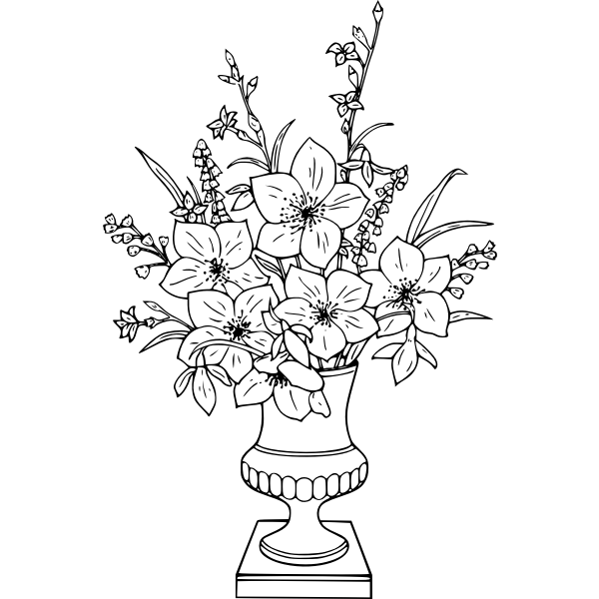



A veterinarian helps keep our pets of all kinds healthy.

A florist will grow and arrange beautiful flowers for you.

A farmer grows plants and animals that we use for food, fiber and fuel.
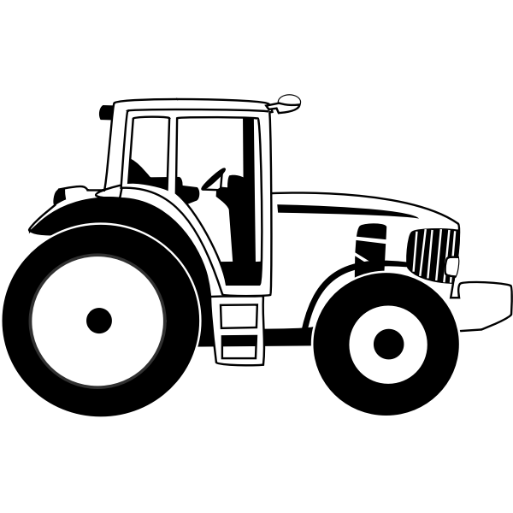
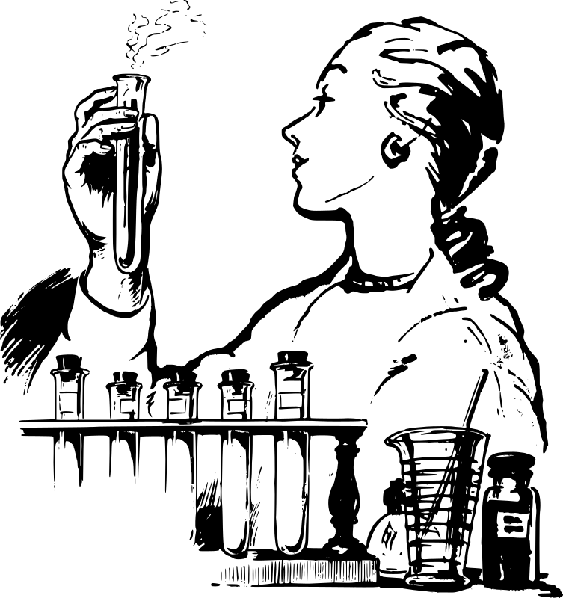

A scientist is needed in agriculture to study how plants and animals grow and how we can use them. This is called biotechnology.
An agriculture mechanic will build and fix mechanical equipment used in farming, such as tractors.

