Agriscience expo

Directions:
View the national finalists research displays in Hall K at national convention. Select one project from each of the six categories to learn more about the research. A list of CDEs and LDEs is included for reference. These links may be helpful: AgExplorer and CDE/LDE Page.
Category | Research Topic/Title | Interesting Fact or Statistic | FFA Connection  List a CDE or LDE that ties to this project. | Career Connection  List an agriculture career that ties to this project.
Animal Systems
Environmental Services/Natural Resources Systems
Food Products and Processing Systems
Plant Systems
Power, Structural and Technical Systems
Social Systems

*Which category within the agriscience fair are you most interested in? Explain why.

*Which agriscience research project was your favorite? Explain why.

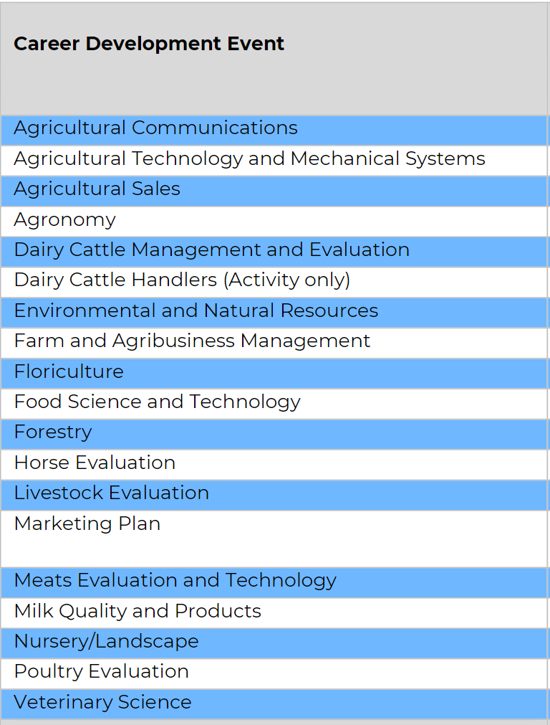
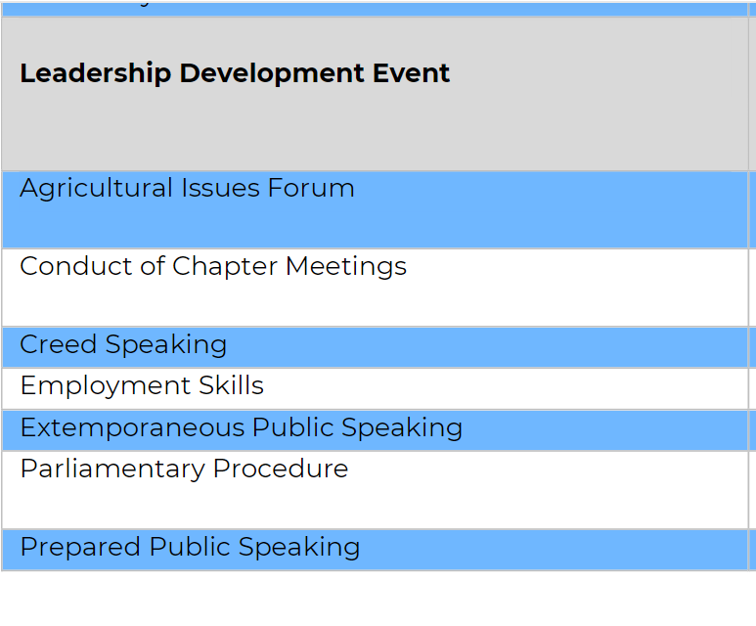
National FFA CDEs and LDEs

