The Research Poster
Created: 06/2021 by the National FFA Organization

Description: The purpose of this lesson series is to guide students through the agriscience research process. Skills learned through this process are in alignment with the National FFA Agriscience Fair award area.

Student Learning Objectives:
After completing these activities, students will …
- Describe the importance of a research poster.
- Identify the important components of a research poster.
- Develop a research poster for their research.

Suggested Grade Level:
Grades 9 and 10 (This lesson is written so instructors can scale up or down based on class needs.)

Suggested Time: 120 minutes (*Time requirements may vary based upon student understanding and class schedule.)

Resources/References:
- Microsoft PowerPoint or similar tool
- Video: “Better Research Poster,” https://youtu.be/AwMFhyH7_5g

Equipment and Supplies Needed:
- A copy of the “Let Your Research Be Seen” worksheet for each student
- A copy of the “How Will You Show What You Know?” worksheet for each student
- A copy of the “Let’s Brainstorm” worksheet for each student
- A copy of the “Poster Rubric” for each student
- Sticky notes
- Internet access to play the video in real time or embed it in a PowerPoint ahead of time

Cross-Curricular Connections:
Science | English/Language Arts | Technology
Present research in a visual format. | Compose the different parts of the research poster. | Utilize a technology platform to develop a research poster.

Student Activity Sheets:
Direct access to student activity sheets without lesson plan or answer key for easy upload to a learning management system or printing for classwork.

https://ffa.box.com/s/aimtnxgo4w0ad67olkhu3fy67lu9bm6b (Word)
https://ffa.box.com/s/fgst3gn6m9e345n8iizkgvsbsa1pshy6 (PDF)

These activities are aligned to the following standards:

FFA Precept
- FFA.PL-A.Action: Assume responsibility and take the necessary steps to achieve the desired results, no matter what the goals or task at hand.
- FFA.PL-C.Vision: Visualize the future and how to get there.
- FFA.PL-E.Awareness: Understand personal vision, mission and goals.
- FFA.PL-F.Continuous Improvement: Accept responsibility for learning and personal growth.
- FFA.PG-J.Mental Growth: Embrace cognitive and intellectual development relative to reasoning, thinking and coping.
- FFA.PG-I.Professional Growth: Assume responsibility for attaining and improving upon the skills needed for career success.
- FFA.CS-N.Decision Making: Analyze a situation and execute an appropriate course of action.
Common Core – Speaking and Listening
- CCSS.ELA-Literacy.SL.9-10.1: Initiate and participate effectively in a range of collaborative discussions (one-on-one, in groups, and teacher-led) with diverse partners on grades 9-10 topics, texts, and issues, building on others' ideas and expressing their own clearly and persuasively.
Common Core – Science & Technical Subjects
- CCSS.ELA-Literacy.RST.9-10.7: Translate quantitative or technical information expressed in words in a text into visual form (e.g., a table or chart) and translate information expressed visually or mathematically (e.g., in an equation) into words.
Common Core – Literacy in Science & Technical Subjects: Writing
- CCSS.ELA-Literacy.WHST.9.10.4: Produce clear and coherent writing in which the development, organization, and style are appropriate to task, purpose, and audience.
- CCSS.ELA-Literacy.RST.9.10.7: Translate quantitative or technical information expressed in words in a text into visual form (e.g., a table or chart) and translate information expressed visually or mathematically (e.g., in an equation) into words.
AFNR Career Ready Practices
- CRP.02. Apply appropriate academic and technical skills. Career-ready individuals readily access and use the knowledge and skills acquired through experience and education to be more productive.
- CRP.04. Communicate clearly, effectively, and with reason. Career-ready individuals communicate thoughts, ideas and action plans with clarity, whether using written, verbal and/or visual methods.
- CRP.06. Demonstrate creativity and innovation. Career-ready individuals regularly think of ideas that solve problems in new and different ways, and they contribute those ideas in a useful and productive manner to improve their organization.
- CRP.07. Employ valid and reliable research strategies. Career-ready individuals are discerning in accepting and using new information to make decisions, change practices or inform strategies.
- CRP.08. Utilize critical thinking to make sense of problems and persevere in solving them. Career-ready individuals readily recognize problems in the workplace, understand the nature of the problem, and devise effective plans to solve the problem.
Partnership for 21st Century Skills
- Communication
- Critical Thinking and Problem Solving
- Flexibility and Adaptability
- Initiative and Self-direction
- Leadership and Responsibility
- Think Creatively

Lesson Plan:
- Bell Ringer: Each student needs a copy of the worksheet “Let Your Research Be Seen.” Students will analyze two research posters and answer some questions. Students should critique the visual components of the posters, not the content. When all students are finished, have them think-pair-share. Then have groups share with the class. For virtual environments, have students share in a group chat and respond to their classmates.

- Introduction: Presenting research through a research poster gives researchers the opportunity to display their research in a concise and visual manner. Today, we are going to learn how to develop a well-put-together research poster.

- Activity 1: Each student needs a copy of the worksheet “How Will You Show What You Know?” Research posters are a great way to share research in a concise and visual manner. Watch the video “Making a Better Research Poster,” available at https://youtu.be/AwMFhyH7_5g, and have students answer the questions. After all students are finished, as a class, develop a list of “do’s and don’ts” for research poster development. Post this list somewhere that can be revisited by students throughout their poster development (Ex. on poster paper or on your LMS).

Activity 2: Each student needs a copy of the worksheet “Let’s Brainstorm.” Now that students understand how a research poster should be constructed, have students use the space provided to plan their poster. Students should consider all the elements they have learned such as flow of the content, bullet points, colors, concise title, and labels, figures and charts to be included as well as the images to include. Once students are done brainstorming, have them hang their concepts around the classroom. Each student should then be provided three sticky notes. They should write one positive and one piece of constructive criticism to help another student on each sticky note. They should place the sticky note next to the poster they critiqued. Note: Choose a required number of sticky notes for each poster to help ensure everyone receives equal amounts of feedback (Ex. each poster can only have three sticky notes). Once all students have finished providing feedback, have students collect their brainstorm and sticky notes and make changes to their concepts. In a virtual setting, have students take a picture of their sketch and upload the picture to a group chat or program like Flipgrid.

Activity 3: Each student needs a copy of the “Poster Rubric.” Students should now use a digital platform to create their poster, such as PowerPoint.

- Follow-up: Host a mini poster session where students stand next to their completed poster while other students walk around and ask questions about their research. For virtual learning, try having students share during a Zoom call or through a sharing program like Flipgrid.

- Exit Ticket: What did you learn from this process that you can apply in your future?

Let Your Research Be Seen
Aligned to the following standards:
FFA.PL-A; FFA.PL-C; FFA.PL-E; FFA.PL-F; FFA.PG-J; FFA.CS_N; CCSS.ELA.SL.9.10.1; CCSS.ELA.RST.9-10.7; CCSS.ELA.WHST.9.10.4; CCSS.ELA.RST.9.10.7; CRP.02; CRP.04; CRP.06; CRP.07; CRP.08
Directions:
Look at the two research posters below and answer the questions. Critique the visual aspects of the poster, not the content.
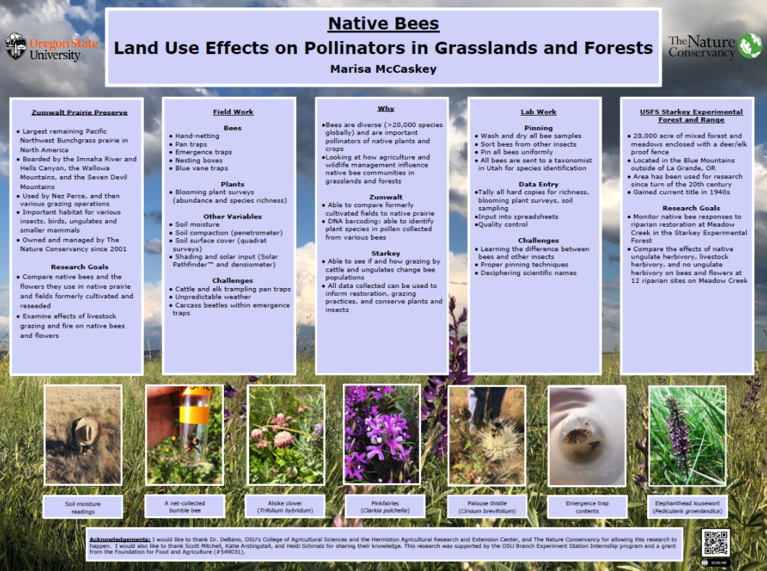
What do you like about this poster? What makes it catch your eye?

What about this poster do you not like, and what could be improved?

What do these posters have in common? Why do you think they have these items in common?

What do you like about this poster? What makes it catch your eye?

What about this poster do you not like, and what could be improved?

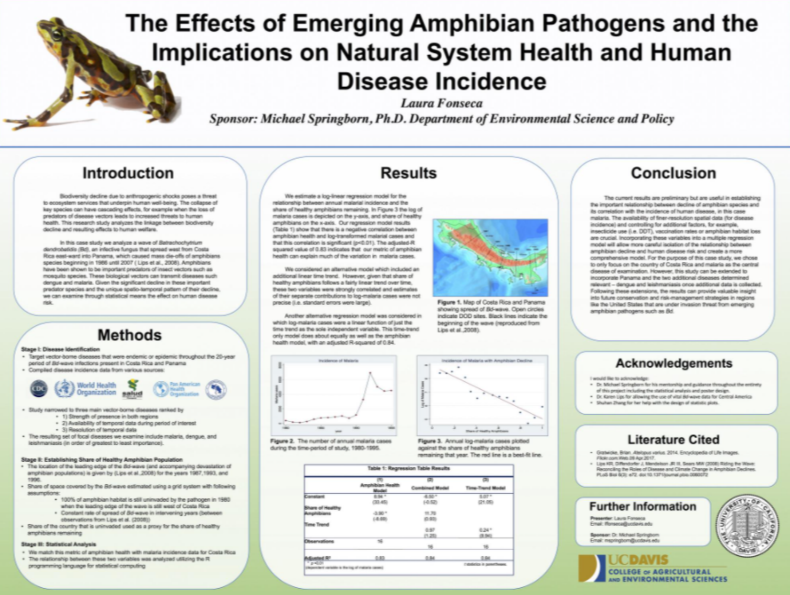

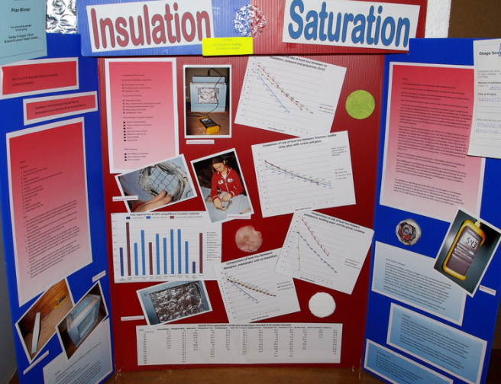
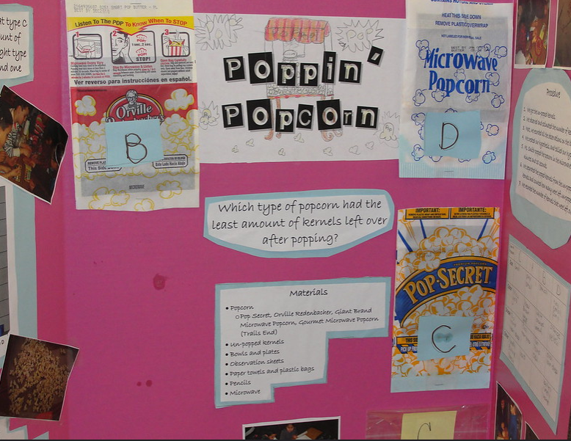
- Circle the poster that you think is the best.

- Why did you select this poster? What makes it the best option for a research poster?
What do you think is the purpose of a research poster?
What about this poster do you not like, and could be improved?
What do you like about this poster? What makes it catch your eye?
What about this poster do you not like, and what could be improved?
What do you like about this poster? What makes it catch your eye?
How Will You Show What You Know?
Aligned to the following standards:
FFA.PL-A; FFA.PL-C; FFA.PL-E; FFA.PL-F; FFA.PG-J; FFA.CS_N; CCSS.ELA.SL.9.10.1; CCSS.ELA.RST.9-10.7; CCSS.ELA.WHST.9.10.4; CCSS.ELA.RST.9.10.7; CRP.02; CRP.04; CRP.06; CRP.07; CRP.08
Directions:
Research posters are a great way to share your research in a concise and visual manner. Watch the video “Making a Better Research Poster,” available at https://youtu.be/AwMFhyH7_5g, and answer the questions below.
Why do you think this mistake is made so often?

What is the number one mistake people make when developing their research posters?

How will you avoid this mistake for your poster?



Full sentences can be used, but you should also try to use what?

- Bullet points
- Fragments
- Clips directly from your paper
Figures and graphs are important for your poster. But what should you be cautious of doing with your graphs and figures?

B________________ them in t__________

How many colors are recommended when designing your poster?
- 1-2
- 3-5
- 6-7
- 8-9
How do people naturally read?

Why is it important to think about this when designing your poster?



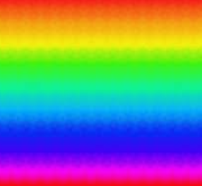
At what distance should all content be viewable?

- Two feet
- Three feet
- Six feet
- Seven feet

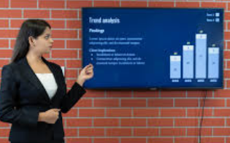

Lastly, describe how you will present your poster.

Let’s Brainstorm
Directions:
Now that you understand how a research poster should be constructed, use the space below to plan your poster. Be sure to consider all the elements we have learned, such as flow of the content, bullet points, colors, concise title, and labels, figures and charts to be included as well as the images you will include.
Note: Do NOT just copy and paste sentences and information from your paper! You should always think about your audience and how to display content concisely and in a readable format.

Poster Rubric
Area | 4 points | 3 points | 2 points | 1 point
Overall Appearance | - Well organized  - Bullet points used  - Not text heavy  - Draws attention | - Some organization is present.  - Text is somewhat heavy.  - Draws attention | Some organization is present. However, readability is still difficult. | Organization is poor with lots of text.  Does not capture your attention
Color | Only three to four colors were used. | More than four colors were used or colors do not work or dark background was used. | Colors are not cohesive. | Color was not well considered in the development of the poster.
Graphics/tables | Two to three graphics/tables were used in the correct places and enhanced the overall poster flow and readability. | Less than two graphics/tables were used. | One or less graphics/tables were included. | No graphics/tables incorporated
Text | Text and images are well balanced. Bullet points were used to help break up information. | Text heavy, with 20% or more of the poster having text directly copied and pasted from the paper | Very text heavy, with over 50% of the poster text having been copied directly from the paper | Paragraphs of text were copied and pasted to the poster.
Readability | Text and images can be read from 6 feet away. | ________________ | __________________ | Text and images are not able to be read from 6 feet away.
Total |  |  |  | ________/20

KEY: How Will You Show What You Know?
Directions:
Research posters are a great way to share your research in a concise and visual manner. Watch the video “Making a Better Research Poster,” available at https://youtu.be/AwMFhyH7_5g, and answer the questions below.
Why do you think this mistake is made so often?
Answers will vary.

What is the number one mistake people make when developing their research posters? Text heavy/too much information

How will you avoid this mistake for your poster? Answers will vary.

Full sentences can be used, but you should also try to use what?

- Bullet points
- Fragments
- Clips directly from your paper
Figures and graphs are important for your poster. But what should you be cautious of doing with your graphs and figures?

Burying them in text

How many colors are recommended when designing your poster?

- 1-2
- 3-5
- 6-7
- 8-9
How do people naturally read?
Left to right, top to bottom

Why is it important to think about this when designing your poster?
Knowing how people naturally read is important for ensuring your reader can follow your poster. Disorganization causes confusion.

At what distance should all content be viewable?

- Two feet
- Three feet
- Six feet
- Seven feet

Lastly, describe how you will present your poster. Answers will vary.

