What Can I Learn?
Created: 06/2021 by the National FFA Organization

Description: The purpose of this lesson series is to guide students through the agriscience research process. Skills learned through this process are in alignment with the National FFA Agriscience Fair award area.

Student Learning Objectives:
After completing these activities, students will …
- Select a research topic.
- Write a research question.
- Describe the importance of reviewing others’ research to inform their own.
- Describe how to find research and information relevant to their own studies.
- Develop a correct works cited page.

Suggested Grade Level:
Grades 9 and 10 (This lesson is written so instructors can scale up or down based on class needs.)

Suggested Time: 120 minutes (*Time requirements may vary based on student understanding and class schedule.)

Resources/References:
- Agriscience Fair Handbook, https://FFA.box.com/s/7csy0fr1adtqx8tibo2dqc0fsm8c5mp6
- Website: George Mason University Writing Lab, https://writingcenter.gmu.edu/guides/how-to-write-a-research-question
- Website: Google Scholar, https://scholar.google.com/
- Video: “How to Write a Literature Review: Three Minute Step-by-Step Guide,” https://youtu.be/zIYC6zG265E
- Website: Literature Review: Purpose of a Literature Review, https://uscupstate.libguides.com/c.php?g=627058&p=4389968
- Website: Purdue University Online Writing Lab, https://owl.purdue.edu/owl/research_and_citation/apa_style/apa_formatting_and_style_guide/general_format.html
- Video: “What Is Aquaculture?” https://youtu.be/k6U3IgT1lVQ
- Video: “What Is a Literature Review?” https://youtu.be/KkAnKGuX7fs
- Document: Agriscience Fair Manuscript Examples, https://ffa.box.com/s/iut6a675rfpd9gq7xupnxvw113pseqdb
- Template: Agriscience Fair Written Report Template, https://ffa.box.com/s/2egran7ktpntyot680scgn3a3fhjy5ul

Equipment and Supplies Needed:
- A copy of the “What Question Do I Have?” worksheet for each student
- A copy of the “What Do We Already Know?” worksheet for each student
- A copy of the “Giving Credit” worksheet for each student
- Internet access to play the videos in real time or embed it in a PowerPoint ahead of time

Cross-Curricular Connections:
Science | English/Language Arts
Reading and using previous research completed to inform own study | APA formatting, research question development and literature review
Student Activity Sheets:
Direct access to student activity sheets without lesson plan or answer key for easy upload to a learning management system or printing for classwork.

https://ffa.box.com/s/mt3h0ieb8sx0mrro1h5d7p7ff2fschqe (Word)
https://ffa.box.com/s/s7qici2150rz973er320pdpyrfwyf5sj (PDF)

These activities are aligned to the following standards:

AFNR Performance Element
- CS.01: Analyze how issues, trends, technologies and public policies impact systems in the Agriculture, Food & Natural Resources Career Cluster.
FFA Precept
- FFA.PL-A.Action: Assume responsibility and take the necessary steps to achieve the desired results, no matter what the goal or task at hand.
- FFA.PL-C.Vision: Visualize the future and how to get there.
- FFA.PL-E.Awareness: Understand personal vision, mission and goals.
- FFA.PL-F.Continuous Improvement: Accept responsibility for learning and personal growth.
- FFA.PG-J.Mental: Embrace cognitive and intellectual development relative to reasoning, thinking and coping.
- FFA.CS-N.Decision Making: Analyze a situation and execute an appropriate course of action.
Common Career Technical Core
- AG1: Analyze how issues, trends, technologies and public policies impact systems in the Agriculture, Food & Natural Resources Career Cluster.
Common Core – Reading: Informational Text
- CCSS.ELA-Literacy.RI.9-10.1: Cite strong and thorough textual evidence to support analysis of what the text says explicitly as well as inferences drawn from the text.
- CCSS.ELA-Literacy.RI.9-10.2: Determine a central idea of a text and analyze its development over the course of the text, including how it emerges and is shaped and refined by specific details; provide an objective summary of the text.
- CCSS.ELA-Literacy.RI.9-10.3: Analyze how the author unfolds an analysis or series of ideas or events, including the order in which the points are made, how they are introduced and developed, and the connections that are drawn between them.
- CCSS.ELA-Literacy.RI.9-10.4: Determine the meaning of words and phrases as they are used in a text, including figurative, connotative, and technical meanings; analyze the cumulative impact of specific word choices on meaning and tone (e.g., how the language of the court opinion differs from that of a newspaper).
- CCSS.ELA-Literacy.RI.9-10.8: Delineate and evaluate the argument and specific claims in a text, assessing whether the reasoning is valid and the evidence is relevant and sufficient; identify statements and fallacious reasonings.
Common Core – Science & Technical Subjects
- CCSS.ELA-Literacy.RST.9-10.1: Cite specific textual evidence to support analysis of science and technical texts, attending to the precise details of explanations or descriptions.
- CCSS.ELA-Literacy.RST.9.10.4: Determine the meaning of symbols, key terms, and other domain-specific words and phrases as they are used in a specific scientific or technical context relevant to grades 9-10 texts and topics.
- CCSS.ELA-Literacy.RST.9-10.8: Assess the extent to which the reasoning and evidence in a text support the author’s claim or a recommendation for solving a scientific or technical problem.
- CCSS.ELA-Literacy.RST.9-10.9: Compare and contrast findings presented in a text to those from other sources (including their own experiments), noting when the findings support or contradict previous explanations or accounts.
Common Core – Literacy in Science & Technical Subjects: Writing
- CCSS.ELA-Literacy.WHST.9.10.1: Write arguments focused on discipline-specific content.
- CCSS.ELA-Literacy.WHST.9.10.4: Produce clear and coherent writing in which the development, organization, and style are appropriate to task, purpose, and audience.
AFNR Career Ready Practices
- CRP.02: Apply appropriate academic and technical skills. Career-ready individuals readily access and use the knowledge and skills acquired through experience and education to be more productive.
- CRP.04: Communicate clearly, effectively, and with reason. Career-ready individuals communicate thoughts, ideas and action plans with clarity, whether using written, verbal and/or visual methods.
- CRP.05: Consider the environmental, social and economic impact of decisions. Career-ready individuals understand the interrelated nature of their actions and regularly make decisions that positively impact and/or mitigate negative impact on other people, organizations and the environment.
- CRP.06: Demonstrate creativity and innovation. Career-ready individuals regularly think of ideas that solve problems in new and different ways, and they contribute those ideas in a useful, productive manner to improve their organization.
- CRP.07: Employ valid and reliable research strategies. Career-ready individuals are discerning in accepting and using new information to make decisions, change practices or inform strategies.
- CRP.08: Utilize critical thinking to make sense of problems and persevere in solving them. Career-ready individuals readily recognize problems in the workplace, understand the nature of the problem, and devise effective plans to solve the problem.
Partnership for 21st Century Skills
- Critical Thinking and Problem Solving
- Flexibility and Adaptability
- Initiative and Self-direction
- Leadership and Responsibility
- Technology Literacy
- Think Creatively

Lesson Plan:
- Bell Ringer: Why should we ask questions every day?

- Introduction: As we have learned, research is very important to help inform society and the practices we follow every day. For example, we know we don’t put standard fuel in a diesel engine because then the engine will not perform properly. So, how do we determine what we should research? Today, we are going to learn about needs in research and how to develop our own research question.

- Activity 1:
  - Part 1: Each student needs a copy of the worksheet “What Question Do I Have?” Having an effective research question is important for being able to complete an effective research study. Students will learn about how to develop proper research questions through the activities. Have students answer the question “What is a research question?” Once students have brainstormed, have them share. Next, have students use the George Mason University Writing Lab as a resource to summarize, in their own words, the five words they should consider when writing an appropriate research question. The sentence should be simple enough that a friend would understand. Next, students will begin brainstorming their interests (both in and out of the classroom) that could lead to a research question. Students will then finish by selecting one interest from their list. Have students share their idea with a neighbor.
  - Part 2: Next, in their own words, students will use the George Mason University Writing Lab to identify the six steps they should take to write an appropriate research question. Students will then think about the five words and the steps needed to write an effective research question by reading through each of the research questions listed on the worksheet and circling the questions that are well written and could be used for a research study. Hold a discussion with students about why certain questions are either poorly written or well written. Next, students will watch the video “What Is Aquaculture?” and write two well-formed research questions they could investigate. Have students think-pair-share their research questions with their neighbor (in a distance learning setting, set up a discussion board). During this time, also have students select one of their four questions, refine the question and then share their completed question with the class. As a class, have students discuss each of the questions and provide feedback of how to improve each question. Students are then going to think about their interests and identify what related needs there are in their community that they could research. Have students identify three community needs. Lastly, have students think about the needs they just identified and their interests, and then have them develop a well-written research question that will serve as the foundation of their research.

- Activity 2:
  - Part 1: Each student needs a copy of the worksheet “What Do We Already Know?” During this time, students are going to learn about literature reviews and their importance. Students should begin by answering the question “What would happen if scientists completed research without ever looking at research that had already been completed?” Have students share their thoughts and hold a discussion. Next, have students watch the video “What Is a Literature Review?” and answer the questions that follow. If internet access is not available use the following resource: https://uscupstate.libguides.com/c.php?g=627058&p=4389968. Students will then, in their own words, identify the purpose of a literature review and give their own example of a study that would require a literature review. Lastly, have students watch the video “How to Write a Literature Review: Three-Minute Step-by-Step Guide” and answer the questions. Once students have finished answering the multiple choice questions, discuss the correct answer for each. Have students end by identifying how a literature review will help them in their own research.
  - Part 2: Utilizing a valid research method (ex. Google Scholar), have students find three sources that will help to inform their research question. Have students read through each resource and identify what gaps, trends or themes they see in the resources they found. Lastly, based on what students learned in their literature reviews, have students identify how they will or can change their research question (developed previously) based upon what they just learned. Have students write their questions on a blank piece of paper and hang them around the classroom. At this time, have students move around the room and provide one positive comment and a piece of constructive feedback to three other students’ questions. Give students time to modify their questions based upon feedback. To sum up what has been learned so far, have students, in their own words, describe the following as if they were talking to a grandparent or best friend: (1) How do you write an effective research question? (2) Why are well-written research questions so important to produce effective research? (3) What is a literature review? (4) Why is it important to conduct a literature review? and (5) How do well-written research questions and your literature review relate?

- Activity 3: Each student needs a copy of the worksheet “Giving Credit.” Giving credit is very important when credit is due. In research, it is always important to give credit to other researchers as well as yourself. When completing research, it is always important to cite your sources (if you score the winning goal in your soccer game, you want the credit, right?). Utilizing APA formatting is a commonly accepted method for giving credit for scientific research. Using the Purdue University Online Writing Lab, have students practice citing resources by reading the information from the two examples provided and have them develop an APA citation for each example article. Next, have students take the three resources they previously identified for their research and cite each in APA formatting using the Purdue University Online Writing Lab for help.

Next, it is important for students to understand that self-plagiarism is; it is something they need to be cautious of when writing their research study. Have students identify why it is important to cite any previous research they may have completed. Note: My student previously completed research that had led to another research question my student would like to explore; what do we do? In this situation, it would be necessary to complete an agriscience fair extension. Check out Page 13 of the National FFA Agriscience Fair Handbook to learn all about extensions.

Next, students will identify how to develop APA-formatted in-text citations. When using information from a resource, students must also include an in-text citation to let a reader know exactly what resource is being given credit. Using the Purdue University Online Writing Lab, students will develop an in-text citation for each of their three resources. Finally, it is important for students to understand that they should be keeping up with their citations throughout their research for best practices in organization. Have students answer the multiple-choice question provided to reinforce this concept. To wrap up, have students identify why it is important to cite resources used during research. Have students share their responses with the class.

- Follow-up: Have students review each other’s statements that they wrote in the “Let’s Sum It Up” portion of the lesson.

- Optional — Extended Learning Opportunities (Not factored into time requirement):
  - Have students share the most interesting article they found in their literature review.

- Exit Ticket: What role does a well-formulated research question play in setting you up for a successful research study?

What Question Do I Have?
Aligned to the following standards:
CS.01; FFA.PL-A; FFA.PL_C; FFA.PL-E; FFA.PL-F; FFA. PG-J; FFA.CS-N; AG1; CCSS.ELA.RI.9-10.1; CCSS.ELA.RI.9-10.2; CCSS.ELA.RI.9-10.3; CCSS.ELA.RI.9-10.4; CCSS.ELA.RI.9-10.8; CCSS.ELA.RST.9-10.1; CCSS.RST.9.10.4; CCSS.ELA.RST.9-10.8; CCSS.ELA.RST.9-10.9; CCSS.ELA.WHST.9.10.1; CCSS.ELA.WHST.9.10.4; CRP.02; CRP.04; CRP.05; CRP.06; CRP.07; CRP.08

Part 1
Directions:
Having an effective research question is important for being able to complete an effective research study. Learn how to develop proper research questions through the activities below.
What is a research question?

Using the resource https://writingcenter.gmu.edu/guides/how-to-write-a-research-question, summarize, in your own words, the five words you should consider when writing an appropriate research question.

- Word: ___________________: __________________________________________________________________________________________________________________________________________________________________________________________________________________________

- Word: ___________________: __________________________________________________________________________________________________________________________________________________________________________________________________________________________

- Word: ___________________: __________________________________________________________________________________________________________________________________________________________________________________________________________________________

- Word: ___________________: __________________________________________________________________________________________________________________________________________________________________________________________________________________________

- Word: ___________________: __________________________________________________________________________________________________________________________________________________________________________________________________________________________


Take one minute and brainstorm a minimum of three of your greatest interests, both in the classroom and out. For example, do you like working on trucks, raising goats, playing soccer? Go!
- Circle three interests on your list.
In one sentence, how would you summarize for a classmate these five needs for a perfect research question?
Interest/topic selected:
- Transfer one to the box.

Part 2
In your own words, using the George Mason University Writing Lab, identify the six steps you should take to write an appropriate research question.

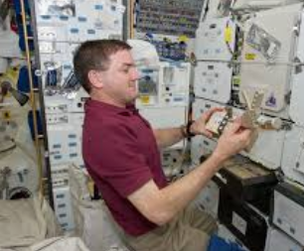

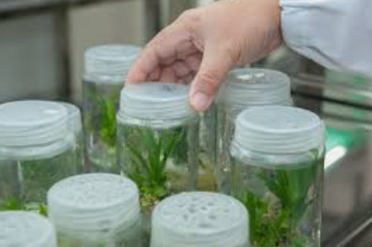
Think about your interests, and then consider what related needs there are in your community that you could research. Identify three.

1.

2.

3.
Think about the needs you just identified and your interests, then develop a well-written research question that can serve as the foundation of your research.
Watch the video “What Is Aquaculture?”, and write two well-formed research questions you could investigate.

Thinking about the five words and the steps needed to write an effective research question, read through each of the research questions below and circle the question(s) that are well-written and could be used for a research study.

- How are doctors addressing heart disease in the United States?

- Do cats prefer wet food or dry food?

- Do carnations or daisies transport water throughout their stems more efficiently?

- Should high schoolers exercise regularly to impact mental health?

- Do corgi dogs have a greater number of surgery complications as compared to large breed dogs?

What Do We Already Know?
Aligned to the following standards:
CS.01; FFA.PL-A; FFA.PL_C; FFA.PL-E; FFA.PL-F; FFA. PG-J; FFA.CS-N; AG1; CCSS.ELA.RI.9-10.1; CCSS.ELA.RI.9-10.2; CCSS.ELA.RI.9-10.3; CCSS.ELA.RI.9-10.4; CCSS.ELA.RI.9-10.8; CCSS.ELA.RST.9-10.1; CCSS.RST.9.10.4; CCSS.ELA.RST.9-10.8; CCSS.ELA.RST.9-10.9; CCSS.ELA.WHST.9.10.1; CCSS.ELA.WHST.9.10.4; CRP.02; CRP.04; CRP.05; CRP.06; CRP.07; CRP.08

Part 1
Directions:
Literature Review!
Complete the following activities to learn about literature reviews.
What would happen if scientists completed research without ever looking at research that had already been completed?



Watch the video “What Is a Literature Review?” and answer the questions below.

What is a literature review?

Identify the purpose behind a literature review.


1.

2.

3.

Give an example of a study that would require a literature review.
In your own words, describe what a literature review is and why it is important for research.

Watch the video “How to Write a Literature Review: Three-Minute Step-by-Step Guide” and answer the following questions:
- Which of the following would NOT be considered an acceptable source for a literature review?
  - Google Scholar
  - A school textbook
  - The Huffington Post
  - A scientific journal (Ex. Journal of Agricultural Education)
- Which of the following should you look at to evaluate if the resource is trustworthy?
  - Abstract
  - References
  - Authors
  - All of the above
- As you read through the resource, what should you pay attention to and take note of?
  - Trends
  - Themes
  - Debates or contradictions
  - Influential studies
  - Gaps
  - All of the above

How will completing a literature review help you in your research?
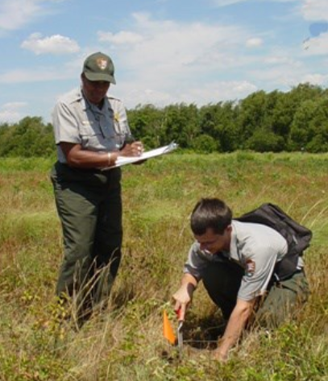
Part 2
Utilizing a valid research method (ex. Google Scholar), find three sources that will help inform your research question. List the titles of each resource below.

1.

2.

3.

What gaps, trends or themes do you see in the resources you found? Identify a minimum of three.

1.

2.

3.

Based on what you have learned in your literature review, how will or can you change your research question (developed previously) to use what you have just learned?

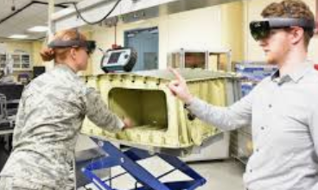

Let’s Sum it Up!
In your own words, describe the following as if you were talking to a grandparent, best friend, sibling or parent:
- How do you write an effective research question?
- Why are well-written research questions so important to produce effective research?
- What is a literature review?
- Why is it important to conduct a literature review?
- How do well-written research questions and your literature review relate?

Giving Credit
Aligned to the following standards:
CS.01; FFA.PL-A; FFA.PL_C; FFA.PL-E; FFA.PL-F; FFA. PG-J; FFA.CS-N; AG1; CCSS.ELA.RI.9-10.1; CCSS.ELA.RI.9-10.2; CCSS.ELA.RI.9-10.3; CCSS.ELA.RI.9-10.4; CCSS.ELA.RI.9-10.8; CCSS.ELA.RST.9-10.1; CCSS.RST.9.10.4; CCSS.ELA.RST.9-10.8; CCSS.ELA.RST.9-10.9; CCSS.ELA.WHST.9.10.1; CCSS.ELA.WHST.9.10.4; CRP.02; CRP.04; CRP.05; CRP.06; CRP.07; CRP.08

Directions:
Giving credit is very important when credit is due. In research, it is always important to give credit to other researchers as well as yourself. Complete the following activities to learn how to properly cite sources.
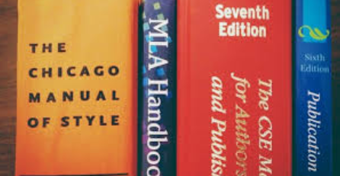
Use the Purdue University Online Writing Lab to help you cite the three resources you identified in the previous activity.
- ___________________________________________________________________________________________________________________________________________________________________________________________________________________________________________________________________________

- ___________________________________________________________________________________________________________________________________________________________________________________________________________________________________________________________________________

- ___________________________________________________________________________________________________________________________________________________________________________________________________________________________________________________________________________
When completing research, it is always important to cite your sources. (If you score the winning goal in your soccer game you want the credit, right?) Utilizing APA formatting is a commonly accepted method for giving credit when conducting scientific research. Using the Purdue University Online Writing Lab, practice citing the resources shown below.
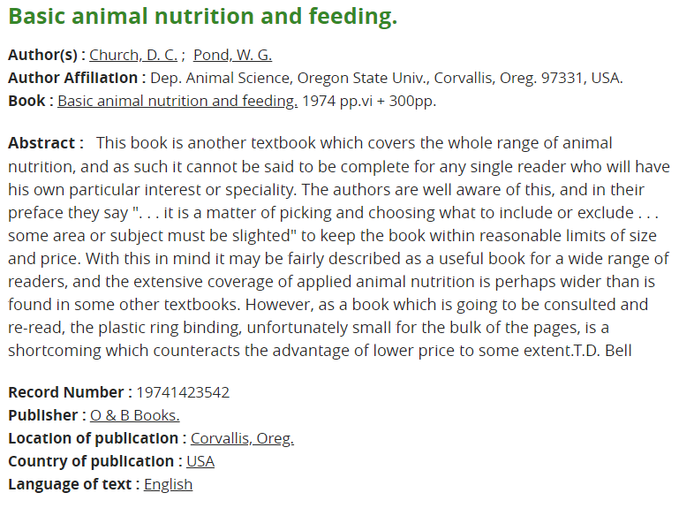
Citation:
Citation:
Did you know that if you have completed previous research you still have to cite yourself? Why do you think this is necessary?
When is the best time to complete your Works Cited page for your final research report?

- Before you start constructing your report
- While you are writing your report
- After you complete your report
When using information from a resource you must also include an in-text citation to let a reader know exactly what resource is being given credit. Using the Purdue University Online Writing Lab, develop an in-text citation for each of your three resources.

1.

2.

3.
Why is it important to use citations in research?



KEY: What Question Do I Have?
Aligned to the following standards:
CS.01; FFA.PL-A; FFA.PL_C; FFA.PL-E; FFA.PL-F; FFA. PG-J; FFA.CS-N; AG1; CCSS.ELA.RI.9-10.1; CCSS.ELA.RI.9-10.2; CCSS.ELA.RI.9-10.3; CCSS.ELA.RI.9-10.4; CCSS.ELA.RI.9-10.8; CCSS.ELA.RST.9-10.1; CCSS.RST.9.10.4; CCSS.ELA.RST.9-10.8; CCSS.ELA.RST.9-10.9; CCSS.ELA.WHST.9.10.1; CCSS.ELA.WHST.9.10.4; CRP.02; CRP.04; CRP.05; CRP.06; CRP.07; CRP.08
Part 1
Directions:
Having an effective research question is important for being able to complete an effective research study. Learn how to develop proper research questions through the activities below.

What is a research question?
A research question is a question that outlines and defines a research study.

Using the resource https://writingcenter.gmu.edu/guides/how-to-write-a-research-question, summarize, in your own words, the five words you should consider when writing an appropriate research question.

- Clear: Research questions should be written in a manner that a reader can easily understand without further explanation.

- Focused: Research questions should be written in a way that is specific and narrow enough to leave no room for misunderstanding of what is being researched.

- Concise: Research questions should be written in a manner that uses as few as words as possible while containing all important information.

- Complex: A research question should be written in a manner that requires analysis and is more than a “yes” or “no” response.

- Arguable: Not all research is final and should be debatable.

Take one minute and brainstorm a minimum of three of your greatest interests, both in the classroom and out. For example, do you like working on trucks, raising goats, playing soccer? Go!
Answers will vary.
- Circle three interests on your list.
In one sentence, how would you summarize for a classmate these five needs for a perfect research question? Answers will vary.
Interest/topic selected:
Answers will vary.
- Transfer one to the box.

Part 2
In your own words, using the George Mason University writing Lab, identify the six steps you should take to write an appropriate research question.

- Choose a topic that is of interest to you.

- Complete a beginning amount of research on your topic.

- Keep your audience in mind.

- Ask questions.

- Make sure your question is well-written and researchable.

- Start your research.
Thinking about the five words and the steps needed to write an effective research question, read through each of the research questions below and circle the question(s) that are well-written and could be used for a research study.

- How are doctors addressing heart disease in the United States?

- Do cats prefer wet food or dry food?

- Do carnations or daisies transport water throughout their stems more efficiently?

- Should high schoolers exercise regularly to impact mental health?

- Do corgi dogs have a greater number of surgery complications as compared to large breed dogs?

Think about the needs you just identified and your interests, then develop a well-written research question that can serve as the foundation of your research.
Answers will vary.
Think about your interests, and then consider what related needs there are in your community that you could research. Identify three.
Answers will vary.

1.

2.

3.
Watch the video “What is Aquaculture?”, and write two well-formed research questions you could investigate.
Answers will vary.

What Do We Already Know?
Aligned to the following standards:
CS.01; FFA.PL-A; FFA.PL_C; FFA.PL-E; FFA.PL-F; FFA. PG-J; FFA.CS-N; AG1; CCSS.ELA.RI.9-10.1; CCSS.ELA.RI.9-10.2; CCSS.ELA.RI.9-10.3; CCSS.ELA.RI.9-10.4; CCSS.ELA.RI.9-10.8; CCSS.ELA.RST.9-10.1; CCSS.RST.9.10.4; CCSS.ELA.RST.9-10.8; CCSS.ELA.RST.9-10.9; CCSS.ELA.WHST.9.10.1; CCSS.ELA.WHST.9.10.4; CRP.02; CRP.04; CRP.05; CRP.06; CRP.07; CRP.08

Directions:
Literature Review!
Complete the following activities to learn about literature reviews.
What would happen if scientists completed research without ever looking at research that had already been completed? Answers will vary. If we never looked at previous research, new questions would not be raised and researched.

Watch the video “What Is a Literature Review?”

What is a literature review?
A review of what has already been researched about a topic

Identify the purpose behind a literature review.

- To find out what has already been learned about a topic

- It allows the person reading your research to study what you found.

- To find out what we still need to know

Give an example of a study that would require a literature review.
Answers will vary.

In your own words, describe what a literature review is and why it is important for research.
Answers will vary.

Watch the video “How to Write a Literature Review: Three-Minute Step-by-Step Guide” and answer the following questions:

- Which of the following would NOT be considered an acceptable source for a literature review?
- Google Scholar
- A school textbook
- The Huffington Post
- A scientific journal (Ex. Journal of Agricultural Education)
- Which of the following should you look at to evaluate if the resource is trustworthy?
- Abstract
- References
- Authors
- All of the above
- As you read through the resource, what should you pay attention to and take note of?
- Trends
- Themes
- Debates or contradictions
- Influential studies
- Gaps
- All of the above

How will completing a literature review help you in your research? A literature review gives background knowledge and an understanding of what has already been researched.
Giving Credit
Aligned to the following standards:
CS.01; FFA.PL-A; FFA.PL_C; FFA.PL-E; FFA.PL-F; FFA. PG-J; FFA.CS-N; AG1; CCSS.ELA.RI.9-10.1; CCSS.ELA.RI.9-10.2; CCSS.ELA.RI.9-10.3; CCSS.ELA.RI.9-10.4; CCSS.ELA.RI.9-10.8; CCSS.ELA.RST.9-10.1; CCSS.RST.9.10.4; CCSS.ELA.RST.9-10.8; CCSS.ELA.RST.9-10.9; CCSS.ELA.WHST.9.10.1; CCSS.ELA.WHST.9.10.4; CRP.02; CRP.04; CRP.05; CRP.06; CRP.07; CRP.08

Directions:
Giving credit is very important when credit is due. In research, it is always important to give credit to other researchers as well as yourself. Complete the following activities to learn how to properly cite sources.
Use the Purdue University Online Writing Lab to help you cite the three resources you identified in the previous activity. Answers will vary.
- ___________________________________________________________________________________________________________________________________________________________________________________________________________________________________________________________________________

- ___________________________________________________________________________________________________________________________________________________________________________________________________________________________________________________________________________

- ___________________________________________________________________________________________________________________________________________________________________________________________________________________________________________________________________________
When completing research, it is always important to cite your resources. (If you score the winning goal in your soccer game, you want the credit, right?) Utilizing APA formatting is a commonly accepted method for giving credit when conducting scientific research. Using the Purdue University Online Writing Lab, practice citing the resources listed below.
Citation: Tripathi, M.K., & Mishra, A.S. (2007). Glucosinolates in animal nutrition: A review. Animal Feed Science and Technology, 132(1), 1–27.
Citation: Church, D.C., & Pond, W. G. (1988). Basic Animal Nutrition and Feeding (3rd ed., pp. 161–172). New York: Wiley.
Did you know that if you have completed previous research you still have to cite yourself? Why do you think this is necessary? It is important because you can self-plagiarize.
When is the best time to complete your Works Cited page for your final research report?

- Before you start constructing your report.
- While you are writing your report.
- After you complete your report.
When using information from a resource you must also include an in-text citation to let a reader know exactly what resource is being given credit. Using the Purdue University Online Writing Lab, develop an in-text citation for each of your three resources. Answers will vary.

1.

2.

3.
Why is it important to use citations in research? Citations allow a researcher to give credit. Citations are mandatory to help avoid plagiarism.

