Materials and Methods
Created: 06/2021 by the National FFA Organization

Description: The purpose of this lesson series is to guide students through the agriscience research process. Skills learned through this process are in alignment with the National FFA Agriscience Fair award area.
Student Learning Objectives:
After completing these activities, students will …
- Describe the importance of a materials section in a research study.
- Describe the importance of a methods section in a research study.
- Develop a materials section for a research study.
- Develop a methods section for a research study.

Suggested Grade level
Grades 9 and 10 (This lesson is written so instructors can scale up or down based on class needs.)
Suggested Required: 90 minutes (*Time requirements may vary based upon student understanding and class schedule.)
Resources/References:
- Website: “How to Write Materials and Method Section in Scientific Writing,” https://radhiah-shukri.squarespace.com/blog/writing-materials-and-method-section
- Document: Agriscience Fair Manuscript Examples, https://ffa.box.com/s/iut6a675rfpd9gq7xupnxvw113pseqdb
- Template: Agriscience Fair Written Report Template, https://ffa.box.com/s/2egran7ktpntyot680scgn3a3fhjy5ul

Equipment and Supplies Needed:
- A copy of the “Camping” worksheet for each student
- A copy of the “You Are the Peanut Butter to My Jelly” worksheet for each student
- A copy of the “Let’s Plan and Prepare” worksheet for each student
- Sandwich bread (2 pieces per group)
- Peanut butter (Note: If there is a student with a peanut allergy, consider an alternative such as sunflower butter.)
- Jelly
- Plastic knife (1 per group)
- Small plastic cups (2 per group)
- Sandwich bags (1 per group)
- Paper towel

Cross-Curricular Connections:
Science | English/Language Arts
- Take measurements using a scale.  - Set up an experiment including the title, purpose, hypothesis, materials, methods and data. | Write a materials and methods section for a research study.

Student Activity Sheets:
Direct access to student activity sheets without lesson plan or answer key for easy upload to a learning management system or printing for classwork.

https://ffa.box.com/s/pvncnao1xpgqmxrts4fa3pqm1nilge7s (Word)
https://ffa.box.com/s/ym9tx4qp6i4wt6uf2uzf6dnw1qfnav6i (PDF)

These activities are aligned to the following standards:

FFA Precept
- FFA.PL-A.Action: Assume responsibility and take the necessary steps to achieve the desired results, no matter what the goals or task at hand.
- FFA.PL-C.Vision: Visualize the future and how to get there.
- FFA.PL-E.Awareness: Understand personal vision, mission and goals.
- FFA.PL-F.Continuous Improvement: Accept responsibility for learning and personal growth.
- FFA.PG-J.Mental Growth: Embrace cognitive and intellectual development relative to reasoning, thinking and coping.
- FFA.PG-I.Professional Growth: Assume responsibility for attaining and improving upon the skills needed for career success.
- FFA.CS-N.Decision Making: Analyze a situation and execute an appropriate course of action.
Common Core – Speaking and Listening
- CCSS.ELA-Literacy.SL.9-10.1: Initiate and participate effectively in a range of collaborative discussions (one-on-one, in groups, and teacher-led) with diverse partners on grades 9-10 topics, texts, and issues, building on others' ideas and expressing their own clearly and persuasively.
Common Core – Science & Technical Subjects
- CCSS.ELA-Literacy.RST.9-10.7: Translate quantitative or technical information expressed in words in a text into visual form (e.g., a table or chart) and translate information expressed visually or mathematically (e.g., in an equation) into words.
Common Core – Literacy in Science & Technical Subjects: Writing
- CCSS.ELA-Literacy.WHST.9.10.4: Produce clear and coherent writing in which the development, organization, and style are appropriate to task, purpose, and audience.
- CCSS.ELA-Literacy.RST.9.10.7: Translate quantitative or technical information expressed in words in a text into visual form (e.g., a table or chart) and translate information expressed visually or mathematically (e.g., in an equation) into words.
AFNR Career Ready Practices
- CRP.02. Apply appropriate academic and technical skills. Career-ready individuals readily access and use the knowledge and skills acquired through experience and education to be more productive.
- CRP.04. Communicate clearly, effectively, and with reason. Career-ready individuals communicate thoughts, ideas and action plans with clarity, whether using written, verbal and/or visual methods.
- CRP.06. Demonstrate creativity and innovation. Career-ready individuals regularly think of ideas that solve problems in new and different ways, and they contribute those ideas in a useful and productive manner to improve their organization.
- CRP.07. Employ valid and reliable research strategies. Career-ready individuals are discerning in accepting and using new information to make decisions, change practices or inform strategies.
- CRP.08. Utilize critical thinking to make sense of problems and persevere in solving them. Career-ready individuals readily recognize problems in the workplace, understand the nature of the problem, and devise effective plans to solve the problem.
Partnership for 21st Century Skills
- Communication
- Critical Thinking and Problem Solving
- Flexibility and Adaptability
- Initiative and Self-direction
- Leadership and Responsibility
- Think Creatively

Lesson Plan:
- Bell Ringer: What is the purpose of a materials and methods section in a research study?

- Introduction: Handout the “Camping” worksheet. Have students read the scenario. Students need to begin by developing a list for their camping trip. Next, students will use their supply packing list to draw their campsites. Students will then develop a detailed procedure on how to build their campsites. Lastly, students will pair with a partner. Each student will take turns reading their procedure while their partner draws the campground exactly as it is read (the student drawing should just use the backside of their paper). Students will then reflect using the questions on their worksheet. Debrief with students about the activity.

- Activity 1: During this activity students are going to learn how specific instructions (not making any assumptions) are necessary when developing an “air-tight” procedure. Each student needs a copy of the worksheet “You Are the Peanut Butter to My Jelly.”
  - Lab set up:
    - Place two slices of sandwich bread into a sandwich bag and close it.
    - Each group will need one cup filled with peanut butter.
    - Each group will need one cup filled with jelly.
    - Each group will need one plastic knife.
    - Each group will need a paper towel.
  - Place students into groups of three. Each student will have a role during this activity: one student will follow instructions and build the peanut butter and jelly sandwich, one student will be giving instructions on how to build the peanut butter and jelly sandwich and the third student will be recording the instructions given, exactly as they are given. During the activity, instruct students that one student is going to build the sandwich EXACTLY as the student giving instructions says without comment (for example, if they are not told to open up the sandwich bag the student building the sandwich cannot open the bag and must proceed). The third group member will be recording the exact instructions that are being given (on their worksheet) to the student building the sandwich. Tip: Once the activity is over, have students add what the recorder wrote on their worksheet so that everyone has a complete lab sheet. Place all of the materials on the table in front of the students and have them record them on their worksheet. Once all students understand what they are going to be doing, allow students to begin.
  - Once students have finished making their sandwiches, have students reflect using the questions on the worksheet.

- Activity 2: Hand out the worksheet “Let’s Plan and Prepare.” Having a well-developed materials and methods is very important for a study for many reasons. Using the resource from “How to Write Materials and Method Section in Scientific Writing,” have students learn some specifics about developing a materials and methods section for their research project. Following these activities, students will develop their own materials and methods section for their studies.

- Follow-up: Have students share their materials and method section with a classmate and provide feedback. Students should consider the feedback and make any changes necessary.

- Optional — Extended Learning Opportunities (Not factored into time requirement):
  - Research one other scientific experiment and brainstorm what could go wrong in the experiment if exact instructions are not given.

- Exit Ticket: In one sentence, describe the role and importance of a materials and methods section in a research study.


Camping
Aligned to the following standards:
FFA.PL-A; FFA.PL-C; FFA.PL-E; FFA.PL-F; FFA.PG-J; FFA.CS_N; CCSS.ELA.SL.9.10.1; CCSS.ELA.RST.9-10.7; CCSS.ELA.WHST.9.10.4; CCSS.ELA.RST.9.10.7; CRP.02; CRP.04; CRP.06; CRP.07; CRP.08
Directions:
Read the following scenario and record your responses below.

“You and your family are celebrating the end of the school year by going on a camping trip out of town. You have been given the task to create the supply list for the weekend. Think about what you will need for the weekend and create a list. Remember, you will be camping with a tent and need a fire to keep warm and make your meals.” Record thoughts in Step 1.

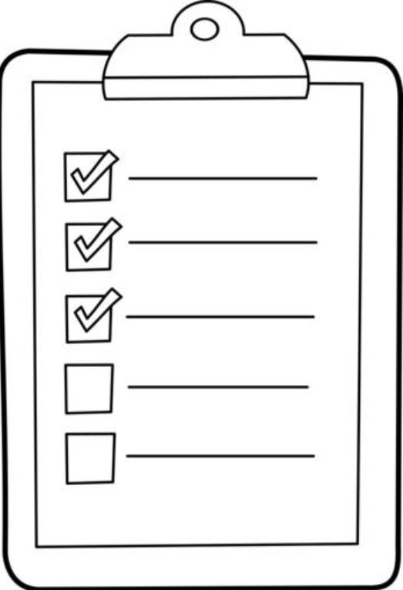



“Develop the detailed procedure you will need to put up your tent, start your fire and prepare your first meal. You can only use the items on your supply list.”
*If you need more space just extend your list to the back of this paper.
Pair up with your neighbor. On the back of their paper your neighbor is going draw as you read your procedure. Do not deviate from the procedure that you created.

- How did the final picture look? Does it match the one you created in Step 3?

- What changes would you make to your procedure?

- Why is it important to have a very detailed procedure?
“Now that you have created your list, packed all the items on your list and arrived at your destination (with very little family drama), you need to put together your campsite. Draw a picture, in the space provided, of the campsite that you will build. You can only include the items on your packing list. Remember that you must have a tent and a fire pit to prepare dinner. As you draw your campsite, develop a procedures list in the box below. This procedure list should be very detailed.”
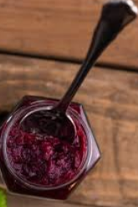
You Are the Peanut Butter to My Jelly
Aligned to the following standards:
FFA.PL-A; FFA.PL-C; FFA.PL-E; FFA.PL-F; FFA.PG-J; FFA.CS_N; CCSS.ELA.SL.9.10.1; CCSS.ELA.RST.9-10.7; CCSS.ELA.WHST.9.10.4; CCSS.ELA.RST.9.10.7; CRP.02; CRP.04; CRP.06; CRP.07; CRP.08
Directions:
You will work with two teammates to make a peanut butter and jelly sandwich. One of you will be responsible for giving instructions to your partner on how to create a peanut butter and jelly sandwich while your third teammate will be recording the instructions given.
Procedure
**This should be a numbered list of the exact instructions given to the sandwich maker.
Materials

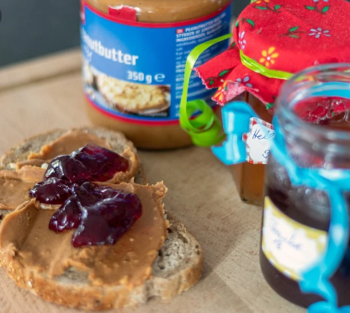

How did you feel during this process? Why?
How did your sandwich turn out? Why do you think it turned out the way that it did?

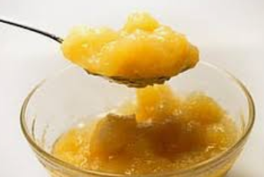

What happened when the instructions were not specific enough or a step was “missed”?
What would you do differently if you were to go through this process again? Why?

What would you tell someone else about the importance of a very specific, well-planned lab procedure?

Let’s Plan and Prepare
Aligned to the following standards:
FFA.PL-A; FFA.PL-C; FFA.PL-E; FFA.PL-F; FFA.PG-J; FFA.CS_N; CCSS.ELA.SL.9.10.1; CCSS.ELA.RST.9-10.7; CCSS.ELA.WHST.9.10.4; CCSS.ELA.RST.9.10.7; CRP.02; CRP.04; CRP.06; CRP.07; CRP.08
Directions:
Having a well-developed materials and methods section is very important for a study for many reasons. Using the resource from “How to Write Materials and Method Section in Scientific Writing,” let us learn some specifics about developing a materials and methods section for a research project.

Identify three key words for why a materials and methods section is important.

1.

2.

3.
In one sentence, describe what a materials and methods section is AND its purpose.

What tense should you write your methods section in?

_______________________
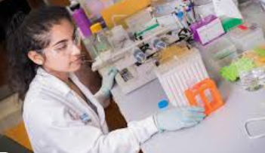
Using what has been learned, develop a detailed procedure for your research study.
Using the reference above, match the step with the correct description about developing a methods section by drawing a line.

- Organization

- Provide References

- Correct Experimental Design

- Effective Abbreviations

- Method Modifications

- Provide Details

Be specific in methodology modifications and the reason why these were made.

Providing credit to others’ research is crucial. Be sure to include in-text citations as well as a works cited page.

The order in which you present the results should match the methodology.

Ensure that your abbreviations are succinct and easily distinguishable.

Always be specific when writing your methodology.

Ensure that you have a control for your experiment as well as have your methodology checked by your teacher.

Create a materials list for your study.
KEY: Let’s Plan and Prepare
Aligned to the following standards:
FFA.PL-A; FFA.PL-C; FFA.PL-E; FFA.PL-F; FFA.PG-J; FFA.CS_N; CCSS.ELA.SL.9.10.1; CCSS.ELA.RST.9-10.7; CCSS.ELA.WHST.9.10.4; CCSS.ELA.RST.9.10.7; CRP.02; CRP.04; CRP.06; CRP.07; CRP.08
Directions:
Having a well-developed materials and methods is very important for a study for many reasons. Using the resource from “How to Write Materials and Method Section in Scientific Writing,” let us learn some specifics about developing a methods section for a research project.
Using what has been learned, develop a detailed procedure for your research study. Answers will vary.
Using the reference above, match the step with the correct description about developing a methods section by drawing a line.

- Organization

- Provide References

- Correct Experimental Design

- Effective Abbreviations

- Method Modifications

- Provide Details

Be specific in methodology modifications and the reason why these were made.

Providing credit to others’ research is crucial. Be sure to include in-text citations as well as a works cited page.

The order in which you present the results should match the methodology.

Ensure that your abbreviations are succinct and easily distinguishable.

Always be specific when writing your methodology.

Ensure that you have a control for your experiment as well as have your methodology checked by your teacher.

Identify three key words for why a materials and methods section is important. Answers will vary.

1.

2.

3.
In one sentence, describe what a materials and methods section is AND its purpose. Answers will vary.
What tense should you write your methods section in?

Past tense
Create a materials list for your study. Answers will vary.

