What Did I Get?
Created: 06/2021 by the National FFA Organization

Description: The purpose of this lesson series is to guide students through the agriscience research process. Skills learned through this process are in alignment with the National FFA Agriscience Fair award area.

Student Learning Objectives:
After completing these activities, students will …
- Describe the purpose of a results section in a research project.
- Develop a results section of a scientific research paper.

Student Grade Level:
Grades 9 and 10 (This lesson is written so instructors can scale up or down based on class needs.)
Suggested Time: 45 minutes (*Time requirements may vary based upon student understanding and class schedule.)

Resources/References:
- Website: Wordvice, https://wordvice.com/writing-the-results-section-for-a-research-paper/
- Video: “The Last Run Is All David Wise Needed to Defend Freestyle Skiing Halfpipe Gold – PyeongChang 2018,” https://youtu.be/VZSzNx1ND9w
- Document: Agriscience Fair Manuscript Examples, https://ffa.box.com/s/iut6a675rfpd9gq7xupnxvw113pseqdb
- Template: Agriscience Fair Written Report Template, https://ffa.box.com/s/2egran7ktpntyot680scgn3a3fhjy5ul

Equipment and Supplies Needed:
- A copy of the “Explain It to Me” worksheet for each student
- A copy of the “Skiing to the Result” worksheet for each student
- Internet access to play the video in real time or embed it in a PowerPoint ahead of time

Cross-Curricular Connections:
Science | English/Language Arts | Mathematics
Write the results section of a scientific study. | Write the results section of a scientific study. | Develop visual representations of data.

Student Activity Sheets:
Direct access to student activity sheets without lesson plan or answer key for easy upload to a learning management system or printing for classwork.

https://ffa.box.com/s/74u0wmelinqn3wragkia6czp7qiojp57 (Word)
https://ffa.box.com/s/9n2gjp35eh1tee250cup9rja1ilg0gk2 (PDF)

These activities are aligned to the following standards:

FFA Precept
- FFA.PL-A.Action: Assume responsibility and take the necessary steps to achieve the desired results, no matter what the goals or task at hand.
- FFA.PL-C.Vision: Visualize the future and how to get there.
- FFA.PL-E.Awareness: Understand personal vision, mission and goals.
- FFA.PL-F.Continuous Improvement: Accept responsibility for learning and personal growth.
- FFA.PG-J.Mental Growth: Embrace cognitive and intellectual development relative to reasoning, thinking and coping.
- FFA.PG-I.Professional Growth: Assume responsibility for attaining and improving upon the skills needed for career success.
- FFA.CS-N.Decision Making: Analyze a situation and execute an appropriate course of action.
Common Core – Speaking and Listening
- CCSS.ELA-Literacy.SL.9-10.1: Initiate and participate effectively in a range of collaborative discussions (one-on-one, in groups, and teacher-led) with diverse partners on grades 9-10 topics, texts, and issues, building on others' ideas and expressing their own clearly and persuasively.
Common Core – Science & Technical Subjects
- CCSS.ELA-Literacy.RST.9-10.7: Translate quantitative or technical information expressed in words in a text into visual form (e.g., a table or chart) and translate information expressed visually or mathematically (e.g., in an equation) into words.
Common Core – Literacy in Science & Technical Subjects: Writing
- CCSS.ELA-Literacy.WHST.9.10.4: Produce clear and coherent writing in which the development, organization, and style are appropriate to task, purpose, and audience.
- CCSS.ELA-Literacy.RST.9.10.7: Translate quantitative or technical information expressed in words in a text into visual form (e.g., a table or chart) and translate information expressed visually or mathematically (e.g., in an equation) into words.
AFNR Career Ready Practices
- CRP.02. Apply appropriate academic and technical skills. Career-ready individuals readily access and use the knowledge and skills acquired through experience and education to be more productive.
- CRP.04. Communicate clearly, effectively, and with reason. Career-ready individuals communicate thoughts, ideas and action plans with clarity, whether using written, verbal and/or visual methods.
- CRP.06. Demonstrate creativity and innovation. Career-ready individuals regularly think of ideas that solve problems in new and different ways, and they contribute those ideas in a useful and productive manner to improve their organization.
- CRP.07. Employ valid and reliable research strategies. Career-ready individuals are discerning in accepting and using new information to make decisions, change practices or inform strategies.
- CRP.08. Utilize critical thinking to make sense of problems and persevere in solving them. Career-ready individuals readily recognize problems in the workplace, understand the nature of the problem, and devise effective plans to solve the problem.
Common Core – Math
- MP1 – Make sense of problems and persevere in solving them.
- MP5 – Use appropriate tools strategically.
- MP6 – Attend to precision.
Partnership for 21st Century Skills
- Communication
- Critical Thinking and Problem Solving
- Flexibility and Adaptability
- Initiative and Self-direction
- Leadership and Responsibility
- Think Creatively

Lesson Plan:
- Bell Ringer: Describe a time in which you received the results from something and explain what the results were. Why were the results important?

- Introduction: Have students share their examples from the bell ringer. Once finished, explain to students that today they are going to learn about what a results section entails, its importance and why structuring the section correctly is important.

- Activity: Each student needs a copy of the worksheet “Explain It to Me.”
  - Part 1: Students will begin by reading two passages about developing the results section in a scientific research paper. During these reading activities, students will follow the instructions in each box to identify important information.
  - Part 2: During this time, students will begin putting their results section together. To begin, students will write down their research questions. Students need to select one question. They will then develop some kind of visual representation for their data (Ex. bar graph, pie chart, etc.). Students will translate their data into words, remembering to only report information and to not use personal opinion. Students will be able to add more inflection in the next section, the discussion section. Have students think-pair-share their visual representation and writing to gain feedback.

- Follow-up: Students should complete their results section by following the steps in Part 2 for all their research questions. If students only have one research question, they should gain constructive feedback from other students in the class to continue to refine their results section.

- Optional — Extended Learning Opportunities (Not factored into time requirement):
  - Students should write a 30-second elevator speech about the importance of a results section in a scientific research paper.

- Exit Ticket: Handout the worksheet “Skiing to the Result.” Have students watch the video “The Last Run Is All David Wise Needed to Defend Freestyle Skiing Halfpipe Gold – PyeongChang 2018,” available at https://youtu.be/VZSzNx1ND9w. While watching the video, students should complete the top half of the “Skiing to the Result” worksheet. Discuss student answers.

Explain It to Me
Aligned to the following standards:
FFA.PL-A; FFA.PL-C; FFA.PL-E; FFA.PL-F; FFA.PG-J; FFA.CS_N; CCSS.ELA.SL.9.10.1; CCSS.ELA.RST.9-10.7; CCSS.ELA.WHST.9.10.4; CCSS.ELA.RST.9.10.7; MP1; MP5; MP6; CRP.02; CRP.04; CRP.06; CRP.07; CRP.08
Part 1
Directions:
Read the following passages about the purpose of a research results section and complete the activities.
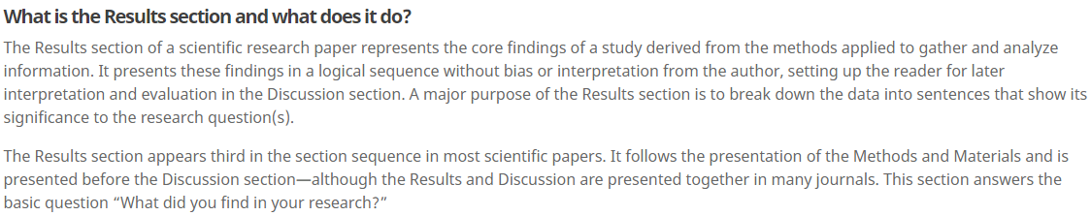
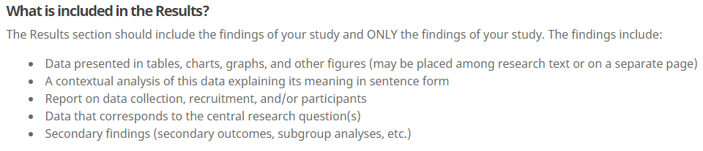


- In your own words, describe the results section of a scientific research study.
3. In purple, circle where the results section is located in a scientific paper.
2. According to the passage, how should the findings be presented? Underline the answer in red.
4. In yellow, highlight the basic question that the results section answers.
Finish the sentence: The results section should include …
- Who/what will you be reporting on?

- Give two examples of how you will visually represent your data for your study.
Helpful Tip: It is a good habit to discuss the results of each research question by itself.
Passages sourced from Wordvice at https://wordvice.com/writing-the-results-section-for-a-research-paper/


Part 2
Aligned to the following standards:
FFA.PL-A; FFA.PL-C; FFA.PL-E; FFA.PL-F; FFA.PG-J; FFA.CS_N; CCSS.ELA.SL.9.10.1; CCSS.ELA.RST.9-10.7; CCSS.ELA.WHST.9.10.4; CCSS.ELA.RST.9.10.7; MP1; MP5; MP6; CRP.02; CRP.04; CRP.06; CRP.07; CRP.08
Directions:
Now that we have discovered what a results section is and how it should be constructed, we are going to start laying out our own results section.
Record your research questions here so that you can reference them.
How can you visually represent your data? (Ex. bar graph, pie chart, etc.)
Select one research question to focus on for this activity.

When adding text to your results section, always be sure to describe what you found. Now that you have created your visual representation for your selected research question, use the space provided to describe exactly what your results are. Tip: Remember, we should not use personal opinion in the results section.
Using this space, develop a visual representation of your data. It can be in any format that will accurately represent your results.
Skiing to the Result
Aligned to the following standards:
FFA.PL-A; FFA.PL-C; FFA.PL-E; FFA.PL-F; FFA.PG-J; FFA.CS_N; CCSS.ELA.SL.9.10.1; CCSS.ELA.RST.9-10.7; CCSS.ELA.WHST.9.10.4; CCSS.ELA.RST.9.10.7; MP1; MP5; MP6; CRP.02; CRP.04; CRP.06; CRP.07; CRP.08
Directions:
Watch the video “The Last Run Is All David Wise Needed to Defend Freestyle Skiing Halfpipe Gold – PyeongChang 2018,” available at https://youtu.be/VZSzNx1ND9w. While watching the video, complete the following activity.



What is the Result?
How long ago did he win the X Games? _____________________________

When the announcers were reviewing the run, were they using personal opinion in their results? Circle your answer.

Yes No

When giving the results in a scientific paper, should personal opinion be given? How do the results of an athletic event differ from a scientific paper? Explain and give an example.




Why should we not give personal opinion in a results section?
What might happen if researchers give their personal opinions?
What is the purpose of a results section?

KEY: Explain It to Me
Aligned to the following standards:
FFA.PL-A; FFA.PL-C; FFA.PL-E; FFA.PL-F; FFA.PG-J; FFA.CS_N; CCSS.ELA.SL.9.10.1; CCSS.ELA.RST.9-10.7; CCSS.ELA.WHST.9.10.4; CCSS.ELA.RST.9.10.7; MP1; MP5; MP6; CRP.02; CRP.04; CRP.06; CRP.07; CRP.08
Part 1
Directions:
Read the following passages about the purpose of a research results section and complete the activities.
- In your own words, describe the results section of a scientific research study. Answers will vary.
3. In purple, circle where the results section is located in a scientific paper.
2. According to the passage, how should the findings be presented? Underline the answer in red.
4. In yellow, highlight the basic question the results section answers.
Finish the sentence: The results section should include … the findings of your study.
- Who/what will you be reporting on? Answers will vary.

- Give two examples of how you will visually represent your data for your study. Answers will vary.
Helpful Tip: It is a good habit to discuss the results of each research question by itself.
Passages sourced from Wordvice at https://wordvice.com/writing-the-results-section-for-a-research-paper/

KEY: Skiing to the Result
Aligned to the following standards:
FFA.PL-A; FFA.PL-C; FFA.PL-E; FFA.PL-F; FFA.PG-J; FFA.CS_N; CCSS.ELA.SL.9.10.1; CCSS.ELA.RST.9-10.7; CCSS.ELA.WHST.9.10.4; CCSS.ELA.RST.9.10.7; MP1; MP5; MP6; CRP.02; CRP.04; CRP.06; CRP.07; CRP.08
Directions:
Watch the video “The Last Run Is All David Wise Needed to Defend Freestyle Skiing Halfpipe Gold – PyeongChang 2018,” available at https://youtu.be/VZSzNx1ND9w. While watching the video, complete the following activity.

What is the Result?
How long ago did he win the X Games? 2 weeks prior to the Olympics

When the announcers were reviewing the run, were they using personal opinion in their results? Circle your answer.
Yes and No can both be correct.

Yes No

When giving the results in a scientific paper, should personal opinion be given? How do the results of an athletic event differ from a scientific paper? Explain and give an example.
Personal opinion should not be used when providing the results in a scientific paper. Personal opinion is given during athletics, which is how the two differ. Examples given will vary.

Why should we not give personal opinion in a results section? The results section is reserved for sharing what was found. The discussion section will allow for some personal inflection.
What might happen if researchers give their personal opinions? The data may not be reflected accurately.
What is the purpose of a results section? To share the data from the study.

