Let’s Discuss and Make Conclusions
Created: 06/2021 by the National FFA Organization

Description: The purpose of this lesson series is to guide students through the agriscience research process. Skills learned through this process are in alignment with the National FFA Agriscience Fair award area.

Student Learning Objectives:
After completing these activities, students will …
- Describe the purpose of a discussion section in a scientific research paper.
- Write a discussion section for a scientific research paper.
- Describe the purpose of a conclusion section in a scientific research paper.
- Write a conclusion section for a scientific research paper.

Suggested Grade Level:
Grades 9 and 10 (This lesson is written so instructors can scale up or down based on class needs.)

Suggested Time: 120 minutes (*Time requirements may vary based upon student understanding and class schedule.)

Resources/References:
- Video: “Discussion vs. Conclusion: Know the Difference,” https://youtu.be/CI2YZtLLXZI
- Document: Agriscience Fair Manuscript Examples, https://ffa.box.com/s/iut6a675rfpd9gq7xupnxvw113pseqdb
- Template: Agriscience Fair Written Report Template, https://ffa.box.com/s/2egran7ktpntyot680scgn3a3fhjy5ul

Equipment and Supplies Needed:
- A copy of the “What’s the Difference?” worksheet for each student
- Internet access to play the video in real time or embed it in a PowerPoint ahead of time

Cross-Curricular Connections:
Science | English/Language Arts
Read and analyze discussion and conclusion sections of completed research papers. | Construct a discussion and conclusion section of a research study.

Student Activity Sheets:
Direct access to student activity sheets without lesson plan or answer key for easy upload to a learning management system or printing for classwork.

https://ffa.box.com/s/i7ydb4vq3aac6pppau4nzjcicu8n0nx0 (Word)
https://ffa.box.com/s/pvrf72daku6c6944t8ugmk6fz6a6qyar (PDF)

These activities are aligned to the following standards:

FFA Precept
- FFA.PL-A.Action: Assume responsibility and take the necessary steps to achieve the desired results, no matter what the goals or task at hand.
- FFA.PL-C.Vision: Visualize the future and how to get there.
- FFA.PL-E.Awareness: Understand personal vision, mission and goals.
- FFA.PL-F.Continuous Improvement: Accept responsibility for learning and personal growth.
- FFA.PG-J.Mental Growth: Embrace cognitive and intellectual development relative to reasoning, thinking and coping.
- FFA.PG-I.Professional Growth: Assume responsibility for attaining and improving upon the skills needed for career success.
- FFA.CS-N.Decision Making: Analyze a situation and execute an appropriate course of action.
Common Core – Speaking and Listening
- CCSS.ELA-Literacy.SL.9-10.1: Initiate and participate effectively in a range of collaborative discussions (one-on-one, in groups, and teacher-led) with diverse partners on grades 9-10 topics, texts, and issues, building on others' ideas and expressing their own clearly and persuasively.
Common Core – Science & Technical Subjects
- CCSS.ELA-Literacy.RST.9-10.7: Translate quantitative or technical information expressed in words in a text into visual form (e.g., a table or chart) and translate information expressed visually or mathematically (e.g., in an equation) into words.
Common Core – Literacy in Science & Technical Subjects: Writing
- CCSS.ELA-Literacy.WHST.9.10.4: Produce clear and coherent writing in which the development, organization, and style are appropriate to task, purpose, and audience.
- CCSS.ELA-Literacy.RST.9.10.7: Translate quantitative or technical information expressed in words in a text into visual form (e.g., a table or chart) and translate information expressed visually or mathematically (e.g., in an equation) into words.
AFNR Career Ready Practices
- CRP.02. Apply appropriate academic and technical skills. Career-ready individuals readily access and use the knowledge and skills acquired through experience and education to be more productive.
- CRP.04. Communicate clearly, effectively, and with reason. Career-ready individuals communicate thoughts, ideas and action plans with clarity, whether using written, verbal and/or visual methods.
- CRP.06. Demonstrate creativity and innovation. Career-ready individuals regularly think of ideas that solve problems in new and different ways, and they contribute those ideas in a useful and productive manner to improve their organization.
- CRP.07. Employ valid and reliable research strategies. Career-ready individuals are discerning in accepting and using new information to make decisions, change practices or inform strategies.
- CRP.08. Utilize critical thinking to make sense of problems and persevere in solving them. Career-ready individuals readily recognize problems in the workplace, understand the nature of the problem, and devise effective plans to solve the problem.
Partnership for 21st Century Skills
- Communication
- Critical Thinking and Problem Solving
- Flexibility and Adaptability
- Initiative and Self-direction
- Leadership and Responsibility
- Think Creatively

Lesson Plan:
- Bell Ringer: What is the difference between a discussion and a conclusion? Explain.

- Introduction: Have students share their responses from the bell ringer. After, explain that today they are going to explore the difference between a discussion and conclusion section of a scientific research paper and develop their own.

- Activity: Each student needs a copy of the worksheet “What’s the Difference?”
  - Part 1: Students will watch the video “Discussion vs. Conclusion: Know the Difference.” The video is available at https://youtu.be/CI2YZtLLXZI. While watching the video, students should answer the questions. Students will think through what they just saw in the video and compare and contrast the discussion and conclusion sections of a research paper.
  - Part 2: Next, students will begin putting their discussion and conclusions together for their studies. Students will walk through each question provided and answer them about their own studies. Then, they will put all the information together in paragraph format. Students will repeat the same format for the conclusion section of their paper.

- Follow-up: Have students pair with other students in class and allow them to give feedback to help each student improve their discussion and conclusion section.

- Optional — Extended Learning Opportunities (Not factored into time requirement):
  - Find two different research studies that have similar themes. Read the discussion and conclusion sections, and identify each of the important components that should be included in a discussion and conclusion sections by underlining the components. Components to look for include the following: major findings; the meaning of those findings; how those findings relate to what others have done; the limitations of the findings; an explanation for any surprising, unexpected or inconclusive results; and suggestions for further research.

- Exit Ticket: What is the purpose of a discussion and conclusion section?

What’s the Difference?
Aligned to the following standards:
FFA.PL-A; FFA.PL-C; FFA.PL-E; FFA.PL-F; FFA.PG-J; FFA.CS_N; CCSS.ELA.SL.9.10.1; CCSS.ELA.RST.9-10.7; CCSS.ELA.WHST.9.10.4; CCSS.ELA.RST.9.10.7; MP1; MP5; MP6; CRP.02; CRP.04; CRP.06; CRP.07; CRP.08
Part 1
Directions:
Watch the video “Discussion vs. Conclusion: Know the Difference,” available at https://youtu.be/CI2YZtLLXZI. While watching the video, complete the following activities.
- The discussion section requires you to think about the ___________________ of what you have done.

- An effective discussion section tells the reader what your study _______________ and why it is ___________________.

- Where does the discussion section go in a scientific research paper?

- What should be included in your discussion section to make it engaging and effective?

- A conclusion is a _____________________ of everything that you have ________________ thus far.

- In the conclusion section, we ___________________the reader of what they just read.

- What should be included in a conclusion section?

Using your own words, compare and contrast the results, discussion and conclusion section of another research paper.




Part 2
Directions:
At this point, we are going to develop a discussion and conclusion for your own scientific research study. Follow the steps below.
Discussion Section:
- What do your results mean?

- What was important about your study, and what were the major findings?

- How do these findings relate to what others have done? (Hint: Refer to your introduction and literature review!)

- What are the limitations (weaknesses) of your study?

- Were there any surprises with your results?

- What suggestions do you have for future research?

Now Put It All Together: Discussion
Conclusion Section:
- What is your research question(s) and hypothesis?

- What are the major findings?

- What contribution does your study make to the industry?

- What recommendations would you make for future research?
What was the easiest part of writing the discussion? Why?
What was the hardest part of writing the discussion? Why?

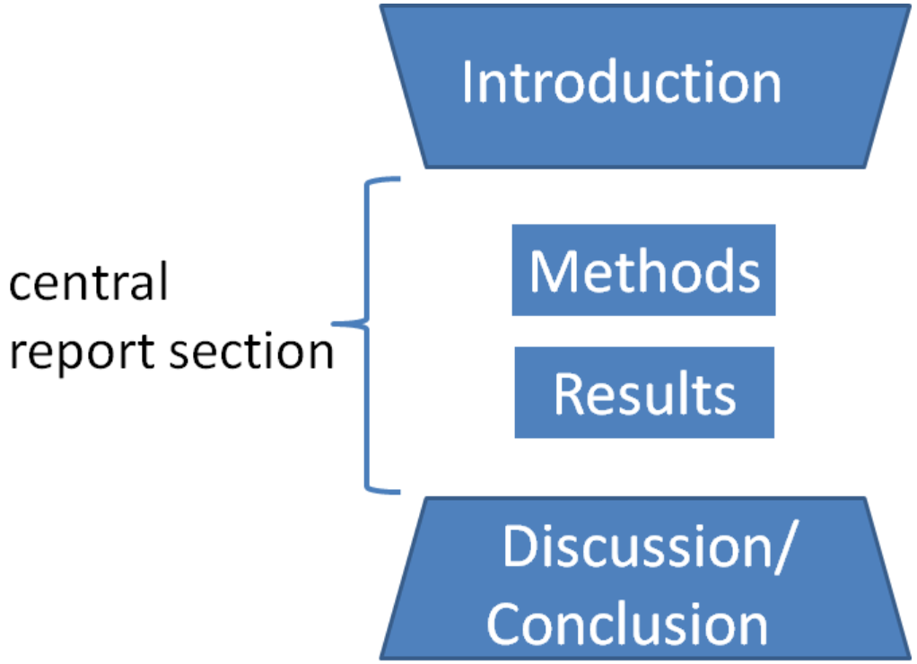

Now Put It All Together: Conclusion
Overall, what are the major components of a discussion and conclusion section of a scientific research study?

Overall, what is the purpose of a discussion and conclusion? Why are these two components required in a research paper?

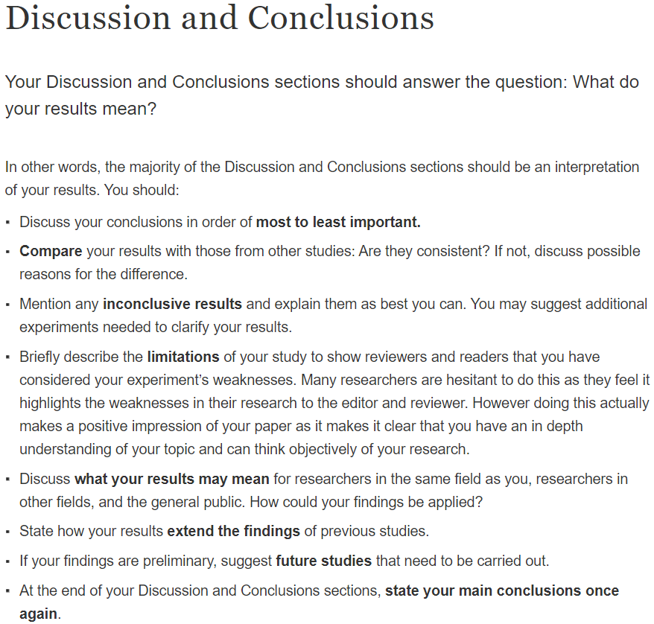
KEY: What’s the Difference?
Aligned to the following standards:
FFA.PL-A; FFA.PL-C; FFA.PL-E; FFA.PL-F; FFA.PG-J; FFA.CS_N; CCSS.ELA.SL.9.10.1; CCSS.ELA.RST.9-10.7; CCSS.ELA.WHST.9.10.4; CCSS.ELA.RST.9.10.7; MP1; MP5; MP6; CRP.02; CRP.04; CRP.06; CRP.07; CRP.08
Part 1
Directions:
Watch the video “Discussion vs. Conclusion: Know the Difference,” available at https://youtu.be/CI2YZtLLXZI. While watching the video, complete the following activities.
- The discussion section requires you to think about the meaning of what you have done.

- An effective discussion section tells the reader what your study means and why it is important.

- Where does the discussion section go in a scientific research paper?
After the methods but before the conclusion

- What should be included in your discussion section to make it engaging and effective?
- Major findings
- Meaning of those findings
- How these findings relate to what others have done
- Limitations of your findings
- Explanation for any surprising, unexpected or inconclusive results
- Suggestions for further research

- A conclusion is a summary of everything that you have said thus far.

- In the conclusion section, we remind the reader of what they just read.

- What should be included in a conclusion section?
- Restate the hypothesis and research question
- Restate major findings
- Tell the reader about the contribution your study has made to the existing literature
- Future recommendations

Using your own words, compare and contrast a results, discussion and conclusion section of a research paper. Answers will vary.

Now Put It All Together: Conclusion
Answers will vary.
Overall, what are the major components of a discussion and conclusion section of a scientific research study?
- Major findings
- Meaning of those findings
- How these findings relate to what others have done
- Limitations of your findings
- Explanation for any surprising, unexpected or inconclusive results
- Suggestions for further research

Overall, what is the purpose of a discussion and conclusion? Why are these two components required in a research paper?
The purpose of the discussion and conclusion section is to present the major findings, the meaning of those findings, the relationship to other studies, limitations, an explanation and suggestions. These are required components to a research paper as it provides a more in-depth description of the study and what comes next.

