All About Chocolate
Created: 02/2018 by the National FFA Organization

Student Learning Objectives:
After completing these activities, students will …
1. Examine the effect of the water cycle on cocoa production.
2. Illustrate the water cycle.
3. Develop a speech about the effects of the water cycle and climate change on cocoa production.

Time REQUIRED: 50 minutes
Resources:
- FFA.org
2. Article: “Could Climate Change Lead to Tastier Chocolate?” https://modernfarmer.com/2017/12/climate-change-lead-tastier-chocolate/
3. Website: “What is Climate Change?” https://www.nasa.gov/audience/forstudents/k-4/stories/nasa-knows/what-is-climate-change-k4.html
4. Website: “The Water Cycle,” https://pmm.nasa.gov/education/water-cycle

Equipment and Supplies Needed:
- A copy of the “Is Stress Good for Chocolate?” worksheet for each student
- Internet access to the article or copies of the article for each student
- Appendix 1 — “Hot Topic” in Agriculture Speech

This quick lesson plan would work well as Part of:
- An agriscience lesson/unit.
- A food science lesson/unit.
- A plant science lesson/unit.

These activities are aligned to the following standards:
FFA Precept
- FFA.PL-A.Action: Assume responsibility and take the necessary steps to achieve the desired results, no matter what the goal or task at hand.
- FFA.PL-C.Vision: Visualize the future and how to get there.
- FFA.PL-D.Character: Conduct oneself appropriately in relation to others regardless of the situation.
- FFA.PL-E.Awareness: Understand personal vision, mission and goals.
- FFA.PL-F.Continuous Improvement: Accept responsibility for learning and personal growth.
- FFA.CS-M.Communication: Effectively interact with others in personal and professional settings.
- FFA.CS-N.Decision Making: Analyze a situation and execute an appropriate course of action.
- FFA.CS-O.Flexibility/Adaptability: Be flexible in various situations and adapt to change.
Common Core-Reading: Informational Text
- CCSS.ELA-Literacy.RI.9-10.2 Determine a central idea of a text and analyze its development over the course of the text, including how it emerges and is shaped and refined by specific details; provide an objective summary of the text.
Common Core-Speaking and Listening
- CCSS.ELA-Literacy.SL.9-10.4 Present information, findings, and supporting evidence clearly, concisely, and logically such that listeners can follow the line of reasoning and the organization, development, substance, and style are appropriate to purpose, audience, and task.
Common Core-Writing
- CCSS.ELA-Literacy.W.9-10.2 Write informative/explanatory texts to examine and convey complex ideas, concepts, and information clearly and accurately through the effective selection, organization, and analysis of content.
- CCSS.ELA-Literacy.W.9-10.4 Produce clear and coherent writing in which the development, organization, and style are appropriate to task, purpose, and audience.
AFNR Career Ready Practices
- CRP.04. Communicate clearly, effectively, and with reason. Career-ready individuals communicate thoughts, ideas and action plans with clarity, whether using written, verbal and/or visual methods.
Partnership for 21st Century Skills
- Communication
- Information, Communications, and Technology Literacy
- Initiative and Self-direction
- Leadership and Responsibility

Lesson Plan:
- Introduction: Have students research this question: What is climate change?
  - Answer: According to the NASA website, climate change is a change in the usual weather found in a place. It could be a change in how much rain a place usually gets in a year. Or it could be a change in a place’s usual temperature for a month or season.
    - https://www.nasa.gov/audience/forstudents/k-4/stories/nasa-knows/what-is-climate-change-k4.html
b. How do you think climate changes affects crop production?

- Activity: Each student needs a copy of the worksheet “Is Stress Good for Chocolate?” and access to (or a copy of) the internet article “Could Climate Change Lead to Tastier Chocolate?”
a. Students will read the article “Could Climate Change Lead to Tastier Chocolate?” and then complete the worksheet. The direct URL is https://modernfarmer.com/2017/12/climate-change-lead-tastier-chocolate/.
The worksheet has three parts:

Part 1: Students will answer questions on the worksheet after reading the article.

Part 2: Students will draw and label the water cycle. (For an example of the water cycle, reference “The Water Cycle,” https://pmm.nasa.gov/education/water-cycle.)

Part 3: Students will complete the processing and research questions on the worksheet.

- Follow-up: When students are finished with the activity, have them complete the following:
  - On a sheet of paper, create a social media “status update” about what you learned in class today. Be sure to include three facts you learned in your social media “status update.”

- Leveling Up: Have students create a two- to three-minute speech on a current “hot topic” within agriculture. Students should answer the questions below and follow these guidelines when developing their speech. Examples of topics include genetically modified organisms (GMOs), gestation crates, etc. (Rubric included. See Appendix 1.)

a. Give a one-paragraph introduction to the topic of the speech. What will you be discussing throughout the entirety of the speech?

b. Main body of speech: Should be two to three paragraphs in length. Suggested information to include in this section:
i. Provide an overall explanation of the “hot topic” you chose.

ii. How does this “hot topic” affect the agriculture industry and consumers?

iii. Based on your research of the “hot topic,” how is this issue/topic being addressed?

c. Conclusion: Students should summarize the key points they made throughout the speech. This should be no longer than a paragraph.

Is Stress Good for Chocolate?
Aligned to the following standards:
FFA.PL-A.; FFA.PL-C., FFA.PL-D.; FFA.PL-E.; FFA.PL-F.; FFA.CS-M.; FFA.CS-N.;FFA.CS-O.;CCSS.RI.9-10.2; CCSS.SL.9-10.4; CCSS.W.9-10.2; CCSS.W.9-10.4;CRP04;
directions
Part 1:
Read the article “Could Climate Change Lead to Tastier Chocolate?” The direct URL is https://modernfarmer.com/2017/12/climate-change-lead-tastier-chocolate/. After reading the article, answer the questions below.
2. What did the researchers discover?
1. What was the goal of this study?

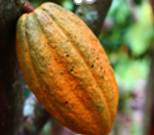

4. Based on the findings of the study, what do you think could be done to address the issue?
3. What was a significant difference found as a result of the study?

Part 2:
Aligned to the following standards:
FFA.PL-A.; FFA.PL-C., FFA.PL-D.; FFA.PL-E.; FFA.PL-F.; FFA.CS-M.; FFA.CS-N.; FFA.CS-O.;CCSS.RI.9-10.2; CCSS.SL.9-10.4; CCSS.W.9-10.2; CCSS.W.9-10.4;CRP04;
After reading the article, complete the activity below.

1. Draw and label the water cycle. (For an example of the water cycle, reference “The Water Cycle,” https://pmm.nasa.gov/education/water-cycle.)

2. How has the water cycle affected cocoa production in Bolivia?

______________________________________________________________________________________________________________________________

______________________________________________________________________________________________________________________________

______________________________________________________________________________________________________________________________

Part 3:
Aligned to the following standards:
FFA.PL-A.; FFA.PL-C., FFA.PL-D.; FFA.PL-E.; FFA.PL-F.; FFA-PL-I.; FFA-PL-M.;FFA.PL-O.; CCSS.SL.9-10.2;CCSS.RI.9-10.2; CCSS.SL.9-10.4; CCSS.W.9-10.2; CRP04; CRP10
Complete the questions below after reading the article.

1. How does stress affect you at school and/or at an after-school job?
___________________________________________________________________________________________________

___________________________________________________________________________________________________

2. How can you turn stress into something positive?

__________________________________________________________________________________________________

__________________________________________________________________________________________________

___________________________________________________________________________________________________

3. Research a plant/crop that is grown in your area, and describe how the water cycle affects the plant’s/crop’s growth.

_______________________________________________________________________________________________

______________________________________________________________________________________

______________________________________________________________________________________

______________________________________________________________________________________

______________________________________________________________________________________

______________________________________________________________________________________

______________________________________________________________________________________

______________________________________________________________________________________

3a. List three websites you used for your research.

__________________________________________________________________________________________________

__________________________________________________________________________________________________

__________________________________________________________________________________________________

__________________________________________________________________________________________________

KEY: Is Stress Good for Chocolate?
Aligned to the following standards:
FFA.PL-A.; FFA.PL-C., FFA.PL-D.; FFA.PL-E.; FFA.PL-F.; FFA.CS-M.;FFA.CS-N.;FFA.CS-O.;CCSS.RI.9-10.2; CCSS.SL.9-10.4; CCSS.W.9-10.2; CCSS.W.9-10.4;CRP04;
Aligned to the following standards:
FFA.PL-A.; FFA.PL-C., FFA.PL-D.; FFA.PL-E.; FFA.PL-F.; FFA-PL-I.; FFA-PL-M.;FFA.PL-O.; CCSS.SL.9-10.2;CCSS.RI.9-10.2; CCSS.SL.9-10.4; CCSS.W.9-10.2; CRP04; CRP10
directions
Part 1:
Read the article “Could Climate Change Lead to Tastier Chocolate?” The direct URL is https://modernfarmer.com/2017/12/climate-change-lead-tastier-chocolate/. After reading the article, complete the questions below.
2. What did the researchers discover?
The researchers found little difference between the chemical composition of the beans taken from different growing conditions.
1. What was the goal of this study?
The goal was to see if “stress” could have an effect on the flavor of cocoa.

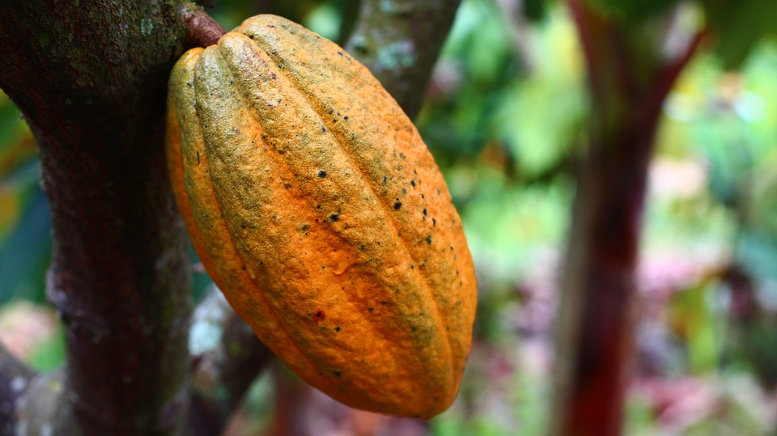

4. Based on the findings of the study, what do you think could be done to address the issue?
Answers will vary.

3. What was a significant difference found as a result of the study?
The weather.

Appendix 1 — “Hot Topic” in Agriculture Speech
Aligned to the following standards:
FFA.PL-A.; FFA.PL-C., FFA.PL-D.; FFA.PL-E.; FFA.PL-F.; FFA.CS-M.;FFA.CS-N.;FFA.CS-O.;CCSS.RI.9-10.2; CCSS.SL.9-10.4; CCSS.W.9-10.2; CCSS.W.9-10.4;CRP04;

directions:
Create a 2- to 3-minute speech on a current “hot topic” within agriculture. Answer the questions below and follow these guidelines when developing your speech.
a. Provide a one-paragraph introduction to the topic of the speech. What will you be discussing throughout the entirety of the speech?
b. Main body of speech: Should be 2 to 3 paragraphs in length. Suggested information to include in this section:
i. Provide an overall explanation of the “hot topic” you chose.
ii. How does this “hot topic affect the agriculture industry and consumers?
iii. Based on your research of the “hot topic,” how is this issue/topic being addressed?
c. Conclusion: Students should summarize the key points they made throughout the speech. This should be no longer than a paragraph.

Criteria | Rating  Excellent (10 points) | Rating  Good (5 points) | Score  Needs Improvement  (0 points)
Introduction | Gets audience’s attention  Introduces main point(s) of the speech | Introduction is shorter than a paragraph in length.  Vaguely introduces main point(s) | No introduction given
Main Body of Speech | Student thoroughly answers the two questions in the prompt and provides an overall explanation of the “hot topic.” | Student thoroughly answers the two questions in the prompt and vaguely provides an overall explanation of the “hot topic.” | No answer given
Conclusion | Student thoroughly summarizes key points made in the speech. | Student vaguely summarizes key points made in the speech. | No conclusion given
Length | Speech is 2–3 minutes in length. | Speech is 1–2 minutes in length. | Speech is less than one minute in length.

Comments:

_________________________________________________________________________________________________

_________________________________________________________________________________________________

