All About Service!
Directions: Choose one of the articles available here (FFA Response to WWII, Food For America, Building Our American Communities [BOAC], FFA Impact on Rural Communities and Seeds of Hope Campaign) and answer the questions below to learn about the FFA history of service.
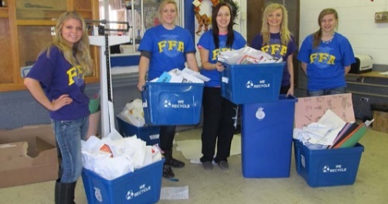
- In the past, what specific service projects/events (or types) do you think FFA has participated in?
- What article did you choose?
- Summarize the article in three to five sentences.
- How can you apply what you have read and learned to your own FFA chapter (or school) and community? What aspects would be the same? What would be different about the service project?
- What does “Living to Serve” mean to you?

