Animal Bio Health Celebration

Directions:
Animal health is important in day-to-day animal operations and for companion animals. Watch the video, Merck Animal Health (https://vimeo.com/447509468), and complete the following activities.

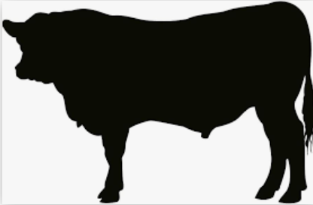
- What are some of the best biosecurity practices for shows? Identify 7 practices.

2. What has been the impact of COVID-19 on the animal health industry?

3. How is Merck Animal Health working with partners to help with animal bio health? Identify 4 ways.

5. What are some tips for those starting out with animal bio health with their animals?

6. What stress might show animals (animals in fairs, livestock shows, etc.) experience, and how will it affect the overall health of the animal?

4. How does animal bio health impact you and your friends and/or family?

7. Using AgExplorer, identify three careers (besides a veterinarian) that are directly related to animal health.

(1)

(2)

(3)

KEY: Animal Bio Health Celebration
Directions:
Animal health is important in day-to-day animal operations and for companion animals. Watch the video, Merck Animal Health (https://vimeo.com/447509468), and complete the following activities.

- What are some of the best biosecurity practices for shows? Identify 7 practices.

- Work with a mentor

- Vaccination/Deworming schedule

- Nutrition program

- Guard against outside pests while at show

- Disinfect and sanitize

- Isolate animals post show

- Control who has access to animals’ food and water

2. What has been the impact of COVID-19 on the animal health industry?

- Flea and tick treatments increase

- Wellness visits decline

- Boarding decline

3. How is Merck Animal Health working with partners to help with animal bio health? Identify 4 ways.

- Providing signage for curbside visits

- Education on telemedicine

- Education on social distancing practices

- Ensuring product fulfilment

5. What are some tips for those starting out with animal bio health with their animals?
- Seek out a mentor

- Research expert information

- Make a nutrition plan

- Make a health plan

- Make a deworming plan

- Look into shared boarding

- Visit other farms

6. What stress might show animals (animals in fairs, livestock shows, etc.) experience, and how will it affect the overall health of the animal?

Cattle may have trouble eating and/or drinking. To help with this, keep fans on them and have ventilation. Keep them as comfortable as possible.

Look into the Y2CA program that comes from the beef quality and pork evaluation assurance programs to ensure handling of animals in a low-stress way.

4. How does animal bio health impact you and your friends and/or family?
Answers will vary.

7. Using AgExplorer, identify three careers (besides a veterinarian) that are directly related to animal health.
Answers will vary. Examples: sales representative: feed and animal health, animal biotechnologist, animal caretake/operations manager, etc.

(1)

(2)

(3)

